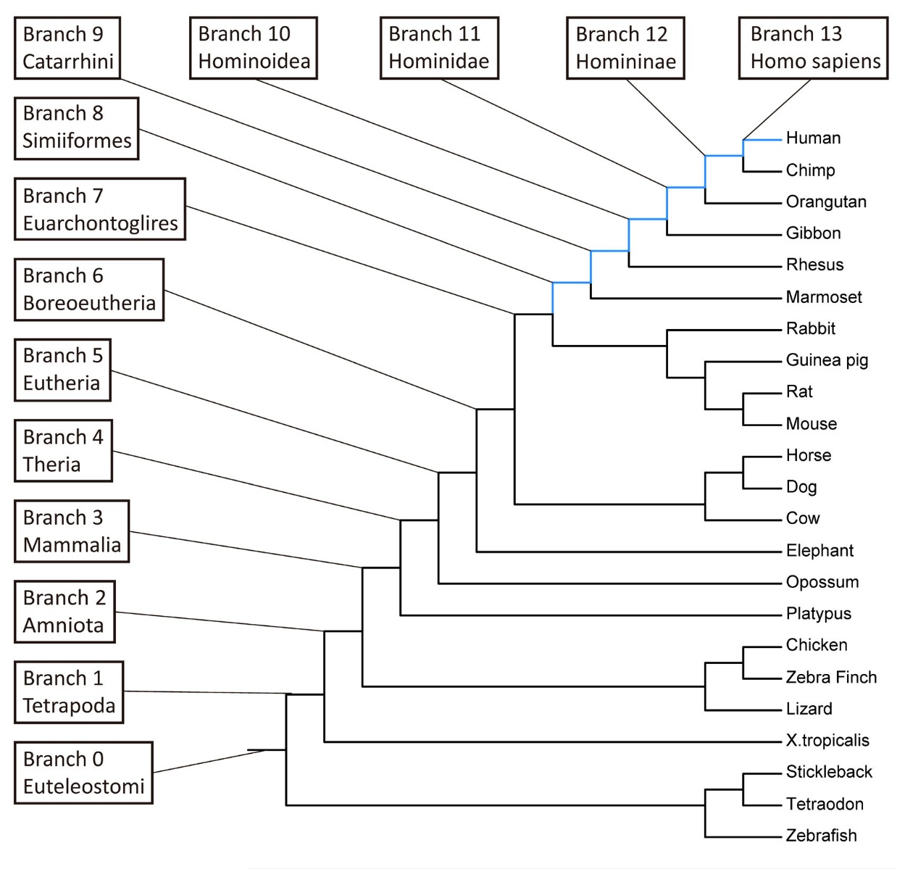
Supplemental Figure S1. Age branch specification.
In SBP, a total of 14 distinct age groups (branch 0-13) were specified based on the phylogenetic context. Genes postdating the human-mouse split (branch 8-13) are referred as primate-specific genes (PSGs, marked in light blue) in the text while all other genes (branch 0-7) are referred to as non-PSGs.

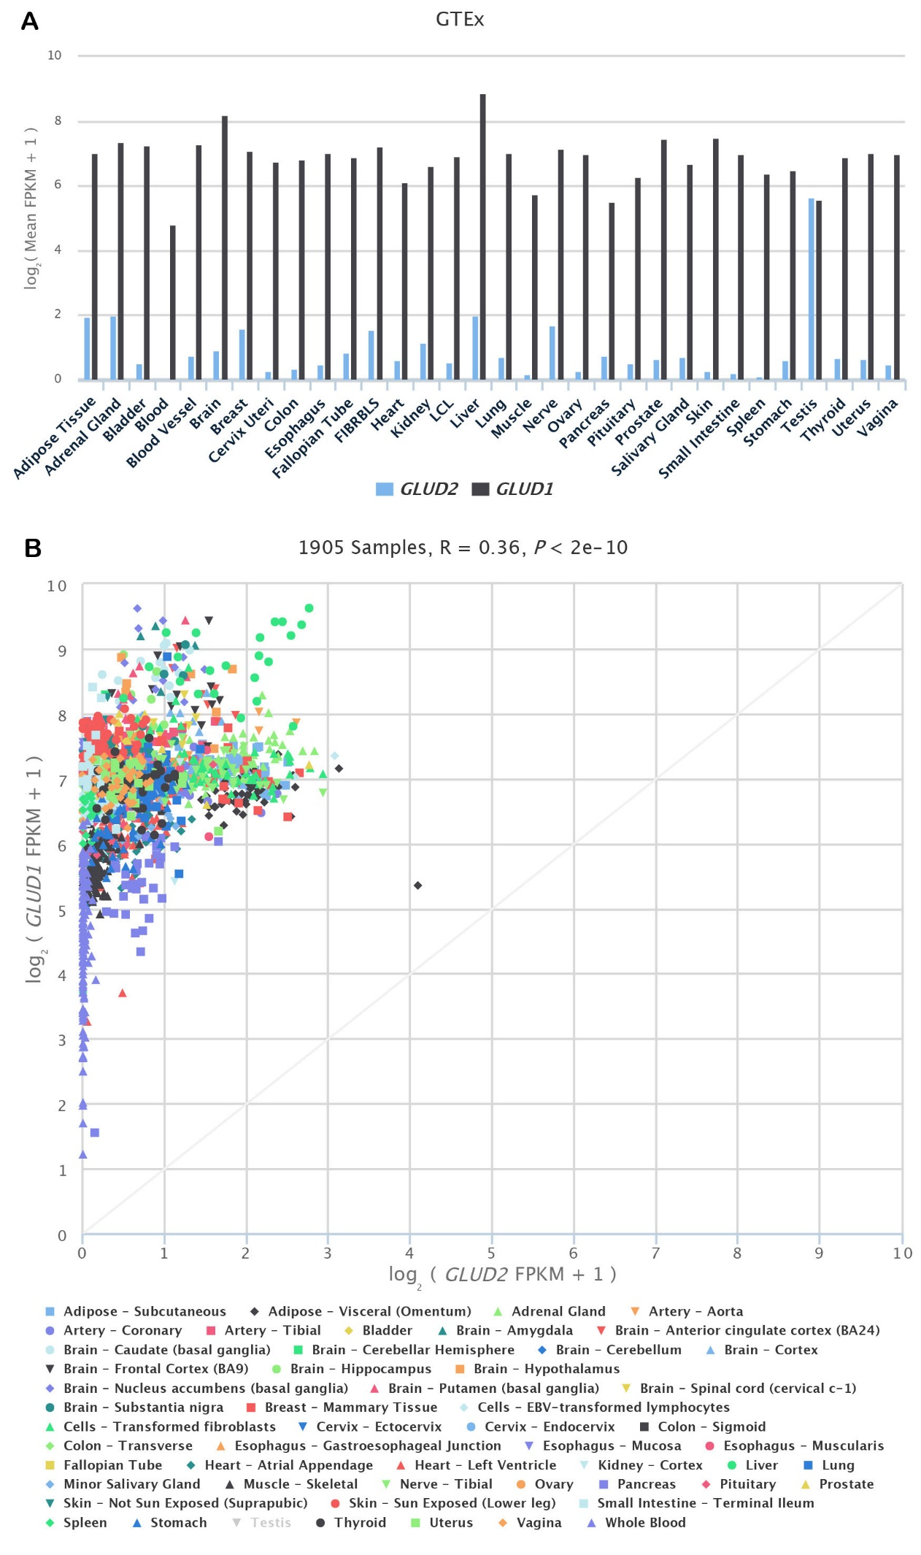

Supplemental Figure S2. GTEx transcriptome profile across tissues for GLUD1 and GLUD2.
The upper and lower panel follows the convention of Figure 2C and D, respectively. In the lower panel, the diagonal line marks when the expression of two duplicates is the same.

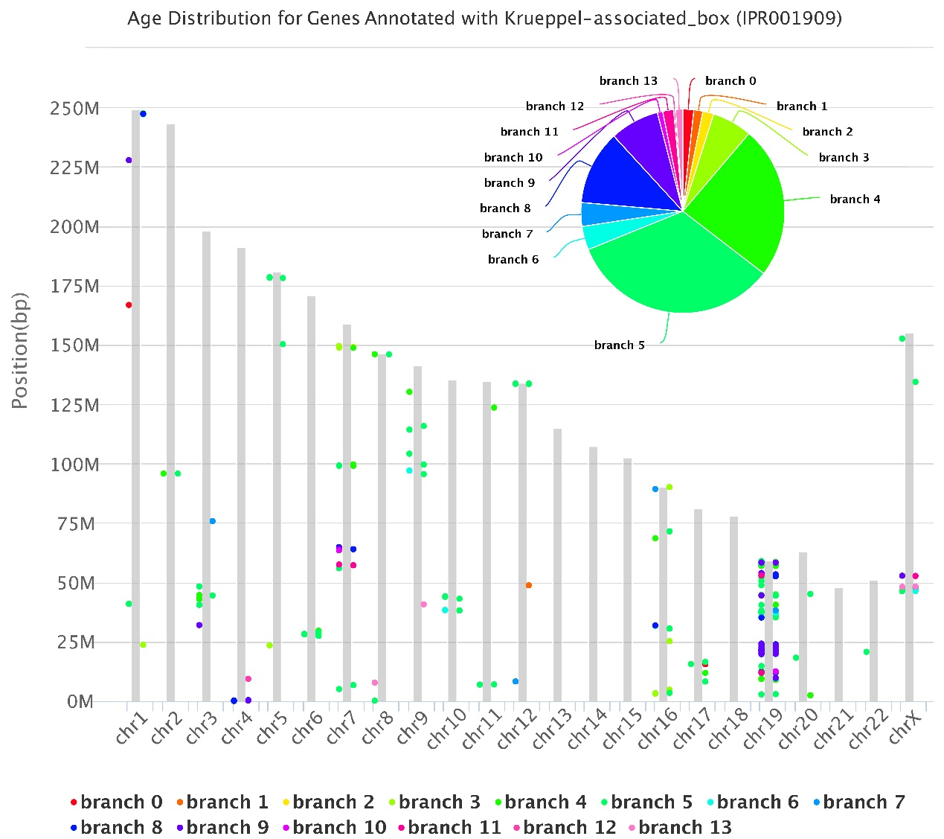
Supplemental Figure S3. GenTree Browse page showing the chromosomal and age distribution of KZNFs.
The gray bars represent different chromosomes (scaled to the corresponding size), and dots along the chromosome indicate genes (color-coded by the GenTree assigned age, branches 0-13 in Supplemental Fig. S1). Each dot is hyperlinked to the corresponding gene page, as shown in Fig. 2 in the main text. The pie chart in the top right shows the proportions of genes in each age branch. This figure is also available at http://gentree.ioz.ac.cn/tools/gene_browse.php?selectc=interpro&content=IPR001909.

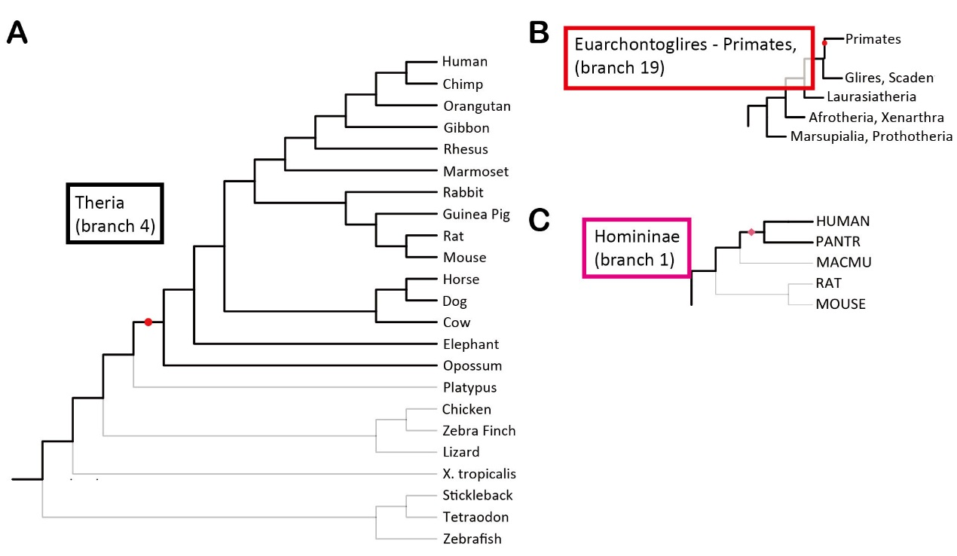
Supplemental Figure S4. The branch view of MYEOV.
Branch view based on SBP (A), phylostratigraphy (B) and ProteinHistorian (C) for MYEOV. Different branch specification is used for each method. The corresponding GenTree webpage is available at http://gentree.ioz.ac.cn/tools/viewIDS.php?speciesselect=Human&genename=ENSG00000172927 .

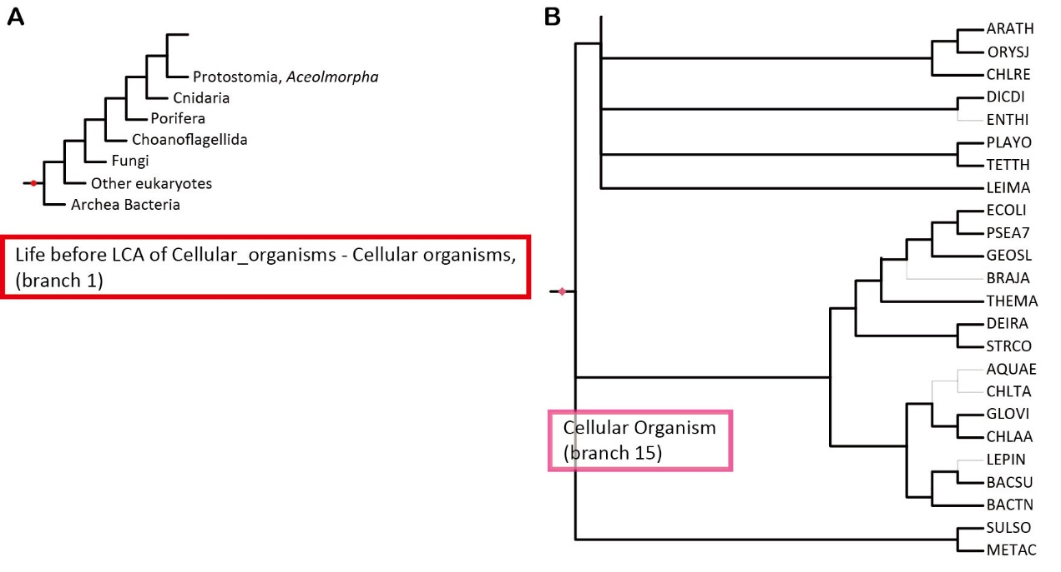
Supplemental Figure S5. The branch view of GLUD2.
The branch view based on phylostratigraphy (A) and ProteinHistorian (B) for GLUD2. The corresponding GenTree webpage with the complete figures is available at http://gentree.ioz.ac.cn/tools/viewIDS.php?speciesselect=Human&genename=ENSG00000182890 .

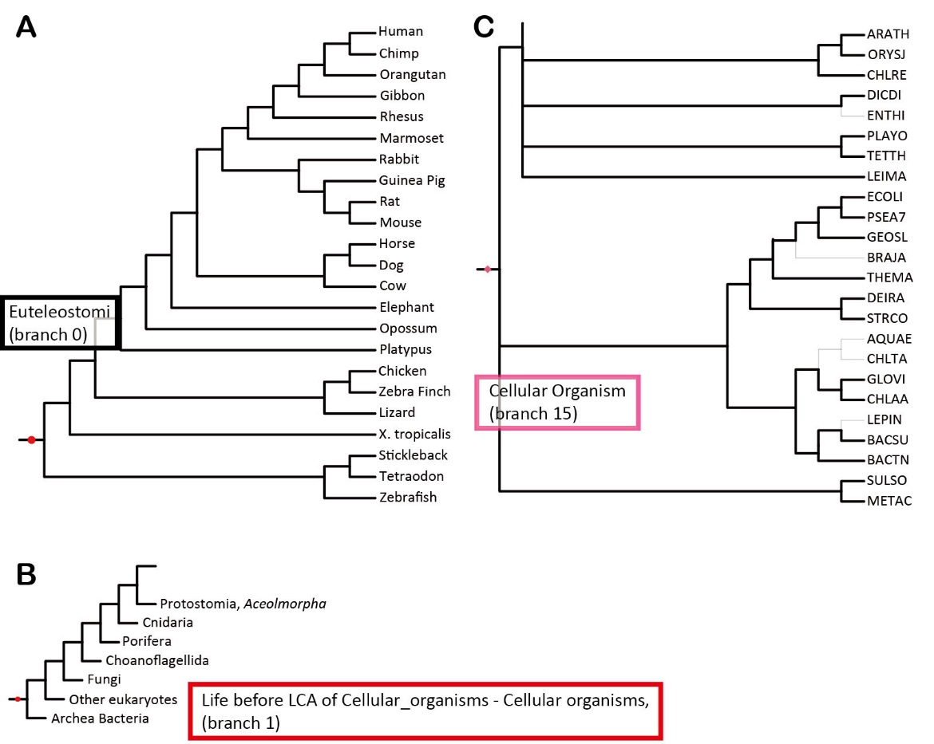
Supplemental Figure S6. The branch view of GLUD1.
The branch view of SBP (A), phylostratigraphy (B) and ProteinHistorian (C) for GLUD1. The corresponding GenTree webpage is available at http://gentree.ioz.ac.cn/tools/viewIDS.php?speciesselect=Human&genename=ENSG00000148672 .

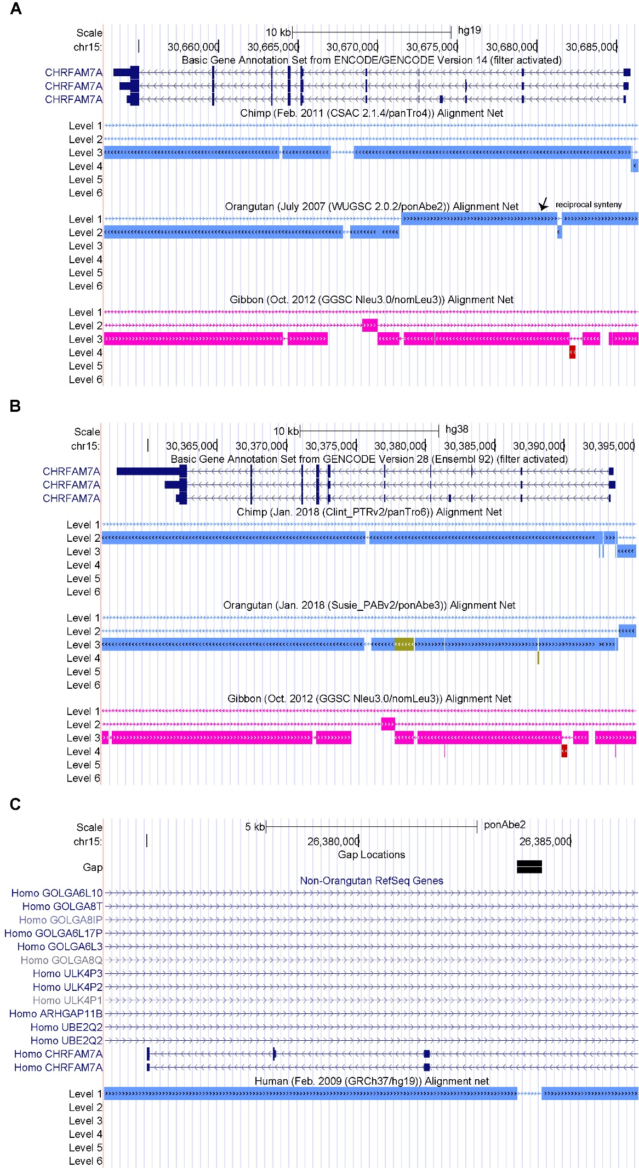
Supplemental Figure S7. Syntenic view of human CHRFAM7A locus relative to outgroups.
UCSC uses the Net track to represent the syntenic information with upper level more likely orthologous compared with lower levels. In other words, the lower panels often represent one-way syntenic mapping. Panel A and B use human as the focal species, while Panel C uses orangutan as the focal species. For GENCODE tracks, noncoding genes are filtered out for simplicity. In the old version (human hg19/orangutan ponAbe2, Panel A, C) used in GenTree, exons at the 5’-terminal (right) is two-way syntenic (level 1) with orangutan. In the new version (hg38/ponAbe3, Panel B), the two-way synteny disappears where only level 3 Net is generated (largely corresponding to parental genes). The misalignment is likely caused by a sequencing gap in the old assembly, i.e., ponAbe2 (Panel C).

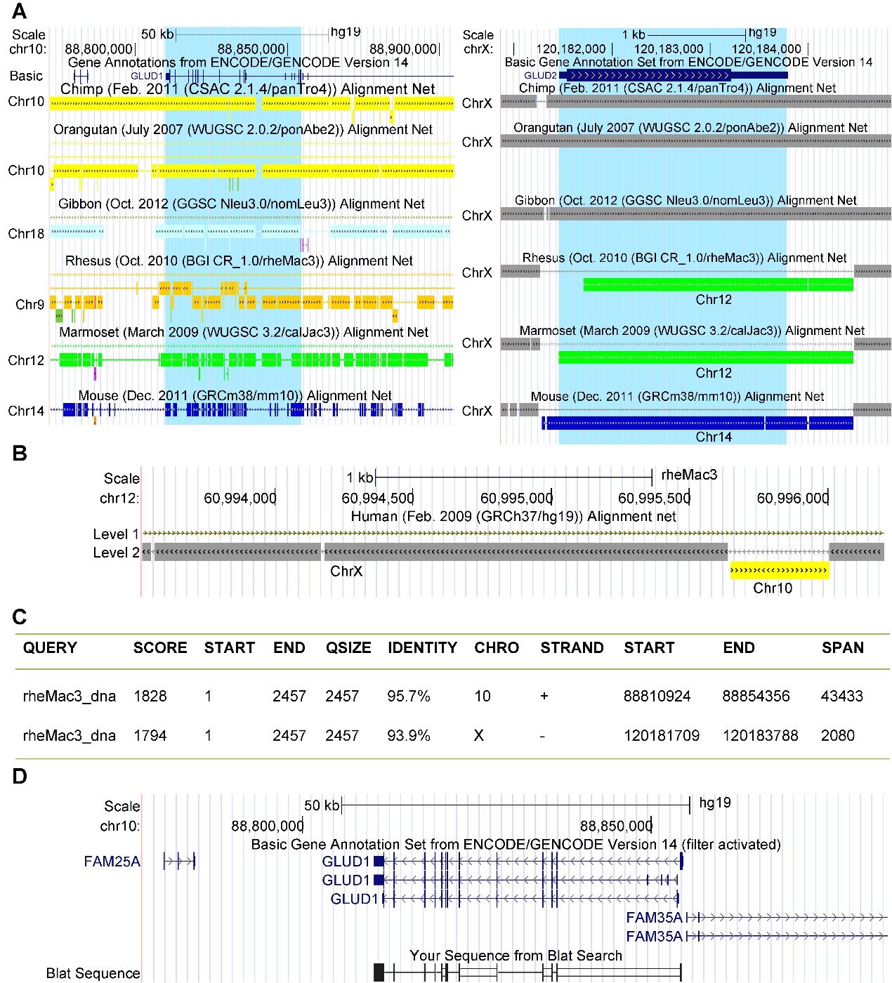
Supplemental Figure S8. Two independent retropositions of GLUD1 in primate evolution.
(A) Side-to-side syntenic view of GLUD1 (left) and GLUD2 (right) between human and other species. The region harboring both genes is highlighted in light blue. For the GENCODE gene annotation track, all noncoding transcripts have been turned off for simplicity. Wider boxes, narrower boxes and lines represent coding exons, untranslated regions and introns, respectively. Different colors in synteny tracks (Net) show different chromosomes with the specific chromosome ID marked on the figure. Continuous tracks show better synteny. The rhesus monkey synteny is of low quality because this region harbors multiple sequencing gaps. The upper-level chain is more likely syntenic, which is further filled with lower-level chains. For example, human GLUD1 maps to two-way orthologous region of Chr12 (green, left panel) in marmoset, which encodes the orthologous locus of GLUD1 in this species. Human GLUD2 maps to the same region of marmoset (right panel), which is not an orthologous mapping. (B) Syntenic view between rhesus monkey and human with rhesus monkey as the focal species. In Net track, the candidate orthologous region in rhesus monkey (Chr12) is largely mapped to the human X Chromosome (gray), which encodes GLUD2. Notably, a small region is mapped to human Chr10, which encodes GLUD1. (C) BLAT alignment results with the rhesus Chr12 region against the human genome. Only the top 2 hits are shown since the other hits are much less significant. The first and second hits correspond to human GLUD1 and GLUD2, respectively. (D) Genome browser view of the top 1 hit shows that an intronless gene of rhesus monkey is mapped to human GLUD1 locus.
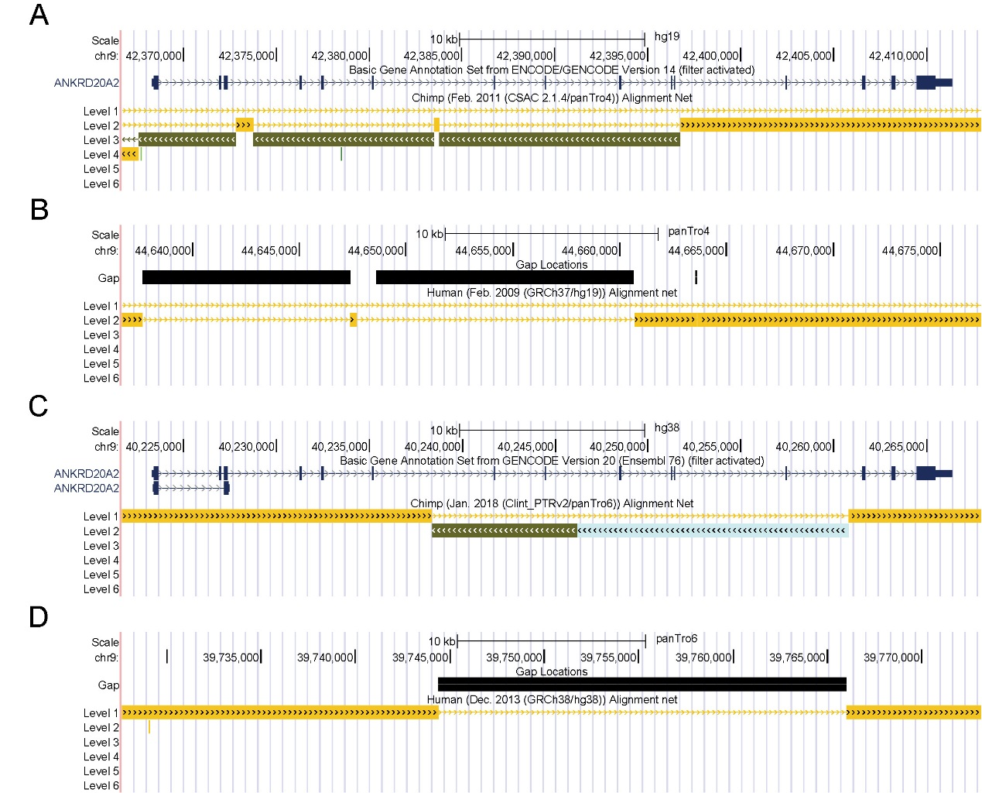
Supplemental Figure S9. Syntenic view of human ANKRD20A2 locus relative to chimpanzee.
Panel A and C takes human as the focal species, while Panel B and D take chimpanzee as the focal species. In the old version (human hg19/chimpanzee panTro4, Panel A), four exons at the 3’-terminal (right) is syntenic with chimpanzee. In the new version (hg38/panTro6, Panel C), the synteny gets better by including both 5’- and 3’-terminal exons. The syntenic gap in the middle is likely caused by sequencing gap(s) in chimpanzee assemblies (old assembly in Panel B, new assembly in Panel D).

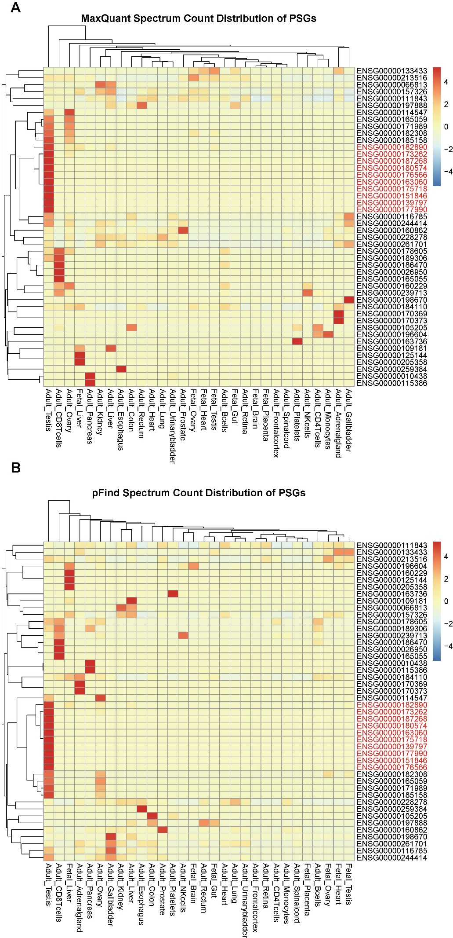
Supplemental Figure S10. Protein expression heatmap of PSGs.
Heatmaps are generated based on mapping results of MaxQuant (A) and pFind (B), respectively. We used spectra count values as the input, which are further scaled by the pheatmap function of R in order to highlight the difference between genes. The 11 testis-dominant protein-coding genes (10 genes for each dataset with 9 genes overlapping) are indicated in red, which are clustered as a single group in both panels.

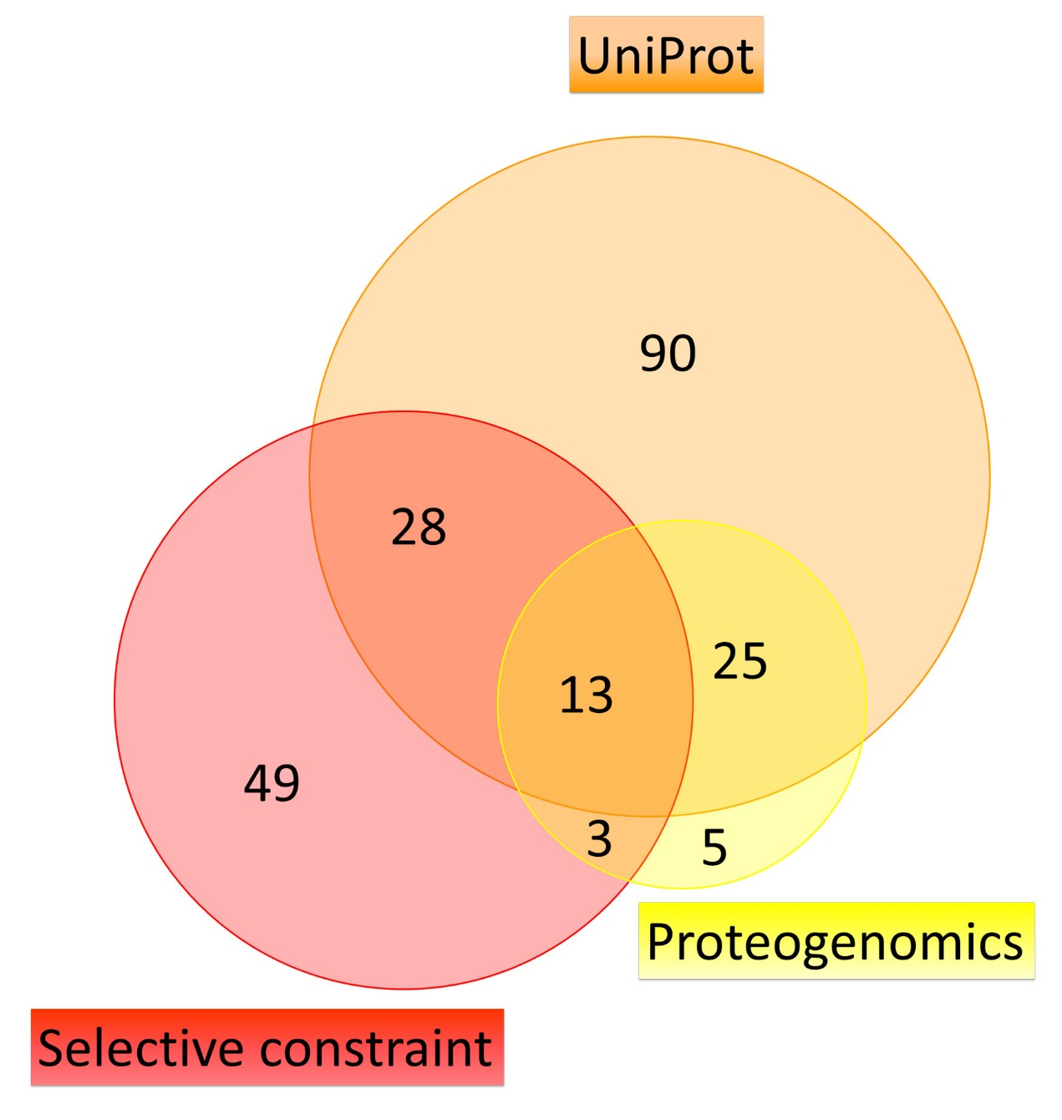
Supplemental Figure S11. Pie chart of PSGs with coding evidence.

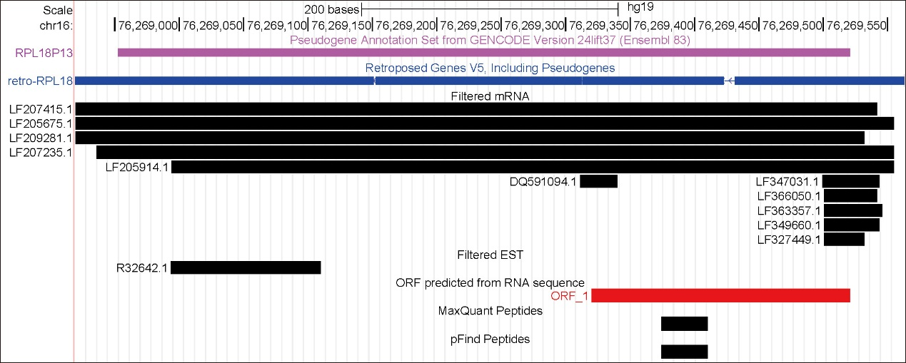
Supplemental Figure S12. Gene structure and expression of RPL18P13.
This figure follows the convention of Fig. 6 in main text, except that the UCSC retrogene track is shown below the GENCODE (Ensembl) annotation. This track shows that RPL18P13 emerged from the retroposition of multi-exonic RPL18 (ribosomal protein L18). All these tracks suggest that the RPL18P13 locus is transcribed, based on the evidence of one EST and several mRNA records. Subsequently, one ORF (ORF_1) is expressed, with one peptide being called by both MaxQuant and pFind. Note that for both algorithms, this peptide was supported by at least two different mass spectra.

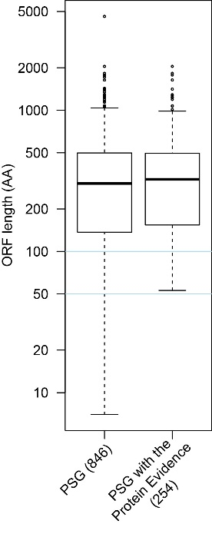
Supplemental Figure S13. The length distribution of open-reading-frame (ORF) across different gene lists.

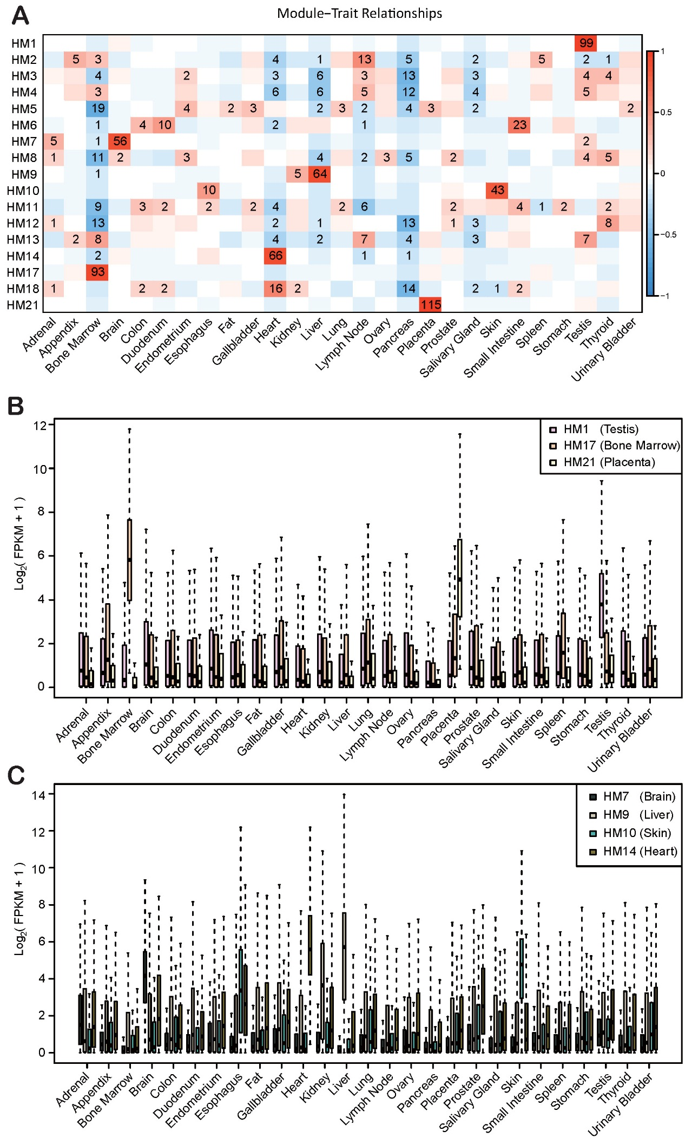
Supplemental Figure S14. Transcriptional features of WGCNA co-expression modules based on the HPA dataset.
(A) The heatmap shows the correspondence between tissues and modules. The relationship is quantified as the color-coded correlation coefficient. The eigenvector for each module was calculated to represent the expression profile of each module (y-axis). These vectors were employed to calculate the correlation to the artificial vectors constructed by setting 1 to a specific tissue and 0 for the others (x-axis). The significantly correlated tiles are further labeled with the minus log P value, which roughly reflects the expression bias toward certain tissues. (B) Expression profile of genes in PSG-enriched modules, i.e., HM1, HM17 and HM21. (C) Expression profile of genes in other modules with tissue bias, i.e., HM7, HM9, HM10 and HM14. For both (B) and (C), the distribution is shown in boxplots with the middle box representing the interquartile range, the lower and upper whiskers corresponding to the extreme values, and the black line representing the median.

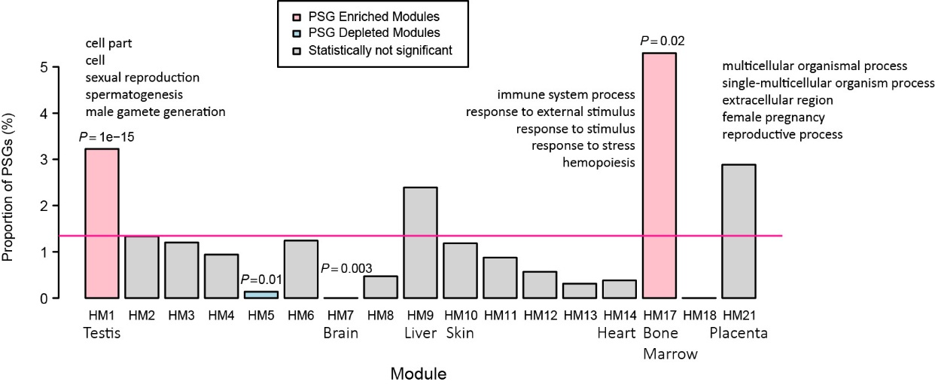
Supplemental Figure S15. Percentages of PSGs with protein evidence in each module for HPA data.
This figure follows the same convention as Fig. 8 in the main text, except that the small dataset of PSGs (254) is employed here. Accordingly, 16,256 non-PSGs with protein evidence serve as the control, which is also the case for Supplemental Fig. S17 and S19B.

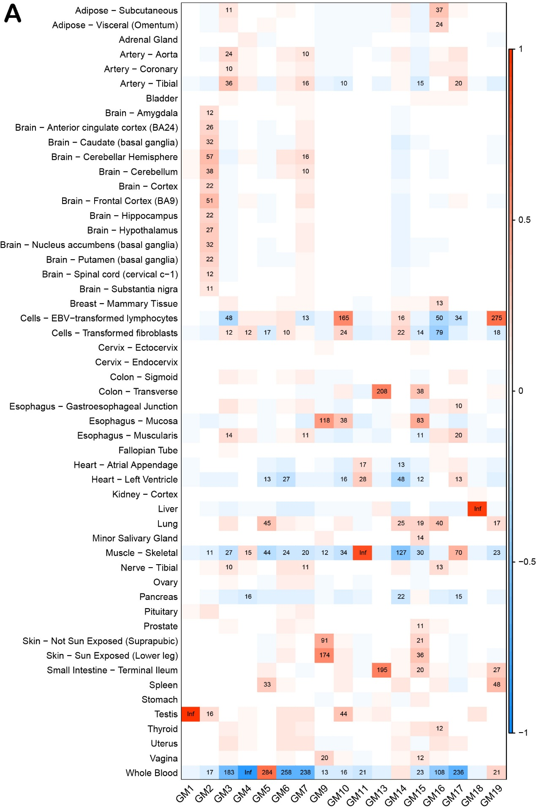
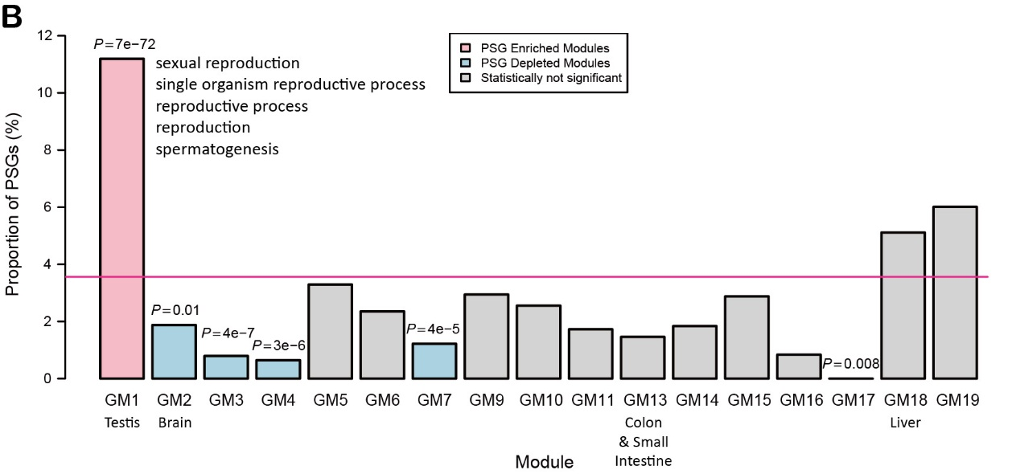
Supplemental Figure S16. The WGCNA related analyses based on the GTEx dataset
(A) The heatmap shows the correspondence between tissues and modules. This figure follows the convention of Supplemental Fig. S14A except that only P<1x10⁻¹⁰ are labeled in the heatmap (the high significance is due to the big sample size of GTEx) and extremely small P (<10⁻³⁰⁰) were shown as “Inf” (infinite). (B) Percentages of PSGs in each module for GTEx data. This figure follows the convention of Fig. 8 in the main text. Since GTEx consists of more tissues compared to HPA, we defined tissue-biased modules as those which consists of functionally similar organs (e.g., brain-biased modules GM2).
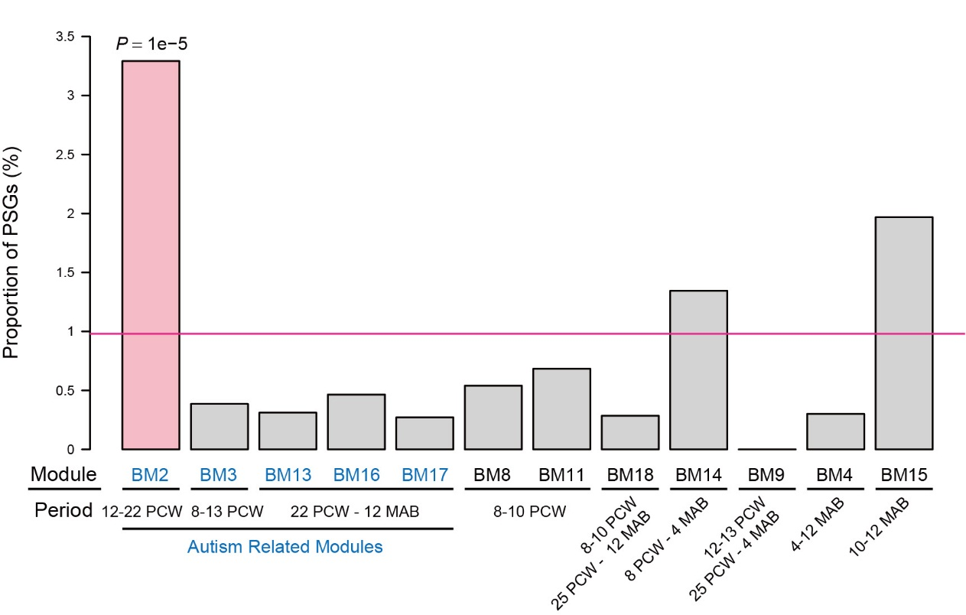
Supplemental Figure S17. Distribution of PSGs with protein-level evidence across brain related modules.
This figure follows the same convention of Fig. 9A in the main text except that the small dataset of PSGs (254) is employed here. We only reproduced Fig. 9A. For Fig. 9B, the number of genes became too small to make analogous analysis.

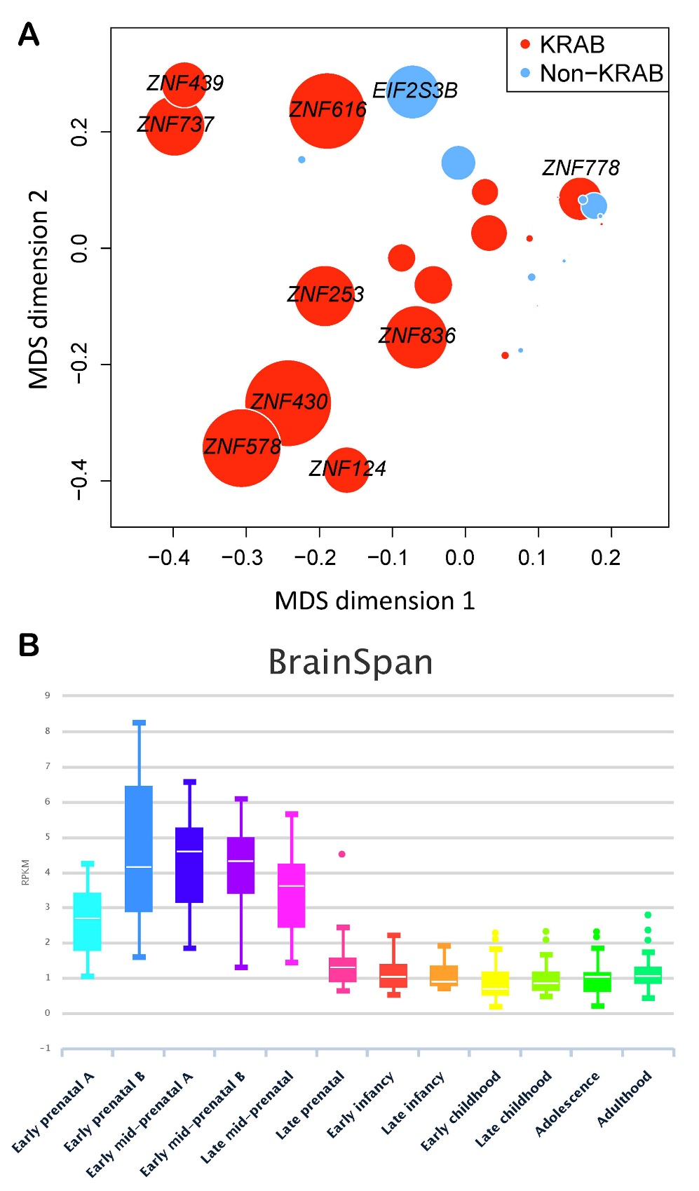
Supplemental Figure S18. Connectivity and expression profile of PSGs in BM2. (A) Bubble plot of the top 10 connected PSGs in BM2.
The co-expression matrix of the PSGs in BM2 was used as the input for multidimensional scaling (MDS) to perform nonlinear dimensionality reduction. The first two dimensions are taken to demonstrate the co-expression relationship between 32 PSGs (18 KZNFs, 14 non-KZNFs). The bubble size is proportional to the degree, with the large bubbles indicating hub genes. The genes that ranked in top 10 are labeled with their gene symbols. (B) Time-course view based on the BrainSpan development data. ZNF836 is shown as an example, which is adapted from http://gentree.ioz.ac.cn/tools/viewIDS.php?speciesselect=Human&genename=ENSG00000196267. Consistent with its membership of BM2, ZNF836 was upregulated in the mid-prenatal stage. Users can also click “Summary by Gender” or “Summary by Region” to examine how the expression changes depend on sex or brain regions via the web interface of GenTree.

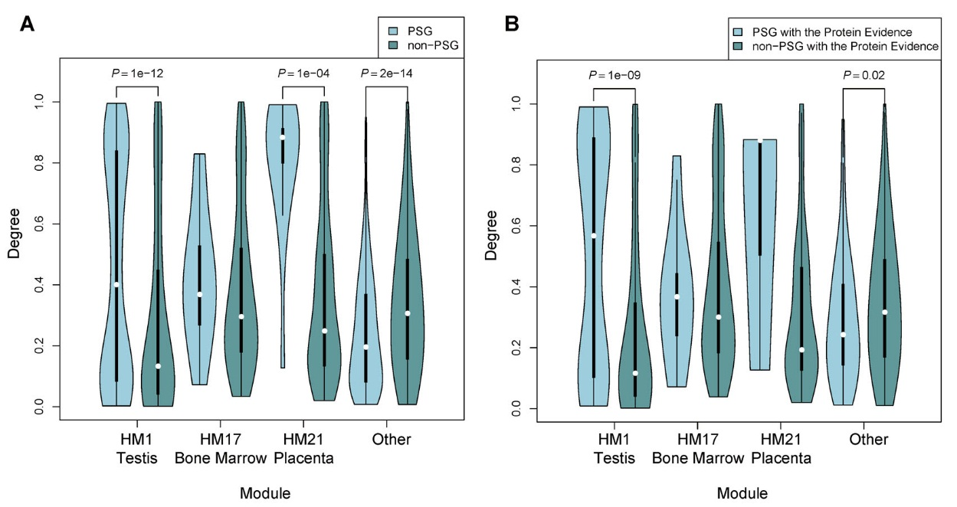
Supplemental Figure S19. Distribution of the degree of connection for PSGs and non-PSGs.
Panel (A) and (B) are based on lists of 846 and 254 genes, respectively. Three modules significantly enriched with PSGs are plotted individually (HM1, HM17 and HM21 in Fig. 8), while all other modules are merged.

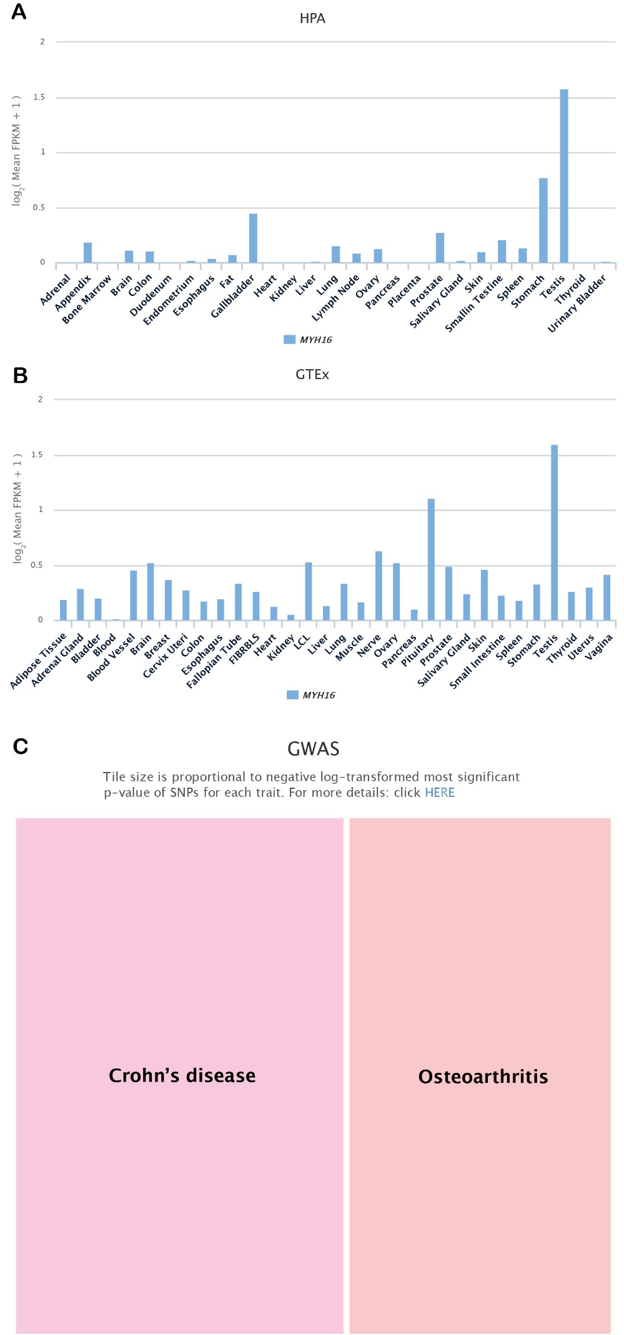
Supplemental Figure S20. Expression profile and phenotypic association of MYH16.
(A) HPA transcription profile across tissues. (B) GTEx transcription profile across tissues. (C) Genome-wide association data from GWASdb2. Multi-mapping SNPs were filtered first (Method). Each tile represents a particular trait. Detailed information, including PubMed links and SNP information, could be accessed by clicking “details”. This figure is adapted from http://gentree.ioz.ac.cn/tools/viewIDS.php?speciesselect=Human&genename=ENSG00000002079.

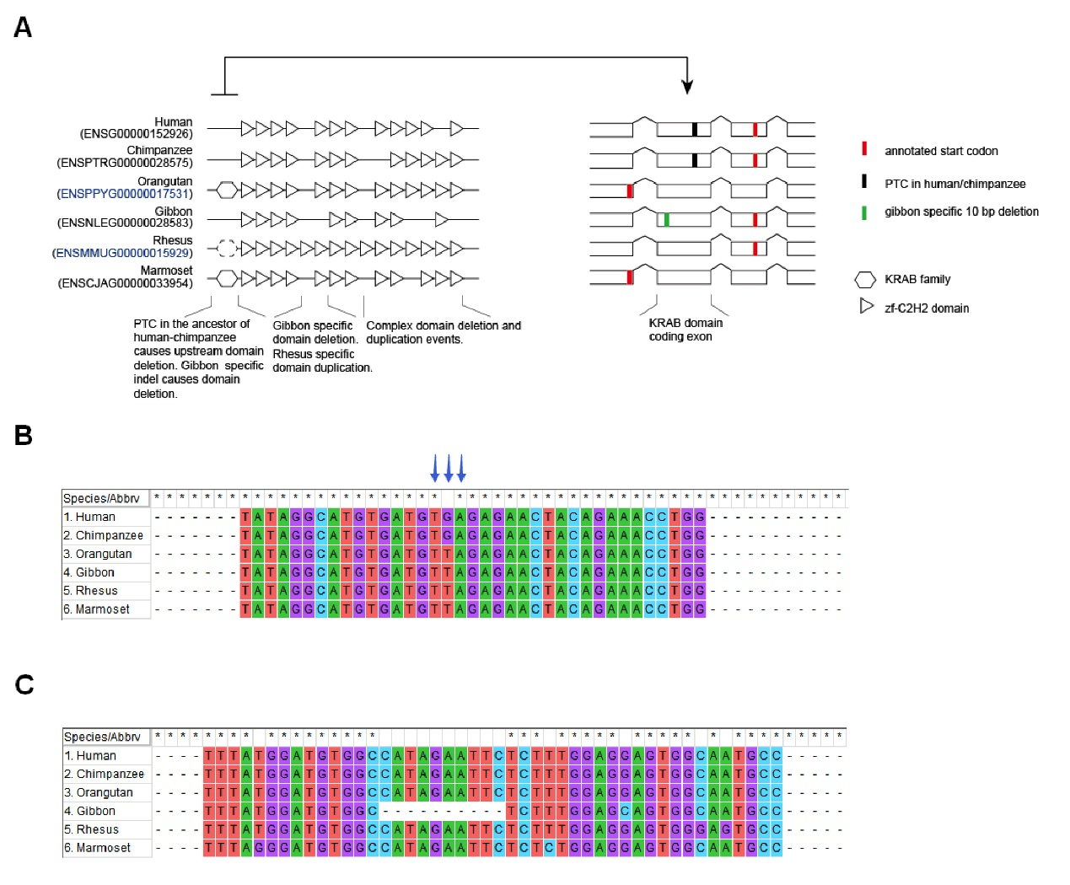
Supplemental Figure S21. Two independent losses of KRAB in both the ancestor of human and chimpanzee, and the gibbon lineage.
(A) Besides the schematic view of domain architecture as in the Supplemental Data Set 1, the exon level alignment of KRAB coding region as well as the flanking regions across primates is further illustrated to demonstrate which mutation causes the loss of KRAB domain in human/chimpanzee and gibbon lineage. Notably, ZNF117 in rhesus monkey should be intact according to the orthologous alignment, but current annotation mis-positioned its start codon to the downstream.
(B) Human ZNF117 and its chimpanzee ortholog shares the same PTC in the orthologous KRAB coding exon.
(C) Gibbon ZNF117 has a 10 bp deletion in the orthologous KRAB coding exon.

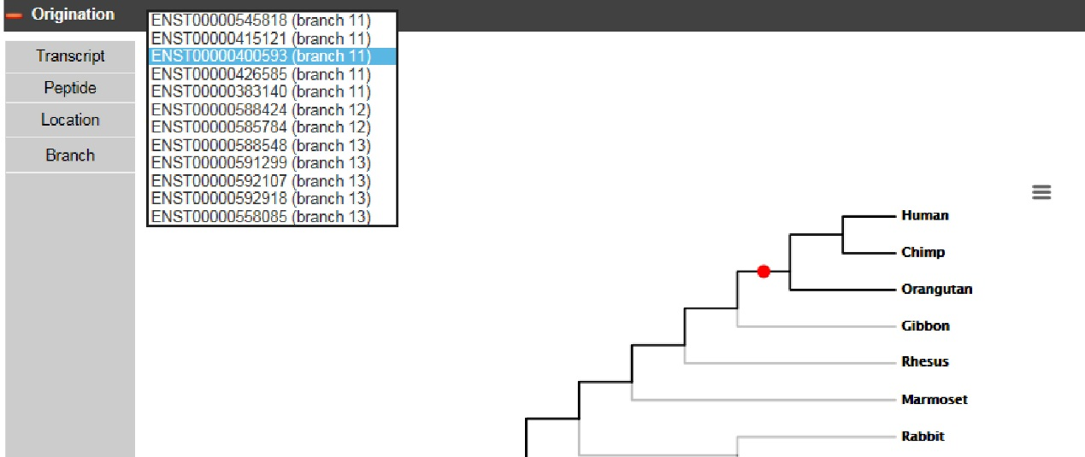
Supplemental Figure S22. A snapshot of transcript level age view.
We took TPTEP1 (ENSG00000100181) as an example, which encodes 12 different transcripts with different ages. The phylogenetic tree would change as the different transcript is clicked on. This figure is adapted from http://gentree.ioz.ac.cn/tools/viewIDS.php?speciesselect=Human&genename= ENSG00000100181.

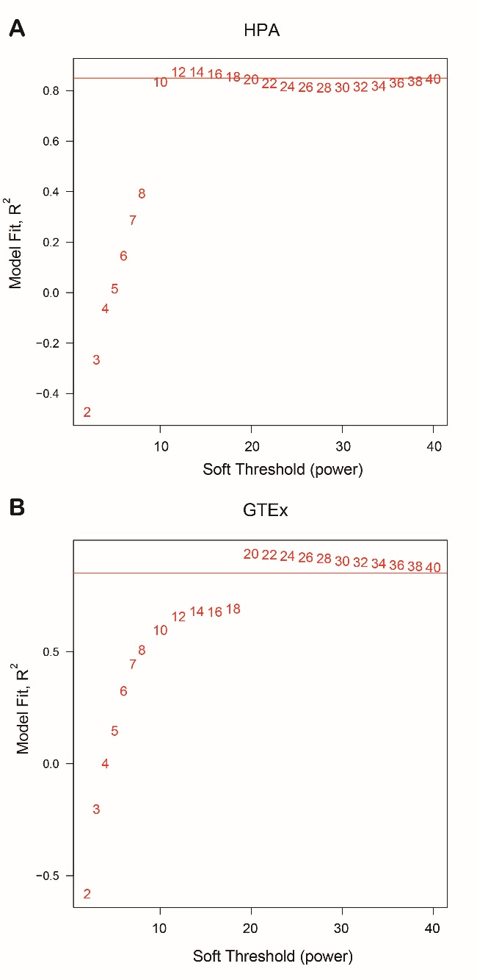
Supplemental Figure S23. The WGCNA parameter for HPA (A) and GTEx (B)
We employed the results of the pickSoftThreshold function in WGCNA to generate these plots. It seems that the power of 12 and 20 reaches the optimal fit in HPA and GTEx, respectively. The red line marks the R² of 0.85.

