SUPPLEMENTAL MATERIAL
Single-Cell Sequencing of Primate Preimplantation Embryos Reveals Chromosome Elimination Via Cellular Fragmentation and Blastomere Exclusion

Brittany L. Daughtry^{1,2}, Jimi L. Rosenkrantz^{2,3}, Nathan H. Lazar⁴, Suzanne S. Fei⁵, Nash Redmayne², Kristof A. Torkenczy³, Andrew Adey^{3,6}, Melissa Yan⁵, Lina Gao⁵, Byung Park⁵, Kimberly A. Nevonen⁶, Lucia Carbone³⁻⁷, and Shawn L. Chavez^{2,8-10*}
¹Department of Cell, Developmental & Cancer Biology, Oregon Health & Science University School of Medicine, Portland, Oregon
²Division of Reproductive & Developmental Sciences, Oregon National Primate Research Center, Beaverton, Oregon
³Department of Molecular and Medical Genetics, Oregon Health & Science University School of Medicine, Portland, Oregon
⁴Department of Medical Informatics & Clinical Epidemiology, Oregon Health & Science University School of Medicine, Portland, Oregon
⁵Bioinformatics & Biostatistics Core, Oregon National Primate Research Center, Beaverton, Oregon
⁶Department of Medicine, Knight Cardiovascular Institute, Oregon Health & Science University School of Medicine, Portland, Oregon
⁷Division of Primate Genetics, Oregon National Primate Research Center, Beaverton, Oregon
⁸Department and Physiology & Pharmacology, Oregon Health & Science University School of Medicine, Portland, Oregon
⁹Department of Obstetrics & Gynecology, Oregon Health & Science University School of Medicine, Portland, Oregon
¹⁰Department of Biomedical Engineering, Oregon Health & Science University School of Medicine, Portland, Oregon
*Corresponding authors: chavesh@ohsu.edu and carbone@ohsu.edu

Extended Methods
Controlled Ovarian Stimulation (COS), follicular aspiration, and sperm collection…………………………………………….2
Whole genome amplification (WGA) and library validation……………………………………………………………………….2
Variable Non-Overlapping Window CBS (VNOWC) pipeline.…………………………………………………………………....3
CBS/HMM Intersect (CHI) pipeline………………………………………………………………………………………………….3
Integration of VNOWC and CHI pipelines……………………………………………………………………….…………………3
Sensitivity and specificity of the integrated VNOWC/CHI pipeline………………………………………………………………4
Supplemental Figures
Supplemental Fig S1………………………………………………………………………………………………………………….5
Supplemental Fig S2………………………………………………………………………………………………………………….7
Supplemental Fig S3..………………………………………………………………………………………………………………...8
Supplemental Fig S4..………………………………………………………………………………………………………………...9
Supplemental Table Legends
Supplemental Table S1..………………………………………………………………………………………………………...……10
Supplemental Table S2..………………………………………………………………………………………………………...……10
Supplemental Table S3..………………………………………………………………………………………………………...……10
Supplemental Table S4..………………………………………………………………………………………………………...……10
Supplemental Table S5..………………………………………………………………………………………………………...……10
Supplemental Movie Legends
Supplemental Movie S1..………………………………………………………………………………………………………......…10
Supplemental Movie S2..………………………………………………………………………………………………………......…10
Supplemental Movie S3..………………………………………………………………………………………………………......…11
Supplemental Movie S4..………………………………………………………………………………………………………......…11

EXTENDED METHODS
Controlled Ovarian Stimulation (COS), follicular aspiration, and sperm collection
Oocytes were collected from cycling adult female rhesus macaques by injecting 30 IU of recombinant human follicular stimulating hormone (FSH; donated from Organon, Roseland, NJ) intramuscularly (IM) twice daily at the start of menses for six consecutive days. On days 7 and 8, 30 IU of both FSH and recombinant human luteinizing hormone (LH; donated by Al Partlow) were co-injected twice each day. When estradiol levels reached greater than 200 pg/ml, females were IM injected with 0.1 ml/kg of Antide (donated by the Salk Institute, La Jolla, CA) the following day to block circulating gonadotropin-releasing hormone and prevent an endogenous LH surge. Approximately 36 hours prior to follicle aspiration, a single dose (1,100 IU) of human chorionic gonadotropin (hCG; EMD Serono Ovidrel®, Rockland, MA) was IM injected to initiate oocyte maturation. Laparoscopic follicular aspirations were aseptically conducted on anesthetized animals using suction to obtain cumulus-oocyte complexes (COCs) collected in Tyrode's albumin lactate pyruvate (TALP)-HEPES media with 0.3% bovine serum albumin (BSA; Sigma-Aldrich, St. Louis, MO) and 1% Heparin sodium salt solution. Oocytes were denuded by gentle micropipeting in TALP-HEPES media containing 0.3% BSA and 3% hyaluronidase (Sigma-Aldrich). Metaphase I (MI) and MII oocytes were incubated in TALP plus 0.3% BSA media at 37°C with 5% CO₂ for 4-6 hours. Mature MII oocytes were fertilized in 100 μL drops of TALP complete media (0.3% BSA and 0.006% sodium pyruvate) with 20×10⁶/ml “swim up” sperm further diluted 9:1 with activator solution [10.3mM caffeine (Sigma C-0750) and 10.2mM cAMP (Sigma D-0627) in saline] as previously described (Lanzendorf et al. 1990). Following IVF at 37°C with 5% CO₂ for 14-16 hours, excess sperm were removed from the fertilized oocytes. All animal procedures adhered to the NIH Guide for the Care and Use of Laboratory Animals and were conducted under the direction and assistance of the veterinary staff and animal technicians in the Division of Comparative Medicine at ONPRC.
Whole genome amplification (WGA) and library validation
WGA of each blastomere, polar body, cellular fragment, and skin fibroblast sample was accomplished with the PicoPLEX single-cell WGA Kit (Rubicon Genomics, Ann Arbor, MI) according to the manufacturer’s instructions. In brief, the DNA was released from samples using the cell extraction enzyme from the PicoPLEX kit at 75°C for 10 min., followed by pre-amplification with the PicoPLEX pre-amp enzyme and a primer mix via 12 cycles of gradient PCR with stepwise annealing temperatures of 15°C to 75°C. Pre-amplified DNA was further amplified with PicoPLEX amplification enzyme and 48 uniquely-indexed Illumina sequencing adapters provided by the kit or custom adapters with indices designed as previously described (Vitak et al. 2017). Prior to pooling and sequencing, 1μl of each library was fluorometrically quantified using the Qubit dsDNA high-sensitivity assay (Thermo Fisher Scientific) and sample pooling concentrations calculated. Library quality was assessed via adapter PCR amplification using the PCR Primer Cocktail and Master Mix (Illumina, San Diego, CA) and the following thermocycling conditions: 98°C for 30 sec., 25 cycles of 98°C for 10 sec., 60°C for 30 sec., and 72°C for 30 sec., and 72°C for 5 min. PCR products were visualized by 2% agarose gel electrophoresis and together with the Qubit results, used to determine which samples should be carried forward for sequencing.
Variable Non-Overlapping Window CBS (VNOWC) pipeline
Although PCR-based WGA strategies such as PicoPlex are more effective for copy number calling than non-PCR-based techniques (de Bourcy et al. 2014), some read accumulation and dropout is expected that needs to be addressed during copy number variation (CNV) analysis. In our VNOWC pipeline, we used known euploid reference samples (rhesus 42XX fibroblast single-end and paired-end PicoPLEX libraries) to generate variable-sized windows with a constant number of expected reads per window. The samples were mapped to the defined windows and R package DNAcopy (version 1.44.0) used to perform circular binary segmentation (CBS) across each chromosome and identify putative copy number changes between windows (Olshen et al. 2004). CNV was calculated using the observed-to-expected ratio of read counts in each window given the total number of mapped reads. Since the window ratios assume that reads are spread evenly across the genome, a recalibration step was necessary to correct for the expected number of reads given the CNV. Samples with mostly empty windows were presumed to have a base copy number of one, while a base copy number of two was assumed for samples with reads in the majority of windows. Copy numbers provided by CBS were rounded to the nearest integer and plotted, along with the corrected ratios for each window. Prior to assessing CNV in rhesus embryos, the pipeline was first trained and tested with rhesus male known euploid (42,XY) single-cell libraries to ensure that the “loss” of ChrY was correctly called in these samples. A similar analysis was performed with human fibroblasts carrying known aneuploidies (trisomy 21 or monosomy X) as described in more detail below.
CBS/HMM Intersect (CHI) pipeline
A bioinformatics pipeline for GC bias correction was also implemented as previously described (Vitak et al. 2017) that uses the Hidden Markov Model (HMMcopy, version 3.3.0; Ha et al. 2012) based on parameters determined previously (Knouse et al. 2016). The validation of the CHI pipeline was previously published using both euploid and aneuploid mouse and human cell lines confirmed by karytoyping (Vitak et al. 2017).
Integration of VNOWC and CHI pipelines
Whole or segmental CNV calls generated by each pipeline were compared and discordant calls further analyzed based on recently described criteria (Vitak et al. 2017). First, the discordant VNOWC plot was examined to determine if it represented the integer loss or gain for the majority of estimated copy number points within the appropriate range of windows. The smoothed, GC corrected HMM CNV plot from the CHI method was then analyzed to determine if the majority of the Log₂ transformed values were above 0.4 for a gain or below 0.35 for a loss. An analogous approach was used for CHI CNV plots to determine if the majority of the Log₂ transformed values were above 1.32 for a gain or below 0.6 for a loss. If two or more out of these three criteria were satisfied, the CNV call was retained. Otherwise, we conservatively estimated that the remaining chromosomes (N=27) in question were euploid.
Sensitivity and specificity of the integrated VNOWC/CHI pipeline
The human fibroblasts with known aneuploidies (trisomy 21 or monosomy X) were also used to determine the sensitivity (lack of false negatives) and specificity (lack of false positives) of CNV calling after integration of the two pipelines. Reads from 10-cells of human monosomy X and trisomy 21 fibroblasts were subsampled 100 times to levels typical of a single-cell sample (1000K, 500K, 250K, and 100K reads). Subsampled reads were then mapped to four different window sizes (500, 1000, 2000, 4000 reads per window) and integrated VNOWC/CHI CNV calling performed as described above. Under the 4000 reads per window, there were no false negative CNVs called for ChrX in the monosomy X samples, while 2-5% of trisomy 21 samples resulted in false negative CNV calling of Chr21 depending on the number of mapped read counts. However, no whole chromosomal false positive calls were detected in either fibroblast sample and segmental (>15 Mb) false positive calls were only observed under 500K and 1000K mapped read counts. This suggests that the over-sequencing samples can be detrimental to downstream CNV calling if reads are spread less evenly across the genome. From this data, we determined that 4000 reads per window size produced the most optimal conditions for accurate CNV calling, which is the window size that was applied to all embryonic samples.

SUPPLEMENTAL FIGURES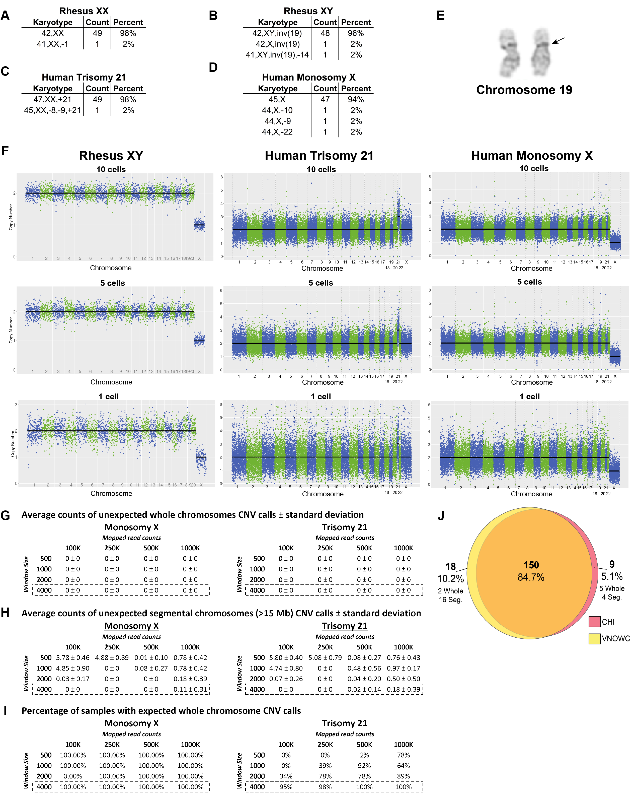
Supplemental Fig S1. Single-cell CNV pipeline development and validation. Karyotyping results of 50 metaphase spreads for (A) rhesus XX passage (p) 3, (B) rhesus XY p3, (C) human trisomy 21 p9, (D) and human monosomy X p6 fibroblasts. (E) Rhesus XY chromosome 19 pericentric inversion with breakpoints just above the short arm proximal dark band and below the centromere in the long arm. (F) Chromosome CNV plots from the VNOWC pipeline of 10-, 5-, and 1-cell rhesus male fibroblasts (42,XY) and human female fibroblasts with known trisomy 21 (47,XX) or monosomy X (45,X). False positive (G) whole and (H) segmental chromosome CNV results for simulated subsamples of 10-cell trisomy 21 (47,XX) or monosomy X (45,X) using the VNOWC/CHI integrated pipeline. Mapped reads were subsampled down to 100K, 250K, 500K, and 1000K reads 100 times and CNVs called with variable sized windows (expected number of control reads in each window of 500, 1000, 2000, and 4000). (I) From this data, the percentage of trisomy and monosomy fibroblast samples with expected whole chromosome CNV calls was calculated. (J) Venn diagram depicting the numbers and percentages of CNV calls between VNOWC (yellow) and CHI (pink) CNV pipelines following primary and secondary assessment of whole and segmental (seg.) chromosome losses and gains in rhesus embryo samples.

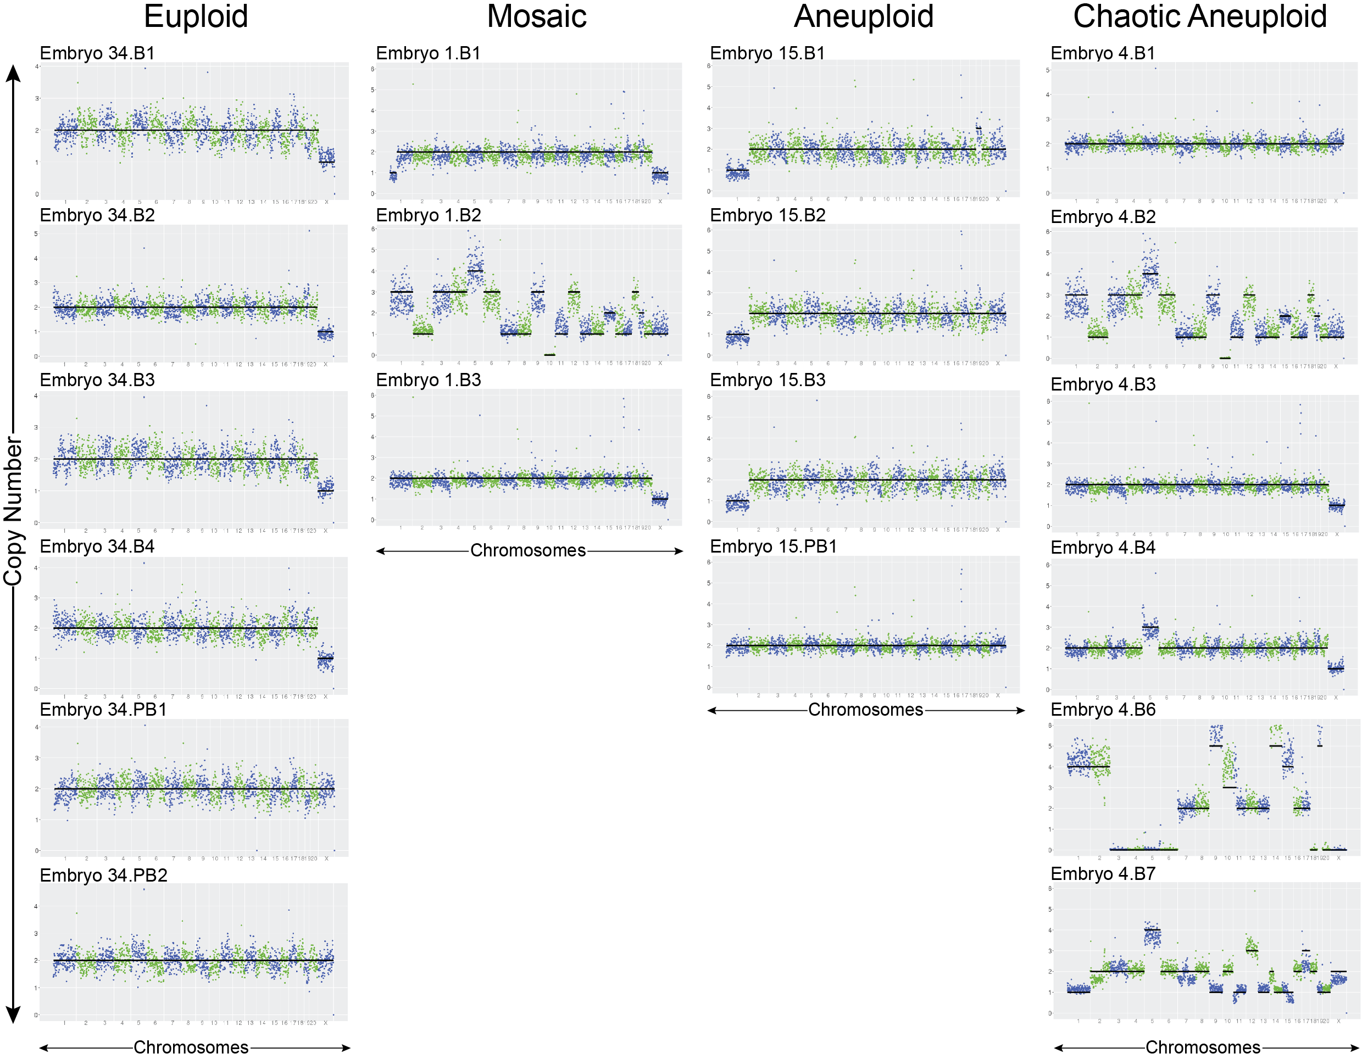
Supplemental Fig S2. Representative CNV plots of cleavage-stage embryos. Chromosome copy number variation (CNV) plots of single blastomeres (B) or polar bodies (PB) from representative cleavage-stage embryos categorized as euploid, euploid-aneuploid mosaic, aneuploid, or chaotic aneuploid.

Supplemental Fig S3. Use of SNP genotyping to determine embryo ploidy and parental inheritance. (A) Heat maps of maternal versus paternal SNP ratios determined that embryos were comprised of biparental, uniparental (androgenetic or gynogenetic), mixoploid (containing a mixture of androgenetic, parthenogenetic, polyploid, or euploid blastomeres), or polyploid cells. (B) Percentage of embryos with chromosomes of entirely biparental origins or abnormal ploidy (left), along with the type of abnormal ploidy (right).

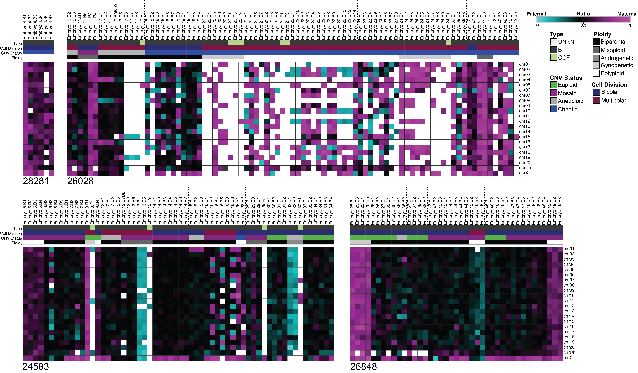
Supplemental Fig S4. Separation of SNP profiles based on paternal donor. Parental SNP analysis of embryos divided into different heat maps according to the ID of the sperm donor. Note that all embryos with both multipolar divisions and chaotic aneuploidy were produced from male #26028.

SUPPLEMENTAL TABLE LEGENDS

Supplemental Table S1. Sequencing statistics of all embryonic and somatic samples. A table depicting the number or percentage of reads following de-multiplexing of embryonic (with embryo stage) and fibroblast samples at each step of the post-sequencing process, including adaptor removal, repeat masking, genome mapping, and quality assessment. The sequencing kit used and whether single- or paired-end is also included.
Supplemental Table S2. Comprehensive CNV assessment of each embryonic sample. Table representing the sample name and type, preimplantation day, chromosomes affected, whether the chromosomes were whole losses/gains or broken, and ploidy status of all embryonic samples based on the CNV analysis.
Supplemental Table S3. Summary of CNV in cleavage-stage embryos based on experiment number. A table divided by experiment number that summarizes the parental IDs, number of embryos sequenced, results of the CNV analysis, and type of chromosomal error. *Embryos from Experiment 5, 15 & 16 were only partially sequenced and therefore, origin of aneuploidy (meiotic versus mitotic) could not be determined (ND).
Supplemental Table S4. Sequencing statistics of maternal and paternal DNA samples. Table depicting the animal ID and number of reads from each parental DNA library following assessment of read length, genome mapping, duplicate removal, and quality control.

Supplemental Table S5. Comprehensive SNP analysis divided by chromosome number. Maternal versus paternal SNP counts, percentages, and adjusted ratios separated by chromosome number with comparison between ploidy classification of each embryonic sample (blastomere, polar body, or cellular fragment) and overall embryo ploidy status. Significance of SNP parental ratios was examined by cumulative binomial test with Bonferroni correction.
SUPPLEMENTAL MOVIE LEGENDS

Supplemental Movie S1. Cellular fragmentation at the zygote stage. Brightfield TLM videos of rhesus zygotes undergoing the 1st mitosis with (right) or without (left) cellular fragmentation. Note the polar bodies in the non-fragmented embryo that were present prior to 1st mitotic division.

Supplemental Movie S2. Multipolar first mitotic divisions. Darkfield TLM videos of rhesus zygotes undergoing a tri-polar (left) or tetra-polar (right) 1st mitotic division. Note the simultaneous appearance of multiple cleavage furrows in each multipolar embryo.

Supplemental Movie S3. Micronucleation and embryo arrest. Brightfield TLM videos of rhesus embryos developing to the blastocyst stage (left) or arresting at the cleavage-stage prior to compaction (right). Note the presence of multiple micronuclei in the arrested embryo at the 10- to 12-cell stage, which were identified by their relative size compared to primary nuclei, the presence of nucleoli, and simultaneous nuclear envelope breakdown prior to mitosis as previously described (Daughtry and Chavez 2018).

Supplemental Movie S4. Exclusion of cellular fragments and blastomeres during blastulation. Darkfield TLM videos of rhesus embryos to the blastocyst stage exhibiting fragment or blastomere exclusion. Cellular fragments were excluded from the embryo to the perivitelline space during the morula-to-blastocyst transition (left). See also Figure 6A, far right panel. Two non-dividing blastomeres were sequestered into the blastocoel cavity of the blastocyst following a tetrapolar division at the 2-cell stage (right). See also Figure 6A, 3rd panel.

