Supplemental Materials – Table of Contents
Supplementary Figures
Supplemental Figure S1: FACS plots synchronization plus dapi stained microscopy images

Supplemental Figure S2: Full 5C heatmap of non-synchronized cells, mitotic cells and mitotic chromatin

Supplemental Figure S3 ATAC V-plots CTCF with ENCODE ChIP, CTCF distal vs proximal and CTCF with mitotic cell peak

Supplemental Figure S4 Clustering of 75-150 bp length bin

Supplemental Figure S5 BedGraph tracks and length distribution of HeLa-S3, HFF and U2OS

Supplemental Figure S6 V-plots of CTCF sites of HeLa-S3, HFF and U2OS

Supplemental Figure S7 ATAC V-plots and length distribution all TSS

Supplemental Figure S8 CUT&RUN CTCF timecourse MNase

Supplemental Figure S9 CUT&RUN signal on ENCODE ChIP CTCF, on all CTCF motifs, on proximal and distal CTCF sites.

Supplemental Figure S10 CUT&RUN aggregate heatmaps

Supplemental Figure S11 Peak calling on data deeply sequenced CUT&RUN data

Supplemental Figure S12 Western blots CTCF antibodies on NS/M Cell/M Cluster

Supplemental Figure S13 CUT&RUN H2A.Z and K4Me3 on TSS

Supplemental Figure S14 Bedgraph, length distribution and V-plots of fresh and frozen mitotic clusters

Supplemental Figure S15 ATAC V-plot normalized vs unnormalized

Supplementary Tables
Table S1 – 5C mapping statistics
Table S2 – Antibodies used for western blot and C&R

Supplementary Movies
Supplemental Movie S1 – Live cell imaging halo-CTCF overlaid with brightfield
Supplemental Movie S2 – Live cell imaging H2B-GFP on left and halo-CTCF on right
Supplemental Movie S3 – Single particle tracking Halo-CTCF in interphase cells
Supplemental Movie S4 - Single particle tracking Halo-CTCF in nocodazole arrested mitotic cells
Supplemental Movie S5 - Single particle tracking Halo-CTCF in “enriched” prometaphase cells

Supplementary Code
Supplemental Code S1 – All code used for Spot-On analysis of single particle tracking experiments. Also available here: https://gitlab.com/tjian-darzacq-lab/spot-on-matlab.
Supplemental Code S2 – Collection of code used for processing of raw SPT movies. Also available here: https://gitlab.com/tjian-darzacq-lab/SPT_LocAndTrack.
Supplemental Code S3 – Code used for ATAC-seq and CUT&RUN analysis. Also available here: https://github.com/dekkerlab/CTCF_in_mitosis_GR_2018.
Supplemental Code S4 – Collection of code for mapping and analysis of 5C data. Also available here: https://github.com/dekkerlab/cworld-dekker.

Supplementary Methods
Cell culturing and synchronization of culture in prometaphase
Mitotic chromatin cluster purification
5C
ATAC-seq
CTCF motif indentification for hg19
ENCODE data sets
CUT&RUN
Western blot
Fluorescence Recovery After Photobleaching (FRAP) imaging
Single-molecule imaging (spaSPT)
Model-based analysis of single-molecule tracking data using Spot-On
Spot-On data and computer code availability
Time-lapse imaging

References
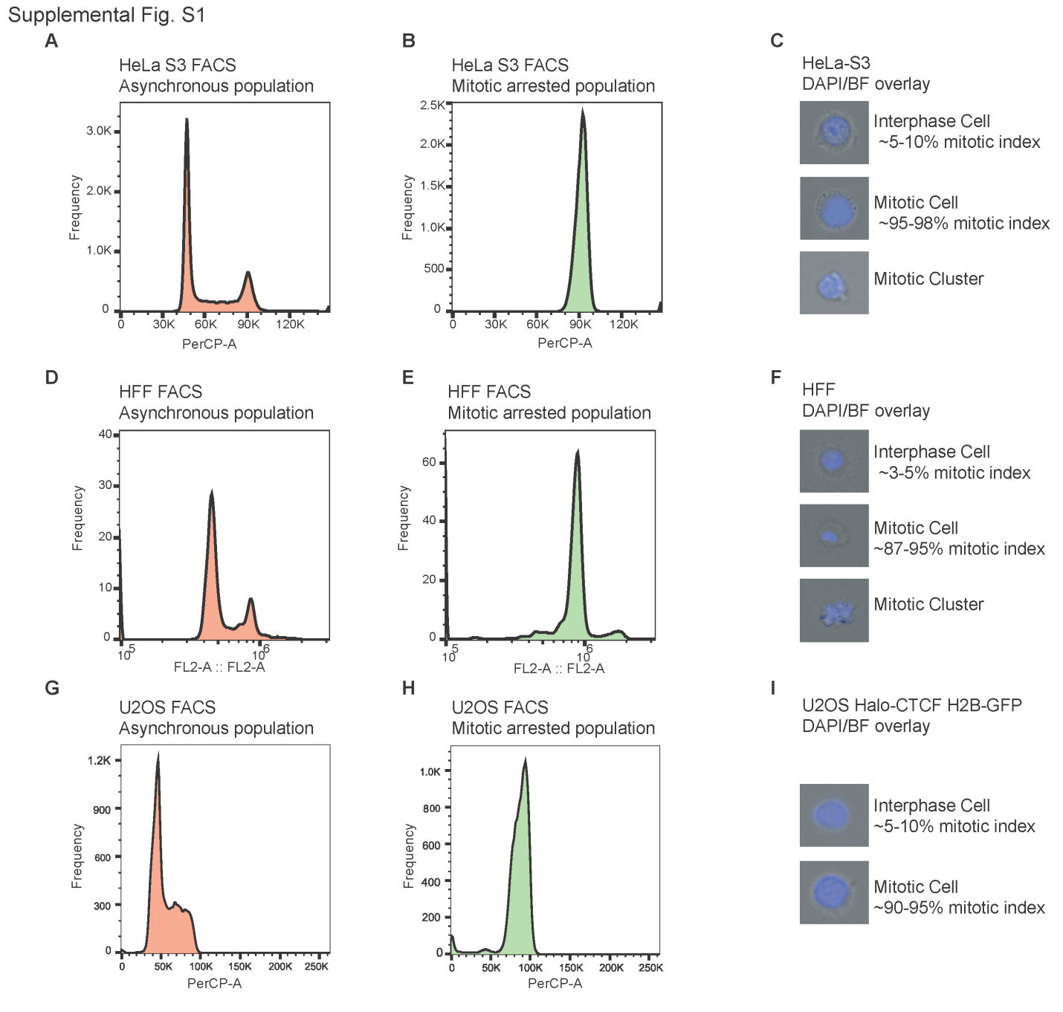
Supplemental Fig. S1 – Flow cytometry using propidium iodide staining and microscopy using DAPI staining show synchronization in M-phase by Nocodazole. (A-B) Cell cycle flow cytometry for non-synchronized (A) and nocodazole arrested (B) HeLa-S3 cell populations. (C) DAPI staining of an interphase cell, nocodazole arrested prometaphase cell and purified mitotic chromatin of HeLa-S3 cells and their average scored mitotic index in percentage of total population. (D-E) Cell cycle flow cytometry for non-synchronized (D) and nocodazole arrested (E) HFF cell populations. (F) DAPI staining of an interphase cell, nocodazole arrested prometaphase cell and purified mitotic chromatin of HFF and their average scored mitotic index in percentage of total population. (G-H) Cell cycle flow cytometry for non-synchronized (G) and nocodazole arrested (H) U2OS Halo-CTCF H2B –GFP cell populations. (I) DAPI staining of an interphase cell and nocodazole arrested prometaphase cell of U2OS Halo-CTCF H2B-GFP and their average scored mitotic index in percentage of total population. Note that the scales of x-axes of the different plots are different dependent on the setting of the FACS equipment.
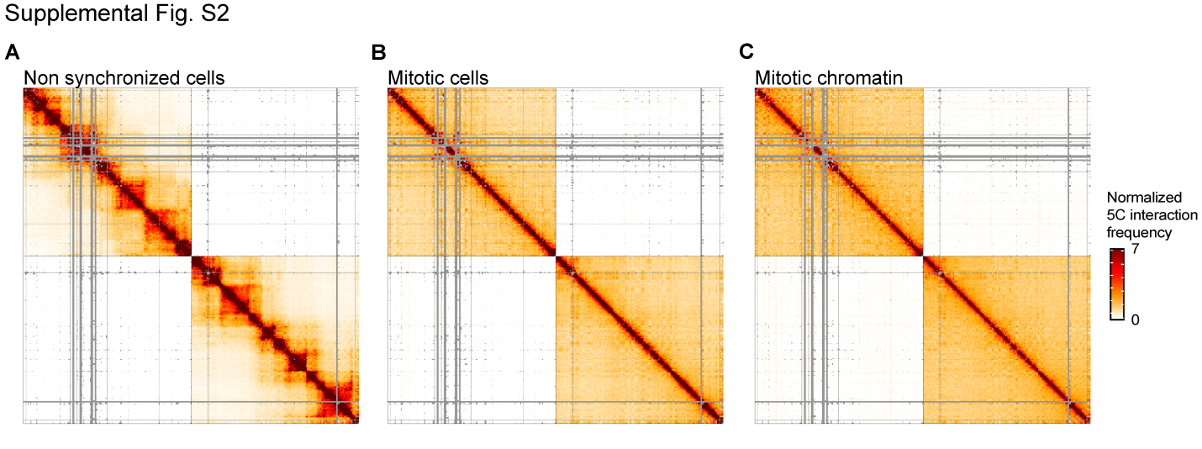
Supplemental Fig. S2 – 5C interaction interaction maps obtained with non-synchronized HeLa-S3 cells (A), mitotic HeLa-S3 cells (B), and mitotic chromatin purified from mitotic HeLa-S3 cells (C). Heatmap shows two 2 MB regions located on chromosome 1 (hg19 chr1: 46740122-48740121 (upper left)) and chromosome 11 (hg19 chr11: 33003550-35003549 (lower right)). Data was binned in 20 kb bins.
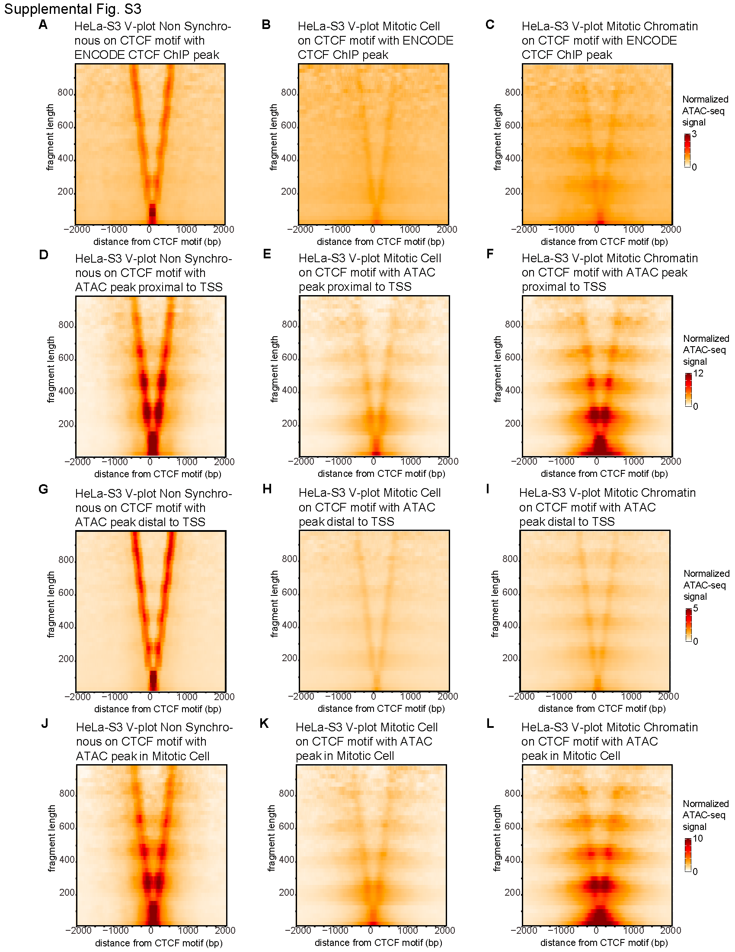
Supplemental Fig. S3 – (A-C) Normalized V-plots at CTCF motifs that display ENCODE CTCF ChIP peaks. V-plots are made based on ATAC-seq data from non-synchronized cells (A), mitotic cells (B) and mitotic chromatin (C). (D-F) Normalized V-plots at CTCF motifs within 2kb of TSS in non-synchronized cells (D), mitotic cells (E) and mitotic chromatin (F). (G-I) Normalized V-plots at CTCF motifs 2 kb or more away from any TSS in non-synchronized cells (G), mitotic cells (H) and mitotic chromatin (I). (J-L) Normalized V-plots at CTCF motifs with mitotic ATAC-seq peak in non-synchronized cells (J), mitotic cells (K) and mitotic chromatin (L).

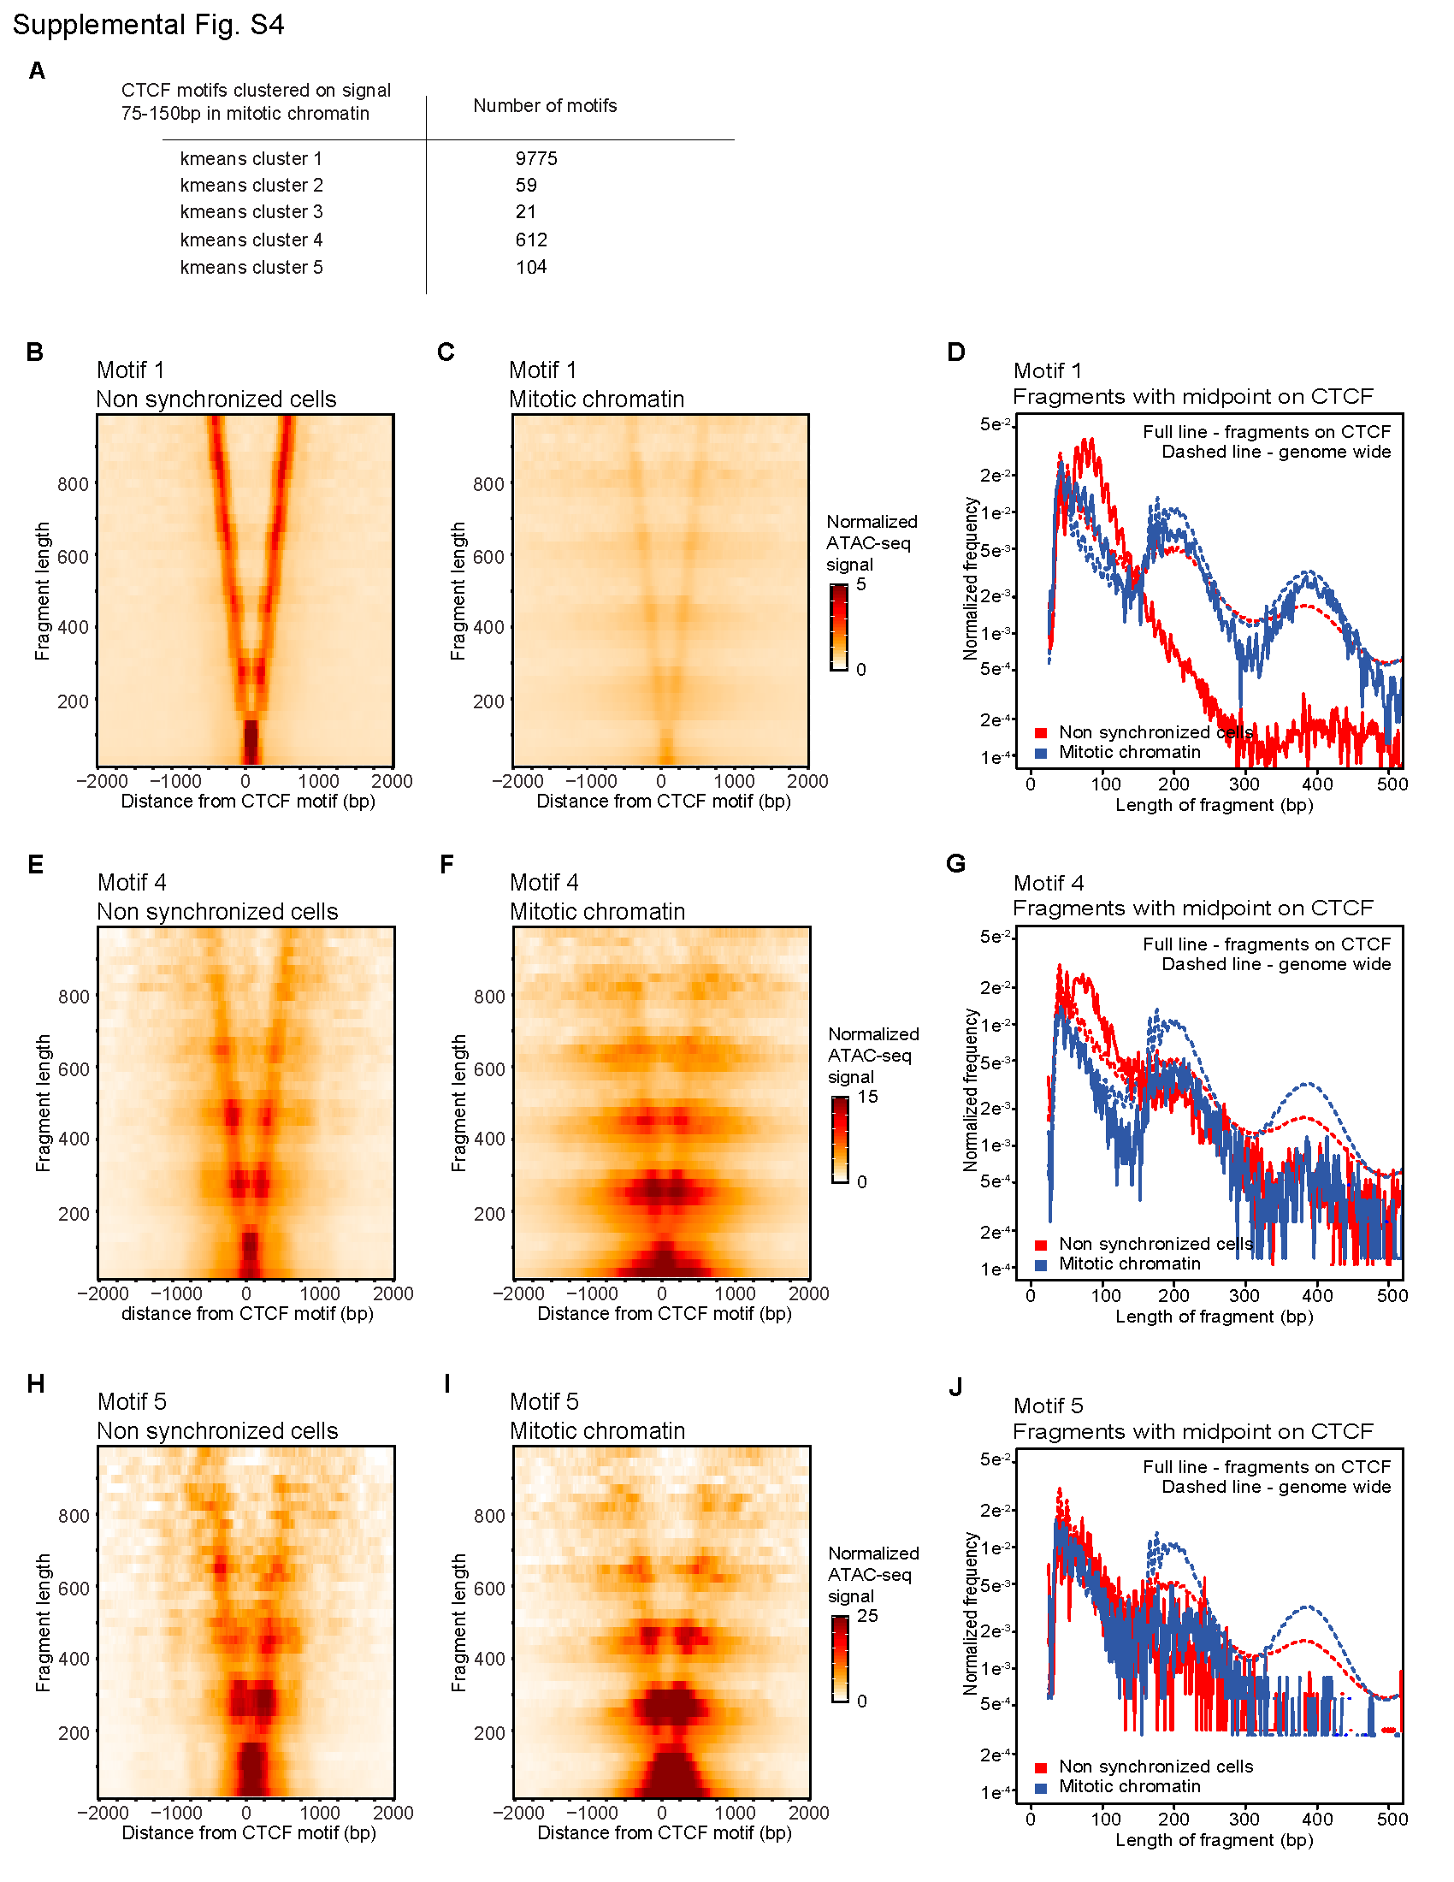
Supplemental Fig. S4 – (A) K-means clustering in 5 clusters of ATAC-seq signal of 75-150 bp length reads in mitotic chromatin at 2kb window from interphase accessible CTCF motifs. (B-C) V-plots of ATAC-seq data obtained with non-synchronized cells (B) and mitotic chromatin (C) at CTCF motifs in cluster 1 representing 9,975 CTCF motifs. (D) Fragment length distribution of reads with their midpoint on a CTCF motif from cluster 1. (E-F) V-plots of ATAC-seq data obtained with non-synchronized cells (E) and mitotic chromatin (F) on CTCF motifs in cluster 4 of kmeans clustering representing 612 CTCF motifs. (G) Fragment length distribution of reads with their midpoint on a CTCF motif from cluster 4. (H-I) V-plots of ATAC-seq data obtained with non-synchronized cells (H) and mitotic chromatin (I) on CTCF motifs in cluster 5 of kmeans clustering representing 104 CTCF motifs. (G) Fragment length distribution of reads with their midpoint on a CTCF motif from cluster 5.

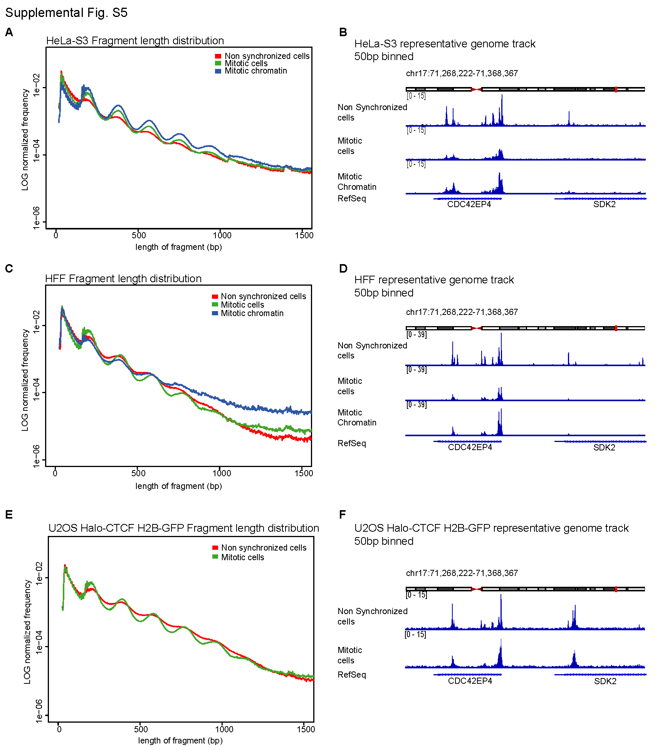
Supplemental Fig. S5 – ATAC-seq fragment length distributions and representative genome tracks for data obtained with HeLa-S3 (A-B), HFF (C-D) and U2OS Halo-CTCF H2B-GFP (E-F).
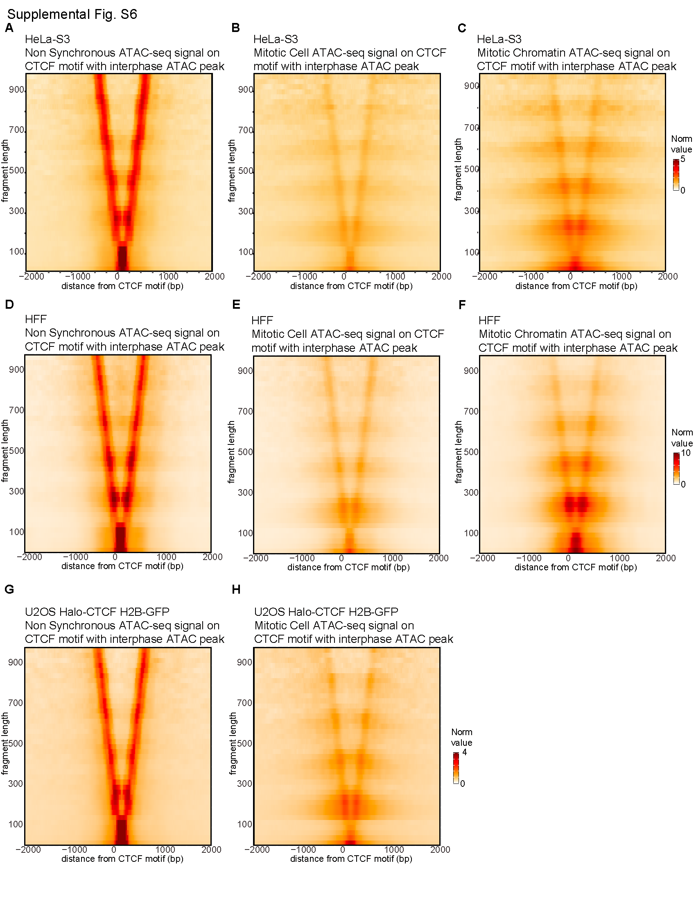
Supplemental Fig. S6 – Normalized V-plots of ATAC-seq data obtained with HeLa-S3 cells at CTCF motifs that display ATAC-seq peaks in interphase for non-synchronized cells (A), mitotic cells (B) and purified mitotic chromatin (C). Normalized V-plots of ATAC-seq data obtained with HFF cells at CTCF sites that display ATAC-seq peaks in interphase for non-synchronized cells (D), mitotic cells (E) and purified mitotic chromatin (F). Normalized V-plots of ATAC-seq data obtained with U2OS Halo-CTCF H2B-GFP cells at CTCF sites that display ATAC-seq peaks in interphase for non-synchronized cells (A), mitotic cells (B) and purified mitotic chromatin (C)
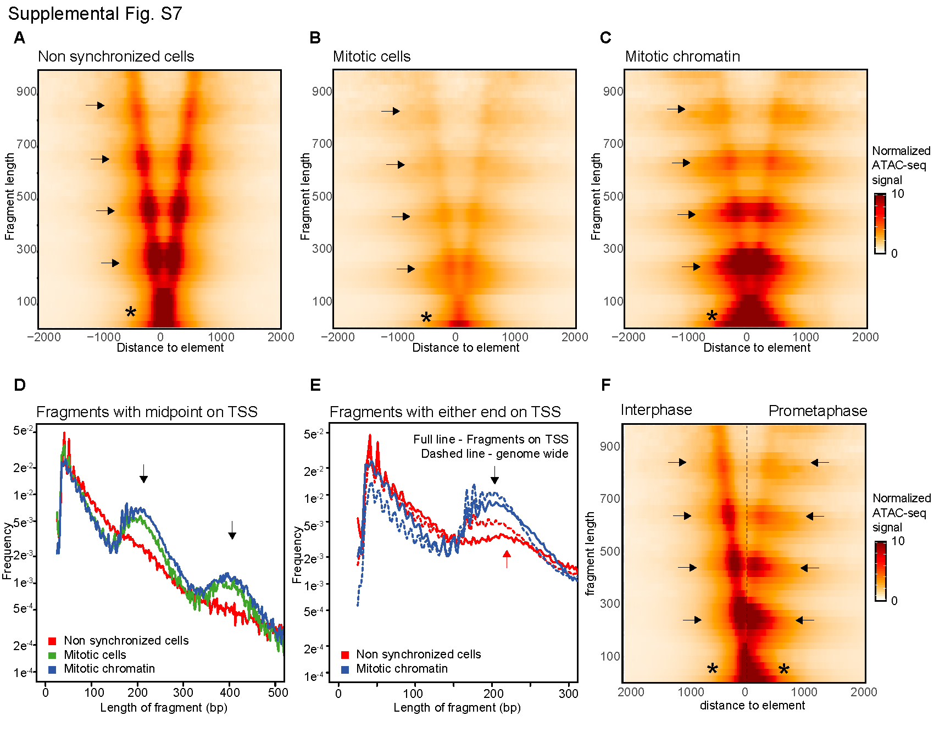Supplemental Fig. S7 – ATAC-seq data obtained with HeLa-S3 in non-synchronozed cells (A), mitotic cells (B), and purified mitotic chromatin (C) represented as V-plots aggregated on all TSS that display an ATAC-seq peak in interphase. (D) Fragment length distribution of non-synchronized cells, mitotic cells and mitotic chromatin for all reads with their midpoint on any TSS. (E) Fragment length distribution of non-synchronized cells and mitotic chromatin for all reads with either end near any TSS compared to the genome-wide distribution (dashed line). (F) Side-to-side comparison of V-plots for non-synchronized cells and mitotic chromatin up to 2 kb upstream of TSS.
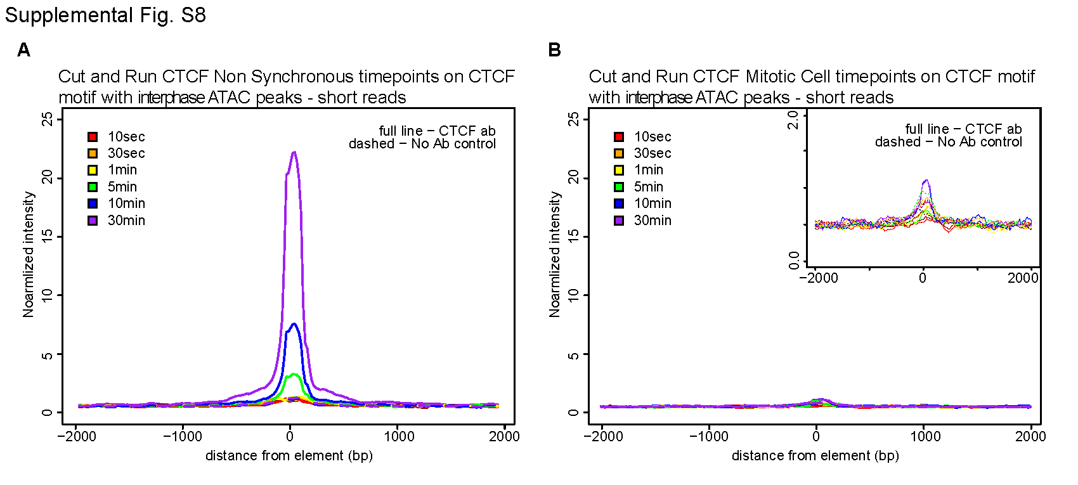
Supplemental Fig. S8 – Aggregation plots of CTCF CUT&RUN signal for reads shorter than 120bp obtained with different digestion times with pA-MNase (10 seconds to 30 min). Data are aggegated at CTCF motifs that display ATAC-seq peaks in interphase for HeLa-S3 non-synchronized cells (A) and mitotic cells (B). Insert in B shows CUT&RUN signal of mitotic cells at a y-axis from (0-2).

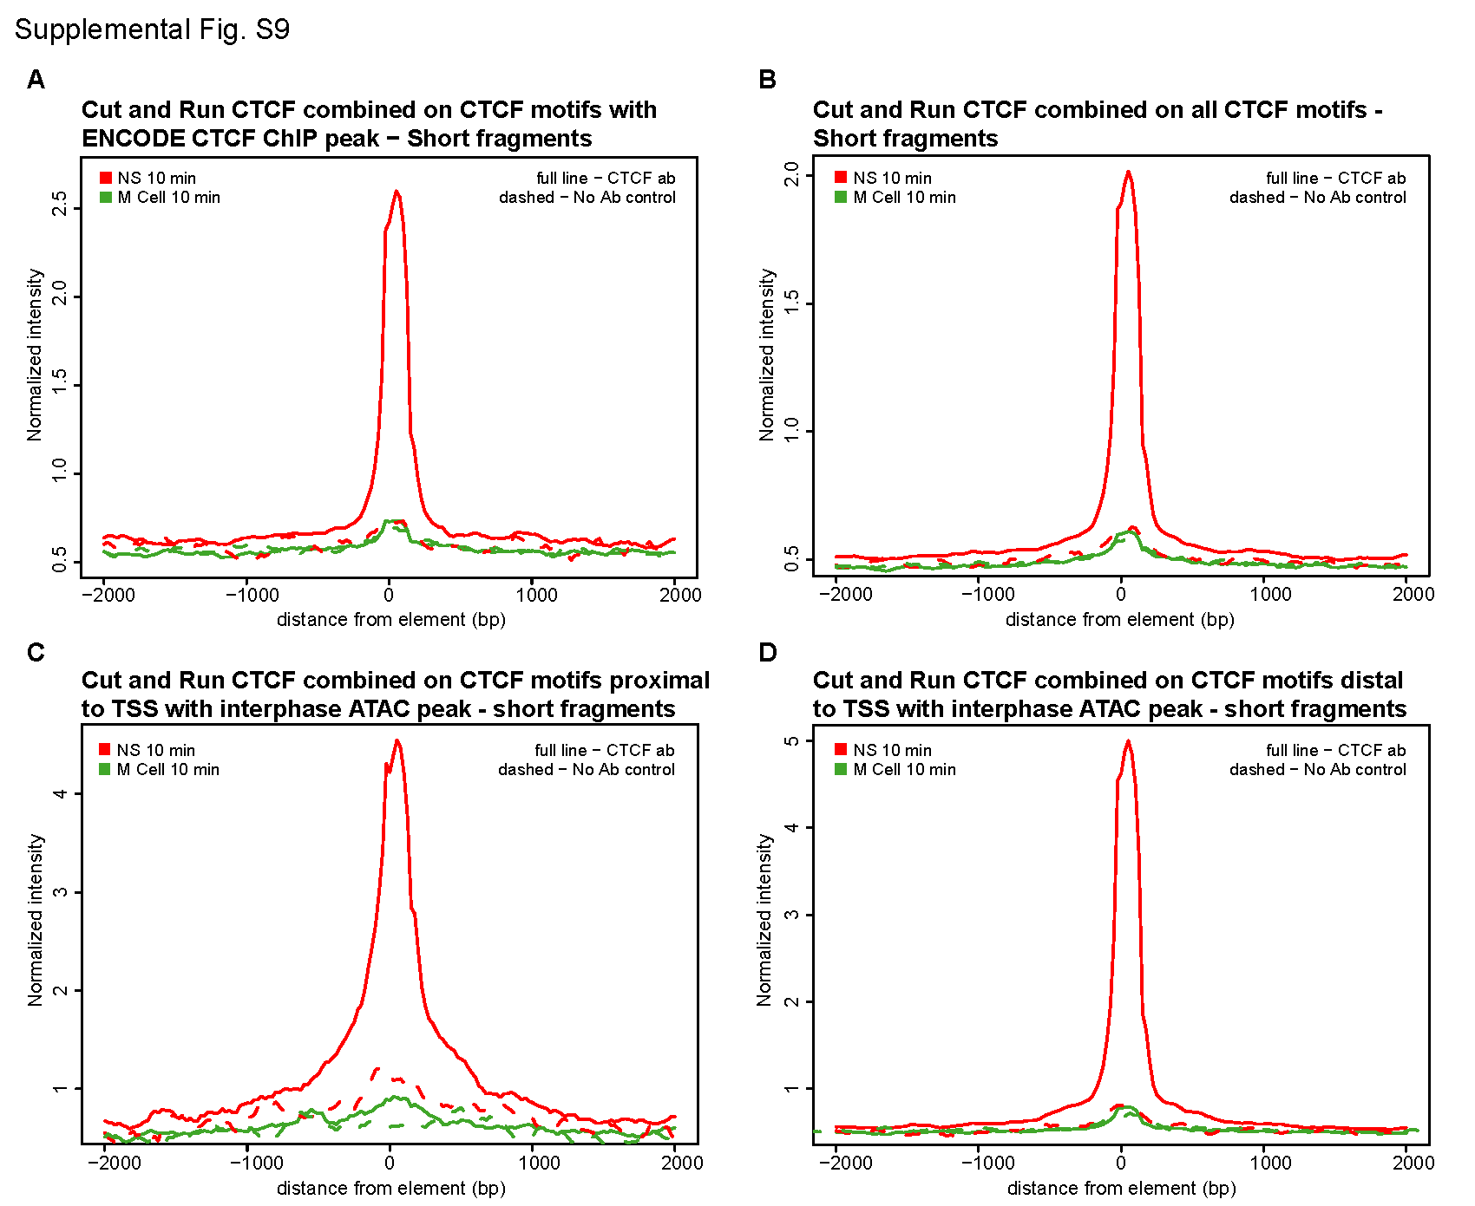
Supplemental Fig. S9 – (A) CTCF CUT&RUN signal obtained with non-synchronized and mitotic HeLa-S3 cells for reads shorter than 120bp aggregated at all CTCF motifs that display ENCODE CTCF ChIP peaks (6,893 sites). (B) CTCF CUT&RUN signal obtained with non-synchronized and mitotic HeLa-S3 cells for reads shorter than 120bp on all CTCF motifs (42,066 sites). (C) CTCF CUT&RUN signal obtained with non-synchronized and mitotic HeLa-S3 cells for reads shorter than 120bp on all CTCF motifs that display an ATAC-seq peak within 2 kb to a TSS in interphase (1,181 peaks). (D) CTCF CUT&RUN signal obtained non-synchronized and mitotic HeLa-S3 cells for reads shorter than 120bp on all CTCF motifs that display an interphase ATAC-seq peak further than 2 kb away from a TSS in interphase (9,459 peaks).
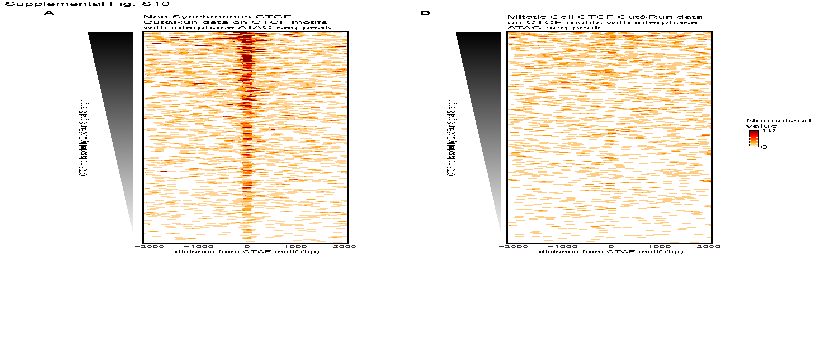
Supplemental Fig. S10 – Aggregation of CUT&RUN data heatmap obtained with HeLa-S3 cells for all reads shorter than 120bp on CTCF motifs that display an ATAC-seq peak in interphase sorted on CUT&RUN signal strength in interphase for non-synchronized cell (A) and mitotic cells (B).

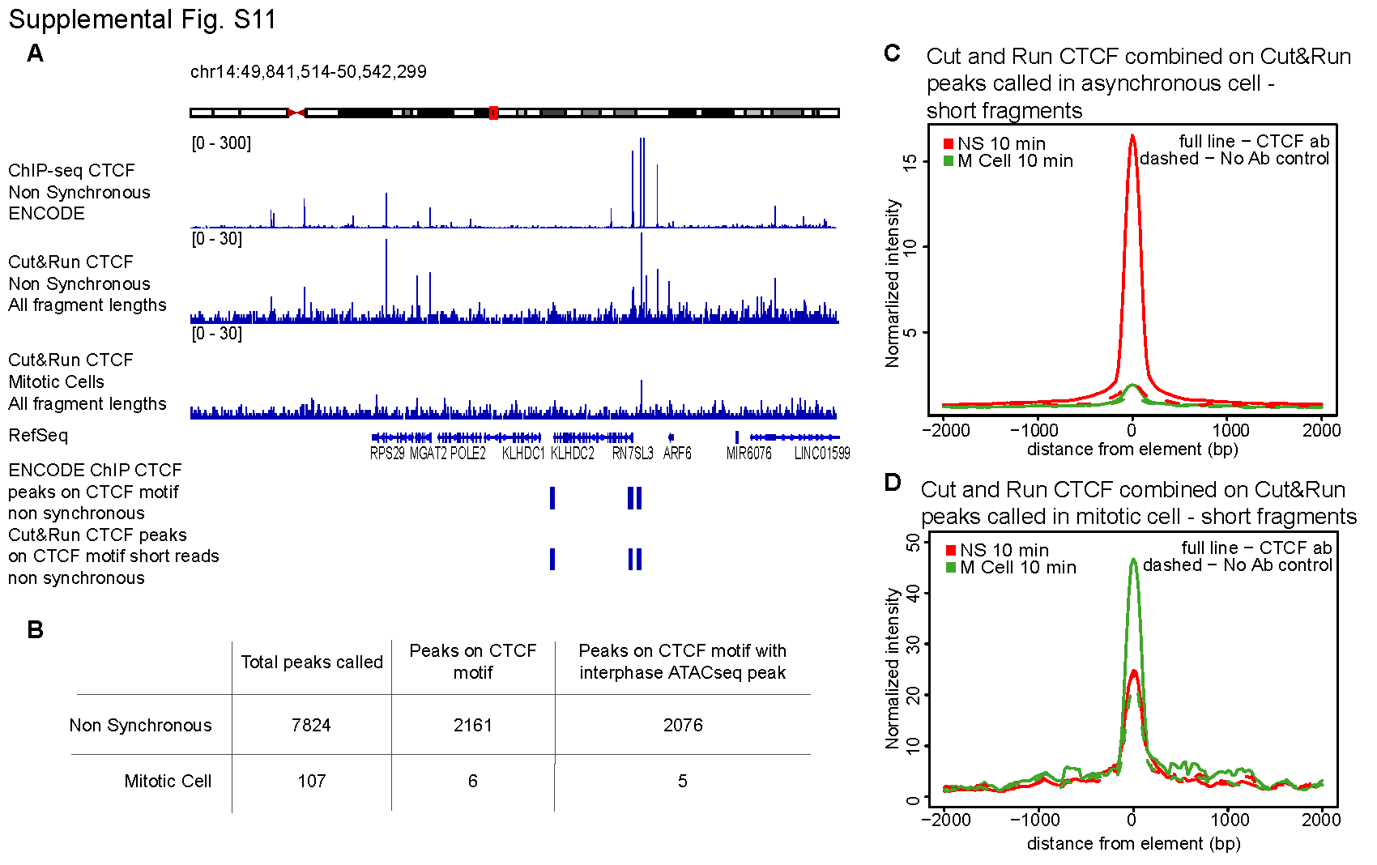
Supplemental Fig. S11 – De novo peak calling on CUT&RUN CTCF data obtained with non-synchronized and mitotic HeLa-S3 cells. (A) Visualization of ENCODE non synchronized CTCF ChIP-seq data and CUT&RUN data obtained with non-synchronized and mitotic HeLa-S3 cells for a representative region. The lower two tracks show the locations of CTCF motifs that display peaks called on ChIP-seq and CUT&RUN data respectively (CTCF motifs were stretched to 2kb to enhance visualization). (B) Number of peaks called on CTCF CUT&RUN data obtained with non-synchronized and mitotic HeLa-S3 cells and their overlap with CTCF motifs and ATAC-seq peaks. (C) CTCF CUT&RUN signal in non-synchronized and mitotic cells for reads shorter than 120bp on all peaks called in non-synchronized cells (7,824 peaks). (D) CTCF CUT&RUN signal in non-synchronized and mitotic cells for reads shorter than 120bp on all peaks called in mitotic cells (107 peaks).

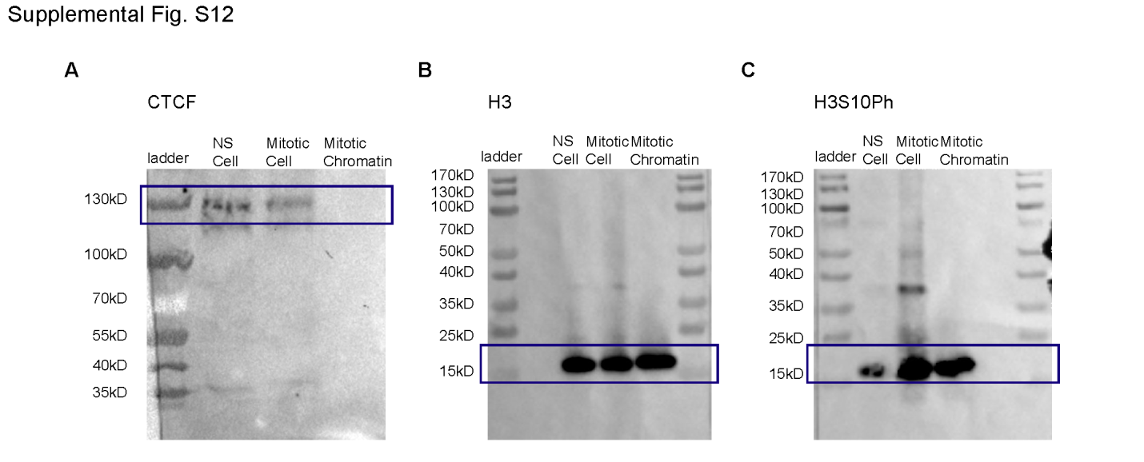
Supplemental Fig. S12 – Western blots of lysates from non-synchronized HeLa-S3 cells, mitotic HeLa-S3 cells and mitotic chromatin purified from mitotic HeLa-S3 cells probed with antibodies detecting CTCF (A), H3 (B) and H3S10ph (C).
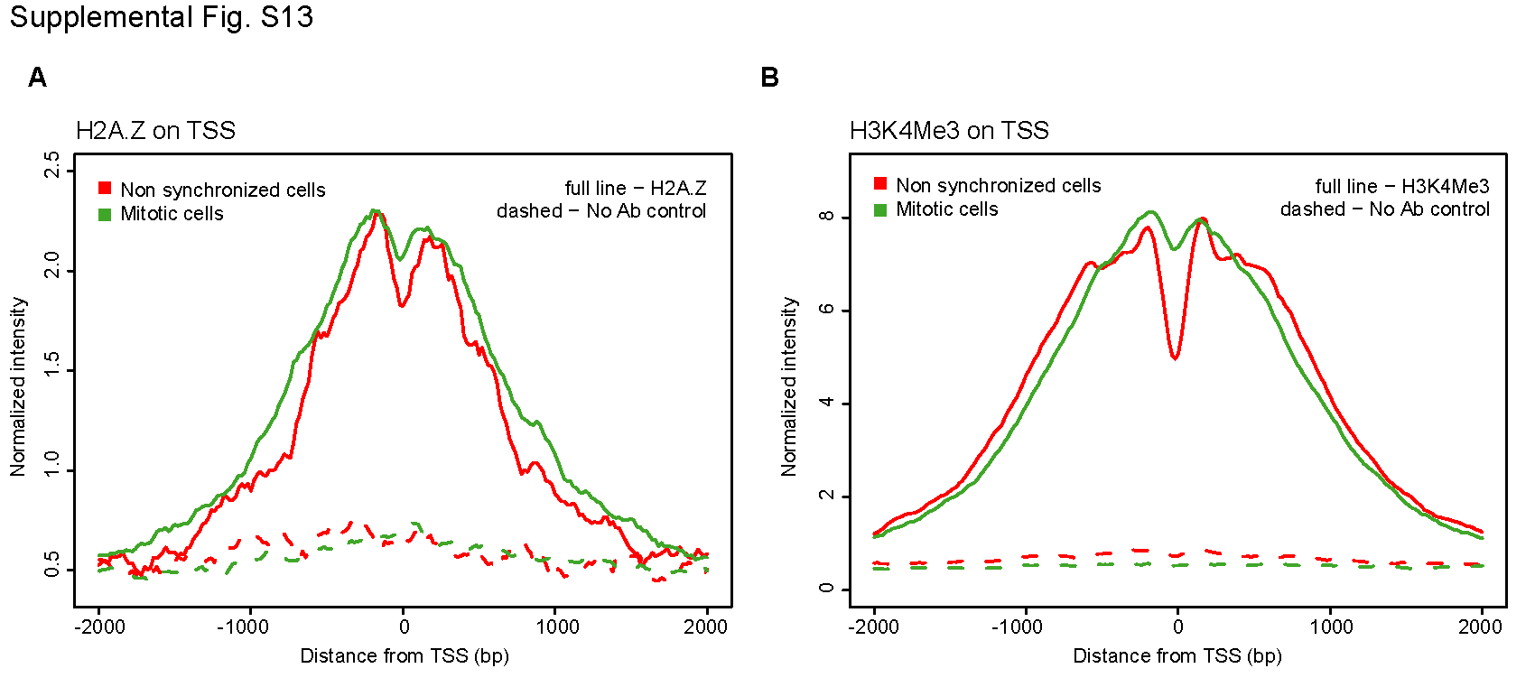
Supplemental Fig. S13 – (A) H2A.Z CUT&RUN signal of fragments larger than 120bp on TSSs that display ATAC-seq peaks in interphase for non-synchronized HeLa-S3 cells (red) and mitotic HeLa-S3 cells (green). (B) H3K4Me3 CUT&RUN signal of fragments larger than 120bp on TSSs that display ATAC-seq peaks in interphase for non-synchronized HeLa-S3 cells (red) and mitotic HeLa-S3 cells (green).
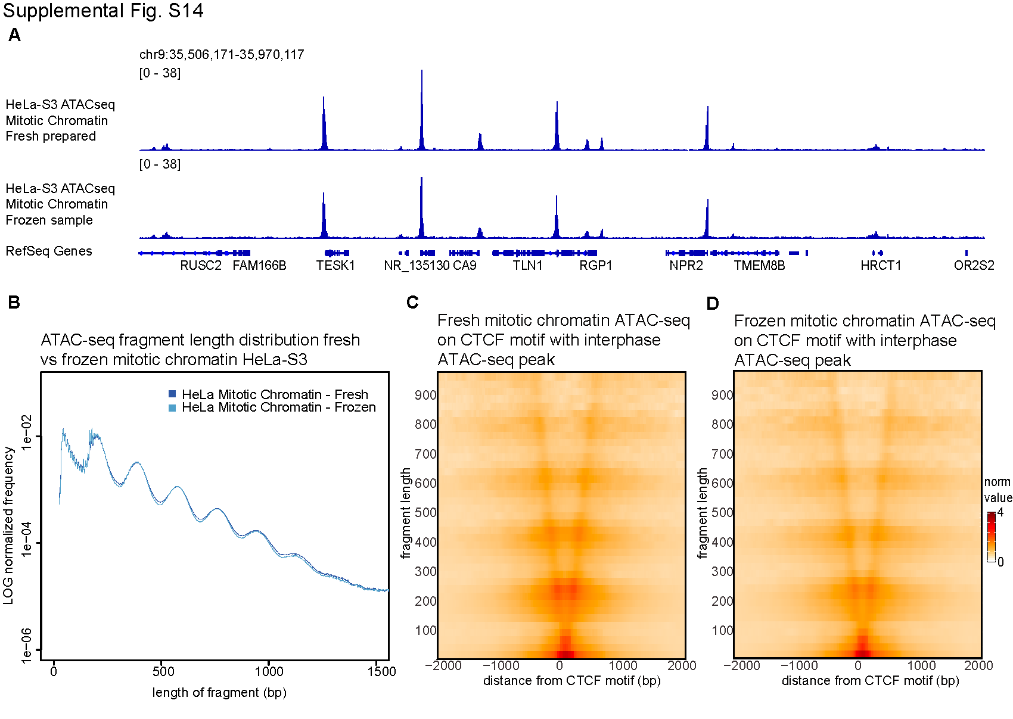
Supplemental Fig. S14 – Comparison of ATAC-seq data with freshly prepared and frozen stored mitotic chromatin from mitotically synchronized HeLa-S3. (A) representative genomic tracks, (B) fragment length distribution, (C-D) V-plots at CTCF motifs that display ATAC-seq peaks in interphase (C-D).
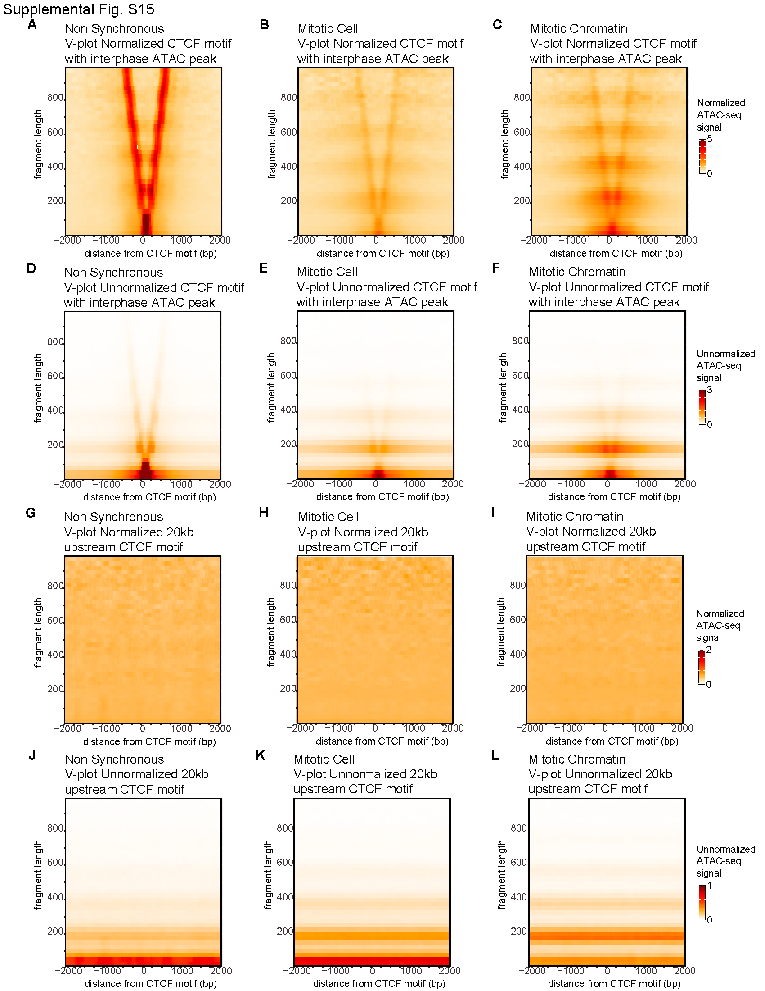
Supplemental Fig. S15 - V-plots normalized (A-C) and unnormalized (D-F) by the genome-wide fragment length distribution for HeLa-S3 ATAC-seq signal on all CTCF motifs that display an ATAC-seq peak in interphase for non-synchronized cells (A/D), mitotic cells (B/E) and purified mitotic chromatin (C/F). V-plots normalized (G-I) and unnormalized (J-L) by the genome-wide fragment length distribution for HeLa-S3 ATAC-seq signal on a region 20kb upstream of every CTCF motifs representing a random region in non-synchronized cells (G/J), mitotic cells (H/K) and purified mitotic chromatin (I/L).

Supplemental tables

Supplemental Table T1 – 5C mapping statistics
 |  | Reads Sequenced | Valid reads mapped
R1 | Asynchronous | 100,986,155 | 99,609,624
 | Mitotic Cell | 67,042,262 | 65,620,645
 | Mitotic Cluster | 38,212,480 | 36,918,691
R2 | Asynchronous | 181,209,251 | 175,402,702
 | Mitotic Cell | 181,966,242 | 175,402,702
 | Mitotic Cluster | 173,399,970 | 166,197,088
Combined | Asynchronous | 282,195,406 | 275,012,326
 | Mitotic Cell | 249,008,504 | 240,312,381
 | Mitotic Cluster | 211,612,450 | 203,115,779

Supplemental Table T2 – Antibodies used for western blot and Cut&Run
 | Company + catalogue number | Western blot concentration | Cut&Run concentration
CTCF | CST #2899 | 1:1000 | 1:100
H2A.Z | Abcam #ab4174 | x | 1:100
H3K4Me1 | Abcam #ab8895 | x | 1:50
H3K4Me3 | Abcam #ab8580 | x | 1:100
H3 | Abcam #ab1791 | 1:1000 | x
H3S10Ph | Abcam #ab5176 | 1:1000 | x

Supplemental Movies
Supplemental Movie S1 – Live cell imaging halo-CTCF overlaid with brightfield
Supplemental Movie S2 – Live cell imaging H2B-GFP on left and halo-CTCF on right
Supplemental Movie S3 – Single particle tracking Halo-CTCF in interphase cells
Supplemental Movie S4 - Single particle tracking Halo-CTCF in nocodazole arrested mitotic cells
Supplemental Movie S5 - Single particle tracking Halo-CTCF in “enriched” prometaphase cells
Supplementary methods
Cell culturing and synchronization of culture in prometaphase
HeLa S3 cells were grown in a humidified incubator at 37C in Gibco glutamax DMEM (Thermo Fisher Scientific #10566024) supplemented with 10% heat inactivated FBS (Thermo Fisher Scientific #10437028) and 5 mL Penicillin-Streptomycin (Thermo Fisher Scientific #15140122) and were passaged every 2-3 days. To obtain mitotic cells, the culture at density 26,000 cells/cm² was synchronized using filter sterilized 2 mM Thymidine (Sigma-Aldrich #T9250) for 24 hr, followed by a 3hr release in fresh media and a 12hr 100ng/mL nocodazole arrest (filter sterile 5000x stock in DMSO; Sigma-Aldrich #M1404). To enrich for mitotic cells, cells were gently shaking off and only rounded floating cells were collected.

HFF hTERT immortalized cells were cultured in the same media conditions as HeLa S3 cells. HFF cells were synchronized by culturing at a density of 10,000 cells/cm² and arresting by a double 2mM Thymidine block of 18 and 17 hours with release in fresh media of 8 and 7 hour respectively. Cells were then synchronized in prometaphase using 100ng/mL nocodazole for 5 hours. Cells were shaken off followed by a gentle wash with dPBS. This results typically in a yield of 500-1000 mitotic cells per cm² cultured cells.

We previously generated a U2OS cell line where CTCF has been homozygously and endogenously N-terminally tagged with HaloTag (FLAG-Halo-hCTCF; C32) using CRISPR/Cas9-mediated genome editing (Hansen et al., 2017a). To additionally enable the visualization of mitotic cells, here we stably integrated a previously described transgene expressing histone H2B-GFP with Puro selection (Teves et al., 2016). We transfected U2OS C32 Halo-hCTCF cells with the H2B-GFP; PURO plasmid using Lipofectamine 3000 (Thermo Fisher Scientific #L3000015) according to manufacturer’s protocol and then selected cells with puromycin for 1 week after which all cells in the population stably expressed H2B-GFP. U2OS cell lines stably expressing H2B-Halo-SNAP and Halo-3xNLS have been described previously (Hansen, Pustova, Cattoglio, Tjian, & Darzacq, 2017; Hansen et al., 2018). The parent wild-type and C32 FLAG-Halo-hCTCF U2OS cells lines have been authenticated using STR profiling and verified to be pathogen-free (Hansen et al., 2017a).

Human U2OS osteosarcoma cells (Research Resource Identifier: RRID:CVCL_0042) were grown in a Sanyo copper alloy IncuSafe humidified incubator (MCO-18AIC(UV)) at 37C/5.5% CO2 in low glucose DMEM with 10% FBS (full recipe: 500 mL DMEM (Thermo Fisher Scientific #10567014), 50 mL fetal bovine serum (HyClone FBS SH30910.03 lot #AXJ47554) and 5 mL Penicillin-streptomycin (Thermo Fisher Scientific #15140122)) and were passaged every 2-4 days before reaching confluency. For live-cell imaging, the medium was identical except DMEM without phenol red was used (Thermo Fisher Scientific #31053028). For live cell single-molecule imaging experiments, cells were grown overnight on 25 mm circular no 1.5H cover glasses (Marienfeld High-Precision 0117650). Prior to all experiments, the cover glasses were plasma-cleaned and then stored in isopropanol until use. For live-cell FRAP experiment and long-term time-lapse, cell preparation was identical except cells where grown on glass-bottom (thickness #1.5) 35 mm dishes (MatTek P35G-1.5-14-C).

Mitotic cells were identified through the histone H2B-GFP channel. For nocodazole prometaphase-arrested conditions, cells were treated with 100 ng/mL nocodazole (1000x stock in DMSO; Sigma-Aldrich, M1404) for 4-6 hours for imaging experiments. For “prometaphase-enriched” cells, there was no drug treatment. Instead mitotic cells with a characteristic prometaphase H2B-GFP signal were manually identified and selected for imaging. Mitotic cells for genomics studies were synchronized at a density of 16,500 cells/cm² using 2mM Thymidine for 24 hrs, followed by a 3hr release in fresh media and 12hr 100ng/mL nocodazole arrest. Mitotic cells were collected by a gentle shake off.

Mitotic chromatin cluster purification
Mitotic chromatin clusters were purified according to previously a published protocol with minor changes (Gasser & Laemmli, 1987). Cells were synchronized in prometaphase using thymidine and nocodazole arrests as described above. After washing cells in dPBS, cells were lysed using 0.1% NP-40, 10% glycerol, 15 mM Tris-HCl, 80 mM KCl, 2mM EDTA-KOH, 0.2 mM spermine, 0.5 mM spermidine, 1mM DTT and Roche cOmplete EDTA-free protease inhibitor (Sigma-Aldrich 11873580001). Lysis was followed by dounce homogenization using pestle B. After proper lysis and removal of cytosolic fractions was obtained, the solution was transferred to percoll gradients, containing a bottom layer of 60% percoll plus (Sigma-Aldrich #E0414), 15% Glycerol, 1 mM DTT, Roche cOmplet EDTE-free protease inhibitor, 0.1% NP-40, 15 mM Tris-HCl, 80 mM KCl, 2mM EDTA-KOH, 0.8 mM Spermidine and 2 mM Spermine, and a top layer of 25% Glycerol, 0.1% NP-40, 15 mM Tris-HCl, 80 mM KCl, 2mM EDTA-KOH, 1 mM DTT, Roche cOmplet EDTE-free protease inhibitor, 0.1 mM Spermidine and 0.25 mM Spermine. Gradients were spun at 1000xg for 30 minutes to separate mitotic chromatin and interphase nuclei. Mitotic chromatin pellets on top of the bottom percoll layer. The top layer was taken off to remove interphase nuclei. Pestle B was again used to dounce mitotic chromatin clusters and the solution was diluted 1 to 4 with 60% percoll plus, 15% Glycerol, 1 mM DTT, Roche cOmplete EDTA-free protease inhibitor, 0.1% NP-40, 15 mM Tris-HCl, 80 mM KCl, 2mM EDTA-KOH, 0.8 mM Spermidine and 2 mM Spermine. The solution was spun down at 3000xg for 5 minutes and then at 44,500xg for 30 minutes. The supernatant was again removed up till 2-3 cm and pelleted chromatin clusters were diluted in 15 mM Tris-HCl, 80 mM KCl, 2mM EDTA-KOH, 1mM DTT, 0.1% NP-40, 0.05 mM spermine, 0.125 mM spermidine and Roche cOmplete EDTA-free protease inhibitor. Mitotic chromatin clusters were washed several times with this solution to remove remaining percoll plus. Mitotic chromatin clusters can be frozen at -80C in 33.33% glycerol. Chromatin clusters were used for ATAC-seq both directly after chromatin cluster purification and after freezing. Supplemental Fig. S14 shows fresh or frozen clusters obtain highly similar results for ATAC-seq. For this reason we continued using frozen chromatin clusters for all further ATAC-seq experiments. Mitotic chromatin clusters for 5C were immediately fixed in 1% formaldehyde before pelleting and storage at -80C.

5C
For each 5C library, 25 million cells or the equivalent in mitotic chromatin clusters from HeLa S3 were used as input. There were two biological replicates produced for each condition. Cells were crosslinked for 10 minutes at room temperature in a final concentration of 1% formaldehyde. Glycine was added to quench crosslinking and cells were incubated for 5 min with gentle agitation and then on ice for 15 min. Cells were spun down and after removal of supernatant, pellets were frozen at -80C and stored until used for 5C. 5C was performed according to published protocols (Dostie et al., 2006; Hnisz et al., 2016). We investigated the same regions as previously described and we used the same primer pool (Hnisz et al., 2016). This 5C primer pool covers two 2 Mb regions located on Chromosome 1 (hg19 Chr1: 46740122-48740121) and Chromosome 11 (hg19 Chr11: 33003550-35003549). Cells were lysed in presence of protease inhibitors and a dounce homogenizer with pestle A was used to obtain proper removal of the cytosolic fraction. Purified mitotic chromatin clusters did not need to be lysed, and were simply resuspended and washed in 1xNEBuffer 2.1 (New England Biolabs #B7202). Chromatin for all conditions was digested using 400U HindIII (New England Biolabs #R0104) and incubated at 37C overnight. After digestion the enzyme was inactivated, followed by ligation for 2 hours at 16C with 10U of T4 ligase (Invitrogen 15224017) in presence of 1% Triton X-100. Proteins were digested using proteinase K, followed by phenol chloroform extraction, ethanol precipitation and RNA digestion using RNase A to purify DNA and obtain 3C templates to continue the 5C protocol. Different conditions were tested to optimize genome copy number, 5C probe concentration and number of amplification cycles. From this, we decided to use ~800,000 genome copies, 0.3 fmole probes and 20 cycles of PCR amplification. Annealing of the 5C probes was performed at 50C overnight, directly followed by ligation of the probes at 50C for 1 hour using Taq ligase (New England Biolabs #M0208). After primer annealing and ligation, 5C ligation products were amplified for 20 cycles and libraries were size selected by gel purification to remove primer dimers and unbound primers. The 5C libraries were then prepared for sequencing using barcoded adaptors and TruSeq Nano DNA sample kit (Illumina 20015964), followed by final amplification with 6 cycles. The libraries were again gel purified and finally sequenced on the Illumina HiSeq4000 platform to obtain 50 bp paired-end reads.

Sequencing data was processed using a custom pipeline for mapping and assembly of 5C interactions, as previously described (Lajoie, van Berkum, Sanyal, & Dekker, 2009). After careful comparison, data from two biological replicates were combined to produce a single interaction map. Mapping statistics for each library can be found in table S1. 5C interaction matrices were filtered to remove the diagonal, flagged outlier singletons and rows/columns based on Z-score cut-off of 12 for both cis and trans interactions. When singletons or row/columns had to be removed from an individual 5C matrix, we removed this singleton or row/column from every of our 5C matrices. As the primers used for this study are designed using the double-alternating pattern, we merged rows/columns that map to the same restriction fragment using the mean of the interactions and the interaction matrices were made symmetrical. Data was balanced using ICE, binned in 20 kb bins and balanced again (Imakaev et al., 2012). Insulation index and 5C anchor plots were calculated using published methods (Crane et al., 2015; Sanyal, Lajoie, Jain, & Dekker, 2012). Data was balanced and binned at 15kb for 5C anchor plot analysis. Scripts used for 5C analysis can be found at Github: https://github.com/dekkerlab/cworld-dekker.

ATAC-seq
ATAC-seq was performed following a previously published protocol (Buenrostro, Wu, Chang, & Greenleaf, 2015). Briefly, 50,000 cells per experiment (typically 2 biological replicates, 4 technical replicates per dataset) were washed and lysed using lysis buffer containing 0.1% NP-40, 10 mM Tris-HCl (pH 7.4), 10 mM NaCl and 3 mM MgCl2. Cells were transposed using the Nextera DNA library prep kit (Illumina #FC-121-1030) for 30 min at 37C. DNA was immediately purified using Qiagen MinElute Kit (Qiagen #28004). Cycle number for PCR amplification of the DNA was determined for each sample individually using qPCR. Primers were removed from amplified libraries using AMpure XP beads (Beckman Coulter #A63881). The libraries were sequenced on HiSeq2000 or HiSeq4000 illumina sequencers to obtain 2x50 paired-end reads.

ATAC-seq data were trimmed from their 3’ end to 24 bp and aligned to hg19 using Bowtie 2 with maximum mapping length of 2000 bp (Langmead & Salzberg, 2012). Paired-end reads that mapped with a mapping quality below 3 were discarded, as were reads mapped to the mitochondrial genome and PCR duplicates. In addition, regions marked as DAC blacklisted regions in hg19 by the ENCODE project were removed (annotation file accession number ENCSR636HFF). Reproducibility between technical replicates was evaluated based on similarities in length distribution, percentage non-valid reads (e.g. percentage mitochondrial DNA, PCR duplicates etc), genome track and peak calling before combining data. For further analysis (unless otherwise indicated) each end +5 bp was taken and analysis was continued treating the reads as single end reads. BEDtools were used to produce bigWig tracks for several bin sizes, as well as for manipulation of other bed files (Quinlan & Hall, 2010). Peak calling was performed using HOMER (Heinz et al., 2010). To group TSSs in top 20% highest accessible sites and top 20% lowest accessible sites, all peaks in mitotic chromatin at TSSs were ranked based on HOMER-score (reflecting signal over background enrichment).

In order to produce V-plots, paired-end reads for each library were separated based on total read length into bins of 25 bp. For each bin, HOMER aggregation plots for an element of interest (e.g. CTCF motifs with interphase ATAC-seq peaks) were produced using only the midpoint of the read. The values of the aggregation plots were used to produce heatmaps. Each read length bin was normalized using HOMER normalization for genome wide coverage in order to visualize the rare larger length bins, ensuring the sum of the reads in each length bin genome wide is comparable. V-plots of unnormalized length bins and V-plots of a randomized region are shown in Supplemental Fig. S15. For CTCF-centered V-plots, all CTCF motifs were aligned in the same direction. For TSS-centered V-plots, all TSS were in the same direction.

CTCF motif identification for hg19
A candidate list of all CTCF motifs in the human genome was produced using CTCF motif consensus for vertebrates published in 2007 by Kim et al. as an input for HOMER (Heinz et al., 2010; Kim et al., 2007). Orientation of CTCF motif was always taken into account during analysis.

ENCODE data sets
ENCODE ChIP-seq data for CTCF in HeLa S3 was downloaded for analysis. GEO accession #SRX067536.

CUT&RUN
CUT&RUN was performed according to the published protocol with minor changes (Skene & Henikoff, 2017). As mitotic cells do not have a nuclear membrane, it was not possible to use concanavalin A beads. Instead, cells were spun at 600xg for 3 min at 4C for every wash or buffer exchange. Asynchronous and mitotic cells were harvested fresh for every CUT&RUN experiment. 500,000 cells were used as input for every time point and there were 2 biological replicates produced for every dataset. Cells were lysed on ice for 10 minutes in 20mM HEPES-KOH pH 7.9, 10mM KCl, 0.5mM spermidine, 0.1% Triton-X-100, 20% glycerol and Roche cOmplete EDTA-free protease inhibitor (Sigma-Aldrich 11873580001). Cells were washed in wash buffer 1 (20mM HEPES pH 7.5, 150mM NaCl, 2mM EDTA 0.5mM spermidine, 0.1% BSA and Roche cOmplete EDTA-free protease inhibitor) and then resuspended in wash buffer 2 (20mM HEPES pH 7.5, 150mM NaCl, 0.5mM spermidine, 0.1% BSA and Roche cOmplete EDTA-free protease inhibitor). Cells were incubated with primary antibody according to table S2 for 2 hours while rotating at 4C. A control, for which no primary antibody was used at this step, was always included in each experiment. Cells were washed several times using wash buffer 2, followed by incubation with 1:400 pA-MNase (batch #6 from Henikoff lab) for 1 hour on rotator at 4C. Cells were washed several times in wash buffer II, after which cell suspensions were split in 150 µL wash buffer II per time-point sample. Samples were transferred to an ice water bath equilibrated at 0 degrees Celsius. MNase digestion was activated by adding CaCl₂ to final concentration of 2mM while vortexing. MNase was inactivated after designated time (typically 5 seconds, and up to 30 minutes) by adding 2XSTOP+ (200mM NaCl, 20mM EDTA, 4mM EGTA, 50µg/mL RNaseA and 40µg/mL Glycogen). The samples were then incubated for 20 minutes at 37C to digest RNA, followed by adding 0.1% SDS and proteinase K and 10 minutes incubation at 65C. DNA was extracted from the samples using 1:1 phenol chloroform extraction, followed by size selection to remove large fragments using AMpure XP beads (Beckman Coulter #A63881). DNA was purified using ethanol precipitation and samples were finally dissolved in Tris-EDTA. Samples were prepared for sequencing using barcoded adaptors of TruSeq Nano DNA Sample Prep Kit (Illumina 20015964) and amplified. Finally libraries were size selected using gel purification for an insert size of 50-200 bp. DNA was purified from gel using QIAquick gel extraction kit (Qiagen #28704). CUT&RUN libraries were sequenced on Illumina MiSeq sequencer to obtain 50 bp paired-end reads to a sequence depth of 1 to 5 million valid reads per sample.
CUT&RUN sequenced reads were trimmed from 3’ end to 24 bp and aligned to hg19 using Bowtie 2 with maximum mapping length of 2000 bp (Langmead & Salzberg, 2012). Paired-end reads that mapped with a mapping quality below 3 were discarded, as well as PCR duplicates. Paired-end reads were separated based on total read length above or below 120 bp. HOMER was used to produce aggregation plots on elements of interest and to perform de novo peak calling on CUT&RUN data (Heinz et al., 2010).

Western blot
Cells and mitotic clusters were harvested, washed in dPBS and pelleted followed by freezing and storage at -80C until used. Protein lysates were obtained using RIPA buffer (Thermo Fisher Scientific #89900) supplemented with 1x HALT protease inhibitor (Thermo Fisher Scientific #78429). All samples were incubated on ice for 15 minutes while firmly pipetting every couple of minutes. Samples were spun down 30 min at 16,100xg at 4C and supernatant was collected. Pierce Lane Marker Reducing Sample buffer (Thermo Fisher Scientific #39000) was added and protein lysate was incubated for 30 min at 95C. Samples to detect CTCF were ran on a 3-8% Tris-Acetate gel, whereas samples for histone detections were ran on a 4-12% Tris-Bis gel. Antibodies used in this study as well as their concentration used for western blot are listed in table S2. Primary antibody incubation was done overnight, followed by secondary antibody incubation by either goat anti-rabbit IgG-HRP (Cell Signaling Technologies #7074) or goat anti-mouse IgG-HRP (Cell Signaling Technologies #7076). HRP was activated using SuperSignal West Dura Chemiluminescent Substrate (Thermo Fisher Scientific #34076) and signal was detected using the BioRad Gel Doc system.

Fluorescence Recovery After Photobleaching (FRAP) imaging
FRAP experiments were performed and analyzed as previously described (Hansen et al., 2017). Briefly, FRAP was performed on an inverted Zeiss LSM 710 AxioObserver confocal microscope equipped with a motorized stage, a full incubation chamber maintaining 37°C/5% CO₂, a heated stage, an X-Cite 120 illumination source as well as several laser lines. Halo-TMR was excited using a 561 nm laser and H2B-GFP was excited using a 488 nm laser. Images were acquired on a 40x Plan NeoFluar NA1.3 oil-immersion objective at a zoom corresponding to a 100 nm x 100 nm pixel size and the microscope controlled using the Zeiss Zen software. In FRAP experiments, 300 frames were acquired at either 1 frame per second allowing 20 frames to be acquired before the bleach pulse to accurately estimate baseline fluorescence. A circular bleach spot (r = 10 pixels) was chosen in a region of homogenous fluorescence at a position at least 1 μm from nuclear boundaries and in a region occupied by chromatin as visualized using the H2B-GFP transgene in the GFP channel. The spot was bleached using maximal 561 nm laser intensity and pixel dwell time corresponding to a total bleach time of ~1 s. We generally collected data from several cells per cell line per condition per day and all presented data is from at least three independent replicates on different days: U2OS C32 Halo-hCTCF interphase: 32 cells; prometaphase-arrested (100 ng/mL nocodazole for 4-6 hours) U2OS C32 Halo-hCTCF, H2B-GFP (19 cells); prometaphase-enriched (no drug treatment; prometaphase-like cells identified through the histone H2B-GFP channel) U2OS C32 Halo-hCTCF, H2B-GFP (18 cells) U2OS Halo-3xNLS in interphase (6 cells); and U2OS H2B-Halo-SNAP prometaphase-enriched (no drug treatment; prometaphase-like cells identified through the histone H2B-TMR channel; 10 cells). To quantify and drift-correct the FRAP movies, we used a previously described custom-written pipeline in MATLAB (Hansen et al., 2017). Briefly, we manually identify the bleach spot. The nucleus is automatically identified by thresholding images after Gaussian smoothing and hole-filling (to avoid the bleach spot as being identified as not belonging to the nucleus). We use an exponentially decaying (from 100% to ~85% (measured) of initial over one movie) threshold to account for whole-nucleus photobleaching during the time-lapse acquisition. Next, we quantify the bleach spot signal as the mean intensity of a slightly smaller circle (r = 0.6 μm), which is more robust to lateral drift. The FRAP signal is corrected for photobleaching using the measured reduction in total nuclear fluorescence (~15% over 300 frames at the low laser intensity used after bleaching) and internally normalized to its mean value during the 20 frames before bleaching. We correct for drift by manually updating a drift vector quantifying cell movement during the experiment. Finally, drift- and photobleaching corrected FRAP curves from each single cell were averaged to generate a mean FRAP recovery. We used the mean FRAP recovery in all figures and error bars show the standard error of the mean.

Single-molecule imaging (spaSPT)
U2OS C32 FLAG-Halo-hCTCF; H2B-GFP cells grown overnight on plasma-cleaned 25 mm circular no 1.5H cover glasses (Marienfeld High-Precision 0117650). After overnight growth, cells were either treated with nocodazole or not and then labeled with 50 nM PA-JF₅₄₉ (Grimm et al., 2016) for ~15-30 min and washed twice (one wash: medium removed; PBS wash; replenished with fresh medium). At the end of the final wash, the medium was changed to phenol red-free medium keeping all other aspects of the medium the same (and adding back 100 ng/mL nocodazole if appropriate). Single-molecule imaging was performed on a custom-built Nikon TI microscope equipped with a 100x/NA 1.49 oil-immersion TIRF objective (Nikon apochromat CFI Apo TIRF 100x Oil), EM-CCD camera (Andor iXon Ultra 897; frame-transfer mode; vertical shift speed: 0.9 μs; -70°C), a perfect focusing system to correct for axial drift and motorized laser illumination (Ti-TIRF, Nikon), which allows an incident angle adjustment to achieve highly inclined and laminated optical sheet illumination (Tokunaga, Imamoto, & Sakata-Sogawa, 2008). An incubation chamber maintained a humidified 37°C atmosphere with 5% CO₂ and the objective was also heated to 37°C. Excitation was achieved using a 561 nm (1 W, Genesis Coherent) laser for PA-JF₅₄₉. Histone H2B-GFP was visualized using epi-illumination (X-cite 120LED). The excitation laser was modulated by an acousto-optic tunable filter (AA Opto-Electronic, AOTFnC-VIS-TN) and triggered with the camera TTL exposure output signal. The laser light was coupled into the microscope by an optical fiber and then reflected using a multi-band dichroic (405 nm/488 nm/561 nm/633 nm quad-band, Semrock) and then focused in the back focal plane of the objective. Fluorescence emission light was filtered using a single band-pass filter placed in front of the camera using the following filters (PA-JF549: Semrock 593/40 nm bandpass filter). The microscope, cameras, and hardware were controlled through NIS-Elements software (Nikon).
We recorded single-molecule tracking movies using our previously developed technique, stroboscopic photo-activation Single-Particle Tracking (spaSPT) (Hansen et al., 2017, 2018). Briefly, 1 ms 561 nm excitation (100% AOTF) of PA-JF₅₄₉ was delivered at the beginning of the frame; 405 nm photo-activation pulses were delivered during the camera integration time (~447 μs) to minimize background and their intensity optimized to achieve a mean density of ~1 molecule per frame per nucleus. 30,000 frames were recorded per cell per experiment. The camera exposure time was 7 ms resulting in a frame rate of approximately 134 Hz (7 ms + ~447 μs per frame).
spaSPT data was analyzed (localization and tracking) and converted into trajectories using a custom-written MATLAB implementation of the MTT-algorithm (Sergé, Bertaux, Rigneault, & Marguet, 2008) and the following settings: Localization error: 10^{-6.25}; deflation loops: 0; Blinking (frames): 1; max competitors: 3; max D (μm²/s): 20.
We considered three conditions and recorded ~7-8 cells per conditions per replicate and performed three independent replicates on three different days. Specifically, the conditions were U2OS C32 Halo-hCTCF; H2B-GFP in interphase (22 cells total); prometaphase-arrested (100 ng/mL nocodazole for 4-6 hours) U2OS C32 Halo-hCTCF; H2B-GFP (24 cells); and prometaphase-enriched (no drug treatment; prometaphase-like cells identified through the histone H2B-GFP channel) U2OS C32 Halo-hCTCF; H2B-GFP (23 cells).

Model-based analysis of single-molecule tracking data using Spot-On
To analyze the spaSPT data, we used our previously described kinetic modeling approach (Spot-On) (Hansen et al., 2017, 2018). Briefly, we analyze each replicate separately and the reported bound fractions and free diffusion coefficients are reported as the mean +/- standard deviation from analyzing each replicate separately. We merged the data from all cells (~7-8) for each replicate, compiled histograms of displacements and then fit the displacement cumulative distribution functions for 8 timepoints using a 2-state model that assumes that CTCF can either exist in a chromatin-bound or freely diffusive state:
$$P\left(r,∆τ\right)=F_{\text{BOUND}}\frac{r}{2\left(D_{\text{BOUND}}∆τ+σ^{2}\right)}e^{-\frac{r^{2}}{4\left(D_{\text{BOUND}}∆τ+σ^{2}\right)}}+Z_{\text{CORR}}\left(∆τ\right)\left({1-F}_{\text{BOUND}}\right)\frac{r∆r}{2\left(D_{\text{FREE}}∆τ+σ^{2}\right)}e^{-\frac{r^{2}}{4\left(D_{\text{FREE}}∆τ+σ^{2}\right)}}$$
where:
$$Z_{\text{CORR}}\left(∆τ\right)=\frac{1}{∆z}\int_{-∆z/2}^{∆z/2}{\left\{1-\sum_{n=0}^{∞}{{\left(-1\right)}^{n}\left[\text{erfc}\left(\frac{\frac{\left(2n+1\right)∆z}{2}-z}{\sqrt{{4D}_{\text{FREE}}∆τ}}\right)+\text{erfc}\left(\frac{\frac{\left(2n+1\right)∆z}{2}+z}{\sqrt{{4D}_{\text{FREE}}∆τ}}\right)\right]}\right\}}\text{d}z$$
and:
$$∆z=0.700 \text{μm}+ 0.20805{\text{s}}^{-1/2}\sqrt{D}+0.20336 \text{μm}$$

Here, $F_{\text{BOUND}}$ is the fraction of molecules that are bound to chromatin, $D_{\text{BOUND}}$ is diffusion coefficient of chromatin bound molecules, $D_{\text{FREE}}$ is diffusion coefficient of freely diffusing molecules, r is the displacement length, $∆τ$ is lag time between frames, $∆z$ is axial detection range, $σ$ is localization error and $Z_{\text{CORR}}$ corrects for defocalization bias (i.e. the fact that freely diffusing molecules gradually move out-of-focus, but chromatin bound molecules do not). Model fitting and parameter optimization was performed using a non-linear least squares algorithm (Levenberg-Marquardt) implemented in the MATLAB version of Spot-On (v1.0; GitLab tag 92cdf210) and the following parameters: dZ=0.7 µm; GapsAllowed=1; TimePoints: 8; JumpsToConsider=4; ModelFit=2; NumberOfStates=2; FitLocError=1; D_Free_2State=[0.4;25]; D_Bound_2State=[0.00001;0.05];

Data and computer code availability
The Spot-On MATLAB code is available together with a step-by-step guide at Gitlab: https://gitlab.com/tjian-darzacq-lab/spot-on-matlab or in Supplemental Code S1. For additional documentation see also the Spot-On website https://SpotOn.berkeley.edu and previous publications (Hansen et al., 2017, 2018). The MTT-algorithm used for localization and tracking of the spaSPT data is also available on GitLab: https://gitlab.com/tjian-darzacq-lab/SPT_LocAndTrack or Supplemental Code S2. Code used for analysis of ATAC-seq and CUT&RUN data can be found at Github: https://github.com/dekkerlab/CTCF_in_mitosis_GR_2018 or in Supplemental Code S3. Scripts used for 5C analysis can also be found at Github: https://github.com/dekkerlab/cworld-dekker or in Supplemental Code S4.

Time-lapse imaging
Multi-color long-term time-lapse imaging of U2OS C32 Halo-hCTCF; H2B-GFP was performed using a Nikon BioStation motorized inverted microscope equipped with a 40x 0.8 NA Plan Fluor objective and filter sets appropriate GFP and TMR and a DS-Qi1 CCD-camera. The BioStation maintains incubation conditions (37C/5% CO2) and remains mechanically stable for hours. Time-lapse movies were recorded using phase, GFP (for H2B-GFP) and TMR (for TMRHalo-hCTCF) acquiring one frame every 2 or 5 minutes and lasted for a total time of at least 10 hours – enough that several cells in a field of view went through mitosis. CTCF was clearly enriched on mitotic chromosomes during most phases of mitosis.

References
Buenrostro, J. D., Wu, B., Chang, H. Y., & Greenleaf, W. J. (2015). ATAC-seq: A method for assaying chromatin accessibility genome-wide. Current Protocols in Molecular Biology, 2015(January), 21.29.1-21.29.9.
Crane, E., Bian, Q., McCord, R. P., Lajoie, B. R., Wheeler, B. S., Ralston, E. J., … Meyer, B. J. (2015). Condensin-driven remodelling of X chromosome topology during dosage compensation. Nature.
Dostie, J., Richmond, T. A., Arnaout, R. A., Selzer, R. R., Lee, W. L., Honan, T. A., … Dekker, J. (2006). Chromosome Conformation Capture Carbon Copy (5C): a massively parallel solution for mapping interactions between genomic elements. Genome Research, 16(10), 1299–1309.
Gasser, S. M., & Laemmli, U. K. (1987). Improved methods for the isolation of individual and clustered mitotic chromosomes. Experimental Cell Research, 173(1), 85–98.
Grimm, J. B., English, B. P., Choi, H., Muthusamy, A. K., Mehl, B. P., Dong, P., … Lavis, L. D. (2016). Bright photoactivatable fluorophores for single-molecule imaging. Nature Methods, 066779.
Hansen, A. S., Pustova, I., Cattoglio, C., Tjian, R., & Darzacq, X. (2017). CTCF and cohesin regulate chromatin loop stability with distinct dynamics. ELife, 6(e25776).
Hansen, A. S., Woringer, M., Grimm, J. B., Lavis, L. D., Tjian, R., & Darzacq, X. (2018). Robust model-based analysis of single-particle tracking experiments with Spot-On. ELife, 7, 1–33.
Heinz, S., Benner, C., Spann, N., Bertolino, E., Lin, Y. C., Laslo, P., … Glass, C. K. (2010). Simple Combinations of Lineage-Determining Transcription Factors Prime cis-Regulatory Elements Required for Macrophage and B Cell Identities. Molecular Cell, 38(4), 576–589.
Hnisz, D., Weintraub, A. S., Day, D. S., Valton, A., Bak, R. O., Li, C. H., … Young, R. A. (2016). Activation of proto-oncogenes by disruption of chromosome neighborhoods. Science (New York, N.Y.), 351(6280), 1454–1458.
Imakaev, M., Fudenberg, G., McCord, R. P., Naumova, N., Goloborodko, A., Lajoie, B. R., … Mirny, L. A. (2012). Iterative correction of Hi-C data reveals hallmarks of chromosome organization. Nature Methods, 9(10), 999–1003.
Kim, T. H., Abdullaev, Z. K., Smith, A. D., Ching, K. A., Loukinov, D. I., Green, R., … Ren, B. (2007). Analysis of the Vertebrate Insulator Protein CTCF-Binding Sites in the Human Genome. Cell, 128(6), 1231–1245.
Lajoie, B. R., van Berkum, N. L., Sanyal, A., & Dekker, J. (2009). My5C: web tools for chromosome conformation capture studies. Nature Methods, 6(10), 690–691.
Langmead, B., & Salzberg, S. L. (2012). Fast gapped-read alignment with Bowtie 2. Nature Methods, 9(4), 357–359.
Quinlan, A. R., & Hall, I. M. (2010). BEDTools: a flexible suite of utilities for comparing genomic features. Bioinformatics (Oxford, England), 26(6), 841–842.
Sanyal, A., Lajoie, B. R., Jain, G., & Dekker, J. (2012). The long-range interaction landscape of gene promoters. Nature, 489(7414), 109–113.
Sergé, A., Bertaux, N., Rigneault, H., & Marguet, D. (2008). Dynamic multiple-target tracing to probe spatiotemporal cartography of cell membranes. Nature Methods, 5(8), 687–694.
Skene, P. J., & Henikoff, S. (2017). An efficient targeted nuclease strategy for high-resolution mapping of DNA binding sites. ELife, 1–35.
Tokunaga, M., Imamoto, N., & Sakata-Sogawa, K. (2008). Highly inclined thin illumination enables clear single-molecule imaging in cells. Nature Methods, 5(2), 159–161.

