Supplemental Figures
Supplemental Figure S1

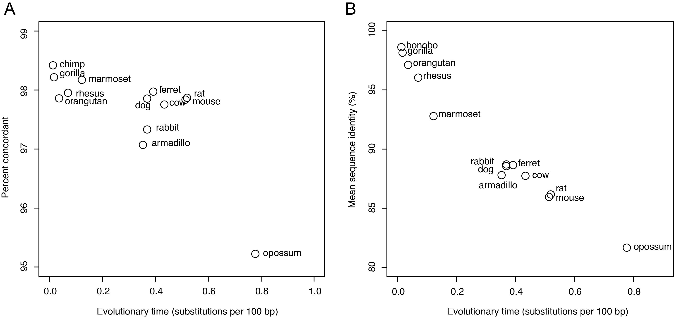

Supplemental Figure S1. Orthology assignments and sequence identity decrease linearly with evolutionary time. (A) Percent concordance (y-axis) between Ensembl-annotated orthologs and orthologs identified using reciprocal-best alignments from tblastx across evolutionary time (x-axis), as estimated by substitutions per 100 bp. (B) Pairwise mean percent sequence identity (y-axis) of Ensembl-annotated orthologs between mammals and human across evolutionary time (x-axis).

Supplemental Figure S2

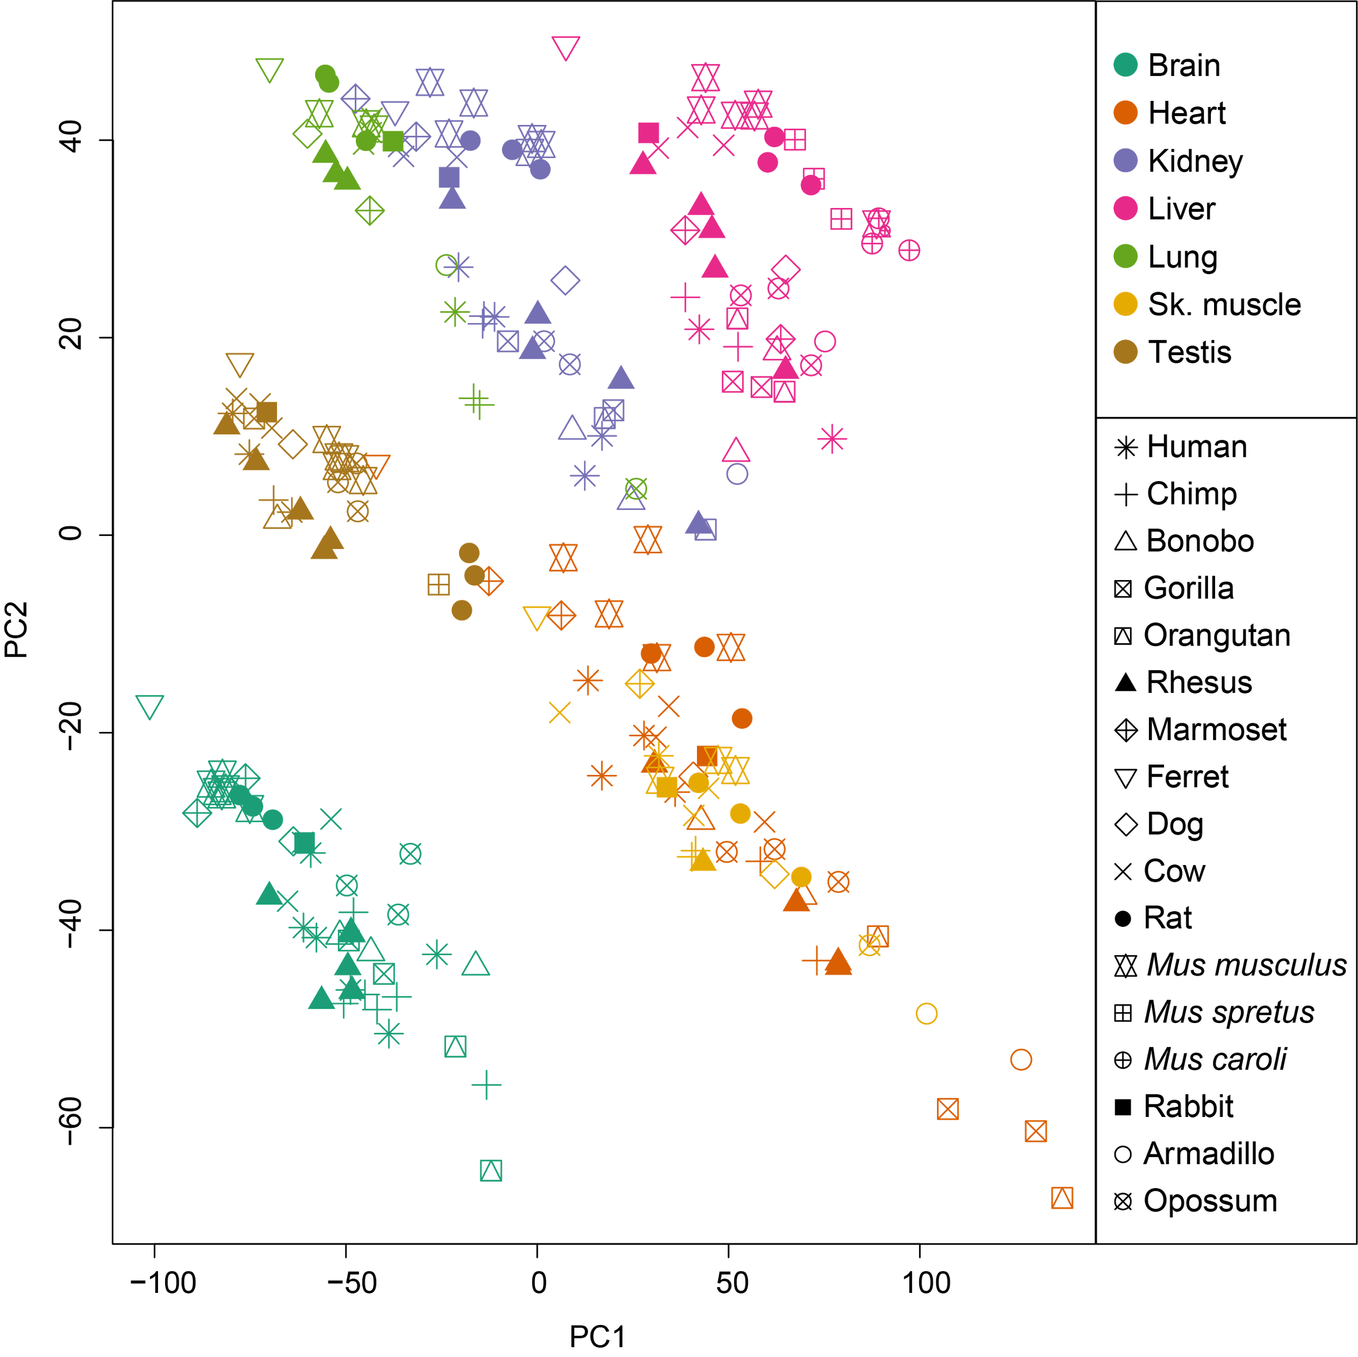

Supplemental Figure S2. RNA profiles partition first by tissue, and then by species. Shown are the first two principal components (PCs) of a principal component analysis (PCA) of expression profiles of all 230 RNA-seq samples across 17 species (symbols) and 7 tissue types (colors).

Supplemental Figure S3
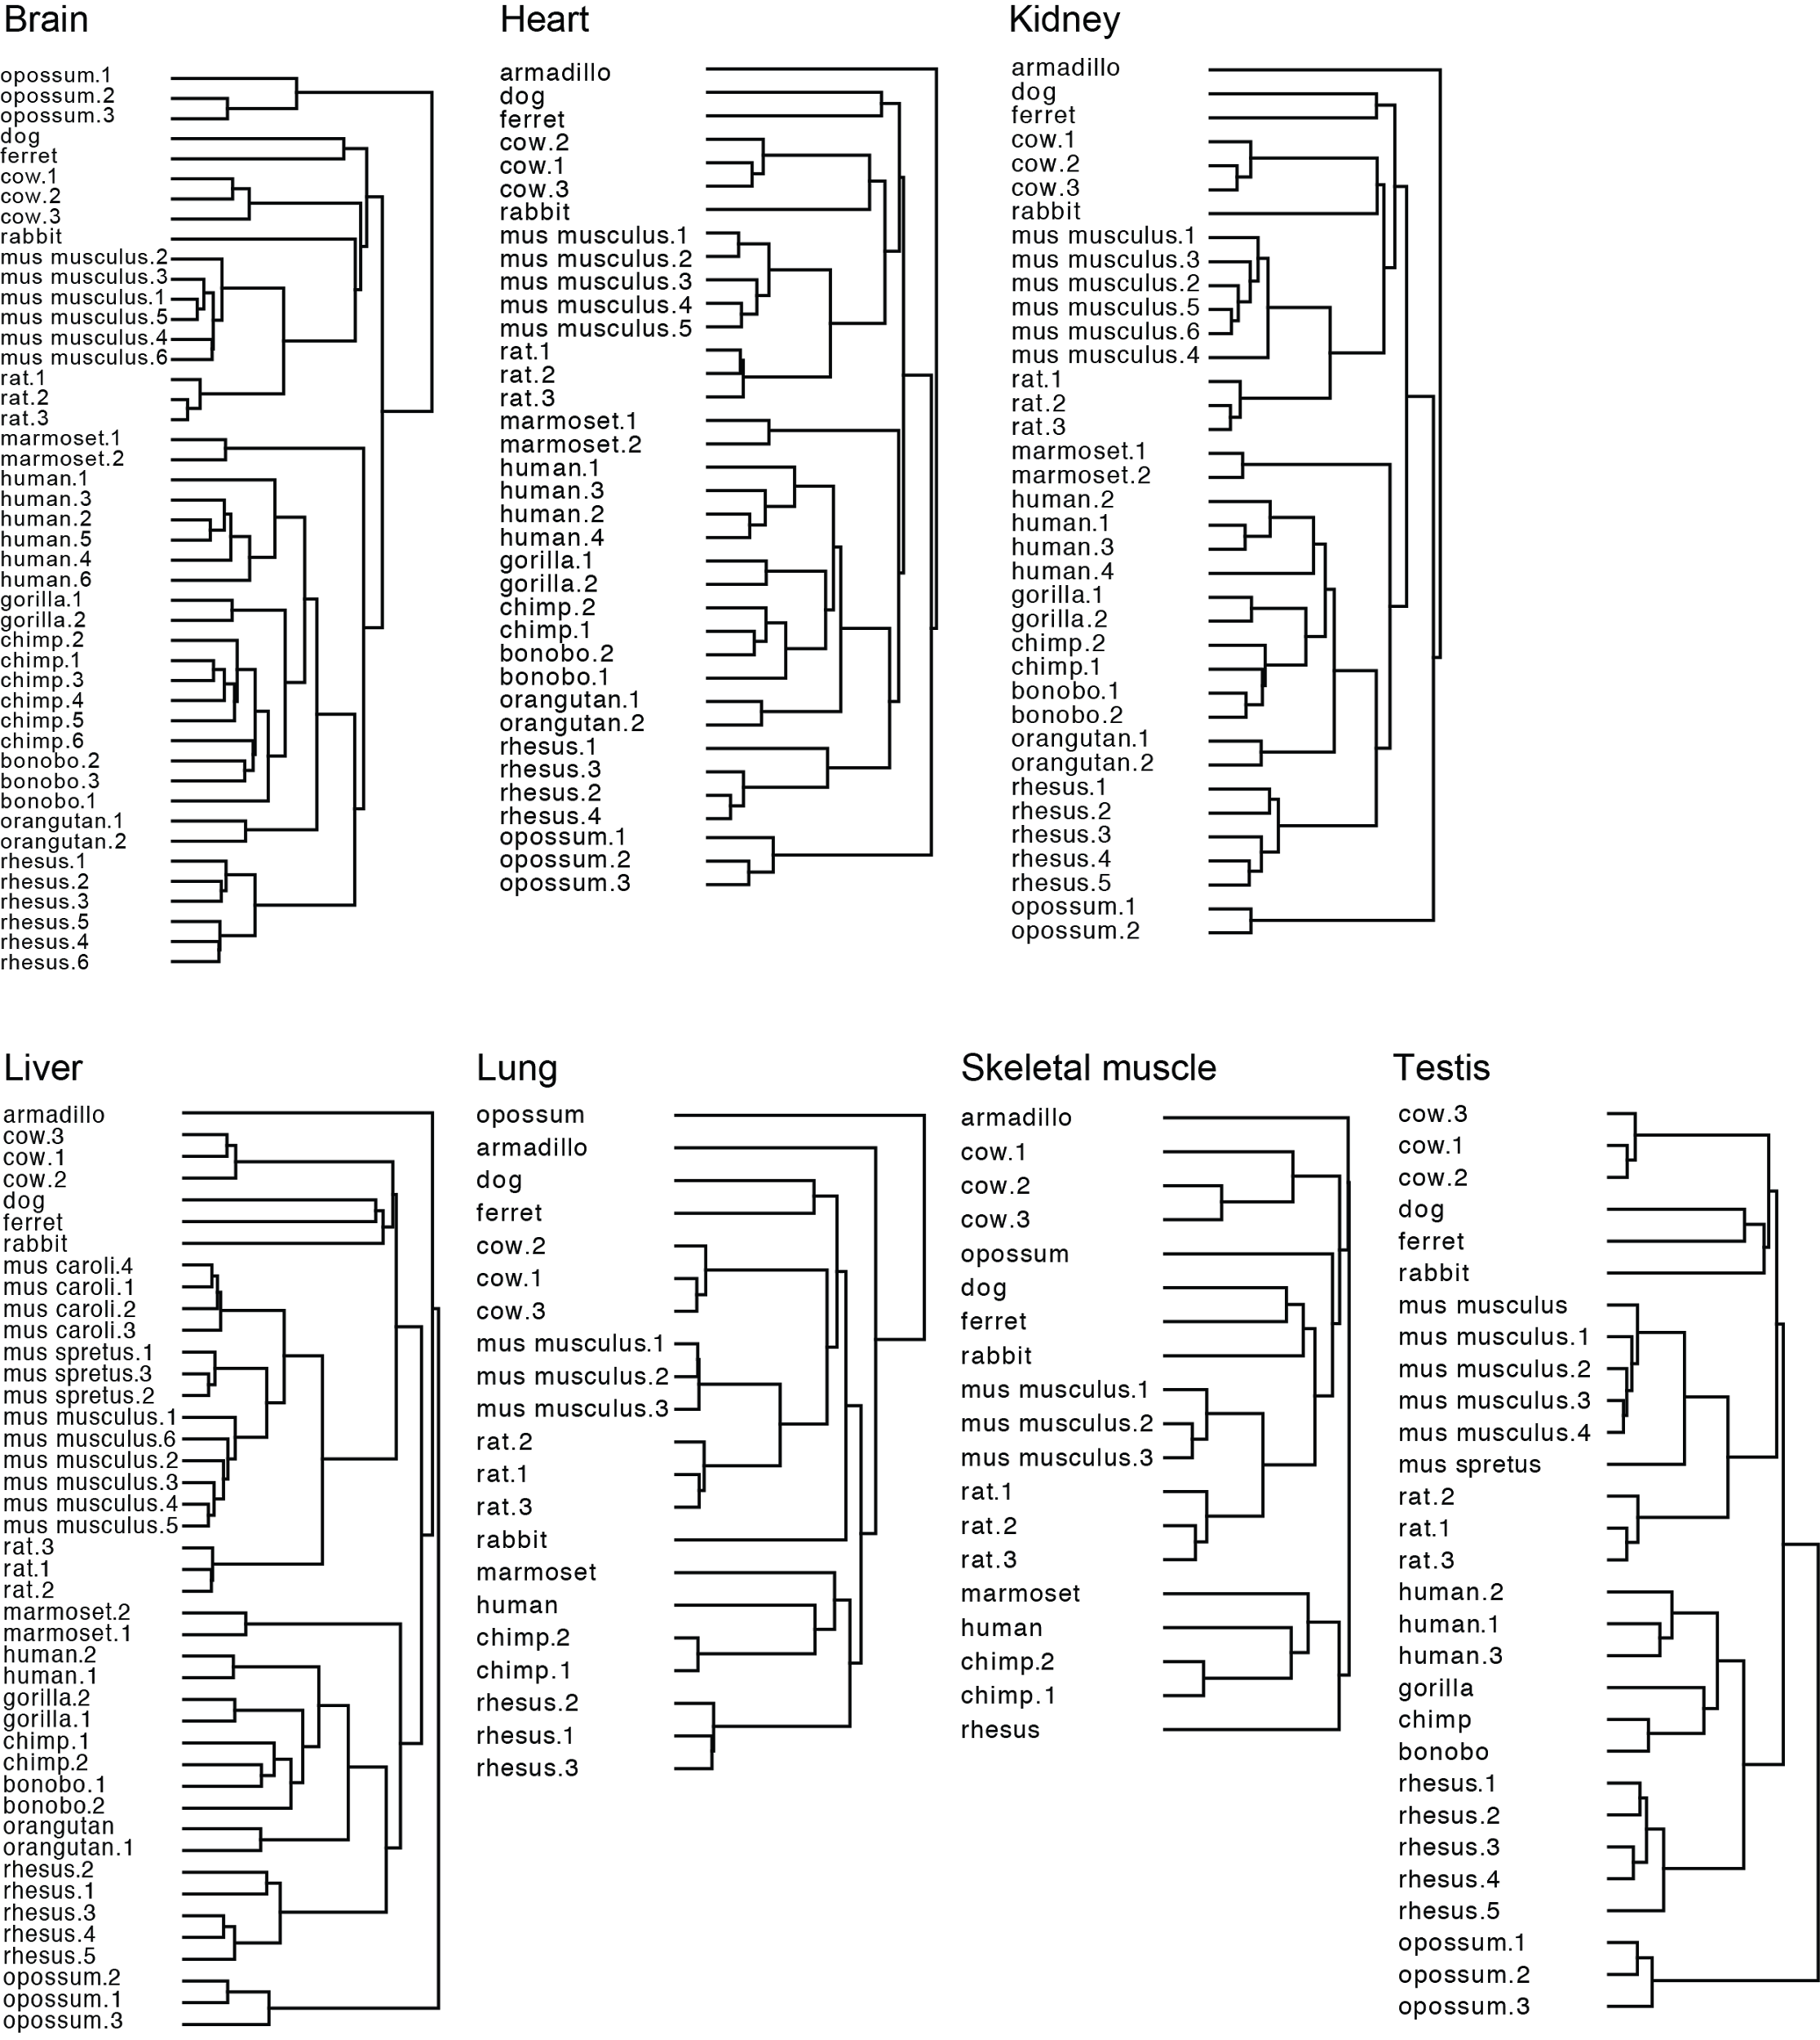

Supplemental Figure S3. Hierarchical clustering of expression within tissues closely matches phylogenetic tree. Dendrograms from hierarchical clustering of gene expression (log₁₀TPM) within each of seven tissue type (label, top) using Pearson’s correlation as the distance metric. See Supplemental Table S1 for detailed information about each sample.

Supplemental Figure S4

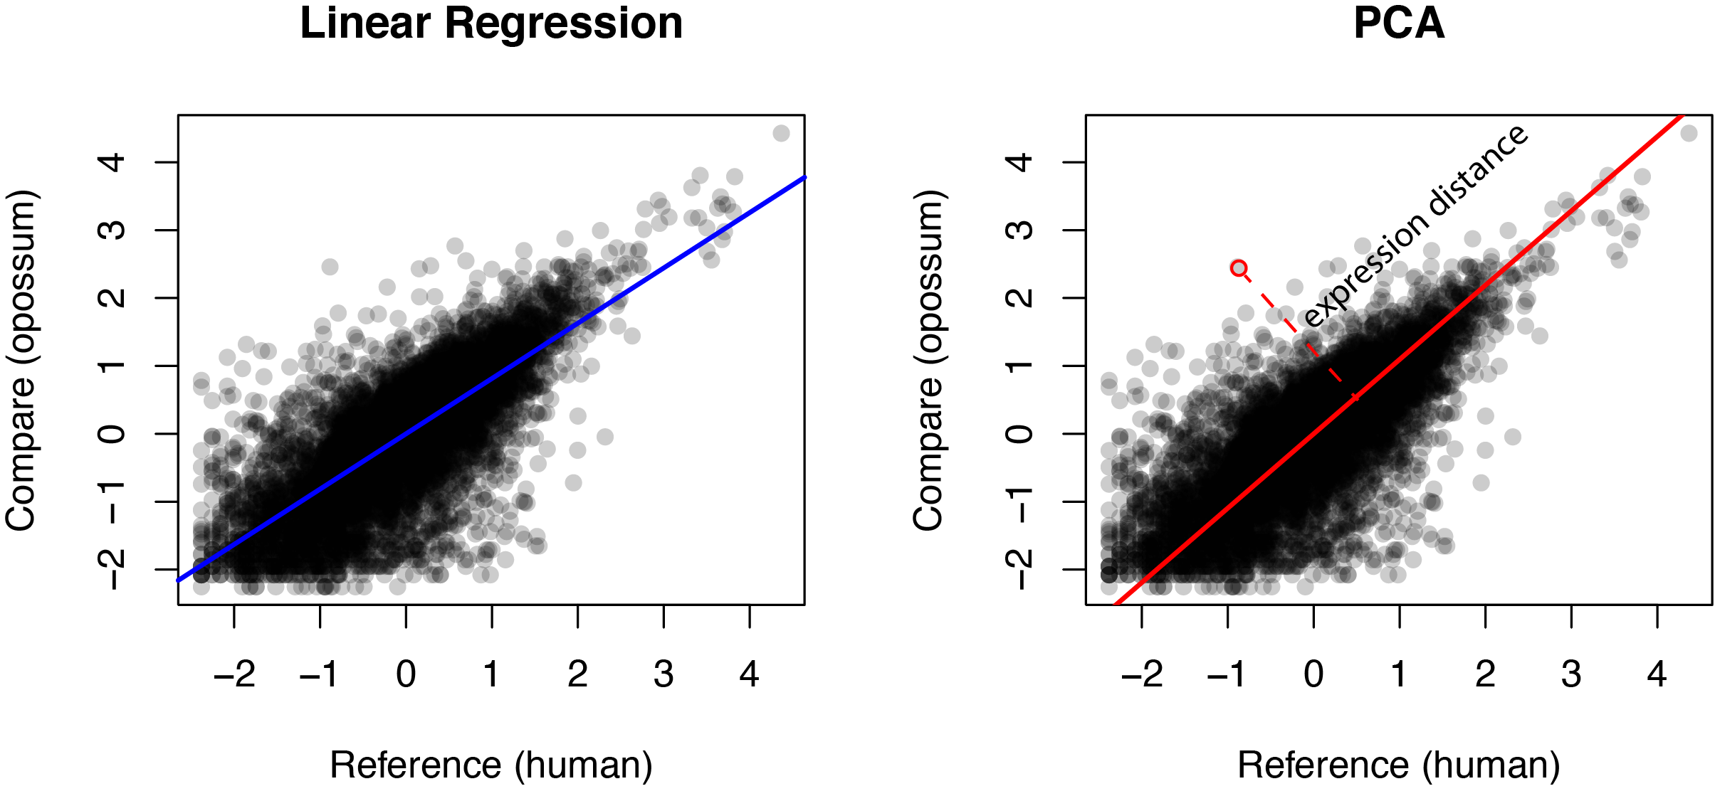

Supplemental Figure S4. Calculation of pairwise expression distance between samples. Illustrative example shows scatter plots of unnormalized expression level of each gene from a human liver sample (x-axis) and an opossum liver sample (y-axis) and the best fit regression line as calculated by a linear regression (left, blue line) and PCA (right, red line). Expression distance is the orthogonal distance from the comparing expression level to the best fit line from PCA (dashed red line, right).

Supplemental Figure S5

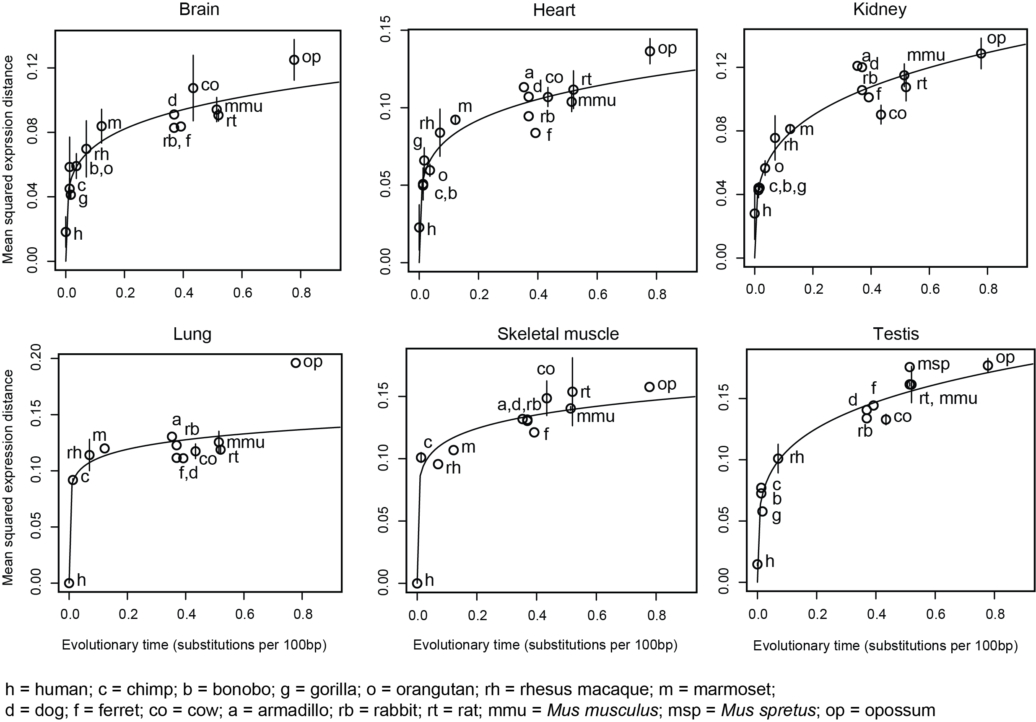

Supplemental Figure S5. Expression evolution across mammalian lineages is accurately modeled by OU process. Pairwise mean squared expression distances (y-axis) between mammals and human for each of six tissue types (label, top) across evolutionary time, as estimated by substitutions per 100 bp (x-axis). Error bars: standard deviation of the mean across replicates. Solid line: Nonlinear (y = ax^{k}) regression fit. Bonobo, gorilla, and orangutan data are not available for lung and skeletal muscle.

Supplemental Figure S6
A
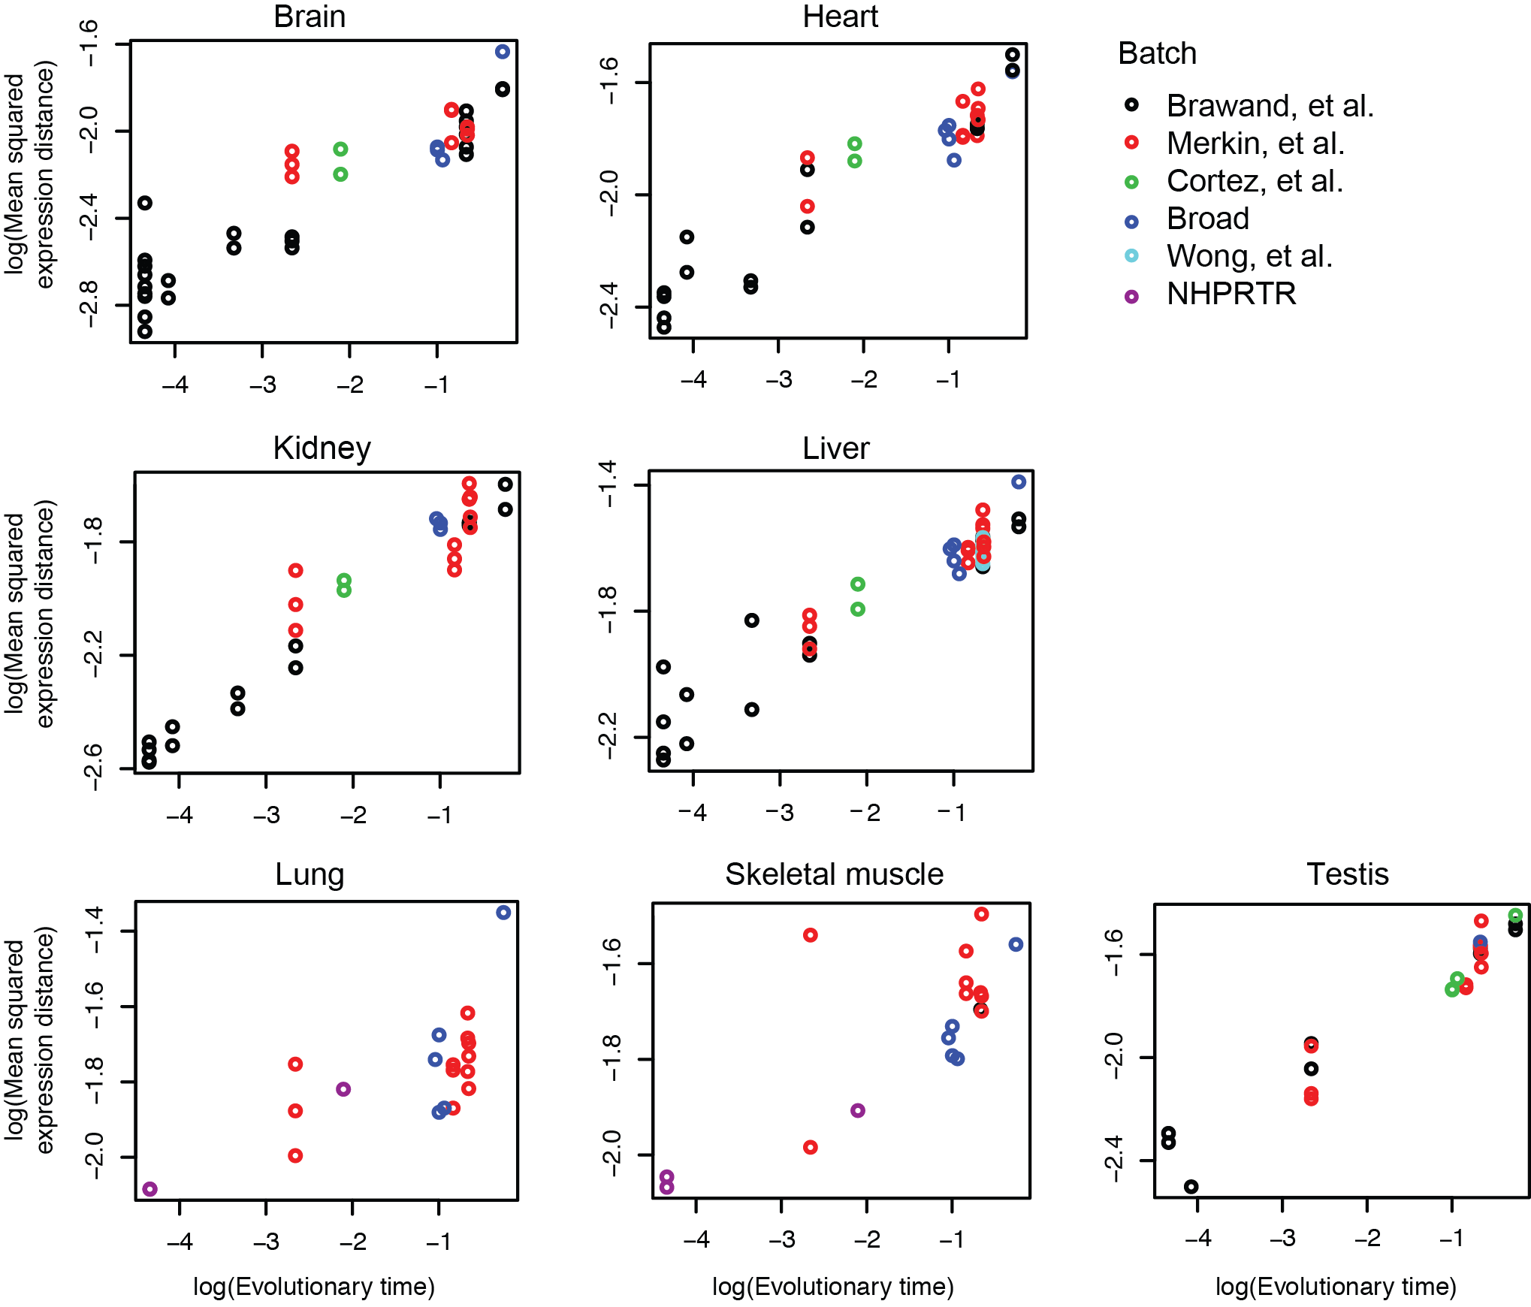
B
 | % variance explained by… |  | Total R²
 | batch | + evolutionary distance
Brain | 29.6% | 58.3% | 87.9%
Heart | 29.0% | 61.7% | 90.7%
Kidney | 34.6% | 61.0% | 95.0%
Liver | 35.6% | 56.3% | 91.9%
Lung | 32.6% | 24.4% | 57.0%
Skeletal muscle | 56.7% | 11.0% | 67.7%
Testis | 14.3% | 79.8% | 94.2%

Supplemental Figure S6. Power-law relationship of expression evolution is not driven by batch effects. (A) Log-log plots of pairwise mean squared expression distances (y-axis) between each sample and mean human expression for each of seven tissue types (label, top) across evolutionary time, as estimated by substitutions per 100 bp (x-axis). Color: batch of data. (B) Percent variance of log(mean squared expression distance) explained by log(evolutionary distance) (second column), in a linear regression, after controlling for batch (first column).

Supplemental Figure S7

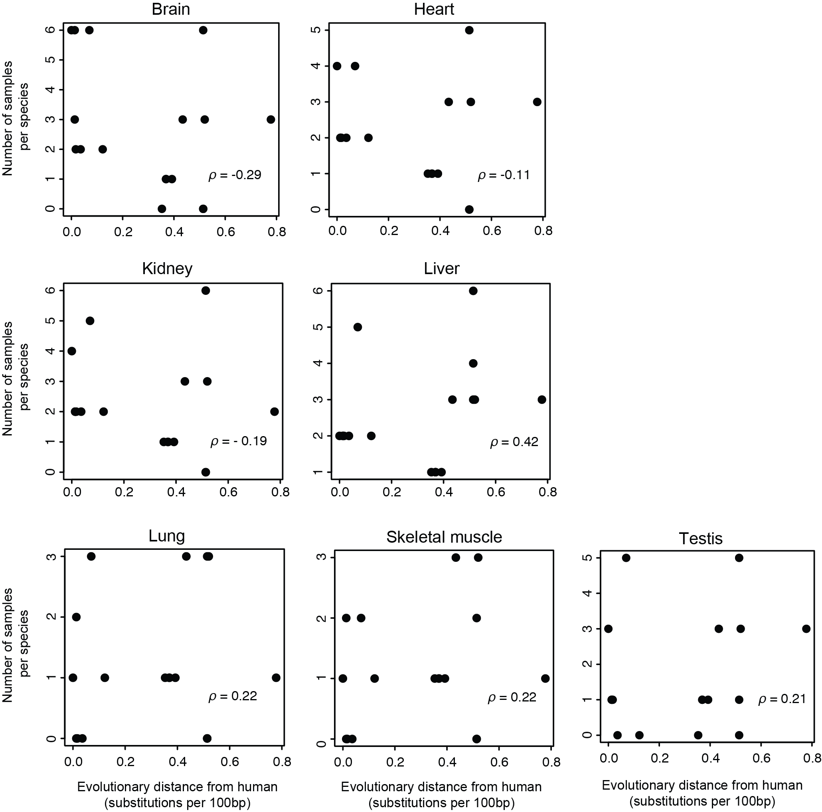

Supplemental Fig S7. Power-law relationship of expression evolution is not driven by bias in the number of samples. Scatterplot of number of individual samples available for each species (y-axis) across evolutionary time, as estimated by substitutions per 100 bp (x-axis) for each of seven tissue types (label, top). Spearman’s correlation (ρ) is listed in each plot.

Supplemental Figure S8
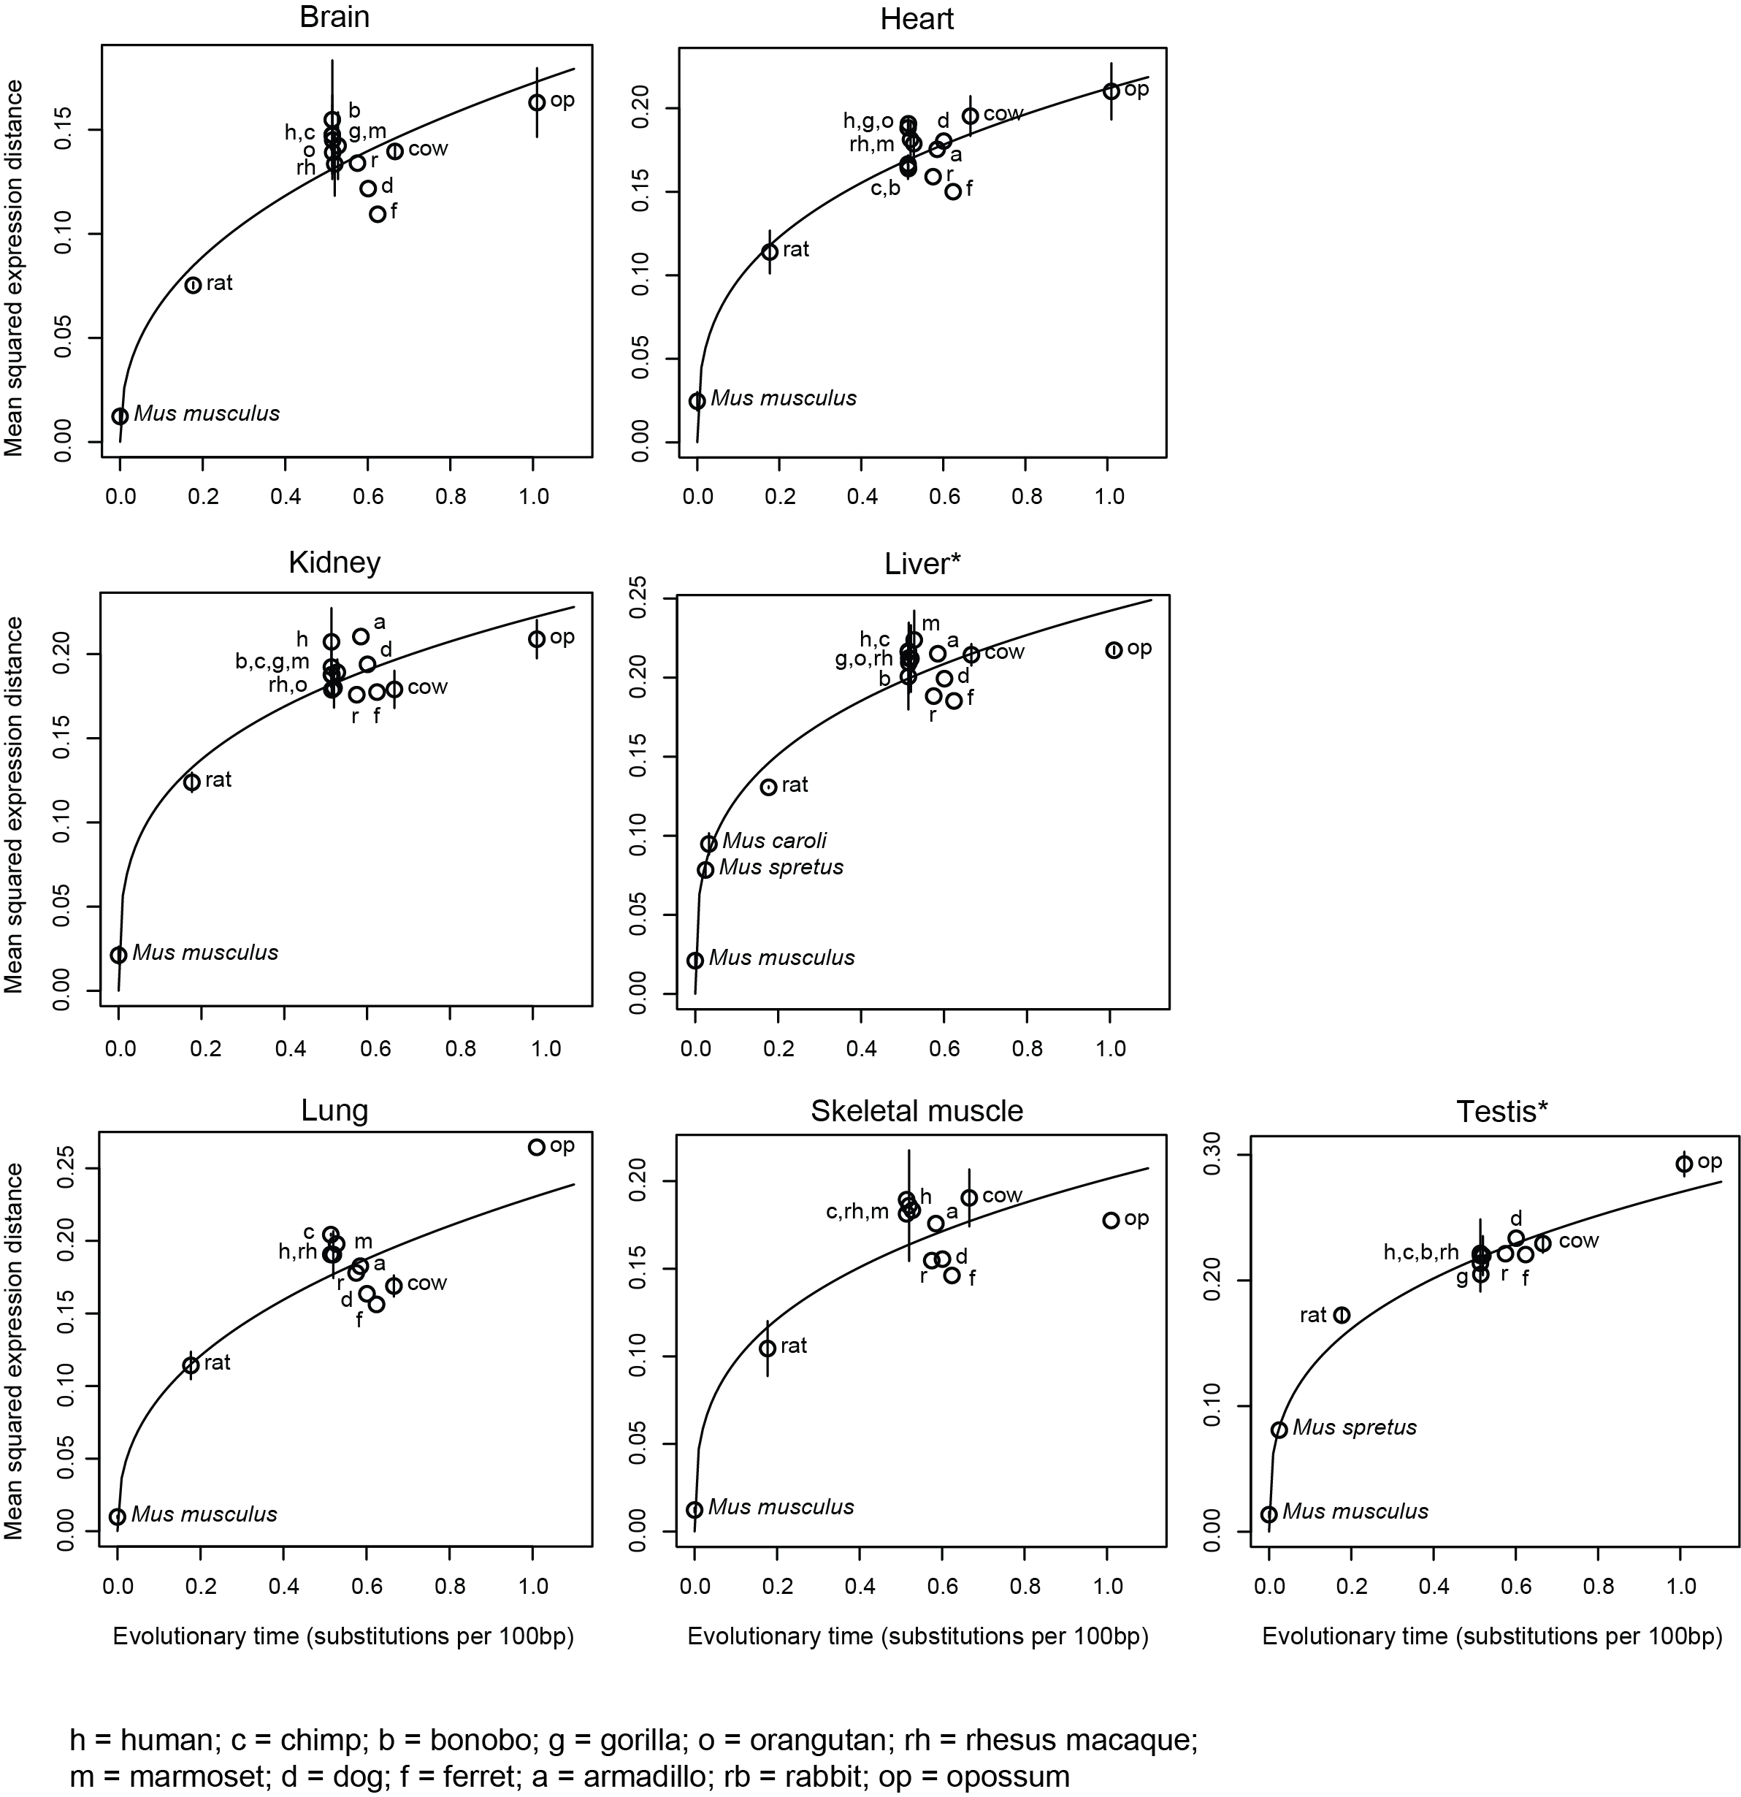

Supplemental Figure S8. Expression shows saturation in evolution, regardless of reference species. Shown are the pairwise mean squared expression distances (y-axis) between mammals and mouse for each of seven tissue types (label, top) across evolutionary time, as estimated by substitutions per 100 bp (x-axis). Error bars: standard deviation of the mean across replicates. Solid line: Nonlinear (y = ax^{k}) regression fit. Asterix denotes tissues where nonlinear regression fit results in higher R² than linear regression fit (see Supplemental Fig. S9).

Supplemental Figure S9

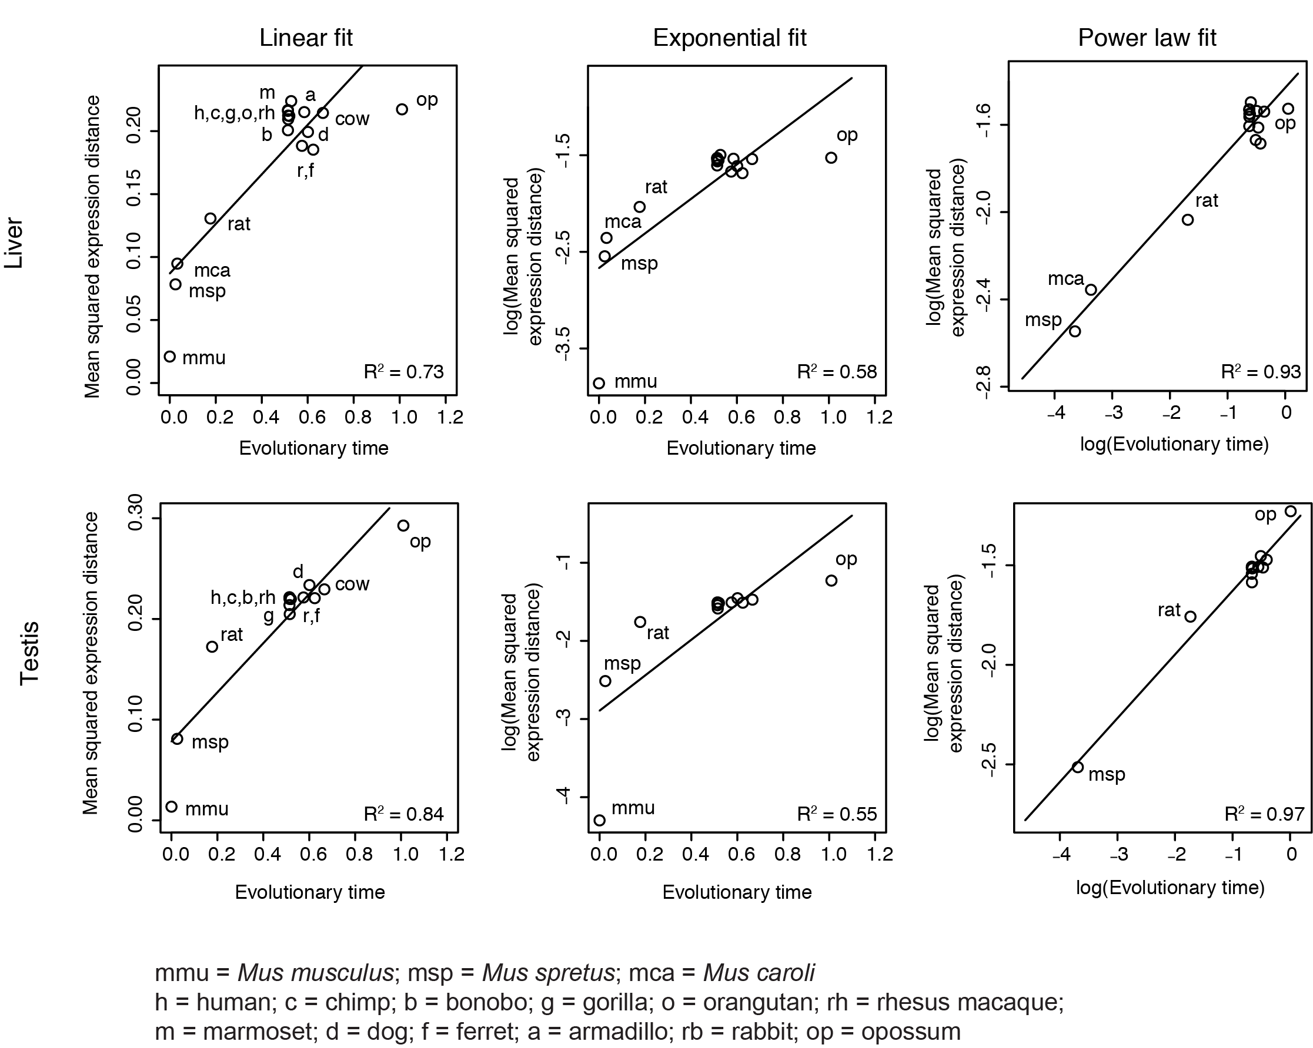

Supplemental Figure S9. Expression distance is accurately modeled by an OU process, regardless of reference species. Shown are mean squared expression distances (y-axis) between mammals and mouse for liver and testis across evolutionary time (x-axis) under a linear (left), exponential (logged y-axis, middle), or power law (logged y- and x-axis, right) fit. Solid line indicates linear (y = ax) (left), exponential (y = k^{x}) (middle), or power law (y = ax^{k}) (right) regression fit. R² of each fit is shown in plots.

Supplemental Figure S10
A
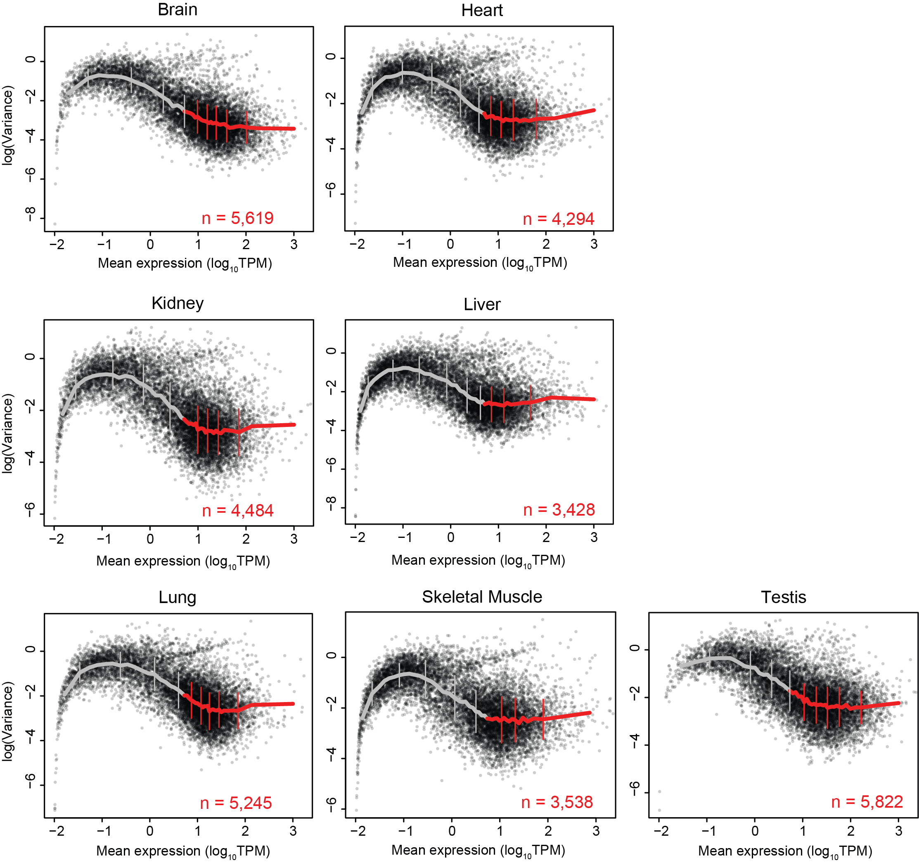
B
 |  | Brain | Heart | Kidney | Liver | Lung | Sk.  Muscle | Testis
Genes > 5 TPM | Number of genes | 5,619 | 4,294 | 4,484 | 3,428 | 5,245 | 3,538 | 5,822
Genes > 5 TPM | Pearson’s correlation between log(variance) and expression | -0.26 | -0.007 | -0.05 | 0.08 | -0.12 | 0.08 | -0.19

Supplemental Figure S10. Lowly expressed genes have high estimates of evolutionary variance. (A) Scatterplots show mean expression (x-axis, log₁₀TPM) and log(evolutionary variance) (y-axis) for each gene as estimated from OU model in each of 7 tissue types (label, top). Mean expression was binned into bins of 250 genes, and mean variance for each bin is shown in solid lines (grey/red: genes with expression lower/higher than 5 TPM). Error bars: standard deviation of the mean. (B) Number of genes expressed higher than 5 TPM in each tissue and Pearson’s correlation between evolutionary variance and expression for those genes.
Supplemental Figure S11

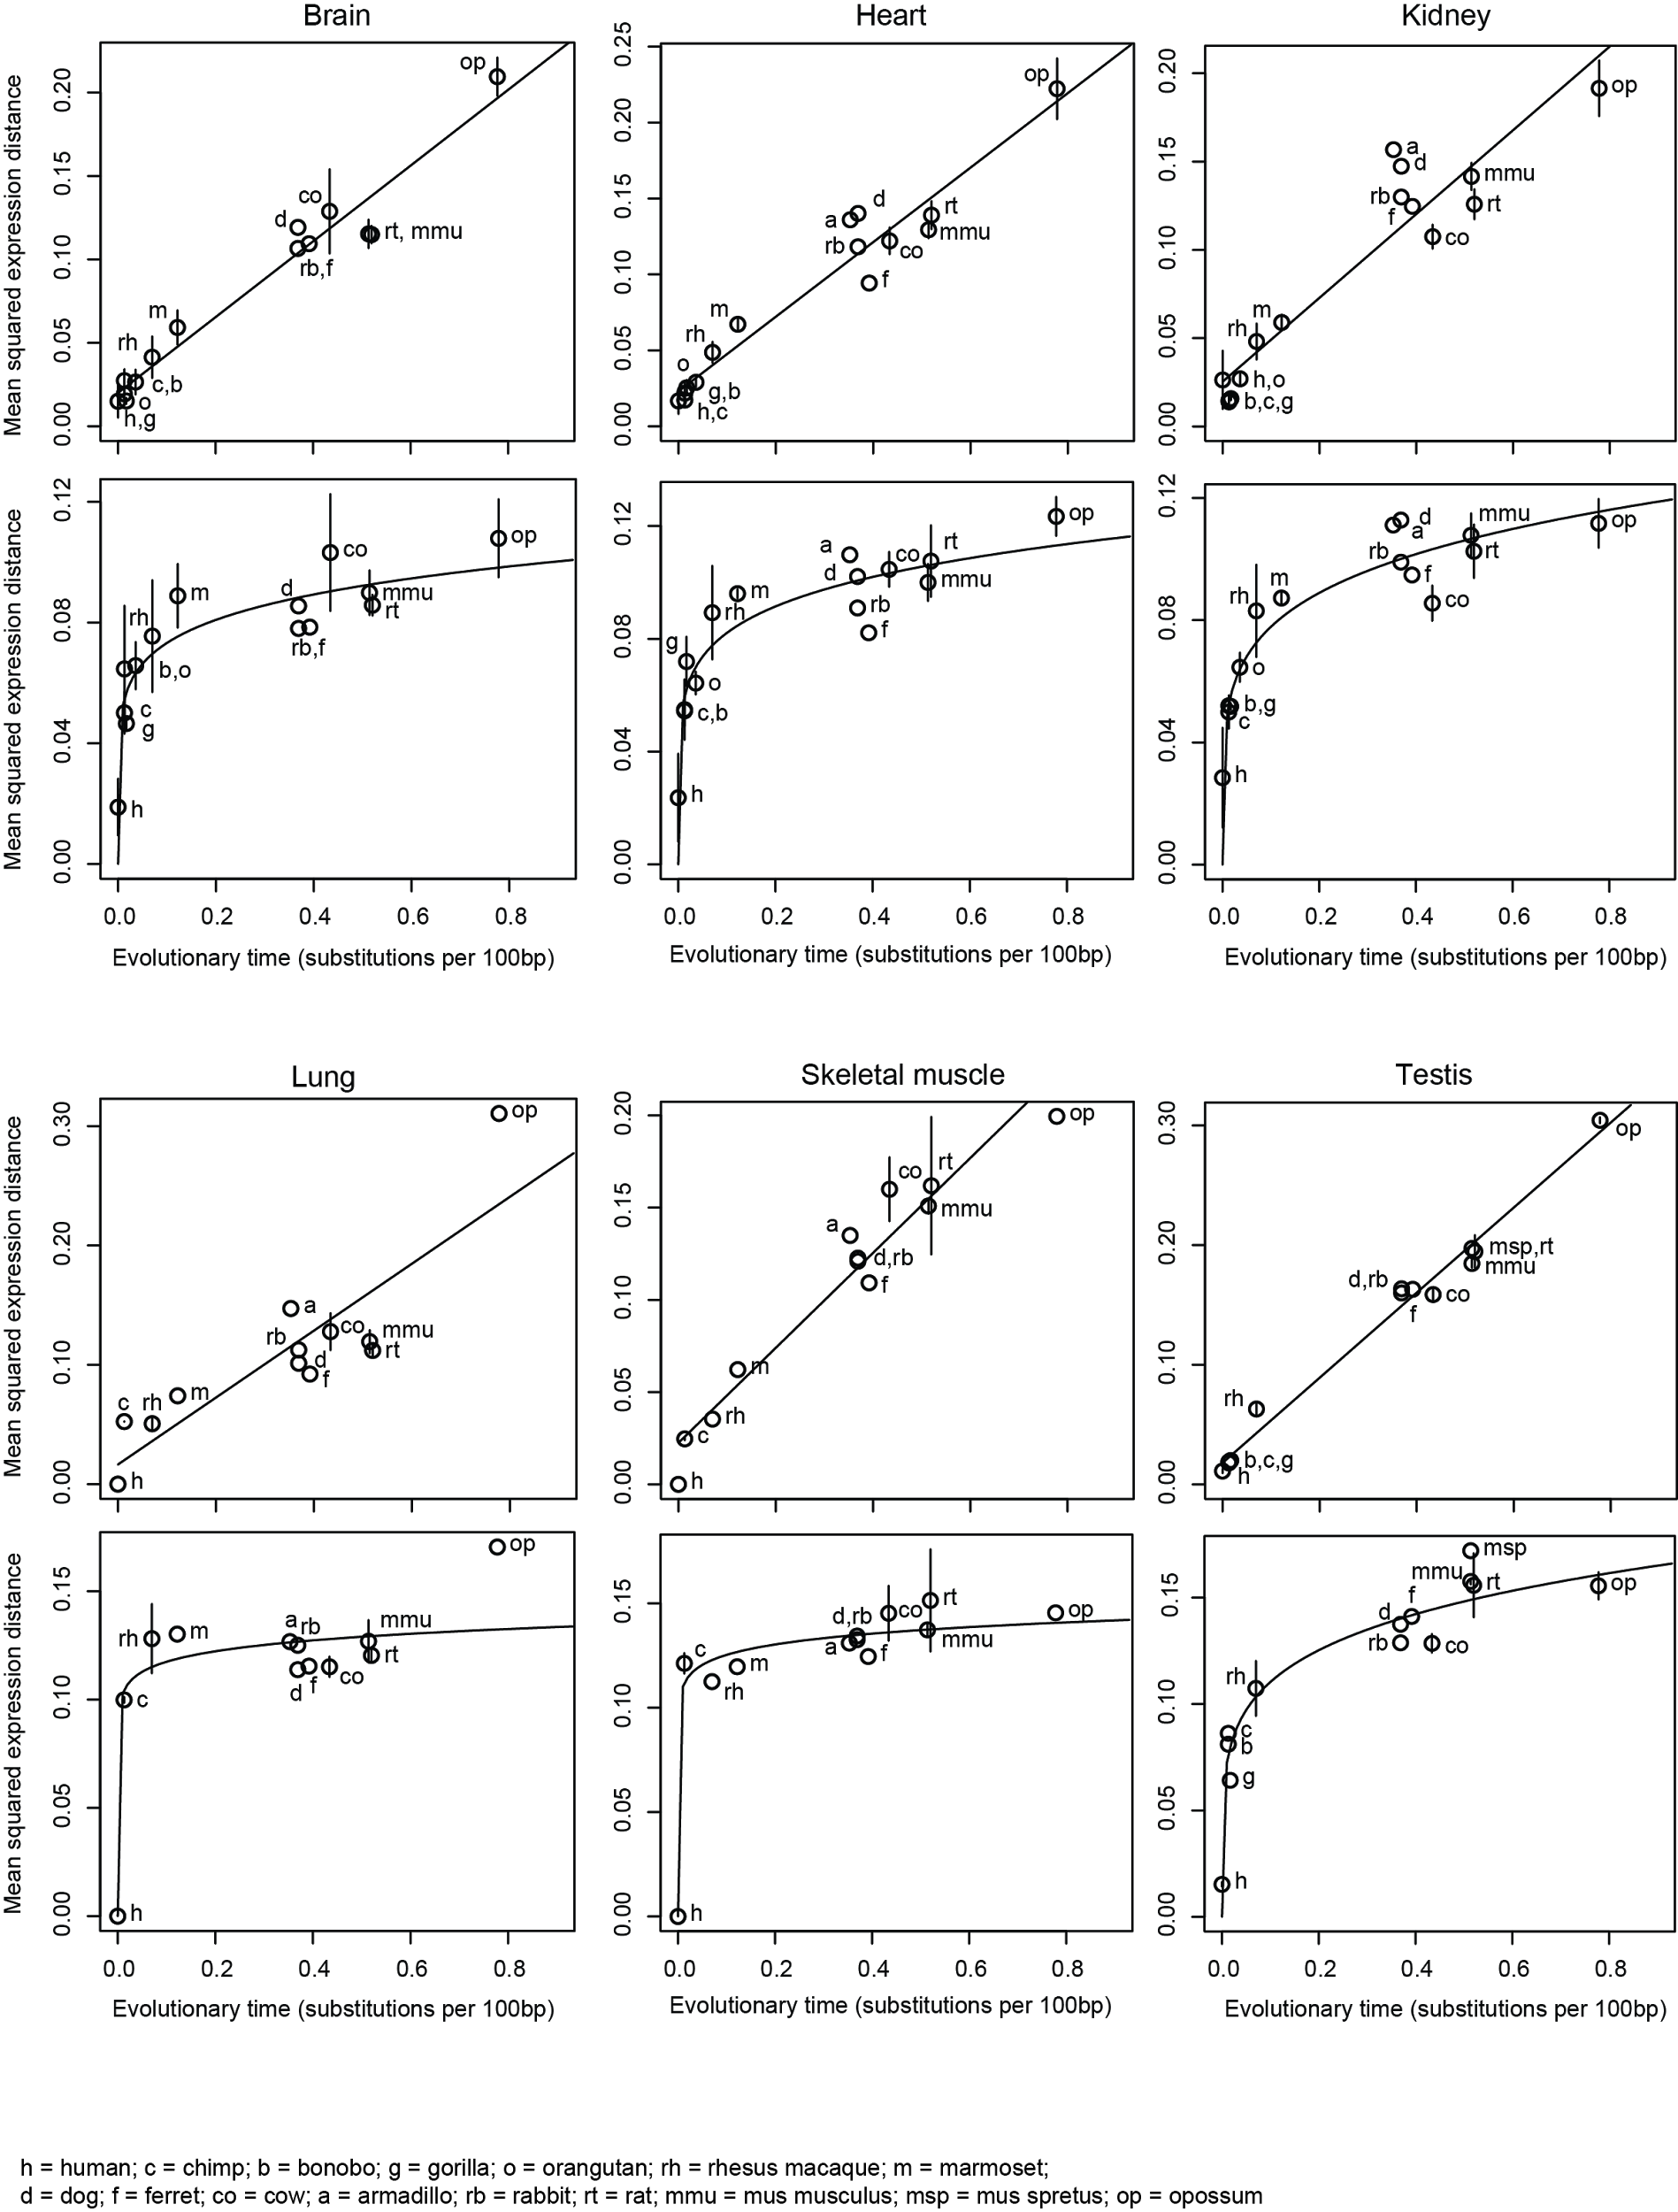
Supplemental Figure S11. Modeling expression evolution by the Ornstein-Uhlenbeck process enables quantification of neutral and constrained selection on gene expression. Shown are the pairwise mean squared expression distances (y-axis) between mammals and human for each of six tissue types (label, top) across evolutionary time, as estimated by substitutions per 100 bp (x-axis), separately for genes whose expression evolution fits better under a BM process (i.e. neutral evolution, top) and for genes whose expression evolution fits better an OU process (i.e. presence of stabilizing selection, bottom). Solid lines: Linear regression fit for BM genes and nonlinear regression fit for OU genes.

Supplemental Figure S12
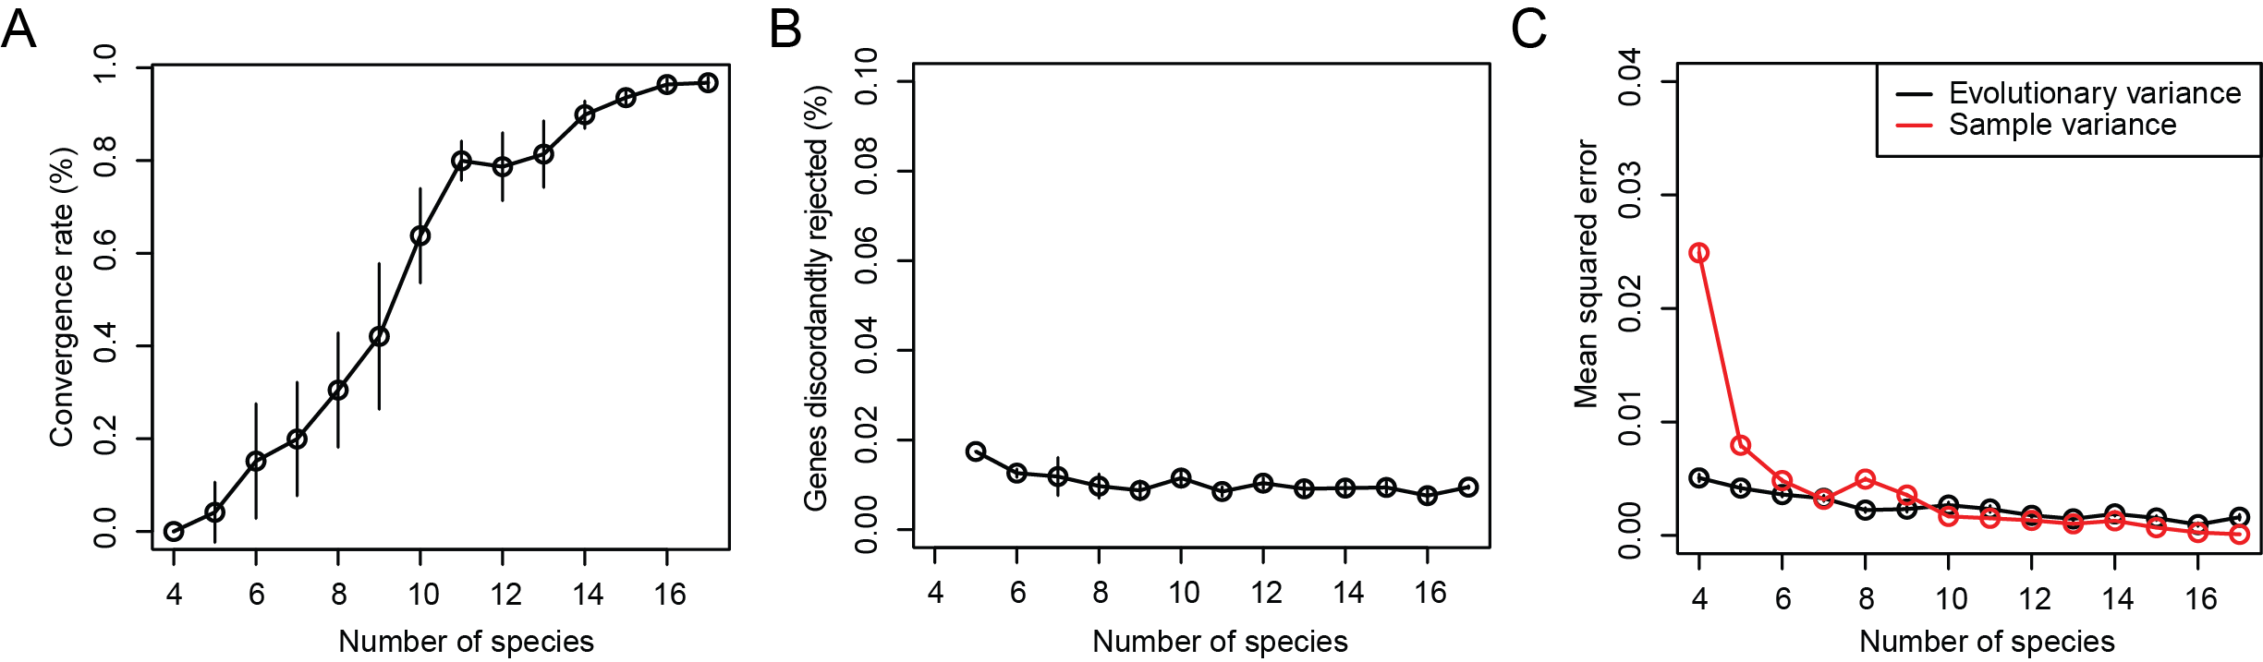

Supplemental Figure S12. The Ornstein-Uhlenbeck process is a robust model for expression evolution. (A) Convergence with increased number of species. Percent of genes that reject the null hypothesis (BM process) (y-axis) when tested based on increasing number of species (x-axis) in the phylogeny, out of genes rejecting the null hypothesis when using the full phylogeny. Error bars: standard deviation of the mean across 10 iterations of sampled phylogenies. (B) Few genes are discordantly rejected. Percent of genes (y-axis) that reject the null hypothesis when using a sub-set of species (x-axis), but not when using all 17 species. Error bars: standard deviation of the mean across 10 iterations of sampled phylogenies. (C) Robustness of expression variance estimation. Mean squared error of variance estimated from OU model (black) or directly from the sample (red) based on increasing number of species (x-axis), compared to the variance was defined from results using the full phylogeny. Error bars: standard deviation of the mean across 10 iterations of sampled phylogenies.

Supplemental Figure S13

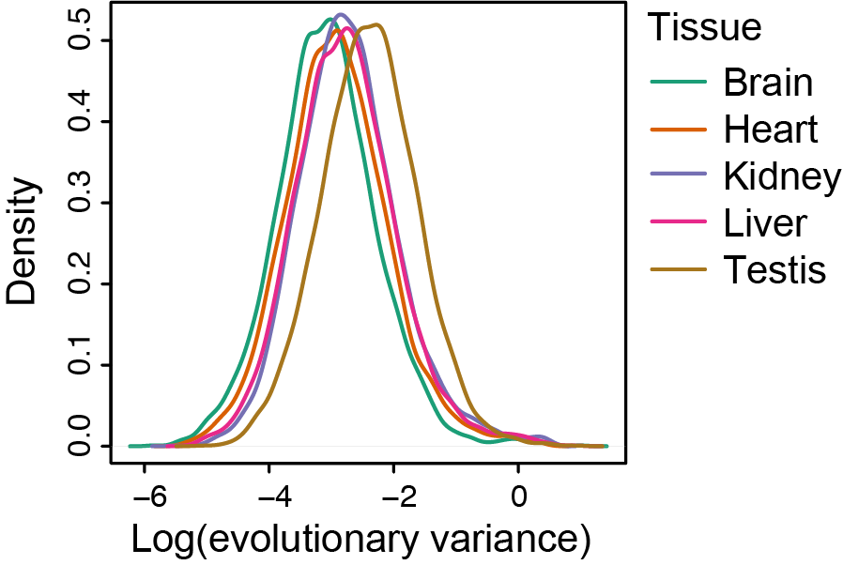

Supplemental Figure S13. Evolutionary variance is most constrained in brain and least in testis. Density plots of log(evolutionary variance) for all genes in each of 7 tissue types.

Supplemental Figure S14
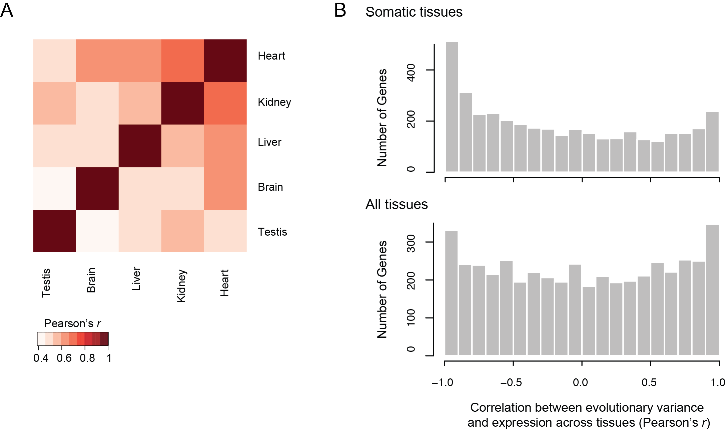

Supplemental Figure S14. Evolutionary variance is correlated across tissues and negatively correlated with expression level. (A) Correlation of evolutionary variance across tissues. Heatmap of Pearson’s correlation coefficient of evolutionary variance estimates for all expressed genes (> 5 TPM) between each pair of tissues. (B) Correlation between evolutionary variance and expression level. Histogram shows the distribution of Pearson’s correlation coefficients between variance and expression across only somatic tissues (top) and across all tissues (bottom; includes testes). Only variance and expression values for genes expressed at > 5 TPM in three or more tissues were used for this analysis.

Supplemental Figure S15

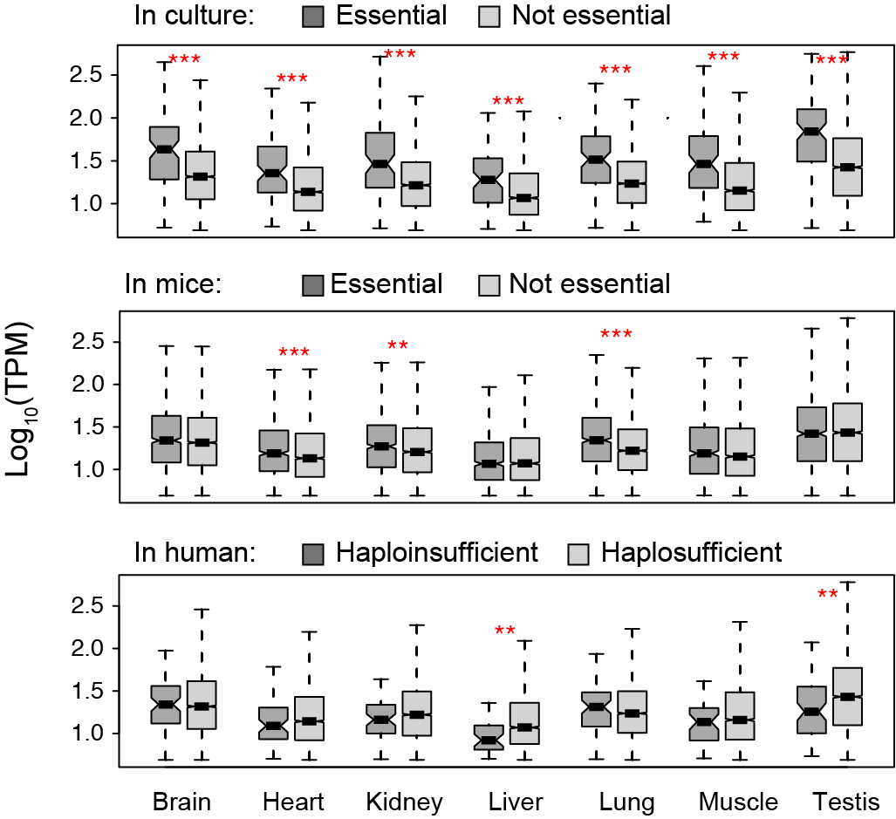

Supplemental Figure S15. Lower evolutionary variance of essential and haploinsufficient genes are not driven by expression differences. Boxplots show the distribution of evolutionary mean expression levels in log₁₀TPM (y-axis) of genes essential in culture (top), essential in mice (middle), and haploinsufficient in human (bottom) (dark gray), and their non-essential or haplosufficient counterparts (light gray) in each of 7 tissues (x-axis). *** p < 0.001; ** p < 0.01.

Supplemental Figure S16

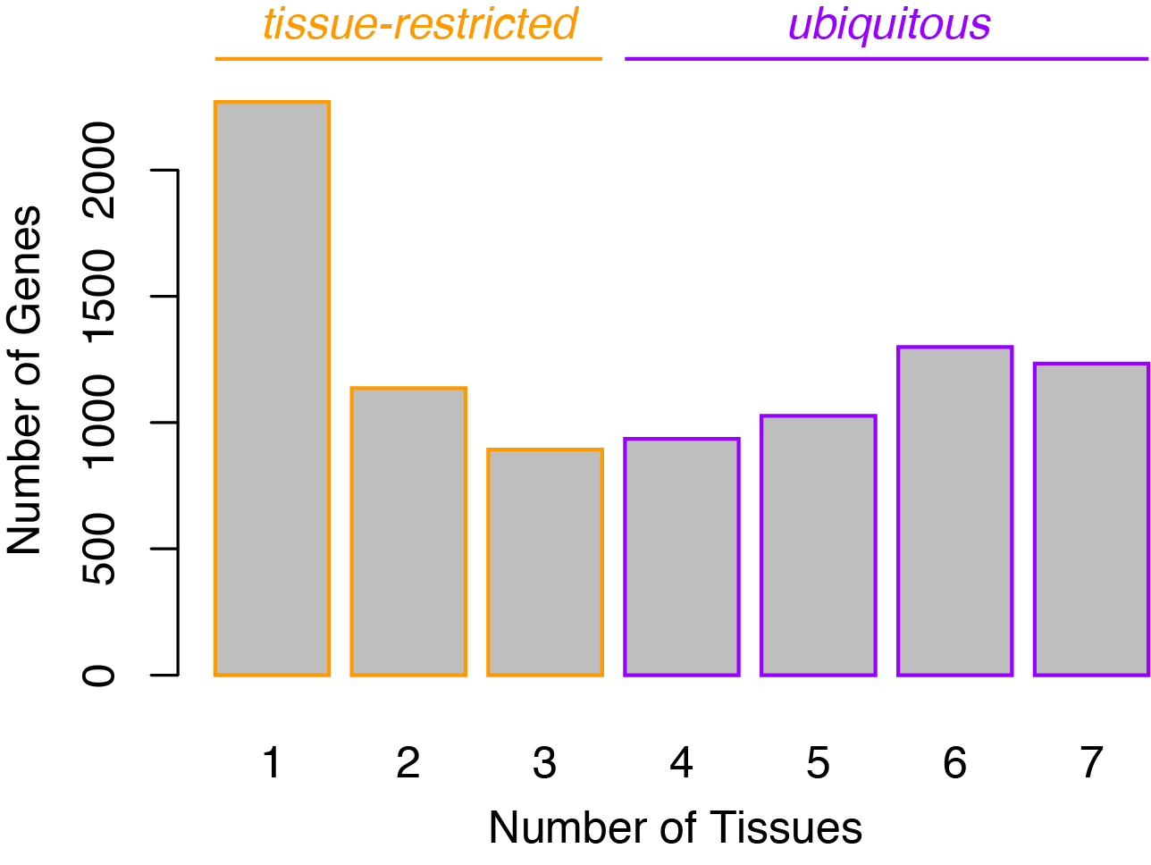
Supplemental Figure S16. Distribution of number of tissues in which genes are expressed. Histogram of the number of genes (y-axis) highly expressed (> 5 TPM) across tissues used in this study. Genes expressed in three or fewer tissues were defined to be tissue-restricted.

Supplemental Figure S17

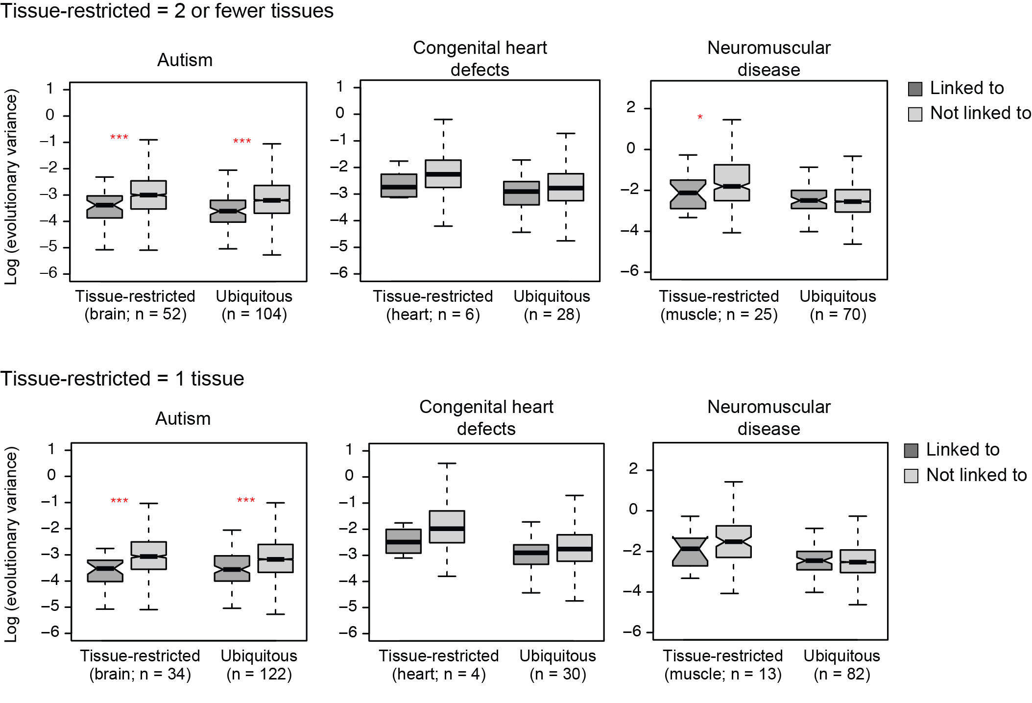

Supplemental Figure S17. Disease genes with tissue-restricted expression profiles have lower evolutionary variance, regardless to the choice of cutoff for defining “tissue-restricted”. Boxplots show the distribution of log(evolutionary variance) (y-axis) of genes linked (dark gray) and not linked (light gray) to high-penetrance monogenic autism spectrum disorder (left), congenital heart defects (middle), and neuromuscular disease (right) in the relevant tissue (brain, heart, and muscle, respectively). Results are shown separately for genes that are restricted in expression (left boxes) or ubiquitously expressed (right boxes) using two different cutoffs to define “tissue-restricted” (top: > 5 TPM in 2 or fewer tissues; bottom: > 5 TPM in 1 tissue). *** p < 0.001; ** p < 0.01; * < 0.05.

Supplemental Figure S18

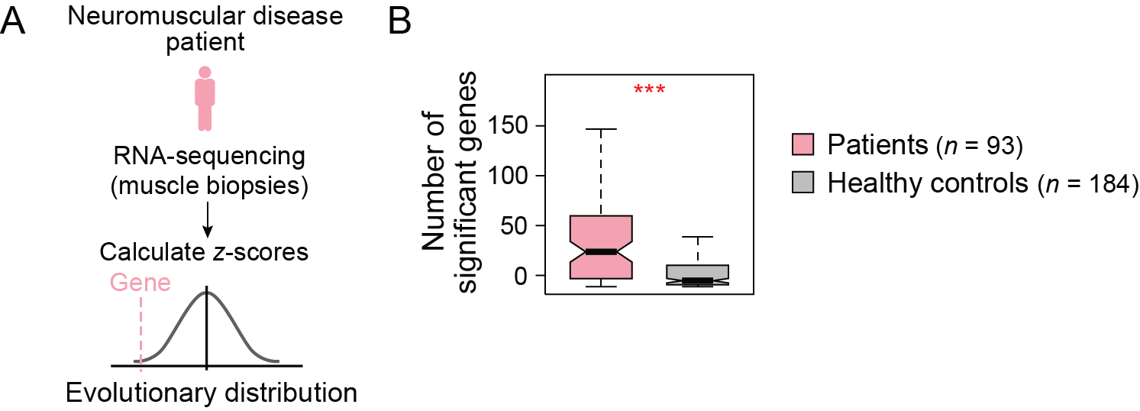

Supplementary Figure S18. Using evolutionary distributions or GTEx RNA-seq distributions to identify outlier gene expression from RNA-seq of muscular dystrophy patients. (A) Overview of using evolutionary distributions to identify outlier gene expression in RNA-seq of patient muscle biopsies. (B) Boxplot of the number of genes with significant z-scores (FDR < 0.01) from neuromuscular patient data (pink) and from healthy controls (gray). *** p < 0.001.

Supplemental Figure S19

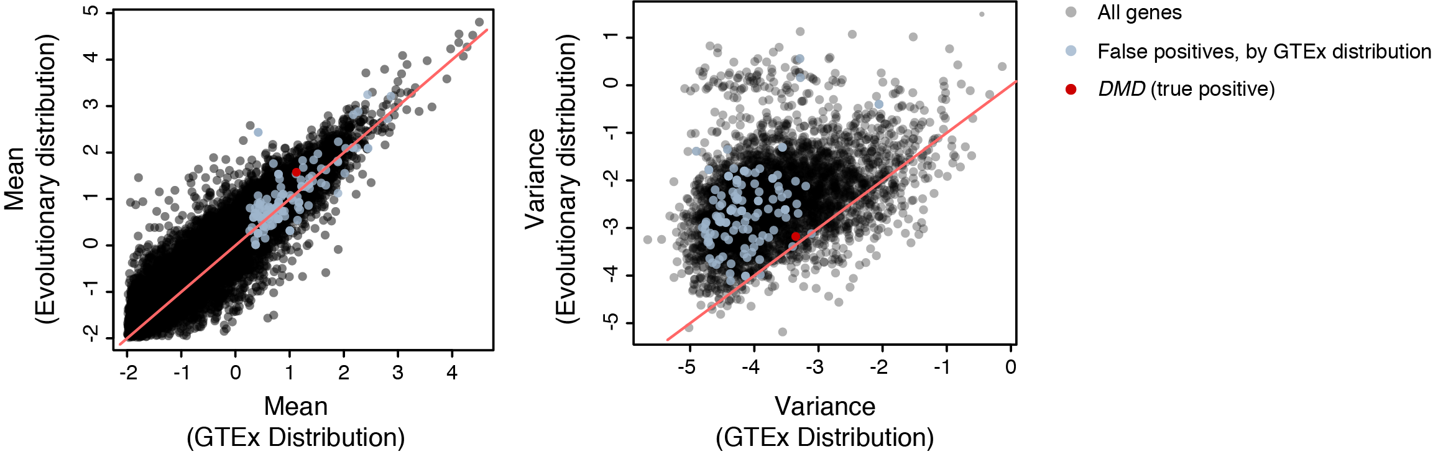

Supplemental Figure S19. Healthy range of gene expression is more accurately estimated with evolutionary distributions. Scatterplots of mean (left) and variance (right) of gene expression in healthy skeletal muscle as estimated by distribution of gene expression in healthy individuals in GTEx (x-axis) and by evolutionary distributions (y-axis). Pink line: y = x. Genes falsely nominated (i.e., scored as significantly aberrantly expressed) as DMD disease genes by GTEx distributions are shown in light blue; DMD (causal disease gene) is shown in red.

Supplemental Figure S20

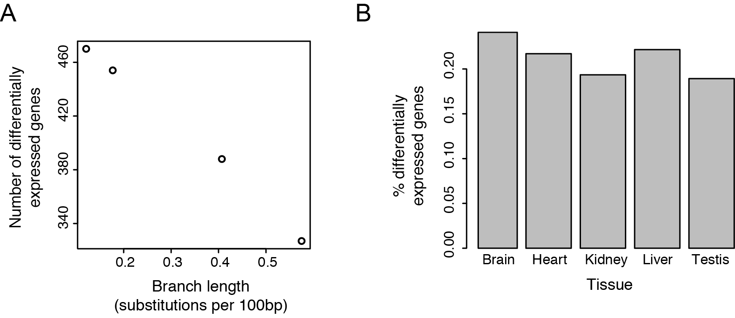

Supplemental Figure S20. Number of differentially expressed genes within a clade decreases with evolutionary span of the clade, regardless of tissue type. (A) Number of differentially expressed genes (y-axis) in liver samples shared across clades of varying branch lengths (x-axis). (B) Percent differentially expressed genes of all expressed genes (y-axis) within the primate clade (human, chimp, bonobo, gorilla, rhesus) across each of 5 tissue types (x-axis), when using a dataset matched for number of samples across tissues.

Supplemental Figure S21
A
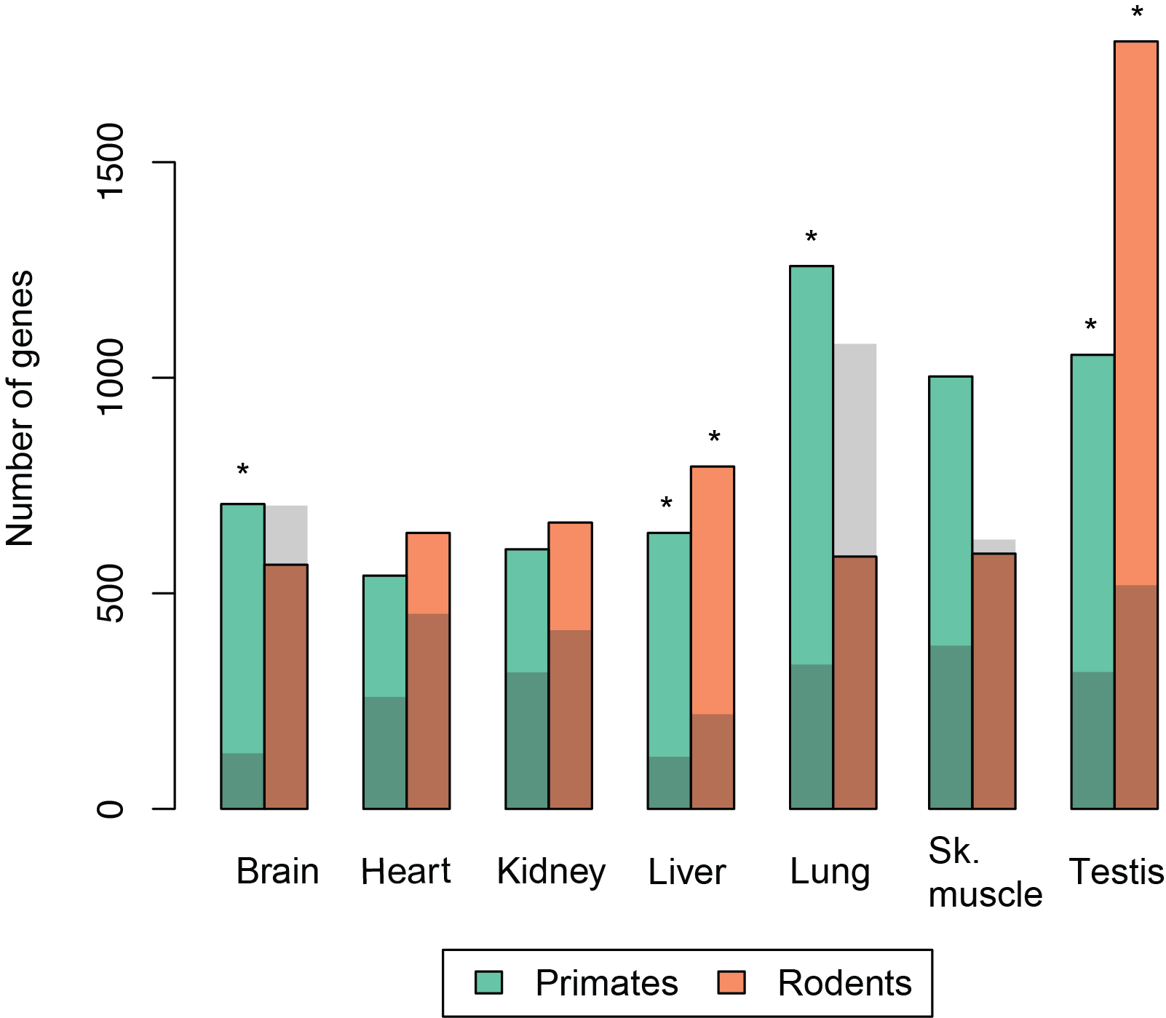

B
 | Primates |  |  | Rodents
 | # of species  in clade | # of comparing  species | Enrichment | # of species  in clade | # of comparing  species | Enrichment
Brain | 7 | 7 | 5.7* | 2 | 12 | 0.8
Heart | 7 | 8 | 2.1 | 2 | 13 | 1.4
Kidney | 7 | 8 | 1.9 | 2 | 13 | 1.6
Liver | 7 | 10 | 5.5* | 4 | 13 | 3.7*
Lung | 4 | 8 | 3.8* | 2 | 10 | 0.5
Sk. Muscle | 4 | 8 | 2.7 | 2 | 10 | 1.0
Testis | 5 | 8 | 3.4* | 3 | 10 | 3.5*

Supplemental Figure S21. Number and enrichment of genes with lineage-specific expression programs. (A) Barplot of number of genes (y-axis) detected to have lineage-specific expression changes across primates (green) and rodents (orange) in each of 7 tissue types (x-axis). Gray shading: number of genes detected by the same analysis when using shuffled data. * FDR < 0.30. (B) Number of species in the clade of interest and number of comparing species used for differential expression analysis, as well as the resulting enrichment over background using shuffled data. * FDR < 0.30.

Supplemental Tables

Table S1. Data accessions and alignment statistics
Table S2. Gene ontology enrichments by evolutionary variance and tissue
Table S3. Gene ontology enrichments by evolutionary variance and sequence conservation
Table S4. RNA-seq statistics of muscle biopsies from patients with neuromuscular disease
Table S5. Gene ontology enrichments of genes with lineage-specific expression changes

