Supplementary Figures

Fig. S1 – Histogram of log₁₀(TPM) of genes with unannotated isoforms. By manual inspection, we chose expression cutoff of 25 TPM (dotted line) for filtering out genes with low quality isoform reconstructions.

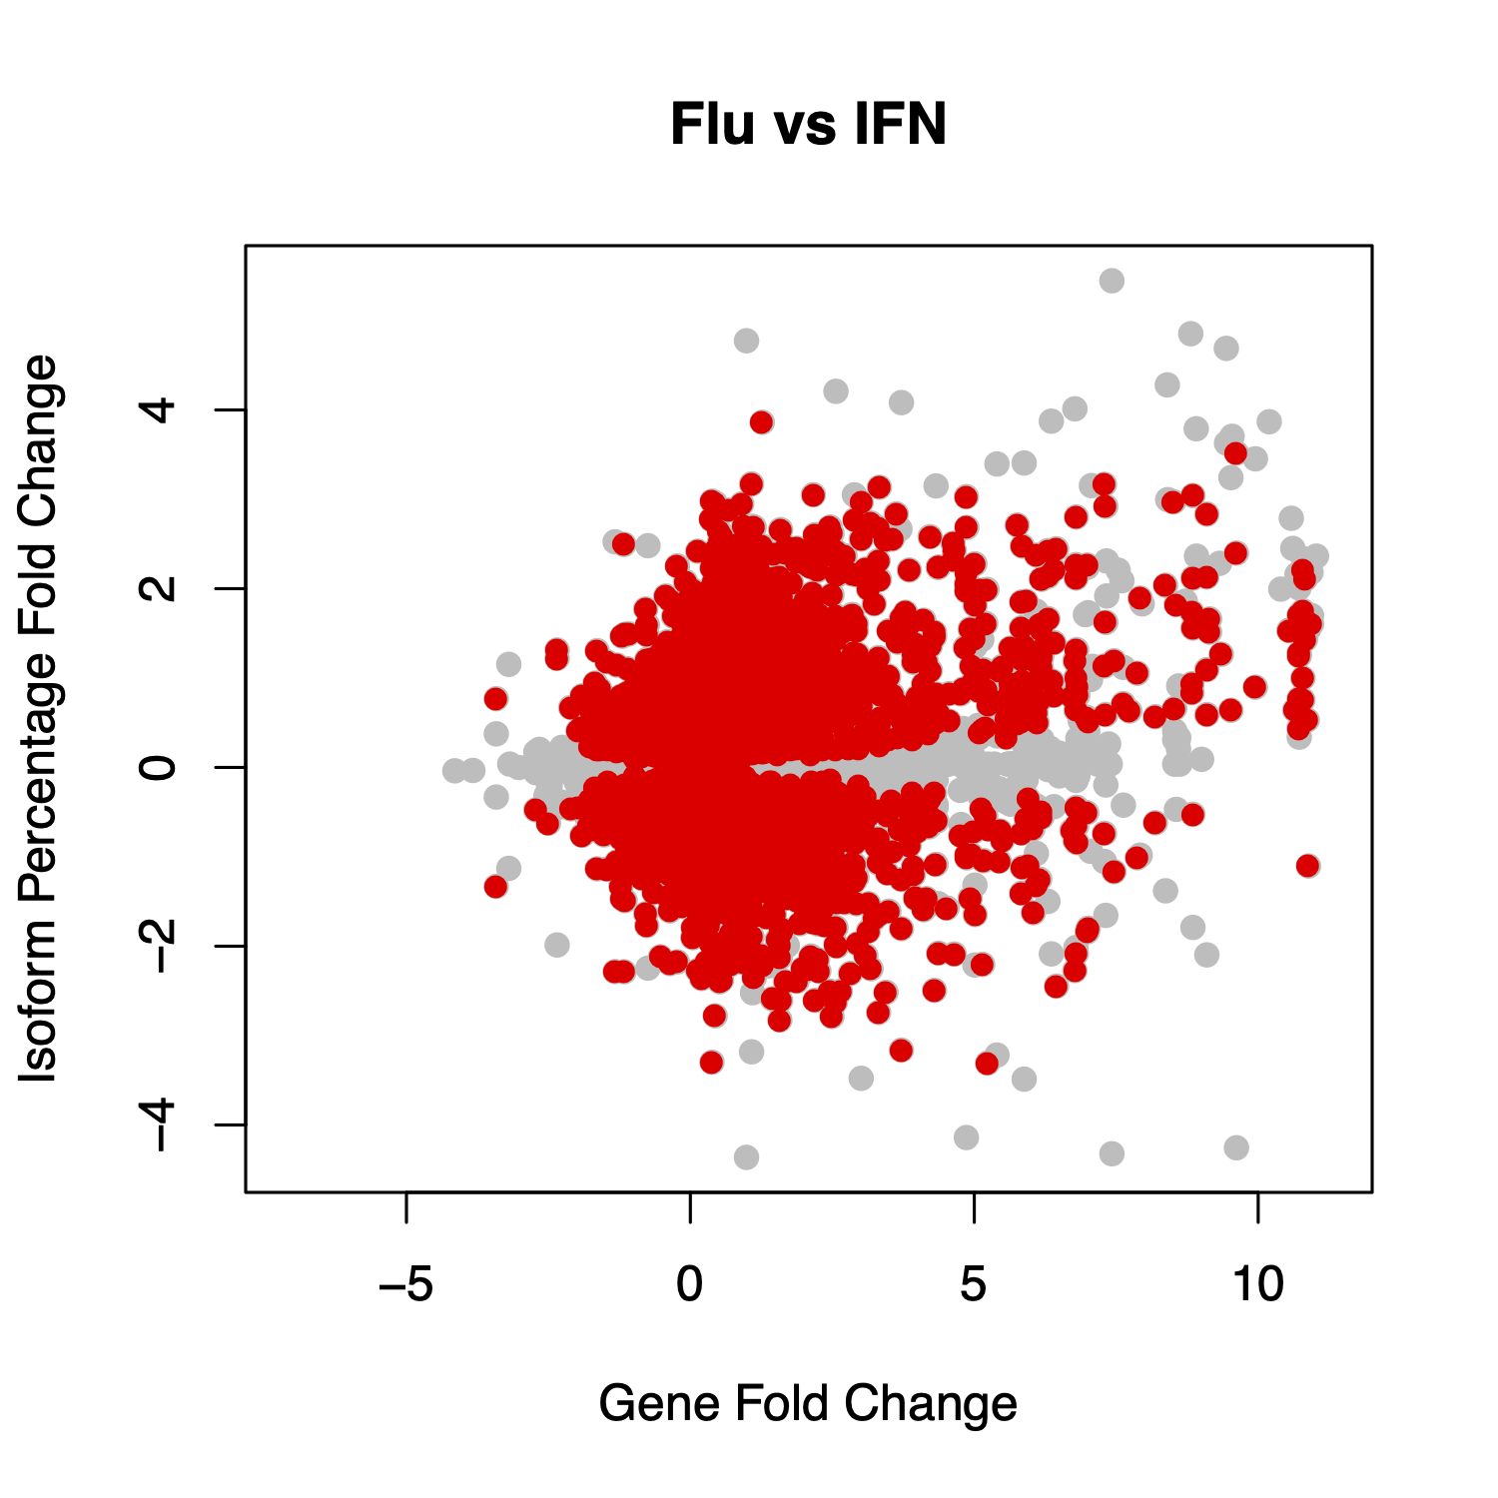
Fig. S2 – Scatter plot of log₂ fold change of overall gene abundance (x-axis) versus log₂ fold change in isoform percentage (y-axis) in flu-infected cells compared to IFNB1-simulated cells. Each dot represents one isoform. Isoforms that significantly differed in their usage percentages (beta regression, FDR < 0.05) are highlighted in red.

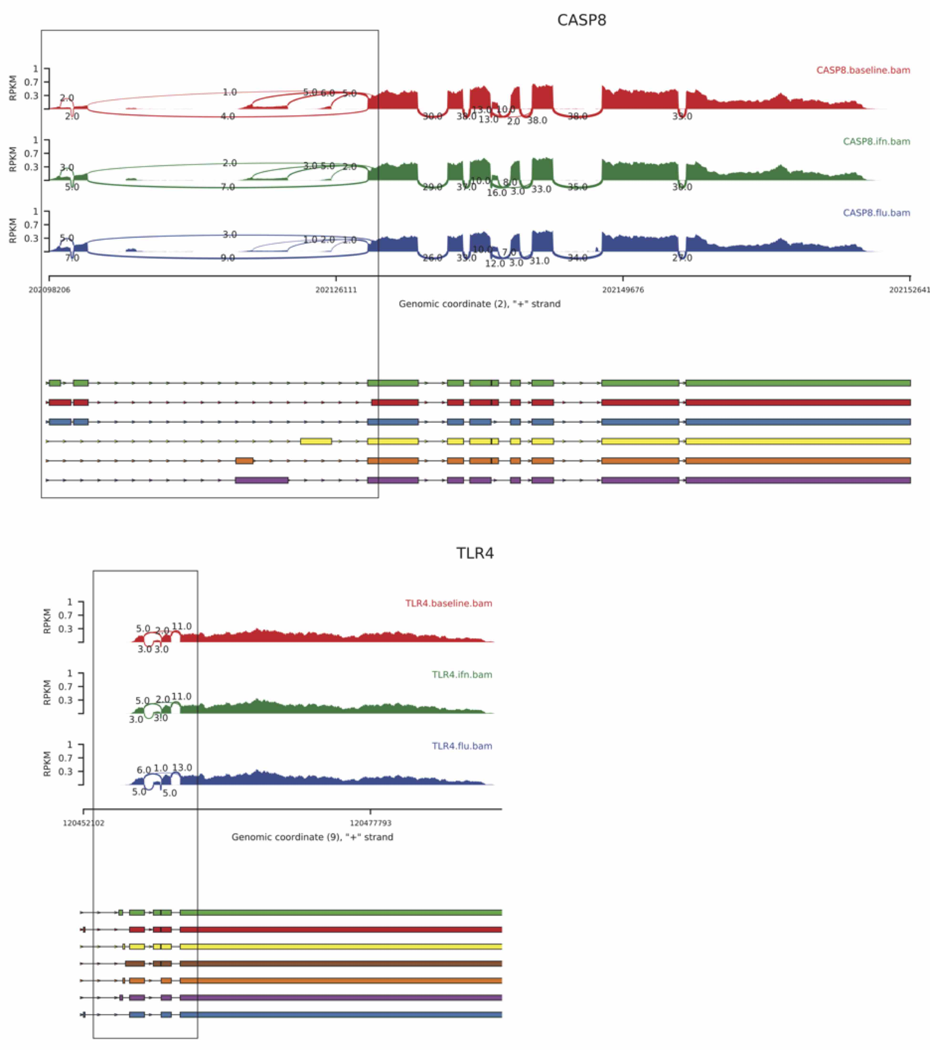
Fig. S3 – Sashimi plots (top) and gene structure (bottom) of CASP8 and TLR4 junctions in response to stimulation.

Fig. S4 – Empirically determined number of principal components (PCs) to adjust for eQTLs.

Fig. S5 – Empirically determined number of PCs to adjust for isoQTLs.

Fig. S6 – Power (y-axis) to detect a QTL for a range of betas (x-axis) and $N=100$, assuming $MAF=0.5$ and the following genetic architecture: SNP $G_{1}$ affects the transcription of $A_{1}$ but not $A_{2}$: $A_{1}\sim NB\left(μ_{1}=μ_{0}+G_{1}×β,r=μ_{1}/3\right)$ and $A_{2}\sim NB\left(μ_{2}=μ_{0},r=μ_{2}/3\right)$. Results from simulations based on both normally distributed and negative binomial (NB) data are shown.
Fig. S7 – Power (y-axis) to detect a QTL for a range of betas (x-axis) and $N=100$, assuming $MAF=0.5$ and the following genetic architecture: SNP $G_{2}$ affects the splicing of $A_{1}$ vs $A_{2}$: $A_{1}\sim NB\left(μ_{1}=μ_{0}+G_{2}×β,r=μ_{1}/3\right)$ and $A_{2}\sim NB\left(μ_{1}=μ_{0}-G_{2}×β,r=μ_{1}/3\right)$. Results from simulations based on both normally distributed and negative binomial (NB) data are shown.

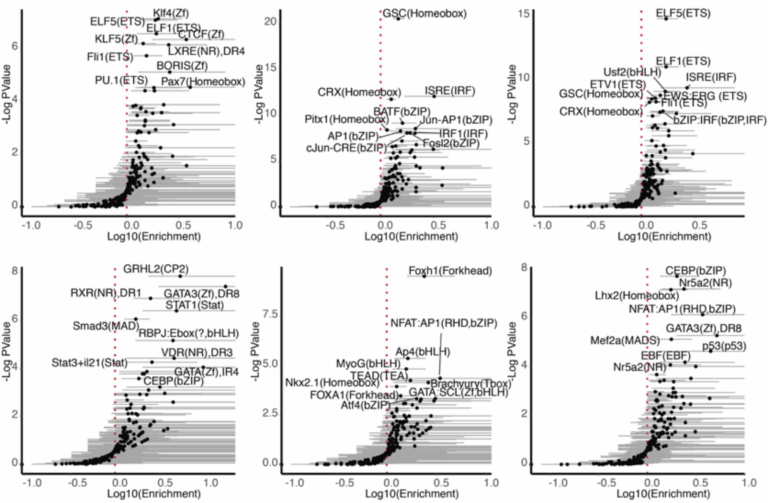
Fig. S8 – Enrichment of eQTLs (top 3 panels) and isoQTLs (bottom 3 panels) for known transcription factor binding sites.
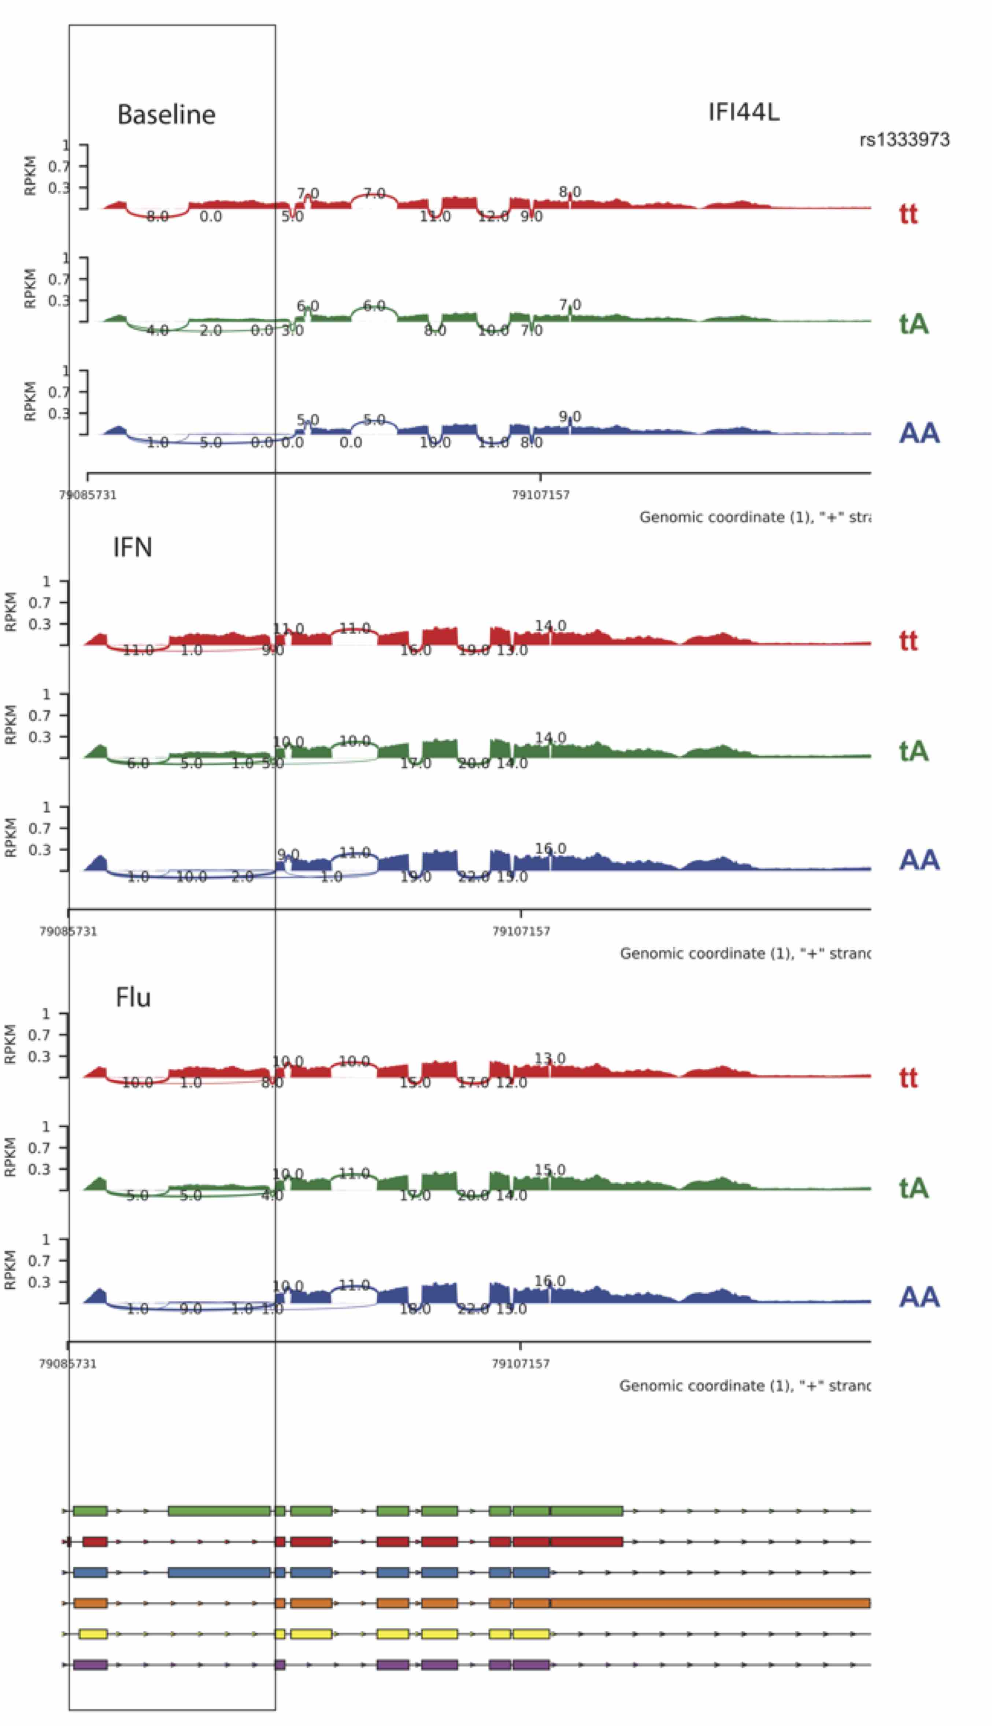
Fig. S9 – Sashimi plot of IFI44L expression at baseline, or in response to interferon or influenza as a function of patient genotype at rs1333973. Key junctions are highlighted.

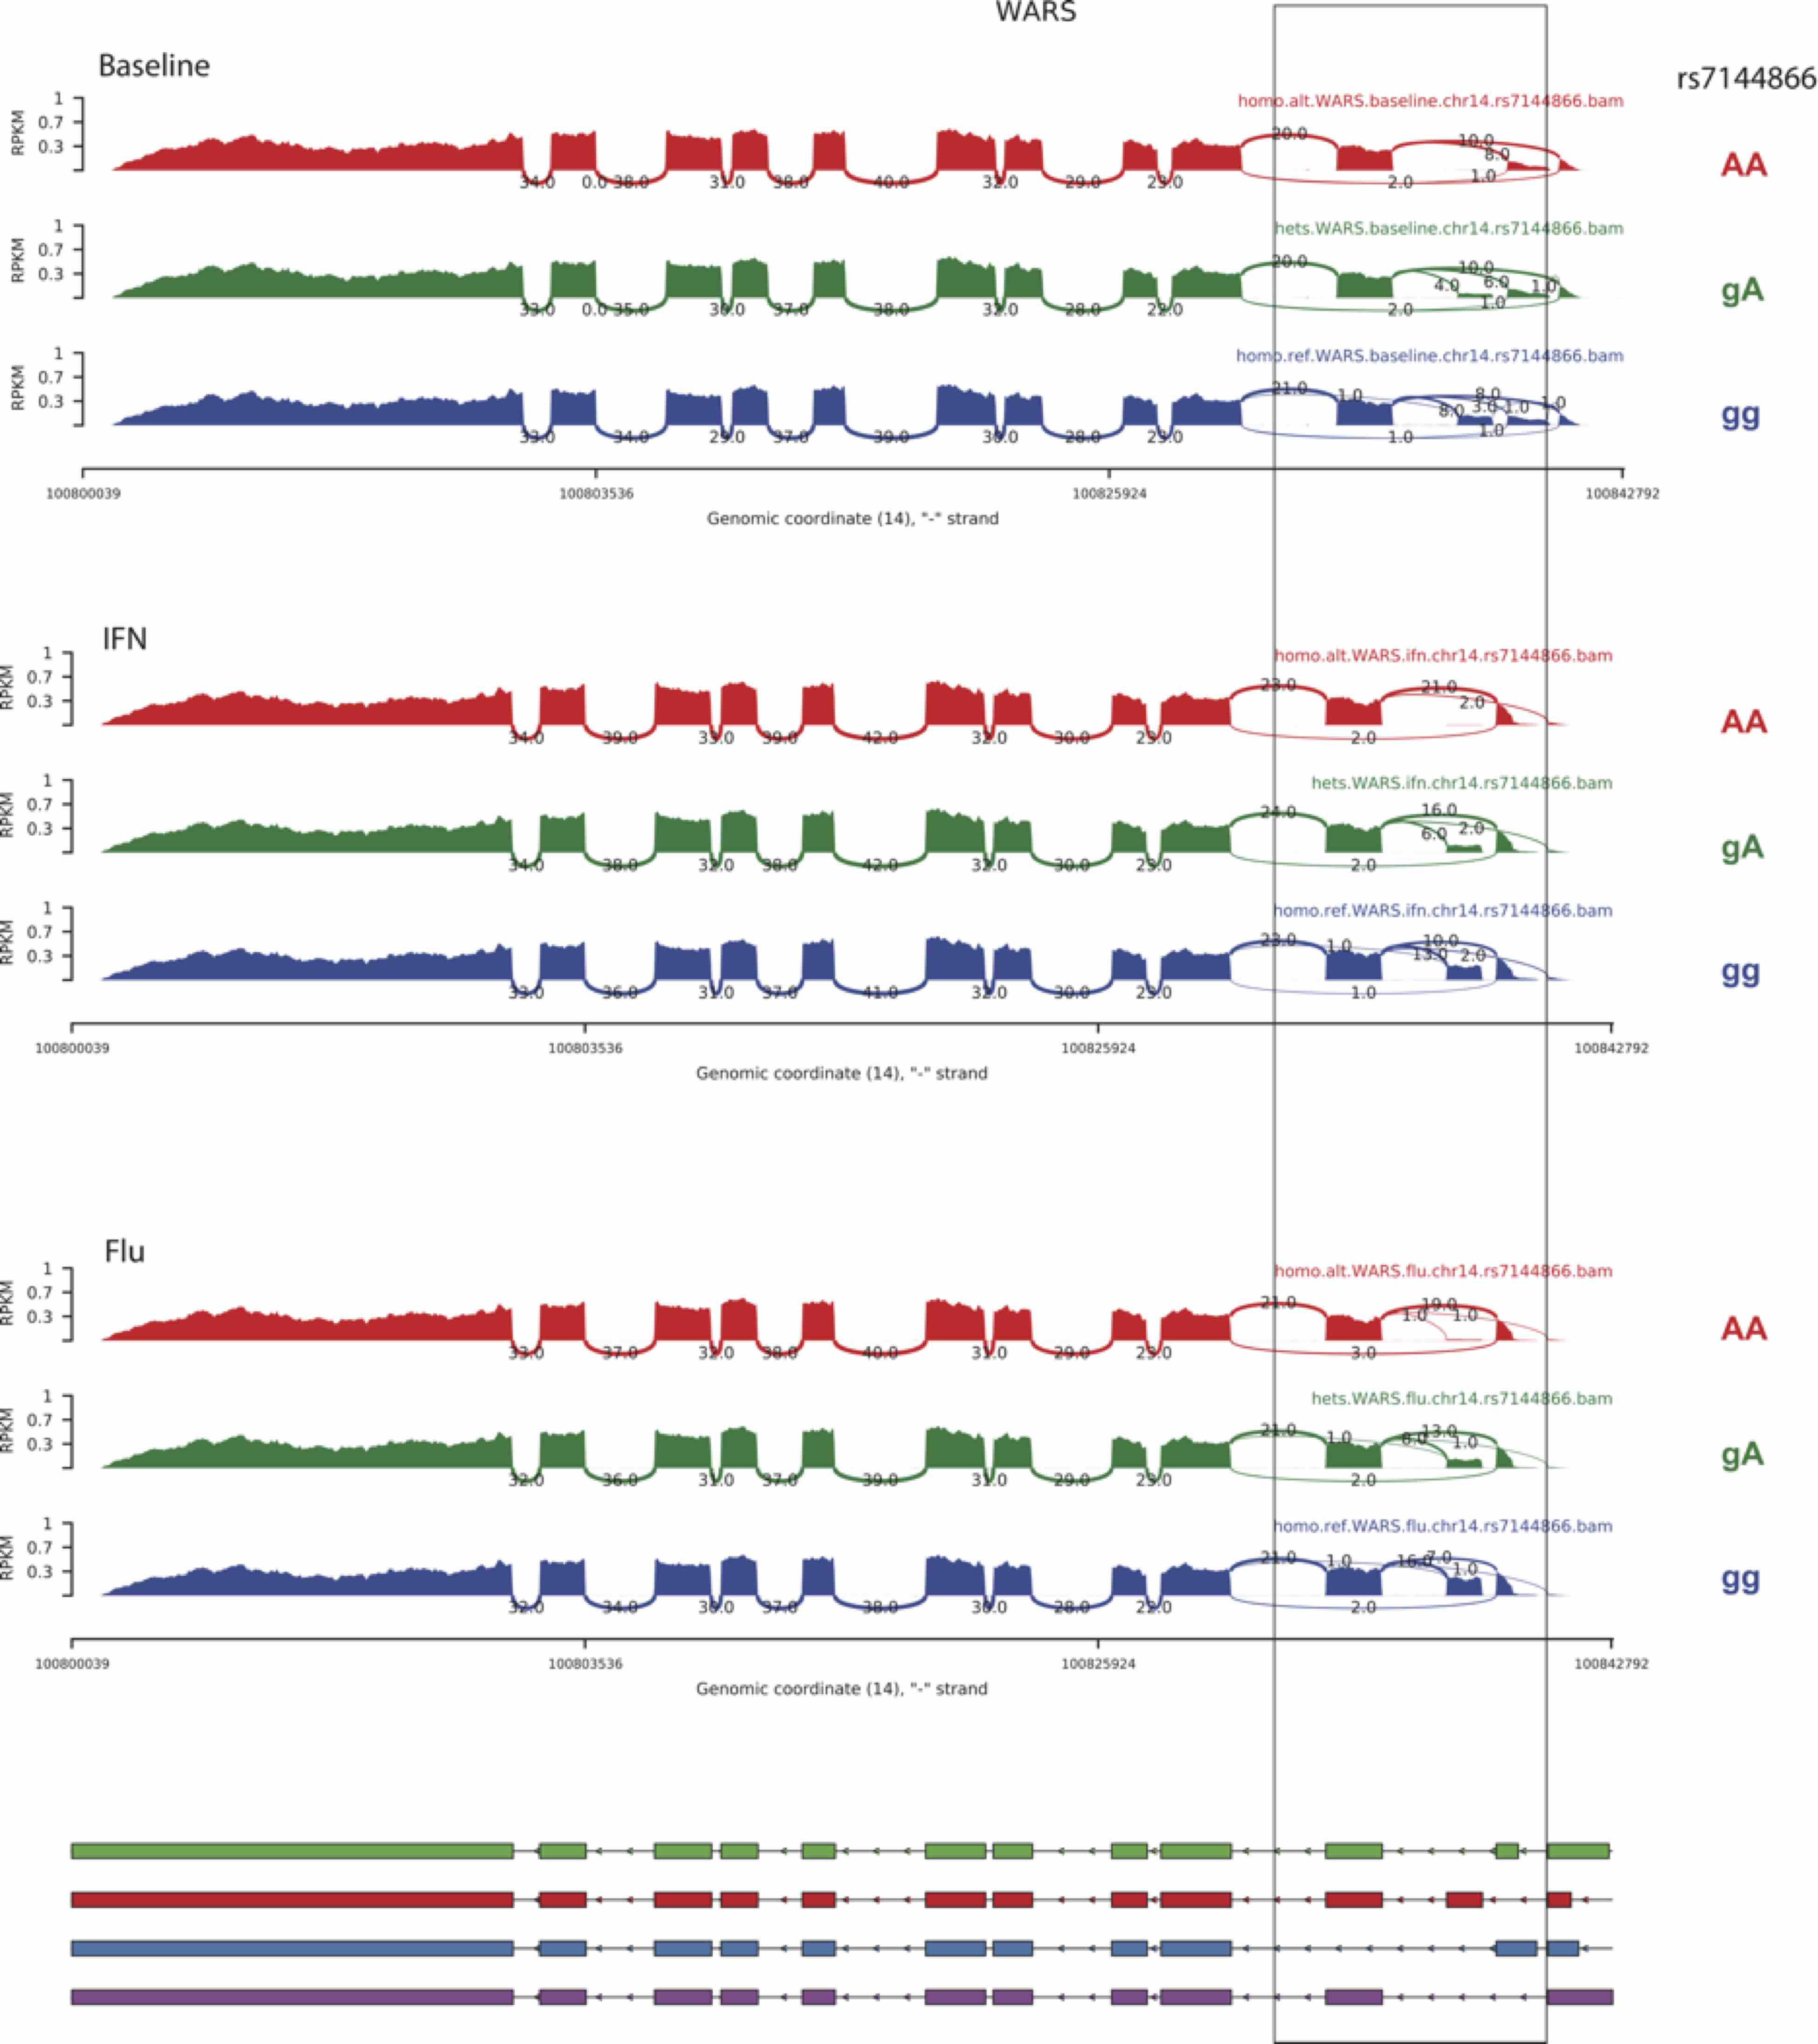
Fig. S10 – Sashimi plot of WARS expression at baseline, or in response to interferon or influenza as a function of patient genotype at rs7144866. Key junctions are highlighted.

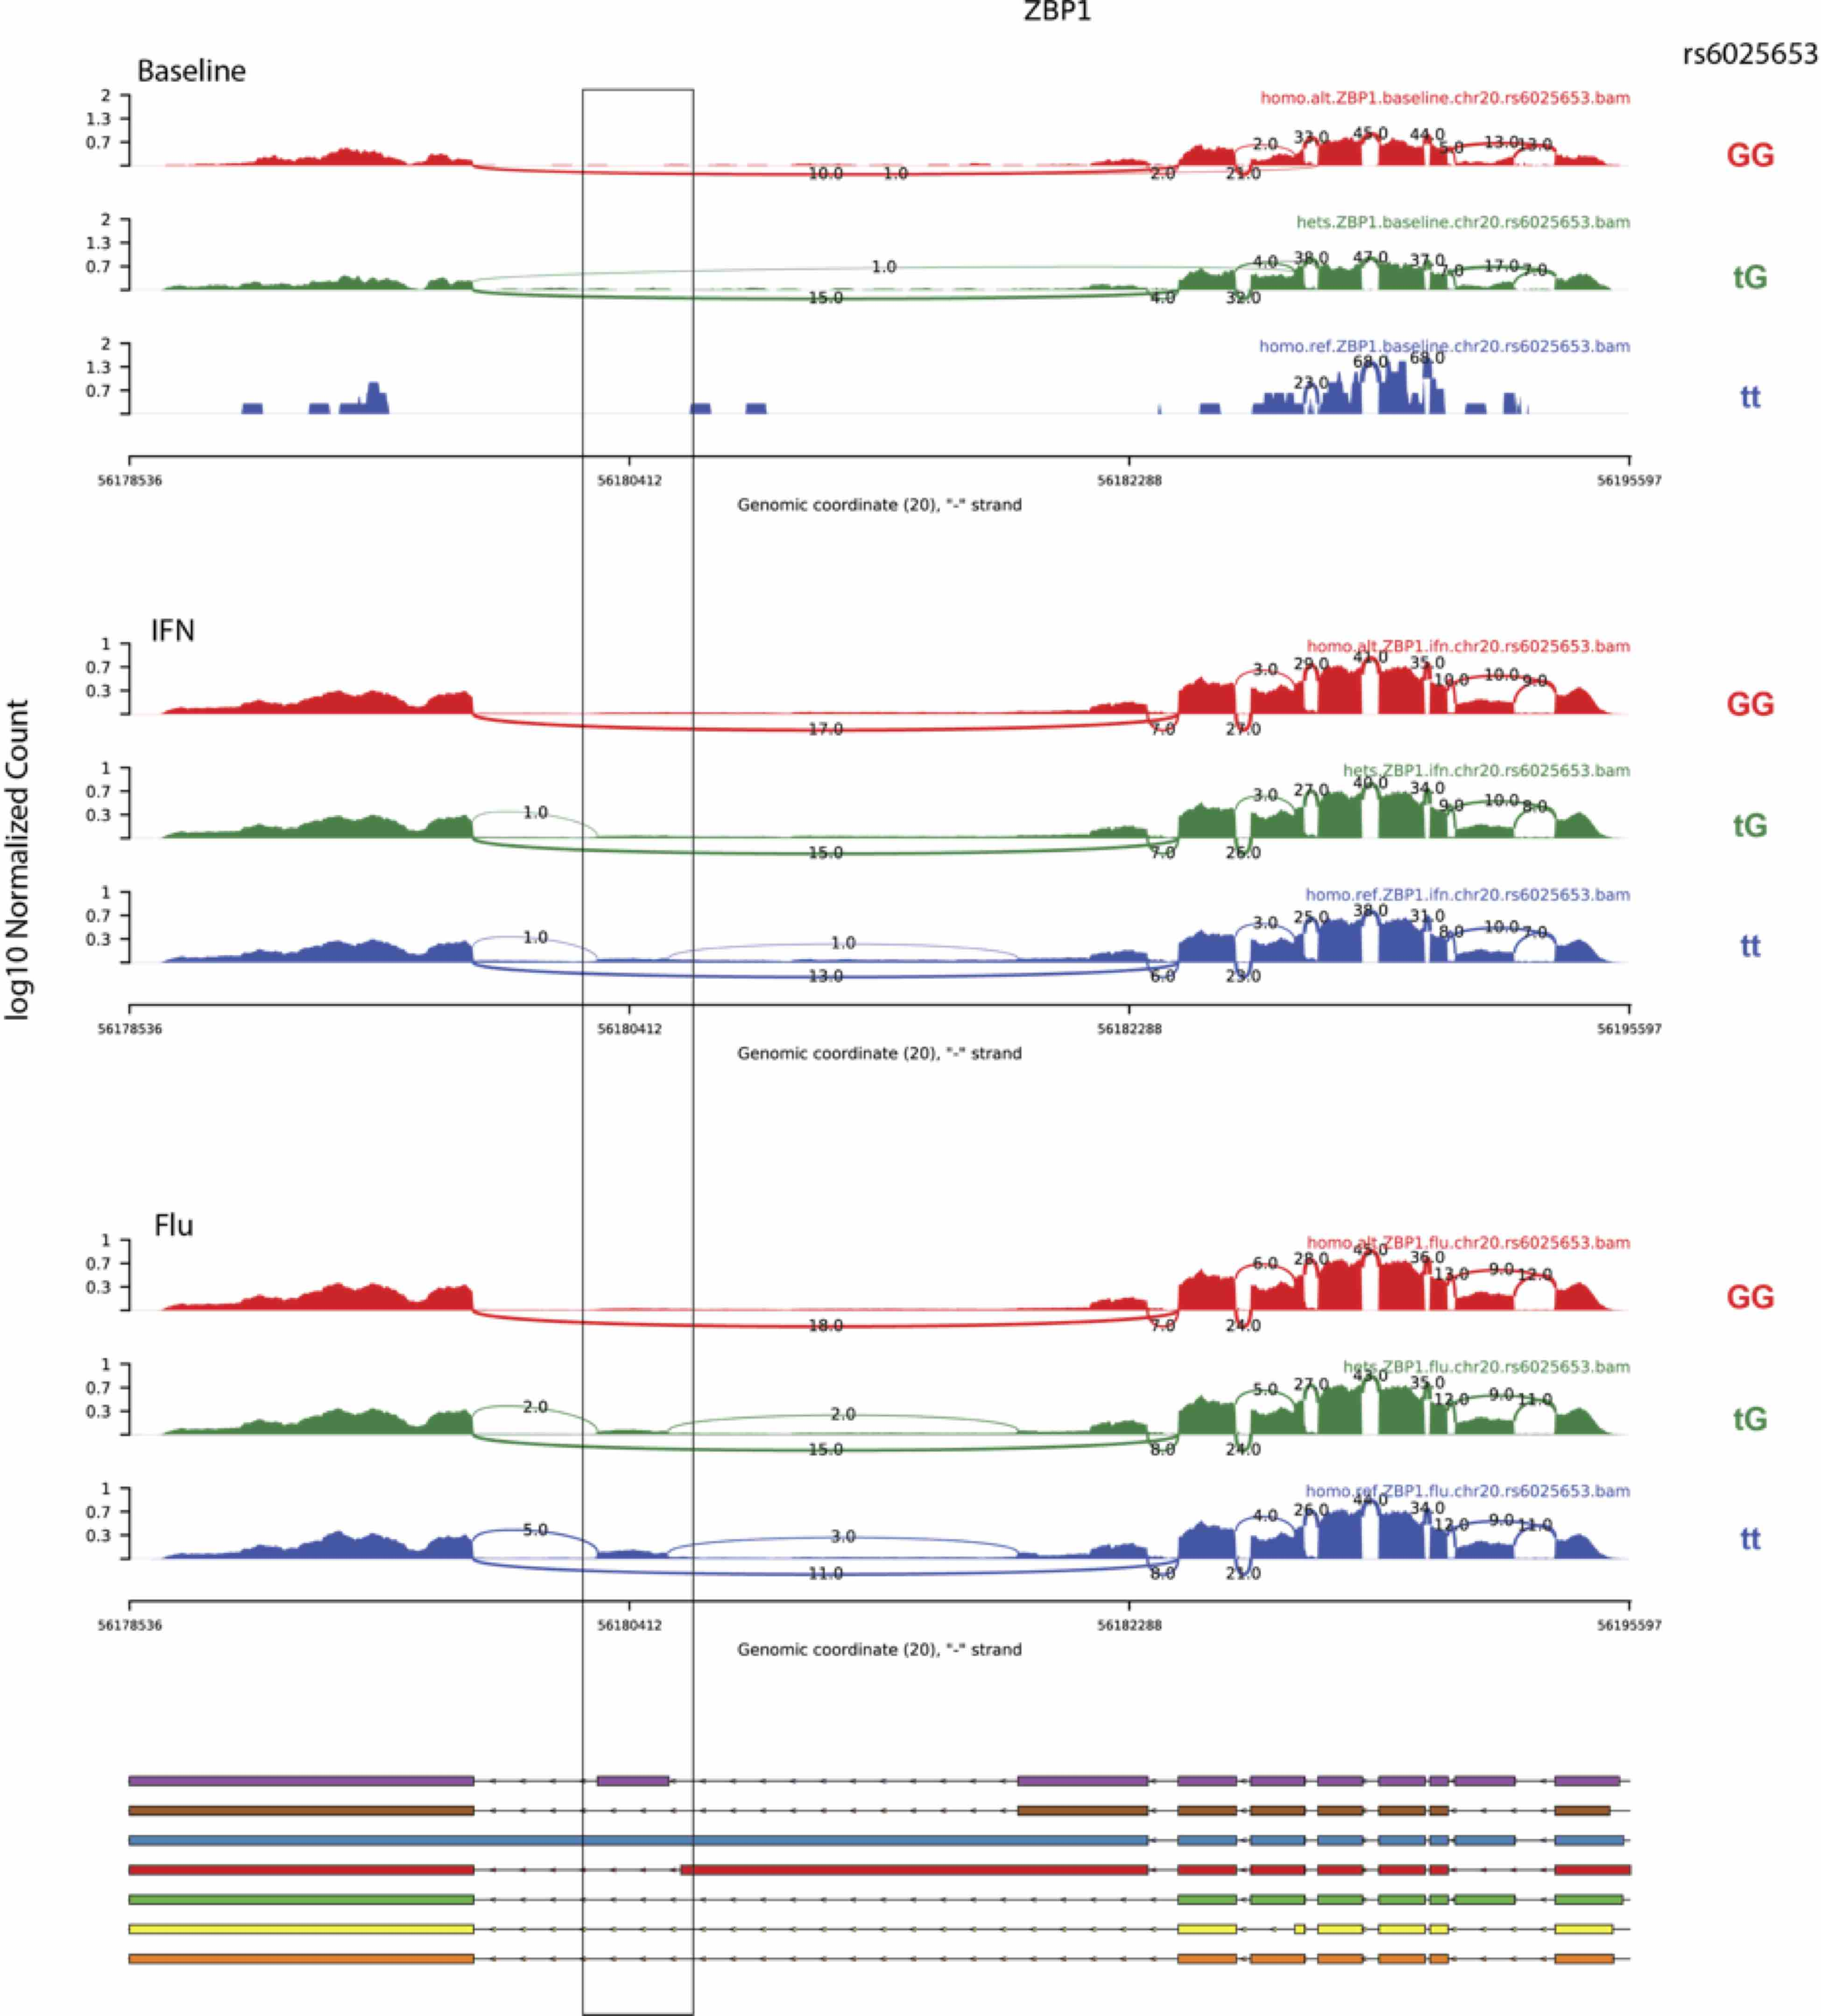

Fig. S11 – Sashimi plot of ZBP1 expression at baseline, or in response to interferon or influenza as a function of patient genotype at rs6025653. Key junctions are highlighted.

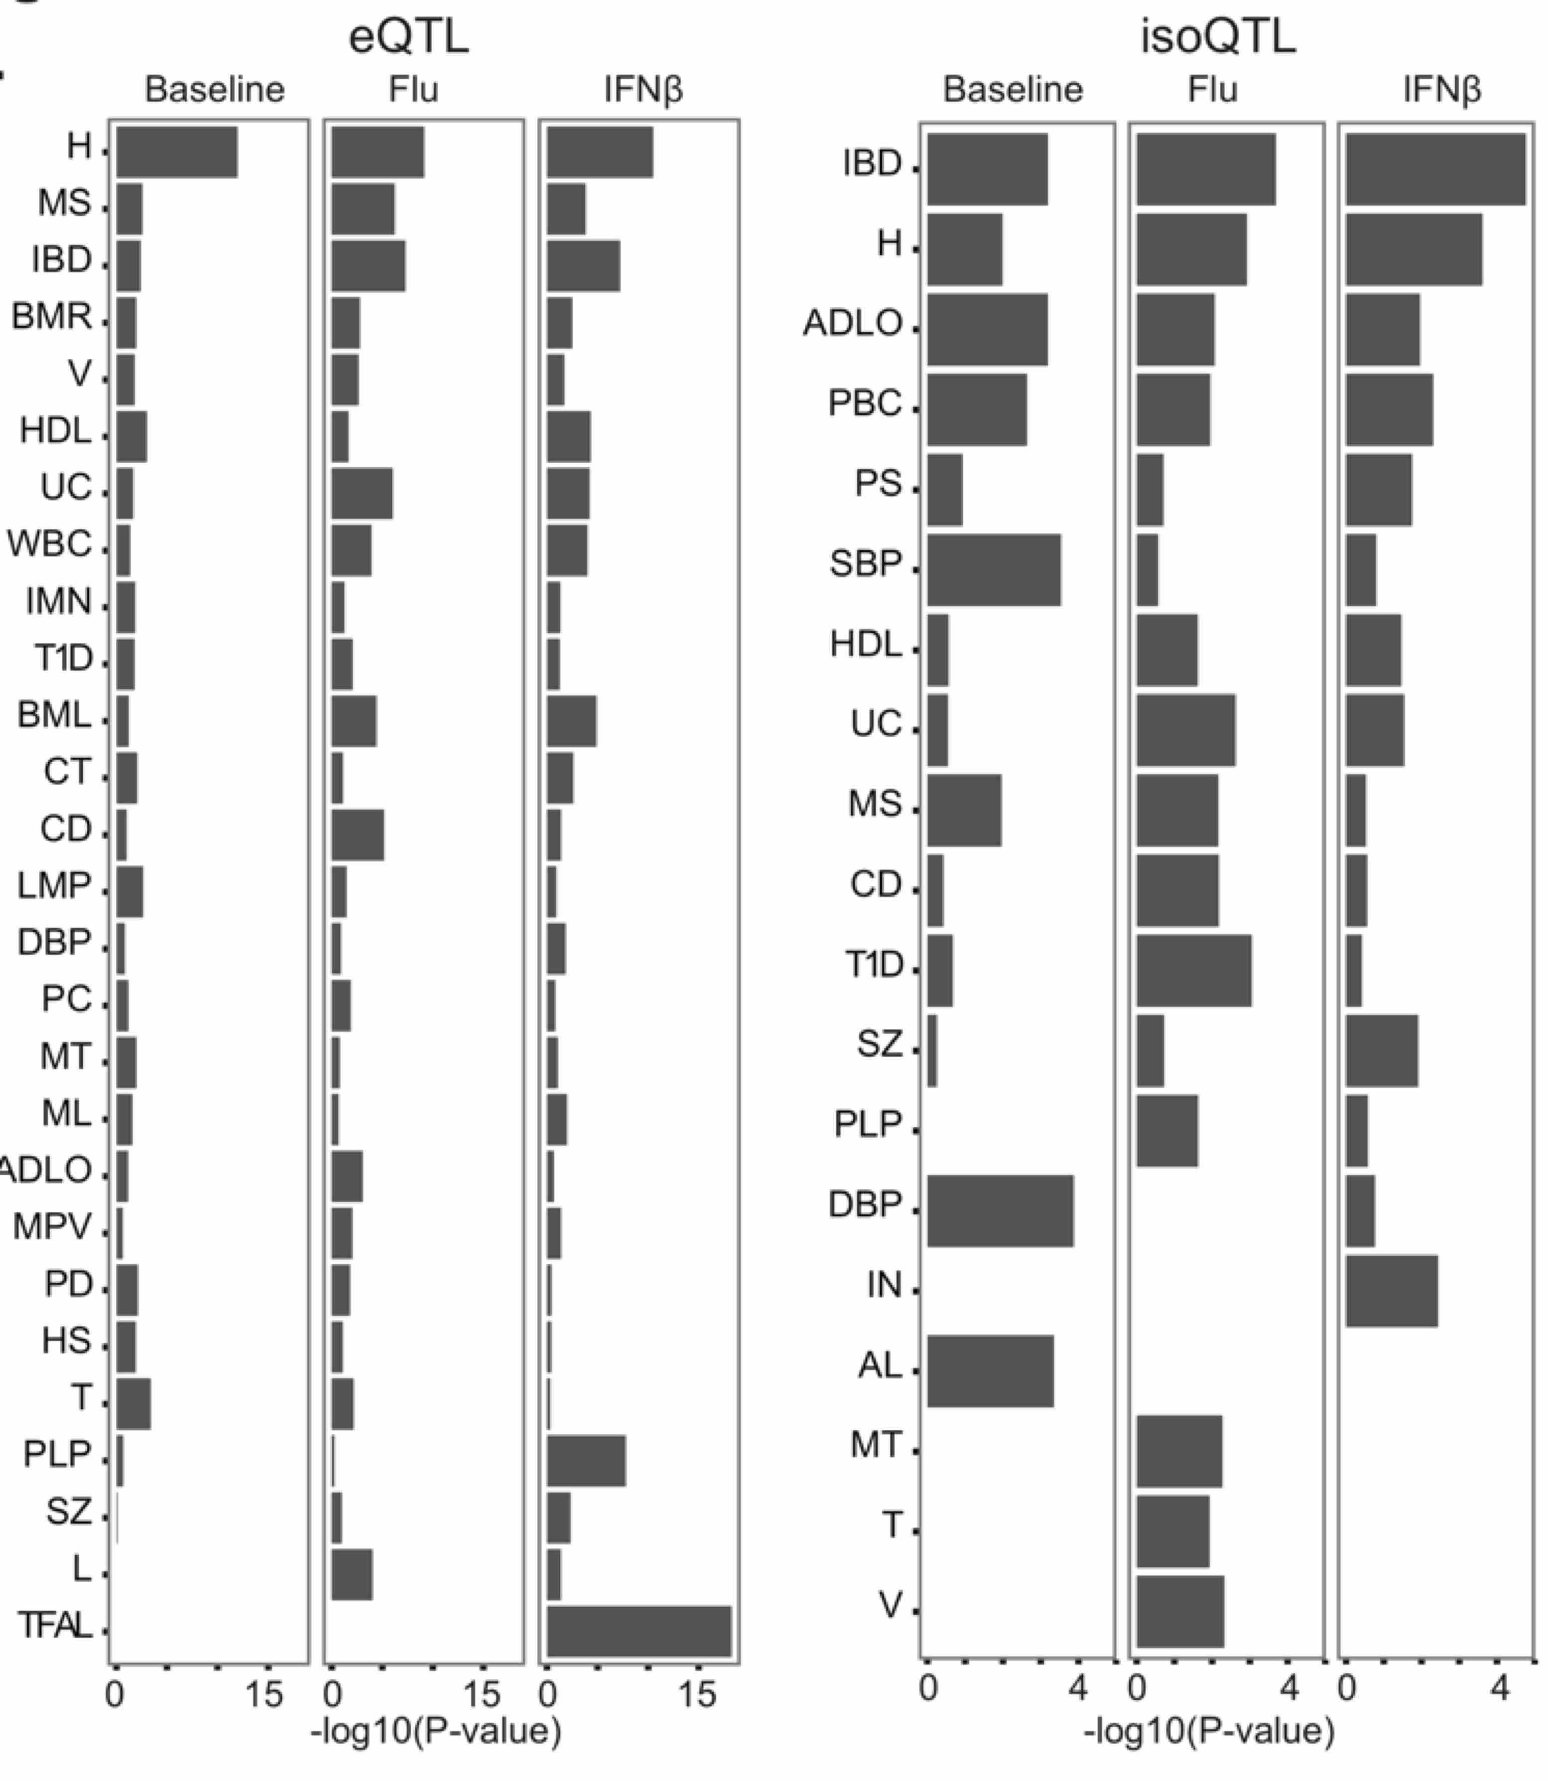
Fig. S12. Enrichment of leading eQTL and isoQTL SNPs for GWAS hits. Only diseases at a FDR < 0.1 for significant local e/isoQTLs (permutation FDR < 0.05) detected at baseline, post flu-infection or IFNB1-stimulation are plotted. X-axis: -log₁₀(hypergeometric enrichment P-value). H: Height, MS: Multiple sclerosis, IBD: inflammatory bowel disease, BMR: basal metabolic rate, V: vertiligo, HDL: high-density lipoprotein, LDL: low-density lipoprotein, UC: ulcerative colitis, WBC: white blood count, IMN: idiopathic membranous nephropathy, T1D: type-1 diabetes, BML: blood metabolite levels, CT: cholesterol total, CD: Crohn’s disease, LMP: lipid metabolism phenotypes, DBP: diastolic blood pressure, PC: platelet counts, MT: metabolic traits, ML: metabolite levels, ADLO: Alzheimer’s disease late onset, MPV: mean platelet volume, PD: Parkinson’s disease, HS: hypospadias, T: triglycerides, PLP: phospholipid levels plasma, SZ: schizophrenia, L: leprosy, TFAL: trans fatty acid levels, PBC: primary biliary cirrhosis, PS: psoriasis, SBP: systolic blood pressure, DBP: diastolic blood pressure, IN: IgA nephropathy, AL: adiponectin levels.
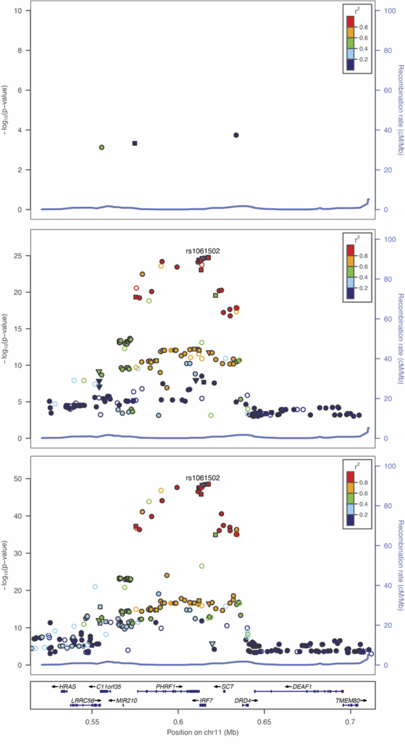
Fig. S13 – LocusZoom plot for IRF7 eQTLs.
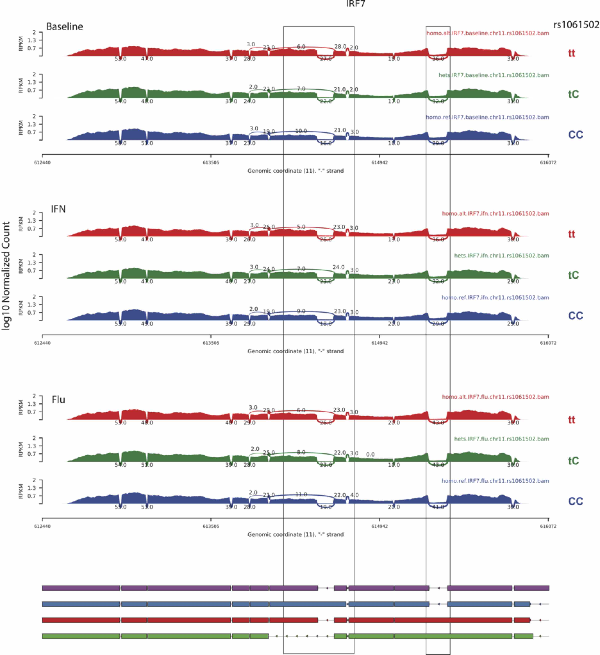
Fig. S14 – Sashimi plot of IRF7 expression at baseline, or in response to interferon or influenza as a function of patient genotype at rs1061502. Key junctions are highlighted.

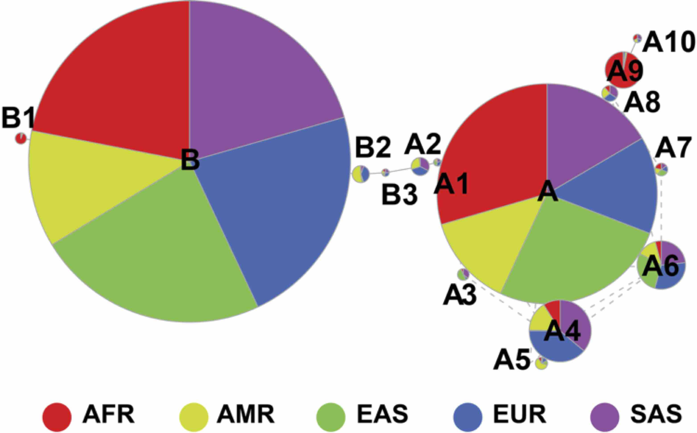
Fig. S15 - Distribution of ERAP2 haplotypes based on 1000 Genomes.

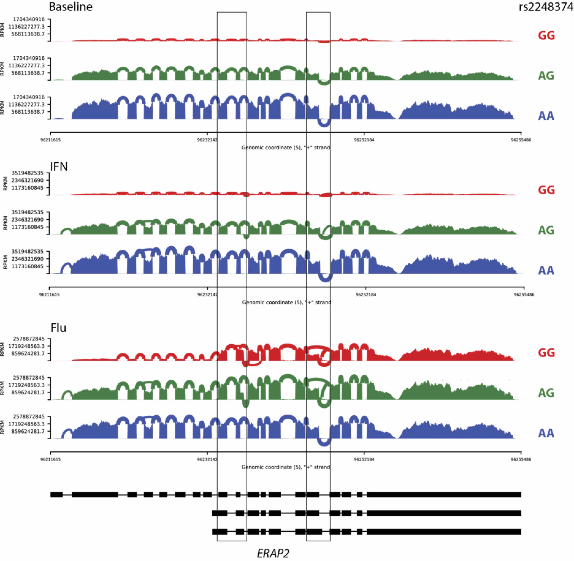
Fig. S16 – Sashimi plot of ERAP2 expression at baseline, or in response to interferon or influenza as a function of patient genotype at rs2248374. Key junctions are highlighted.

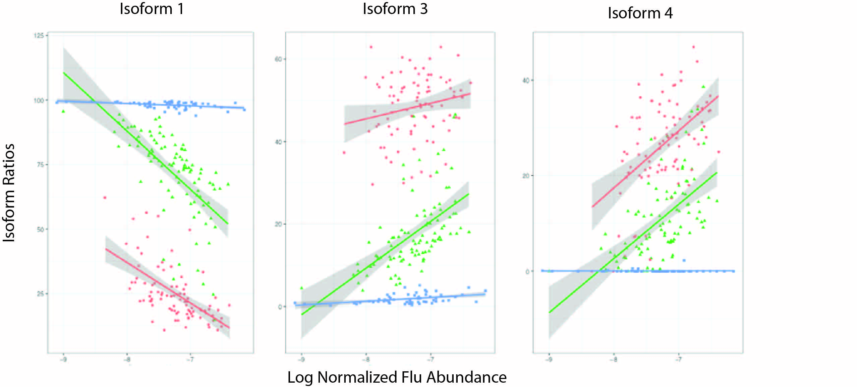Fig. S17 – Ratio of ERAP2 isoforms to total ERAP2 abundance expression (y-axis) vs log normalized flu segment 4 transcript abundance (x-axis). Color and shape indicate rs2248374 genotype (Red: GG, Green: AG, Blue: AA).

Fig. S18 – RNA-seq reads at ERAP2 exon10 from H3N2-infected (left) or mock (right) monocyte derived macrophages.

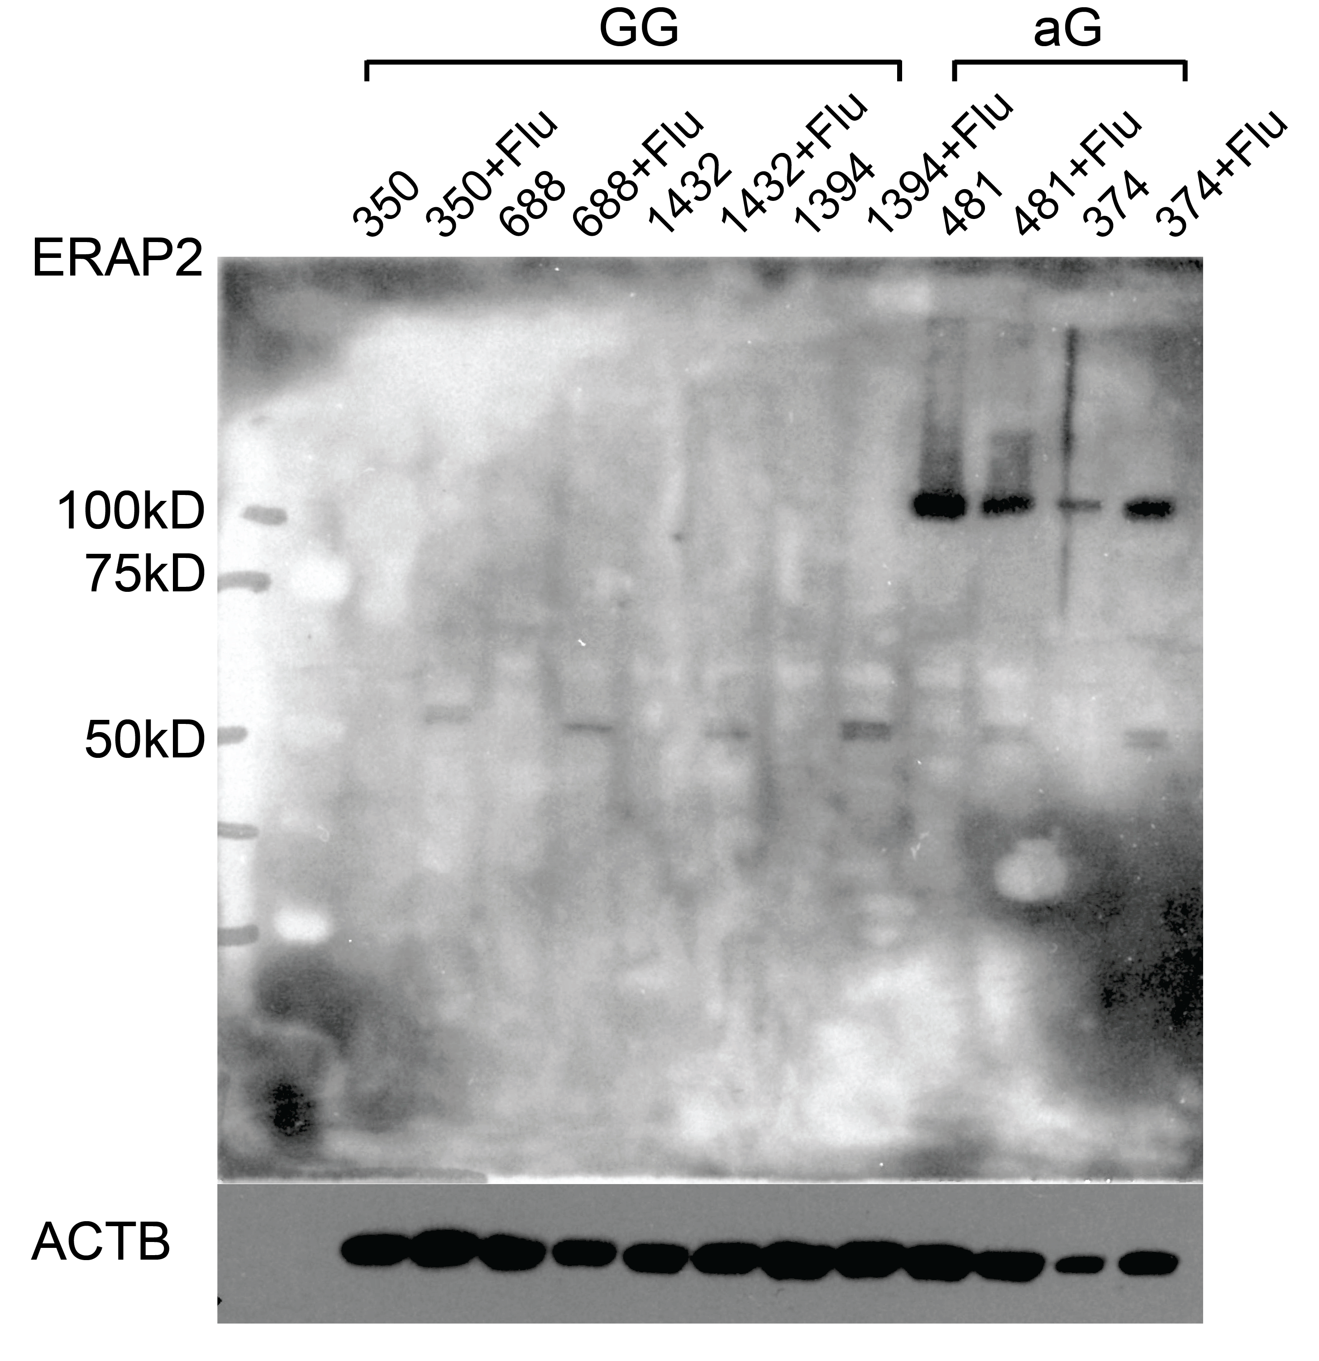
Fig. S19 – Full western blot (see Figure 5D).

Flu Reference

>gi|8486138|ref|NC_002023.1| Influenza A virus (A/Puerto Rico/8/34(H1N1)) segment 1, complete sequence
AGCGAAAGCAGGTCAATTATATTCAATATGGAAAGAATAAAAGAACTAAGAAATCTAATGTCGCAGTCTC
GCACCCGCGAGATACTCACAAAAACCACCGTGGACCATATGGCCATAATCAAGAAGTACACATCAGGAAG
ACAGGAGAAGAACCCAGCACTTAGGATGAAATGGATGATGGCAATGAAATATCCAATTACAGCAGACAAG
AGGATAACGGAAATGATTCCTGAGAGAAATGAGCAAGGACAAACTTTATGGAGTAAAATGAATGATGCCG
GATCAGACCGAGTGATGGTATCACCTCTGGCTGTGACATGGTGGAATAGGAATGGACCAATGACAAATAC
AGTTCATTATCCAAAAATCTACAAAACTTATTTTGAAAGAGTCGAAAGGCTAAAGCATGGAACCTTTGGC
CCTGTCCATTTTAGAAACCAAGTCAAAATACGTCGGAGAGTTGACATAAATCCTGGTCATGCAGATCTCA
GTGCCAAGGAGGCACAGGATGTAATCATGGAAGTTGTTTTCCCTAACGAAGTGGGAGCCAGGATACTAAC
ATCGGAATCGCAACTAACGATAACCAAAGAGAAGAAAGAAGAACTCCAGGATTGCAAAATTTCTCCTTTG
ATGGTTGCATACATGTTGGAGAGAGAACTGGTCCGCAAAACGAGATTCCTCCCAGTGGCTGGTGGAACAA
GCAGTGTGTACATTGAAGTGTTGCATTTGACTCAAGGAACATGCTGGGAACAGATGTATACTCCAGGAGG
GGAAGTGAAGAATGATGATGTTGATCAAAGCTTGATTATTGCTGCTAGGAACATAGTGAGAAGAGCTGCA
GTATCAGCAGACCCACTAGCATCTTTATTGGAGATGTGCCACAGCACACAGATTGGTGGAATTAGGATGG
TAGACATCCTTAAGCAGAACCCAACAGAAGAGCAAGCCGTGGGTATATGCAAGGCTGCAATGGGACTGAG
AATTAGCTCATCCTTCAGTTTTGGTGGATTCACATTTAAGAGAACAAGCGGATCATCAGTCAAGAGAGAG
GAAGAGGTGCTTACGGGCAATCTTCAAACATTGAAGATAAGAGTGCATGAGGGATATGAAGAGTTCACAA
TGGTTGGGAGAAGAGCAACAGCCATACTCAGAAAAGCAACCAGGAGATTGATTCAGCTGATAGTGAGTGG
GAGAGACGAACAGTCGATTGCCGAAGCAATAATTGTGGCCATGGTATTTTCACAAGAGGATTGTATGATA
AAAGCAGTTAGAGGTGATCTGAATTTCGTCAATAGGGCGAATCAGCGACTGAATCCTATGCATCAACTTT
TAAGACATTTTCAGAAGGATGCGAAAGTGCTTTTTCAAAATTGGGGAGTTGAACCTATCGACAATGTGAT
GGGAATGATTGGGATATTGCCCGACATGACTCCAAGCATCGAGATGTCAATGAGAGGAGTGAGAATCAGC
AAAATGGGTGTAGATGAGTACTCCAGCACGGAGAGGGTAGTGGTGAGCATTGACCGGTTCTTGAGAGTCC
GGGACCAACGAGGAAATGTACTACTGTCTCCCGAGGAGGTCAGTGAAACACAGGGAACAGAGAAACTGAC
AATAACTTACTCATCGTCAATGATGTGGGAGATTAATGGTCCTGAATCAGTGTTGGTCAATACCTATCAA
TGGATCATCAGAAACTGGGAAACTGTTAAAATTCAGTGGTCCCAGAACCCTACAATGCTATACAATAAAA
TGGAATTTGAACCATTTCAGTCTTTAGTACCTAAGGCCATTAGAGGCCAATACAGTGGGTTTGTGAGAAC
TCTGTTCCAACAAATGAGGGATGTGCTTGGGACATTTGATACCGCACAGATAATAAAACTTCTTCCCTTC
GCAGCCGCTCCACCAAAGCAAAGTAGAATGCAGTTCTCCTCATTTACTGTGAATGTGAGGGGATCAGGAA
TGAGAATACTTGTAAGGGGCAATTCTCCTGTATTCAACTACAACAAGGCCACGAAGAGACTCACAGTTCT
CGGAAAGGATGCTGGCACTTTAACCGAAGACCCAGATGAAGGCACAGCTGGAGTGGAGTCCGCTGTTCTG
AGGGGATTCCTCATTCTGGGCAAAGAAGACAGGAGATATGGGCCAGCATTAAGCATCAATGAACTGAGCA
ACCTTGCGAAAGGAGAGAAGGCTAATGTGCTAATTGGGCAAGGAGACGTGGTGTTGGTAATGAAACGAAA
ACGGGACTCTAGCATACTTACTGACAGCCAGACAGCGACCAAAAGAATTCGGATGGCCATCAATTAGTGT
CGAATAGTTTAAAAACGACCTTGTTTCTACT

>gi|8486136|ref|NC_002022.1| Influenza A virus (A/Puerto Rico/8/34(H1N1)) segment 3, complete sequence
AGCGAAAGCAGGTACTGATCCAAAATGGAAGATTTTGTGCGACAATGCTTCAATCCGATGATTGTCGAGC
TTGCGGAAAAAACAATGAAAGAGTATGGGGAGGACCTGAAAATCGAAACAAACAAATTTGCAGCAATATG
CACTCACTTGGAAGTATGCTTCATGTATTCAGATTTCCACTTCATCAATGAGCAAGGCGAGTCAATAATC
GTAGAACTTGGTGATCCTAATGCACTTTTGAAGCACAGATTTGAAATAATCGAGGGAAGAGATCGCACAA
TGGCCTGGACAGTAGTAAACAGTATTTGCAACACTACAGGGGCTGAGAAACCAAAGTTTCTACCAGATTT
GTATGATTACAAGGAAAATAGATTCATCGAAATTGGAGTAACAAGGAGAGAAGTTCACATATACTATCTG
GAAAAGGCCAATAAAATTAAATCTGAGAAAACACACATCCACATTTTCTCGTTCACTGGGGAAGAAATGG
CCACAAAGGCCGACTACACTCTCGATGAAGAAAGCAGGGCTAGGATCAAAACCAGGCTATTCACCATAAG
ACAAGAAATGGCCAGCAGAGGCCTCTGGGATTCCTTTCGTCAGTCCGAGAGAGGAGAAGAGACAATTGAA
GAAAGGTTTGAAATCACAGGAACAATGCGCAAGCTTGCCGACCAAAGTCTCCCGCCGAACTTCTCCAGCC
TTGAAAATTTTAGAGCCTATGTGGATGGATTCGAACCGAACGGCTACATTGAGGGCAAGCTGTCTCAAAT
GTCCAAAGAAGTAAATGCTAGAATTGAACCTTTTTTGAAAACAACACCACGACCACTTAGACTTCCGAAT
GGGCCTCCCTGTTCTCAGCGGTCCAAATTCCTGCTGATGGATGCCTTAAAATTAAGCATTGAGGACCCAA
GTCATGAAGGAGAGGGAATACCGCTATATGATGCAATCAAATGCATGAGAACATTCTTTGGATGGAAGGA
ACCCAATGTTGTTAAACCACACGAAAAGGGAATAAATCCAAATTATCTTCTGTCATGGAAGCAAGTACTG
GCAGAACTGCAGGACATTGAGAATGAGGAGAAAATTCCAAAGACTAAAAATATGAAAAAAACAAGTCAGC
TAAAGTGGGCACTTGGTGAGAACATGGCACCAGAAAAGGTAGACTTTGACGACTGTAAAGATGTAGGTGA
TTTGAAGCAATATGATAGTGATGAACCAGAATTGAGGTCGCTTGCAAGTTGGATTCAGAATGAGTTCAAC
AAGGCATGCGAACTGACAGATTCAAGCTGGATAGAGCTTGATGAGATTGGAGAAGATGTGGCTCCAATTG
AACACATTGCAAGCATGAGAAGGAATTATTTCACATCAGAGGTGTCTCACTGCAGAGCCACAGAATACAT
AATGAAGGGGGTGTACATCAATACTGCCTTACTTAATGCATCTTGTGCAGCAATGGATGATTTCCAATTA
ATTCCAATGATAAGCAAGTGTAGAACTAAGGAGGGAAGGCGAAAGACCAACTTGTATGGTTTCATCATAA
AAGGAAGATCCCACTTAAGGAATGACACCGACGTGGTAAACTTTGTGAGCATGGAGTTTTCTCTCACTGA
CCCAAGACTTGAACCACACAAATGGGAGAAGTACTGTGTTCTTGAGATAGGAGATATGCTTCTAAGAAGT
GCCATAGGCCAGGTTTCAAGGCCCATGTTCTTGTATGTGAGGACAAATGGAACCTCAAAAATTAAAATGA
AATGGGGAATGGAGATGAGGCGTTGTCTCCTCCAGTCACTTCAACAAATTGAGAGTATGATTGAAGCTGA
GTCCTCTGTCAAAGAGAAAGACATGACCAAAGAGTTCTTTGAGAACAAATCAGAAACATGGCCCATTGGA
GAGTCTCCCAAAGGAGTGGAGGAAAGTTCCATTGGGAAGGTCTGCAGGACTTTATTAGCAAAGTCGGTAT
TTAACAGCTTGTATGCATCTCCACAACTAGAAGGATTTTCAGCTGAATCAAGAAAACTGCTTCTTATCGT
TCAGGCTCTTAGGGACAATCTGGAACCTGGGACCTTTGATCTTGGGGGGCTATATGAAGCAATTGAGGAG
TGCCTAATTAATGATCCCTGGGTTTTGCTTAATGCTTCTTGGTTCAACTCCTTCCTTACACATGCATTGA
GTTAGTTGTGGCAGTGCTACTATTTGCTATCCATACTGTCCAAAAAAGTACCTTGTTTCTACT

>gi|8486134|ref|NC_002021.1| Influenza A virus (A/Puerto Rico/8/34(H1N1)) segment 2, complete sequence
AGCGAAAGCAGGCAAACCATTTGAATGGATGTCAATCCGACCTTACTTTTCTTAAAAGTGCCAGCACAAA
ATGCTATAAGCACAACTTTCCCTTATACCGGAGACCCTCCTTACAGCCATGGGACAGGAACAGGATACAC
CATGGATACTGTCAACAGGACACATCAGTACTCAGAAAAGGCAAGATGGACAACAAACACCGAAACTGGA
GCACCGCAACTCAACCCGATTGATGGGCCACTGCCAGAAGACAATGAACCAAGTGGTTATGCCCAAACAG
ATTGTGTATTGGAAGCAATGGCTTTCCTTGAGGAATCCCATCCTGGTATTTTTGAAAACTCGTGTATTGA
AACGATGGAGGTTGTTCAGCAAACACGAGTAGACAAGCTGACACAAGGCCGACAGACCTATGACTGGACT
TTAAATAGAAACCAGCCTGCTGCAACAGCATTGGCCAACACAATAGAAGTGTTCAGATCAAATGGCCTCA
CGGCCAATGAGTCTGGAAGGCTCATAGACTTCCTTAAGGATGTAATGGAGTCAATGAAAAAAGAAGAAAT
GGGGATCACAACTCATTTTCAGAGAAAGAGACGGGTGAGAGACAATATGACTAAGAAAATGATAACACAG
AGAACAATAGGTAAAAGGAAACAGAGATTGAACAAAAGGAGTTATCTAATTAGAGCATTGACCCTGAACA
CAATGACCAAAGATGCTGAGAGAGGGAAGCTAAAACGGAGAGCAATTGCAACCCCAGGGATGCAAATAAG
GGGGTTTGTATACTTTGTTGAGACACTGGCAAGGAGTATATGTGAGAAACTTGAACAATCAGGGTTGCCA
GTTGGAGGCAATGAGAAGAAAGCAAAGTTGGCAAATGTTGTAAGGAAGATGATGACCAATTCTCAGGACA
CCGAACTTTCTTTGACCATCACTGGAGATAACACCAAATGGAACGAAAATCAGAATCCTCGGATGTTTTT
GGCCATGATCACATATATGACCAGAAATCAGCCCGAATGGTTCAGAAATGTTCTAAGTATTGCTCCAATA
ATGTTCTCAAACAAAATGGCGAGACTGGGAAAAGGGTATATGTTTGAGAGCAAGAGTATGAAACTTAGAA
CTCAAATACCTGCAGAAATGCTAGCAAGCATTGATTTGAAATATTTCAATGATTCAACAAGAAAGAAGAT
TGAAAAAATCCGACCGCTCTTAATAGAGGGGACTGCATCATTGAGCCCTGGAATGATGATGGGCATGTTC
AATATGTTAAGCACTGTATTAGGCGTCTCCATCCTGAATCTTGGACAAAAGAGATACACCAAGACTACTT
ACTGGTGGGATGGTCTTCAATCCTCTGACGATTTTGCTCTGATTGTGAATGCACCCAATCATGAAGGGAT
TCAAGCCGGAGTCGACAGGTTTTATCGAACCTGTAAGCTACATGGAATCAATATGAGCAAGAAAAAGTCT
TACATAAACAGAACAGGTACATTTGAATTCACAAGTTTTTTCTATCGTTATGGGTTTGTTGCCAATTTCA
GCATGGAGCTTCCCAGTTTTGGTGTGTCTGGGAGCAACGAGTCAGCGGACATGAGTATTGGAGTTACTGT
CATCAAAAACAATATGATAAACAATGATCTTGGTCCAGCAACAGCTCAAATGGCCCTTCAGTTGTTCATC
AAAGATTACAGGTACACGTACCGATGCCATAGAGGTGACACACAAATACAAACCCGAAGATCATTTGAAA
TAAAGAAACTGTGGGAGCAAACCCGTTCCAAAGCTGGACTGCTGGTCTCCGACGGAGGCCCAAATTTATA
CAACATTAGAAATCTCCACATTCCTGAAGTCTGCCTAAAATGGGAATTGATGGATGAGGATTACCAGGGG
CGTTTATGCAACCCACTGAACCCATTTGTCAGCCATAAAGAAATTGAATCAATGAACAATGCAGTGATGA
TGCCAGCACATGGTCCAGCCAAAAACATGGAGTATGATGCTGTTGCAACAACACACTCCTGGATCCCCAA
AAGAAATCGATCCATCTTGAATACAAGTCAAAGAGGAGTACTTGAAGATGAACAAATGTACCAAAGGTGC
TGCAATTTATTTGAAAAATTCTTCCCCAGCAGTTCATACAGAAGACCAGTCGGGATATCCAGTATGGTGG
AGGCTATGGTTTCCAGAGCCCGAATTGATGCACGGATTGATTTCGAATCTGGAAGGATAAAGAAAGAAGA
GTTCACTGAGATCATGAAGATCTGTTCCACCATTGAAGAGCTCAGACGGCAAAAATAGTGAATTTAGCTT
GTCCTTCATGAAAAAATGCCTTGTTCCTACT

>gi|8486131|ref|NC_002020.1| Influenza A virus (A/Puerto Rico/8/34(H1N1)) segment 8, complete sequence
AGCAAAAGCAGGGTGACAAAGACATAATGGATCCAAACACTGTGTCAAGCTTTCAGGTAGATTGCTTTCT
TTGGCATGTCCGCAAACGAGTTGCAGACCAAGAACTAGGTGATGCCCCATTCCTTGATCGGCTTCGCCGA
GATCAGAAATCCCTAAGAGGAAGGGGCAGCACTCTTGGTCTGGACATCGAGACAGCCACACGTGCTGGAA
AGCAGATAGTGGAGCGGATTCTGAAAGAAGAATCCGATGAGGCACTTAAAATGACCATGGCCTCTGTACC
TGCGTCGCGTTACCTAACCGACATGACTCTTGAGGAAATGTCAAGGGAATGGTCCATGCTCATACCCAAG
CAGAAAGTGGCAGGCCCTCTTTGTATCAGAATGGACCAGGCGATCATGGATAAAAACATCATACTGAAAG
CGAACTTCAGTGTGATTTTTGACCGGCTGGAGACTCTAATATTGCTAAGGGCTTTCACCGAAGAGGGAGC
AATTGTTGGCGAAATTTCACCATTGCCTTCTCTTCCAGGACATACTGCTGAGGATGTCAAAAATGCAGTT
GGAGTCCTCATCGGAGGACTTGAATGGAATGATAACACAGTTCGAGTCTCTGAAACTCTACAGAGATTCG
CTTGGAGAAGCAGTAATGAGAATGGGAGACCTCCACTCACTCCAAAACAGAAACGAGAAATGGCGGGAAC
AATTAGGTCAGAAGTTTGAAGAAATAAGATGGTTGATTGAAGAAGTGAGACACAAACTGAAGGTAACAGA
GAATAGTTTTGAGCAAATAACATTTATGCAAGCCTTACATCTATTGCTTGAAGTGGAGCAAGAGATAAGA
ACTTTCTCATTTCAGCTTATTTAATAATAAAAAACACCCTTGTTTCTACT

>gi|8486129|ref|NC_002019.1| Influenza A virus (A/Puerto Rico/8/34(H1N1)) segment 5, complete sequence
AGCAAAAGCAGGGTAGATAATCACTCACTGAGTGACATCAAAATCATGGCGTCCCAAGGCACCAAACGGT
CTTACGAACAGATGGAGACTGATGGAGAACGCCAGAATGCCACTGAAATCAGAGCATCCGTCGGAAAAAT
GATTGGTGGAATTGGACGATTCTACATCCAAATGTGCACAGAACTTAAACTCAGTGATTATGAGGGACGG
TTGATCCAAAACAGCTTAACAATAGAGAGAATGGTGCTCTCTGCTTTTGACGAAAGGAGAAATAAATACC
TGGAAGAACATCCCAGTGCGGGGAAGGATCCTAAGAAAACTGGAGGACCTATATACAGAAGAGTAAACGG
AAAGTGGATGAGAGAACTCATCCTTTATGACAAAGAAGAAATAAGGCGAATCTGGCGCCAAGCTAATAAT
GGTGACGATGCAACGGCTGGTCTGACTCACATGATGATCTGGCATTCCAATTTGAATGATGCAACTTATC
AGAGGACAAGGGCTCTTGTTCGCACCGGAATGGATCCCAGGATGTGCTCTCTGATGCAAGGTTCAACTCT
CCCTAGGAGGTCTGGAGCCGCAGGTGCTGCAGTCAAAGGAGTTGGAACAATGGTGATGGAATTGGTCAGG
ATGATCAAACGTGGGATCAATGATCGGAACTTCTGGAGGGGTGAGAATGGACGAAAAACAAGAATTGCTT
ATGAAAGAATGTGCAACATTCTCAAAGGGAAATTTCAAACTGCTGCACAAAAAGCAATGATGGATCAAGT
GAGAGAGAGCCGGGACCCAGGGAATGCTGAGTTCGAAGATCTCACTTTTCTAGCACGGTCTGCACTCATA
TTGAGAGGGTCGGTTGCTCACAAGTCCTGCCTGCCTGCCTGTGTGTATGGACCTGCCGTAGCCAGTGGGT
ACGACTTTGAAAGAGAGGGATACTCTCTAGTCGGAATAGACCCTTTCAGACTGCTTCAAAACAGCCAAGT
GTACAGCCTAATCAGACCAAATGAGAATCCAGCACACAAGAGTCAACTGGTGTGGATGGCATGCCATTCT
GCCGCATTTGAAGATCTAAGAGTATTGAGCTTCATCAAAGGGACGAAGGTGGTCCCAAGAGGGAAGCTTT
CCACTAGAGGAGTTCAAATTGCTTCCAATGAAAATATGGAGACTATGGAATCAAGTACACTTGAACTGAG
AAGCAGGTACTGGGCCATAAGGACCAGAAGTGGAGGAAACACCAATCAACAGAGGGCATCTGCGGGCCAA
ATCAGCATACAACCTACGTTCTCAGTACAGAGAAATCTCCCTTTTGACAGAACAACCGTTATGGCAGCAT
TCACTGGGAATACAGAGGGGAGAACATCTGACATGAGGACCGAAATCATAAGGATGATGGAAAGTGCAAG
ACCAGAAGATGTGTCTTTCCAGGGGCGGGGAGTCTTCGAGCTCTCGGACGAAAAGGCAGCGAGCCCGATC
GTGCCTTCCTTTGACATGAGTAATGAAGGATCTTATTTCTTCGGAGACAATGCAGAGGAGTACGACAATT
AAAGAAAAATACCCTTGTTTCTACT

>gi|8486127|ref|NC_002018.1| Influenza A virus (A/Puerto Rico/8/34(H1N1)) segment 6, complete sequence
AGCGAAAGCAGGGGTTTAAAATGAATCCAAATCAGAAAATAATAACCATTGGATCAATCTGTCTGGTAGT
CGGACTAATTAGCCTAATATTGCAAATAGGGAATATAATCTCAATATGGATTAGCCATTCAATTCAAACT
GGAAGTCAAAACCATACTGGAATATGCAACCAAAACATCATTACCTATAAAAATAGCACCTGGGTAAAGG
ACACAACTTCAGTGATATTAACCGGCAATTCATCTCTTTGTCCCATCCGTGGGTGGGCTATATACAGCAA
AGACAATAGCATAAGAATTGGTTCCAAAGGAGACGTTTTTGTCATAAGAGAGCCCTTTATTTCATGTTCT
CACTTGGAATGCAGGACCTTTTTTCTGACCCAAGGTGCCTTACTGAATGACAGGCATTCAAATGGGACTG
TTAAGGACAGAAGCCCTTATAGGGCCTTAATGAGCTGCCCTGTCGGTGAAGCTCCGTCCCCGTACAATTC
AAGATTTGAATCGGTTGCTTGGTCAGCAAGTGCATGTCATGATGGCATGGGCTGGCTAACAATCGGAATT
TCAGGTCCAGATAATGGAGCAGTGGCTGTATTAAAATACAACGGCATAATAACTGAAACCATAAAAAGTT
GGAGGAAGAAAATATTGAGGACACAAGAGTCTGAATGTGCCTGTGTAAATGGTTCATGTTTTACTATAAT
GACTGATGGCCCGAGTGATGGGCTGGCCTCGTACAAAATTTTCAAGATCGAAAAGGGGAAGGTTACTAAA
TCAATAGAGTTGAATGCACCTAATTCTCACTATGAGGAATGTTCCTGTTACCCTGATACCGGCAAAGTGA
TGTGTGTGTGCAGAGACAATTGGCATGGTTCGAACCGGCCATGGGTGTCTTTCGATCAAAACCTGGATTA
TCAAATAGGATACATCTGCAGTGGGGTTTTCGGTGACAACCCGCGTCCCAAAGATGGAACAGGCAGCTGT
GGTCCAGTGTATGTTGATGGAGCAAACGGAGTAAAGGGATTTTCATATAGGTATGGTAATGGTGTTTGGA
TAGGAAGGACCAAAAGTCACAGTTCCAGACATGGGTTTGAGATGATTTGGGATCCTAATGGATGGACAGA
GACTGATAGTAAGTTCTCTGTGAGGCAAGATGTTGTGGCAATGACTGATTGGTCAGGGTATAGCGGGAGT
TTCGTTCAACATCCTGAGCTAACAGGGCTAGACTGTATAAGGCCGTGCTTCTGGGTTGAATTAATCAGGG
GACGACCTAAAGAAAAAACAATCTGGACTAGTGCGAGCAGCATTTCTTTTTGTGGCGTGAATAGTGATAC
TGTAGATTGGTCTTGGCCAGACGGTGCTGAGTTGCCATTCACCATTGACAAGTAGTCTGTTCAAAAAACT
CCTTGTTTCTACT

>gi|8486125|ref|NC_002017.1| Influenza A virus (A/Puerto Rico/8/34(H1N1)) segment 4, complete sequence
AGCAAAAGCAGGGGAAAATAAAAACAACCAAAATGAAGGCAAACCTACTGGTCCTGTTATGTGCACTTGC
AGCTGCAGATGCAGACACAATATGTATAGGCTACCATGCGAACAATTCAACCGACACTGTTGACACAGTG
CTCGAGAAGAATGTGACAGTGACACACTCTGTTAACCTGCTCGAAGACAGCCACAACGGAAAACTATGTA
GATTAAAAGGAATAGCCCCACTACAATTGGGGAAATGTAACATCGCCGGATGGCTCTTGGGAAACCCAGA
ATGCGACCCACTGCTTCCAGTGAGATCATGGTCCTACATTGTAGAAACACCAAACTCTGAGAATGGAATA
TGTTATCCAGGAGATTTCATCGACTATGAGGAGCTGAGGGAGCAATTGAGCTCAGTGTCATCATTCGAAA
GATTCGAAATATTTCCCAAAGAAAGCTCATGGCCCAACCACAACACAACCAAAGGAGTAACGGCAGCATG
CTCCCATGCGGGGAAAAGCAGTTTTTACAGAAATTTGCTATGGCTGACGGAGAAGGAGGGCTCATACCCA
AAGCTGAAAAATTCTTATGTGAACAAGAAAGGGAAAGAAGTCCTTGTACTGTGGGGTATTCATCACCCGT
CTAACAGTAAGGATCAACAGAATATCTATCAGAATGAAAATGCTTATGTCTCTGTAGTGACTTCAAATTA
TAACAGGAGATTTACCCCGGAAATAGCAGAAAGACCCAAAGTAAGAGATCAAGCTGGGAGGATGAACTAT
TACTGGACCTTGCTAAAACCCGGAGACACAATAATATTTGAGGCAAATGGAAATCTAATAGCACCAAGGT
ATGCTTTCGCACTGAGTAGAGGCTTTGGGTCCGGCATCATCACCTCAAACGCATCAATGCATGAGTGTAA
CACGAAGTGTCAAACACCCCTGGGAGCTATAAACAGCAGTCTCCCTTTCCAGAATATACACCCAGTCACA
ATAGGAGAGTGCCCAAAATACGTCAGGAGTGCCAAATTGAGGATGGTTACAGGACTAAGGAACATTCCGT
CCATTCAATCCAGAGGTCTATTTGGAGCCATTGCCGGTTTTATTGAAGGGGGATGGACTGGAATGATAGA
TGGATGGTACGGTTATCATCATCAGAATGAACAGGGATCAGGCTATGCAGCGGATCAAAAAAGCACACAA
AATGCCATTAACGGGATTACAAACAAGGTGAACTCTGTTATCGAGAAAATGAACATTCAATTCACAGCTG
TGGGTAAAGAATTCAACAAATTAGAAAAAAGGATGGAAAATTTAAATAAAAAAGTTGATGATGGATTTCT
GGACATTTGGACATATAATGCAGAATTGTTAGTTCTACTGGAAAATGAAAGGACTCTGGATTTCCATGAC
TCAAATGTGAAGAATCTGTATGAGAAAGTAAAAAGCCAATTAAAGAATAATGCCAAAGAAATCGGAAATG
GATGTTTTGAGTTCTACCACAAGTGTGACAATGAATGCATGGAAAGTGTAAGAAATGGGACTTATGATTA
TCCCAAATATTCAGAAGAGTCAAAGTTGAACAGGGAAAAGGTAGATGGAGTGAAATTGGAATCAATGGGG
ATCTATCAGATTCTGGCGATCTACTCAACTGTCGCCAGTTCACTGGTGCTTTTGGTCTCCCTGGGGGCAA
TCAGTTTCTGGATGTGTTCTAATGGATCTTTGCAGTGCAGAATATGCATCTGAGATTAGAATTTCAGAAA
TATGAGGAAAAACACCCTTGTTTCTACT

>gi|8486122|ref|NC_002016.1| Influenza A virus (A/Puerto Rico/8/34(H1N1)) segment 7, complete sequence
AGCGAAAGCAGGTAGATATTGAAAGATGAGTCTTCTAACCGAGGTCGAAACGTACGTTCTCTCTATCATC
CCGTCAGGCCCCCTCAAAGCCGAGATCGCACAGAGACTTGAAGATGTCTTTGCAGGGAAGAACACCGATC
TTGAGGTTCTCATGGAATGGCTAAAGACAAGACCAATCCTGTCACCTCTGACTAAGGGGATTTTAGGATT
TGTGTTCACGCTCACCGTGCCCAGTGAGCGAGGACTGCAGCGTAGACGCTTTGTCCAAAATGCCCTTAAT
GGGAACGGGGATCCAAATAACATGGACAAAGCAGTTAAACTGTATAGGAAGCTCAAGAGGGAGATAACAT
TCCATGGGGCCAAAGAAATCTCACTCAGTTATTCTGCTGGTGCACTTGCCAGTTGTATGGGCCTCATATA
CAACAGGATGGGGGCTGTGACCACTGAAGTGGCATTTGGCCTGGTATGTGCAACCTGTGAACAGATTGCT
GACTCCCAGCATCGGTCTCATAGGCAAATGGTGACAACAACCAACCCACTAATCAGACATGAGAACAGAA
TGGTTTTAGCCAGCACTACAGCTAAGGCTATGGAGCAAATGGCTGGATCGAGTGAGCAAGCAGCAGAGGC
CATGGAGGTTGCTAGTCAGGCTAGGCAAATGGTGCAAGCGATGAGAACCATTGGGACTCATCCTAGCTCC
AGTGCTGGTCTGAAAAATGATCTTCTTGAAAATTTGCAGGCCTATCAGAAACGAATGGGGGTGCAGATGC
AACGGTTCAAGTGATCCTCTCGCTATTGCCGCAAATATCATTGGGATCTTGCACTTGATATTGTGGATTC
TTGATCGTCTTTTTTTCAAATGCATTTACCGTCGCTTTAAATACGGACTGAAAGGAGGGCCTTCTACGGA
AGGAGTGCCAAAGTCTATGAGGGAAGAATATCGAAAGGAACAGCAGAGTGCTGTGGATGCTGACGATGGT
CATTTTGTCAGCATAGAGCTGGAGTAAAAAACTACCTTGTTTCTACT

