SUPPLEMENTAL MATERIALS
Hocher A. et al. Expanding heterochromatin reveals discrete subtelomeric domains delimited by chromatin landscape transitions

Table of content:

Supplemental_Fig_S1: 3
Supplemental_Fig_S2: 5
Supplemental_Fig_S3: 6
Supplemental_Fig_S4: 7
Supplemental_Fig_S5: 9
Supplemental_Fig_S6: 11
Supplemental_Fig_S7: 13

Supplemental_Fig_S1: (A) Western Blot anti-Sir3 in the strains used in Fig 1 for ChIP-chip. (B) Representative examples of Sir3 fluorescence in strains overexpressing Sir3-GFP. (C) FACS profile of exponentially growing WT and pGPD-SIR3 strains. (D) ChIP signal at highly expressed genes in the indicated strains. PolII enrichment data were obtained from Szilard et al. 2010. For comparison, subtelomeric binding signal is generally much higher (light blue probes at TELVL and TELVIR panel F. (E) Quantification of Sir3-GFP nuclear background in strains overexpressing SIR3-GFP. (F) Representative images of loci bound by Sir3 within euchromatin, light blue color indicates the probes included in Extended silent domains. Scale: 0-300. (G) Sir3 binding in function of Sir3 dosage at individual subtelomeres classified as in main Fig 1F. 6 subtelomeres are not shown due to insufficient data. (H) Chromosomal arm length versus spreading of Sir3. (I) Subtelomere groups as defined in Fig 1F in function of chromosomal arm length and telomeric middle repeat content.

Supplemental_Fig_S2: (A) Transcriptional changes in sir3-A2Q mutants versus sir3∆ mutants. (B) Transcription of ncRNAs within subtelomeres, color code is identical to the main Fig 2D. (C) Average Read density at Y' elements. (D) All transcriptional changes coined significant by EdgeR within euchromatin, color code indicates log2(FC). (E) Transcriptional changes of genes from subtelomeric families.

Supplemental_Fig_S3: (A) Example of fitting of the ChIP-chip data, function used is shown on the graph. Right: Inferred slope versus position of inflexion point. (B) Examples of identified barrier at three subtelomeres at which Sir3 spreading did not extend when Sir3 dosage was increased. (C) Table listing transcription factor bound within ESDs or at genes neighboring ESDs Original data source is indicated.

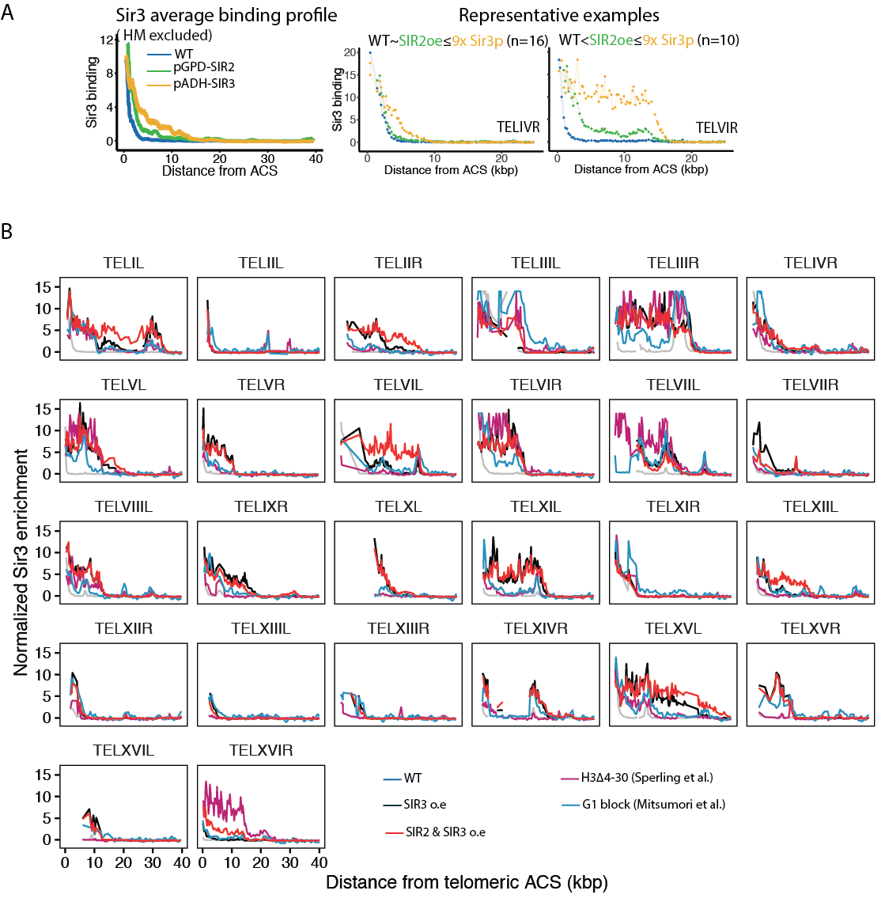
Supplemental_Fig_4: (A) Moving average of Sir3 binding at telomeres (with the exception of TELIIIL and TELIIIR, which contain HM loci) as in Fig 1F, in the indicated genotypes. Representative examples of Sir3 binding. (B) Sir3 binding at individual subtelomeres. Enrichment corresponds to standardized Sir3 binding (z-score). Origin of external dataset is indicated. 6 subtelomeres are not shown due to insufficient data.

Supplemental_Fig_S5: (A) Distribution of selected histone marks relative to H3 (data from Weiner et al. 2015, except H3K79me2 from Schulze et al. 2009) at the flanks of WT silent domain ends (5kb) at the three groups of subtelomeres that are eventually sensitive to SIR3 overexpression. (B) Distribution of selected histone marks relative to H3 (data from Weiner et al. 2015 except H3K79me2, from Schulze et al. 2009) along wild type silenced domains and within the contiguous subtelomeric domains accessible to Sir3 upon overexpression. As a control, the distribution of those marks within the 5 kb contiguous to the end of extended silent domains as well as the genome wide distribution of those. (C) Identical as B but focusing on nucleosomes localized over gene bodies.

Supplemental_Fig_S6: (A) Drop assays probing viability in the presence or absence of 5 mM NAM. Protocol is identical to the one of Fig 6B. Genotypes are as indicated. (B) dot1 mutants overexpressing Sir3-A2Q are viable. (C) DOT1 overexpression counteracts SIR3 overexpression. WT strains have an ADE2 reporter gene located at telomere VL. (D) SGA score of all histone point mutants probed, colored points pass our significance criterion and are colored according to their respective behavior (rescued by NAM treatment, sick in all conditions). (E) Genome browser visualization of Sir3 binding in pGPD-SIR3 and dot1∆ pGPD-SIR3 strains 8 hours after being released from 5 mM NAM. tRNA tL(UAA)B1 is labelled in red. H3K79 methylation enrichment were obtained from Weiner et al. 2015 for H3K79me and H3K79me3 and from Schulze et al. 2009 for H3K79me2 (Mat score is shown). (F) Drop assays probing viability in the presence or absence of 5 mM NAM in rad6 mutants. Cells were grown over night in YPD + 5 mM NAM and release 3h in YPD before plating on YPD or YPD + NAM.
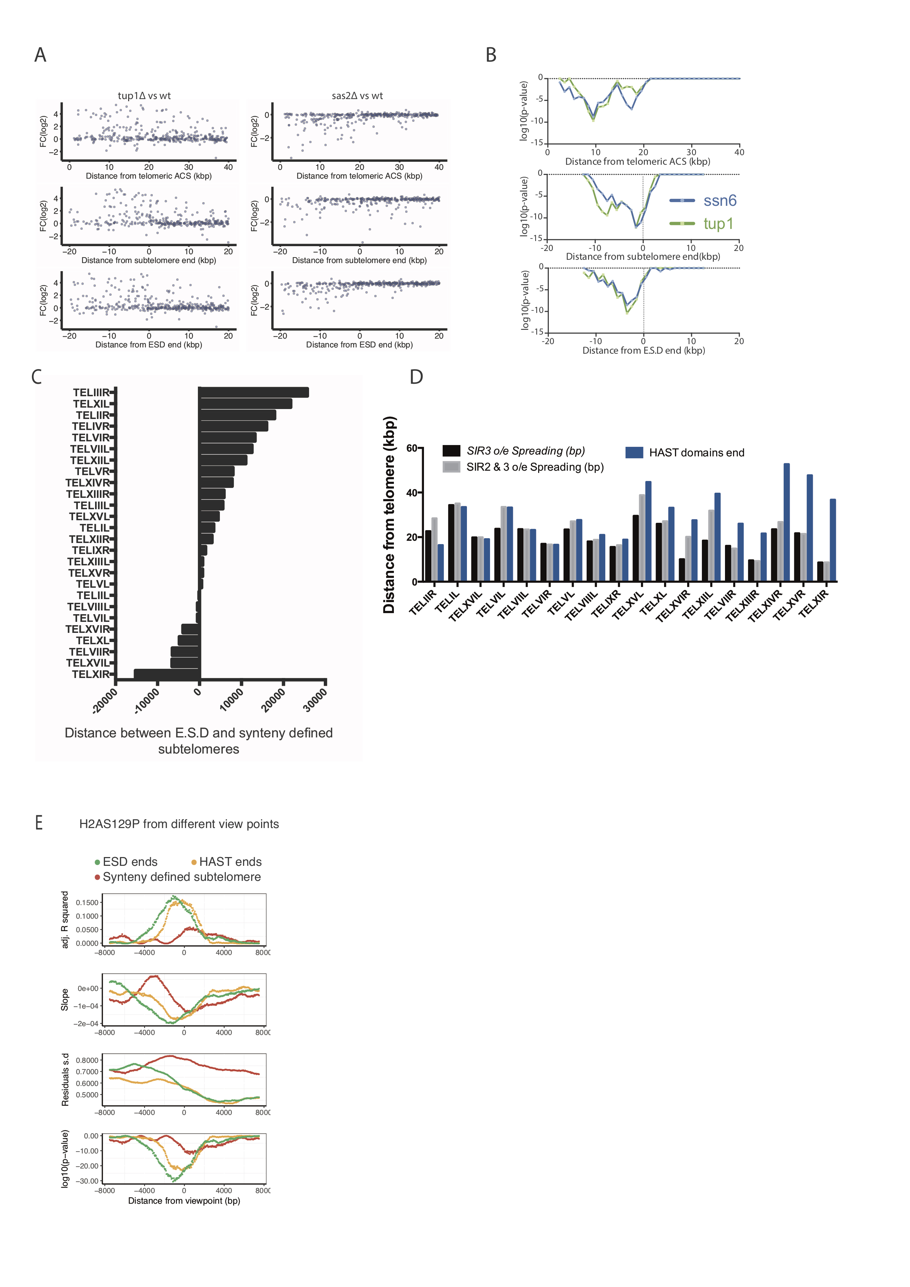
Supplemental_Fig_S7: (A) Expression changes in the tup1 and sas2 mutants in function of different subtelomeric viewpoints. (B) Corrected p-values of hyper-geometric test for sliding 5 kb windows (step=1kb) is shown for tup1 and ssn6 mutants in function of different subtelomeric viewpoints. This analysis corresponds to Fig 7B. Each point represents the center of a 5 kb window. (C) Comparison of ESD ends with subtelomere ends as defined by synteny in Yue et al. 2017. (D) Comparison of ESD ends with HAST domain ends as defined in Robyr et al. 2002. (E) H2AS129ph transitions at subtelomeres in function of different viewpoints, similar to Fig 7C.

