Supplemental_Table_S1. Summary statistics of sequencing data for polysome profiling.

Samples | Raw reads | Qualified reads | Mapped to genome | Uniquely mapped to genome | Mapped to nuclear genome | After IP filter | Genes sampled by reads | All poly(A) sites | Genes sampled by cleavage clusters
MCF10A_1_unbound | 21232051 | 21166714 | 19553302 | 10733549 | 5566391 | 5086976 | 16042 | 66106 | 13322
MCF10A_1_bound | 21271826 | 21233488 | 19587492 | 13024406 | 12376892 | 11567565 | 15558 | 82405 | 13757
MCF-7_1_unbound | 18402120 | 18376712 | 11985553 | 7282818 | 2544680 | 2247561 | 14597 | 47663 | 12374
MCF-7_1_bound | 23958672 | 23902672 | 20895060 | 14843820 | 14071736 | 12949933 | 15948 | 98613 | 14292
MCF-7_2_unbound | 13140635 | 13112364 | 10154448 | 5470872 | 2291225 | 2034928 | 14524 | 42733 | 12112
MCF-7_2_bound | 17502342 | 17456713 | 15976423 | 11382002 | 10952239 | 10042944 | 15418 | 82887 | 13804
MCF-7_3_unbound | 32029095 | 31984789 | 25257322 | 14788095 | 6690618 | 6044811 | 16947 | 82478 | 14061
MCF-7_3_bound | 23601923 | 23551974 | 21133070 | 14948239 | 14174094 | 13208333 | 16326 | 93196 | 14326
NCM460_1_unbound | 20038516 | 19878935 | 15064159 | 9427744 | 7371153 | 6516940 | 14996 | 74159 | 13292
NCM460_1_bound | 15610833 | 15520001 | 13068771 | 8653543 | 8395203 | 7591431 | 14769 | 74839 | 13193
NCM460_2_unbound | 19665124 | 19545639 | 15414189 | 9136842 | 6968897 | 6080768 | 14885 | 78244 | 13244
NCM460_2_bound | 13466352 | 13311273 | 11465025 | 7759373 | 7487138 | 6902166 | 14648 | 63263 | 12999
NCM460_3_unbound | 13238288 | 13175709 | 9835325 | 4960382 | 3817047 | 3236153 | 14487 | 62976 | 12545
NCM460_3_bound | 17001191 | 16883102 | 13687967 | 8972736 | 8587493 | 7701666 | 14863 | 79483 | 13265
SW480_1_unbound | 21671807 | 21531267 | 19521678 | 11967265 | 8923942 | 6869221 | 15781 | 117938 | 13865
SW480_1_bound | 20578443 | 20483228 | 18620201 | 12467299 | 11786441 | 9987267 | 15719 | 104434 | 13967
SW480_2_unbound | 20283528 | 20214805 | 18329716 | 11275823 | 8597409 | 6978564 | 15668 | 109157 | 13826
SW480_2_bound | 16761250 | 16693329 | 15114726 | 9997310 | 9463709 | 8103801 | 15446 | 95116 | 13722
SW480_3_unbound | 66470470 | 66315810 | 60458130 | 36530688 | 26244783 | 21022078 | 16986 | 225629 | 15325
SW480_3_bound | 58807435 | 58662147 | 53394555 | 35102852 | 33117480 | 28406369 | 16893 | 196673 | 15233
RKO_1_unbound | 14342563 | 14223088 | 13325898 | 7300403 | 4020027 | 3531726 | 13964 | 53288 | 11998
RKO_1_bound | 13956052 | 13857846 | 12596306 | 7870192 | 7357750 | 6593812 | 14208 | 79445 | 12551
RKO_2_unbound | 13704450 | 13544876 | 12609970 | 6870392 | 3683046 | 3267622 | 13654 | 53528 | 11969
RKO_2_bound | 13961098 | 13860050 | 12639250 | 8093871 | 7393994 | 6644118 | 13921 | 77896 | 12539
RKO_3_unbound | 13038295 | 12979231 | 12088225 | 6052715 | 3078163 | 2620731 | 13548 | 52273 | 11603
RKO_3_bound | 13227981 | 13126800 | 11833660 | 7805354 | 7320338 | 6651078 | 13828 | 72947 | 12402
NIH3T3_1_unbound | 18480272 | 18295405 | 16815247 | 7031896 | 5400915 | 4874359 | 15180 | 119322 | 13223
NIH3T3_1_bound | 18859553 | 18647252 | 17146702 | 9964819 | 9845212 | 9223404 | 14386 | 84021 | 12779
NIH3T3_2_unbound | 19115389 | 18942619 | 17297214 | 7580468 | 5021175 | 4456670 | 15270 | 121422 | 13196
NIH3T3_2_bound | 20862556 | 20601825 | 18982969 | 10702731 | 10348457 | 9758415 | 14740 | 91566 | 13045
NIH3T3_3_unbound | 29974180 | 29902618 | 26564268 | 11849769 | 7147395 | 6617810 | 15085 | 123550 | 13224
NIH3T3_3_bound | 28946211 | 28912870 | 2858986 | 15934460 | 15531842 | 14880064 | 14460 | 84885 | 13013
NIH3T3_sub-confluency_unbound | 21276033 | 21112294 | 19287831 | 8574373 | 6054785 | 5563295 | 15102 | 110493 | 13220
NIH3T3_sub-confluency_bound | 19291457 | 19125088 | 17169006 | 1002629 | 9947535 | 9289845 | 14262 | 85759 | 12618
L929_1_unbound | 21802172 | 21782092 | 12757647 | 6476297 | 6062831 | 5604304 | 14430 | 66797 | 12788
L929_1_bound | 22475053 | 22459689 | 19653460 | 12563563 | 12442932 | 11850743 | 14517 | 73033 | 13055
L929_2_unbound | 23724428 | 23705754 | 14501420 | 7739482 | 7275036 | 6732978 | 14564 | 71219 | 13009
L929_2_bound | 23328773 | 23315826 | 20632820 | 13221743 | 13134554 | 12484223 | 14552 | 74409 | 13152
L929_3_unbound | 25829412 | 25809303 | 14536207 | 8158933 | 7423345 | 6802852 | 14571 | 77411 | 13036
L929_3_bound | 22249776 | 22235403 | 19293512 | 12499529 | 12327960 | 11561018 | 14530 | 78097 | 13074
MCF-7_TNRC6A_KD_1_unbound | 27652978 | 27604757 | 20612679 | 13682297 | 7298320 | 6411261 | 15597 | 82504 | 13728
MCF-7_TNRC6A_KD_1_bound | 31967879 | 31898012 | 25246736 | 18895999 | 18319311 | 16800694 | 15939 | 103487 | 14330
MCF-7_TNRC6A_KD_2_unbound | 32834640 | 32822684 | 30252410 | 17907932 | 10234517 | 8969170 | 15907 | 100628 | 14054
MCF-7_TNRC6A_KD_2_bound | 31190043 | 31170951 | 28257320 | 19302122 | 18733222 | 17725653 | 15648 | 97486 | 14199
NIH3T3_Tnrc6a_OE_unbound | 32029658 | 31939358 | 28346842 | 12100700 | 8731961 | 7983811 | 16415 | 137610 | 14279
NIH3T3_Tnrc6a_OE_bound | 23327115 | 23307026 | 21138710 | 13290131 | 12732595 | 12103148 | 15287 | 93756 | 13506
NIH3T3_G0/G1_phase_unbound | 16091026 | 16077246 | 14397269 | 6858760 | 4437027 | 4140839 | 14747 | 62968 | 12789
NIH3T3_G0/G1_phase_bound | 22011619 | 21995354 | 19609262 | 13055142 | 12739018 | 12144057 | 15107 | 77165 | 13404
NIH3T3_G2/M_phase_unbound | 42461237 | 42118110 | 35917002 | 13289881 | 10267723 | 8842961 | 16836 | 156304 | 14750
NIH3T3_G2/M_phase_bound | 18467777 | 18413277 | 16063255 | 8789542 | 8447519 | 7991882 | 15458 | 86370 | 13338
L929_G0/G1_phase_ unbound | 26554389 | 26465633 | 22448220 | 12545312 | 7351046 | 6740338 | 15197 | 82720 | 13577
L929_G0/G1_phase_ bound | 28456997 | 28405299 | 24984341 | 17573466 | 16878153 | 15844451 | 15300 | 91073 | 13807
L929_G2/M_phase_ unbound | 28195360 | 28119031 | 15919264 | 7107381 | 6695082 | 5676410 | 15883 | 93107 | 13932
L929_G2/M_phase_ bound | 21930330 | 21915523 | 14888111 | 9140119 | 9088730 | 8624763 | 15074 | 73292 | 13377
Naive_T_unbound | 28495203 | 28488925 | 25593441 | 12362154 | 9052372 | 8497011 | 14159 | 58360 | 12436
Naive_T_bound | 30957394 | 30952248 | 28114558 | 17712297 | 15182539 | 13844813 | 15120 | 93021 | 13627

Supplemental_Table_S2. Genes and Primers of qRT-PCR validation with polysome profiling.

Cell line | Gene | Common region | Extended region
MCF10A | PRDX6 | AGATTCTCAGGGTAGTCA  CCATCCTTCCAATCAACT | CTTGCTTCACTCCATCAG  AGTTCTGCCACTCTTCAA
MCF10A | SNRPD1 | GTGGATGTTGAACCTAAG  CTCTTCCTCTTCCTCTTC | ACCATAATAGGCTCAGAG  TGTTGCTGTATCTCACTT
MCF10A | PAICS | CTTAGGCTAGACACCAAGATAT  CTCAATAGTAGTGACCACCAATA | TAACCACAGTGACTACAA  CTAAGCATAGCACATCAG
MCF10A | ESYT2 | TTATTACCAGACAAGAGG  GTAACGAAACACTGAAAT | TTCAATGTTAGCAATTAAGC  AATATCCTGTCTACTCACT
MCF10A | MYO1B | CTCTATCGCACAACTCTC  TGTCCTGTCTGAACTGTA | CTGTGCTAGATGGTATGA  GGTTCCTAATAATGCTGTC
MCF-7 | PRDX1 | GATCACTGTAAATGACCTCCCT  CGCAGCCTGGCACTAAA | CGCTGGGCTGTTTTAGTGC  ACGCCAACTCAGGCCATTC
MCF-7 | MFSD1 | AGTGTTCTTCATTGCCTGTGT  TTATTTCTTCCCTTTGTCTTGC | TTTGAGGGAAATAGAAGGGCTG  GCTCGGCAATCCACATAACTAC
MCF-7 | PGK1 | CAAGTCGGTAGTCCTTATGAGCC  CCACATGAAAGCGGAGGTTCT | TTTGTTAGGAAGGGTGAGAATAG  CACAATGTCTGCCATAAAGTAGG
MCF-7 | HNRNPH3 | AAGTCTTGACAACAGCATCTGG  AAACATTTTCCCATCACAATC | TTTTCTTTAGTTCCTCCTGGAC  TTTTGGTATTTCGGTCAAGTG
MCF-7 | LAMP2 | GTTCGCTGGATGATGACAC  GAGCTGGACTGCAACTAAATAT | GCGGCTGAGGCAGGAGAAT  GCAATCAATGCAAGCTGGAAAC
MCF-7 | PEX19 | TTCGATAAAGCCAAACCCTC  TCCTCAGCCAACTCCTTCAT | CAGGGCTTACTCCAGGAATCTA  AGTACCATAACTCCACCACAAGTC
MCF-7 | CNIH4 | GATACATTATGGTGCCGAGTGG  ACTTCAACCACGGCTTCTCC | GCTACTACCTCCACAATCACC  TAAGGCTCAATTTCACAGACAG
MCF-7 | MLX | ATTGTGATTGGCGTCCTG  GCCTCTTGTTGGCTGTTCT | ATGGCAGAGGCAGGTATAAC  AGATATGCTTGACAGAAAGGGT
MCF-7 | PERP | ACCCAGACCTTCACCCTTCA  CCATCTCAGCAGCAGCGAT | CTTACTATTTCATGGTCCAAACC  CAAGAATGACCCTCCTAATGC
MCF-7 | YME1L1 | GAGGAAGAGTGGCAGAGGAG  TTGTTCGATGGCAGATTGG | AAAATTGTGCCTTTAGCCTTC  CTGGCTCTGTGTTTCCGAG
MCF-7 | GHITM | TGTGCTACTATGGCTTGGGACT  CAGGCGTTCTGCTGATTGC | TGGAGCTTTGGTAAAGGGAC  AGCAACAGCAGGAGAATGC
MCF-7 | UBE2N | TCTGCCAAGACTTCCTCCT  AGATGATACTTCTAGCCTCTGC | TTGCTTTCATCCCTCCAGTAT  TGGGCTACAATATCCATTACCT

Supplemental _Table_S3. Primers for dual luciferase reporter assay.

Dual-Luciferase gene qRT-PCR primers
Renilla_luciferase_F | GGCTCGCTGCAAGCAAATGAA
Renilla_luciferase_R | CCAGTCGTGGCCCACAAAGAT
Firefly_luciferase_F | GTGGACATCACCTATGCCGAGTA
Firefly_luciferase_R | CCACGGTAGGCTGAGAAATGC
3'UTR cloning and PAS mutation primers (MCF7 cell line)
CNIH4_S_UTR_F | CCGCTCGAGAGCTGGAGAAGCCGTGGTT
CNIH4_S_UTR_R | CCGGCGGCCGCACTTTATATGGTAAAAATACAGCAAAAAT
CNIH4_L_UTR_F | CCGCTCGAGAGCTGGAGAAGCCGTGGTT
CNIH4_L_UTR_R | CCGGCGGCCGCGAGGATAAATTGCCAGGTTTATTTTAC
CNIH4_mut_APA_F1 | AGCTGGAGAAGCCGTG
CNIH4_mut_APA_R1 | GGGAGATGGTAAAAATACAGCAAAAATAGTT
CNIH4_mut_APA_F2 | GCTGTATTTTTACCATCTCCCGTATTT
CNIH4_mut_APA_R2 | GAGGATAAATTGCCAGG
PPIA_S_UTR_F | CCGCTCGAGGTTTGACTTGTGTTTTATCTTAACC
PPIA_S_UTR_R | CCGGCGGCCGCAACGAGGACAATTGTTATTTAGTT
PPIA_L_UTR_F | CCGCTCGAGGTTTGACTTGTGTTTTATCTTAACC
PPIA_L_UTR_R | CCGGCGGCCGCTAGGGATAATGAAAAGATGTTT
PPIA_mut_APA_F1 | CCGCTCGAGGTTTGACTTGTGTTTTATCTTAACC
PPIA_mut_APA_R1 | ATTTAGTTGGGAGGTCATAATCATAAACTTAACTCTGC
PPIA_mut_APA_F2 | CACCACCACCCATCTCAGTCTTGTGTGTTGTC
PPIA_mut_APA_R2 | CCGGCGGCCGCTAGGGATAATGAAAAGATGTTT
ACSL3_S_UTR_F | CCGCTCGAGTTATTCTCTTCTGGCATCAG
ACSL3_S_UTR_R | CCGGCGGCCGCTGTCTTAATGTTTTACTAATCCTG
ACSL3_L_UTR_F | CCGCTCGAGTTATTCTCTTCTGGCATCAG
ACSL3_L_UTR_R | CCGGCGGCCGCGGGTATATTTATTTCTCTCAAATG
ACSL3_mut_APA_F1 | CCGCTCGAGTTATTCTCTTCTGGCATCAG
ACSL3_mut_APA_R1 | TTGCTGTCTTAATGTGGGAGGAATCCT
ACSL3_mut_APA_F2 | CCTCCCACATTAAGACAGCAAACTTGTG
ACSL3_mut_APA_R2 | CCGGCGGCCGCGGGTATATTTATTTCTCTCAAATG
TRAM1_S_UTR_F | CCGCTCGAGTGAATTATAAACTAATTGATTAATGTCC
TRAM1_S_UTR_R | CCGGCGGCCGCAAGAGCACAGACTGTATTTTCAAGA
TRAM1_L_UTR_F | CCGCTCGAGTGAATTATAAACTAATTGATTAATGTCC
TRAM1_L_UTR_R | CCGGCGGCCGCAAGTAAAAATTTTTATTTTGATTGATT
TRAM1_mut_APA_F1 | CCGCTCGAGTGAATTATAAACTAATTGATTAATGTCC
TRAM1_mut_APA_R1 | CAAAAATCAAAGAGCACAGAGGGGTTTTCAAGA
TRAM1_mut_APA_F2 | AACCCCGTCTGTGCTCTTTGATTTTTG
TRAM1_mut_APA_R2 | CCGGCGGCCGCAAGTAAAAATTTTTATTTTGATTGATT
CCND1_S_UTR_F | AATTCTAGGCGATCGCTCGAGGGGCGCCAGGCAGGCGGG
CCND1_S_UTR_R | ATTTTATTGCGGCCAGCGGCCGCTAATCTTTTTCTTTTGCTTAAGTCAGAGA
CCND1_mut_APA_F1 | AATTCTAGGCGATCGCTCGAGGGGCGCCAGGCAGGCGGG
CCND1_mut_APA_R1 | GGGTAATCTTGGTGAGTTGCTTAAGTCAGA
CCND1_mut_APA_F2 | GCAACTCACCAAGATTACCCAAAAACTGTCTTTAAAAGAGAGA
CCND1_mut_APA_R2 | ATTTTATTGCGGCCAGCGGCCGCGTTTTACCAGTTTTATTTCTAGACTTTCATG
3'UTR cloning and PAS mutation primers (NIH3T3 cell line)
Ank_S_UTR_F | AATTCTAGGCGATCGCTCGAGGCACAGGCTGCTGGGGGC
Ank_S_UTR_R | ATTTTATTGCGGCCAGCGGCCGCATTAGAGACATTTTATTGAAAATGCGA
Ank_mut_APA_F1 | AATTCTAGGCGATCGCTCGAGGCACAGGCTGCTGGGGGC
Ank_mut_APA_R1 | GAGACATGGGGTGGAAAATGCGAAAATAGGAAATGT
Ank_mut_APA_F2 | CATTTTCCACCCCATGTCTCTAATACAATTCAGTGATTGCC
Ank_mut_APA_R2 | ATTTTATTGCGGCCAGCGGCCGCAAAATATTGCTGTTTAATTTTCTAGTCATG
Arf6_S_UTR_F | AATTCTAGGCGATCGCTCGAGTGAGCGTCCTCCACCCAGC
Arf6_S_UTR_R | ATTTTATTGCGGCCAGCGGCCGCGCAATAATTTTCAGTTTACTAGATGAAACA
Arf6_mut_APA_F1 | AATTCTAGGCGATCGCTCGAGTGAGCGTCCTCCACCCAGC
Arf6_mut_APA_R1 | CAGGTGGCTAGATGAAACAGACTTGGAACATAGTC
Arf6_mut_APA_F2 | CTGTTTCATCTAGCCACCTGAAAATTATTGCTTAATCAAACTGC
Arf6_mut_APA_R2 | ATTTTATTGCGGCCAGCGGCCGCACTGTGTAATTCCTTTATTTTCTGCATG
E2f1_S_UTR_F | AATTCTAGGCGATCGCTCGAGCAGAAGCCTAGGGATTCAGGG
E2f1_S_UTR_R | ATTTTATTGCGGCCAGCGGCCGCATCGGAAAACTTTTAAGCAGTGC
E2f1_L_UTR_F | AATTCTAGGCGATCGCTCGAGCAGAAGCCTAGGGATTCAGGG
E2f1_L_UTR_R | ATTTTATTGCGGCCAGCGGCCGCCATCAAAACATTTATTAAAATCAAAGCA
Nudcd2_S_UTR_F | AATTCTAGGCGATCGCTCGAGCTGCTATTGCTTAGTGTTTCTCTGTCT
Nudcd2_S_UTR_R | ATTTTATTGCGGCCAGCGGCCGCCAACATGGTTGTGAGATCACACAC
Nudcd2_mut_APA_F1 | AATTCTAGGCGATCGCTCGAGCTGCTATTGCTTAGTGTTTCTCTGTCT
Nudcd2_mut_APA_R1 | CTCAACATGGTTGTGAGATCACACACATACAAAAAAA
Nudcd2_mut_APA_F2 | GATCTCACAACCATGTTGAGTAAATTTCTGAGTAAGAGTTGTATACC
Nudcd2_mut_APA_R2 | ATTTTATTGCGGCCAGCGGCCGCGGTGACAACATGTCAATTTATTAGAAAA
Dtd2_S_UTR_F | AATTCTAGGCGATCGCTCGAGTGATTCATAGATCTCTGTTTCCCTGG
Dtd2_S_UTR_R | ATTTTATTGCGGCCAGCGGCCGCAGACACAGTCTCACTACATAGTCTTAGCTT
Dtd2_L_UTR_F | AATTCTAGGCGATCGCTCGAGTGATTCATAGATCTCTGTTTCCCTGG
Dtd2_L_UTR_R | ATTTTATTGCGGCCAGCGGCCGCGGGCACAAAGTTTAATAGTTGCTTC
Rnf11_S_UTR_F | AATTCTAGGCGATCGCTCGAGGCCAGGGTCTCTCGTCTGACT
Rnf11_S_UTR_R | ATTTTATTGCGGCCAGCGGCCGCGCCAGTGTTATAAAATGTAGCTGGTG
Rnf11_mut_APA_F1 | AATTCTAGGCGATCGCTCGAGGCCAGGGTCTCTCGTCTGACT
Rnf11_mut_APA_R1 | GCTGGTGAGAAAACCTTGACCCAAATGTCAGTAA
Rnf11_mut_APA_F2 | GTCAAGGTTTTCTCACCAGCTACATTTTATAACACTGGCACAA
Rnf11_mut_APA_R2 | ATTTTATTGCGGCCAGCGGCCGCATAAAACATTACACTTTACTAGACCATTTCTAC

Supplemental_Table_S4. Primers and Oligo sequences for TNRC6A.

Primers for amplification of mouse Tnrc6a.
Tnrc6a_clone_F | ACCTCTGGATCCACAGAATTCATGAGAGAATTGGAAGCTAAAGCTACC
Tnrc6a_clone_R | ACTGATTCTAGATGACTCGAGTTTACGTCTATACCTATGCCATTACATG
qRT-PCR primers for human TNRC6A
TNRC6A_qF | CAAAATGGAGATTGATGATGGAA
TNRC6A_qR | ACAGTTGTGGCTGGAGTAGAAGG
qRT-PCR primers for mouse Tnrc6a
Tnrc6a_qF | ACTAATAATAATGCCAAGCGAGC
Tnrc6a_qR | GTTTAACACCTTAACAGCAGATCC
SiRNA target sequences for human TNRC6A
siRNA1 | GGAGAAACTTCAAGGAATA
siRNA2 | CAGAAATAGTGATTCCAAA

Supplemental_Fig_S1. Schematic of polysome profiling and IVT-SAPAS.

Supplemental_Fig_S2. IVT-SAPAS reads distribution for genes validated with qRT-PCR in Fig. 3A.

Supplemental_Fig_S3. Validation of miRNA effects on translational efficiency difference between mRNAs with shorter and longer 3'UTR by TNRC6A-knockdown. Dual-luciferase reporter plasmid and siRNA were co-transfected into MCF-7 cell line. Six replicates were performed. Renilla fluorescence and mRNA level were normalized to firefly fluorescence and the mRNA level, respectively, and then the translational efficiency was calculated as the renilla protein/mRNA ratio. Bootstrap with 1000 times was performed to obtain the distribution of translation efficiency ratio (Shorter/Longer) difference between TNRC6A-knockdown and the control. For each resampling, we calculated the mean of translational efficiency for the shorter and longer 3'UTRs and their ratios, then we calculated the difference between TNRC6A-knockdown and the control.

Supplemental_Fig_S4. PI Analysis of percentage of cell cycle of different cell lines in continued culture. Cells were labelled with PI (50ug/ml) and analyzed with FACS Callibur flow cytometer (BD Biosciences). ModFit LT software was applied to calculate percentage of G1/G0, S, G2/M phase. A) NIH3T3 cells were collected at ~70% density; B) MCF-7 cells were harvested at ~70% density; C) L929 cells were collected at ~70% density.

Supplemental_Fig_S5. PI Analysis of percentage of cell cycle of synchronization of cell sample. Cells were labelled with PI (50ug/ml) and analyzed the percentage of G1/G0, S, G2/M phase with FACS Callibur flow cytometer (BD Biosciences). A) NIH3T3 G1/G0 cells were acquired by contact inhibition; B) NIH3T3 G2/M phase cells were obtained by double thymidine block and release; C) L929 G1/G0 cells were obtained by serum starvation; D) L929 G2/M cells were acquired by double thymidine block and release.

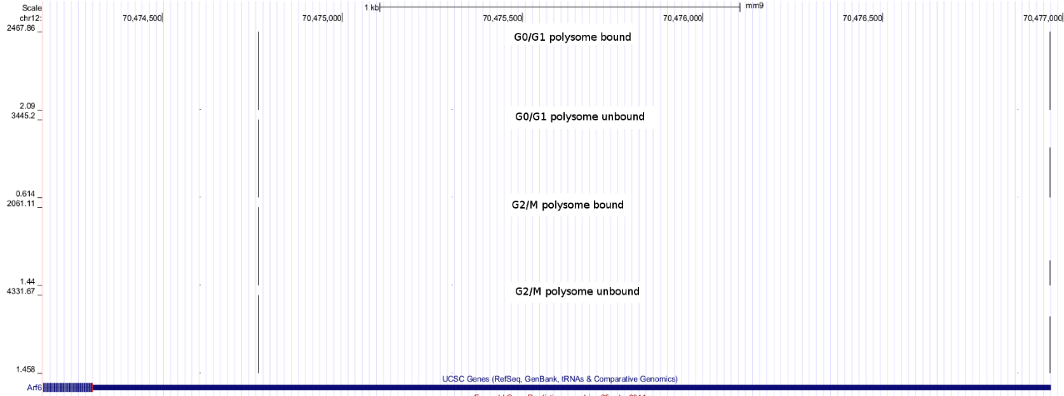

Supplemental_Fig_S6. IVT-SAPAS reads distribution for Arf6 gene at different cell-cycle phases of L929 cell line.

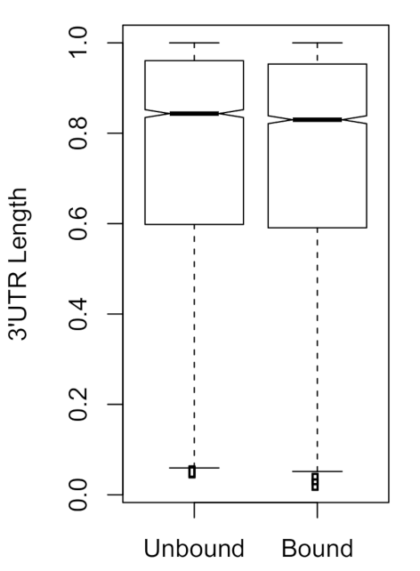

Supplemental_Fig_S7. mRNAs bound with polysome shows shorter 3'UTRs in NIH3T3 cells culturing with 50% confluency.
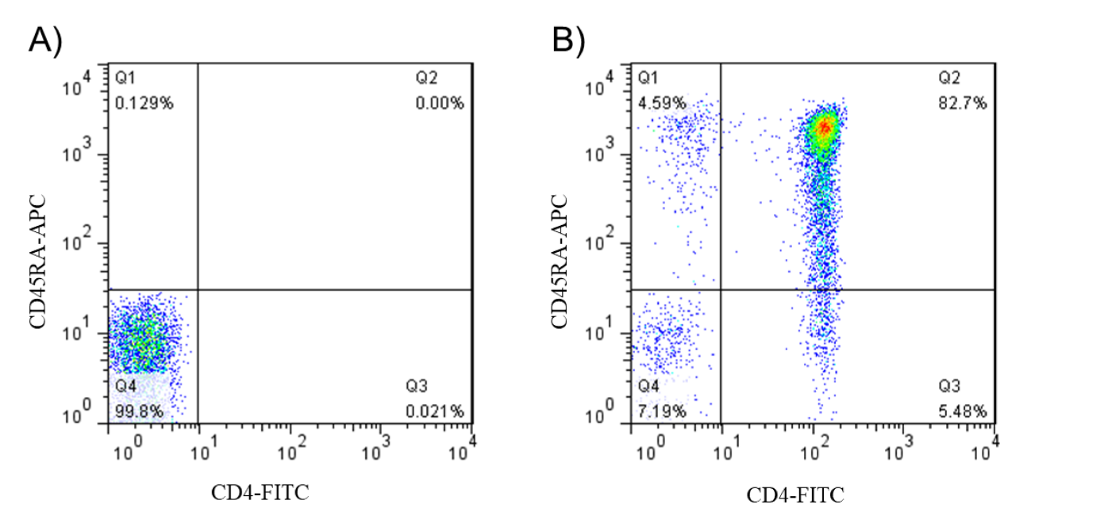

Supplemental_Fig_S8. Analysis of purification of naive CD4⁺ T cells with Flow cytometer. Flow cytometric analysis were performed for 1x 10⁶ purified naive CD4⁺ T cells without (A) and with (B) anti-CD45RA-APC and anti-CD4-FITCs staining.

