SUPPLEMENTAL MATERIALS

Goltsman D. A. et al., Metagenomic analysis with strain-level resolution reveals fine-scale variation in the human pregnancy microbiome.

- Extended Methods
- Supplemental Figures S1, S2, S3, S4, S5, S6, S7, S8, S9, S10, S11, S12, S13

EXTENDED METHODS
DNA sample preparation and whole community metagenomic sequencing
A subset of subjects from the cohort examined with 16S rRNA gene amplicon analysis in (DiGiulio et al. 2015) were selected for this study. The subject ID used in this paper corresponded to those used in the prior study: Term1 = 10039, Term2 = 10044, Term3 = 10034, Term4 = 10032, Term5 = 10047, Term6 = 10046, Pre1 = 10101; Pre2 = 10031; Pre3 = 10036; Pre4 = 10029 (DiGiulio et al. 2015). Data about these subjects are available in Supplementary Table 1. Six of these subjects (Term1-6) gave birth at term (after 37 weeks) while four of these subjects (Pre1-4) gave birth prematurely (before the completion of 37 weeks). Although prematurity is not addressed in this paper, subjects who delivered preterm were selected to include the microbiome functional potential from subjects that suffered this complication. Two of the term pregnancies were complicated by preeclampsia, one by oligohydramnios, and one by type 2 diabetes. One of the preterm pregnancies was complicated by preeclampsia. Subjects and samples were selected based on the following criteria: 1) subjects with samples collected roughly every third gestational week and on the same weeks across all subjects, to enable cross-subject comparisons; and 2) subjects with the highest compliance with sample collection at all three body sites. A total of 292 samples (101 vaginal swabs, 101 saliva, and 90 stool or rectal swabs) were selected for shotgun metagenomic analysis. No non-pregnant control subjects were included in this study.
DNA extraction methods have been reported previously (DiGiulio et al. 2015). DNA from each of the 292 samples was sheared to an average length of 400-500 bp. Barcoded TruSeq libraries were sequenced across 20 lanes of an Illumina HiSeq 2500 (150 bp x 2 mode) at the High-Throughput Sequencing and Genotyping Unit at the University of Illinois Roy J. Carver Biotechnology Center.

Sequence processing and assembly
More than 7 billion paired-end reads were obtained, for a total of 1.08 Tbp (Table 1). Briefly, low quality bases were trimmed using the Sickle trimmer script with default parameters (Joshi and Fass 2011), adapter sequences were removed with SeqPrep (John JS 2011), and sequences >100 bp were retained.
The Burrows-Wheeler Alignment (BWA) tool (Li and Durbin 2009) was used to map all trimmed reads to human genome version GRCh37, and human reads were filtered out. Although a newer release of the human genome is available, the alignments used here were performed prior to the release of GRCh38 in December 2013. Regardless of the reference, some human derived reads will likely remain due to natural variation in the human genome. We would not expect any significant effects on our conclusions as the mapping across our datasets were all relative to one human reference (GRCh37). Remaining reads were co-assembled across all time points per subject, per body site. Assemblies were created with IDBA_UD (Peng et al. 2012) using default parameters. Scaffolds from vaginal samples were binned based on %GC and coverage using the public knowledgebase, ggKbase (http://ggkbase.berkeley.edu), as well as time-series information using ESOM (Dick et al. 2009). Genes were predicted with Prodigal (Hyatt et al. 2010), tRNAs with tRNA-scan (Lowe and Eddy 1997), and functional annotations were assigned from BLAST (Camacho et al. 2008) searches against the KEGG (Kanehisa and Goto 2000) and UniRef100 (The UniProt Consortium 2017) databases.

Assessing the community composition
Full-length 16S rRNA gene sequences were reconstructed per body site with EMIRGE (Miller et al. 2011), using the SILVA database SSURef 111 (Pruesse et al. 2007) and run with 100 iterations. Sequences that were identified as chimeras with any two of the three chimera check software packages, UCHIME (Edgar et al. 2011), DECIPHER (Wright et al. 2012), and Bellerophon (Huber et al. 2004), were removed. The full-length 16S rRNA gene sequences from the six G. vaginalis strain genomes, and those from 22 publicly available genomes were aligned with MUSCLE (Edgar 2004) and visualized with Geneious (Kearse et al. 2012). 16S rRNA gene amplicon data from (DiGiulio et al. 2015; Callahan et al. 2017) were used to evaluate increasing richness trends with gestation. Briefly, the Shannon’s diversity index was plotted vs. gestational age for subsets of samples, with subsets generated based on the sample’s dominant taxon.

Calculations of relative abundances of genes and genome bins
The relative abundance was calculated for all genome bins from vaginal assemblies for each time point sampled. Using Bowtie 2 (Langmead 2010), sequencing reads from each time point were mapped to the co-assembled scaffolds from each subject. Vaginal genome bin abundance was calculated based on the numbers of reads that mapped to all co-assembled scaffolds within a bin, relative to the total number of reads that mapped to scaffolds from all bins within a subject. The final values were then taken as proportions (stacked 100%). Note that reads that did not map to any of the scaffolds or that mapped to scaffolds from unknown genome bins were not used in the calculations.
16 single-copy ribosomal protein (RP) gene sets were used to estimate bacterial diversity within body sites, as previously described (Hug et al. 2016). In total, 22,737 ribosomal proteins annotated as L14b/L23e, L15, L16/L10E, L18P/L5E, L2 rplB, L22, L24, L3, L4/L1e, L5, L6, S10, S17, S19, S3, and S8 were identified in 4,650 scaffolds from all body sites. Individual RP gene sets were clustered at 99% average amino acid identity (AAI) with usearch64 (Edgar 2010), and scaffolds containing the same sets of clustered RPs were considered to be derived from the same taxon (accounting for a total of 4,024 taxa). For example, when 4 RPs encoded in one scaffold belonged to the same RP cluster encoded in a different, longer scaffold, the two scaffolds were labeled as associated with the same taxon, and the longer scaffold was taken as the reference. Therefore, each taxon was represented by between 1 and 16 RPs.
Scaffold coverage (number of reads per scaffold divided by the scaffold length) was used to estimate read counts for predicted genes, by multiplying coverage by the predicted gene length. RP abundance tables (taxa abundance tables) were obtained by taking the average gene read counts within scaffolds (between 1 and 16 genes in a scaffold), and summed over the RP clusters described above. In addition, gene abundance tables were used to generate UniRef90 gene family abundance tables by summing the estimated gene read counts over each UniRef90 family. NMDS ordination (which seeks all underlying variation in a dataset (Oksanen et al. 2012)) was performed on Bray-Curtis distance matrices of variance-stabilizing transformed UniRef90 gene family abundance tables using the DESeq2 (Love et al. 2014) and phyloseq (McMurdie and Holmes 2013) packages in R (R Core Team 2017). In addition, and assuming that prior knowledge indicates doing so is sensible, RDA ordination can be used to test specific factors (or ‘constraints’) as sources of variation (Oksanen et al. 2012). RDA was performed directly on variance-stabilizing transformed UniRef90 gene family abundance tables using the same packages used for NMDS, with the formula: genes ~ gestational age + complication (for gut and oral samples), and genes ~ gestational age + top taxon (vaginal samples). The 16S rRNA gene tables, UniRef90 gene family tables, RP tables, pathway abundance tables, and R code are available at the Stanford Digital Repository (SDR) at https://purl.stanford.edu/vp282bh3698 (.rmd files contain the code, .RData files contain data tables).

Functional pathway presence and abundance analysis.
Functional pathways were predicted with HUMAnN2 (Abubucker et al. 2012) using the read FASTQ files. The output, a table of the presence and abundance (adjusted read counts) of functional pathways, was used to estimate potential trends with gestational age and with degree of diversity. Pathway abundance tables were variance-stabilized with DESeq2 in R and are available in .RData files at SDR (https://purl.stanford.edu/vp282bh3698).

G. vaginalis, L. iners, and L. crispatus phylogenetic trees and genome comparisons
Full-length 16S rRNA gene sequences from the six G. vaginalis strain genomes recovered via metagenomics, and those from 22 publicly available genomes were aligned with Muscle (Kearse et al. 2012) to generate Supplemental Fig. S8. Given that closed G. vaginalis genomes encode two identical copies of the 16S rRNA gene (Yeoman et al. 2010), 16S rRNA fragment sequences in four of the public genomes (strains 284V, JCP8108, JCP7672, and JCP7276) were joined with gaps.
The publicly available genomes of 34 G. vaginalis strains, plus the six strains recovered in this study were used to build the tree as shown in Fig. 4. The multiple genome alignments were obtained with progressiveMauve (Darling et al. 2010). Briefly, progressiveMauve finds initial local alignments and uses them as seeds, which are then progressively extended to global alignments (the pangenome) using a guide tree. The output of progressiveMauve, a specially formatted, extended multi-fasta file (.xmfa format), was visualized and exported in standard xmfa format using Gingr (Treangen et al. 2014), and converted to fasta format using a publicly available Perl script (Jolley K 2010). For G. vaginalis, the multiple genome alignment in fasta format was used to construct the phylogenetic trees using FastTree (Price et al. 2009) version 2.1.8 with parameters –nt –gtr –gamma. The trees in Newick format were visualized and exported using Geneious (Kearse et al. 2012).
Orthologous gene groups between G. vaginalis genomes were exported from the Mauve alignment based on at least 60% identity over 70% alignment coverage. Presence or absence of genes unique to each strain were not evaluated because only three of the 34 Gardnerella genomes were closed, making inferences about the presence/absence of genes difficult. 41,245 orthologous genes were present in at least half of the genomes within each of the five clades depicted in Fig. 4 (in total 1763 orthologous groups). Orthologous groups were classified into functional categories represented in the Gene Ontology (GO) Database by mapping GI gene numbers to GO ids in bioDBnet (Mudunuri et al. 2009). Predicted annotation was also used to group genes into functional categories. The 1763 orthologous groups could be classified into 212 functional categories represented in the Gene Ontology Database. Hierarchical clustering on the Jaccard distances of the presence/absence of these 1763 orthologous groups was performed with the vegan (Oksanen et al. 2012) and pheatmap (Kolde 2015) packages in R (R Core Team 2017). The number of clusters was determined visually from the hierarchical clustering, and the list of genes within each cluster was obtained with the function cutree from the R package “stats” (R Core Team 2017). The enrichment of genes within functional categories was estimated from the number of genes in each functional category within each cluster divided by the total number of orthologous genes in each cluster. kSNP3.0 (Gardner et al. 2015) was used to build phylogenetic trees from whole-genome SNP patterns in Supplemental Figs. S8B, S10A, and S11A.
Accession numbers for Gardnerella vaginalis genomes used in this study are SAMN02436832, SAMN02472074, SAMN02472073, SAMN02393773, SAMN02393775, SAMN00138210, SAMN02393781, SAMN02393782, SAMN02393783, SAMN02393779, SAMN02393784, SAMN02393777, SAMN02393778, SAMN02393774, SAMN02472072, SAMN02471014, SAMN02436904, SAMN02436712, SAMN02436831, SAMN02436711, SAMN02436912, SAMN02436773, SAMN02436710, SAMN02436911, SAMN02436830, SAMN02436772, SAMN02436771, SAMN02436910, SAMN02436829, SAMN02436909, SAMN02472071, CP001849, CP002104, and CP002725.
Six L. iners genomes assembled from vaginal samples in this study were used to assess synteny in Fig. 5. All strains were aligned as above, with L. iners DSM 13335 (the NCBI representative genome) as a reference. 16 publicly available L. iners strains as well as all 8 L. iners genomes assembled from this study were used for whole-genome SNPs and orthologous genes analyses in Supplemental Fig. S11. The NCBI assembly numbers for the publicly available L. iners genomes used in this study are: GCA_000160875.1, GCA_000185405.1, GCA_000149065.2, GCA_000149085.2, GCA_000149105.2, GCA_000149125.2, GCA_000149145.2, GCA_000177755.1, GCA_000179935.1, GCA_000179955.1, GCA_000179975.1, GCA_000179995.1, GCA_000191685.2, GCA_000191705.2, GCA_000204435.2, and GCA_001435015.1.
37 publicly available L. crispatus genomes (draft genomes in <120 scaffolds) as well as 6 L. crispatus genomes reconstructed from this study were used for whole-genome SNPs and orthologous genes analyses in Supplemental Fig. S12. All strains were aligned with the same methods as above, with L. crispatus ST1 (the NCBI representative genome) used as a reference. The NCBI assembly numbers for the publically available L. crispatus genomes used in this study are: GCA_000091765.1, GCA_000160515.1, GCA_000161915.2, GCA_000162255.1, GCA_000162315.1, GCA_000176975.2, GCA_000301115.1, GCA_000301135.1, GCA_000497065.1, GCA_001541385.1, GCA_001567095.1, GCA_001704465.1, GCA_002218565.1, GCA_002218655.1, GCA_002218735.1, GCA_002218765.1, GCA_002218775.1, GCA_002218805.1, GCA_001700475.1, GCA_002218615.1, GCA_002218645.1, GCA_002218685.1, GCA_002218695.1, GCA_002218815.1, GCA_002218855.1, GCA_002218885.1, GCA_002218895.1, GCA_002218925.1, GCA_002218945.1, GCA_002218965.1, GCA_002218975.1, GCA_002219005.1, GCA_002219015.1, GCA_002219045.1, GCA_002219055.1, GCA_002219085.1, GCA_000165885.1.
In order to determine if the L. iners and L. crispatus genomes from the gut and vagina were similar, we evaluated the single nucleotide polymorphisms (SNPs) between the two population genomes. First, we used Bowtie 2 to identify reads from the gut dataset that mapped to the genome of the corresponding Lactobacillus species assembled from the gut. Then Bowtie 2 was used to map that subset of reads against the vaginal population genome. Reads from the vaginal samples were also mapped to the corresponding Lactobacillus species assembled from the vagina. SAMtools (Li et al. 2009) was used to convert the SAM files to BAM and sort the BAM files. BAM files were processed with mpileup (with –B and –f), and VarScan (Koboldt et al. 2012) was used to identify the SNPs, with parameters, minimum coverage > 3 and p value < 0.05.

Calculating iRep values
We used iRep (with default parameters) to estimate the replication rate of genomes reconstructed from our vaginal metagenomic datasets as in (Brown et al. 2015). Briefly, we screened the genomes of interest (L. iners, L. crispatus, and G. vaginalis) with CheckM (Parks et al. 2015) to ensure that the genomes complied with the recommended genome completeness. For each genome, we obtained the vaginal reads from the same subject and mapped them to the consensus genome sequence separately per time point in order to generate a SAM file. Only genomes that passed quality control (completeness of the genome and coverage) were used.

Identification of CRISPR repeats/spacers, predicted Cas proteins, and CRISPR-Cas systems
The program Crass (Skennerton et al. 2013), with default settings, was used to identify CRISPR repeats and spacers from all reads from each sample. The output was parsed using CRISPRtools (http://ctskennerton.github.io/crisprtools/). HMMER3 (Mistry et al. 2013) was used to search all predicted proteins against a Cas proteins HMM database created from alignments from (Makarova et al. 2015; Shmakov et al. 2015). The HMM database can be found in Supp. Data 6 in (Burstein et al. 2016). Results were filtered for clusters of two or more Cas proteins that have less than 5 intervening ORFs (as done in Burstein et al. 2016). CRISPR-Cas system types were identified based on the presence of 2 predicted Cas proteins, one of which is required to be a key protein: Cas3 = type I, Cas9 = type II, Cas10 = type III, Csf1 = type IV, and Cpf1 = type V. CRISPR-Cas types were only calculated for gut and saliva samples, as the vaginal samples had low organismal diversity. Cas types that were incomplete were marked as unknown/unclassified.

Detection of potential phage and plasmid sequences and dynamics of spacer matching
In order to gain perspective on the potential phage and plasmid sequences in our dataset, we used CRISPR spacers to detect and assess variability of mobile element sequences. We used site-specific analyses to examine how spacer matches are shared between sites and individual analyses to determine how spacer matches are shared between subjects.
For site-specific analysis, CRISPR repeats and spacers were extracted from the reads combined across all sites (vaginal reads, gut reads, and saliva reads). For individual analyses, CRISPR repeats and spacers were extracted from each subject and combined for each site (term1 vaginal reads, term 1 gut reads, term1 saliva reads, etc.). Prior to any sequence search of spacers against scaffolds, we removed any scaffolds that had any sequence similarity to any CRISPR repeat. Briefly, all repeats detected in the site specific analysis were used to screen scaffolds with CRISPR loci within them, using blastn (modified for short queries). We removed all scaffolds with at least one repeat match that was at least 85% identical across 85% of the repeat length. While we might have screened for identical matches, we chose to be more conservative in order to reduce the chances of false detection of potential phage and plasmid sequences. For both the site-specific and the individual analyses, a spacer was recorded as a match if the spacer matched at least 85% identity and 85% of the spacer length across a scaffold. using BLASTN (Camacho et al. 2008), with parameter “-task blastn-short”.

REFERENCES

Abubucker S, Segata N, Goll J, Schubert AM, Izard J, Cantarel BL, Rodriguez-Mueller B, Zucker J, Thiagarajan M, Henrissat B et al. 2012. Metabolic reconstruction for metagenomic data and its application to the human microbiome. PLoS Comput Biol 8: e1002358.
Brown CT, Hug LA, Thomas BC, Sharon I, Castelle CJ, Singh A, Wilkins MJ, Wrighton KC, Williams KH, Banfield JF. 2015. Unusual biology across a group comprising more than 15% of domain Bacteria. Nature 523: 208-211.
Burstein D, Sun CL, Brown CT, Sharon I, Anantharaman K, Probst AJ, Thomas BC, Banfield JF. 2016. Major bacterial lineages are essentially devoid of CRISPR-Cas viral defence systems. Nature Commun 7: 10613.
Camacho C, Coulouris G, Avagyan V, Ma N, Papadopoulos J, Bealer K, Madden TL. 2008. BLAST+: architecture and applications. BMC Bioinformatics 10:421
Darling AE, Mau B, Perna NT. 2010. progressiveMauve: multiple genome alignment with gene gain, loss and rearrangement. PLoS One 5: e11147.
Dick GJ, Andersson AF, Baker BJ, Simmons SL, Thomas BC, Yelton AP, Banfield JF. 2009. Community-wide analysis of microbial genome sequence signatures. Genome Biol 10: R85.
Edgar RC. 2004. MUSCLE: multiple sequence alignment with high accuracy and high throughput. Nucleic Acids Res 32: 1792-1797.
Edgar RC. 2010. Search and clustering orders of magnitude faster than BLAST. Bioinformatics 26: 2460-2461.
Edgar RC, Haas BJ, Clemente JC, Quince C, Knight R. 2011. UCHIME improves sensitivity and speed of chimera detection. Bioinformatics 27: 2194-2200.
Gardner SN, Slezak T, Hall BG. 2015. kSNP3.0: SNP detection and phylogenetic analysis of genomes without genome alignment or reference genome. Bioinformatics 31: 2877-2878.
Huber T, Faulkner G, Hugenholtz P. 2004. Bellerophon: a program to detect chimeric sequences in multiple sequence alignments. Bioinformatics 20: 2317-2319.
Hug LA, Baker BJ, Anantharaman K, Brown CT, Probst AJ, Castelle CJ, Butterfield CN, Hernsdorf AW, Amano Y, Ise K et al. 2016. A new view of the tree of life. Nat Microbiol 1: 16048.
Hyatt D, Chen GL, Locascio PF, Land ML, Larimer FW, Hauser LJ. 2010. Prodigal: prokaryotic gene recognition and translation initiation site identification. BMC bioinformatics 11: 119.
John JS. 2011. SeqPrep. https://github.com/jstjohn/SeqPrep.
Joshi NA, Fass JN. 2011. Sickle: A sliding-window, adaptive, quality-based trimming tool for FastQ files (Version 1.33). https://github.com/najoshi/sickle.
Kanehisa M, Goto S. 2000. KEGG: kyoto encyclopedia of genes and genomes. Nucleic Acids Res 28: 27-30.
Kearse M, Moir R, Wilson A, Stones-Havas S, Cheung M, Sturrock S, Buxton S, Cooper A, Markowitz S, Duran C et al. 2012. Geneious Basic: an integrated and extendable desktop software platform for the organization and analysis of sequence data. Bioinformatics 28: 1647-1649.
Koboldt DC, Zhang Q, Larson DE, Shen D, McLellan MD, Lin L, Miller CA, Mardis ER, Ding L, Wilson RK. 2012. VarScan 2: somatic mutation and copy number alteration discovery in cancer by exome sequencing. Genome Res 22:568-76.
Kolde R. 2015. pheatmap: Pretty Heatmaps.
Langmead B. 2010. Aligning short sequencing reads with Bowtie. Curr Protoc Bioinformatics Chapter 11: Unit 11 17.
Li H, Handsaker B, Wysoker A, Fennell T, Ruan J, Homer N, Marth G, Abecasis G, Durbin R, and 1000 Genome Project Data Processing Subgroup. 2009. The Sequence alignment/map (SAM) format and SAMtools. Bioinformatics 25: 2078-9
Li H, Durbin R. 2009. Fast and accurate short read alignment with Burrows-Wheeler transform. Bioinformatics 25: 1754-1760.
Love MI, Huber W, Anders S. 2014. Moderated estimation of fold change and dispersion for RNA-seq data with DESeq2. Genome Biol 15: 550.
Lowe TM, Eddy SR. 1997. tRNAscan-SE: a program for improved detection of transfer RNA genes in genomic sequence. Nucleic Acids Res 25: 955-964.
Makarova KS, Wolf YI, Alkhnbashi OS, Costa F, Shah SA, Saunders SJ, Barrangou R, Brouns SJ, Charpentier E, Haft DH et al. 2015. An updated evolutionary classification of CRISPR-Cas systems. Nature Rev Microbiol 13: 722-736.
McMurdie PJ, Holmes S. 2013. phyloseq: an R package for reproducible interactive analysis and graphics of microbiome census data. PLoS One 8: e61217.
Miller CS, Baker BJ, Thomas BC, Singer SW, Banfield JF. 2011. EMIRGE: reconstruction of full-length ribosomal genes from microbial community short read sequencing data. Genome Biol 12: R44.
Mistry J, Finn RD, Eddy SR, Bateman A, Punta M. 2013. Challenges in Homology Search: HMMER3 and Convergent Evolution of Coiled-Coil Regions. Nucleic Acids Res 41:e121.
Mudunuri U, Che A, Yi M, Stephens RM. 2009. bioDBnet: the biological database network. Bioinformatics 25: 555-556.
Oksanen J, Blanchet F, Kindt R, Legendre P, O'Hara R, Simpson G, Solymos P, Stevens M, Wagner H. 2012. vegan: Community Ecology Package.
Parks DH, Imelfort M, Skennerton CT, Hugenholtz P, Tyson GW. 2015. CheckM: assessing the quality of microbial genomes recovered from isolates, single cells, and metagenomes. Genome Research 25: 1043-1055.
Peng Y, Leung HC, Yiu SM, Chin FY. 2012. IDBA-UD: a de novo assembler for single-cell and metagenomic sequencing data with highly uneven depth. Bioinformatics 28: 1420-1428.
Price MN, Dehal PS, Arkin AP. 2009. FastTree: computing large minimum evolution trees with profiles instead of a distance matrix. Mol Biol Evol 26: 1641-1650.
Pruesse E, Quast C, Knittel K, Fuchs BM, Ludwig W, Peplies J, Glockner FO. 2007. SILVA: a comprehensive online resource for quality checked and aligned ribosomal RNA sequence data compatible with ARB. Nucleic Acids Res 35: 7188-7196.
R Core Team. 2017. R: A language and environment for statistical computing. R Foundation for Statistical Computing, Vienna, Austria. https://www.R-project.org/.
Shmakov S, Abudayyeh OO, Makarova KS, Wol YIf, Gootenberg JS, Semenova E, Minakhin L, et al. 2015. Discovery and Functional Characterization of Diverse Class 2 CRISPR-Cas Systems. Molecular Cell 60: 385–97.
Skennerton CT, Imelfort M, Tyson GW. 2013. Crass: identification and reconstruction of CRISPR from unassembled metagenomic data. Nucleic Acids Res 41: e105.
The UniProt Consortium. 2017. UniProt: the universal protein knowledgebase. Nucleic Acids Research 45: D158-D169
Treangen TJ, Ondov BD, Koren S, Phillippy AM. 2014. The Harvest suite for rapid core-genome alignment and visualization of thousands of intraspecific microbial genomes. Genome Biol 15: 524.
Wright ES, Yilmaz LS, Noguera DR. 2012. DECIPHER, a search-based approach to chimera identification for 16S rRNA sequences. Appl Environ Microbiol 78: 717-725.
Yeoman CJ, Yildirim S, Thomas SM, Durkin AS, Torralba M, Sutton G, Buhay CJ, Ding Y, Dugan-Rocha SP, Muzny DM et al. 2010. Comparative genomics of Gardnerella vaginalis strains reveals substantial differences in metabolic and virulence potential. PLoS One 5: e12411.

SUPPLEMENTAL FIGURES

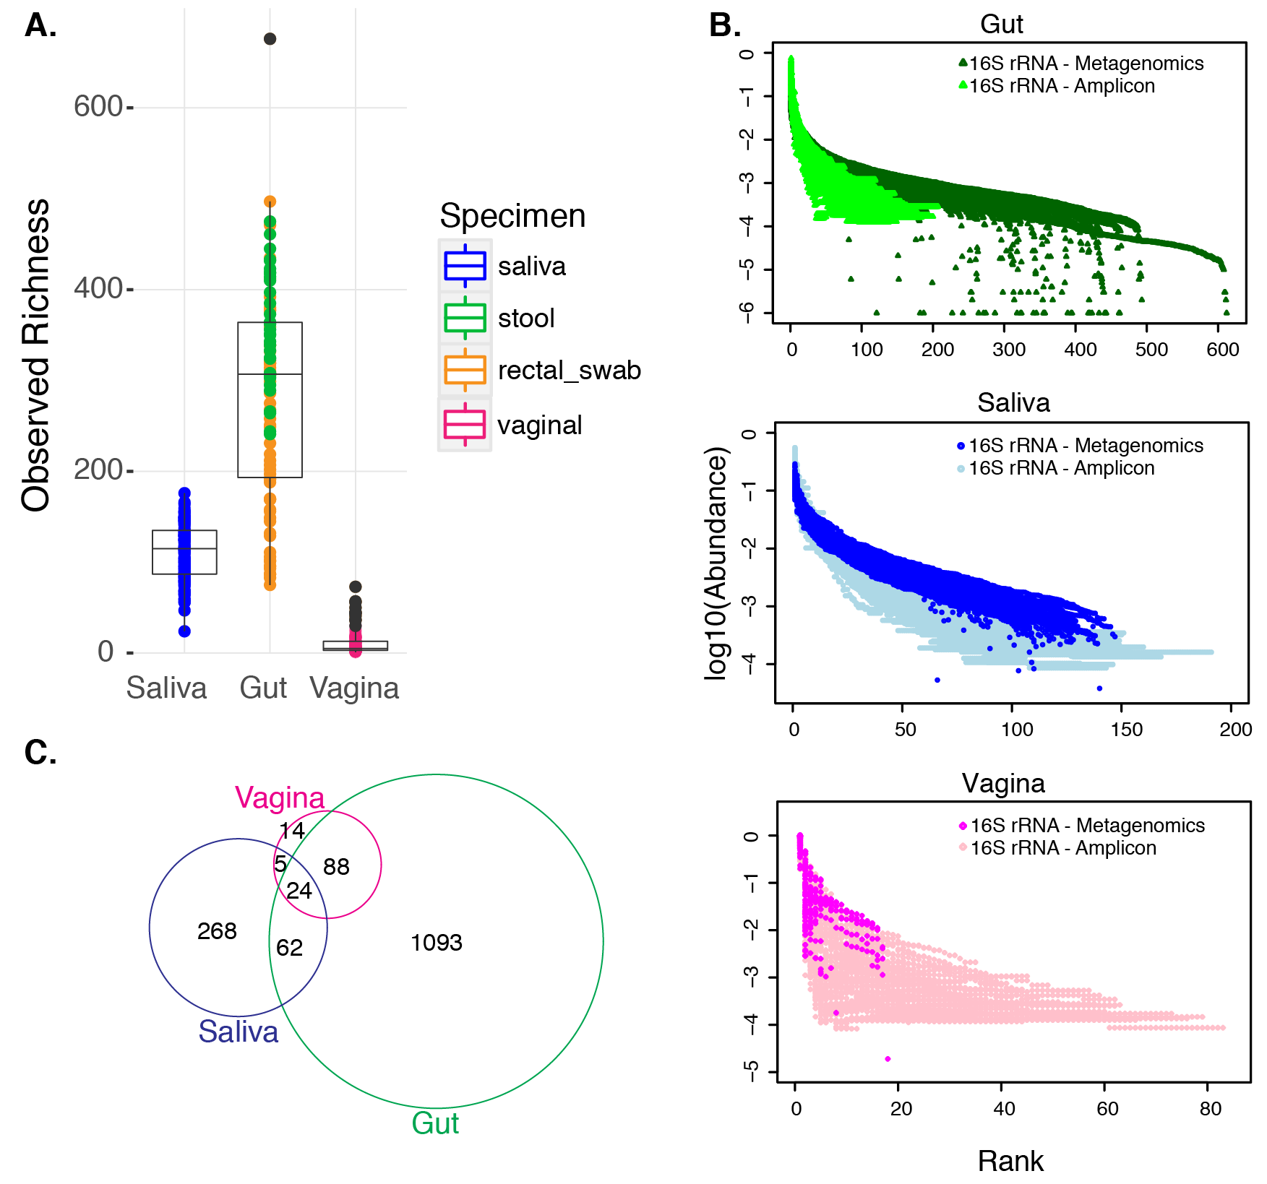

Supplemental Figure S1. Richness of vaginal, stool and saliva samples, based on full-length 16S rRNA gene reconstruction from metagenomic data. A) Boxplots of observed richness per body site. Richness was estimated from the presence/absence of taxa in at least one sample. Each dot represents a sample, color-coded by specimen type. One gut sample, which was much more deeply sequenced than the others, is shown as a distant outlier. B) Rank abundance curves from 16S rRNA gene sequences recovered through metagenomics (this study) and amplicon data (DiGiulio, 2015). C) Venn diagram of the number of taxa unique to, and shared between each body site.

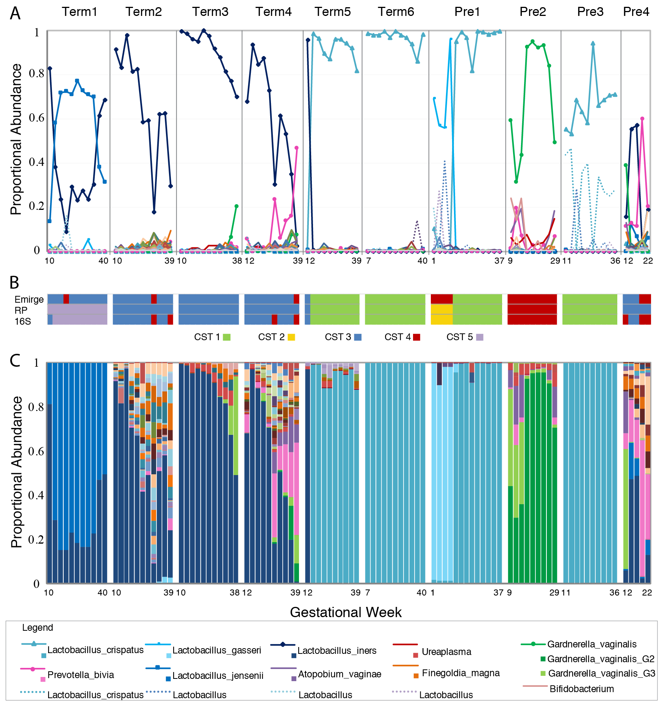
Supplemental Figure S2. Community structure of vaginal communities as revealed by full-length 16S rRNA, ribosomal protein, and 16S rRNA gene amplicon sequences. A. Relative abundances of taxa based on 16S rRNA gene sequences assembled from metagenomic data via EMIRGE (taxa were classified at 97% identity, and all 65 taxa recovered are displayed). B. Community state type (CST) determined by clustering taxa abundances as described in DiGiulio et al (2015). Top, EMIRGE 16S rRNA gene sequences; middle, ribosomal proteins (RPs); and bottom, 16S rRNA gene amplicon data (16S). Ordination with k = 5 clusters was used to assign samples to 1 of the 5 commonly accepted CSTs, for both 16S rRNA taxa tables (EMIRGE and 16S rRNA amplicon data), as described in DiGiulio et al (2015). Ordination with k = 7 clusters was used to assign samples to one of the five CSTs for the RP taxa table. Three of the clusters contain samples dominated by L. iners and were assigned to CST 3. The code for determining CST assignments is available at the Stanford Digital Repository. C) Taxa abundances based on 16S rRNA gene amplicon sequence data from DiGiulio et al (2015) (top 65 most abundant taxa are displayed). Key (legend) for only the top 15 most abundant taxa in vaginal samples.

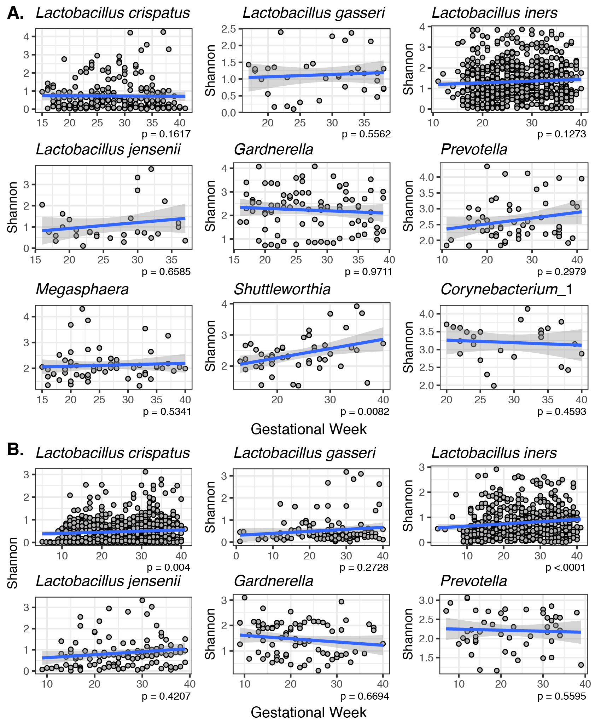
Supplemental Figure S3. Effect of gestational age on Shannon’s diversity in vaginal samples from two populations of pregnant women. Shannon’s diversity index was estimated for each sample, grouped by the most abundant taxon, and plotted vs. gestational age. Linear smoothing with confidence intervals was added to aid in detecting trends. A linear mixed-effects regression was fitted to each grouped dataset (using the lme function in R, where the subject was included as a random effect for the intercept of the estimated fit) and the trend was tested for statistical significance with anova in R. A. 16S rRNA gene amplicon data for the UAB cohort from (Callahan et al. 2017). B. 16S rRNA gene amplicon data for the Stanford cohorts from (DiGiulio et al. 2015; Callahan et al. 2017).
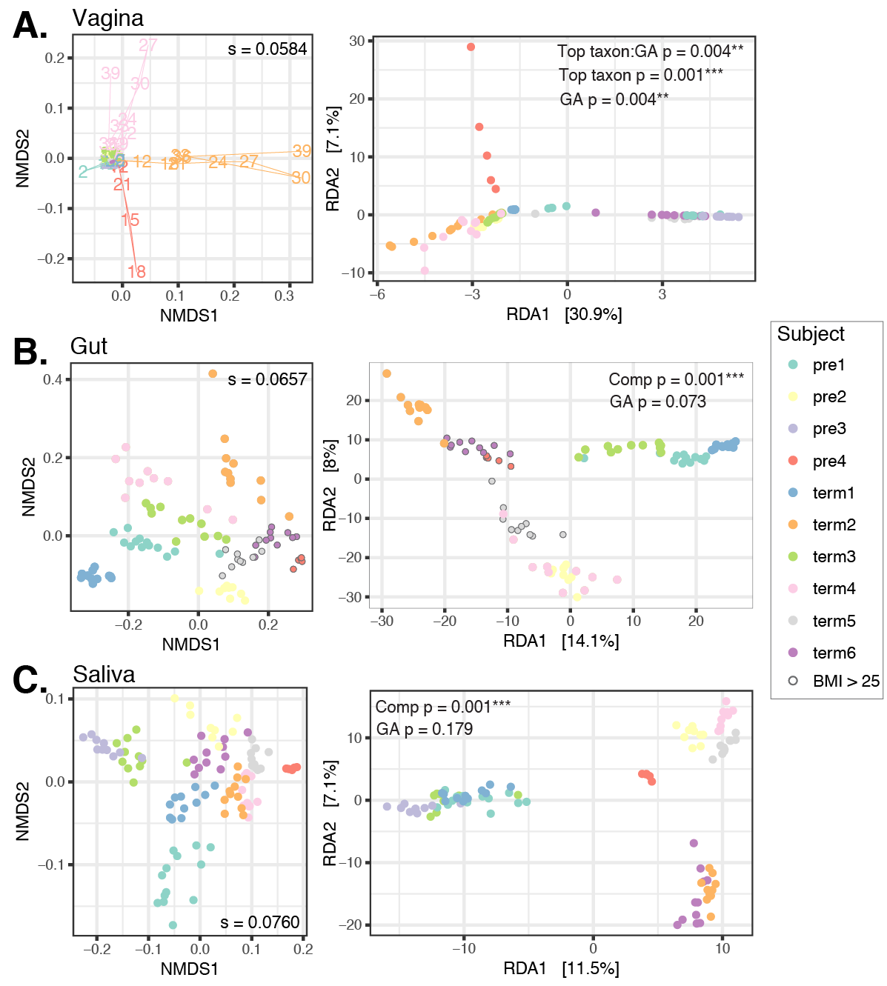
Supplemental Figure S4. Subject effect on sample variation on ordination plots from UniRef90 gene families. Left: non-metric multidimensional scaling (NMDS) plots; and right: redundancy analysis (RDA) plots from vagina (A), gut (B), and saliva (C) samples. Each point is a sample, color-coded by subject. Ordination was done on variance-stabilized gene family abundances. The stress (the amount of variability unexplained by the NMDS ordination) is shown on each NMDS plot. The path connecting samples in (A) shows the gestational age effect. The top most abundant taxon and gestational age effects were used to constrain the RDA analyses from vaginal communities, while health complication and gestational age were used to constrain the RDA analyses for gut and oral samples. Complication: uncomplicated (5 subject); preeclampsia (3 subjects); and other: Type II diabetes (1 subject) and oligohydramnios (1 subject).

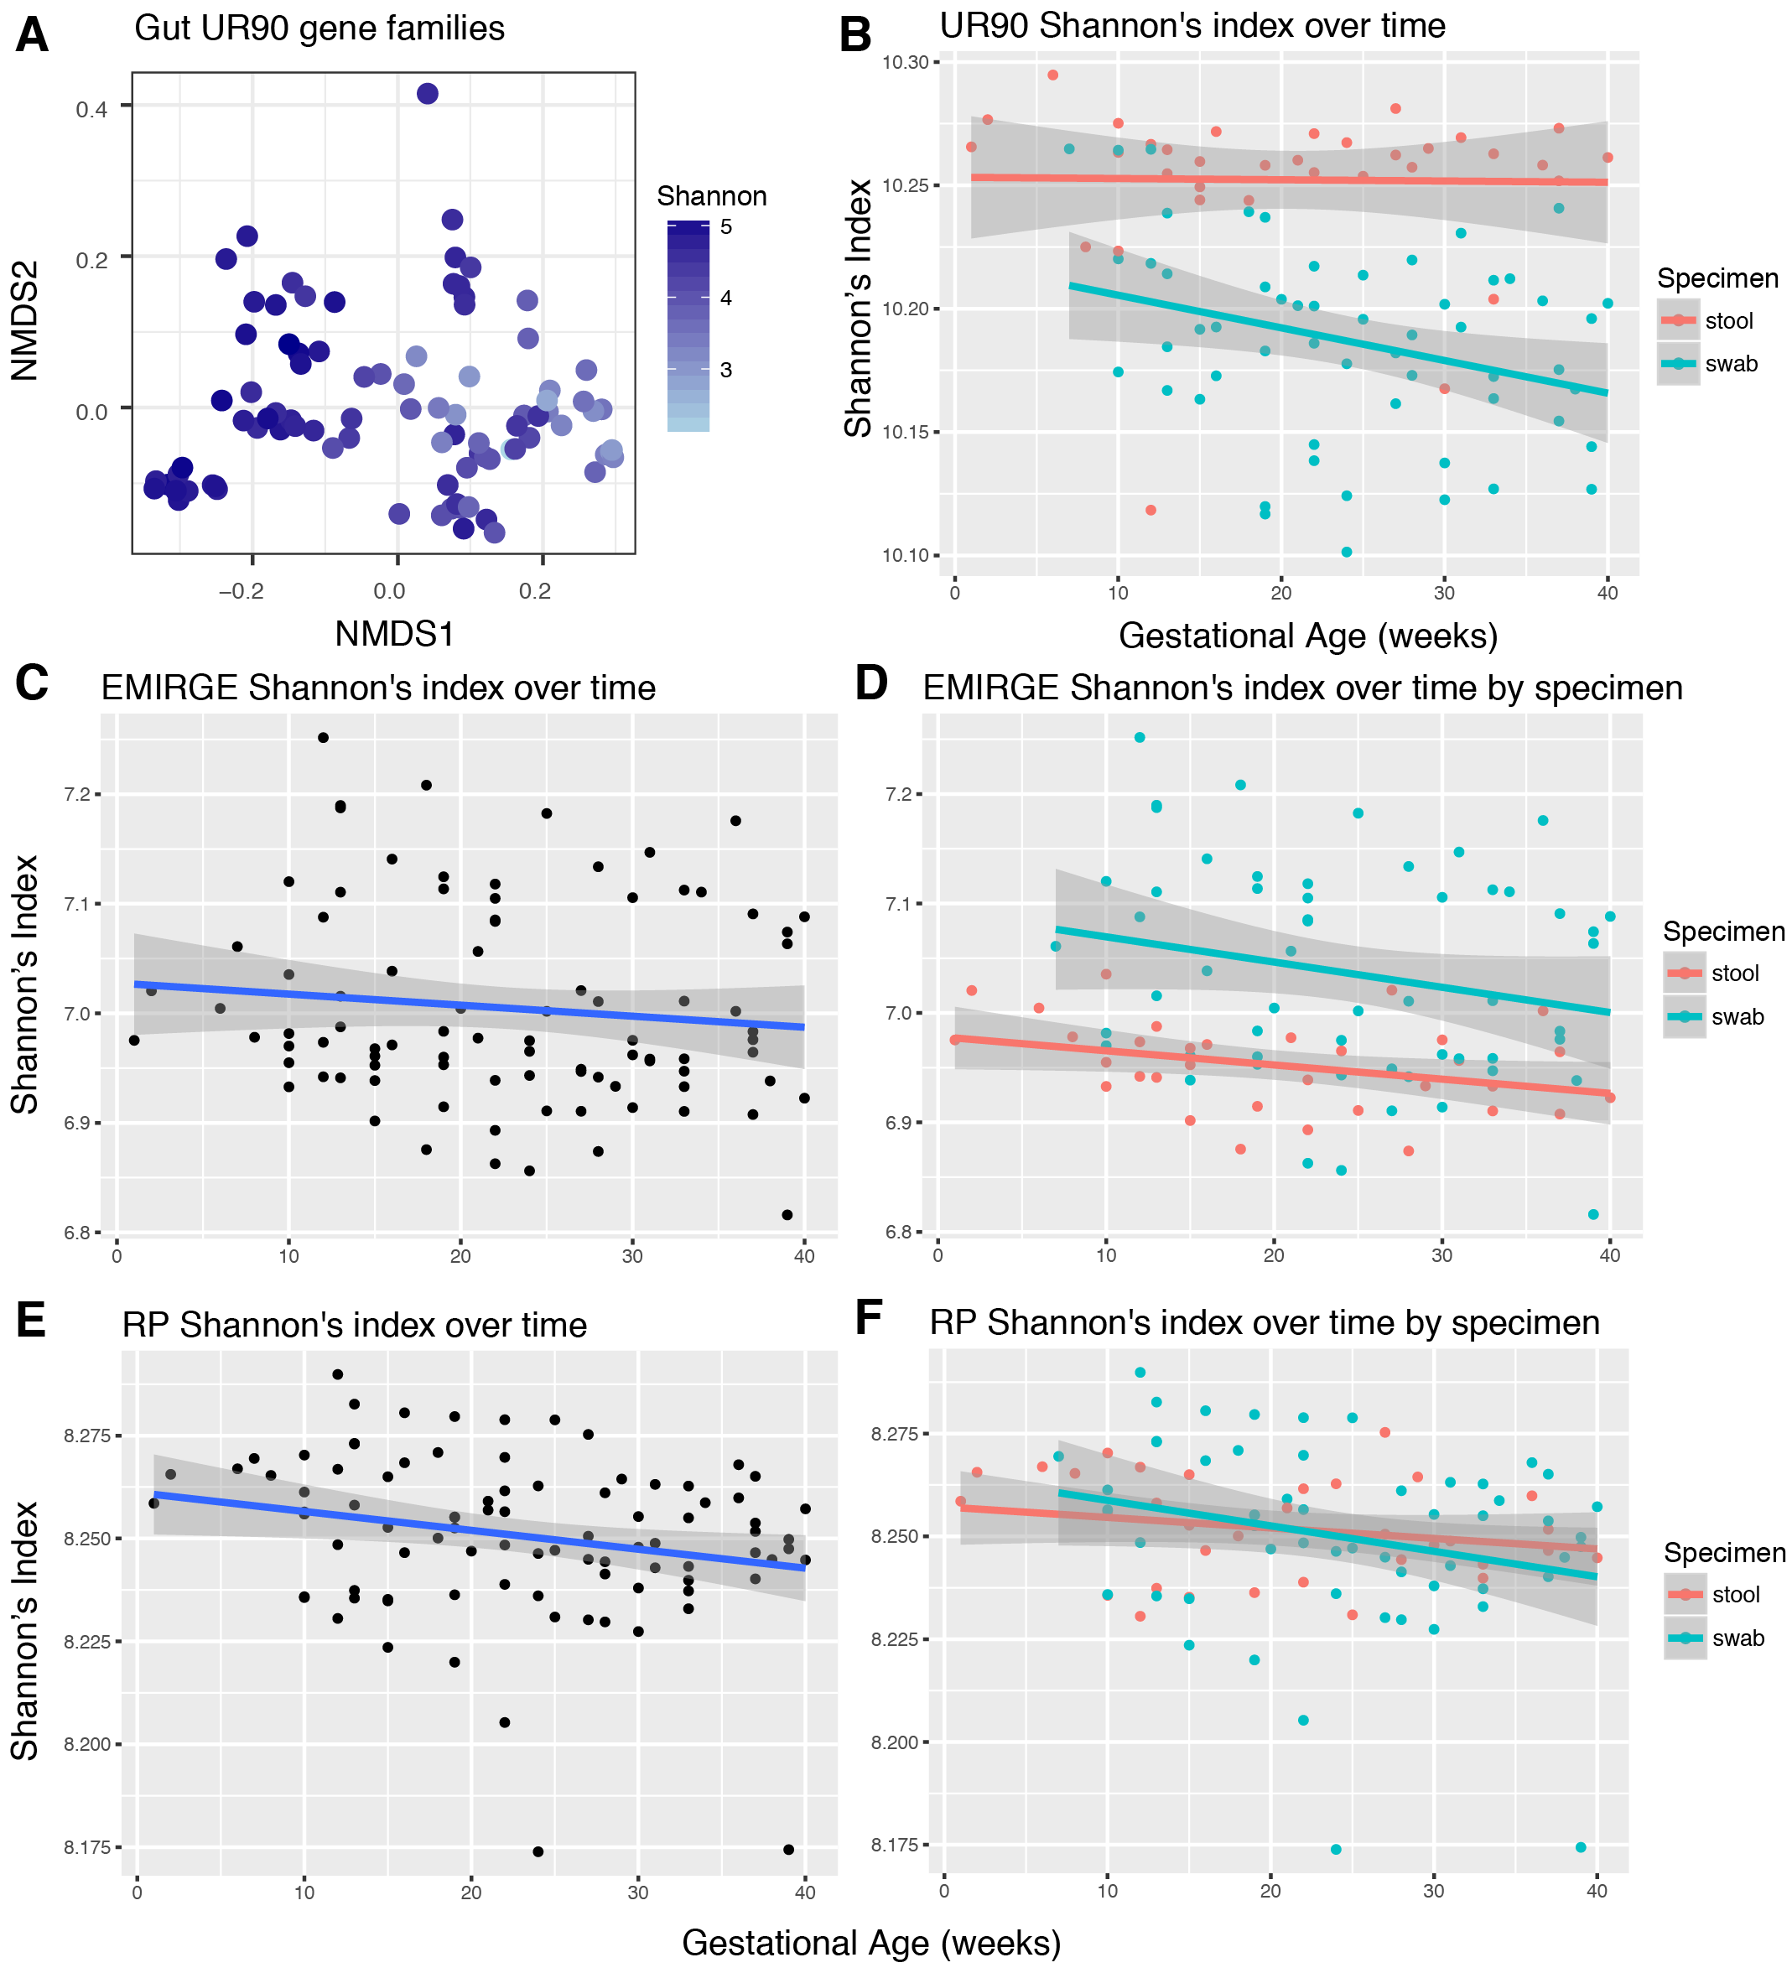
Supplemental Figure S5. Gut microbiota diversity decreases during pregnancy. A) Effect on sample variation of Shannon’s diversity index, based on NMDS ordination of Bray-Curtis distances of variance-stabilized UniRef90 gene families. B.-F. Shannon’s diversity index effect was evaluated over time. Shannon’s diversity was estimated from: B. variance-stabilized UniRef90 gene family abundances; C., D. the presence and abundance of reconstructed 16S rRNA gene sequences via EMIRGE; and E., F. the presence and abundance of ribosomal protein set clusters (RP). Diversity was calculated using the “diversity” function from the vegan package in R.

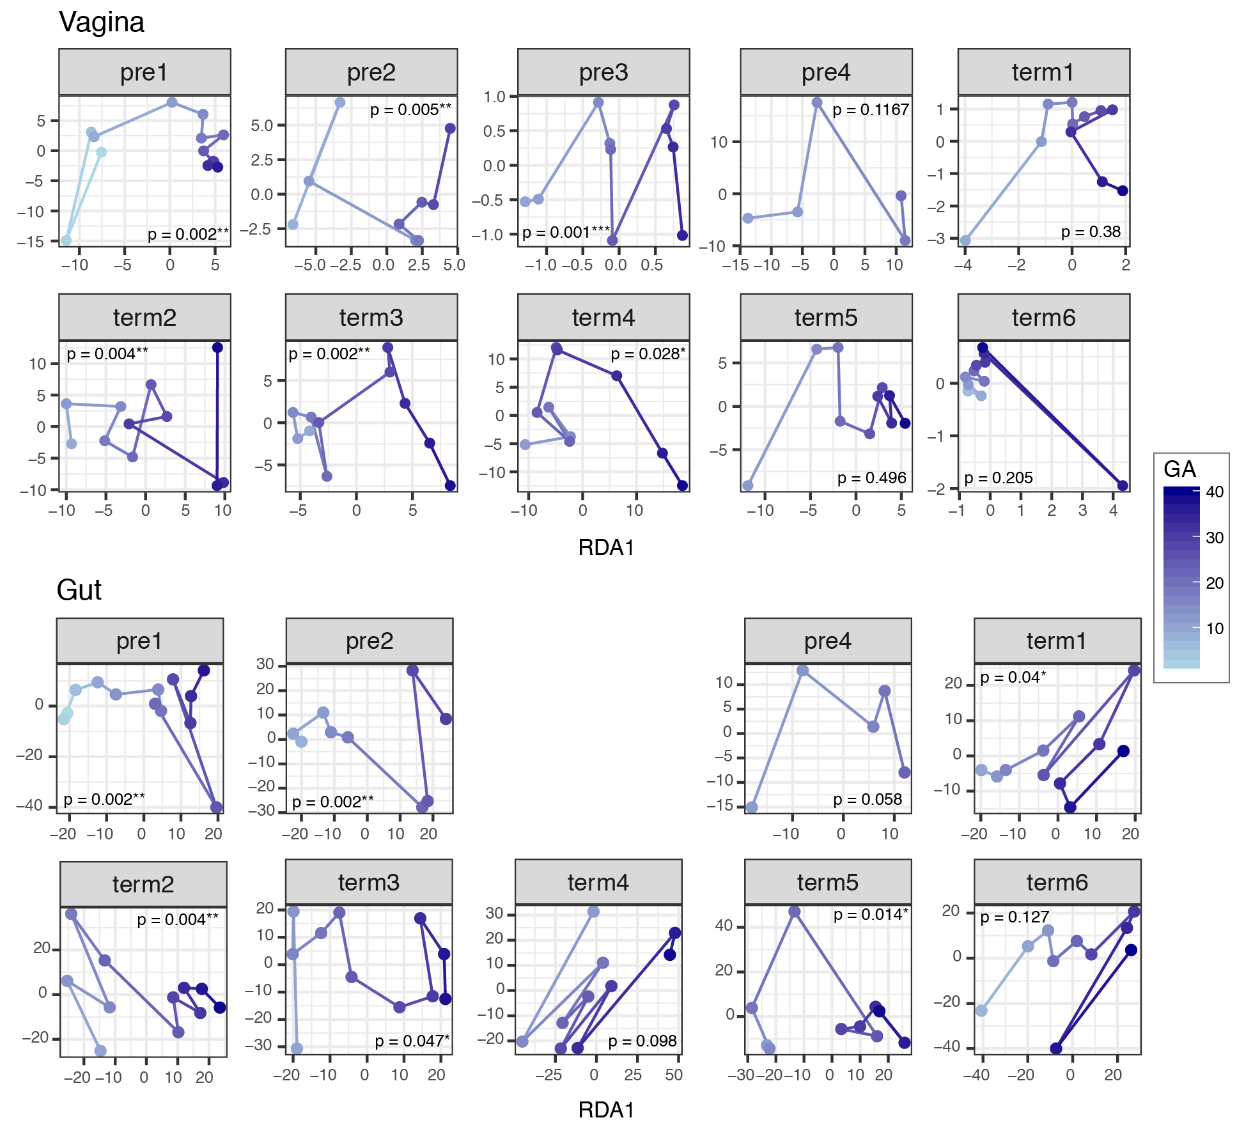
Supplemental Figure S6. Gestational age effects from the abundances of vaginal and gut gene families represented in the UniRef90 database. Gestational age was used to constrain the redundancy analysis (RDA) of variance-stabilized gene family abundances per body site within individuals. Gut samples from subject Pre3 were not available. Gestational age effect is observed along the X axis (RDA axis), and points within plots were connected based on the resulting ordination scores. P-values were calculated with anova on the RDA ordination constraint using the anova.cca function of the vegan package in R.

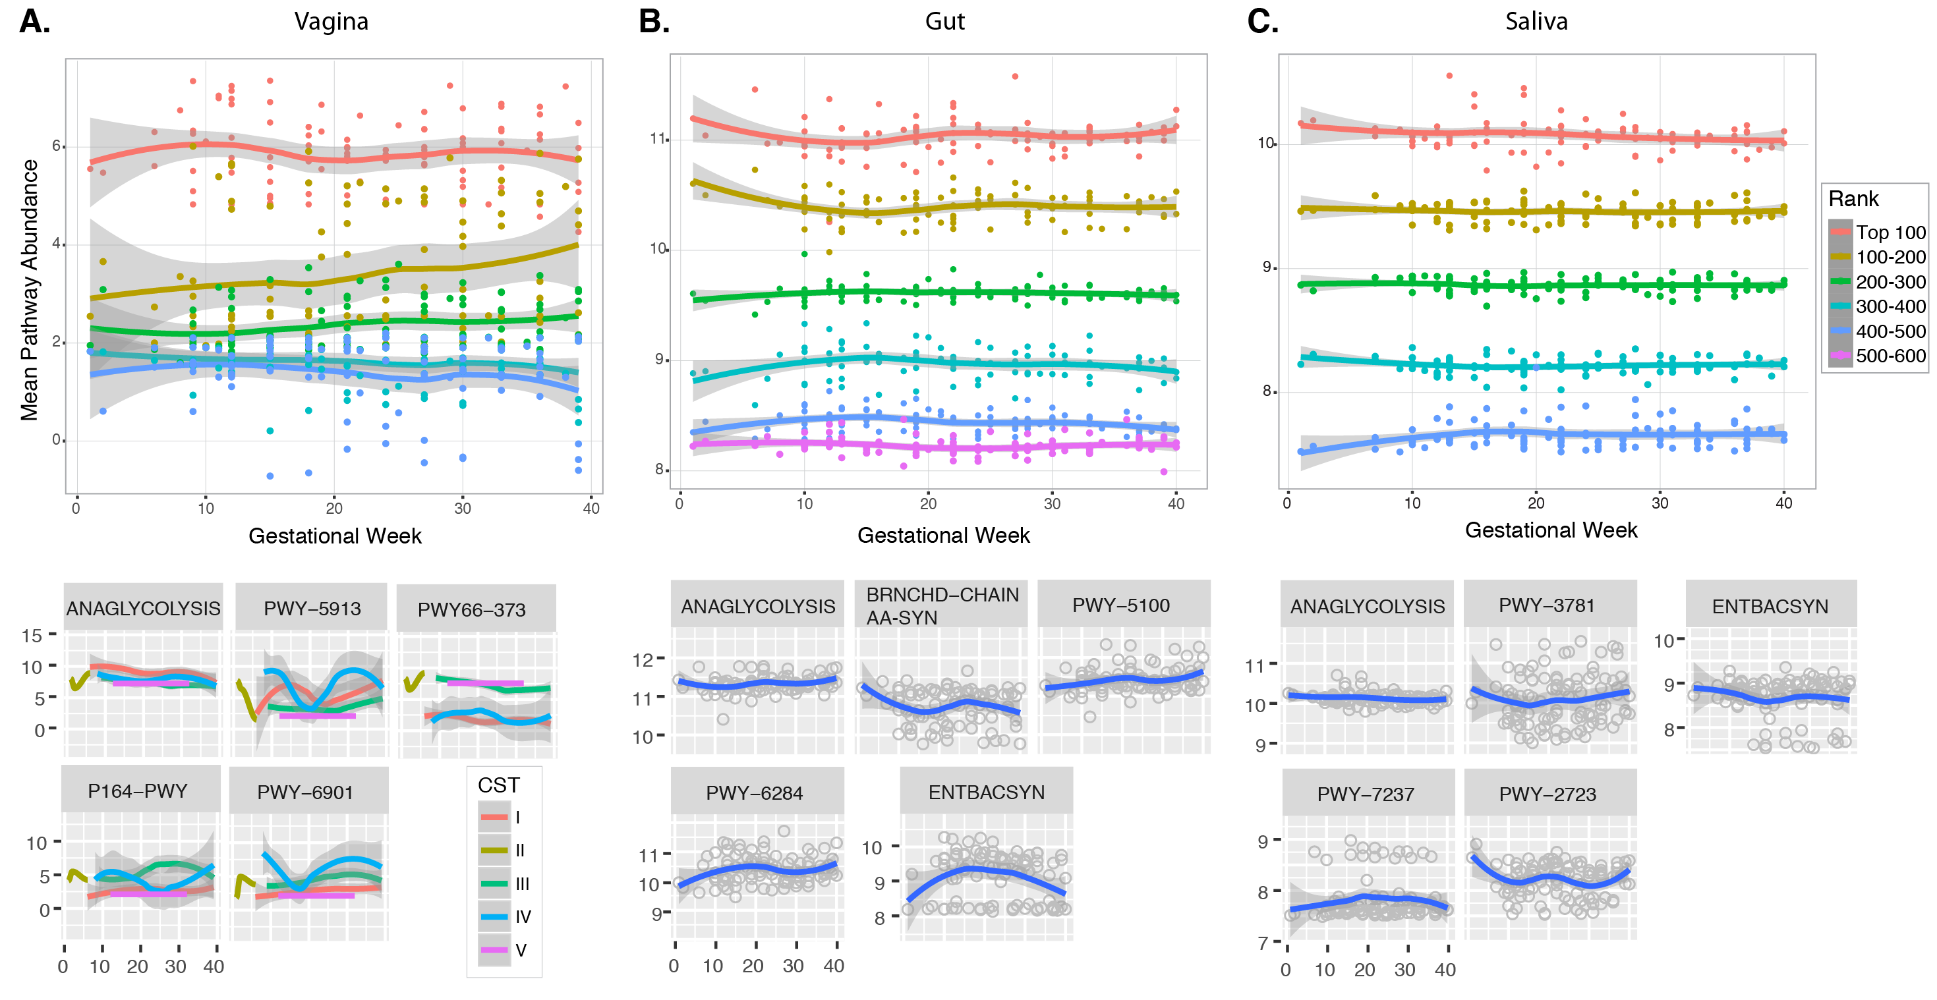
Supplemental Figure S7. Pathway presence and abundance analysis at all body sites. A) vagina, B) gut, and C) saliva. Top plots: mean pathway abundance over time. Pathways were ranked from top to bottom most abundant, and mean abundances stratified every 100 pathways (color coded by rank range). Bottom five small plots per body site: pathway abundance over time for selected pathways that showed variable behavior in vaginal, gut, and saliva samples. The first pathway at each body site (ANAGLYCOLYSIS) is a core metabolic pathway (glycolysis) that illustrates the behavior of most of the pathways represented within that site. A smoothing function was added to each plot to illustrate trends. Vaginal pathways were color-coded based on CST. Anaglycolysis: Glycolysis III; PWY-5913: TCA cycle VI; PWY66-373: sucrose degradation V; P164-PWY: purine nucleobases degradation I (anaerobic); PWY-6901: superpathway of glucose and xylose degradation; BRNCHD-CHAIN-AA-SYN: superpathway of branched amino acid biosynthesis; PWY-5100: pyruvate fermentation to acetate and lactate II; PWY-6284: superpathway of unsaturated fatty acids biosynthesis; ENTBACSYN: enterobactin biosynthesis; PWY-3781: aerobic respiration I (cytochrome c); PWY-7237: myo-, chiro- and scillo-inositol degradation; PWY-2723: trehalose degradation V.

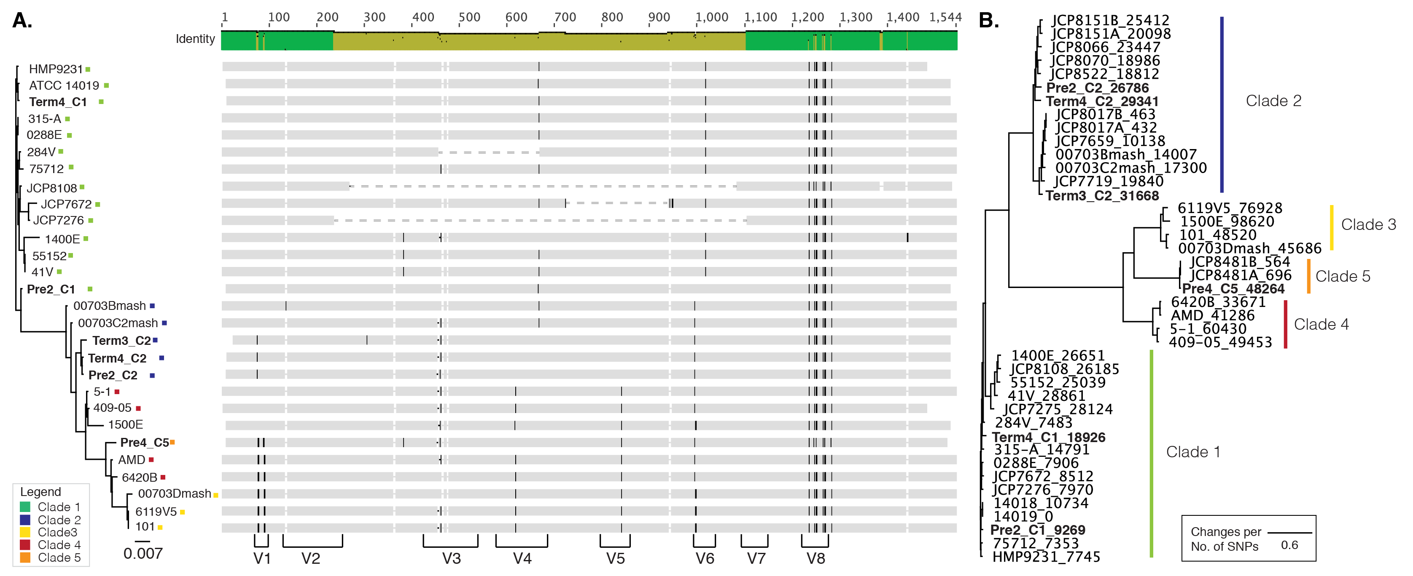

Supplemental Figure S8. Gardnerella vaginalis strain analysis. A) G. vaginalis 16S rRNA gene phylogenetic tree and alignment. 16S rRNA gene sequences from most of the publicly available genomes and the six strains identified in this work were aligned using the SINA aligner (Pruesse, 2012), and the phylogenetic tree was constructed using Fasttree (Price, 2010) with parameters -nt -gtr -gamma. Colored squares represent the genotypic group given in Fig.3A. Variable regions (adapted from the E. coli 16S rRNA gene variable regions) are shown at the bottom of the alignment to illustrate where the SNP patterns are in the G. vaginalis gene. B) Phylogenetic tree from the total number of SNPs shared between two or more G. vaginalis genomes was constructed using kSNP3 (Gardner, 2015). The total number of SNPs relative to the reference genome ATCC 14019 is shown next to the strain ID.

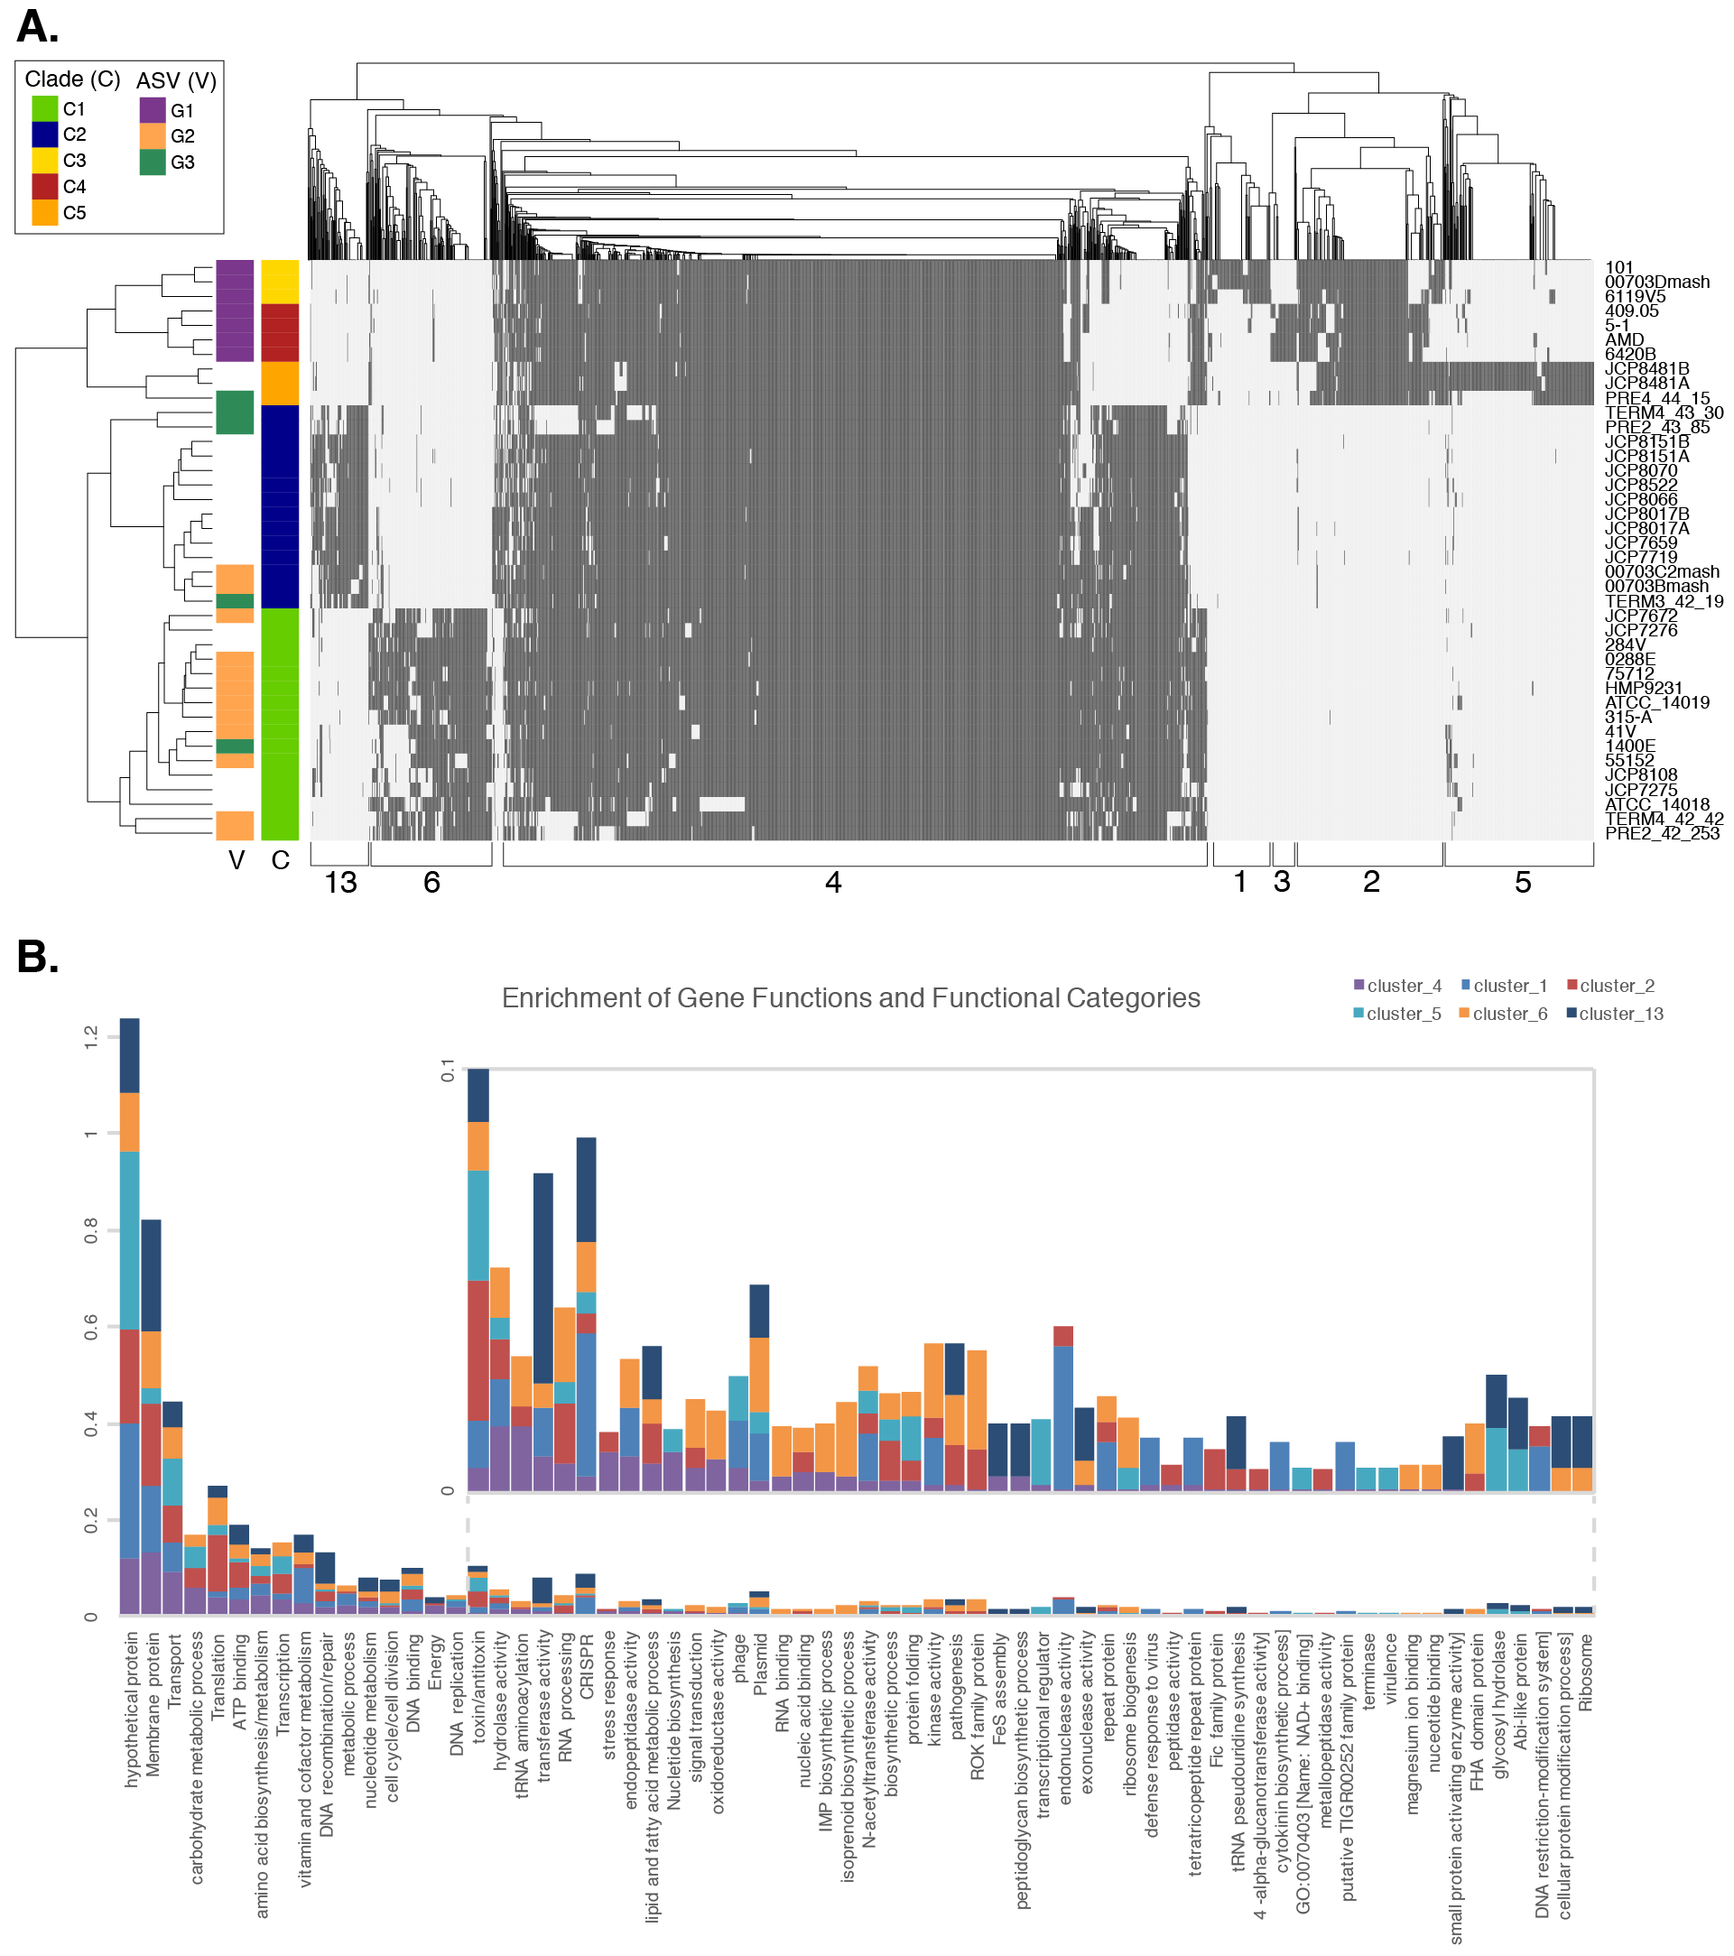
Supplemental Figure S9. Clade-specific orthologous genes across G. vaginalis genomes. A) Hierarchical clustering of the presence/absence of orthologous genes in G. vaginalis genomes. Hierarchical clustering was done on the Jaccard distance of the presence (dark grey) or absence (light grey) of orthologous genes, with Average Linkage as clustering method. Genome clusters (rows) were color-coded based on the genome type classification described in Fig. 3 (C: 5 colors), and on sequence variant classification described in Callahan et al (2017) (V: 3 colors). Gene clusters indicate genes shared among genome types: 1) genes present in C3 genomes; 2) genes shared among C3, C4 and C5 genomes; 3) genes present in C4; 4) pangenome; 5) genes present in C5 genomes; 6) genes present in C1 genomes; and 13) genes present in C2 genomes. B) Enrichment of functions within G. vaginalis orthologous gene clusters. Clusters of orthologous genes were evaluated for the relative contribution of functional categories in the Gene Ontology (GO) database. When GO annotation was lacking, functional groups were assigned based on the gene annotation for the orthologous group representative gene. Only clusters 1, 2, 4, 5, 6, and 13 are represented in the stacked bar chart (cluster 3 was not evaluated because it consists of 33 orthologous gene groups). Enrichment was determined from the number of times each functional category was found in an orthologous gene cluster from a), divided by the total number of functional categories within that cluster. Therefore, the height of each bar color is comparable within and across a functional category. Inset: zoomed image of low abundance functional categories (bars are aligned with their label on the x axis).

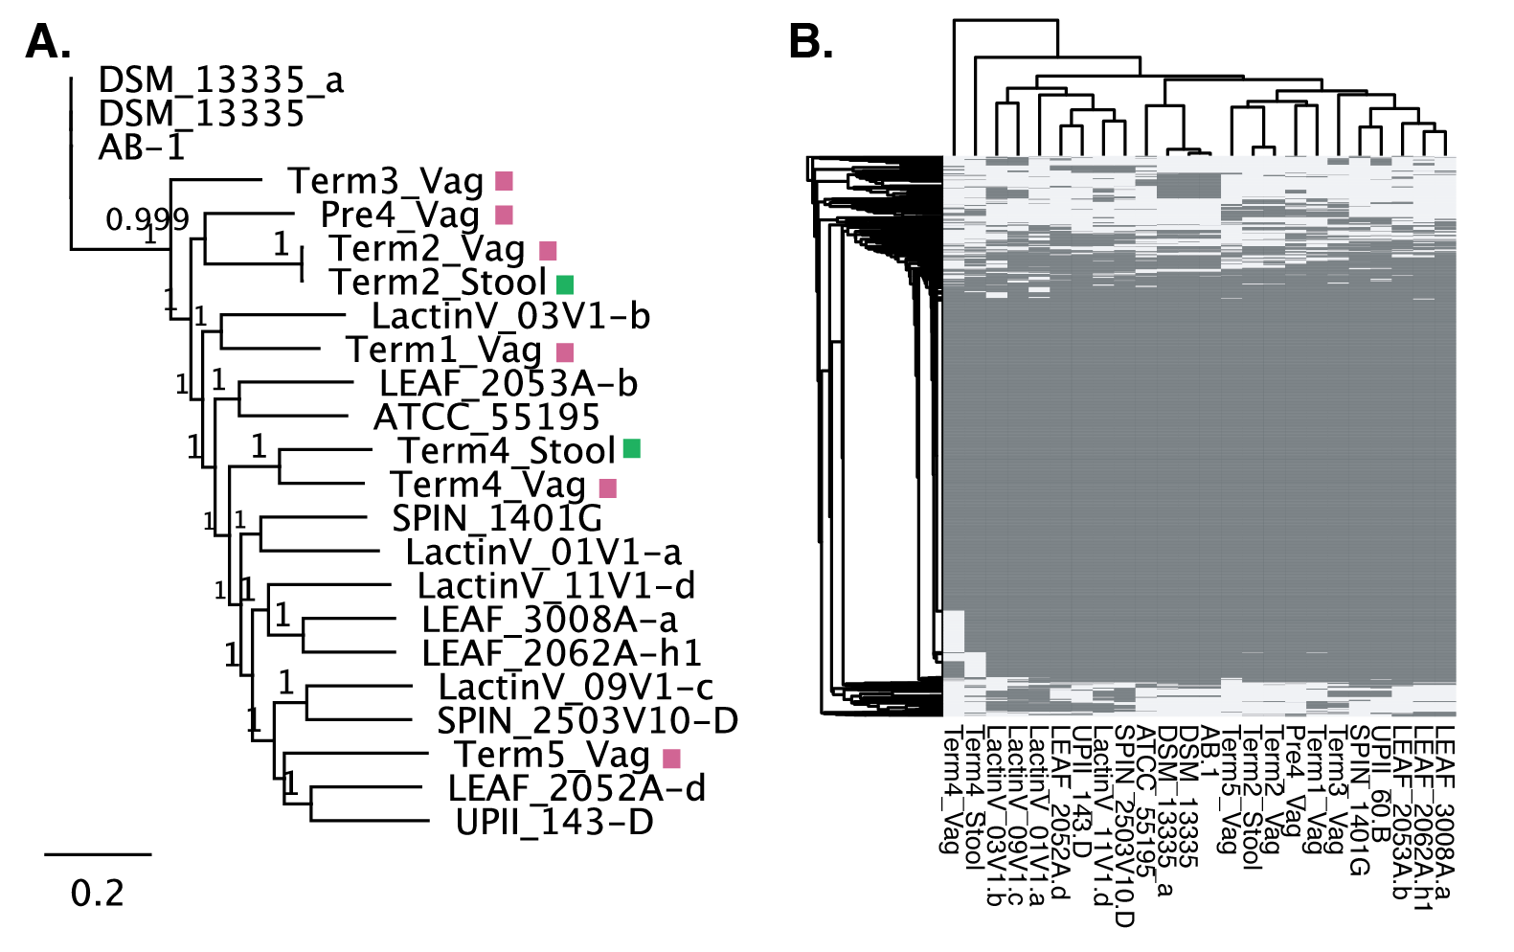
Supplemental Figure S10. Synteny in L. iners genomes. A) Phylogenomic tree reconstructed from core SNPs (SNPs present in all genomes analyzed) with kSNP3. Genomes recovered in this work are indicated by a colored square (pink: vagina, green: gut). Support values for each split is shown at the nodes. B) Hierarchical clustering of the presence/absence of orthologous genes in L. iners genomes. Only orthologous genes found in at least 4 of the 24 genomes were evaluated. Hierarchical clustering was done in R, on the Jaccard distance of the presence (dark grey) or absence (light grey) of orthologous genes, with Average Linkage as the clustering method.

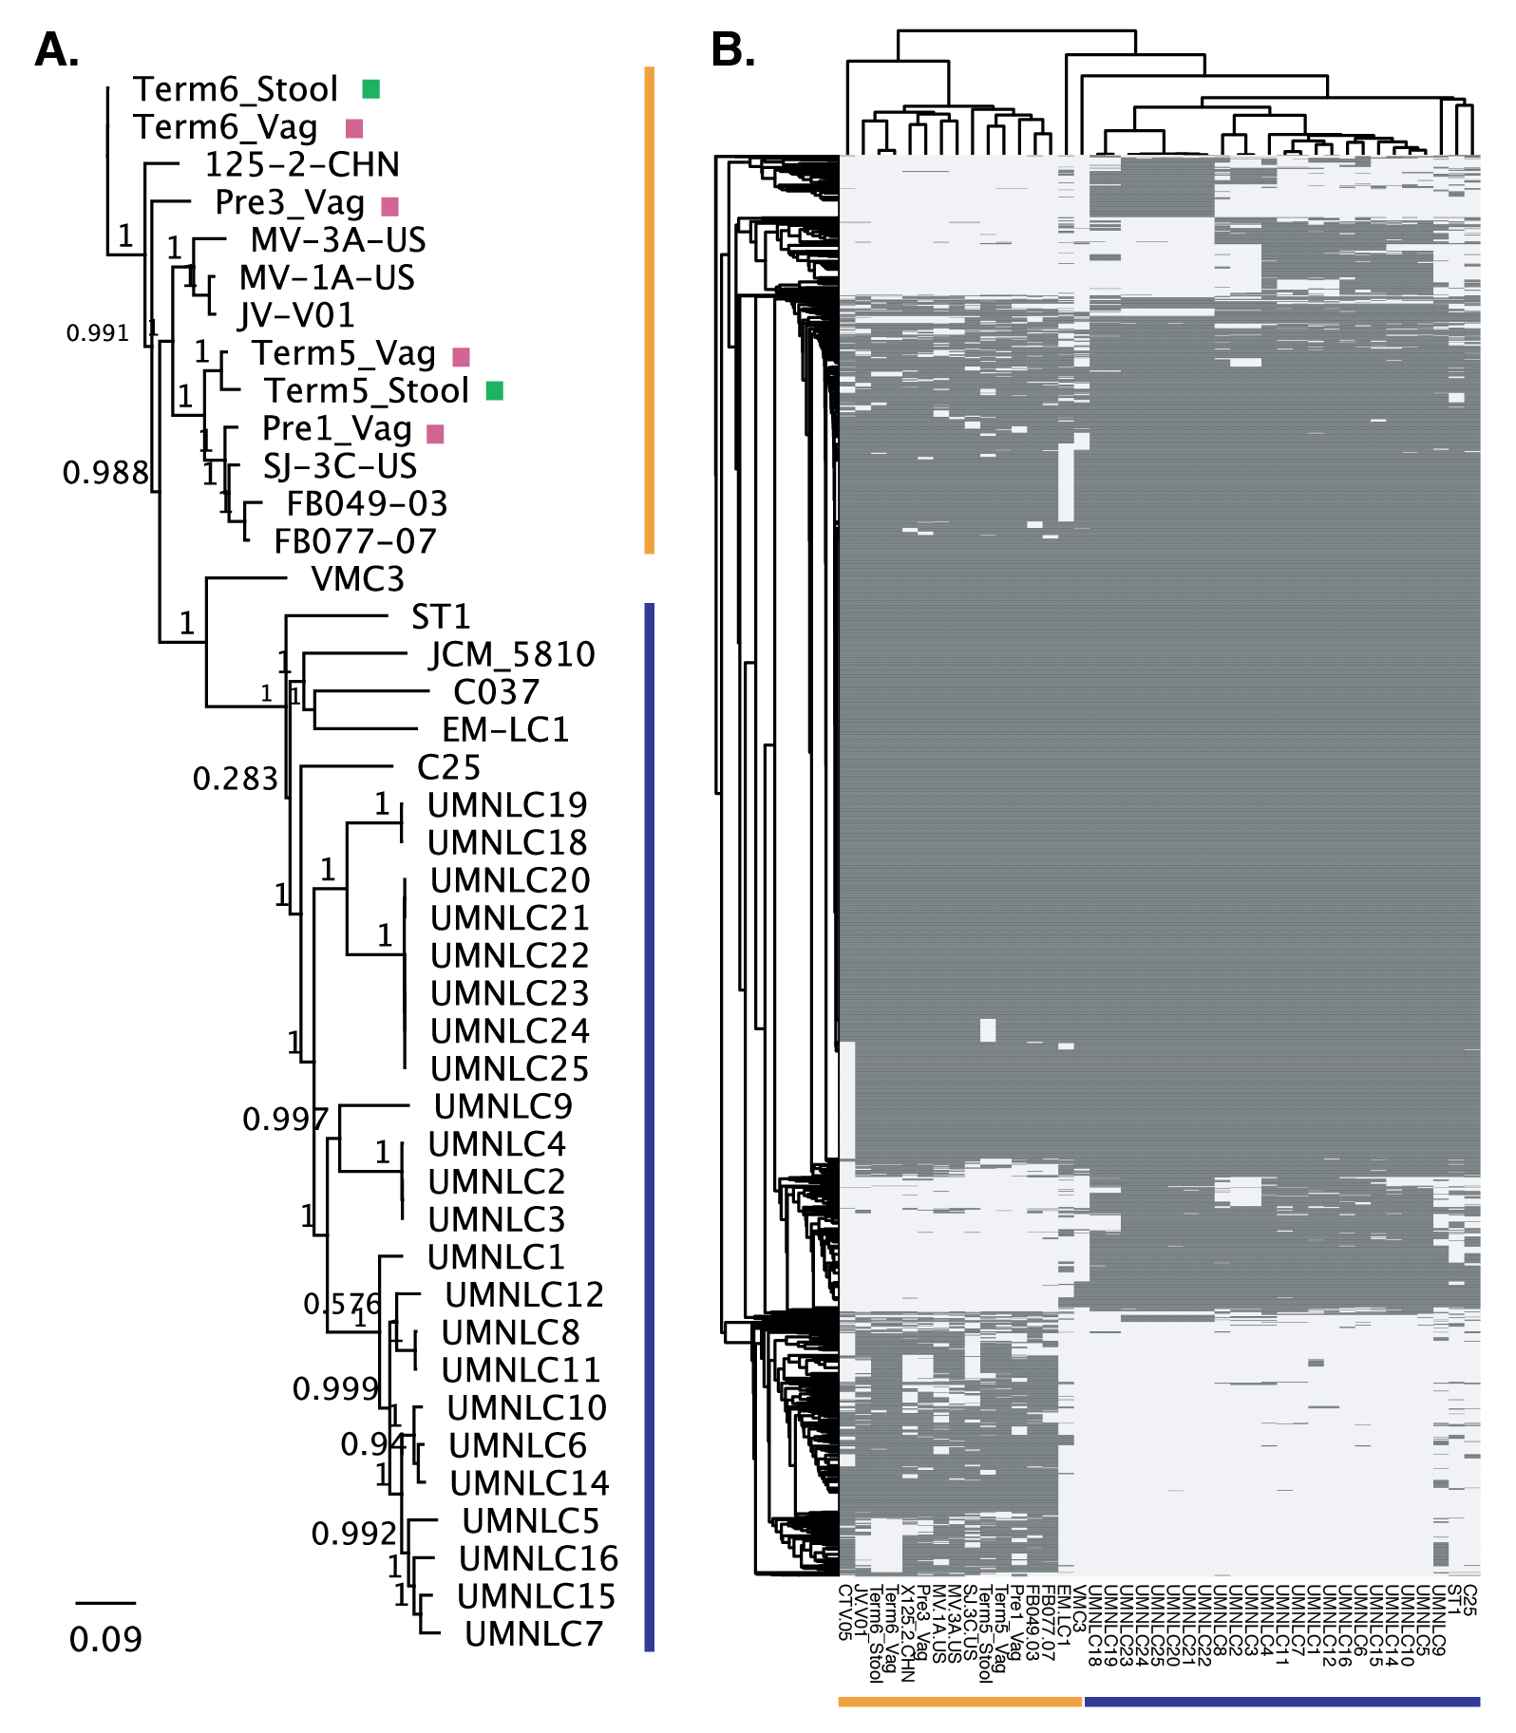

Supplemental Figure S11. Conservation of L. crispatus genomes. A) Phylogenomic tree reconstructed from core SNPs (SNPs present in all genomes analyzed) with kSNP3. Genomes recovered in this work are indicated by a colored square (pink: vagina, green: gut). Support values for each split is shown at the nodes. B) Hierarchical clustering of the presence/absence of orthologous genes in L. iners genomes. Only orthologous genes found in at least 8 of the 43 genomes were evaluated. Hierarchical clustering was done in R, on the Jaccard distance of the presence (dark grey) or absence (light grey) of orthologous genes, with Average Linkage as the clustering method. Two divergent groups of L. crispatus genomes are visualized with colored bars in A) and B).

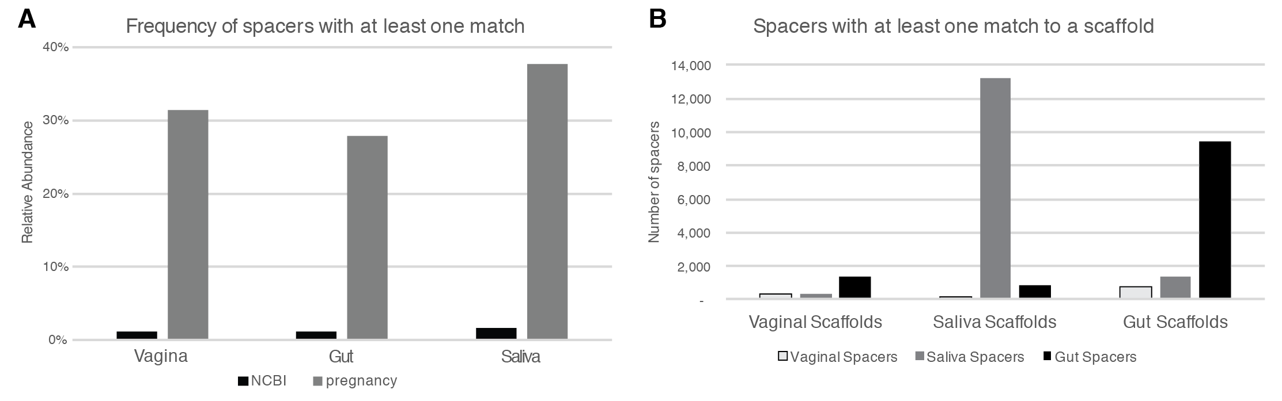
Supplemental Figure S12. CRIPSR spacer matches across different datasets. A) Comparison of CRISPR spacer matches between publicly available viral sequences (NCBI) and the pregnancy metagenomic datasets. Results of relative abundance CRISPR spacers (separated by the site from which they derive) that have at least one match to the dataset used in this study (shown in grey bars) and to the NCBI viral database (shown in black bars). B) CRISPR spacers with at least one match to a pregnancy dataset scaffold. This graph shows the number of unique spacers with matches to a scaffold, separated by body site (outlined grey, vaginal spacers; light gray, saliva spacers; and dark grey, gut spacers).

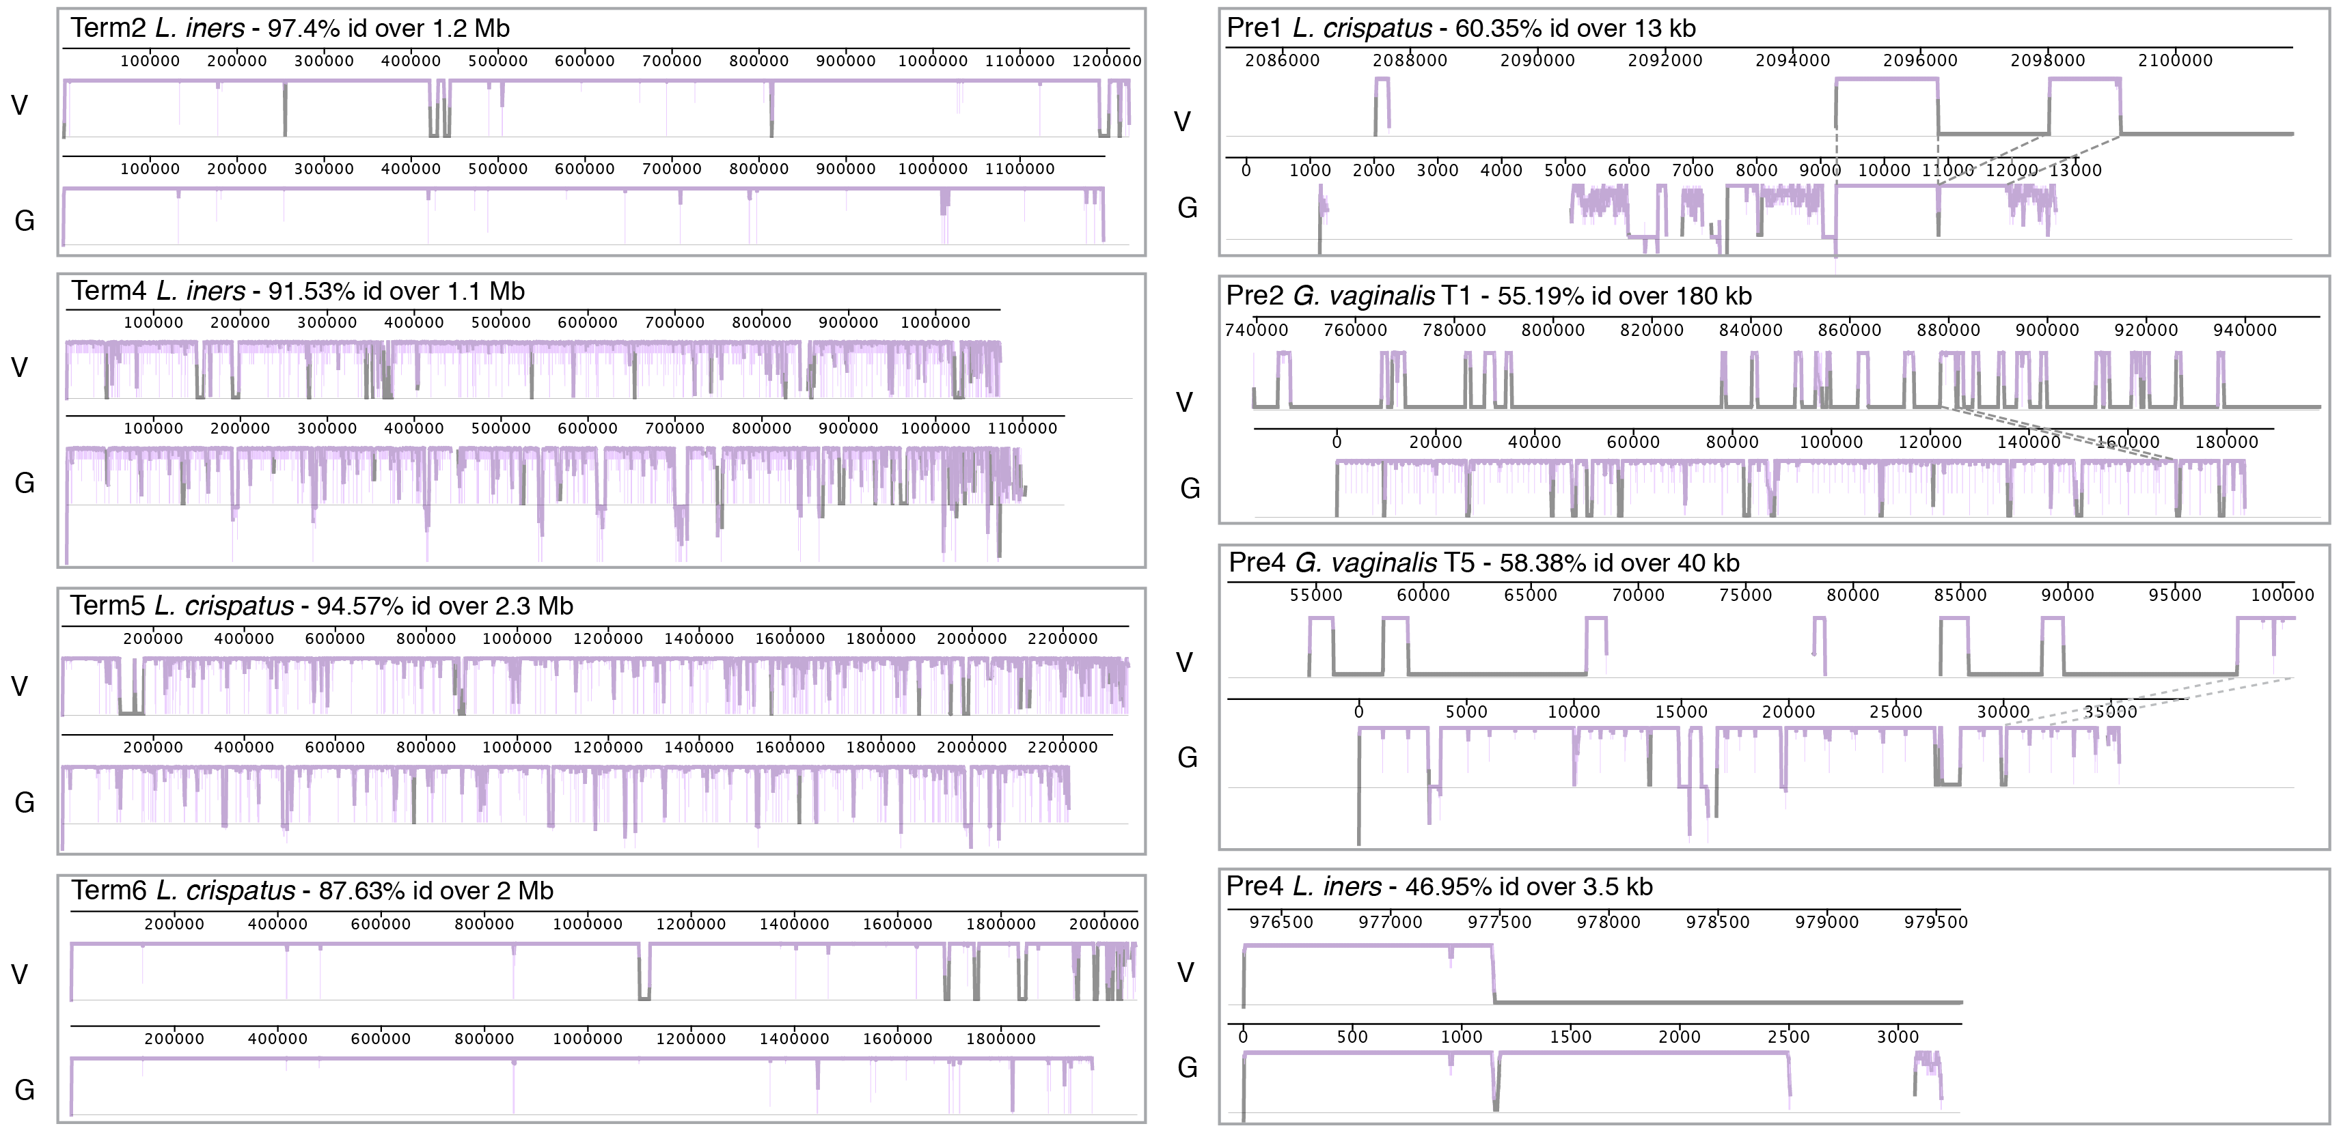

Supplemental Figure S13. Pairwise genome alignment of shared bacterial taxa found in the vagina and gut within subjects. Genomes and genomic fragments were aligned with progressiveMauve. Each panel represents the alignment between vaginal and gut genomes. Vertical purple lines indicate degree of divergence at those nucleotide positions (thus, the more purple lines, the more divergent the genomes are). Dips within a genome indicate unique genomic islands within that genome. The average pairwise genome identity and alignment coverage was estimated from the pairwise identity of all aligned block pairs within the alignment.

