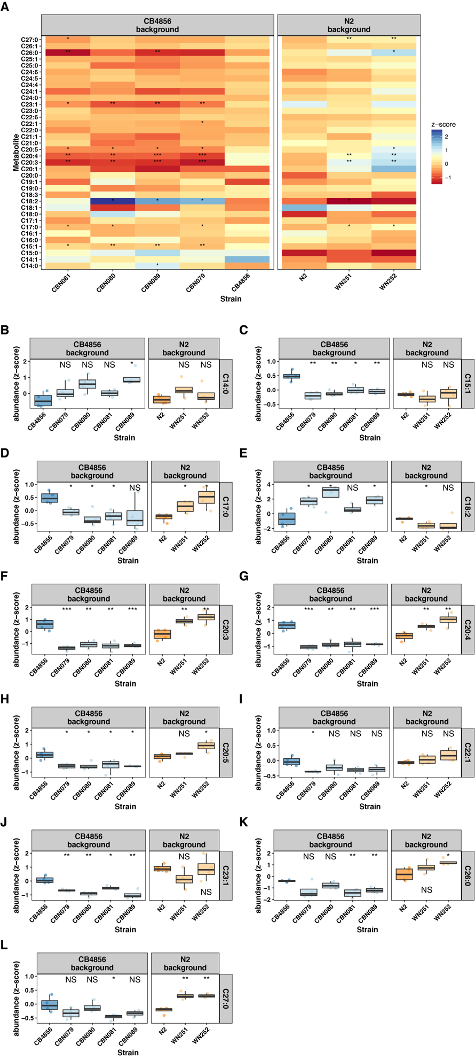
Figure S4. Chromosome IV introgression lines
(A) A heat map with the average metabolite levels for the fatty acids in the introgression lines covering chromosome IV. The significances indicated are based on a two-sided Students t-test adjusted for multiple testing. NS, FDR > 0.05; *, FDR < 0.05; **, FDR < 0.01; ***, FDR < 0.001. (B-L) the measured values per IL for the metabolites with at least one significantly different strain (FDR < 0.05) in (A).

