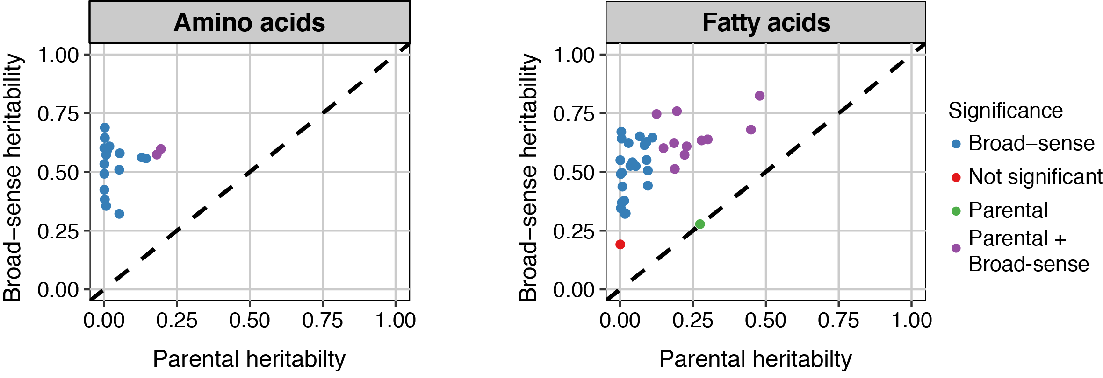
Supplemental Figure S2. Heritability in the parental strains versus the broad sense heritability
Plots of the heritability for both amino acids and fatty acids calculated in the parental strains versus the broad-sense heritability calculated in the RILs. The colors indicate the significance of the heritability estimated (as determined by permutation, false discovery rate < 0.05). If the broad-sense heritability exceeds the heritability in the parental strains, it indicates a complex trait architecture (multiple regulatory loci)

