Supplemental Figures

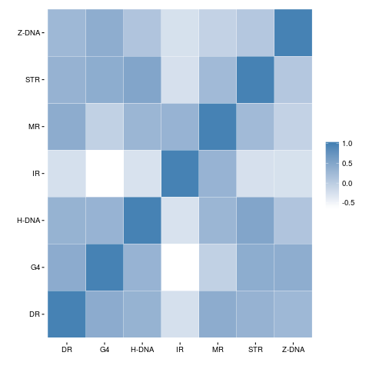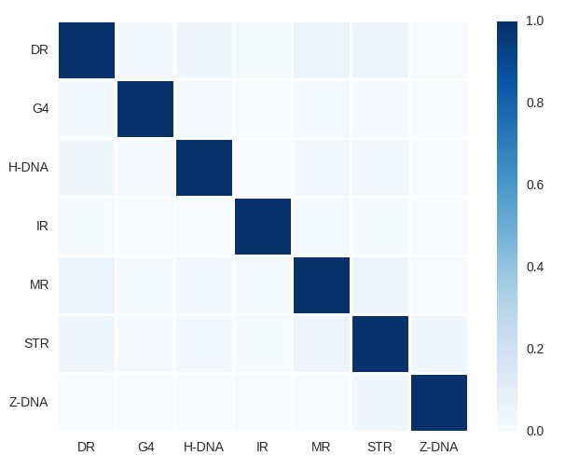
a. b.
Fig. S1: a. Correlation between different non-B DNA motifs in the human genome (Pearson correlation, genomic bins of 500kb). b. Jaccard Index heatmap reporting the amount of overlap between different non-B DNA motifs. 1 represents complete overlap, whereas 0 represents no overlap.

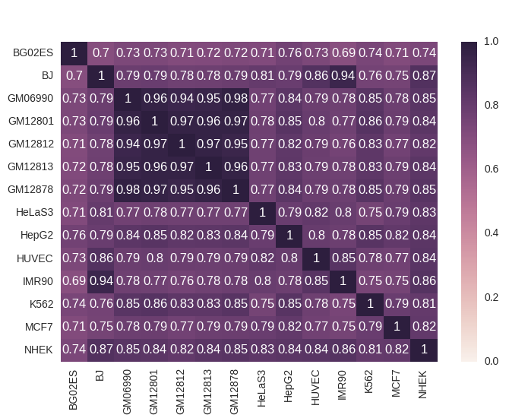

Fig. S2: Correlations between replication timing domains of different cell lines (Pearson, 500kb genome windows).

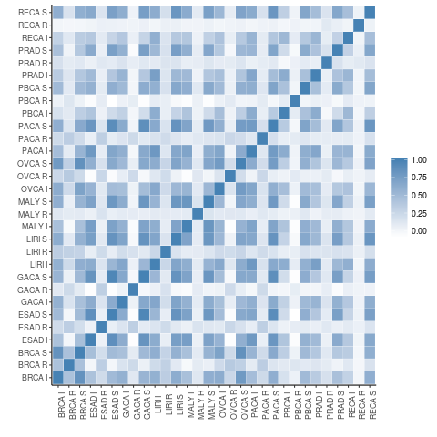
Fig. S3: Pearson correlation between the number of substitutions (S), indels (I) and rearrangements (R) found in non-overlapping 500 kb bins across the ten tumour types.

- SUBSTITUTIONS

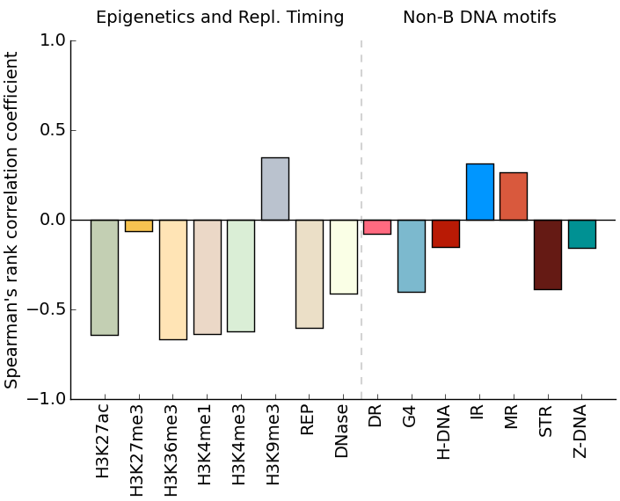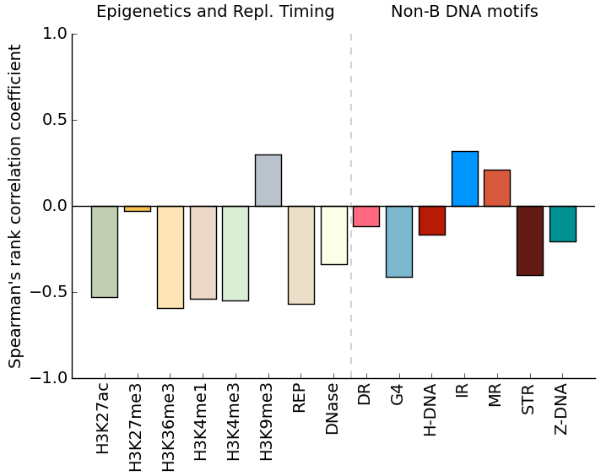
Pancreatic Ovarian
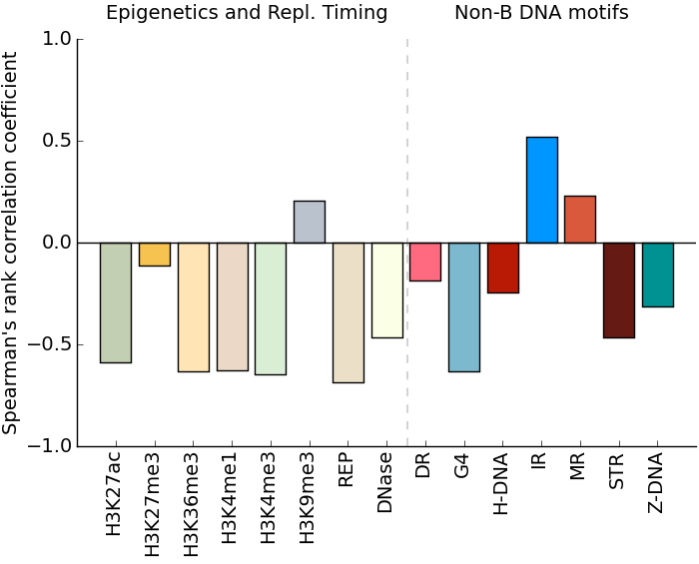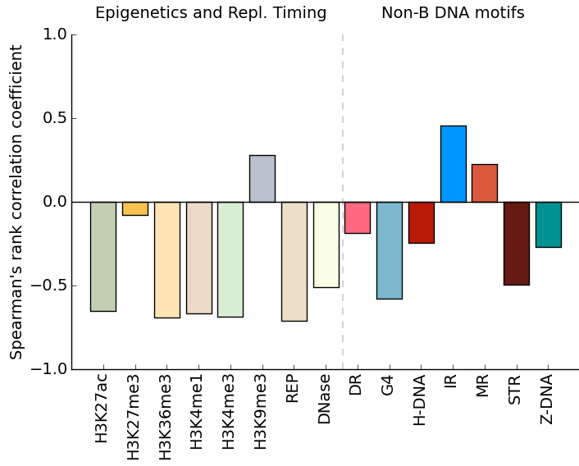
Liver Gastric
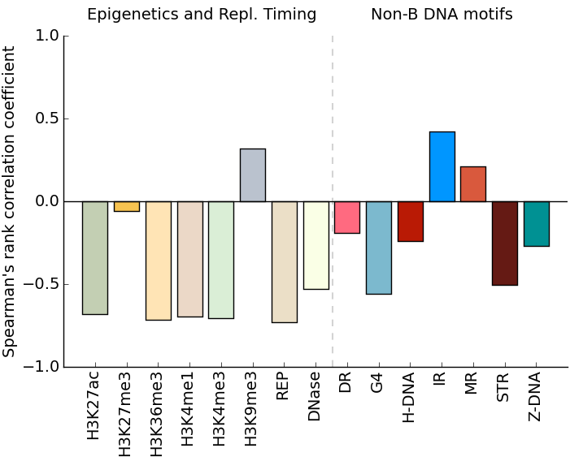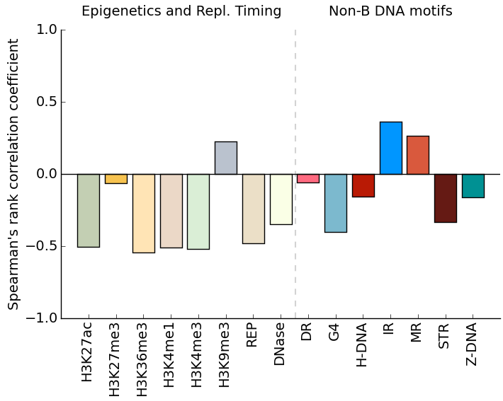
Esophagus Renal cell cancer
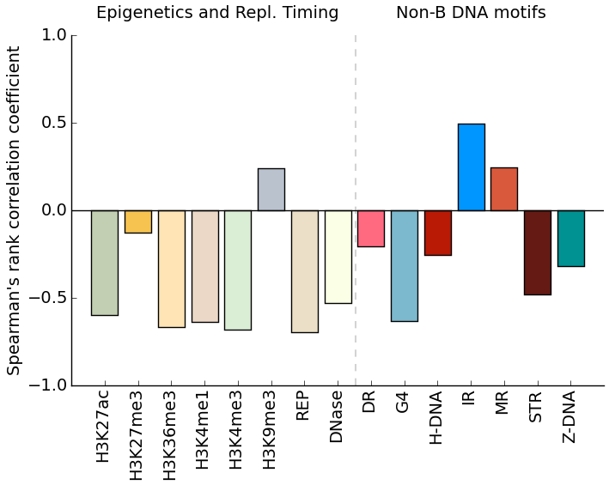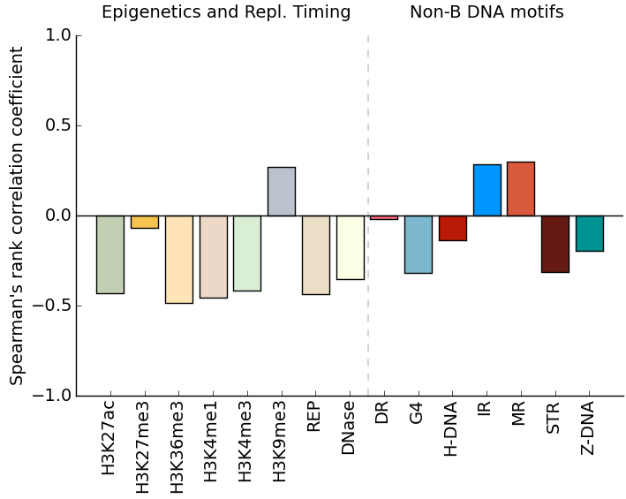
Malignant Lymphoma Pedriatic Brain Tumour

- INDELS
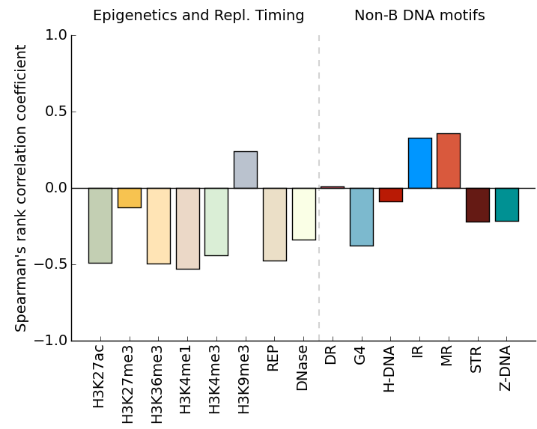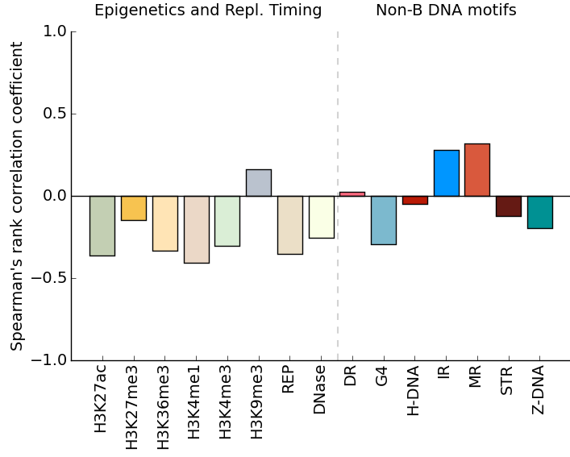
Pancreatic Ovarian
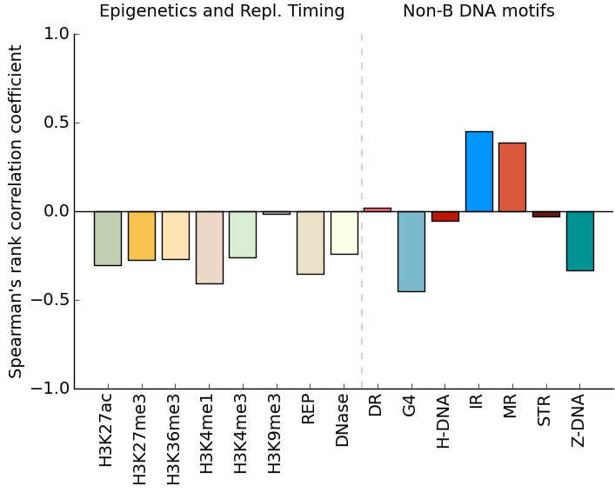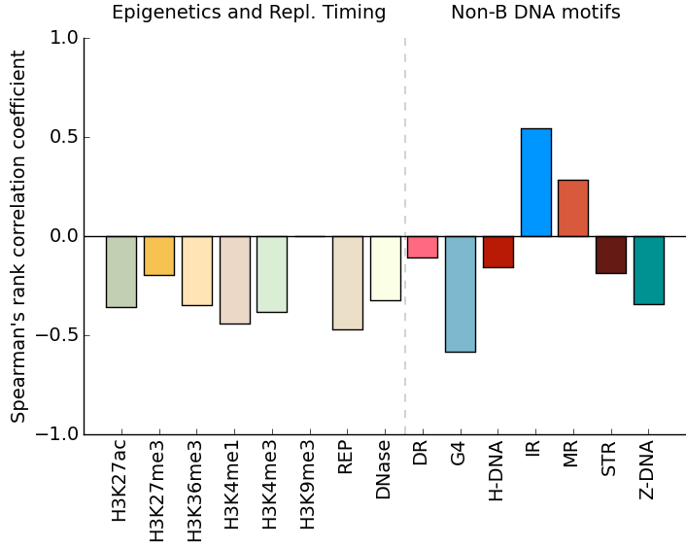
Liver Gastric
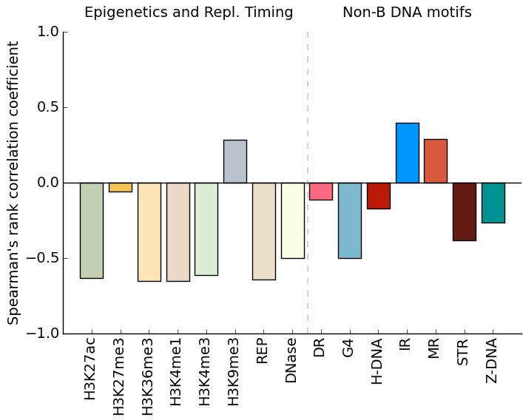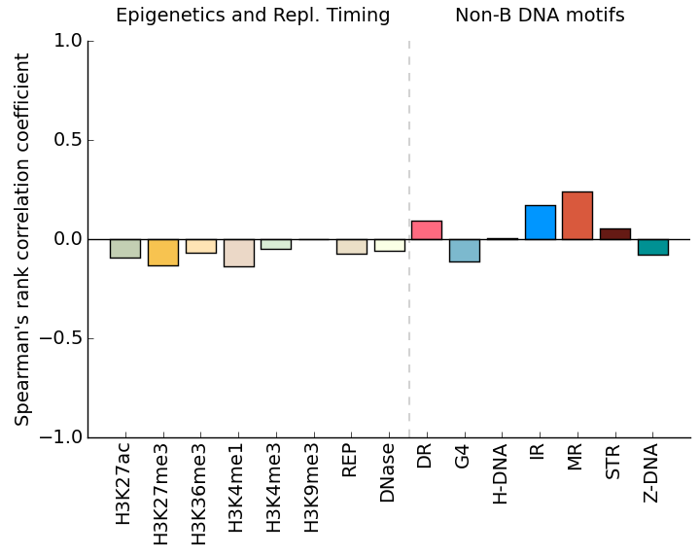
Esophagus Renal cell cancer
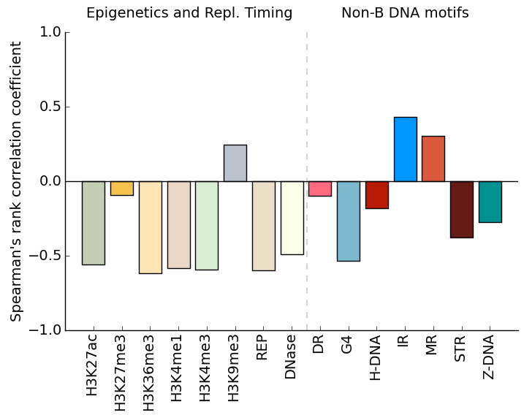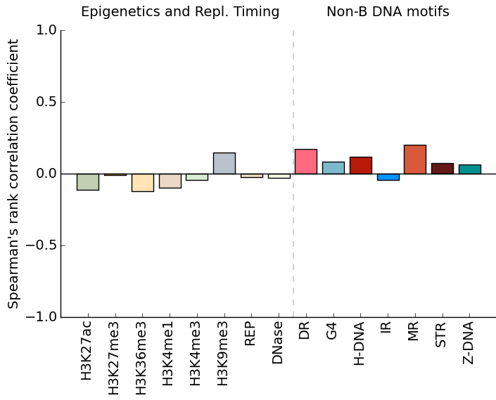
Malignant Lymphoma Pedriatic Brain Tumour
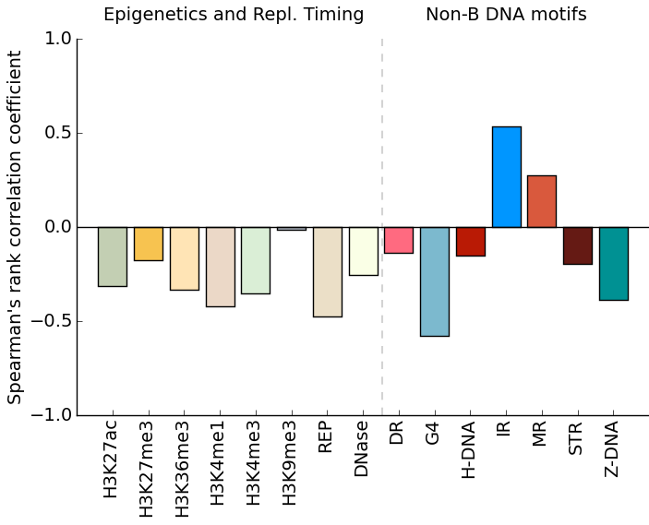

Breast

- REARRANGEMENTS

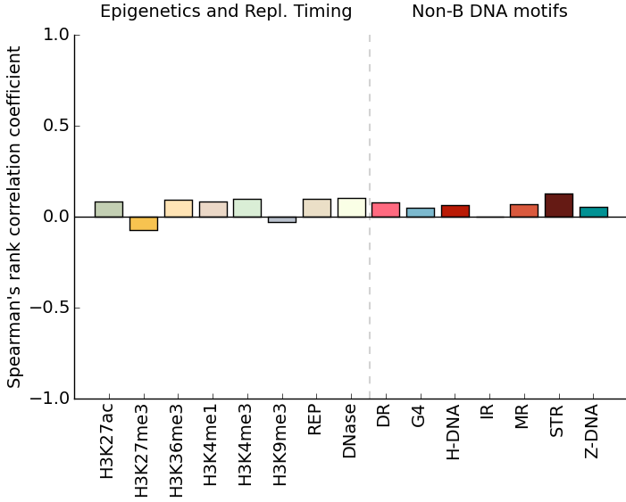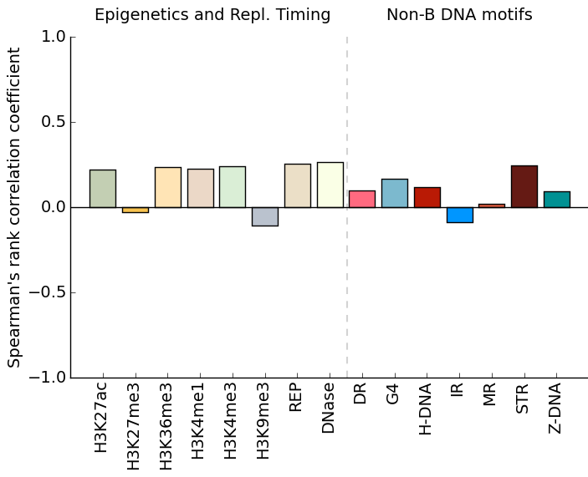
Pancreatic Ovarian
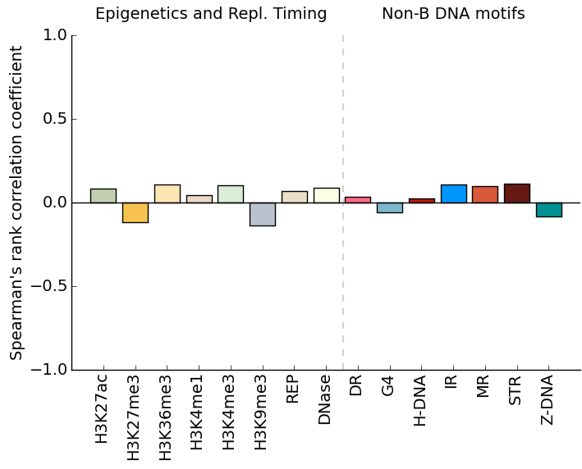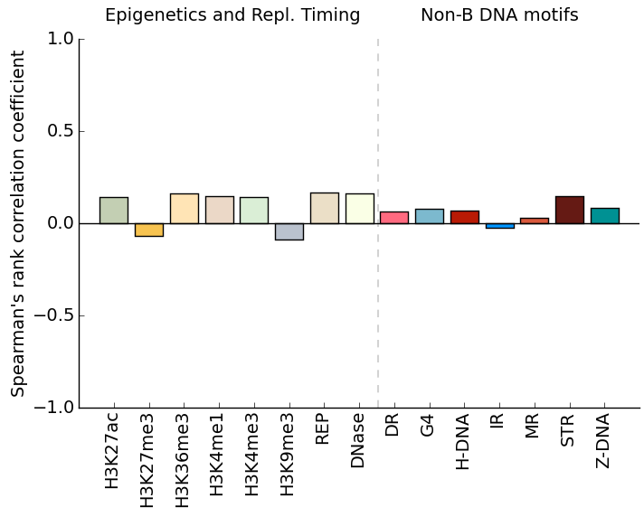
Liver Gastric
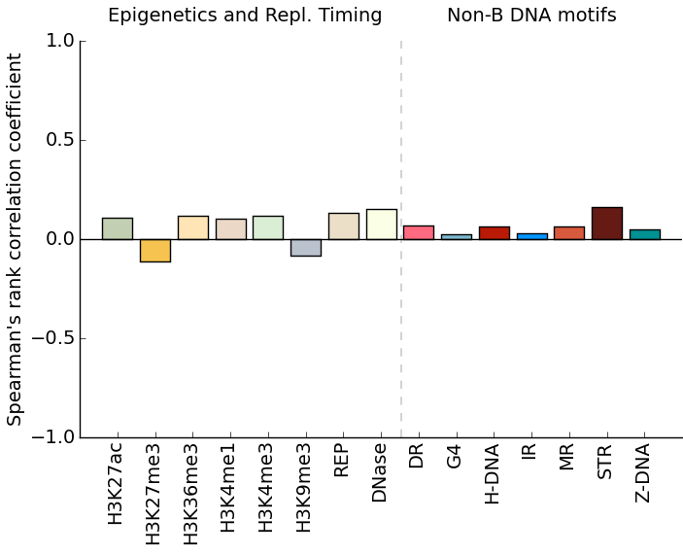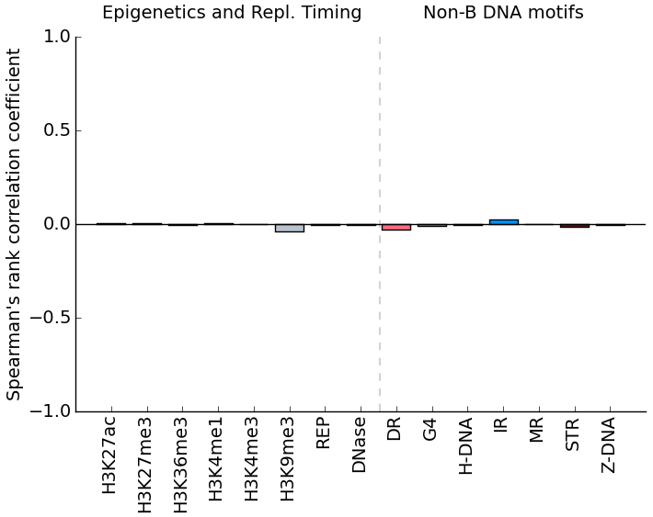
Esophagus Renal cell cancer
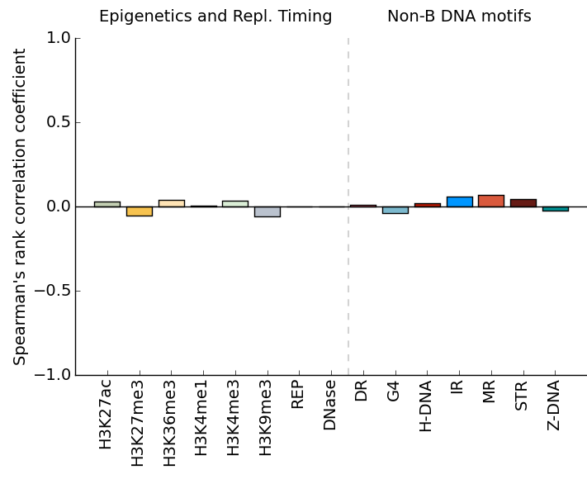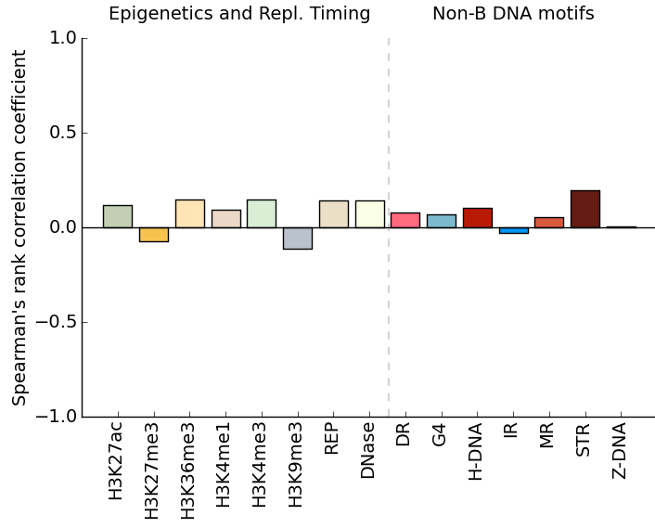
Malignant Lymphoma Pedriatic Brain Tumour
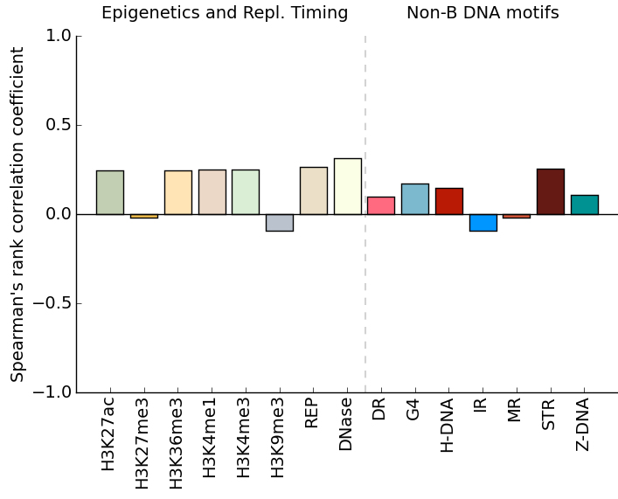

Breast
c.

Fig. S4: Spearman’s rank correlation coefficient between non-B motifs and epigenetic markers/replication timing for: a. substitutions, b. indels, c. rearrangements across multiple tumour types. *For prostate cancer, epigenetic marks for a cell of origin were not available and was excluded.

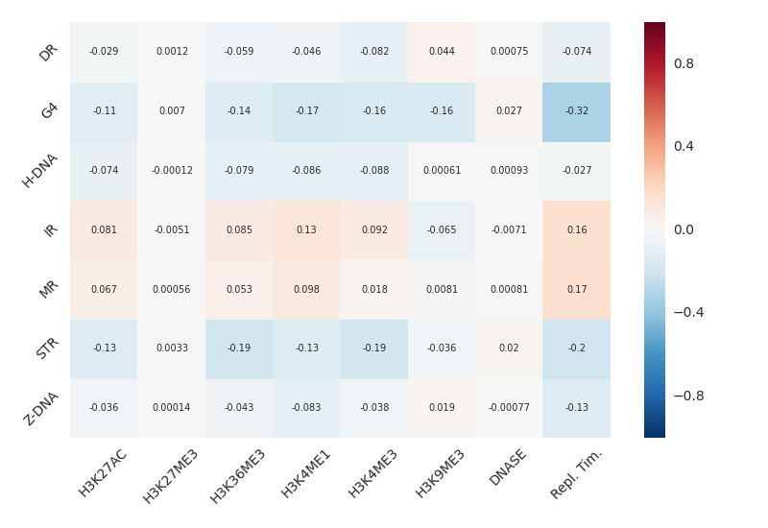

Fig. S5: Results following partial correlation analyses. Remaining correlations (Pearson - partial) for each non-B motif (y-axis) when controlling for epigenetic features and replication timing (x-axis).

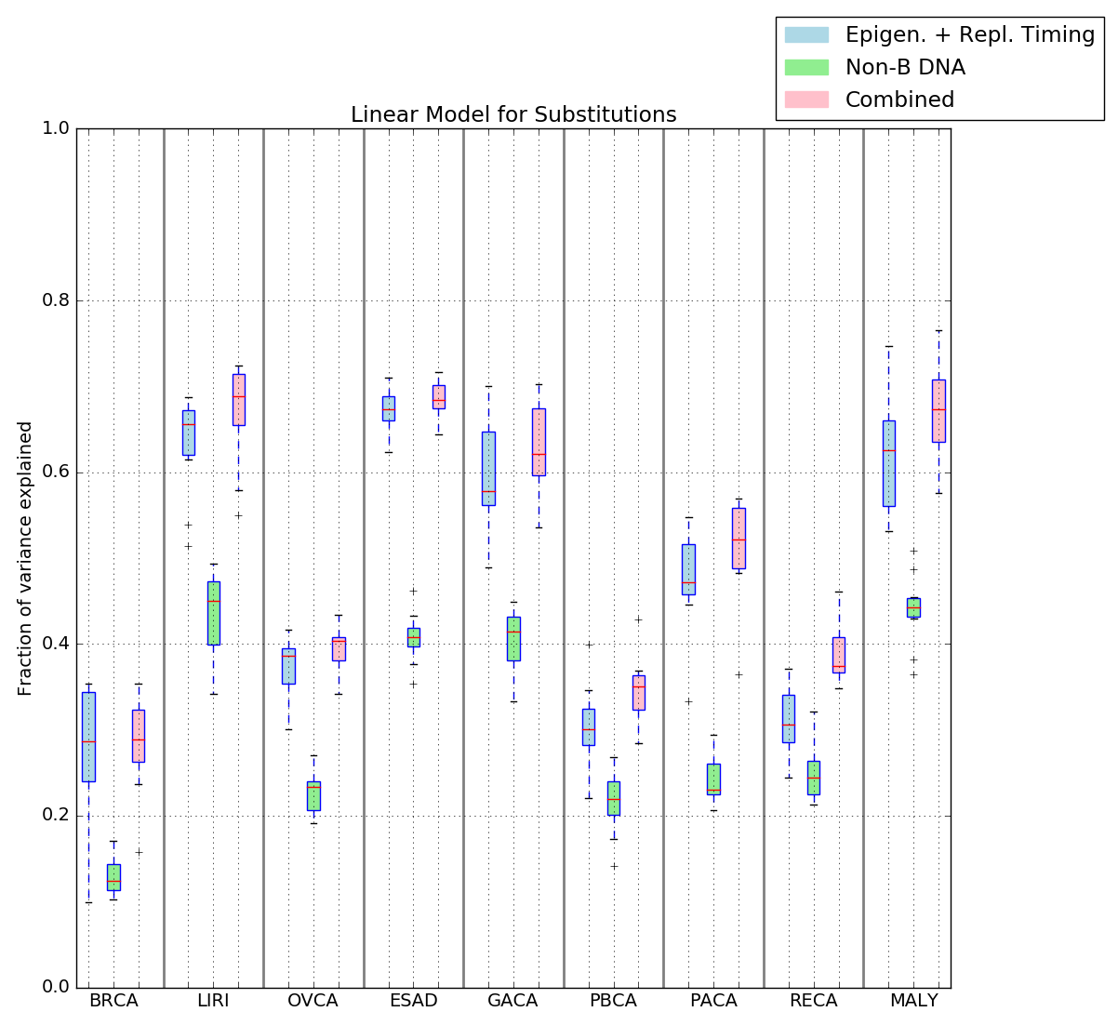

Fig. S6: Linear model predicts mutability of base substitutions. Results depicted across nine tumour types using the following factors: non-B DNA motifs (green), epigenetics/replication timing (blue), or a combination of both (pink).

- SUBSTITUTIONS

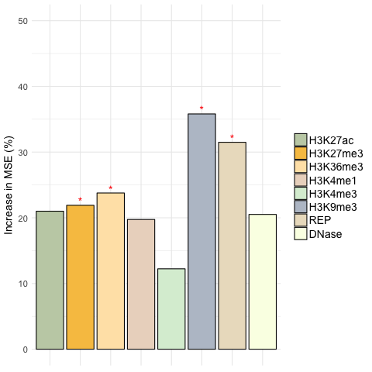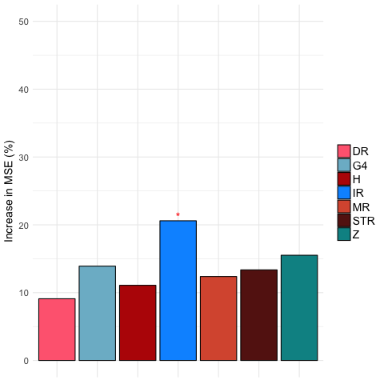

Ovarian
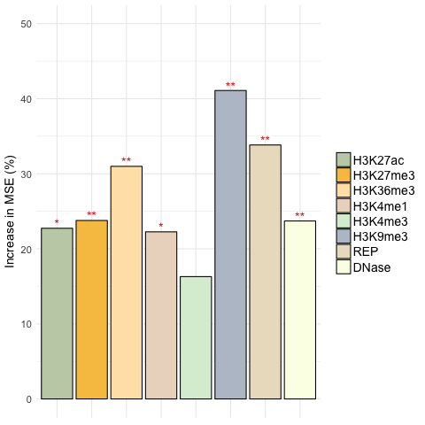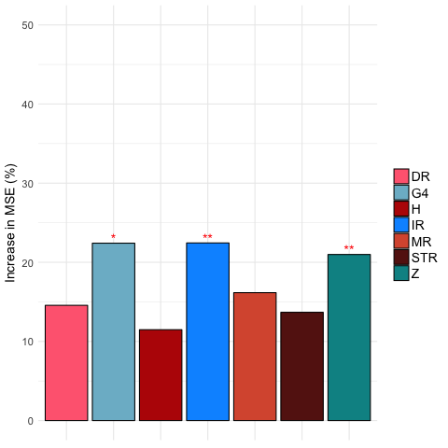

Pancreatic
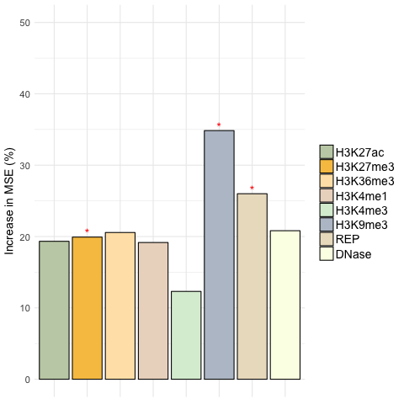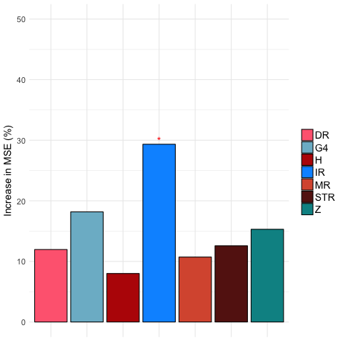

Liver
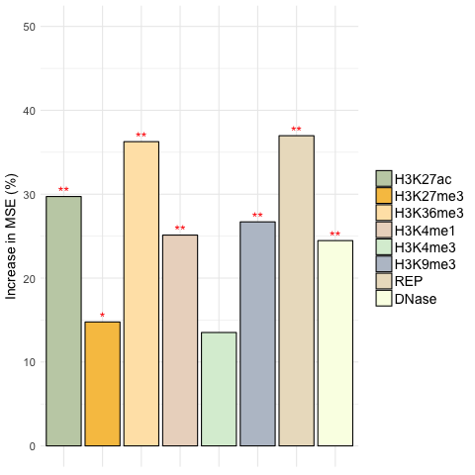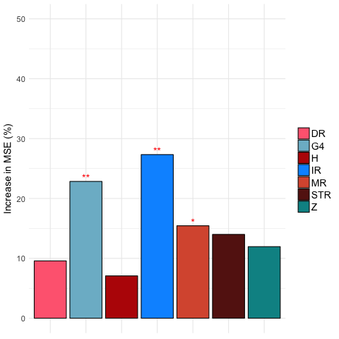

Gastric
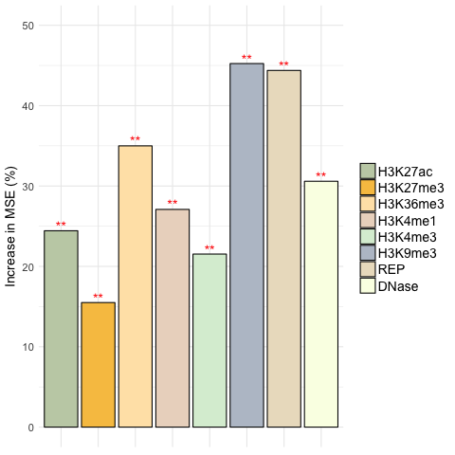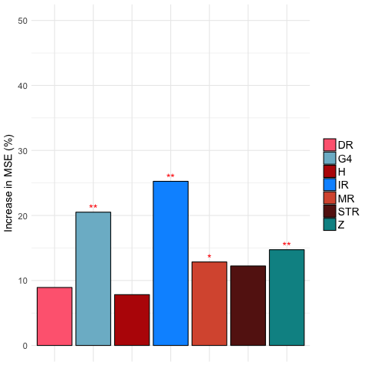

Esophagus
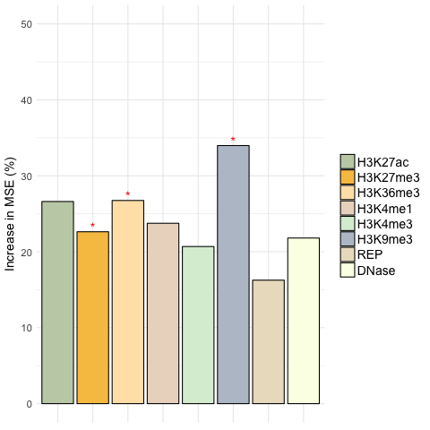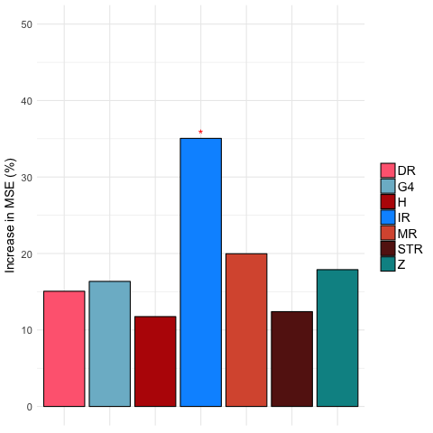

Renal cell cancer
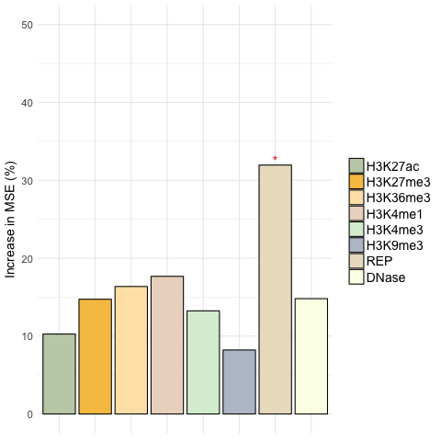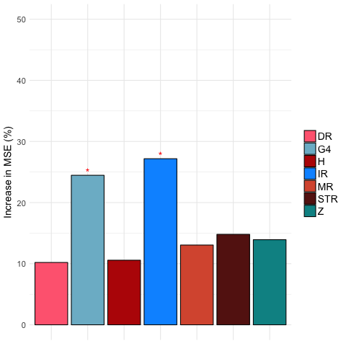

Malignant Lymphoma

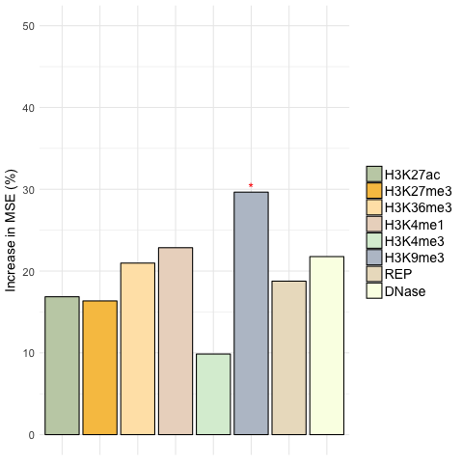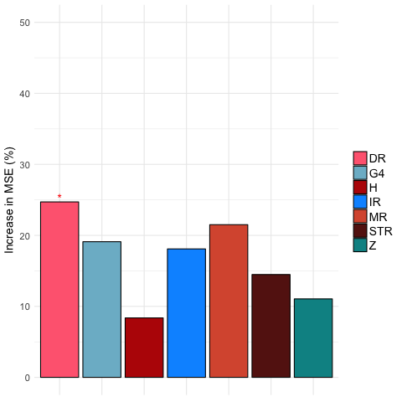

Pedriatic Brain Tumour

B. INDELS

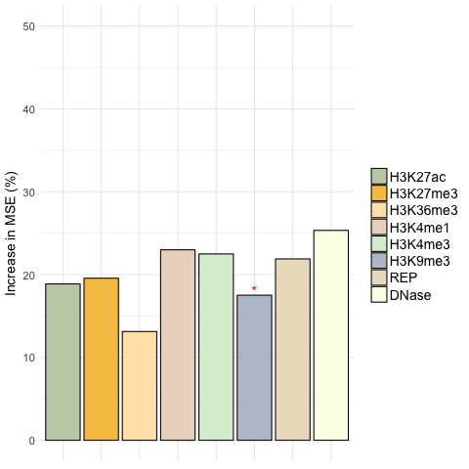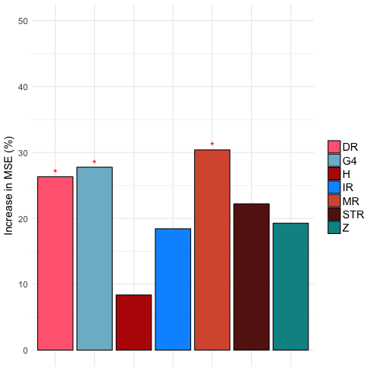

Ovarian
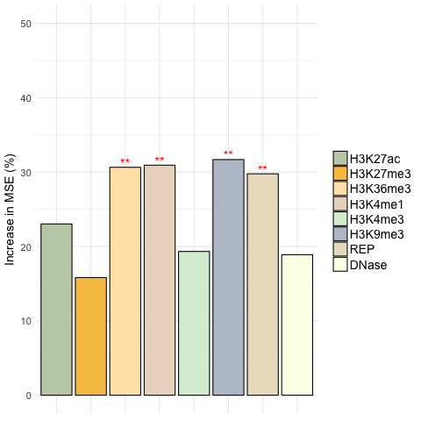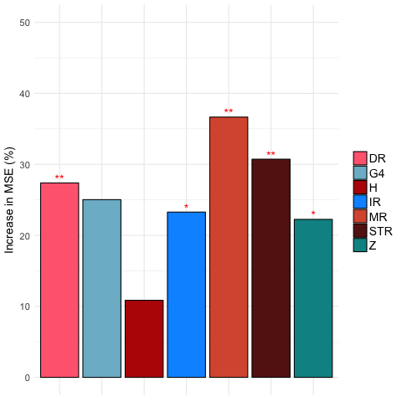

Pancreatic
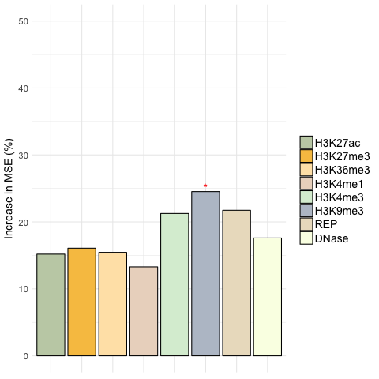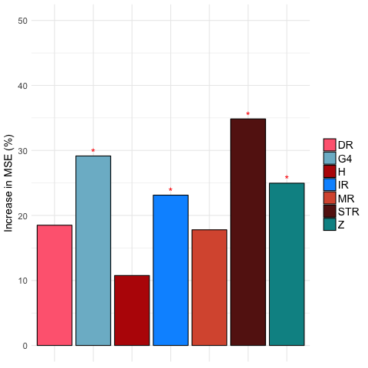

Liver
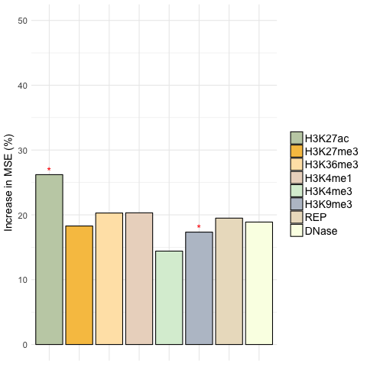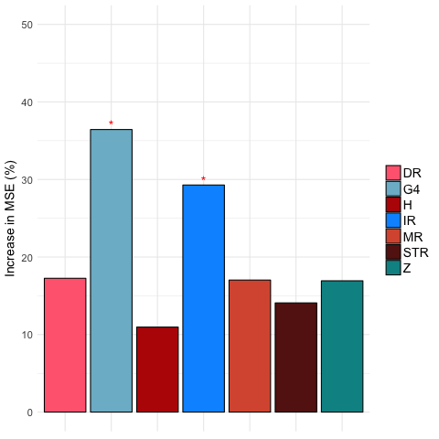

Gastric
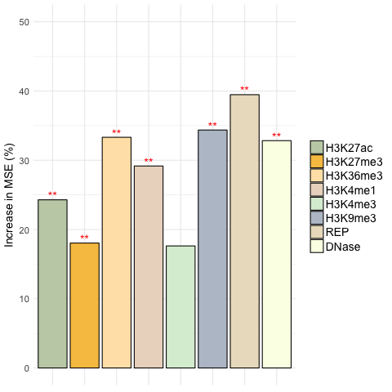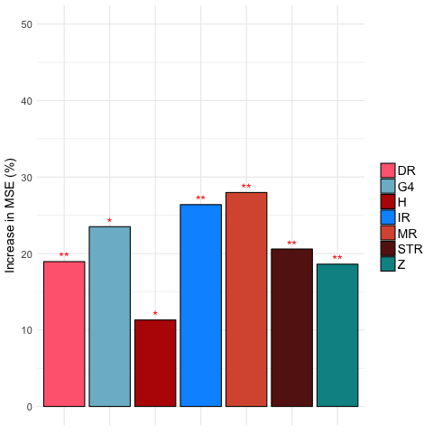

Esophagus
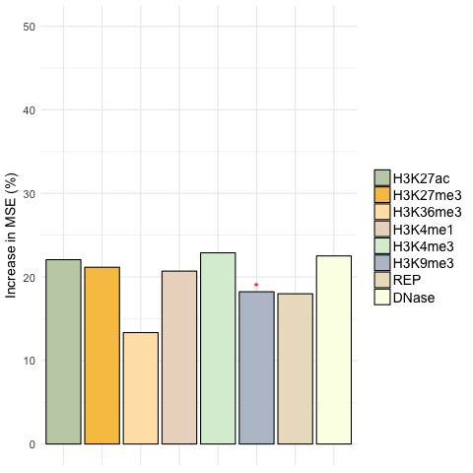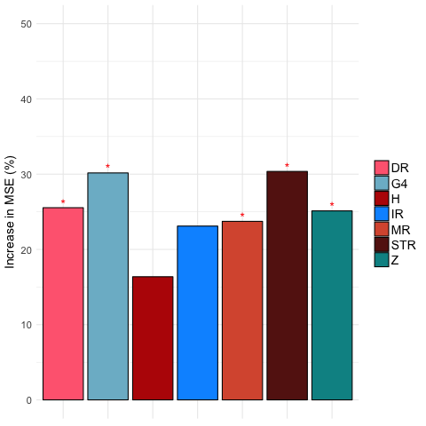

Renal cell cancer
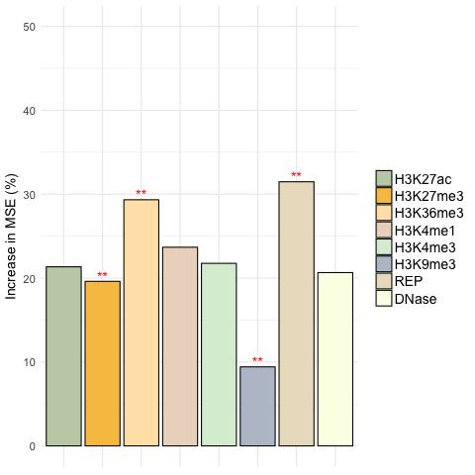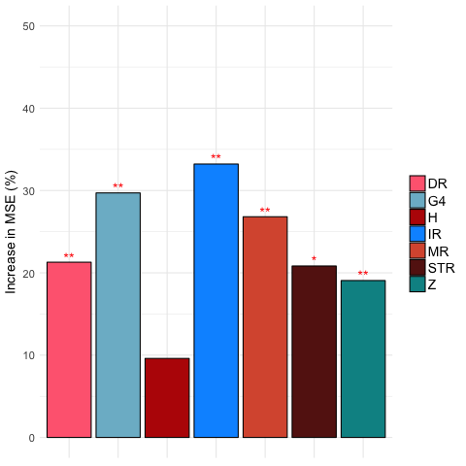

Malignant Lymphoma

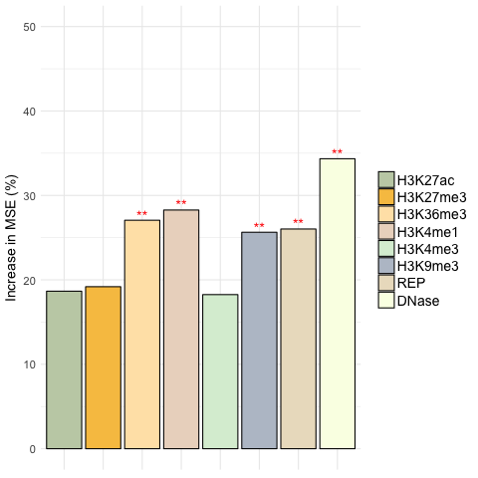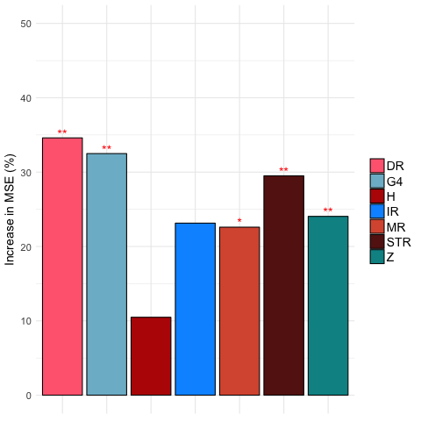

Pedriatic Brain Tumour

C. REARRANGEMENTS

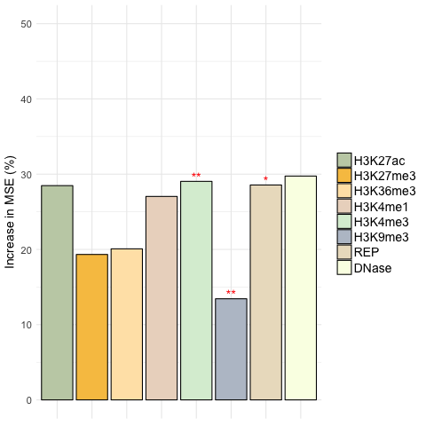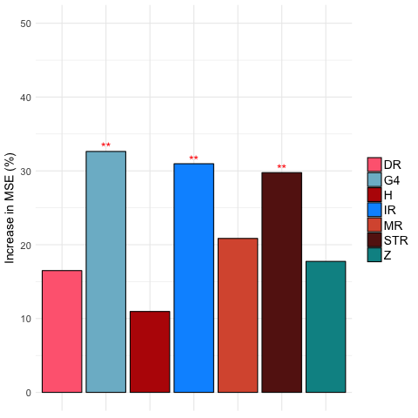

Ovarian
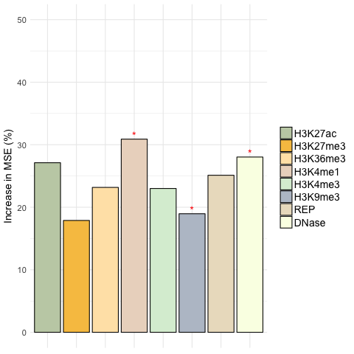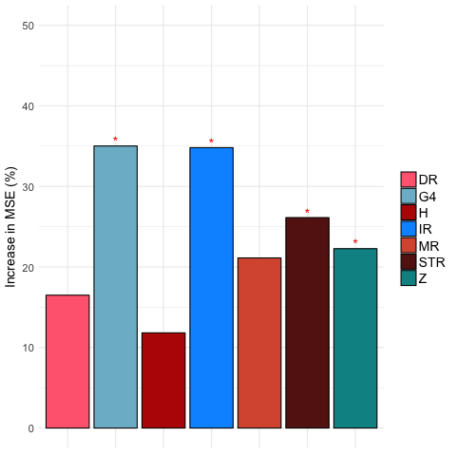

Pancreatic
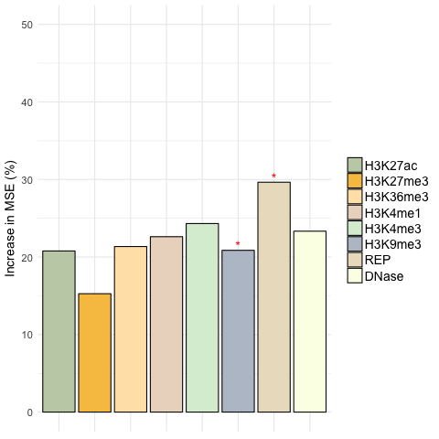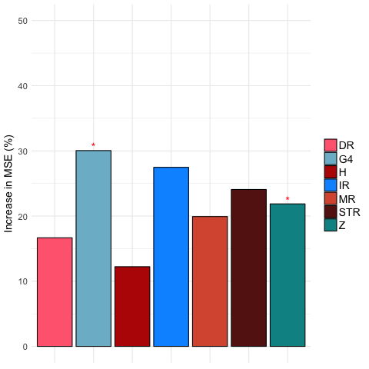

Liver

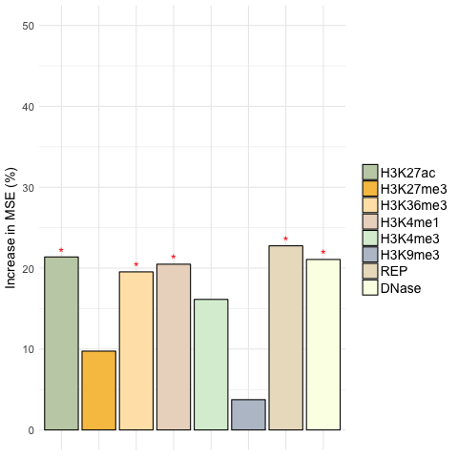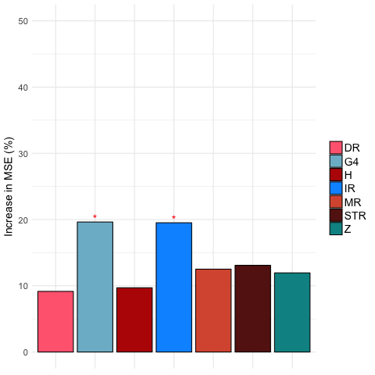

Gastric
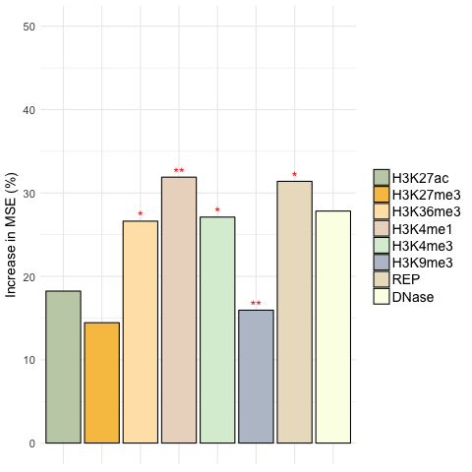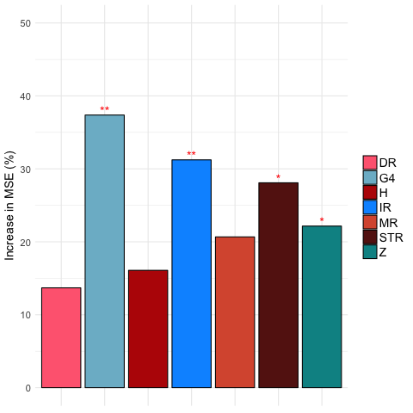

Esophagus
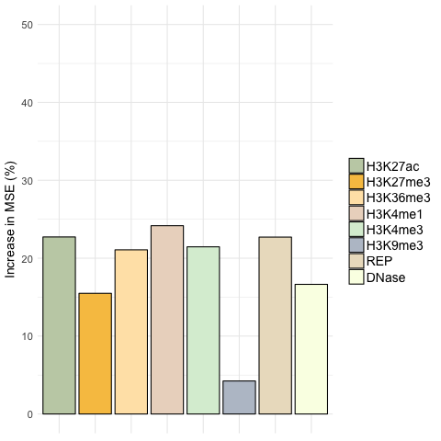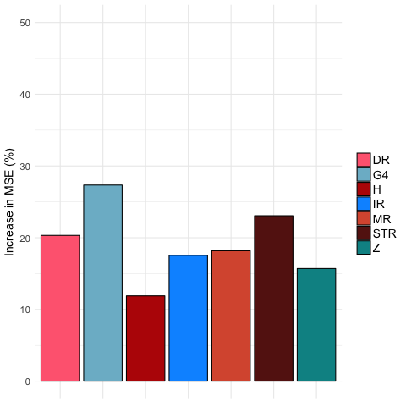

Renal cell cancer
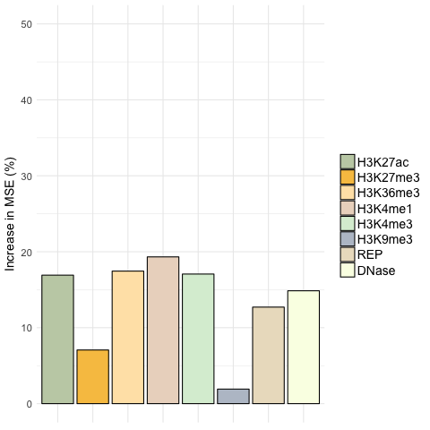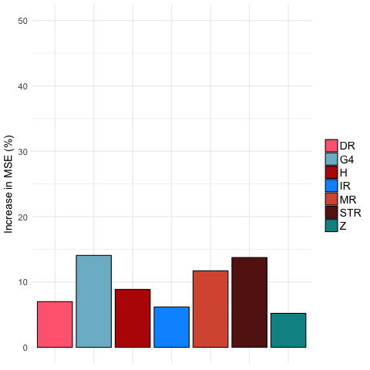

Malignant Lymphoma
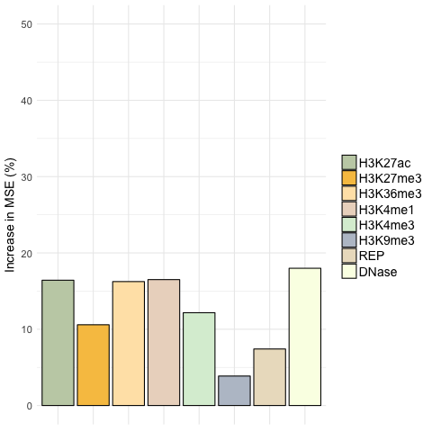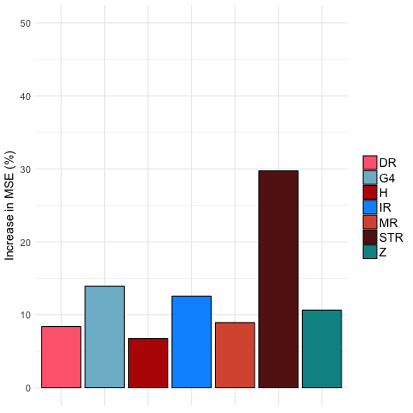

Pedriatic Brain Tumour

Fig. S7: Importance of the different predictors for the random forest regression for different tumor types. The y-axis shows the increase in mean square error (MSE) when the variable is excluded. Bars with * have an FDR<.05 and ** have FDR<.01 as determined by a permutation test. Results depicted are for different mutation classes: a) substitutions, b) indels and c) rearrangements.

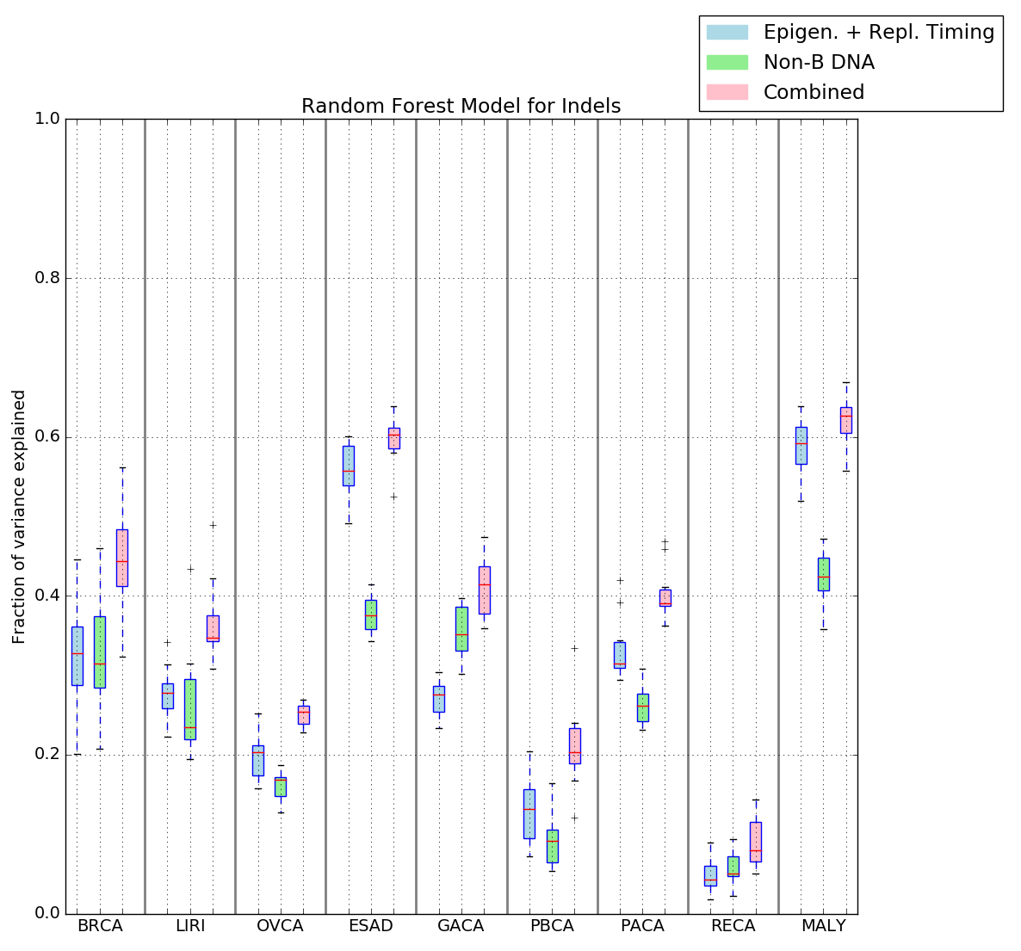
a.
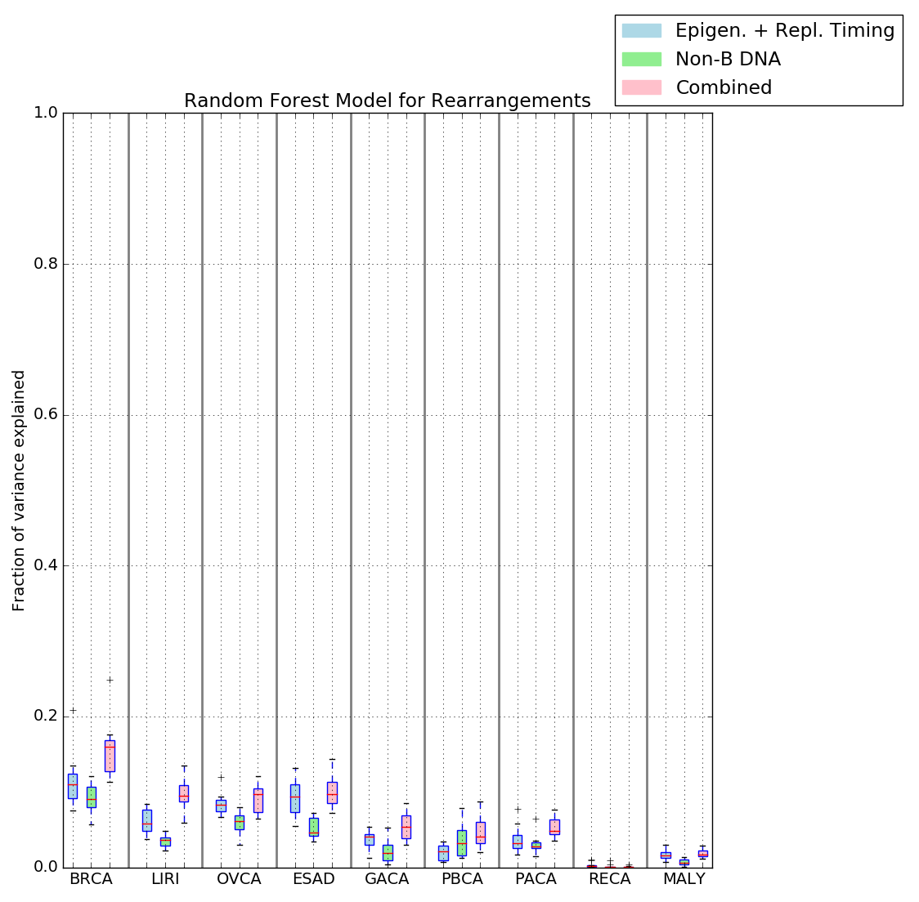
b.

Fig. S8: Random forest model predicts mutability. (a) Indels and (b) rearrangements. Results depicted across nine tumour types using the following factors: non-B DNA motifs (green), epigenetics/replication timing (blue), or a combination of both (pink).

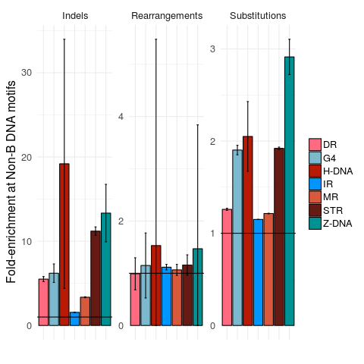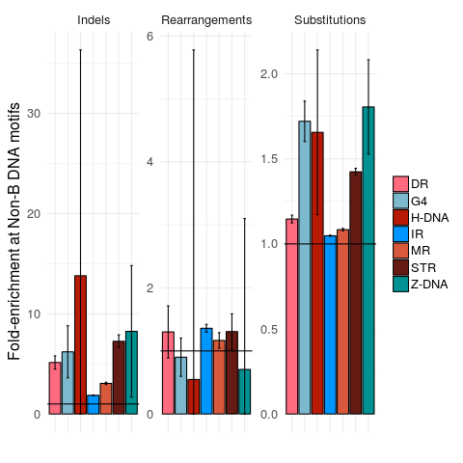
Pancreatic Ovarian
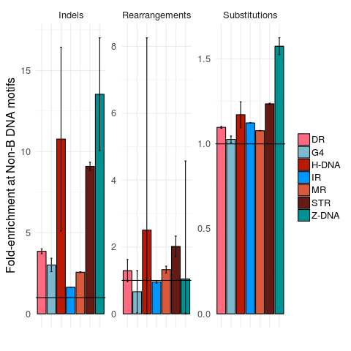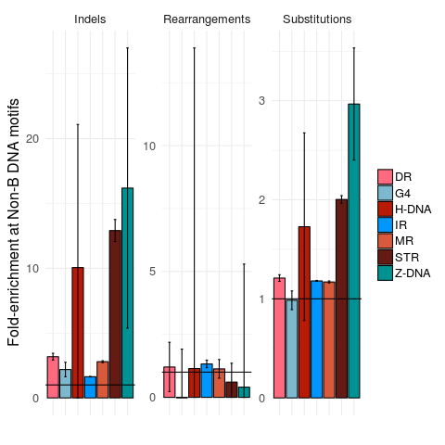
Liver Gastric
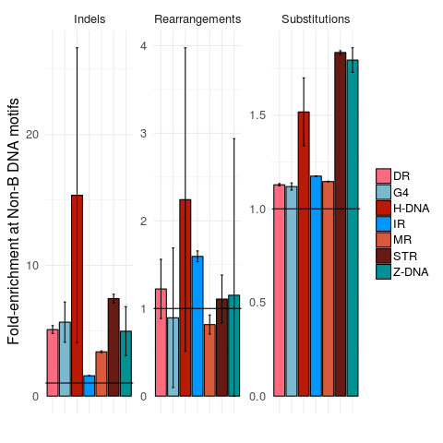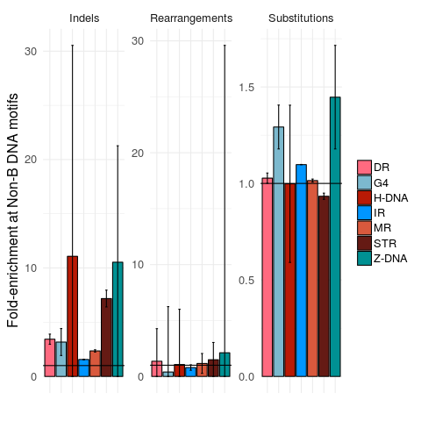
Esophagus Renal cell cancer
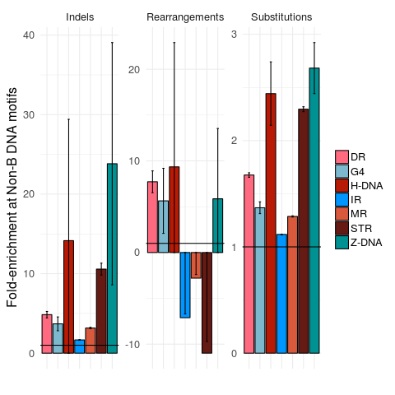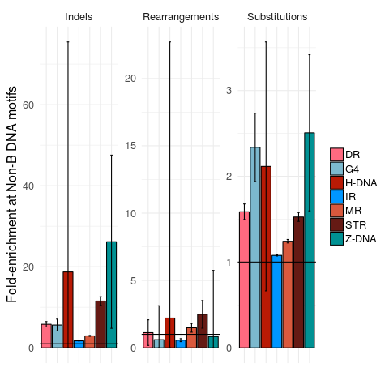
Malignant Lymphoma Pedriatic Brain Tumour
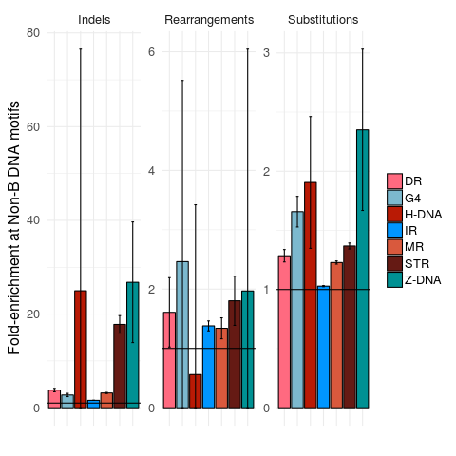

Prostate

Fig. S9: Enrichment of mutations overlapping non B-DNA motifs across nine tumour types. *Negative enrichment in malignant lymphoma IR, MR, STR for rearrangements is due to correction (see Methods).
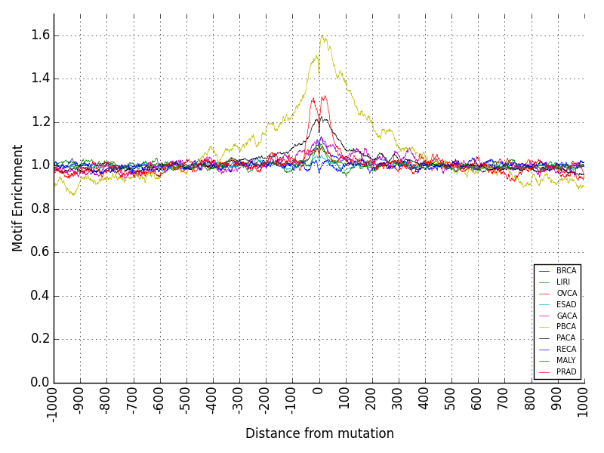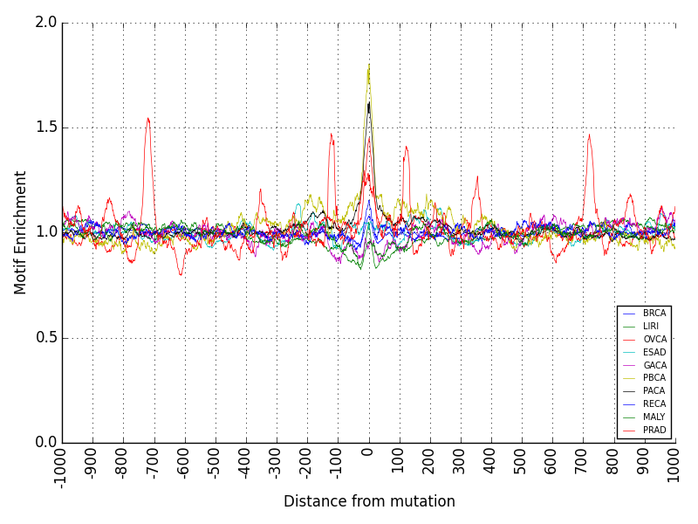
DR G4
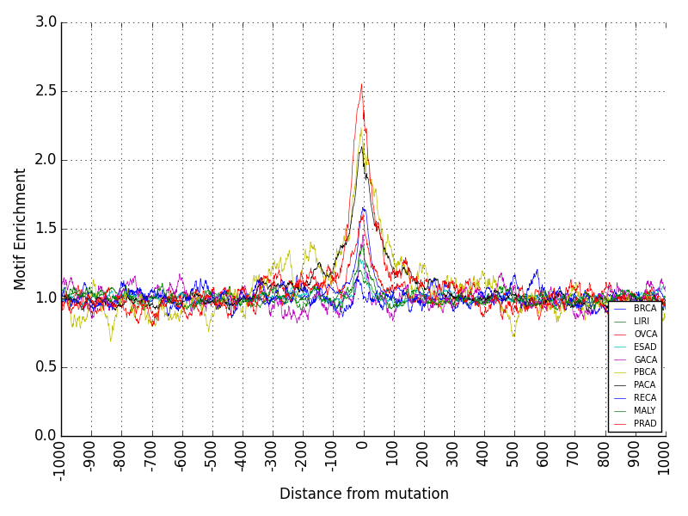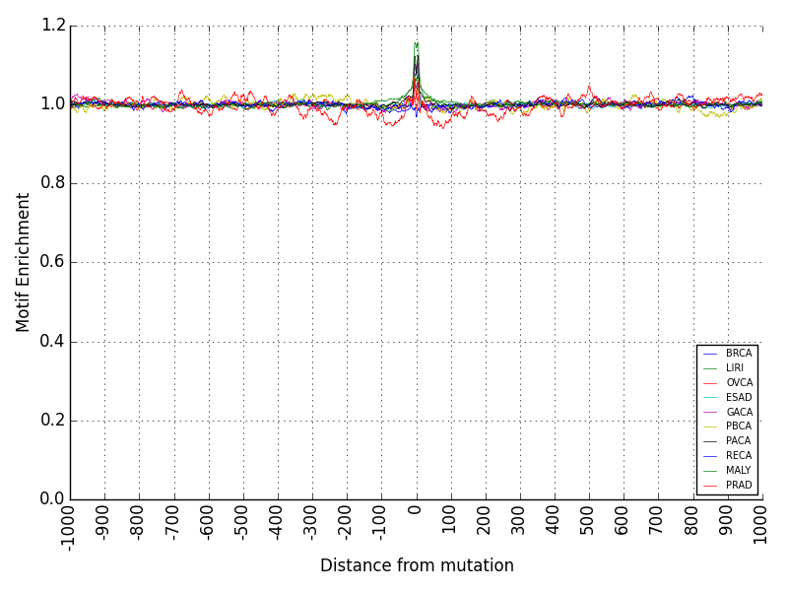
H-DNA IR
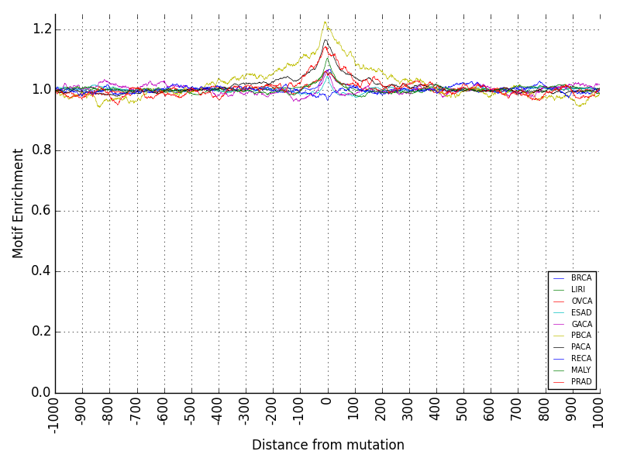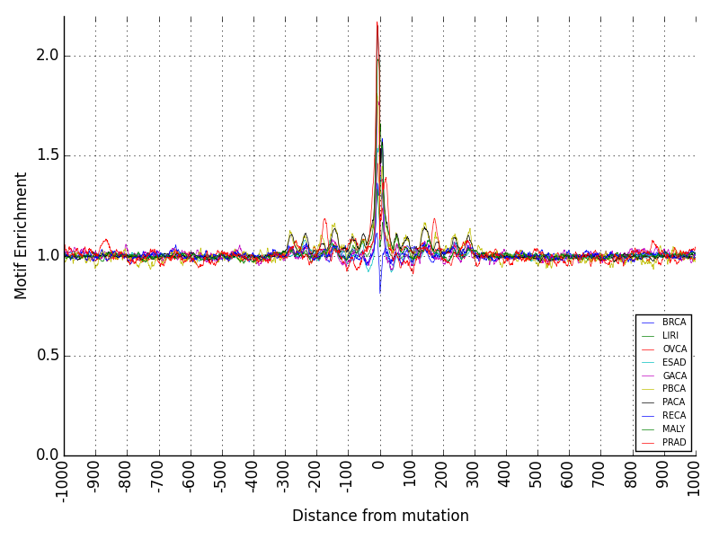
MR STR
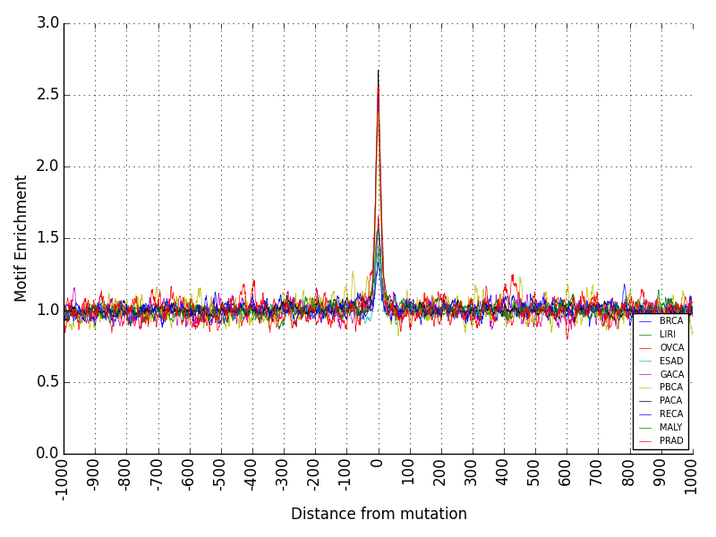

Z-DNA
a)
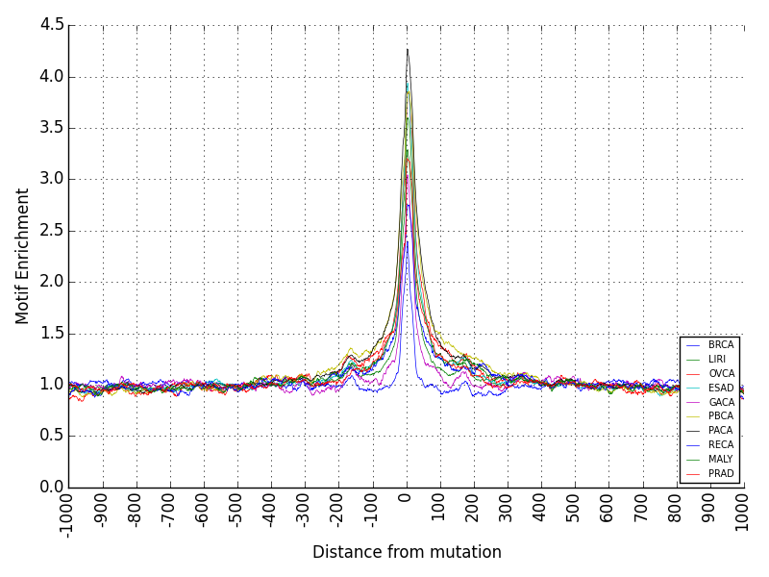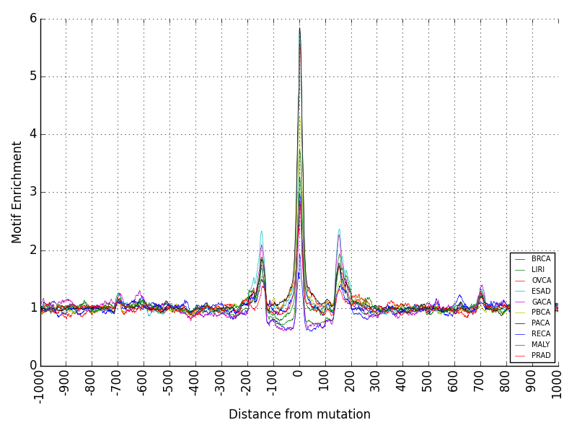
DR G4
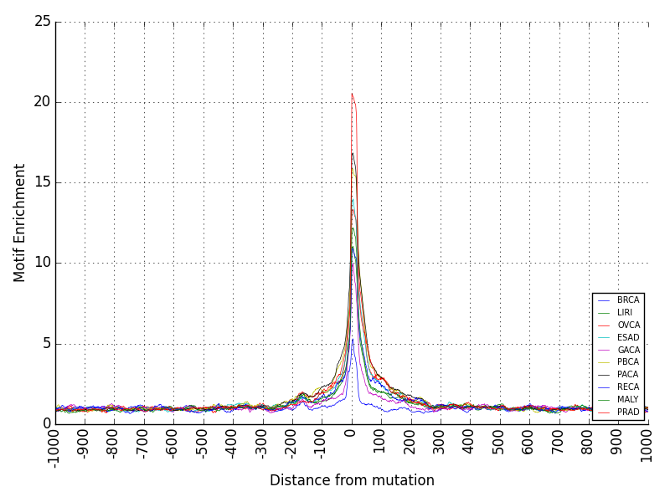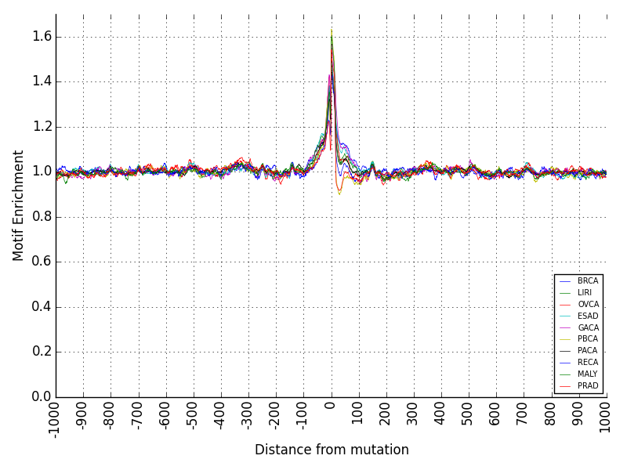
H-DNA IR
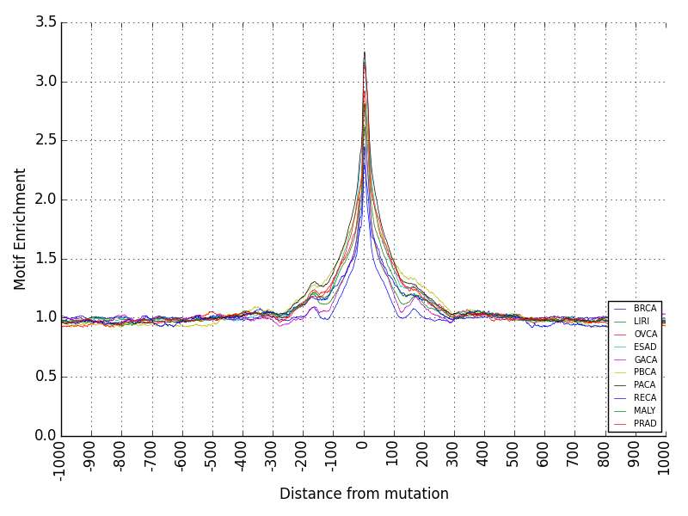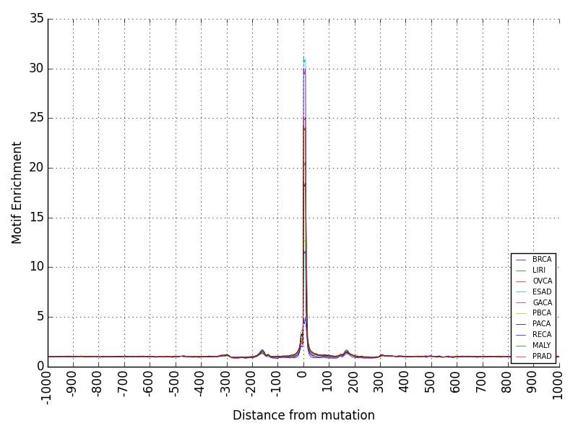
MR STR
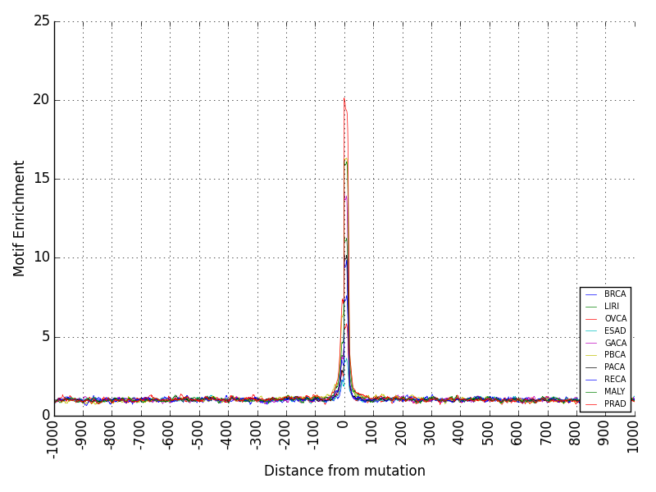

Z-DNA
b)
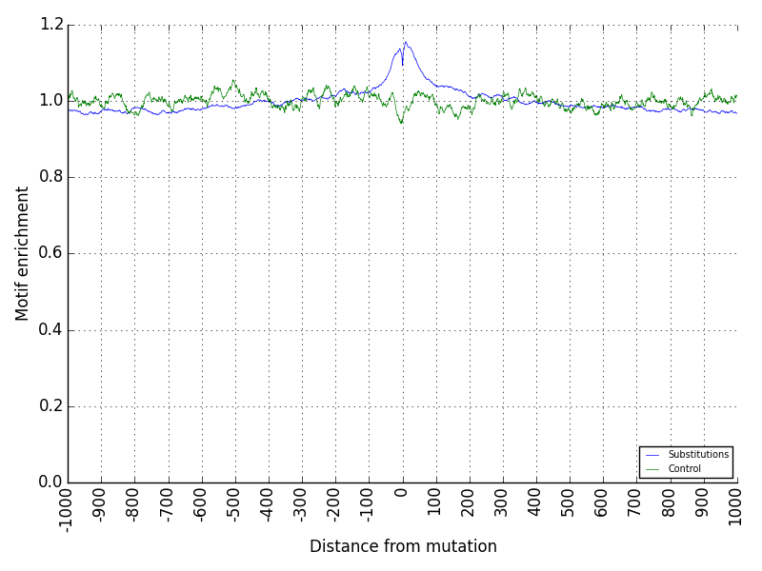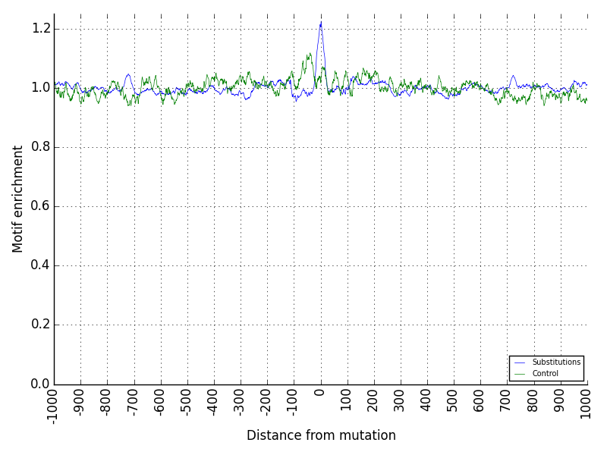
DR G4
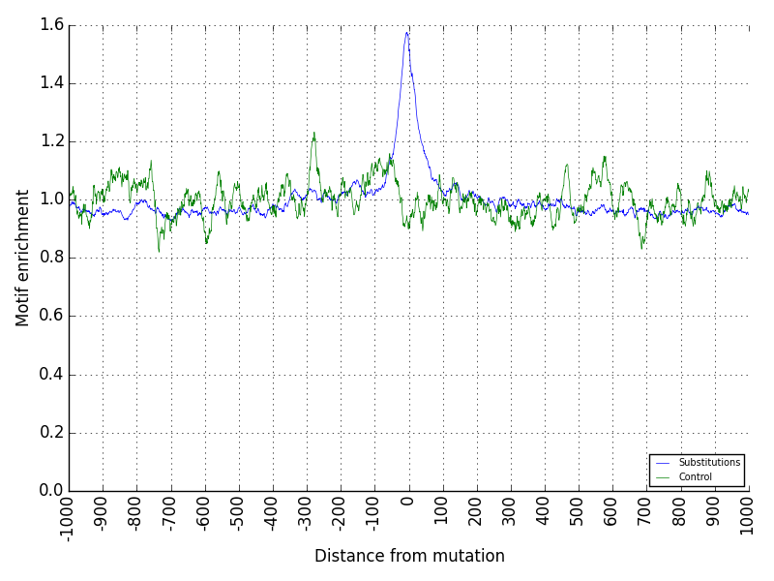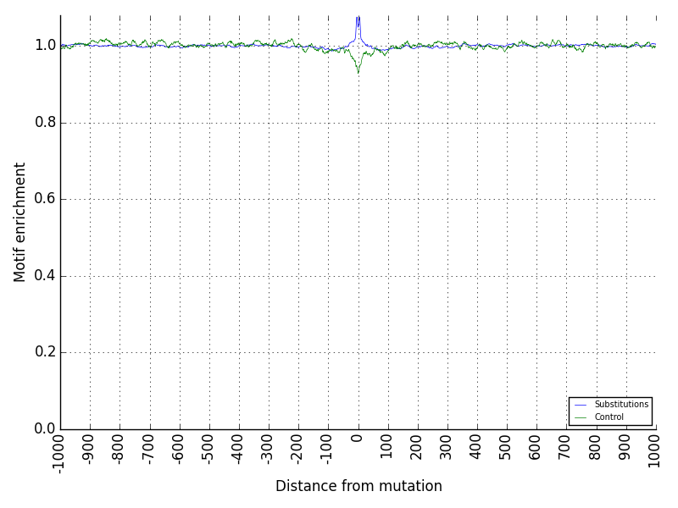
H-DNA IR
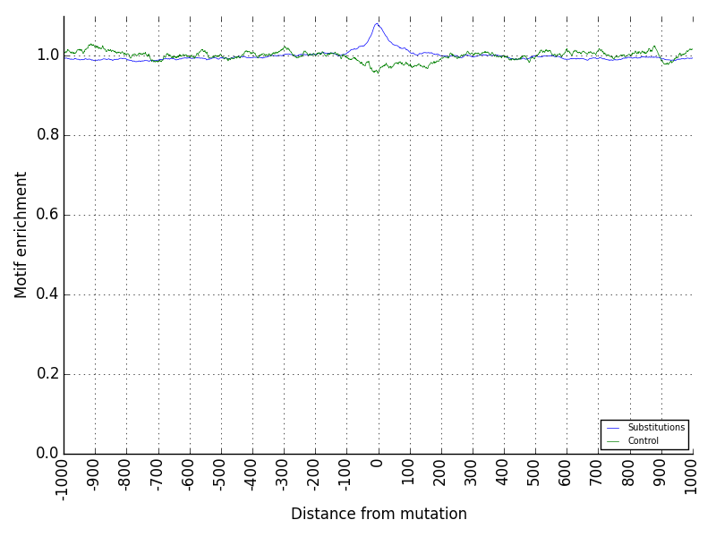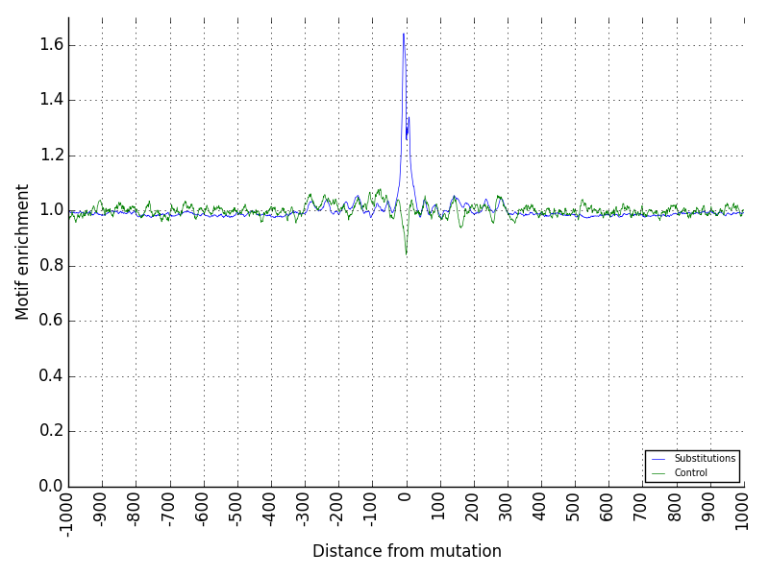
MR STR
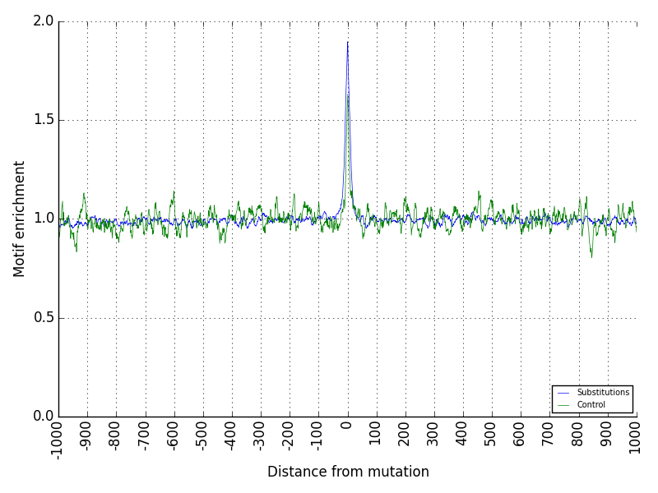

Z-DNA
c)
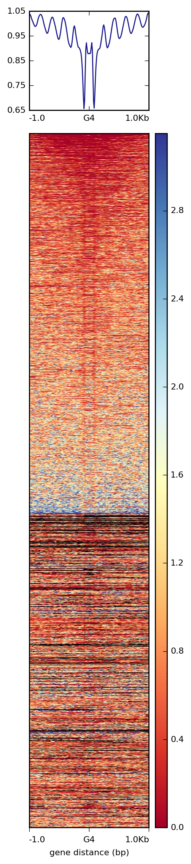
d)
Fig. S10: Relationship between non-B DNA motifs and mutability. Mutational enrichment at 2kb window (+/- 1kb) showing the distribution of non-B DNA motifs for: a) substitutions, centered at position 0 on x-axis, b) indels, centered at position 0 on x-axis, c) substitutions and controls generated with same trinucleotide content, both centered at position 0 on x-axis. d) Nucleosome density at 2kb window centered at G4s (position 0, x-axis), indicating the relationship between G4s and nucleosome occupancy (MNase signal).

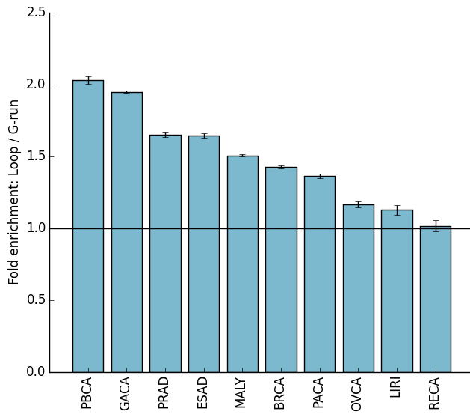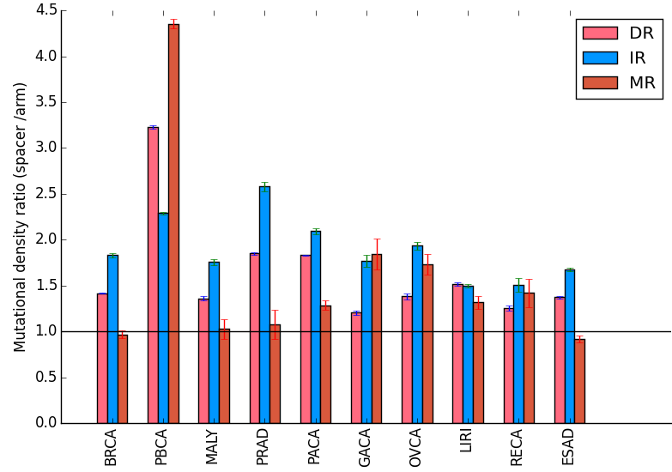
a) b)
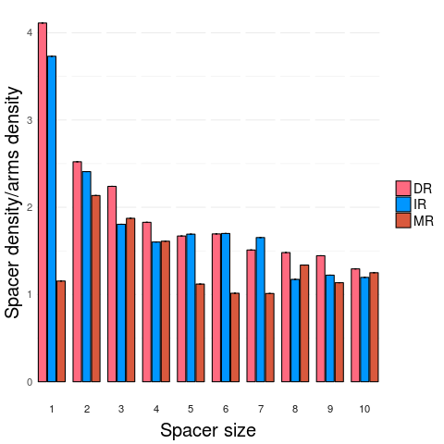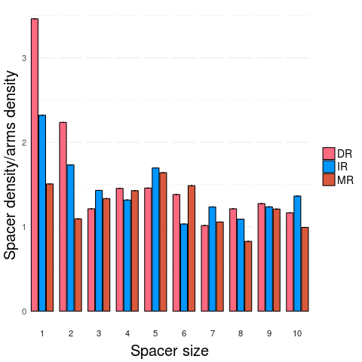
Pancreatic Ovarian
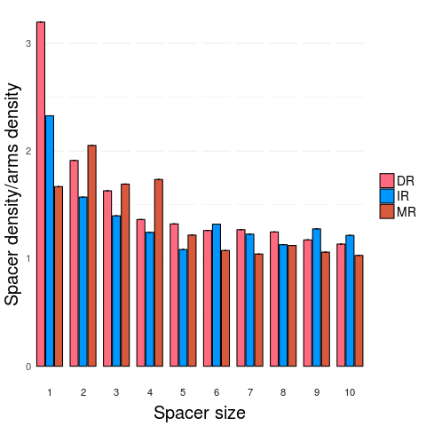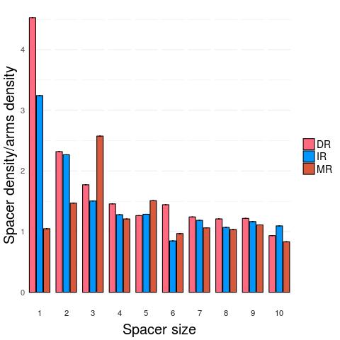
Liver Gastric
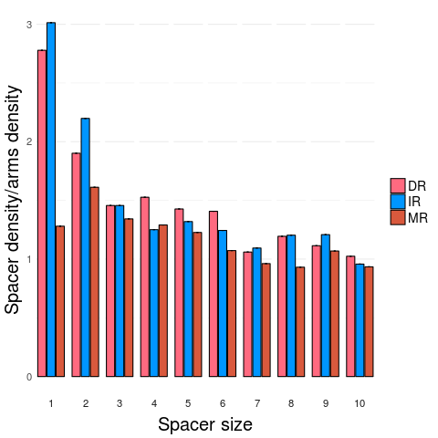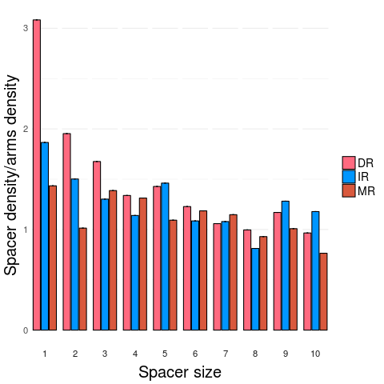
Esophagus Renal cell cancer
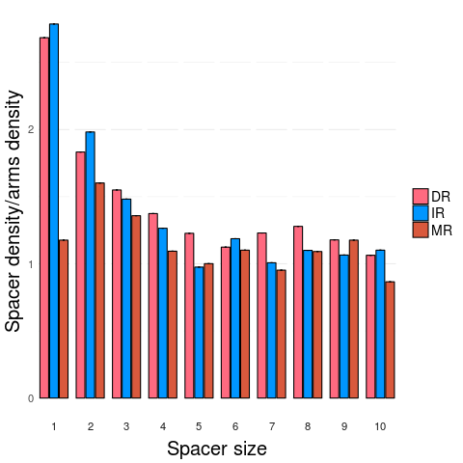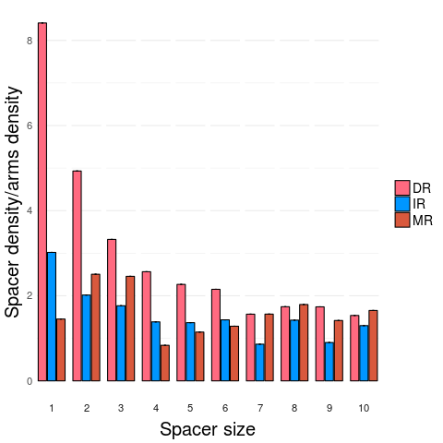
Malignant Lymphoma Pediatric Brain Tumour
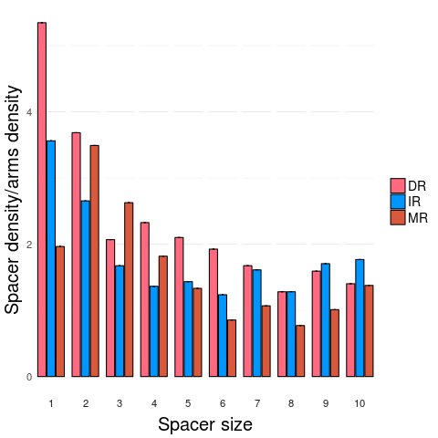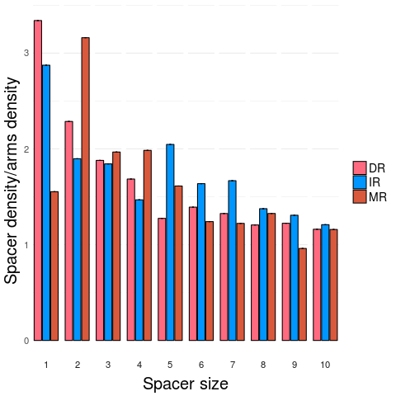
Prostate Breast
c)

Fig. S11: Increased mutability is domain-specific for particular non-B DNA motifs. a) Mutational density in loops compared to G-runs for G-quadruplexes, corrected for trinucleotide content. b) Mutational density in spacers compared to arms for direct repeats, inverted repeats and mirror repeats, corrected for trinucleotide content. Error bars represent standard error from bootstrapping in a-b. c) Mutational density in spacers compared to arms for direct repeats, inverted repeats and mirror repeats as a function of the length of the spacer. Error bars represent the standard error. Results shown for ten tumour types.

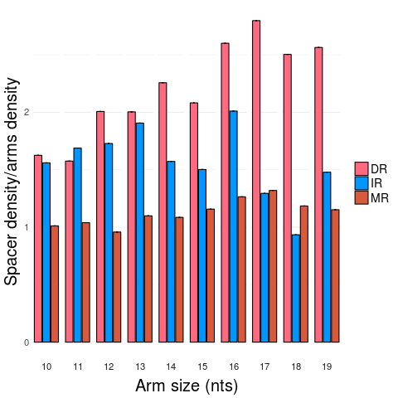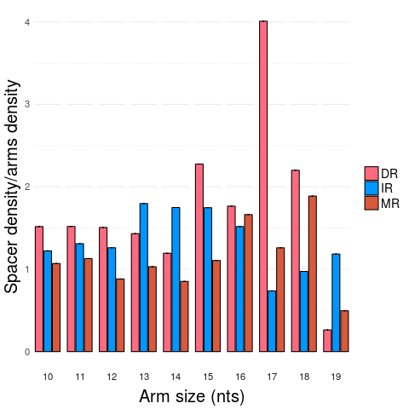
Pancreatic Ovarian
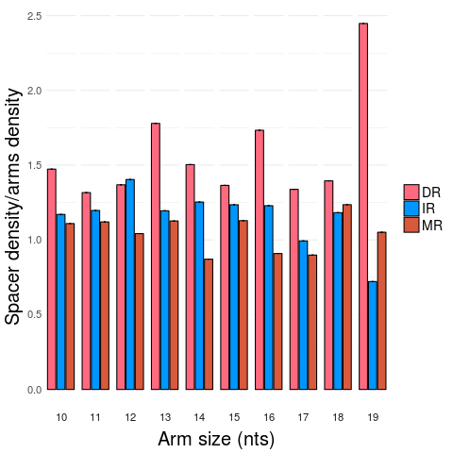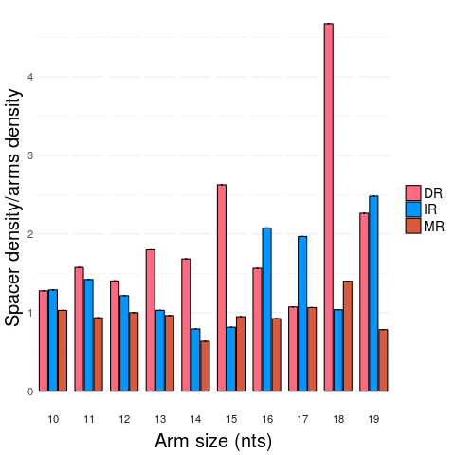
Liver Gastric

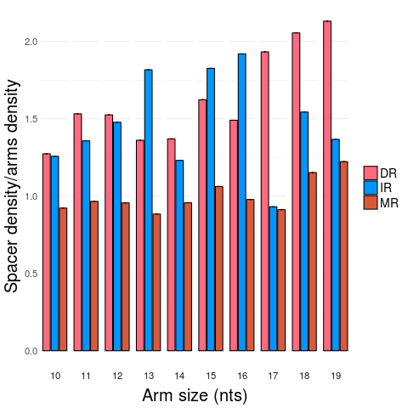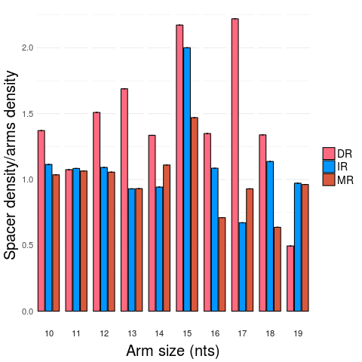
Esophagus Renal cell cancer

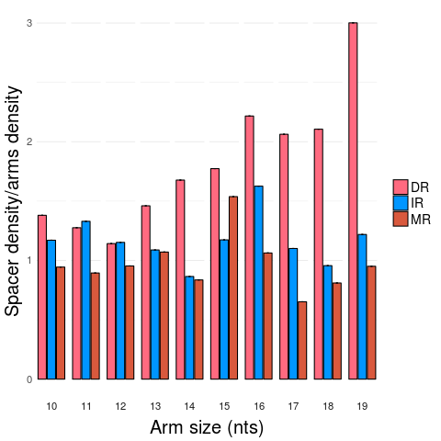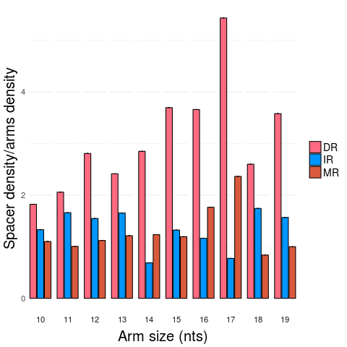
Malignant Lymphoma Pediatric Brain Tumour

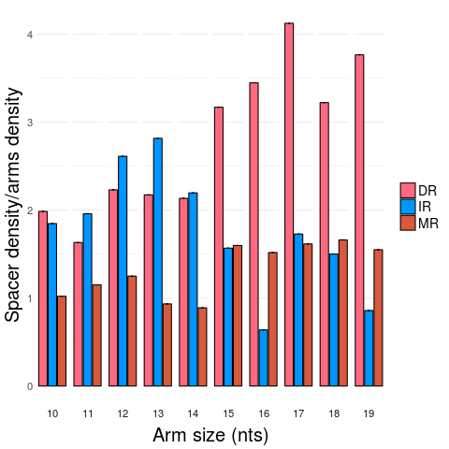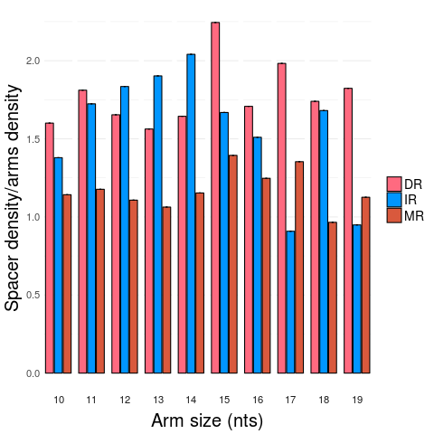
Prostate Breast

Fig. S12: Increased mutability is domain-specific for particular non-B motifs. Mutation density in spacers compared to arms for direct repeats, inverted repeats and mirror repeats as a function of the length of the arm. Error bars represent the standard error. Results shown for ten tumour types.

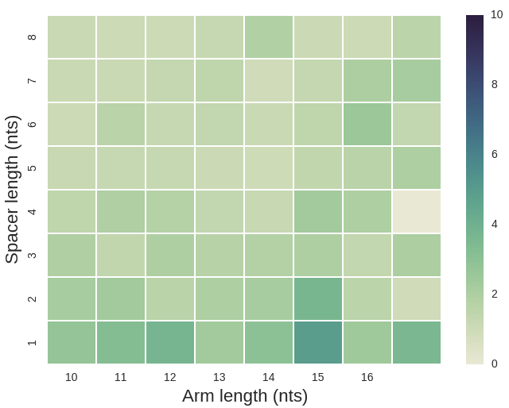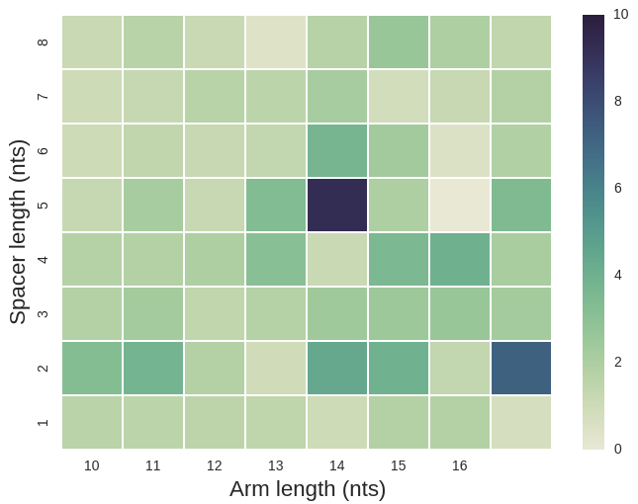
DR MR

Fig. S13: Differences in spacer to arm mutability in non-B motifs for different spacer and arm lengths variable from one non-B motif to another in breast cancer. Heatmap of mutational density at spacer versus arms for different spacer and arm lengths for direct repeats (DR) and mirror repeats (MR) for breast cancer showing differences to inverted repeats (IR, as seen in Fig. 3d).

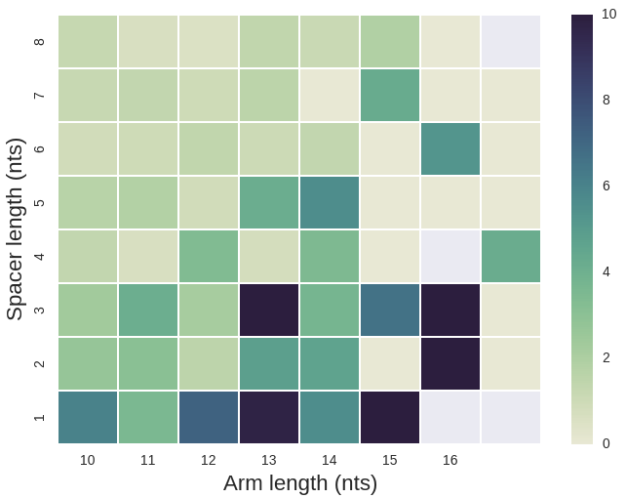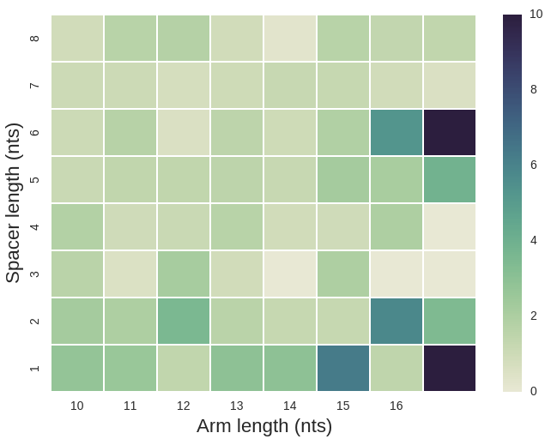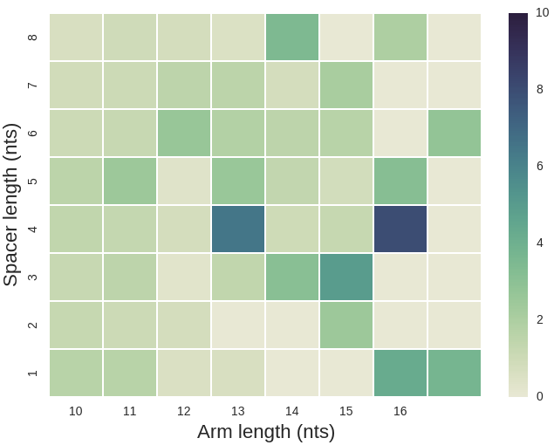
IR DR MR

Ovarian
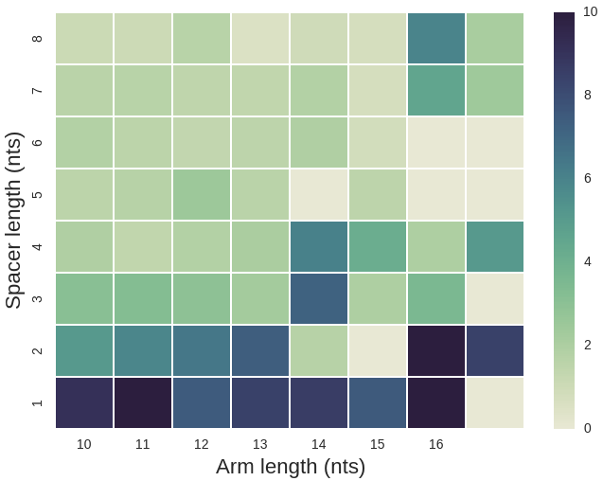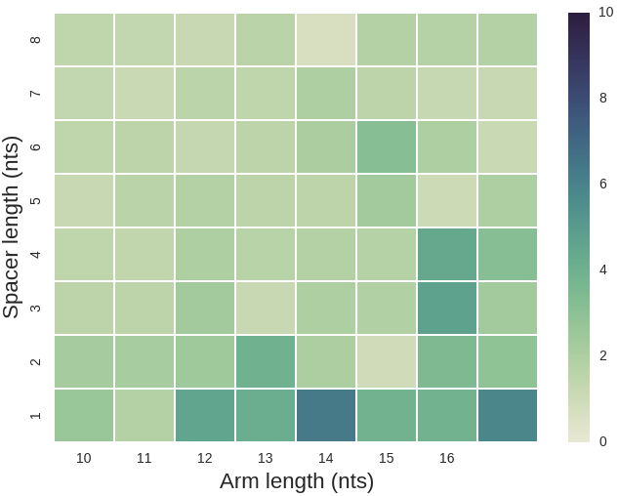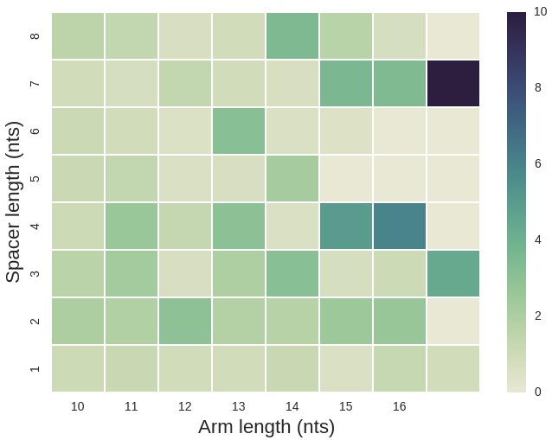
IR DR MR

Pancreatic
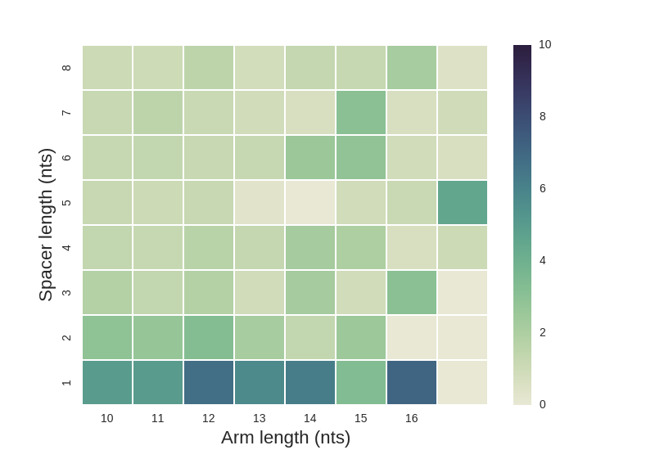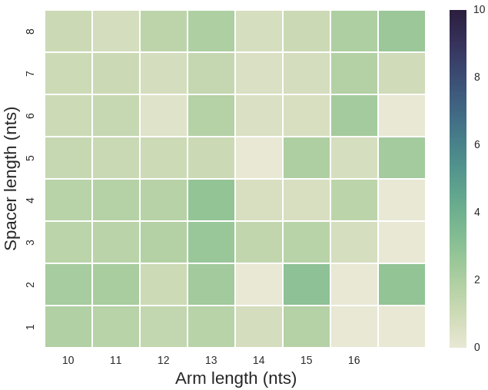
IR DR MR

Liver
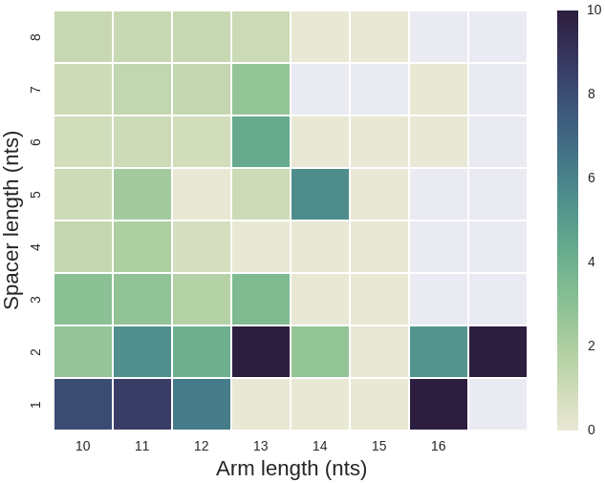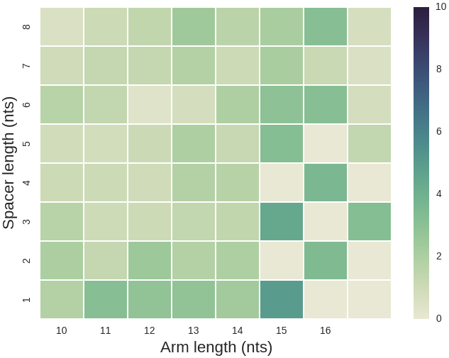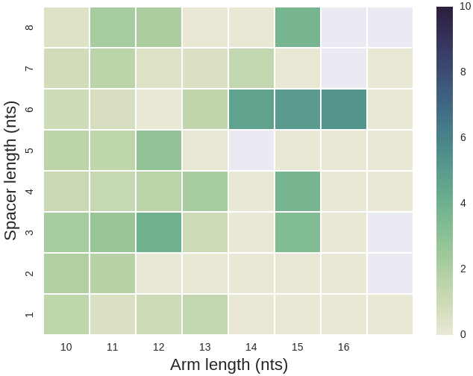
IR DR MR

Gastric
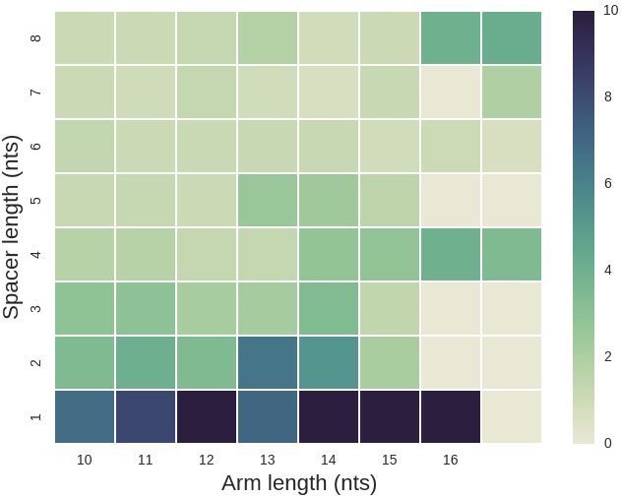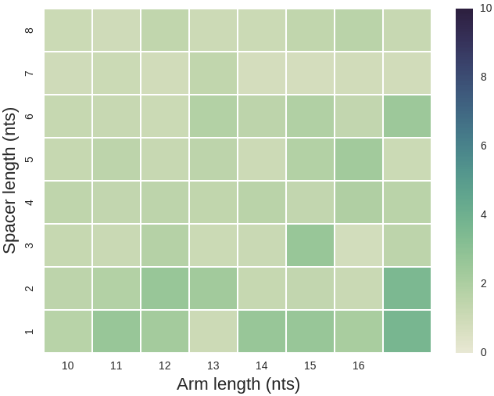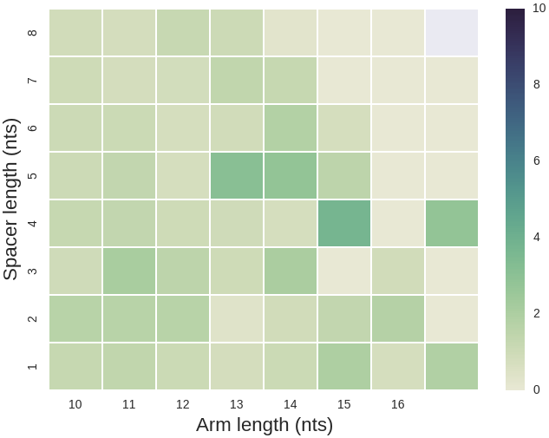
IR DR MR

Esophagus
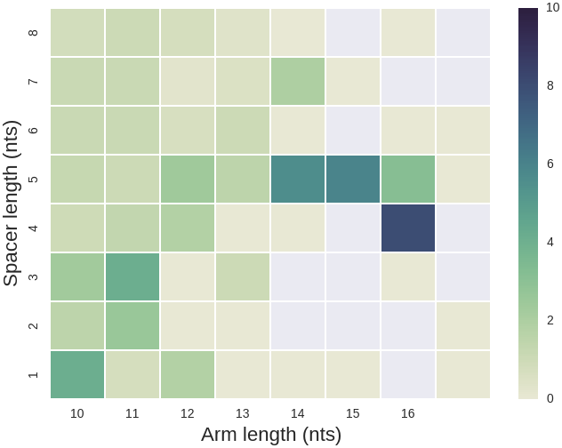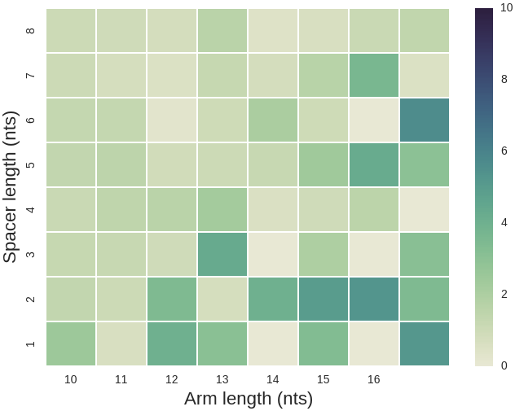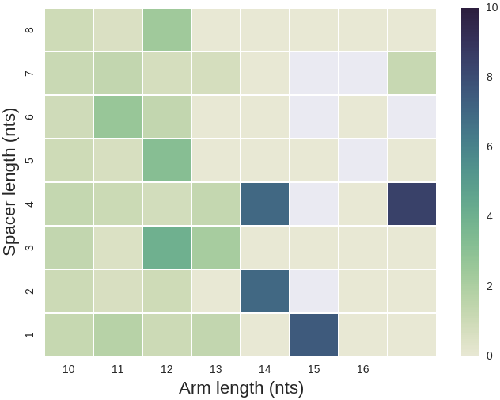
IR DR MR

Renal cell cancer
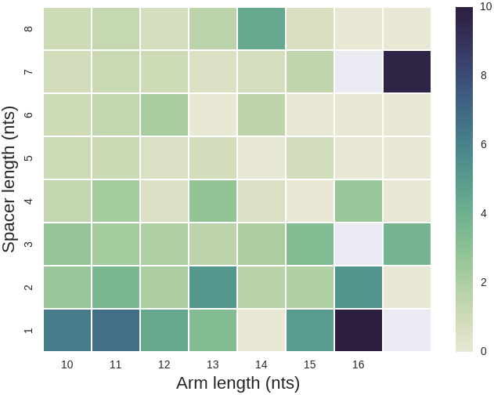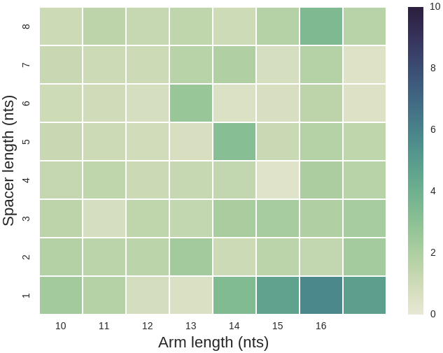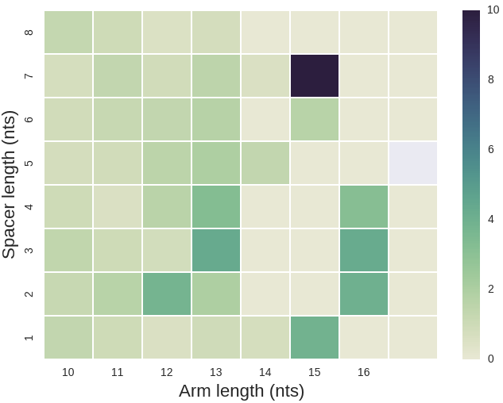
IR DR MR

Malignant Lymphoma
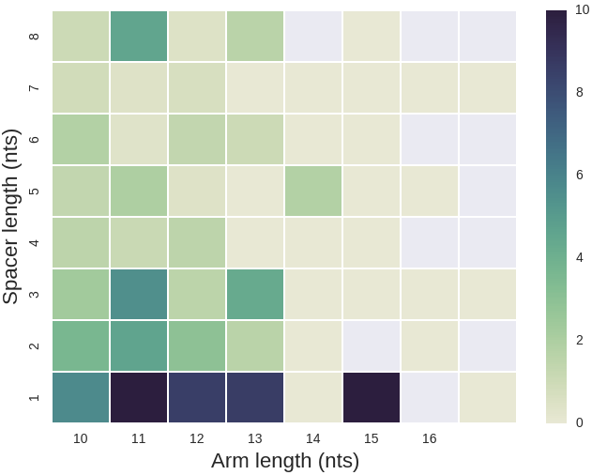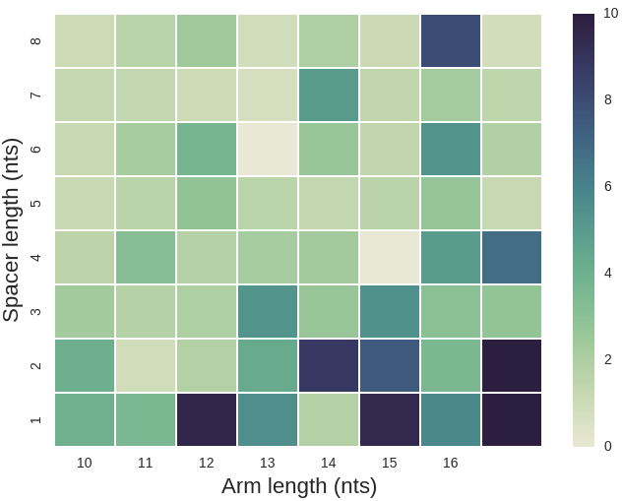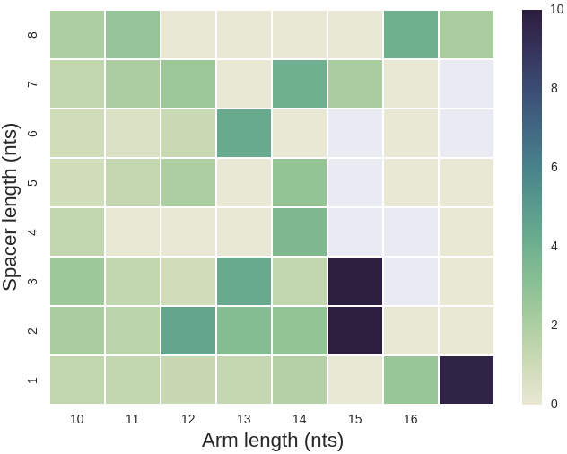
IR DR MR

Pedriatic Brain Tumour
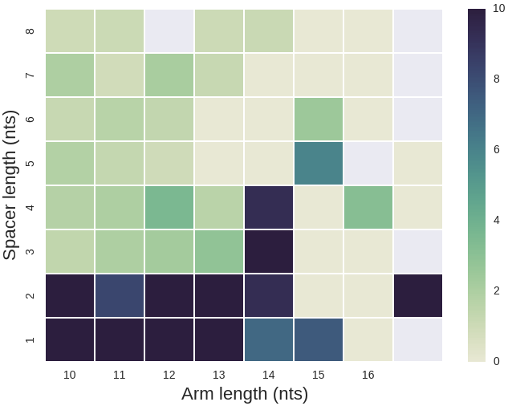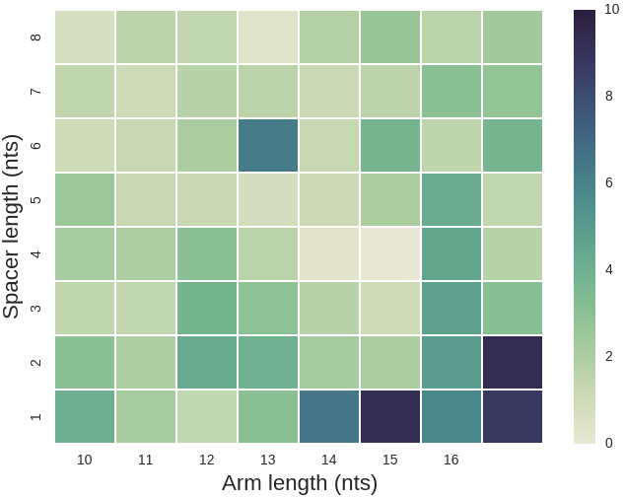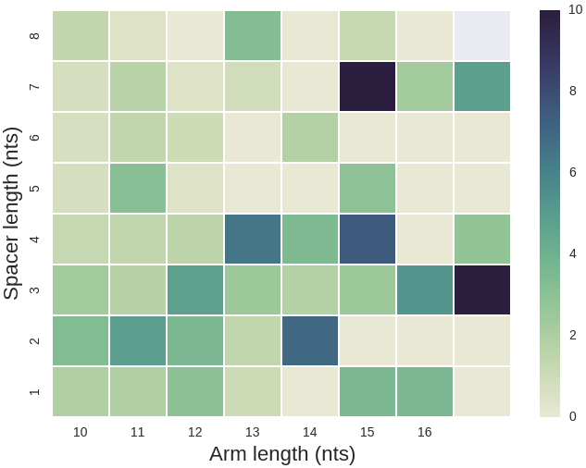
IR DR MR

Prostate

Fig. S14: Differences in spacer to arm mutability in non-B motifs is particularly elevated for spacer and arm lengths that are associated with increased thermodynamic stability for secondary structure formation in different tumor types. Heatmap of mutational density at spacer versus arms for different spacer and arm lengths for inverted repeats (IR, left), direct repeats (DR, middle), mirror repeats (MR right) across nine tumour types.

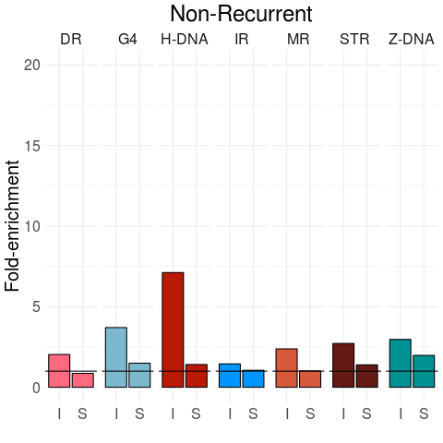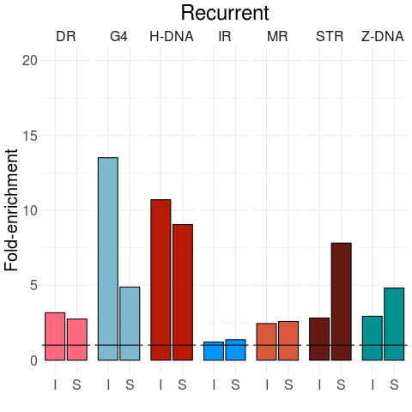

Ovarian
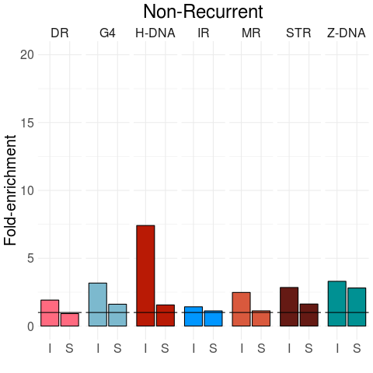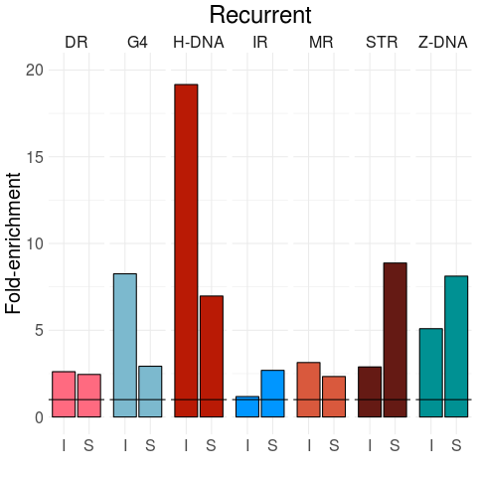

Pancreatic
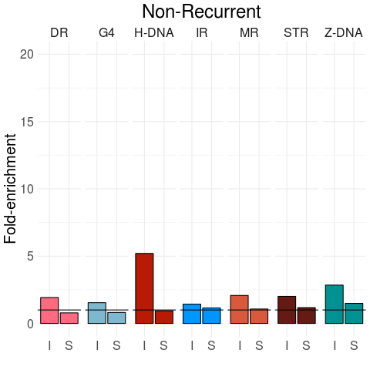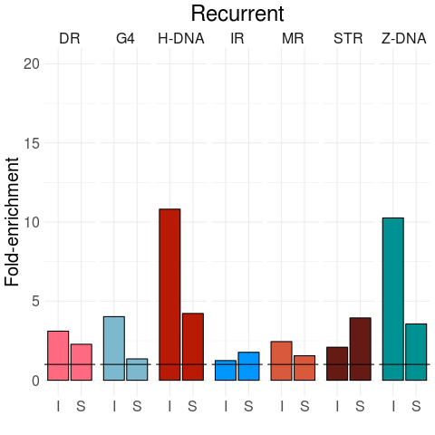

Liver
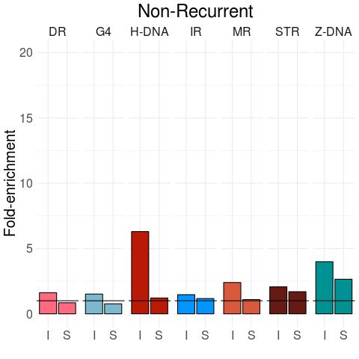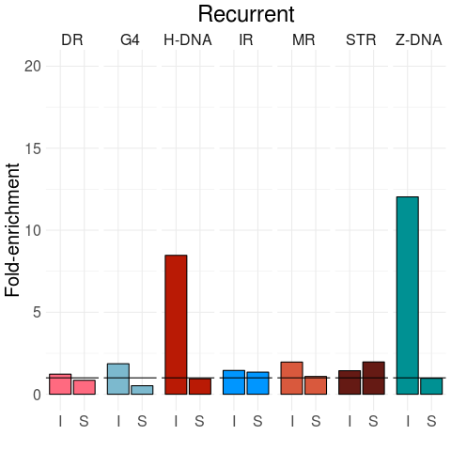

Gastric
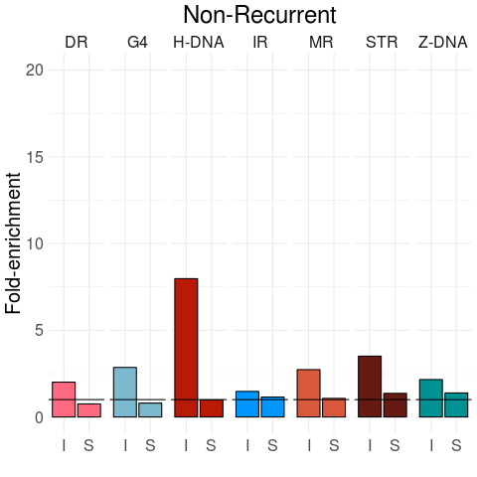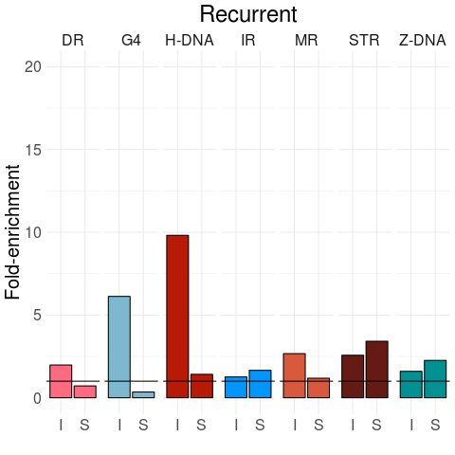

Esophagus
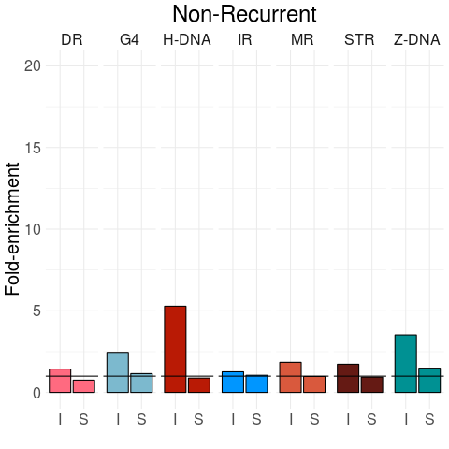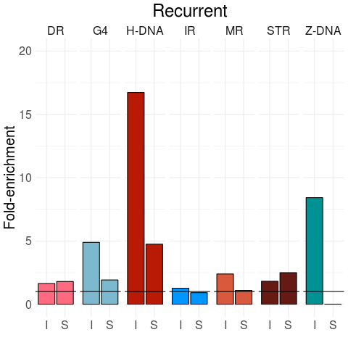

Renal cell cancer

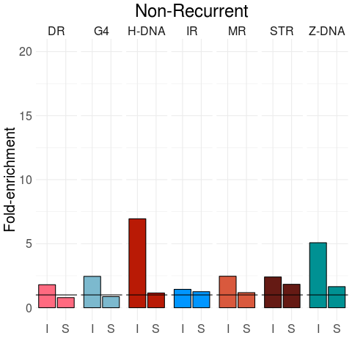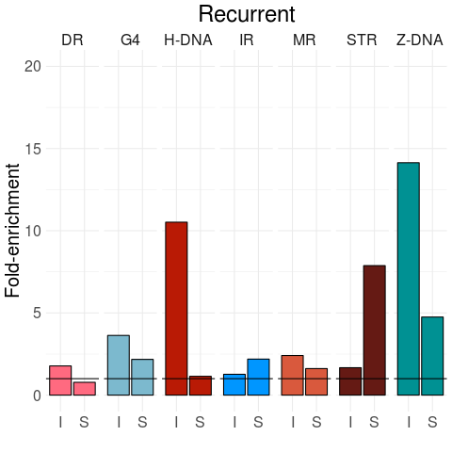

Malignant Lymphoma
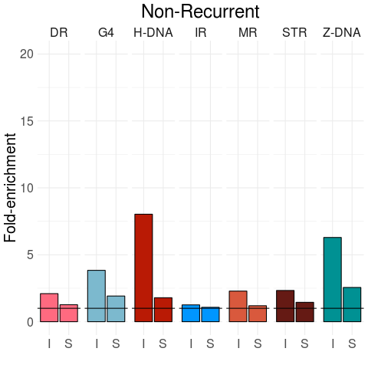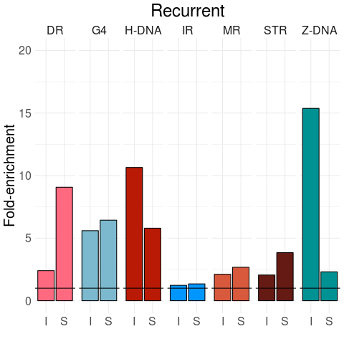

Pedriatic Brain Tumour
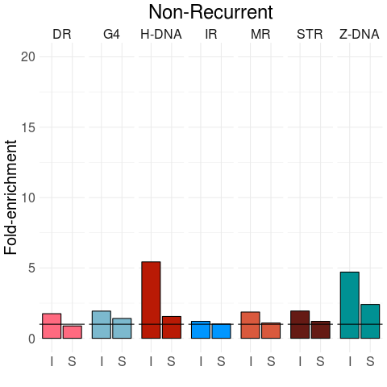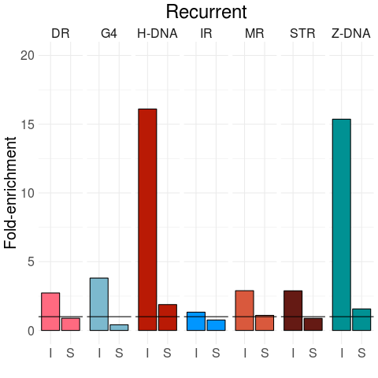

Prostate

Fig. S15: Recurrent mutations are more likely to overlap non-B DNA motifs. Comparison of enrichment of non-recurrent mutations (left-hand panel) versus recurrent mutations (right hand panel) that are overlapping non-B-DNA motifs for indels (I) and substitutions (S) in human cancer. Mann-Whitney U test for: substitutions in ovarian cancer (p-value <0.001 for DR, STR, H-DNA and G4 and p-value <0.05 for IR and Z-DNA), indels in ovarian cancer (p-value < 0.001 for DR, MR, G4 and p-value <0.05 for H-DNA, IR), substitutions in pancreatic cancer (p-value <0.001 across all non-B DNA motifs), indels in pancreatic cancer (p-value <0.001 for DR, IR, H-DNA, Z-DNA, MR and G4), substitutions in liver cancer (p-value <0.001 for all non-B DNA motifs), indels in liver cancer (p-value <0.001 for DR, IR, H-DNA, Z-DNA, G4, MR), substitutions for gastric cancer (p-value <0.001 for IR, Z-DNA, MR, p-value <0.05 for G4, STR), indels for gastric cancer (p-value <0.001 for Z-DNA, p-value<0.05 for STR, DR), substitutions in esophageal cancer (p-value <0.001 for STR, IR, Z-DNA, G4 and p-value < 0.05 for H-DNA), in esophageal cancer for indels (p-value <0.001 for STR, IR, G4, MR and p-value <0.05 for H-DNA, Z-DNA), substitutions in renal cell cancer (p-value <0.001 for MR, STR, p-value < 0.05 in DR, H-DNA), indels in renal cell cancer (p-value <0.001 for H-DNA, Z-DNA, G4), substitutions in malignant lymphoma (p-value <0.001 for STR, IR, Z-DNA, G4) and indels in malignant lymphoma (p-value <0.001 for STR, IR, H-DNA, Z-DNA, G4, MR), substitutions in pedriatic brain tumour (p-value <0.001 for DR, STR, H-DNA, G4, MR and p-value <0.05 for IRs), indels in pedriatic brain tumour (p-value<0.001 for H-DNA, Z-DNA, G4, MR and p-value <0.05 for DR, STR), substitutions in prostate (p-value <0.001 for STR, IR, G4, MR and p-value <0.05 for Z-DNA), indels in prostate (p-value <0.001 for DR, STR, IR, H-DNA, Z-DNA, G4).

