Supplemental Materials

High Resolution Annotation Of Zebrafish Transcriptome Using Long-Read Sequencing

German Nudelman^{1,2}*, Antonio Frasca³*, Brandon Kent⁴, Kirsten C. Sadler⁵, Stuart C. Sealfon^{1,2,3}, Martin J. Walsh^{3,6,7}§, Elena Zaslavsky^{1,2}§

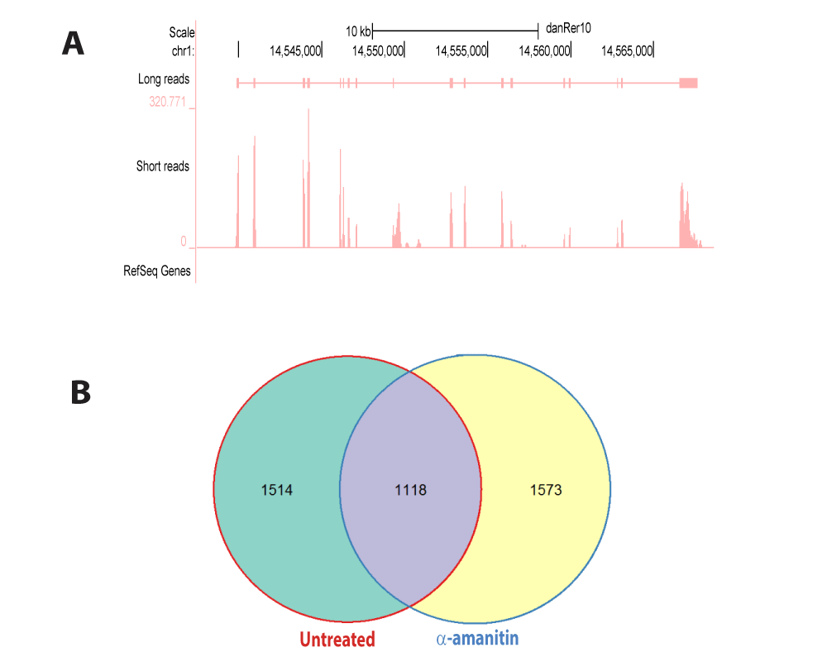Supplemental Fig. S1. Characterization of Novel Transcribed Regions (NTR). (A) An illustration of a novel transcribed region. Chromosomal location Chr1:14,537,481-14,568,630 is shown in the UCSC genome browser. The bottom (empty) track indicates that no annotation exists in the RefSeq reference. The top track illustrates a novel transcript found by long-read sequencing in the ɑ-amanitin treated sample, and the middle track shows corresponding mapped short reads after reference augmentation with the long-read detected NTRs. Note the precise correspondence in the exonic structures between the long-read and short-read data. (B) Novel transcribed regions show many transcripts specific to individual treatment conditions. A Venn diagram of all long-read discovered NTRs shows that the majority of transcripts in each treatment condition is not found in the set overlap.

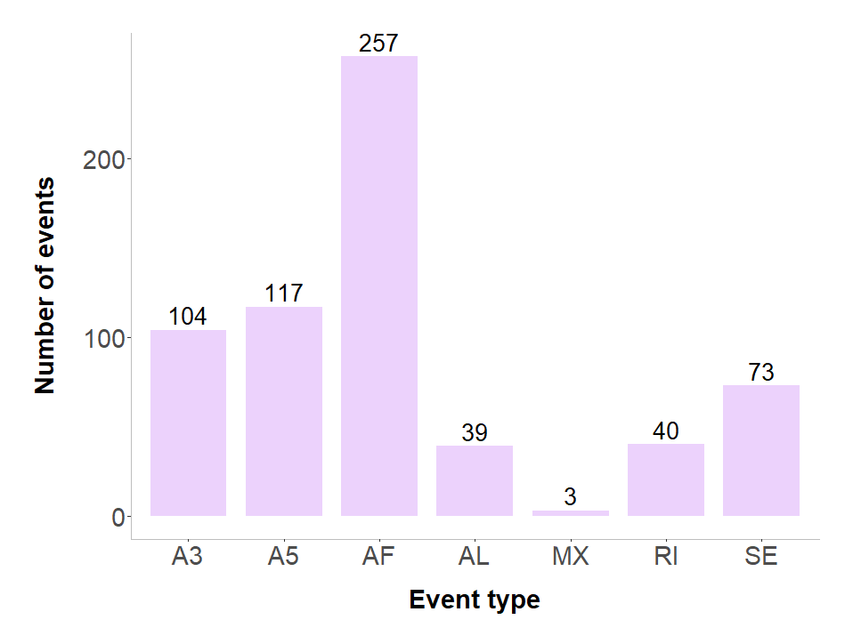Supplemental Fig. S2. Characterization of Alternative Splicing in Novel Transcribed Regions (NTR). Distribution of alternative splicing (AS) event types in the novel transcribed regions identified in the long-read data. Alternative splicing events were identified using SUPPA (Alamancos et al. 2015). Listed AS include: skipped exon (SE), alternative 5′ or 3′ splice site (A5, A3), mutually exclusive exons (MX), retained intron (RI), and alternative first or last exon (AF, AL). Presence of AS events further supports the validity of these novel transcripts.

Gene | Forward (5′→3′) | Reverse (5′→3′) | Additional
mvk | GGAAAGTAATTCTCCACGGCGAG | GGGAGGTTGATGCACACTTG | Not applicable
tead3b | GGTCGCAATGAGCTTATTGCCAGA | CTTTATACTTGCTTGATACTC | CTGGAATCTCACGAGATTTTCTC  Reverse 2 (5′→3′)
srsf7a | GAACGCAAGTAGCATGAGATAAG | CCTTGGCTGAAAGGAGGAAACG | Not applicable
h3f3c | GTGATATTGACTAGCAATGGCCC | GTGAACGTGTTTTAATTCGCGCGG | CGTAAGTCCACTGGAGGAAAAGC  Forward 2 (5′→3′)
miR430 (1) | GATTTTAGTCTGCCACCATTGTCT | ATGTGTTTTAGATGCAGATGTCAC | Not applicable
miR430 (2) | AGGAGCATTGATTTGTCCTTTGTTC | CCAACTTGTTGGAATATCAAGACGA | Not applicable

Supplemental Table S1. All PCR/qPCR primers used in validation experiments.

