SUPPLEMENT

SUPPLEMENTARY TABLES

Supplemental Table S1. DNA mixing experiment.
CEU genotype | YRI genotype | AAF  100%:0% | AAF  99.5%:0.5% | AAF  95%:5% | AAF  90%:10% | AAF  75%:25% | AAF  50%:50%
0/1 | 1/1 | 0.5 | 0.5025 | 0.525 | 0.55 | 0.625 | 0.75
0/1 | 0/0 | 0.5 | 0.4975 | 0.475 | 0.45 | 0.375 | 0.25
0/0 | 1/1 | 0 | 0.005 | 0.05 | 0.1 | 0.25 | 0.5
1/1 | 0/0 | 1 | 0.995 | 0.95 | 0.9 | 0.75 | 0.5

DNA samples from a male Yoruban (YRI) and a female Caucasian (CEU) individual were mixed to mimic different proportions of mosaic aneuploidy. As the genotypes of these two cell lines was known, we could mimic different types of mosaic aneuploidy: (1) The loci with the genotypes defined by the first two rows (yellow) were extracted to mimic mosaic mitotic aneuploidy, which should be represented by two separated mixtures of alternate allele frequencies (AAF). The columns represent the mean alternate allele fractions in the different conditions (assuming no reference bias); (2) The four different combinations of genotypes in the table are extracted to mimic meiotic trisomy, the 3rd and 4th rows (blue) representing the boundary mixtures specific to meiotic trisomy.

Supplemental Table S2. Detection of mosaic aneuploidy using exome sequencing data from the 1000 Genomes project (high confidence set).
Provided as separate file.

Supplemental Table S3. Enrichment of detected mosaic aneuploidies from the 1000 Genomes data.
Chromosome | Type of aneuploidy | Number of detected aneuploidies | p-value (binomial test)
Chr1 | LOH | 2 | 0.6692
Chr2 | Mitotic trisomy | 1 | 0.8607
Chr2 | LOH | 1 | 0.8607
Chr3 | LOH | 2 | 0.6692
Chr4 | Monosomy | 1 | 0.8607
Chr5 | Mitotic trisomy | 1 | 0.8607
Chr5 | LOH | 1 | 0.8607
Chr6 | LOH | 1 | 0.8607
Chr7 | LOH | 3 | 0.4472
Chr8 | LOH | 1 | 0.8607
Chr9 | LOH | 2 | 0.6692
Chr9 | Mitotic trisomy | 2 | 0.6692
Chr10 | LOH | 1 | 0.8607
Chr11 | Mitotic trisomy | 5 | 0.1272
Chr11 | LOH | 2 | 0.6692
Chr12 | Mitotic trisomy | 11 | 1.495 x 10⁻⁴
Chr12 | LOH | 1 | 0.8607
Chr13 | Mitotic trisomy | 1 | 0.8607
Chr13 | LOH | 1 | 0.8607
Chr14 | LOH | 2 | 0.6692
Chr15 | Mitotic trisomy | 1 | 0.8607
Chr15 | LOH | 1 | 0.8607
Chr17 | LOH | 2 | 0.6692
Chr18 | LOH | 1 | 0.8607
Chr19 | LOH | 2 | 0.6692
Chr19 | Mitotic trisomy | 1 | 0.8607
Chr20 | LOH | 1 | 0.8607
Chr21 | LOH | 2 | 0.6692
Chr22 | LOH | 8 | 7.136 x 10⁻³
ChrX | Monosomy | 18 | 9.32 x 10⁻¹⁰
ChrX | Mitotic trisomy | 2 | 0.6692

The enrichment of detected aneuploidy sorted by affected chromosomes. We performed a Binomial Test to assess whether there is enrichment of mosaic aneuploidy in specific chromosomes. The test showed that there is significant enrichment of trisomy 12 (yellow). We also found significant enrichment of segmental LOH in chromosome 22 (blue) and enrichment of mosaic monosomy for chromosome X (green), in all cases from female samples.

SUPPLEMENTARY FIGURES
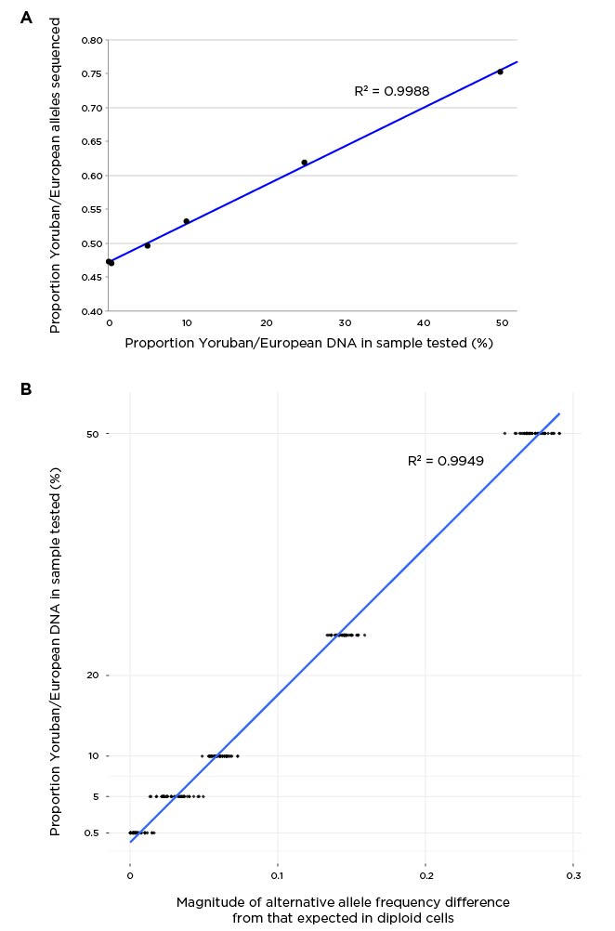

Supplemental Fig S1
Performance of the v1MAD-seq capture assay using a DNA mixture simulation. In (a) we show the dilutions of Yoruban male GM19239 DNA in Caucasian female GM06990 DNA on the x axis, and the proportions of reads from each sample on the y axis. The 5%:95% mixture is clearly distinguishable, but the 0.5%:99.5% mixture is not obviously different from 0%:100%. In (b) we fit the alternate allele frequency (AAF) with a beta distribution, measuring the deviation from an expected diploid distribution. The dots at each dilution point (y axis) represent the size of the deviation for each chromosome. We find the known dilutions to be reflected by the AAF deviation distances for the chromosomes.

Supplemental Fig S2
Illustrating the events occurring in the different types of events being detected by MADSEQ. The major (A) and alternate (B) alleles are shown in situations of normal diploidy (left), complete aneuploidy (right) and 50% mosaicism (middle). The non-recombined region in the meiotic trisomy example (blue) will be identical between homologues. Note that cnnLOH is sought as an aneuploidy-related event that could occur as a result of trisomy rescue. When it occurs at 100% frequency, it represents instead non-mosaic loss of heterozygosity in a consanguineous individual in a region of identity by descent.
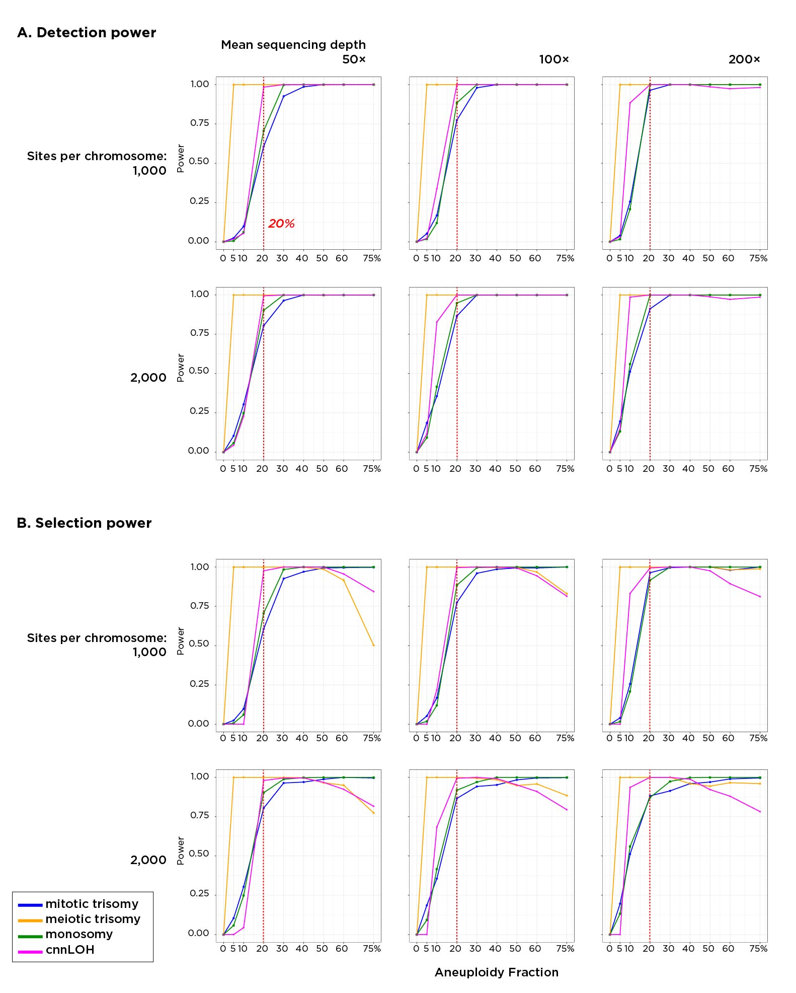

Supplemental Fig S3
Testing MADSEQ performance using simulated data. In (a), we assess the ability of the approach to detect the presence of aneuploidy on the simulated data examples shown in Figure 2, while in (b) we show its additional ability to categorize correctly the type of aneuploidy (or LOH) being simulated. The upper row in each case simulates 1,000 heterozygous sites per chromosome, the lower row 2,000 sites. From left to right in each row represents 50x, 100x and 200x mean coverage at these loci.
We observe that mosaicism for meiotic trisomy (yellow) is the more readily detected and classified type of event, detectable in as few as 5% of cells with only 50x coverage and 1,000 heterozygous sites per chromosome. The same sequencing depth and number of sites allows detection of the other types of aneuploidy/LOH in ≥20% of cells (red dashed line), while increasing coverage and number of sites per chromosome improves performance still further. At the highest levels of mosaicism our ability to categorize LOH correctly diminishes, but otherwise increased levels of mosaicism are readily detected and categorized.

Supplemental Fig S4
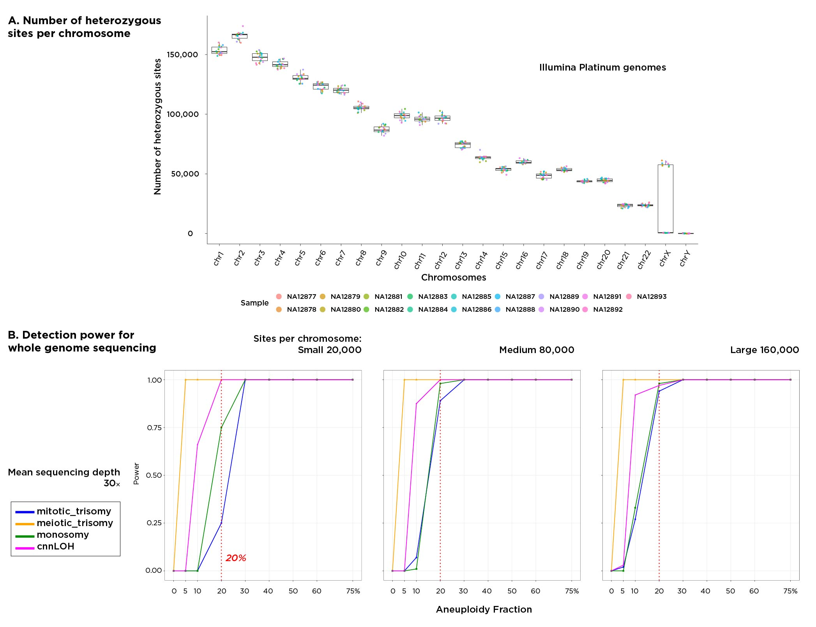
Testing MADSEQ performance using simulated whole genome sequencing (WGS) data. We assumed WGS would be typically performed at 30x coverage. Using WGS data from the Illumina Platinum genomes, and our MADSEQ filtering approach to call heterozygous sites, we find the largest chromosomes to have ~160,000 heterozygous sites, the smallest ~20,000, with 80,000 representing a mid-range value (a). In (b) we show the simulations for the small (left), mid-size (middle) and largest (right) chromosomes. While the ability to detect events in low mosaic proportions is optimal in the largest chromosomes, the large number of heterozygous sites in even the smallest chromosomes helps to counterbalance the relatively low coverage of WGS.

Supplemental Fig S5
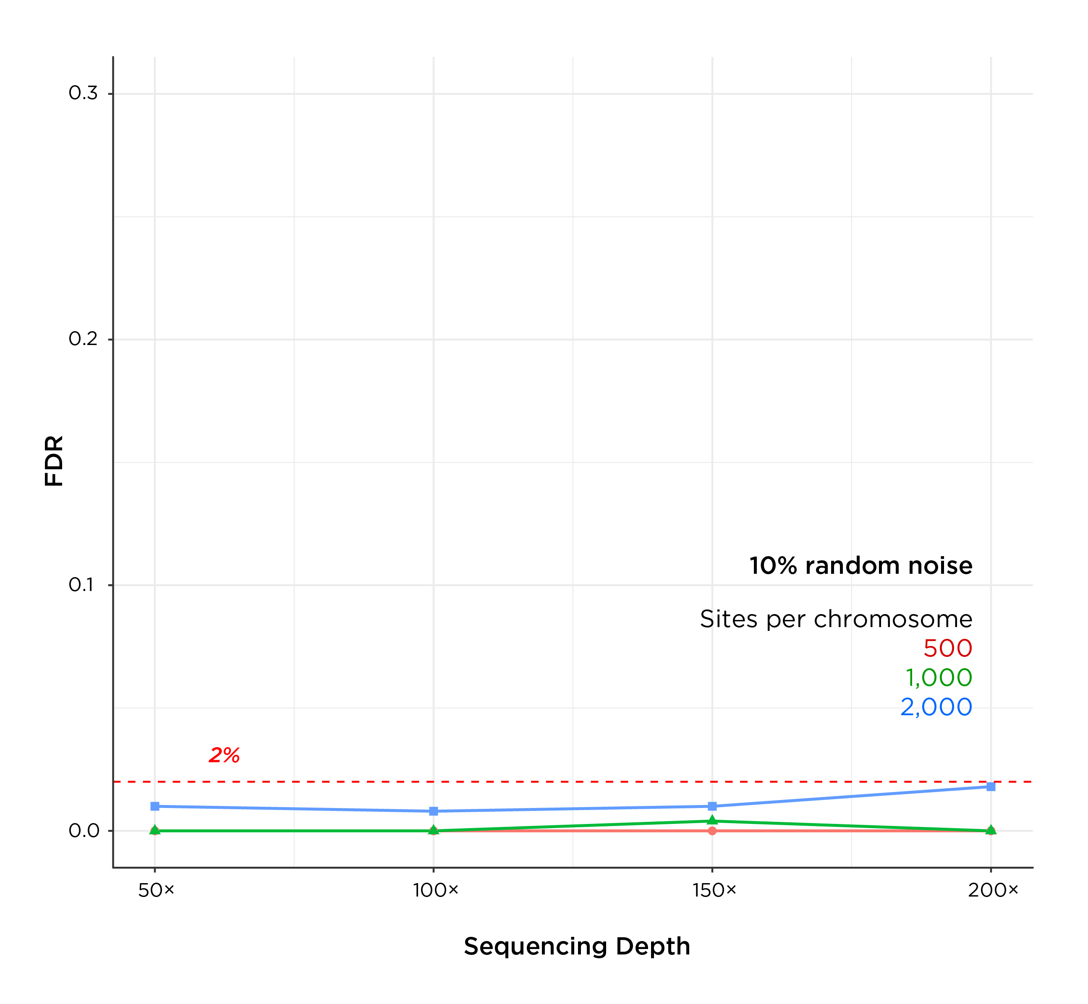
The MADSEQ analysis is relatively insensitive to noise. We simulated adding 10% noise by randomly distributing alternate allele frequencies on chromosome from 0 to 1, testing how frequently a diploid chromosome gets misclassified as aneuploid/LOH. Even with this high degree of noise we see FDR rates consistently less than 2%.

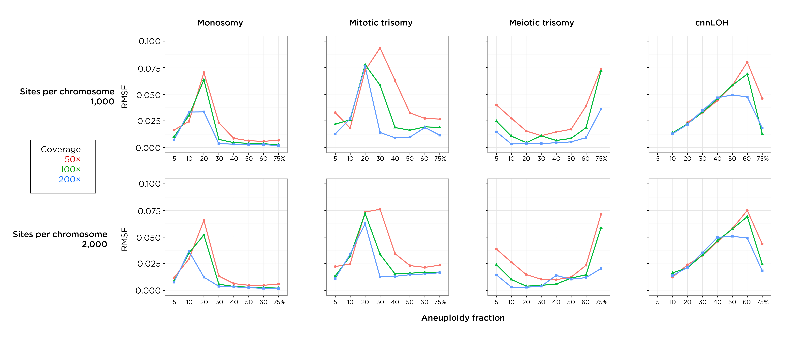

Supplemental Fig S6
We calculate the accuracy of the quantification of the fraction of abnormal cells using the root-mean-square-error (RMSE), based on computational simulations. The different types of chromosomal events are shown, with a simulated number of heterozygous sites per chromosome of 1,000 in the top row, and 2,000 in the bottom row. Coverage simulations are represented by the different colors as shown. We show the quantification is associated with prediction errors of less than 10% for all these conditions. With deeper coverage we see increased accuracy, but including more sequenced sites per chromosome has less of a positive effect.

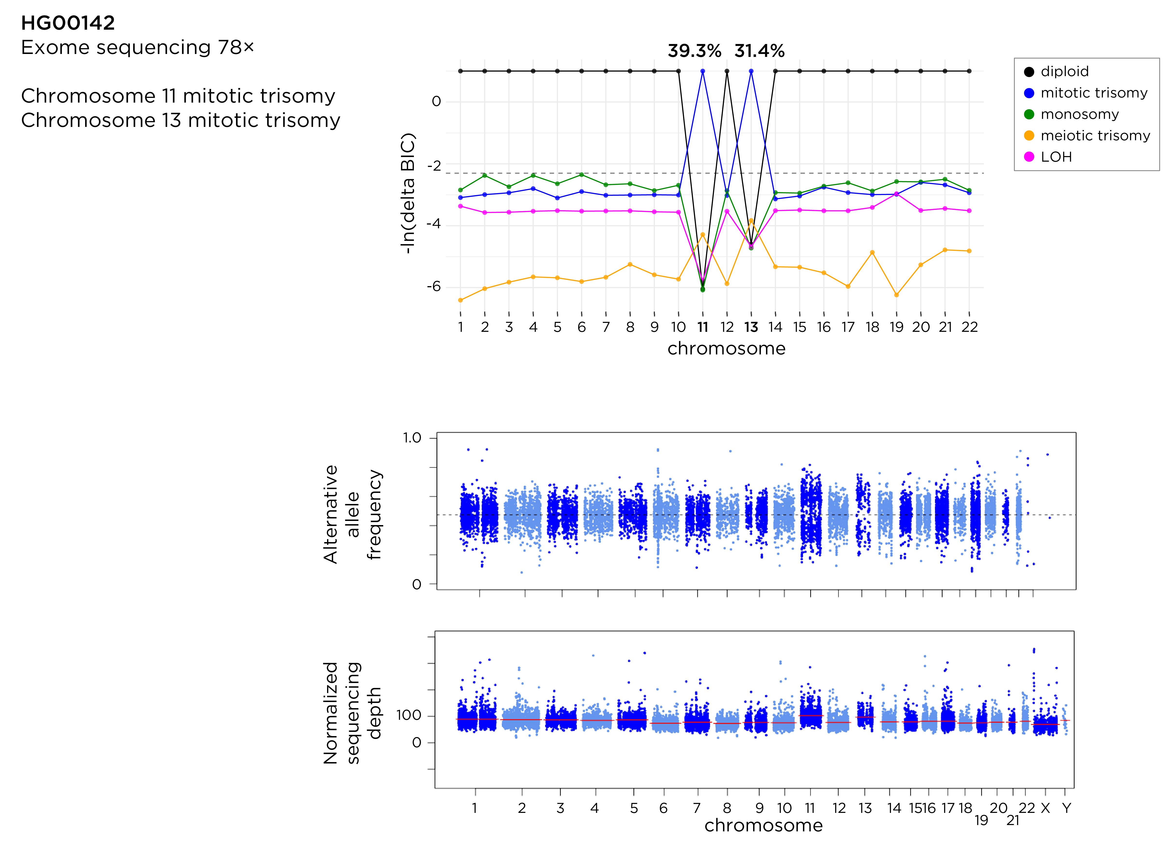

Supplemental Fig S7a
Exome sequencing data from the 1000 Genomes project reveals an example of two mosaic mitotic trisomies in cell line HG00142 in over 30% of cells. The y axis shows the relative difference in the Bayesian Information Criterion (BIC) distinguishing the models. The gray dashed line illustrates the degree of difference in which we have confidence when distinguishing models. Separation of the AAF distributions for chromosomes 11 and 13 is clear, with apparent increases in the depth of sequencing for these chromosomes also.

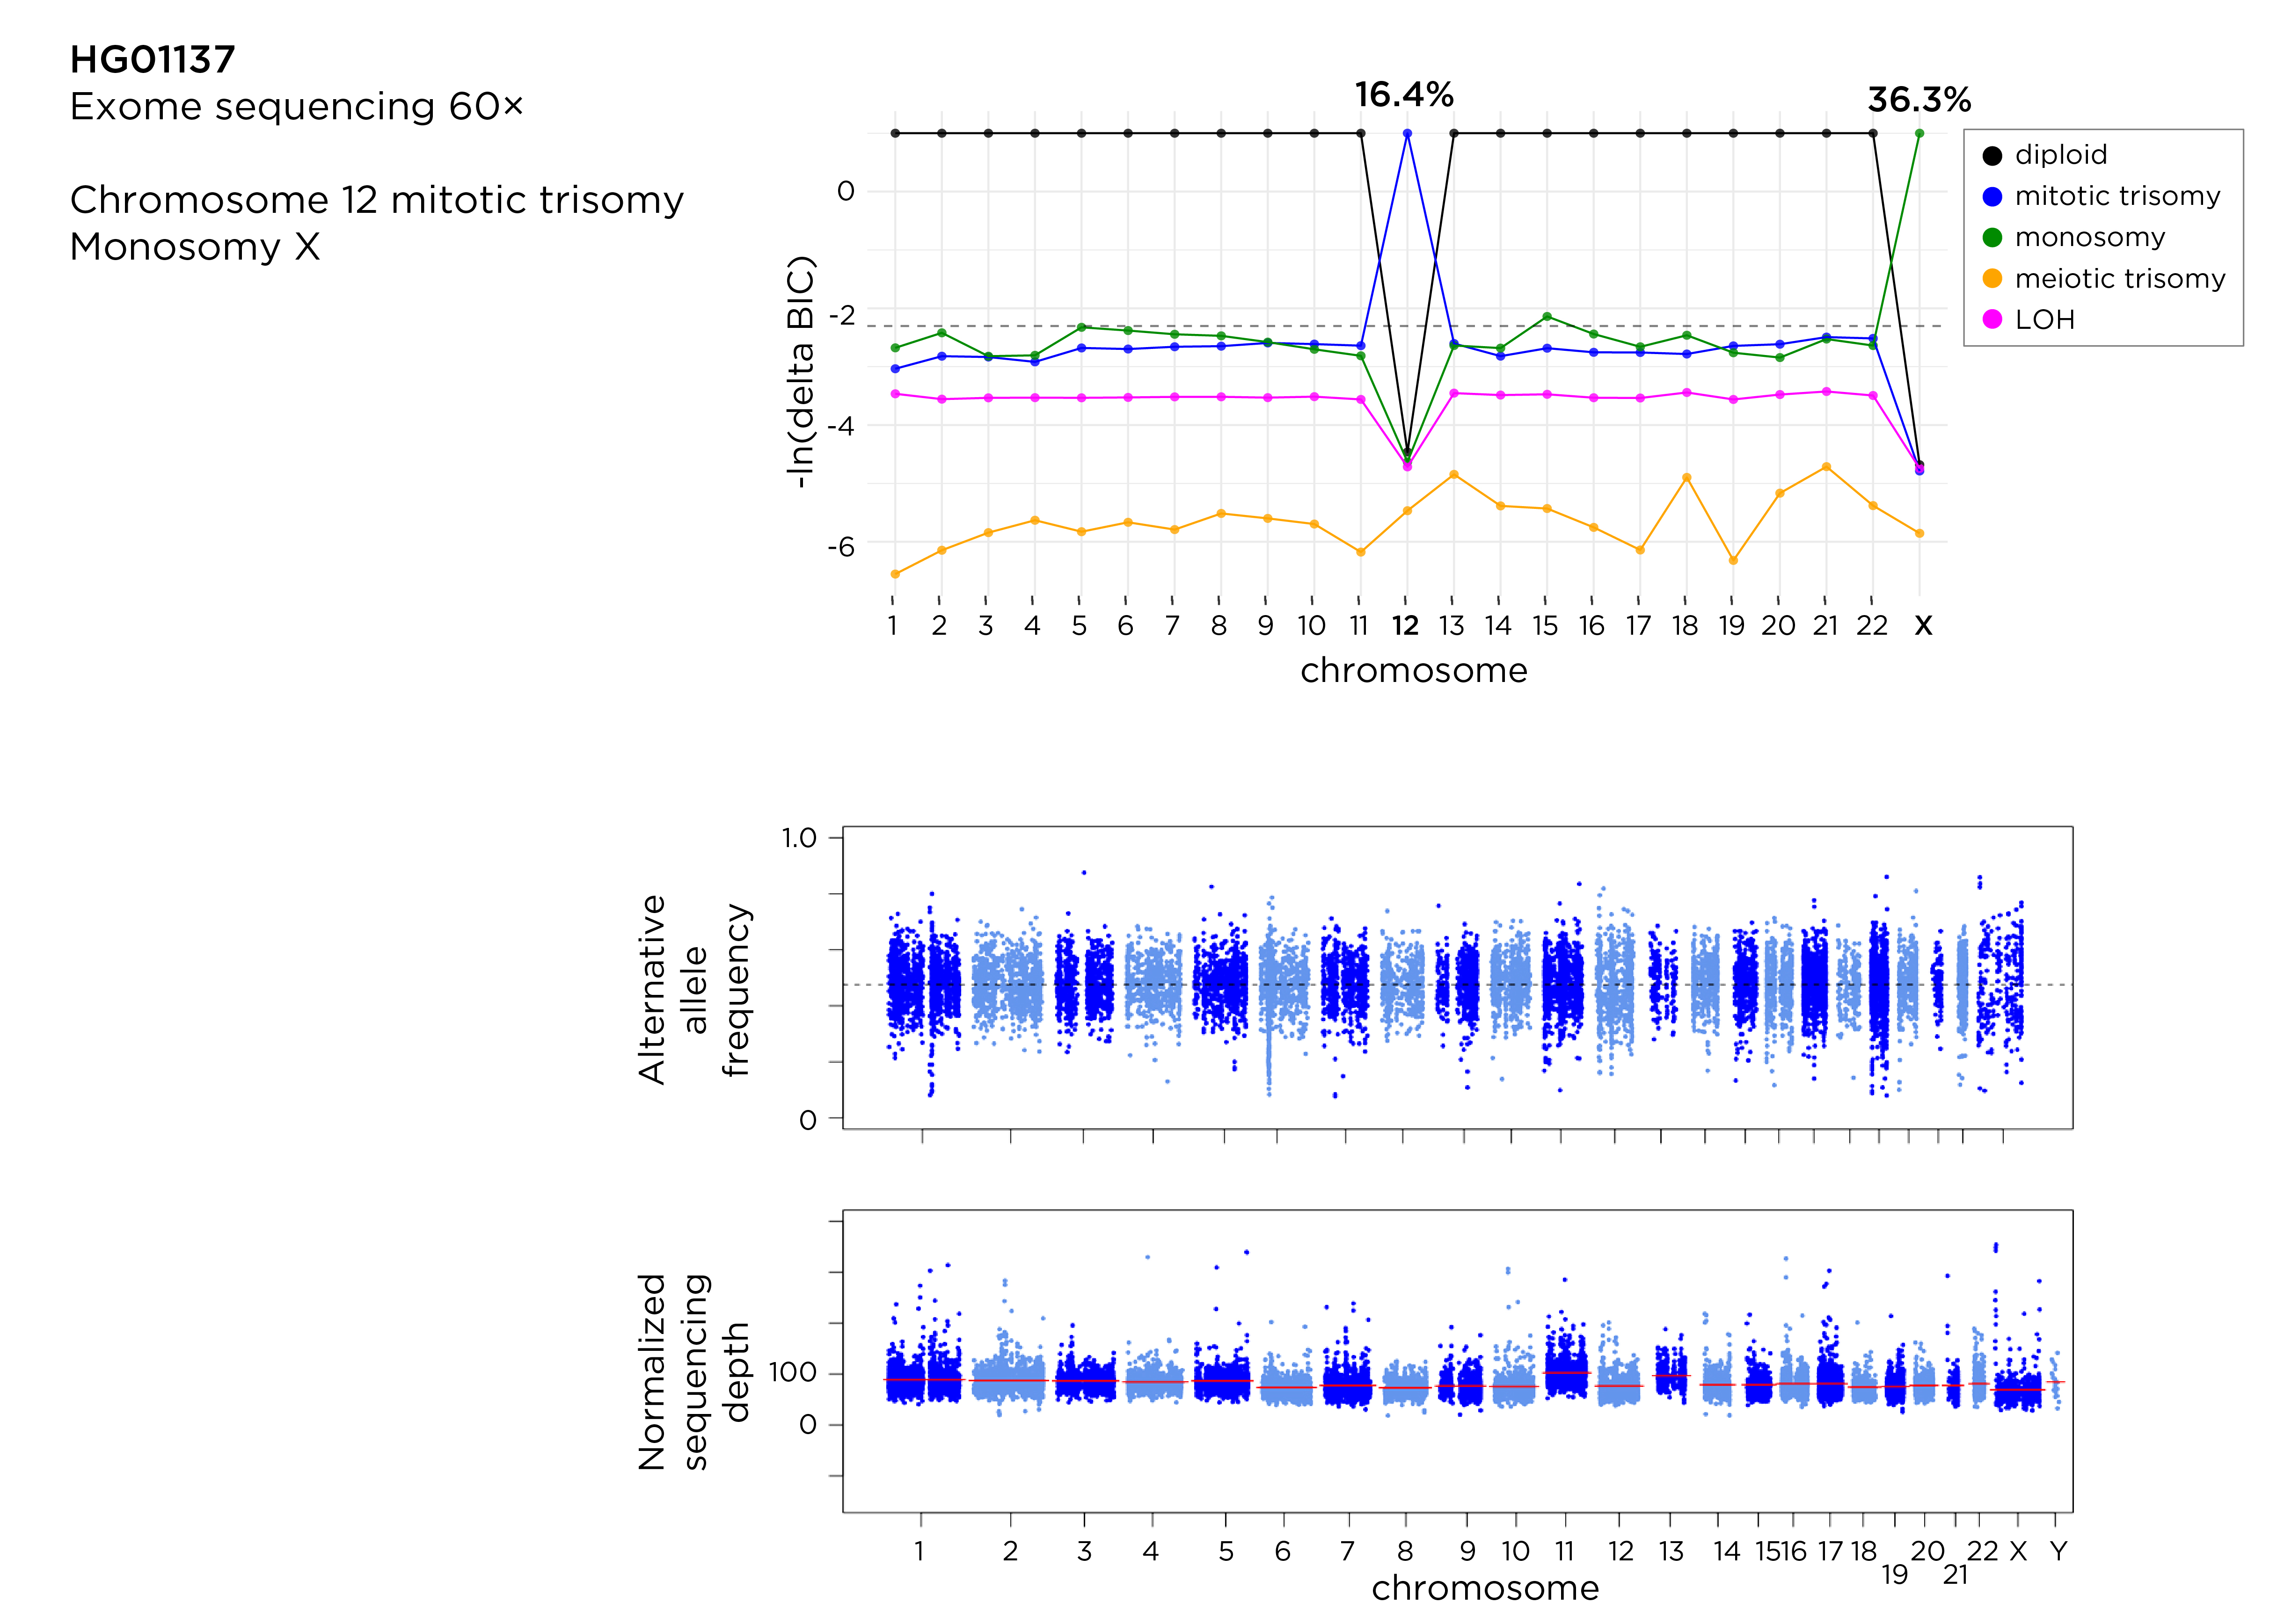

Supplemental Fig S7b
Exome sequencing data from the 1000 Genomes project shows two types of events, mitotic trisomy 12 and monosomy X, both of which are common events in these LCLs.

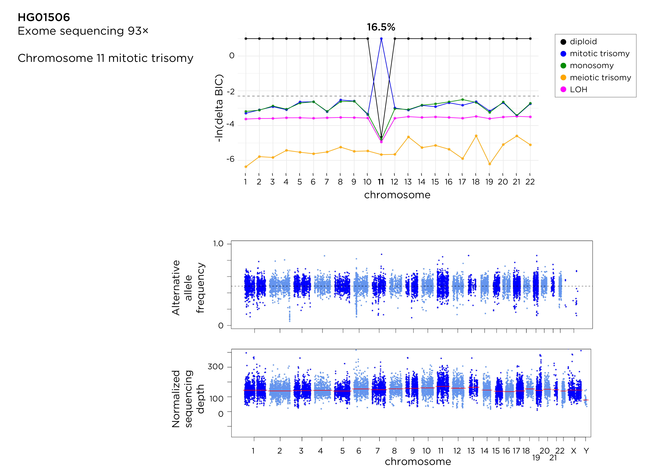

Supplemental Fig S7c
Exome sequencing data from the 1000 Genomes project showing detection of mitotic trisomy 11 in a low proportion of cells (16.5%) that would be challenging to detect with current routine assays.

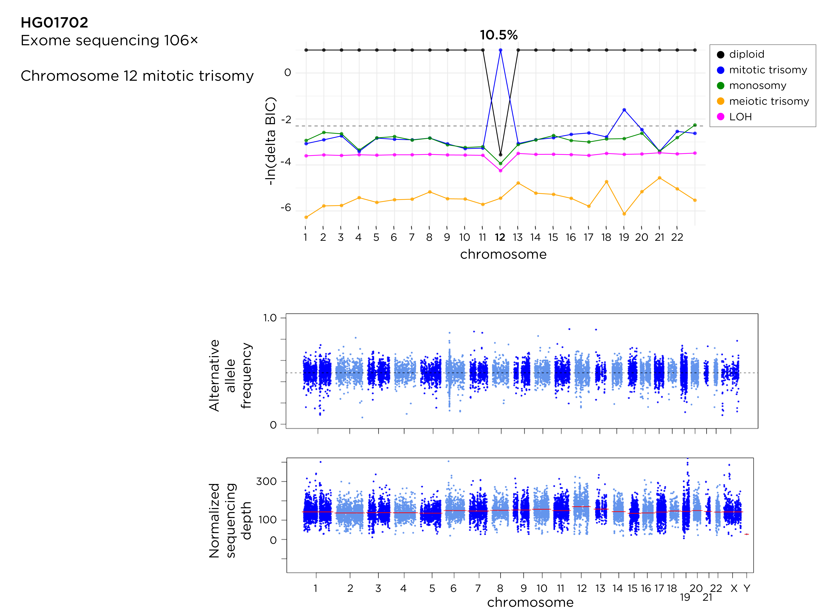

Supplemental Fig S7d
Exome sequencing data from the 1000 Genomes project revealing the common chromosome 12 mitotic trisomy event in these LCLs, but this time predicted to be in only 10.5% of cells.

Supplemental Fig S7e
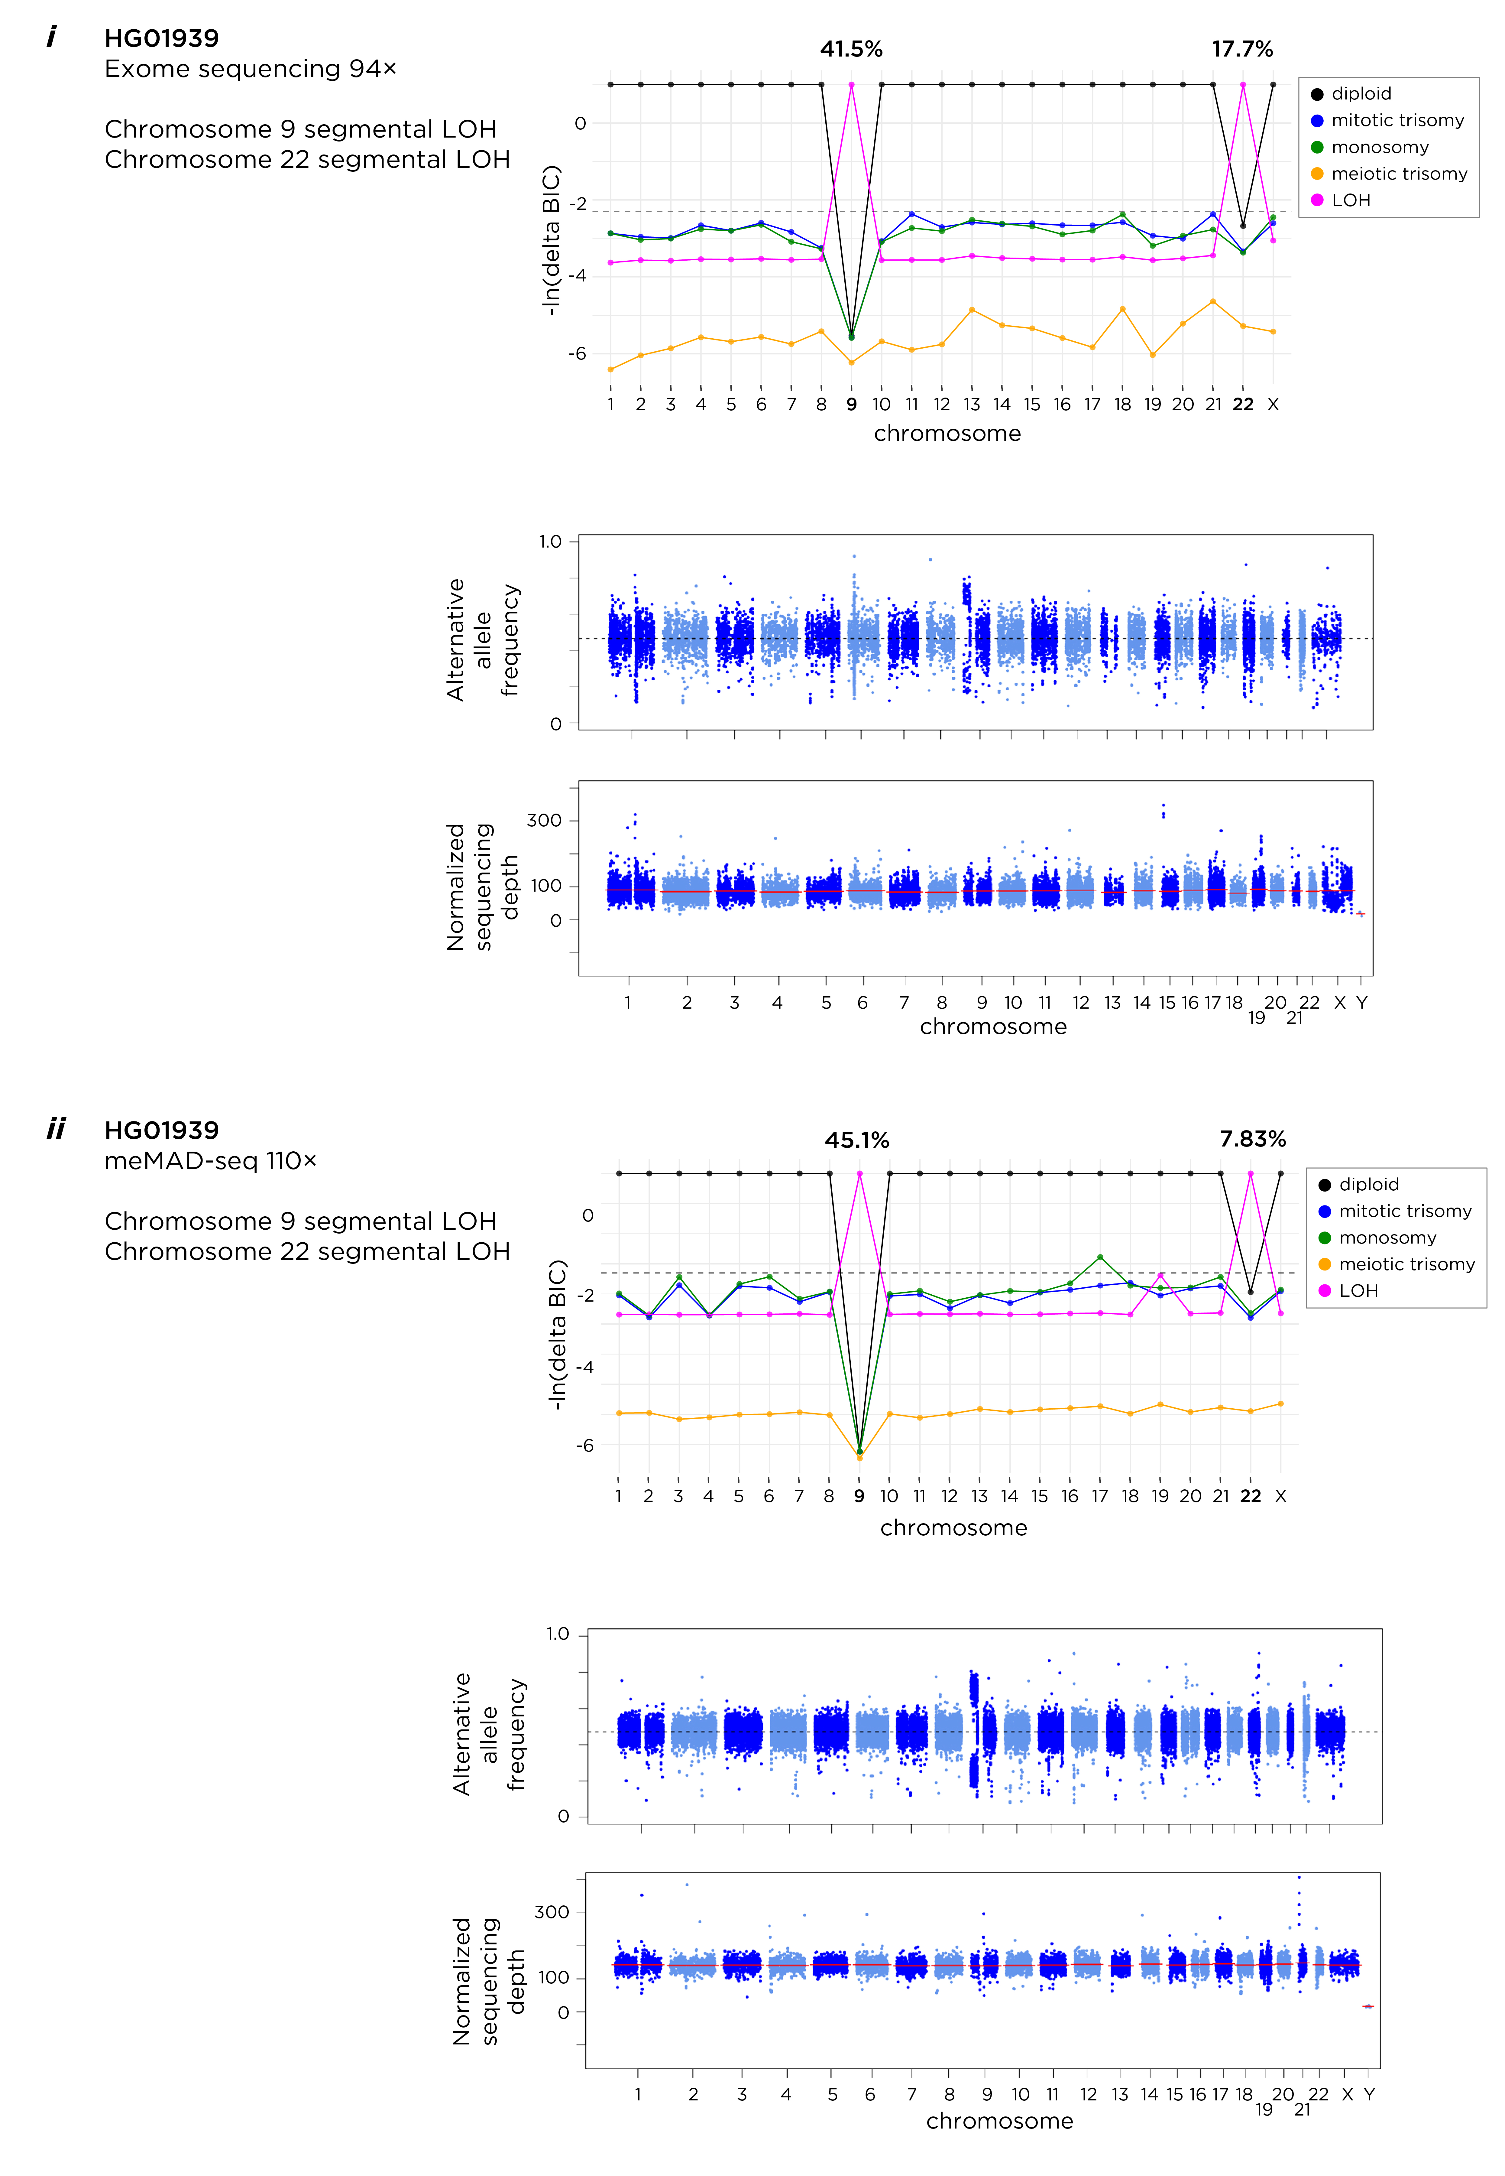
Concordance of results between 1000 Genomes exome sequencing and meMAD-seq capture data, showing concordant results of copy neutral segmental LOH in chromosomes 9 and 22, the latter predicted to occur in ~8-18% of cells.
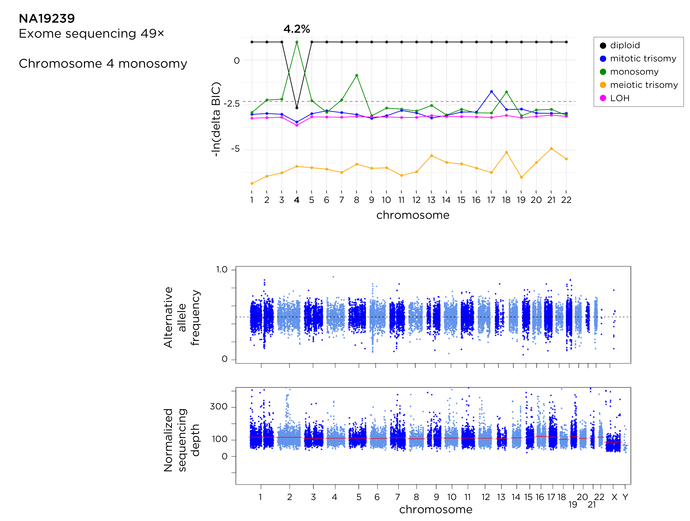

Supplemental Fig S7f
Exome sequencing data from the 1000 Genomes project showing evidence for monosomy 4 in ~4% of cells, representing a high confidence prediction of an event in a small proportion of cells. The larger number of heterozygous sites testable with exome sequencing on this large chromosome may be a reason why this event was detectable.

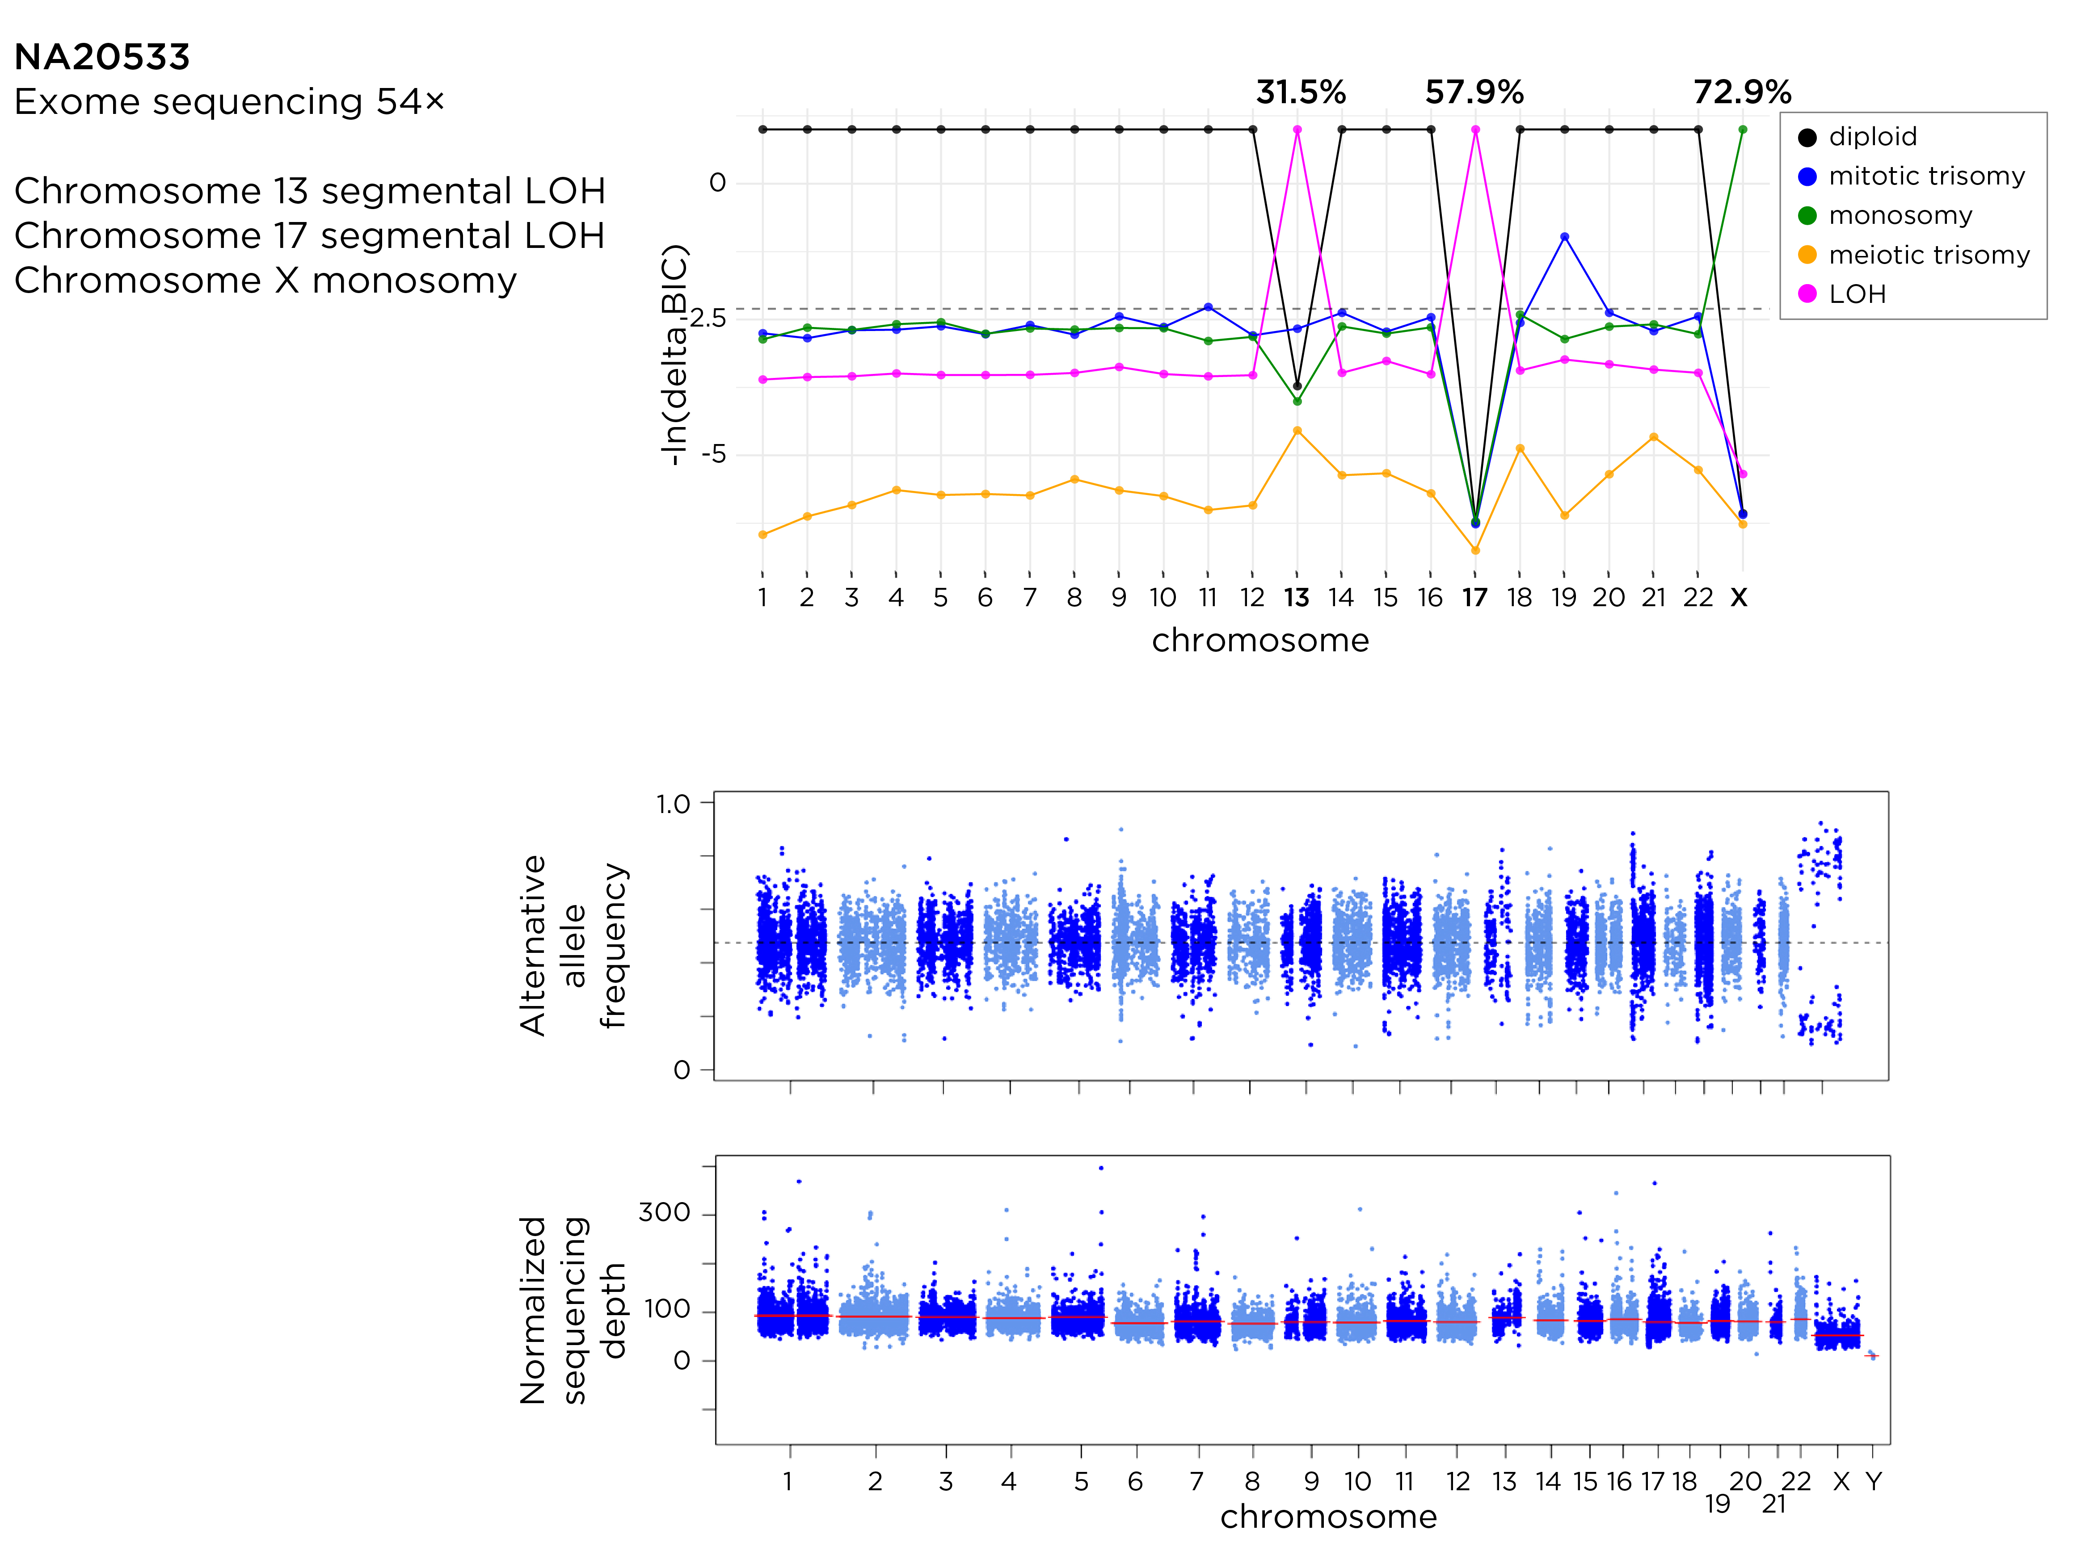

Supplemental Fig S7g
Exome sequencing data from the 1000 Genomes project revealing a complex situation of three events with different origins (LOH, monosomy) affecting separate chromosomes in different proportions of cells.

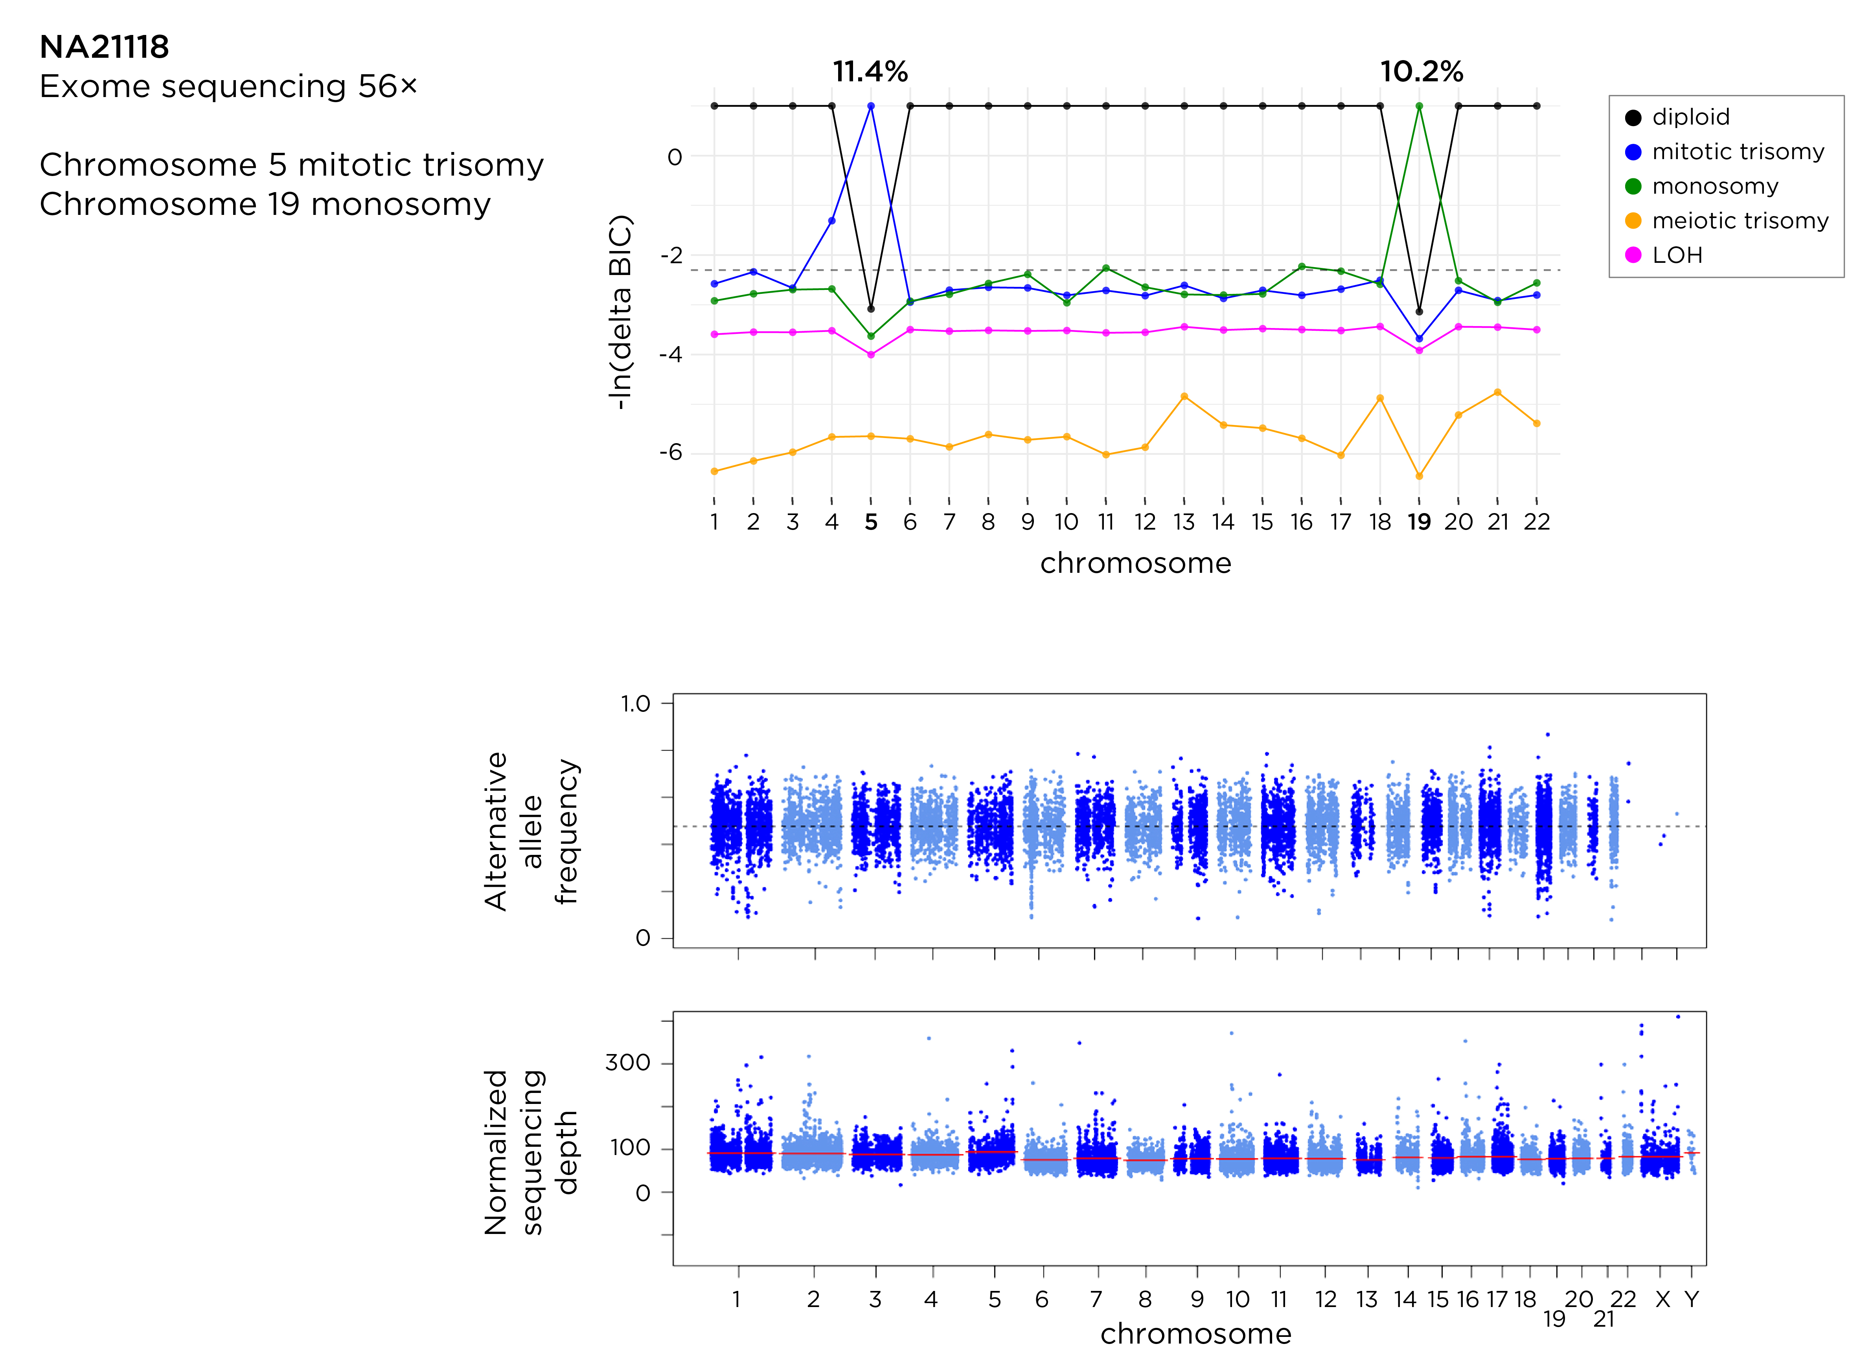

Supplemental Fig S7h
Exome sequencing data from the 1000 Genomes project showing mitotic trisomy 5 and monosomy 19 in similar proportions of cells, suggesting that the same cell sub-clone has both events in the same genome.

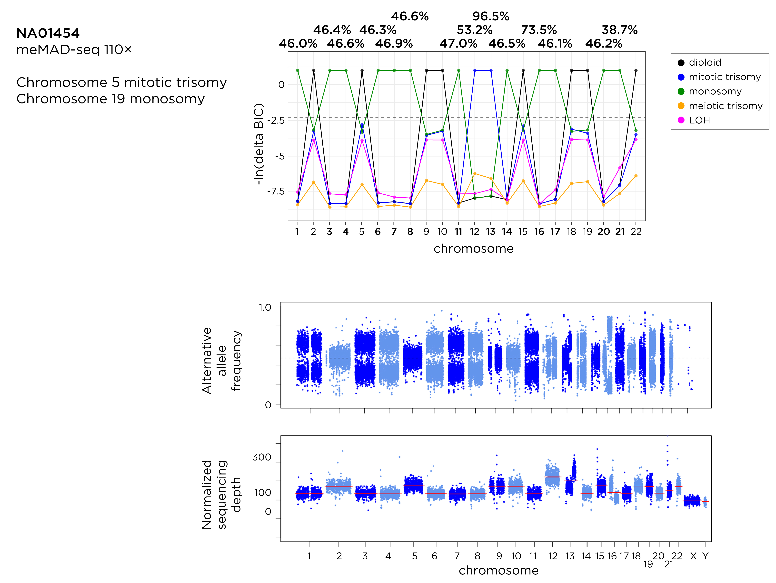

Supplemental Fig S7i
meMAD-seq data from the NA01454 sample shows a number of different mosaic or aneuploid events, those already known for chromosomes 12 and 13, plus what seems to be a single cell subclone present in ~46% of the population with multiple monosomies. This example serves to indicate that while MADSEQ can detect the kinds of multiple abnormalities occurring in cancer cells, work remains to be done before it will be able to model these events accurately.

Supplemental Fig S8
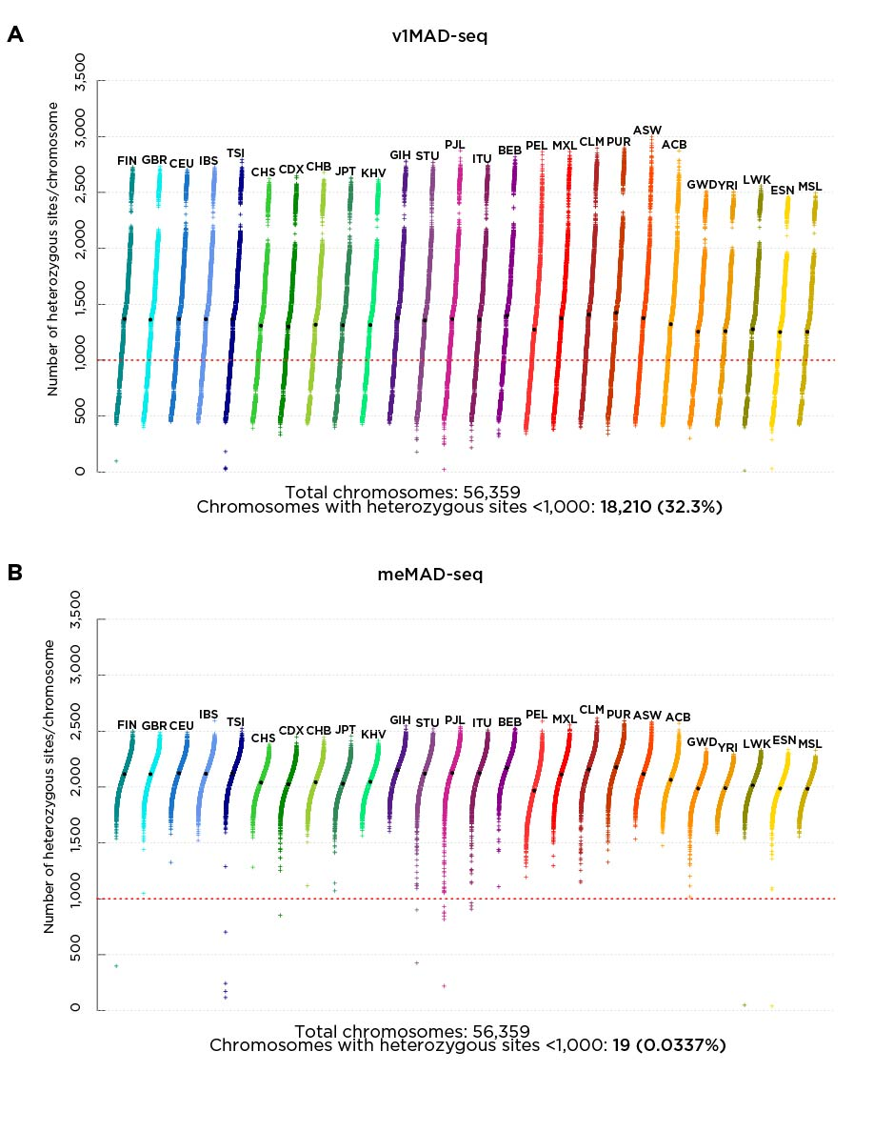
The choice of SNPs for the v1MAD-seq design based on having a minor allele frequency of at least 0.4 generates fewer than 1,000 heterozygous sites per chromosome in over 30% of chromosomes in individuals from the populations studied by the 1000 Genomes project. The meMAD-seq strategy to identify SNPs in common across all of these populations has <1% of the chromosomes with fewer than 1,000 heterozygous sites.

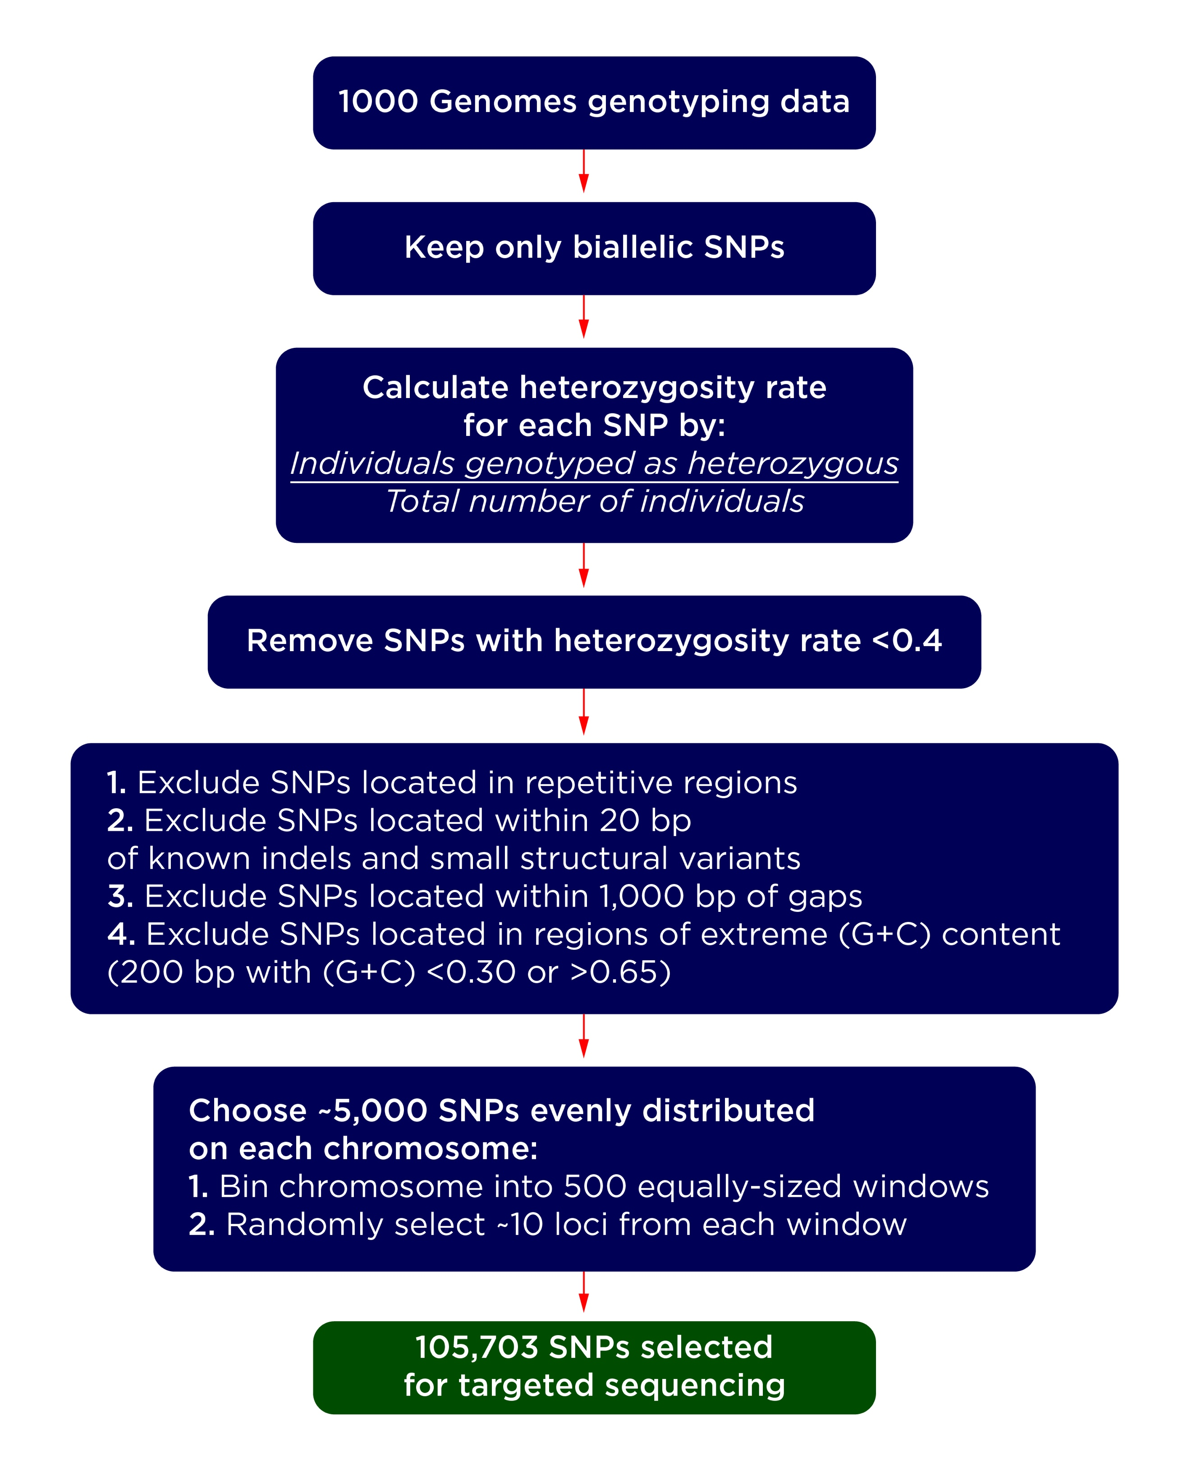

Supplemental Fig S9

Our strategy for identifying the SNPs to include in our meMAD-seq capture design.

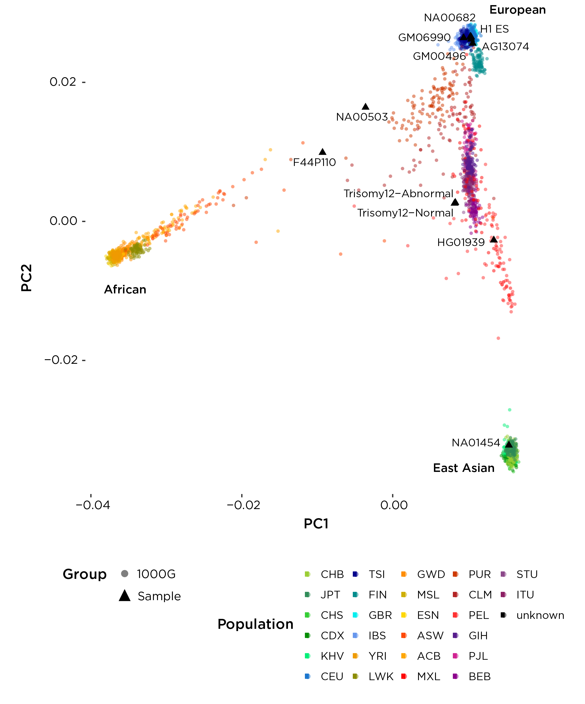

Supplemental Fig S10
A principal components analysis plot based on 1000 Genomes genotypes, overlaid with the samples tested using meMAD-seq capture. The plot confirms the diverse ancestries of these individuals.
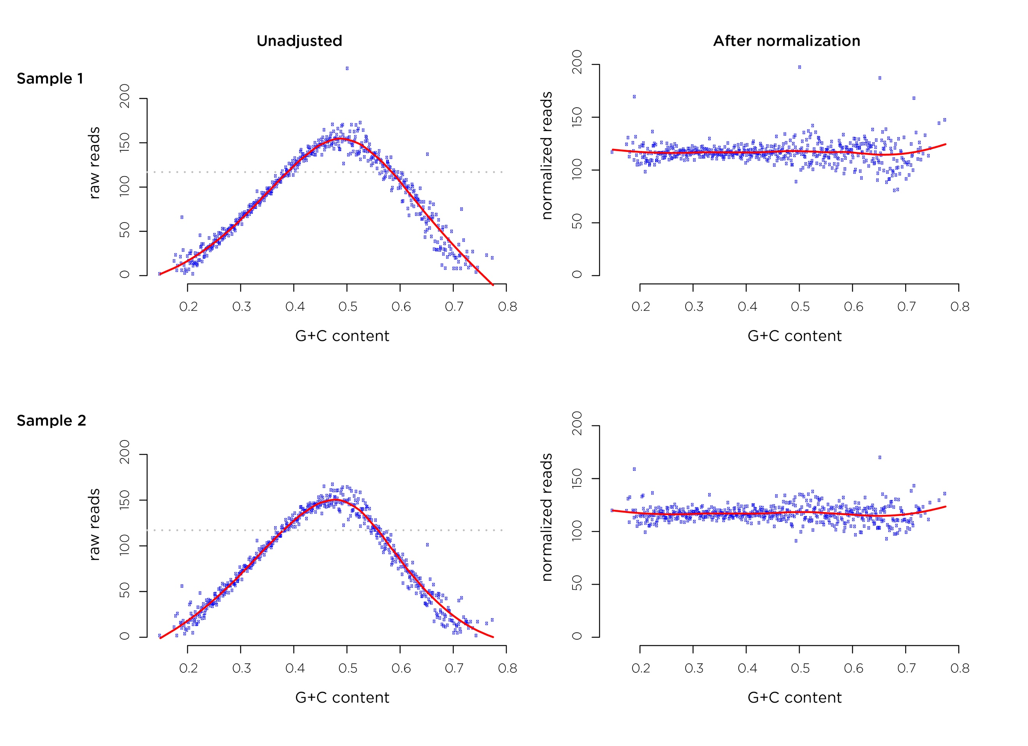

Supplemental Fig S11
We show for two samples a scatterplot representing G+C content plotted against average coverage. This plot can be produced as part of the MADSEQ pipeline. On the right is the plot following correction using LOESS. As sequencing depth is a major component of the Bayesian model selection, this approach is used to ensure that G+C content does not bias the results obtained.

