Supplemental Methods

Algorithm for refining SD boundaries

The boundaries of pairwise alignments constructed in the step (5) “Verifying putative SDs” may be inaccurate because (i) the SD spans defined by repetitive k-mers are typically smaller than the spans defined by the pairwise alignments and (ii) reinsertion of common repeats may artificially inflate spans when the LASTZ alignment slightly extends the span of a real SD (Figure M1).

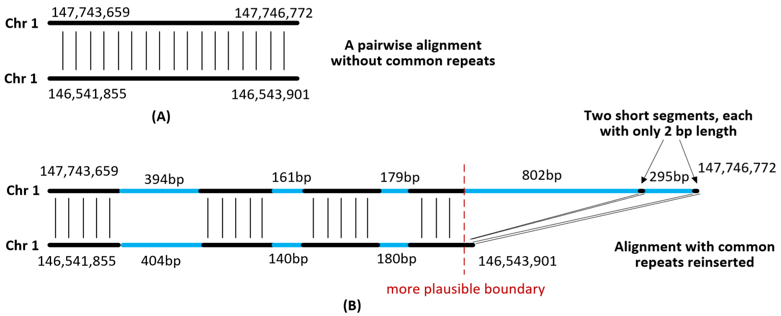
Figure M1: A pairwise alignment constructed by LASTZ in the compact genome before (A) and after (B) re-inserting common repeats in the pairwise alignment. The black lines represent unique genomic sequence in the compact genome and the blue lines represent common repeats reinserted into the compact genome. The two short segments (each with only 2 bp length) reflect the fact that slightly extended boundary in the compact genome result in short spurious segments incorrectly reinserted into the pairwise alignment and thus artificially extending its span.

For the case (i), SDquest attempts to extend the alignment boundary for each pairwise alignment after common repeats are reinserted. SDquest iteratively extends the alignment boundary by 50 bp for each pairwise alignment until the identity between the extending 50 bp sequences falls below 70%.

For the case (ii), we refer to the segment between the start/end of SD and the positions of the first/last reinserted repeat as a cap. SDquest refines boundaries for all pairwise alignments with short caps (< 50 bp) by checking the alignment between the last 50 bp of the sequences (including the first/last reinserted common repeats). If its percent identity falls below 70%, SDquest trims the end of this alignment to the position before the first/last common repeats. SDquest iteratively trims this boundary until the cap of this boundary exceeds 50 bp or the last 50 bp of the alignment on this boundary have percent identity above 70%.

Analysis of cyclic components in the breakpoint graph of SDs.

Gorilla genome. Using the default parameters, SDquest identified 15,395 SD-blocks in the gorilla genome. The breakpoint graph of SDs for the gorilla genome consists of 4,153 connected components and 2,933 of them represent trivial SDs formed by a single SD-block. However, most of 15,395 SD-blocks in the gorilla genome are organized into 4,153-2,933=1,220 connected components with the number of SD-blocks varying from 2 to 6,066 (96 of them contain more than 10 SD-blocks).

213 out of 1,220 non-trivial connected components contain cycles (87 of them contain cycles with more than 2 edges). 106 out of 213 cyclical components contain simple cycles (62 of them contain simple cycles with more than 3 edges). 102 out of the remaining 213-106=107 cyclical components turned out to be indel components. Circular structure of the remaining 107-102=5 connected component in the breakpoint graph of gorilla SDs suggests that ecDNA may have contributed to accumulation of SDs in the gorilla genome.

Mouse SDs. Using the default parameters, SDquest identified 15,108 SD-blocks in mouse genome (mm8 version). The breakpoint graph of SDs for the mouse genome consists of 4,189 connected components and 3,071 of them represent trivial SDs formed by a single SD-block. However, most of 15,108 SD-blocks in the mouse genome are organized into 4,189-3,071=1,118 connected components with the number of SD-blocks varying from 2 to 4,648 (128 of them contain more than 10 SD-blocks).

220 out of 1,118 non-trivial connected components contain cycles (104 of them contain cycles with more than 2 edges). 118 out of 220 cyclical components contain simple cycles (76 of them contain simple cycles with more than 3 edges). 96 out of the remaining 220-118=102 cyclical components turned out to be indel components. Circular structure of the remaining 102-96=6 connected components in the breakpoint graph of mouse SDs suggests that ecDNA may have contributed to accumulation of SDs in the mouse genome.

