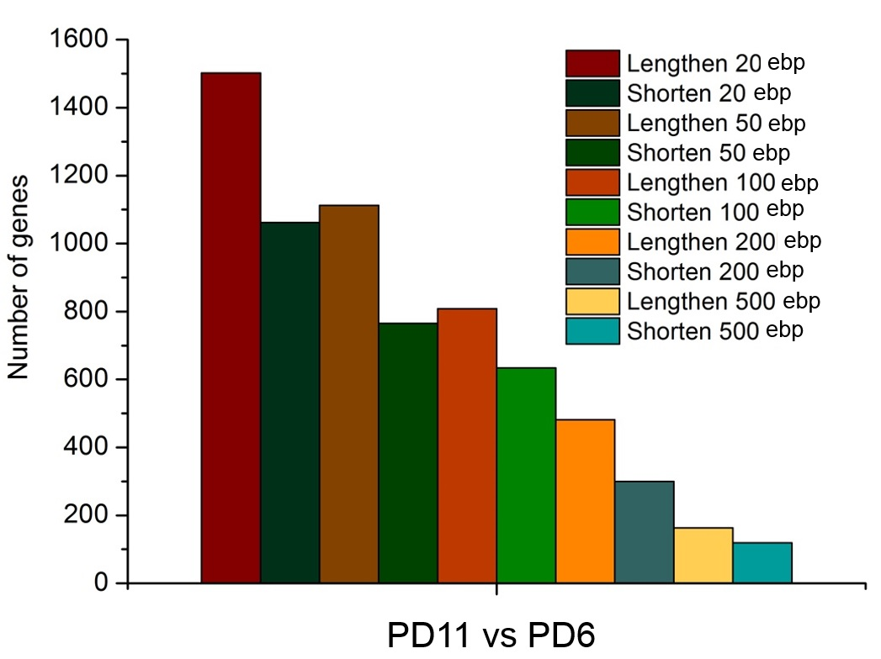
Supplemental Figure S6. Biological replicate of senescent MEFs confirmed global lengthening of 3′ UTRs for genes with APA regulation. Number of genes with lengthened effective 3′ UTRs and number of genes with shortened effective 3′ UTRs by comparing PD11 to PD6 given different thresholds based on PA-seq data.

