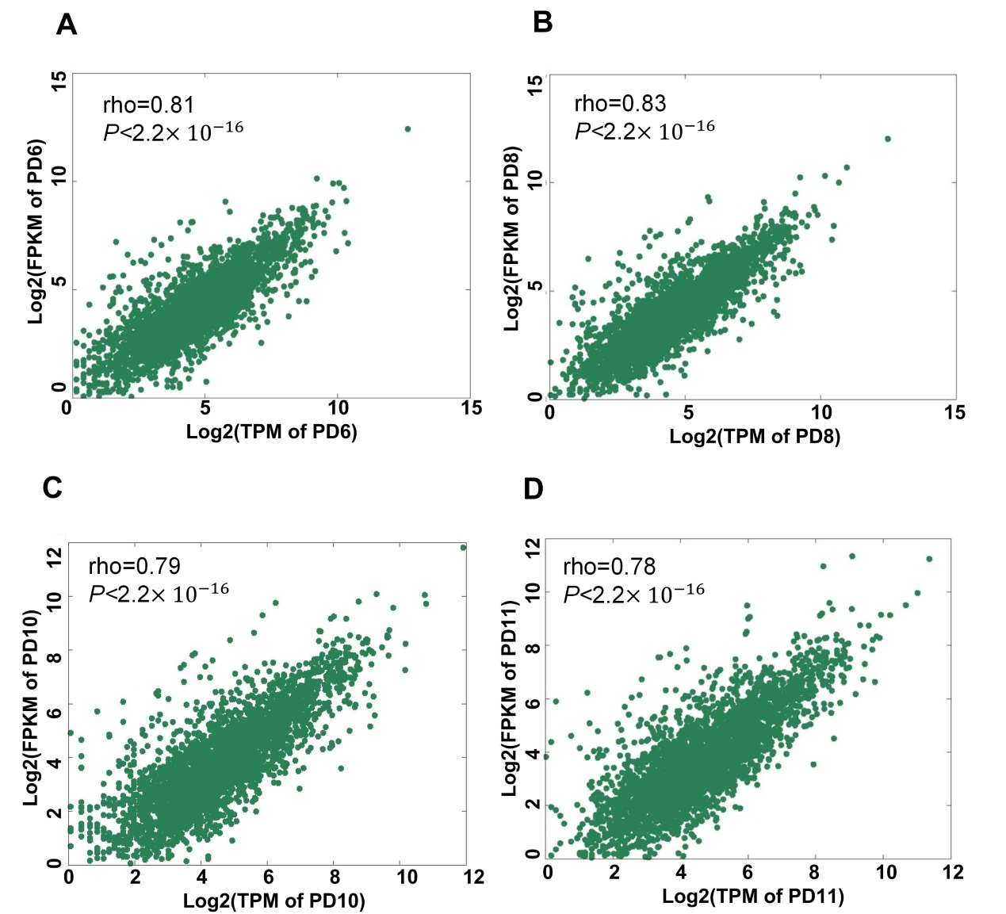

Supplemental Figure S4. Correlation of expression measured by PA-seq and RNA-seq for genes with multiple pAs. (A-D) Correlation of expression measured by PA-seq and RNA-seq for genes with APA regulation in PD6, PD8, PD10, and PD11. Rho indicates Spearman's rank correlation coefficient.

