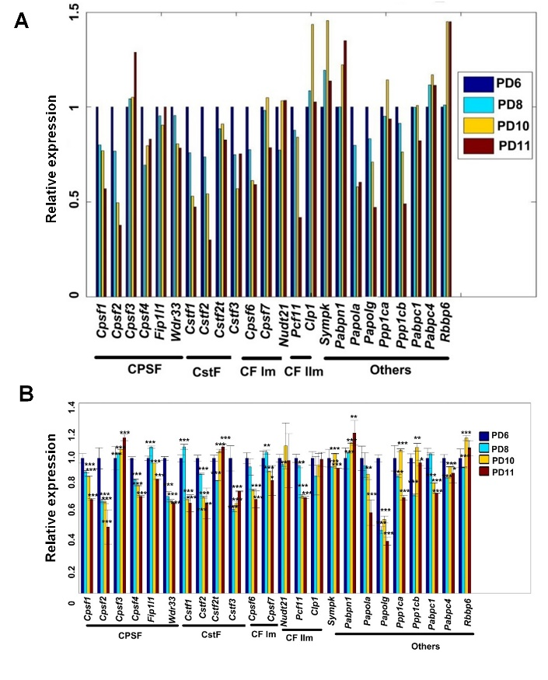
Supplemental Figure S20. Gene expression of known cleavage and polyadenylation factors during replicative senescence of MEFs based on RNA-seq data (A) and qRT-PCR validation (B). (***) P < 0.001, (**) P < 0.01 and (*) P < 0.05, two-tailed t-test.

