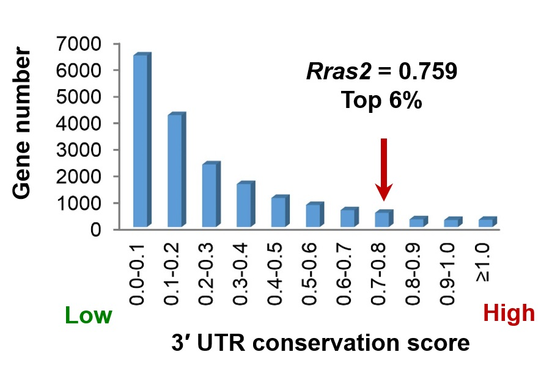

Supplemental Figure S19. 3′ UTR of Rras2 ranks top 6% regarding sequence conservation in 100 species based on Vertebrate Multiz Alignment & Conservation (UCSC).

