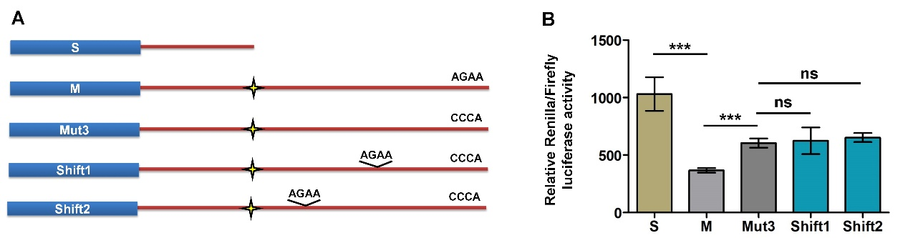
Supplemental Fig. 18. Dual luciferase activity assay for the ‘AGAA’ motif shift in the alternative 3′-UTR of Rras2. (A) ‘AGAA’ was mutated to ‘CCCA’ in the Mut3 construct. The ‘AGAA’ motif was introduced into two different locations in the alternative 3′-UTR of Rras2, which was labeled as ‘shift1’ and ‘shift2’. M denotes the full length 3′-UTR of Rras2 with a mutated proximal polyA signal to force usage of only the distal pA site. (B) Relative Renilla/Firefly luciferase activity of constructs indicated in panel A. ** and *** represent p values of less than 0.01 and 0.001, respectively, t-test. ns denotes not significant.

