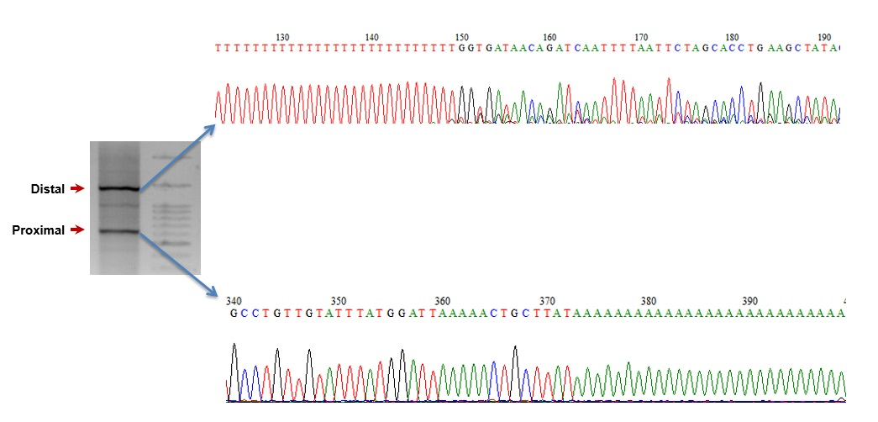

Supplemental Figure S17. Sanger sequencing of 3′ RACE products derived from proximal (bottom) or distal (top) pA sites in human HUVEC cells.

