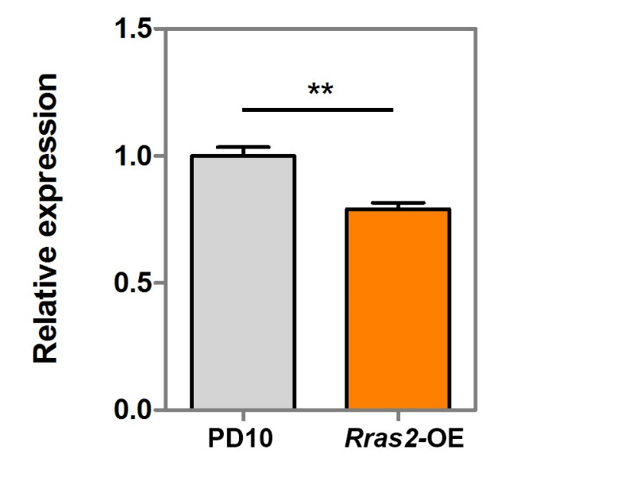
Supplemental Figure S16. Overexpression of Rras2 led to decreased Cdkn1a in primary MEF cells by qRT-PCR. ** represents p value < 0.01, t-test.

