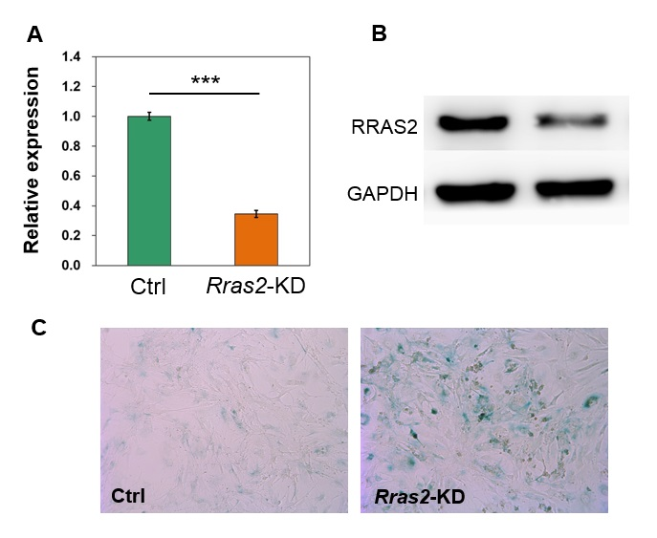
Supplemental Figure S15. Knockdown of Rras2 leads to higher SA-β-gal staining in primary MEF cells. (A-B) qRT-PCR (A) and Western blot (B) in control (Ctrl) and KD (sh979) MEFs. (C) SA-β-gal staining for control and Rras2-KD MEFs. Scale bar, 200 μm.

