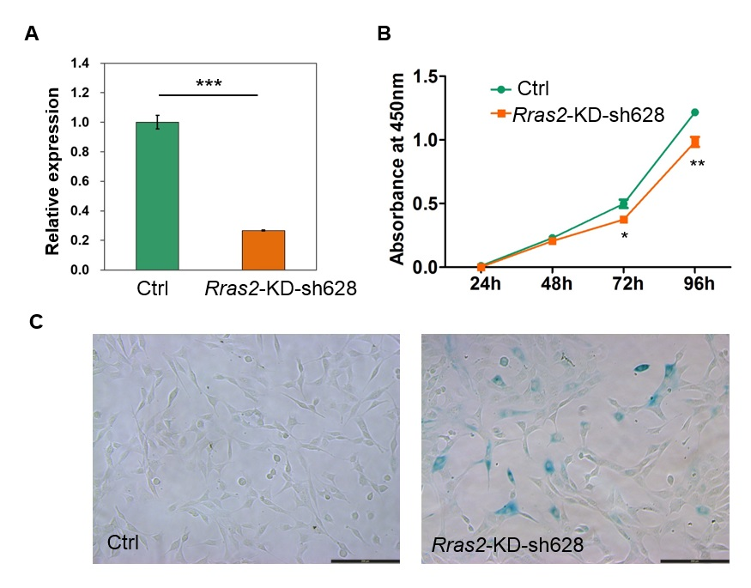
Supplemental Figure S14. Knockdown of Rras2 by shRNA sh628 leads to senescence in NIH3T3 cells. (A) qRT-PCR results in control (Ctrl) and KD NIH3T3 cells. (B-C) CCK-8 assay (B) and SA-β-gal staining (C) for control and KD NIH3T3 cells. Scale bar, 200 μm.

