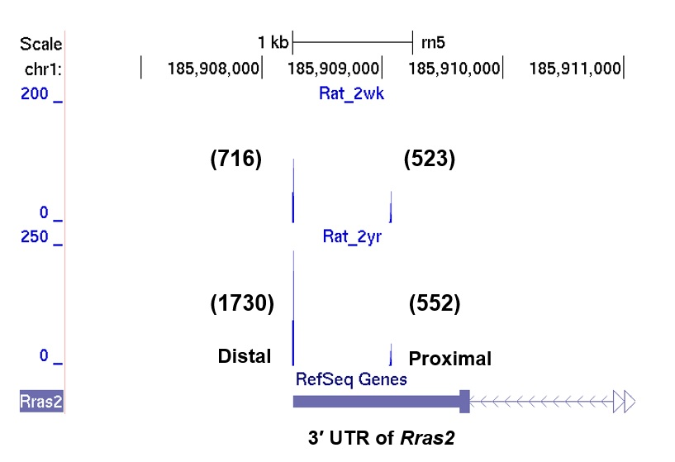

Supplemental Figure S13. PA-seq track of proximal and distal pA site usage in VMSCs from 2-year (2yr) and 2-week (2wk) old rat. Raw tag number for each pA site was indicated in parentheses.

