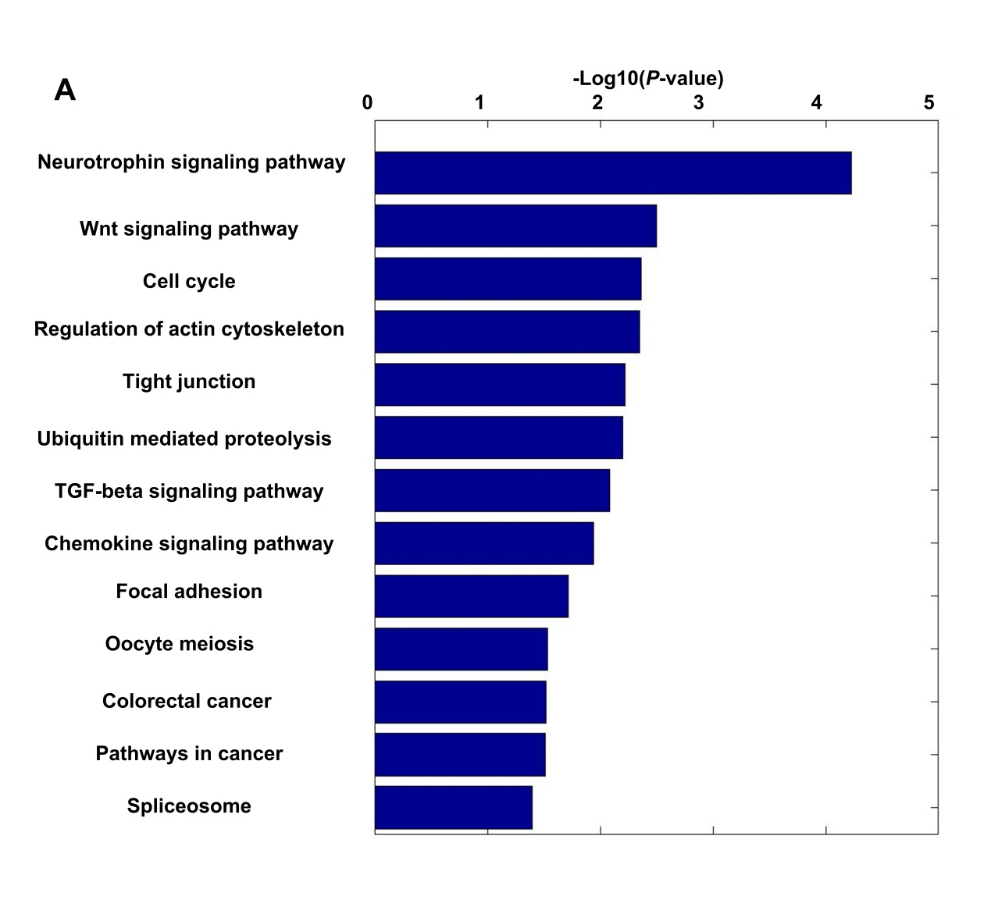
Supplemental Figure S12. Genes progressively tend to use distal pAs during replicative senescence of MEFs are enriched in senescence-related pathways. Genes with progressively lengthened 3′ UTRs were shown in Supplemental Fig. S8C.

