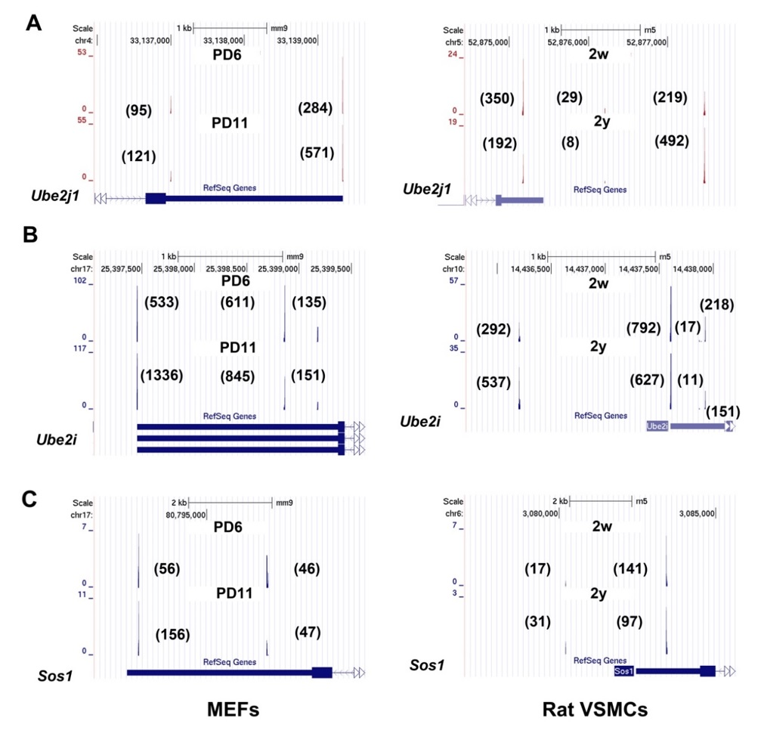
Supplemental Figure S11. Examples of genes tended to use distal pAs in senescent MEFs and VSMCs of aged rat. (A-C) PA-seq tracks of Ube2j1, Ube2i, and Sos1 in senescent and young MEFs and VSMCs from old and young rats. Numbers in brackets indicate the raw tag numbers for each pA site.

