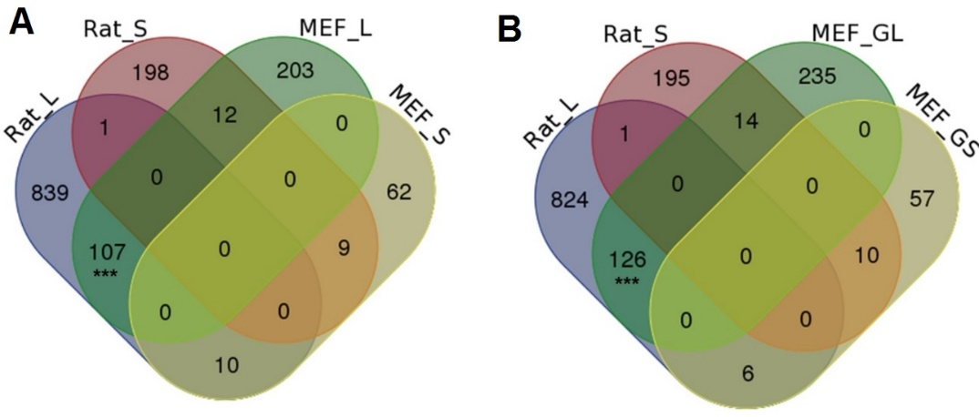
Supplemental Figure S10. Comparison among genes significantly tended to use distal pAs and proximal pAs in senescent MEFs and aged rat VSMCs. (A) Venn diagram for genes preferring distal (named Rat_L) and proximal (named Rat_S) pAs when comparing VSMCs of old rat with young rat, and genes preferring distal (MEF_L) and proximal (MEF_S) pAs when comparing senescent MEFs (PD11) with young MEFs (PD6). (B) Venn diagram comparison among Rat_L, Rat_S, and genes gradually preferred to use distal (MEF_GL) and proximal (MEF_GS) pAs during replicative senescence of MEFs. MEF_L, MEF_S, Rat_L, Rat_S, MEF_GL, and MEF_GS were identified by linear trend test with the Benjamini-Hochberg (BH) false-discovery rate (FDR) at 5%. (***) P$<$0.001, Fishers′ exact test.

