Supplemental Material for

Local sequence features that specify AP-1 cis-regulatory activity
Hemangi G. Chaudhari and Barak A. Cohen
List of supplemental data, each included as a tab-separated text file:

Supplemental Data SD1: Expression data of sequences in Library 1.
Supplemental Data SD2: Expression data of sequences in Library 2, Part 1.
Supplemental Data SD3: Expression data of sequences in Library 2, Part 2.
Supplemental Data SD4: Expression data of sequences in Library 3.
Supplemental Data SD5: Motif matches to saturation mutagenesis substitutions.
Supplemental Data SD6: Motifs from logistic regression.

Supplemental Table S1: Effect of single base mutations on activity in Library 2
 | Wild-type | AP-1_{mut}
Total number of flanking substitutions tested | 2565 | 2565
Statistically significant change from parent | 814 | 618
Increased expression | 285 | 354
Decreased expression | 529 | 455
> 2-fold change | 92 | 30

Supplemental Table S2: Library 1 composition
Type | Wild-type | AP-1_{mut} | Lengths per sequence | Total
High Expression | 40 | 109 | 5 | 745
Low Expression | 41 | 110 | 5 | 755
Positive Controls | 5 | 14 | 5 | 70
Experimental Controls | 20 | - | 1 | 20
Basal | 35 | - | 1 | 35
 |  |  | Total with 4 barcodes | 6500

Supplemental Table S3: Library 2 composition
Type | Wild-type | AP-1_{mut} | Variants | Total
Parental Sequences | 20 | 20 | - | 80 | Both parts
Saturation Mutants | 20 | 20 | ~150 each | 5959
Positive Control | 1 | 1 | ~150 each | 293
Weak Enhancers | 156 |  |  | 156
Basal | 35 |  |  | 70 | Both parts
Experimental Controls | 40 |  |  | 80 | Both parts
Positive Controls | 15 |  |  | 30 | Both parts
Common | 41 |  |  | 82 | Both parts
 |  |  |  | Total with 4 barcodes | 27000

Supplemental Table S4: Library 3 composition
Type | Number
DHS | 5000
AP-1 mutant (AP-1_{mut}) | 250
Positive Controls | 5
Experimental Controls | 40
Basal | 80
Library 2 | 20
Total with 5 barcodes | 26975

Supplemental Table S5: Primers and adapters used in this study
Primer | Sequence | Annealing Temp (ºC)  (Phusion) | Description
1F | GTAGCATCTGTCC | 57 | Amplification of Agilent Library 1
1R | CGACTACTACTACG | 57 | Amplification of Agilent Library 1
2F | GTCGAGAGTCGCAGGCTA | 60 | Amplification of Agilent Library 2, Part 1
2R | CTGATGGCACTCGGTCTAGAC | 60 | Amplification of Agilent Library 2, Part 1
3F | CGGAGTCGAGACGTATGTGC | 62 | Amplification of Agilent Library 2, Part 2
3R | TGATGGTGTAGCGATCTAGAGC | 62 | Amplification of Agilent Library 2, Part 2
4F | GGAGGTCCACTGACTAGTGCT | 64 | Amplification of Agilent Library 3
4R | ACCTTGACGATCCGTCTGC | 64 | Amplification of Agilent Library 3
5F | TACACCGTGGTGGAGCAGTA | 55 | Amplification of barcodes from cDNA
5R | AGCGTACTCGAGTTGTTAACTTGTTTATTGCAGCTT | 55 | Amplification of barcodes from cDNA
6F | AATGATACGGCGACCACCGAGATCTACACTCTTTCCCTACACGACGCTCTTCCGATCTGCTCGATCAT*G | - | P1 Illumina adapter cDNA Replicate 1
6R | /5Phos/ATCGAGCAGATCGGAAGAGCGTCGTGTAGGGAAAGAGTGTAGATCTCGGTGGTCGCCGTATCATT | - | P1 Illumina adapter cDNA Replicate 1
7F | AATGATACGGCGACCACCGAGATCTACACTCTTTCCCTACACGACGCTCTTCCGATCTTAGACTATCAT*G | - | P1 Illumina adapter cDNA Replicate 2
7R | /5Phos/ATAGTCTAAGATCGGAAGAGCGTCGTGTAGGGAAAGAGTGTAGATCTCGGTGGTCGCCGTATCATT | - | P1 Illumina adapter cDNA Replicate 2
8F | AATGATACGGCGACCACCGAGATCTACACTCTTTCCCTACACGACGCTCTTCCGATCTCGCTACCCTCAT*G | - | P1 Illumina adapter cDNA Replicate 3
8R | /5Phos/AGGGTAGCGAGATCGGAAGAGCGTCGTGTAGGGAAAGAGTGTAGATCTCGGTGGTCGCCGTATCATT | - | P1 Illumina adapter cDNA Replicate 3
9F | AATGATACGGCGACCACCGAGATCTACACTCTTTCCCTACACGACGCTCTTCCGATCTATAGTGGACACAT*G | - | P1 Illumina adapter cDNA Replicate 4
9R | /5Phos/TGTCCACTATAGATCGGAAGAGCGTCGTGTAGGGAAAGAGTGTAGATCTCGGTGGTCGCCGTATCATT | - | P1 Illumina adapter cDNA Replicate 4
10F | AATGATACGGCGACCACCGAGATCTACACTCTTTCCCTACACGACGCTCTTCCGATCTGTCAGTAGGTACAT*G | - | P1 Illumina adapter DNA
10R | /5Phos/TACCTACTGACAGATCGGAAGAGCGTCGTGTAGGGAAAGAGTGTAGATCTCGGTGGTCGCCGTATCATT | - | P1 Illumina adapter DNA
11F | /5Phos/T*CGAAGATCGGAAGAGCACACGTCTGAACTCCAGTCACAGCGTGCCCATCTCGTATGCCGTCTTCTGCTTG | - | P2 Illumina adapter
11R | CAAGCAGAAGACGGCATACGAGATGGGCACGCTGTGACTGGAGTTCAGACGTGTGCTCTTCCGATCT | - | P2 Illumina adapter
12F | AATGATACGGCGACCACCGAG | 66 | Enrichment PCR primer
12R | CAAGCAGAAGACGGCATACGAGAT | 66 | Enrichment PCR primer
Supplemental Table S6: Sequencing depth for all libraries
Library | Library complexity | Reads (million) | Sequencing Platform | Read type
1 | 6500 | 88 | HiSeq Illumina | 1x50
2, Part 1 | 13500 | 178 | HiSeq Illumina | 1x50
2, Part 2 | 13500 | 186 | HiSeq Illumina | 1x50
3 | 26975 | 210 | NextSeq Illumina | 1x75

Supplementary Figures

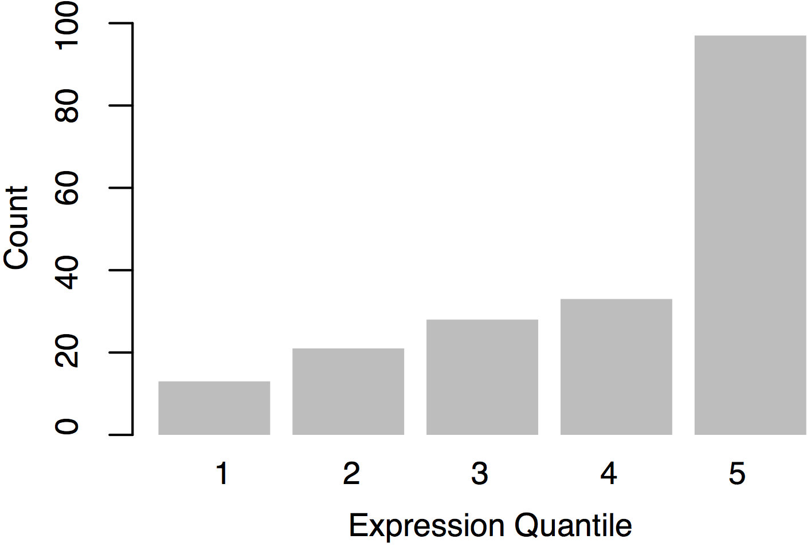

Supplemental Fig S1: Distribution of expression levels driven by sequences containing AP-1 binding sites in K562 cells. 192 sequences containing the AP-1 site were tested in K562 cells using a massively parallel reporter gene assay in a library of 13,000 elements. Sequences in expression quantile five were defined as active. Only 50% of the 192 sequences were present in quantile five. Data from Kwasnieski et al. 2014.

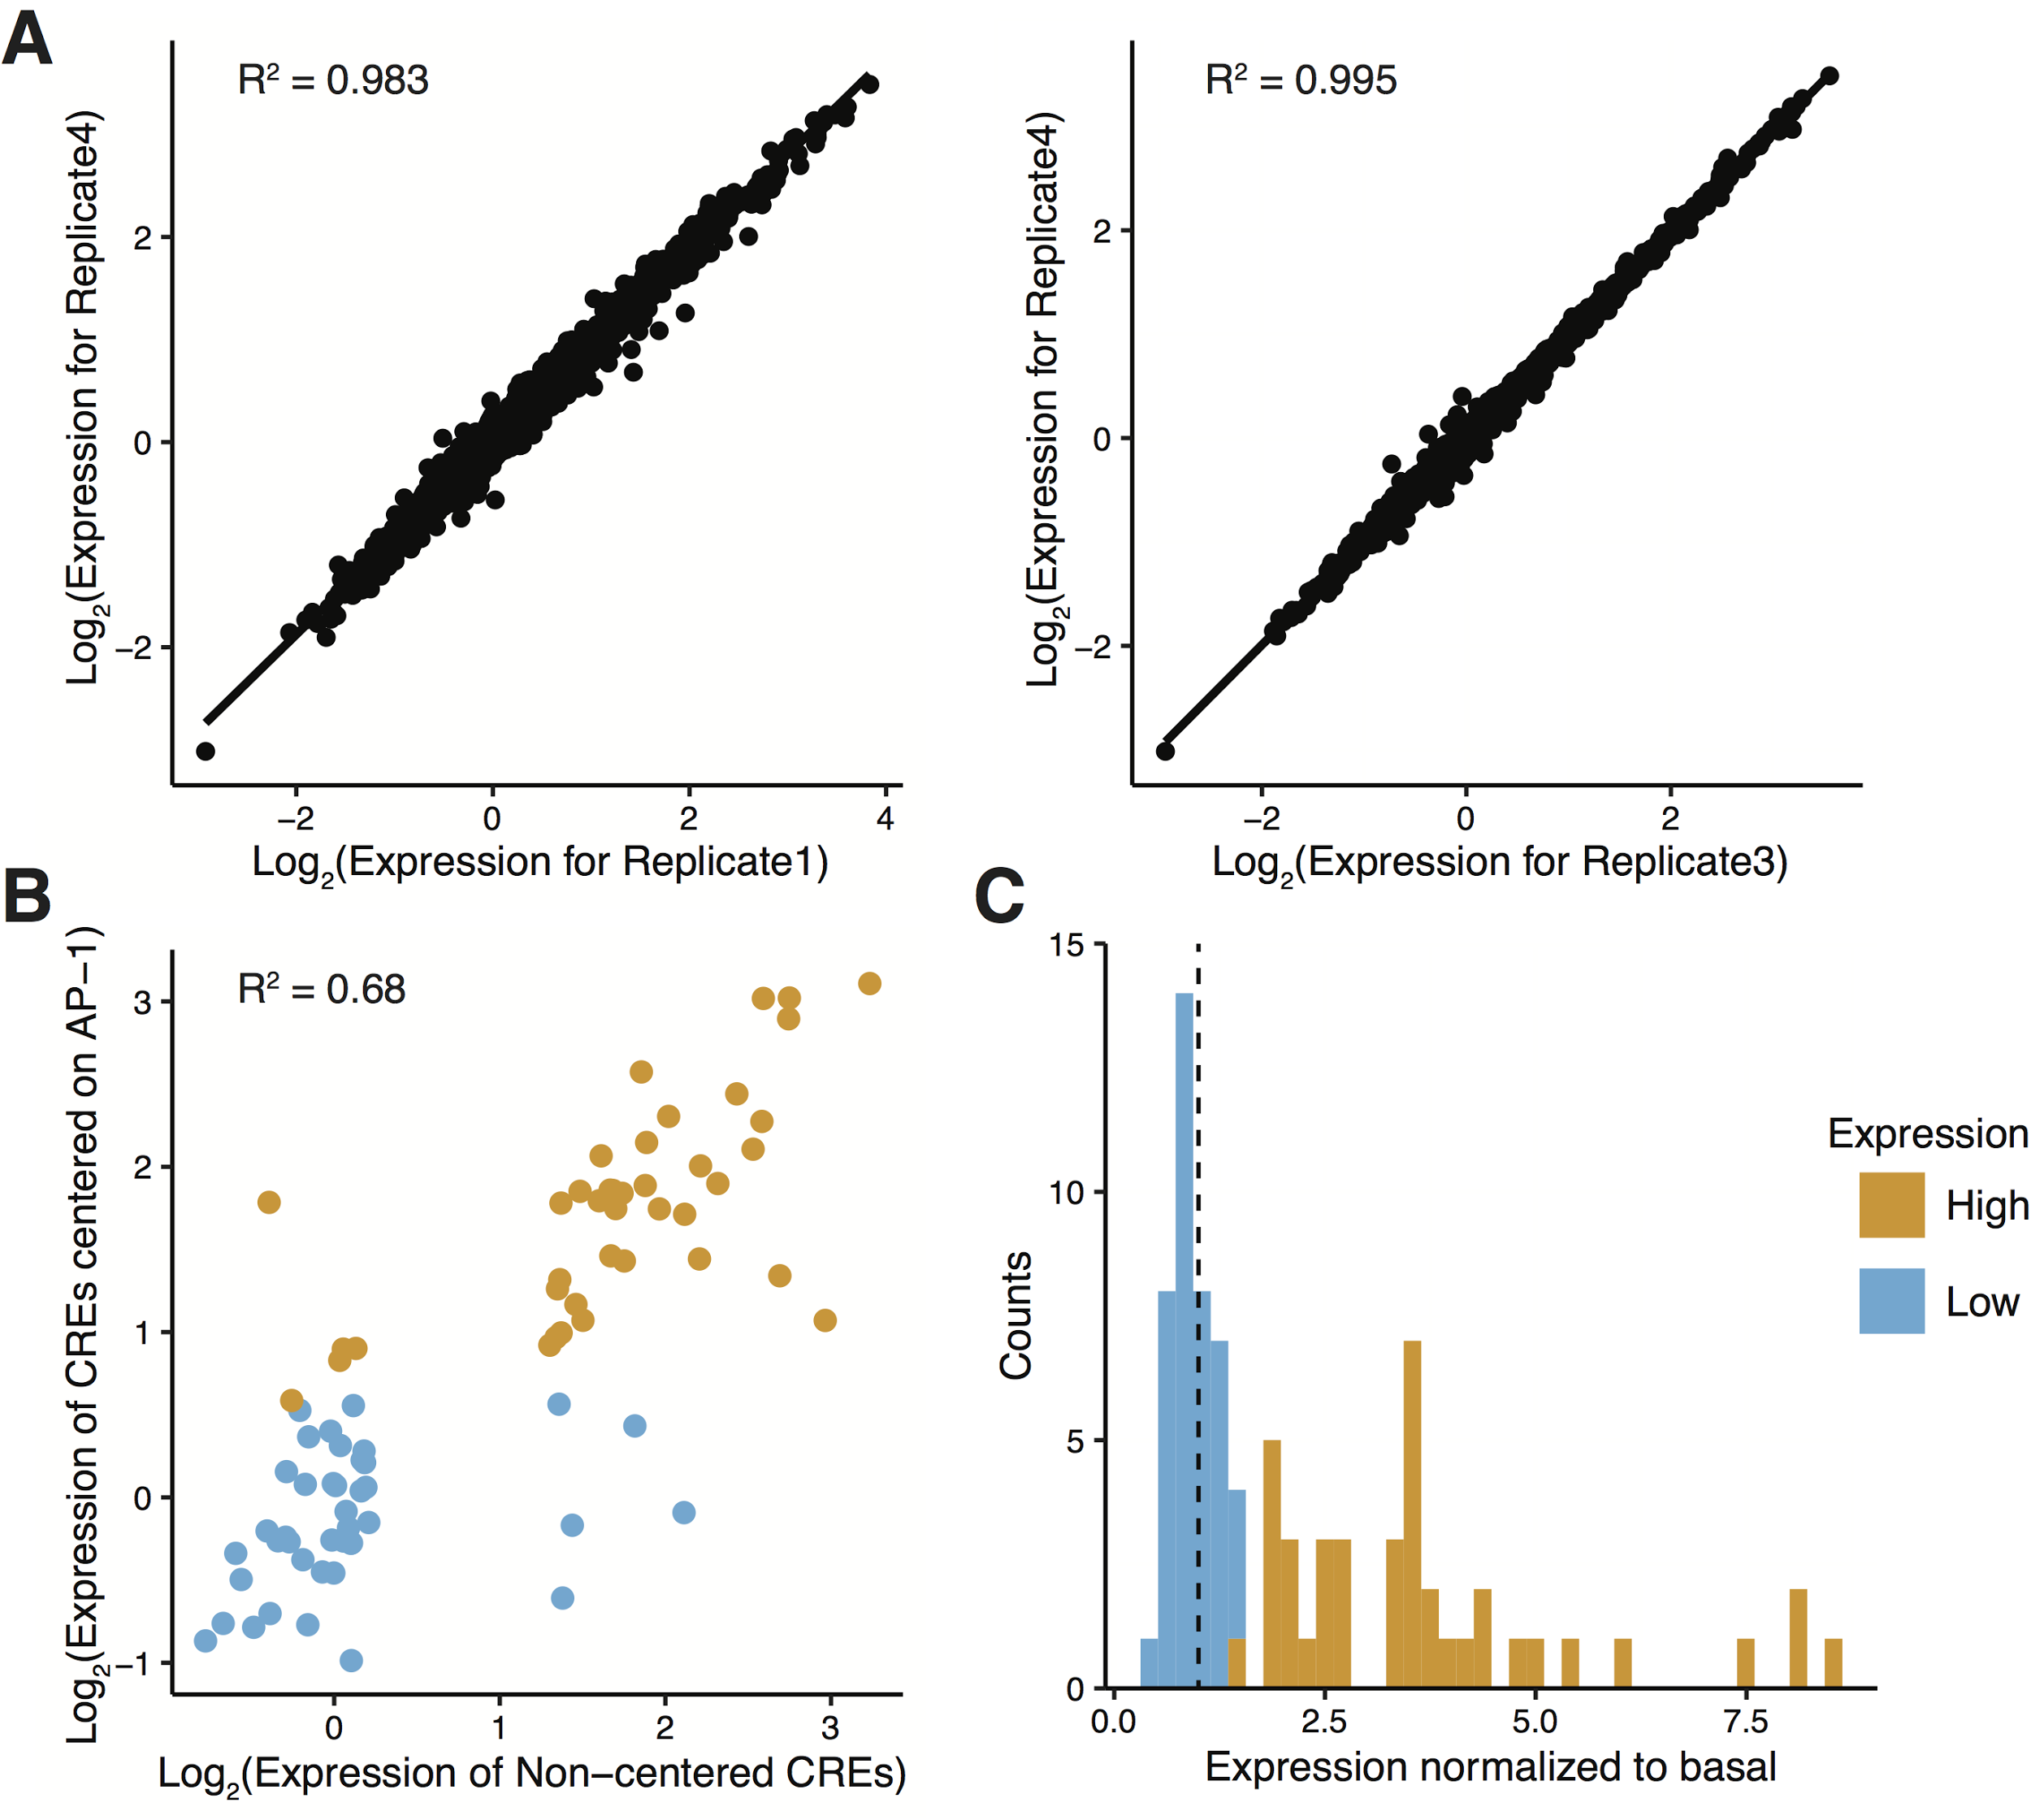

Supplemental Fig S2: Expression distribution for sequences in Library 1. A. Replicate experiments were highly reproducible. We performed four independent transfections of the plasmid library. Each point depicts the expression of a regulatory element averaged across four barcodes. Correlation between replicates 1 and 4 was the lowest (left, R² = 0.983) and correlation between replicates 3 and 4 was the highest (right, R² = 0.995). B. Expression of 130 bp sequences centered on AP-1 was highly correlated to the starting set of sequences (R² = 0.68). Each point represents the expression of one regulatory element, colored by its classification in the starting set. C. HIGH and LOW groups were redefined for 130 bp AP-1 centered sequences based on median expression. Dotted line shows expression level of basal control construct.
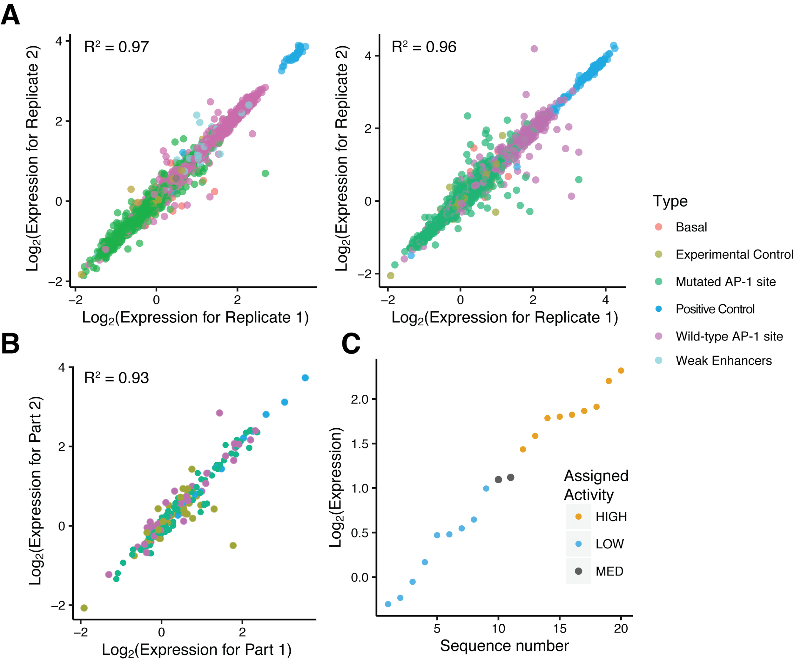
Supplemental Fig S3: Expression distribution of sequences in Library 2. A. We designed, cloned, transfected and sequenced the saturation mutagenesis library in two parts. Expression measurements from both parts were reproducible (min R² = 0.96, L: Part 1, R: Part 2). Each point depicts the expression of a regulatory element averaged across four barcodes. Color of the point represents sequence category. B. We included common sequences in the two parts. The expression measurements were highly correlated between the two libraries (R² = 0.9). Each point depicts the expression of a regulatory element averaged across 16 measurements (four barcodes in four replicates). Colors are same as in Panel A. C. Expression of 20 wild-type sequences is shown on the Y-axis. We annotated the wild-type sequences as LOW, MEDIUM and HIGH according to their measured expression in Library 2.

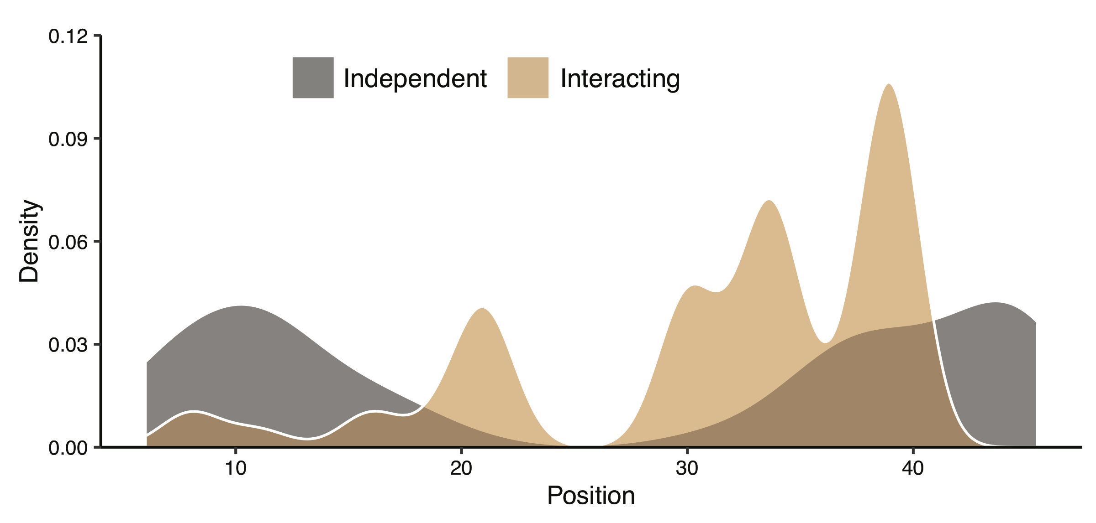
Supplementary Figure S4: Positional bias of independent (gray) and interacting (tan) motifs relative to the central AP-1 core for twenty sequences subject to saturation mutagenesis. Interacting motifs are enriched closer to the AP-1 core site.

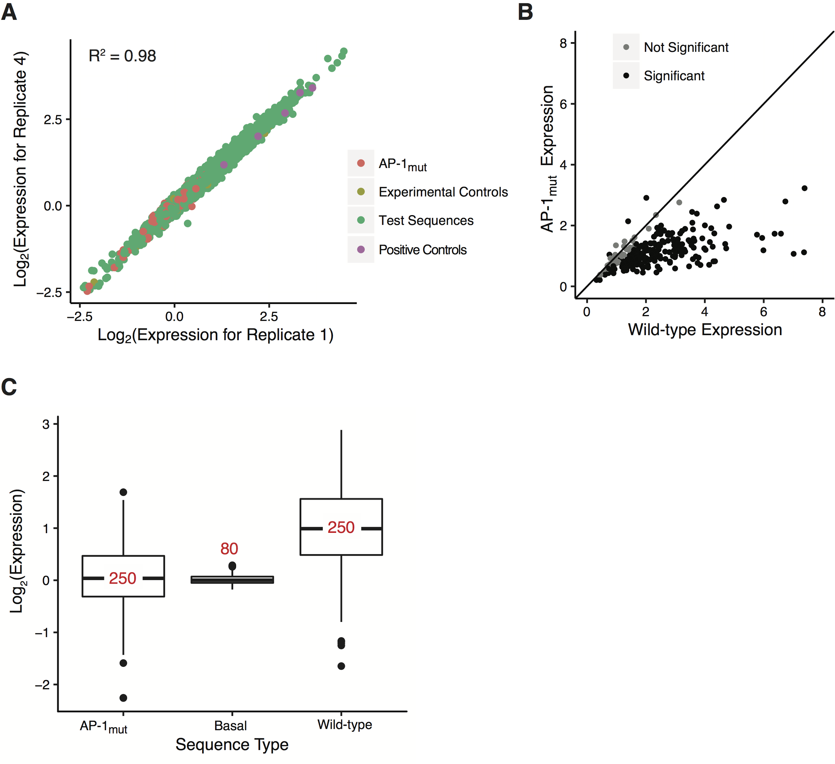
Supplemental Fig S5: Expression data of sequences from DHS regions in K562 cells. A. We performed four independent transfections of the plasmid library. Each point depicts the expression of a regulatory element averaged across five barcodes. Color of the point represents sequence category. Replicates 1 and 4 were the least correlated (R² = 0.98) B. Mutating the AP-1 site (AP-1_{mut}) reduces expression. Wild-type expression is plotted on the X-axis and AP-1_{mut} expression is plotted on the Y-axis. Each point depicts the expression of a regulatory element averaged across 20 measurements (five barcodes in four replicates). Color represents the statistical significance of the difference between wild-type and AP-1_{mut} expression according to Wilcoxon test (Black: significant, P < 2e-04; gray: not significant) (R² = 0.32) C. AP-1_{mut} sequences drive lower expression than wild-type sequences. Median activity of AP-1_{mut} sequences was the same as that of basal constructs. Numbers in red show the number of sequences in each category.

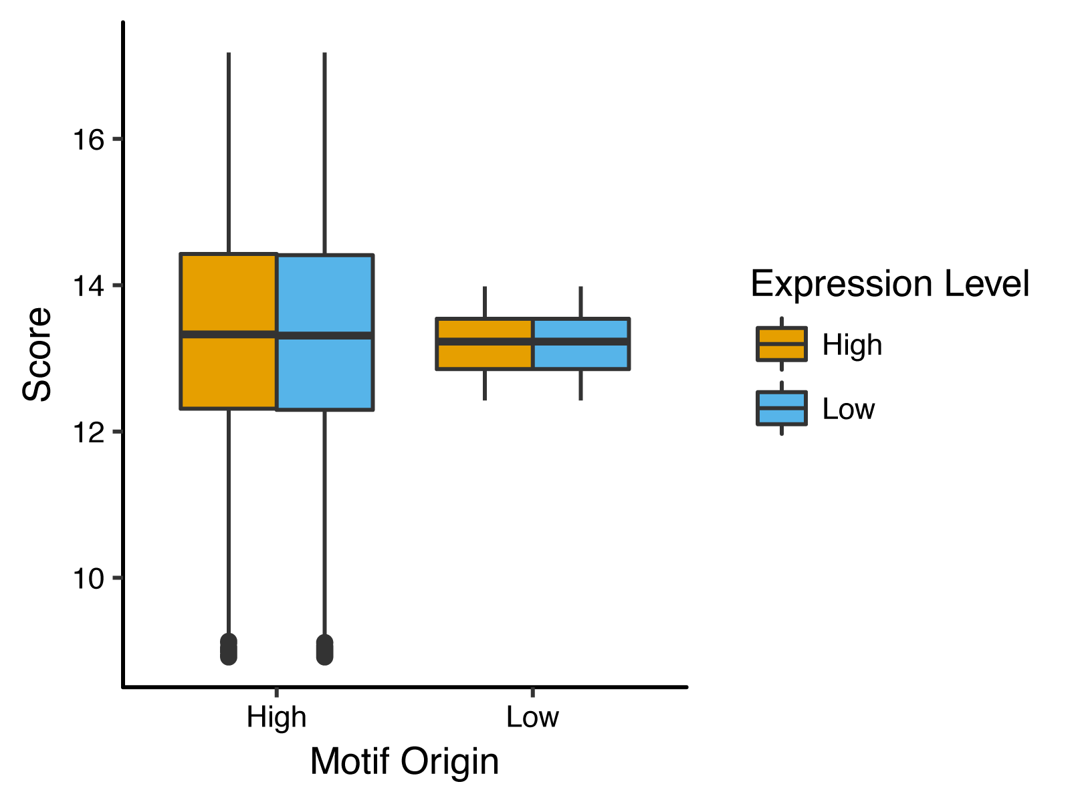
Supplemental Fig S6: PWMs derived from HIGH and LOW activity DHS cannot distinguish between these two classes. X-axis, PWMs derived from HIGH and LOW sequences using the MEME suite. Y-axis, scores for HIGH (Orange) and LOW (blue) sequences for both the motifs calculated using FIMO. The HIGH motif and the LOW motif both score HIGH and LOW sequences equally well.

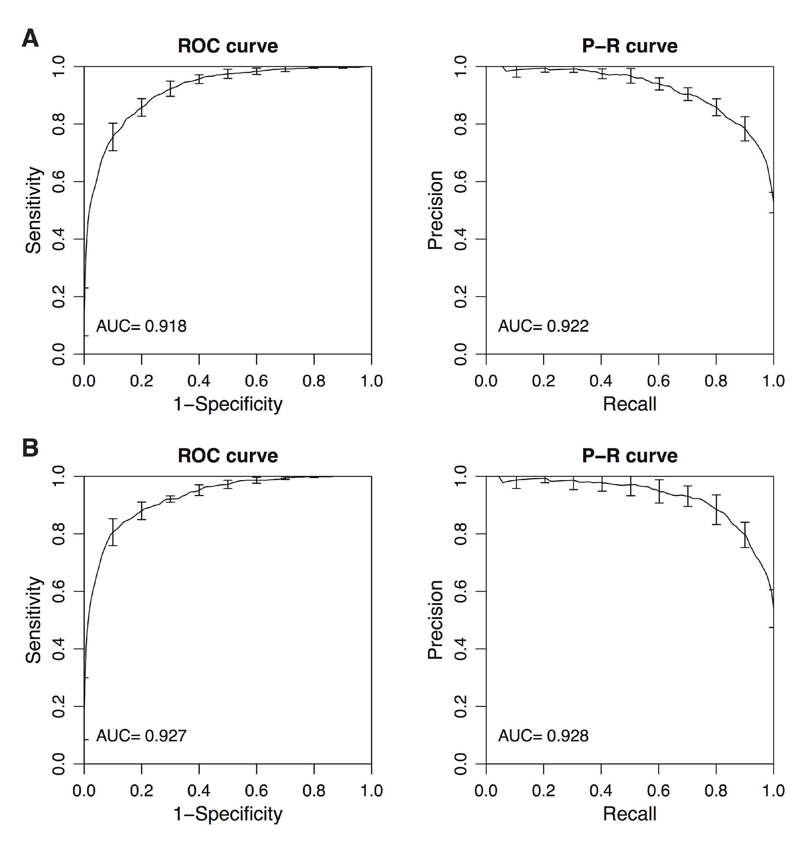
Supplemental Fig S7: Analysis of 1000 HIGH and 1000 LOW DHS sequences using gkmSVM A. Receiver operating characteristic (ROC) curve (Left) and precision-recall (PREC) curve (Right) from a 6-mer, ungapped model. B. ROC curve (Left) and PREC curve (Right) from an 8-mer, ungapped model.

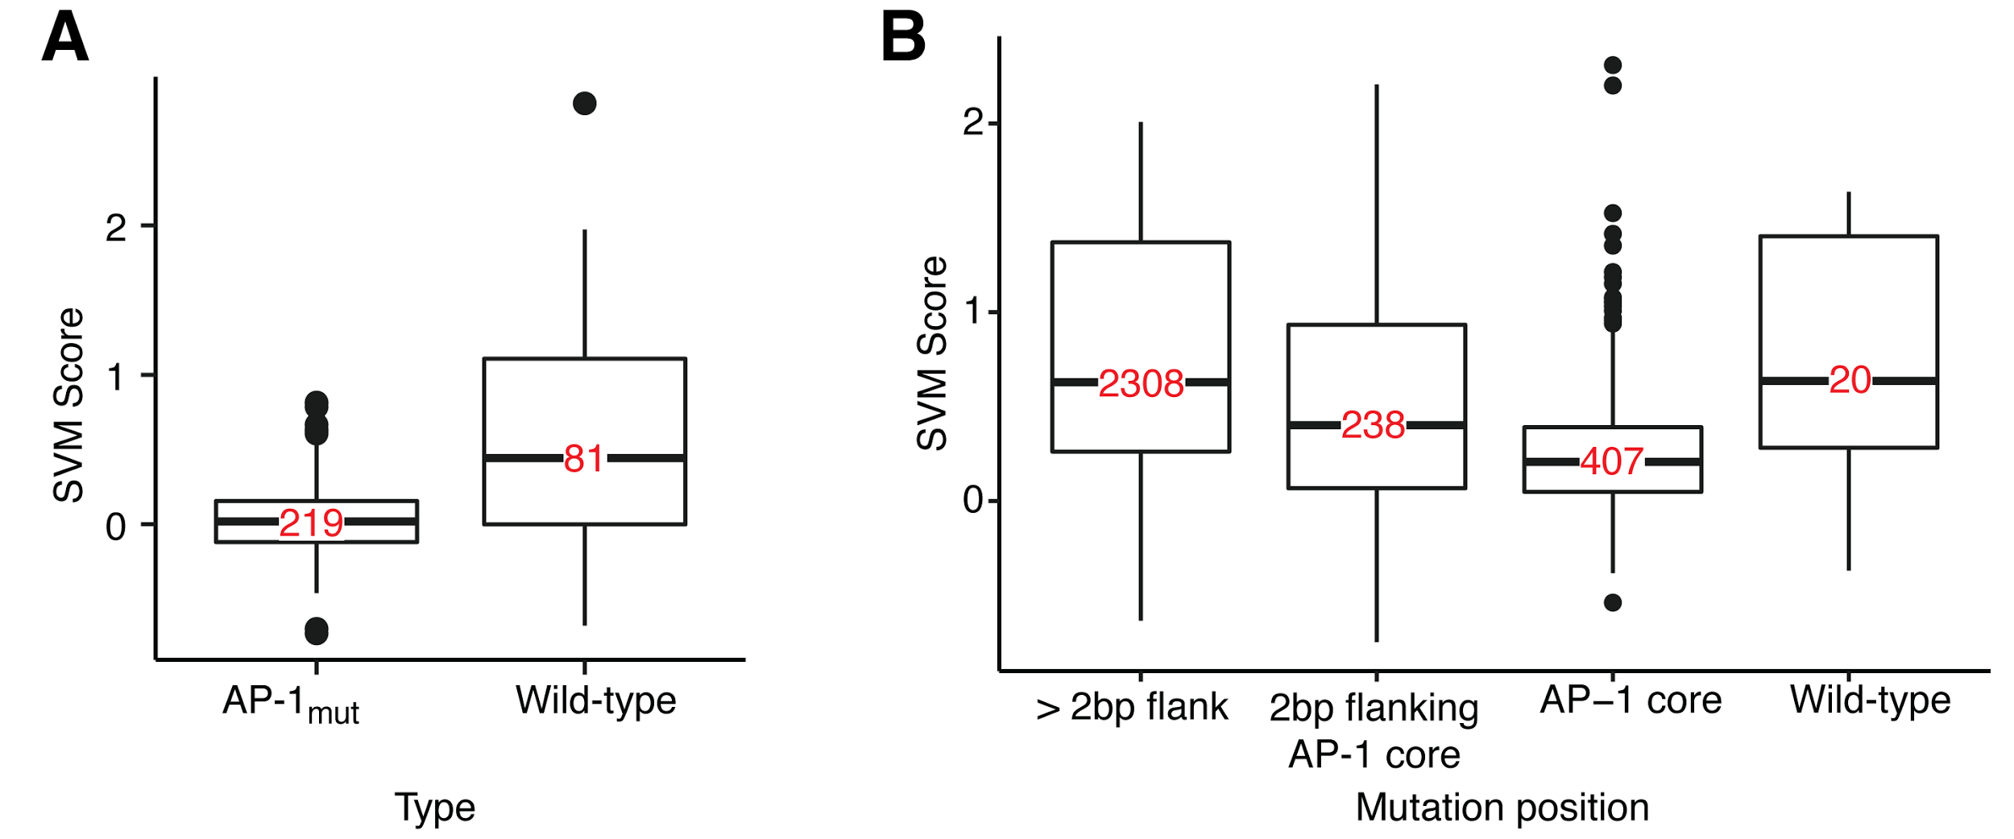
Supplemental Fig S8: Performance of a 10-mer gapped SVM trained on 1000 HIGH and 1000 LOW activity DHS sequences A. Library 1 included 81 fifty bp long wild-type sequences and two to three AP-1_{mut} variants per sequence. AP-1_{mut} sequences had lower SVM scores compared to sequences with wild-type AP-1 sites. Wilcoxon Test, P = 3.5e-09 B. Library 2 was composed of 20 wild-type elements and their single base mutants. Mutations in the AP-1 core had the lowest SVM score. Mutations in 2 base pairs flanking the AP-1 core motif had lower scores than mutations outside of these flanks. Numbers in red depict number of data points in each box. Bonferroni corrected Wilcoxon Test, P <0.05 for all comparisons except for >2bp flank & wild-type and 2bp flanking AP-1 core & wild-type.
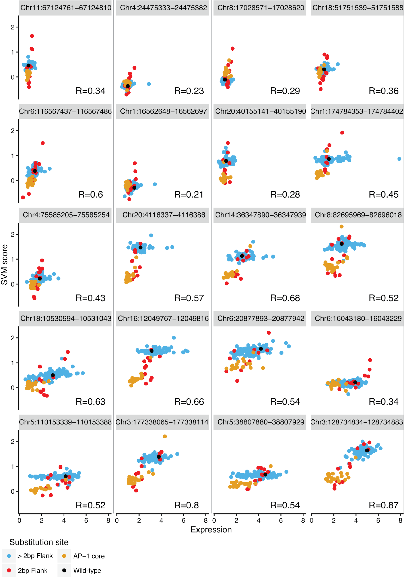
Supplemental Fig S9: SVM trained on DHS sequences predicted expression of saturation mutagenesis constructs. Expression measurements are shown on the X-axis and SVM score is shown on the Y-axis. Each point represents a sequence with one base pair substitution and color of the point represents the position of the mutation. Wild-type sequence is shown in black. Each subpanel shows a scatter plot for an individual sequence. SVM score is correlated with expression for each sequence. Sequences are arranged by the expression level of the wild-type sequence (Left to Right and Top to Bottom). The correlation coefficient is itself correlated with wild-type expression (R=0.7, data not shown).

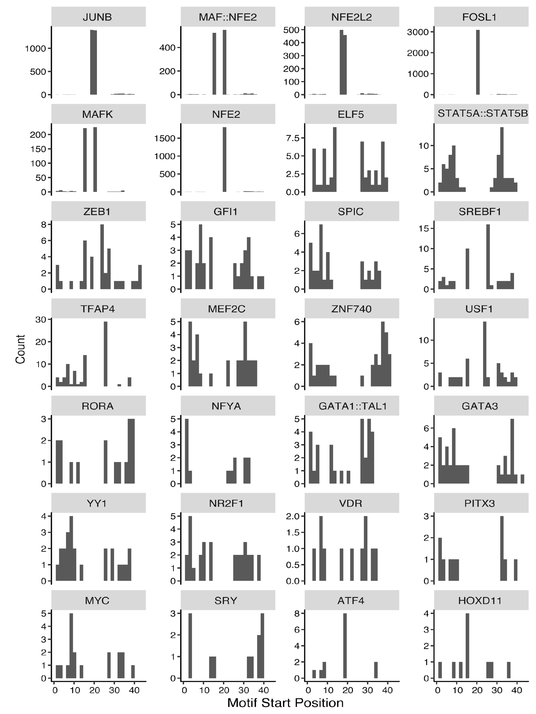
Supplementary Figure S10: Position distributions of matches to PWMs of 28TFs from logistic regression across 1000 HIGH and 1000 LOW sequences. X-axis, position along the sequence. Y-axis, number of matches in both orientations at a particular position across the 2000 sequences. Panels are arranged in decreasing order of power of the individual motif to classify HIGH from LOW sequences. The top 6 PWMs all either match or overlap the AP-1 site.

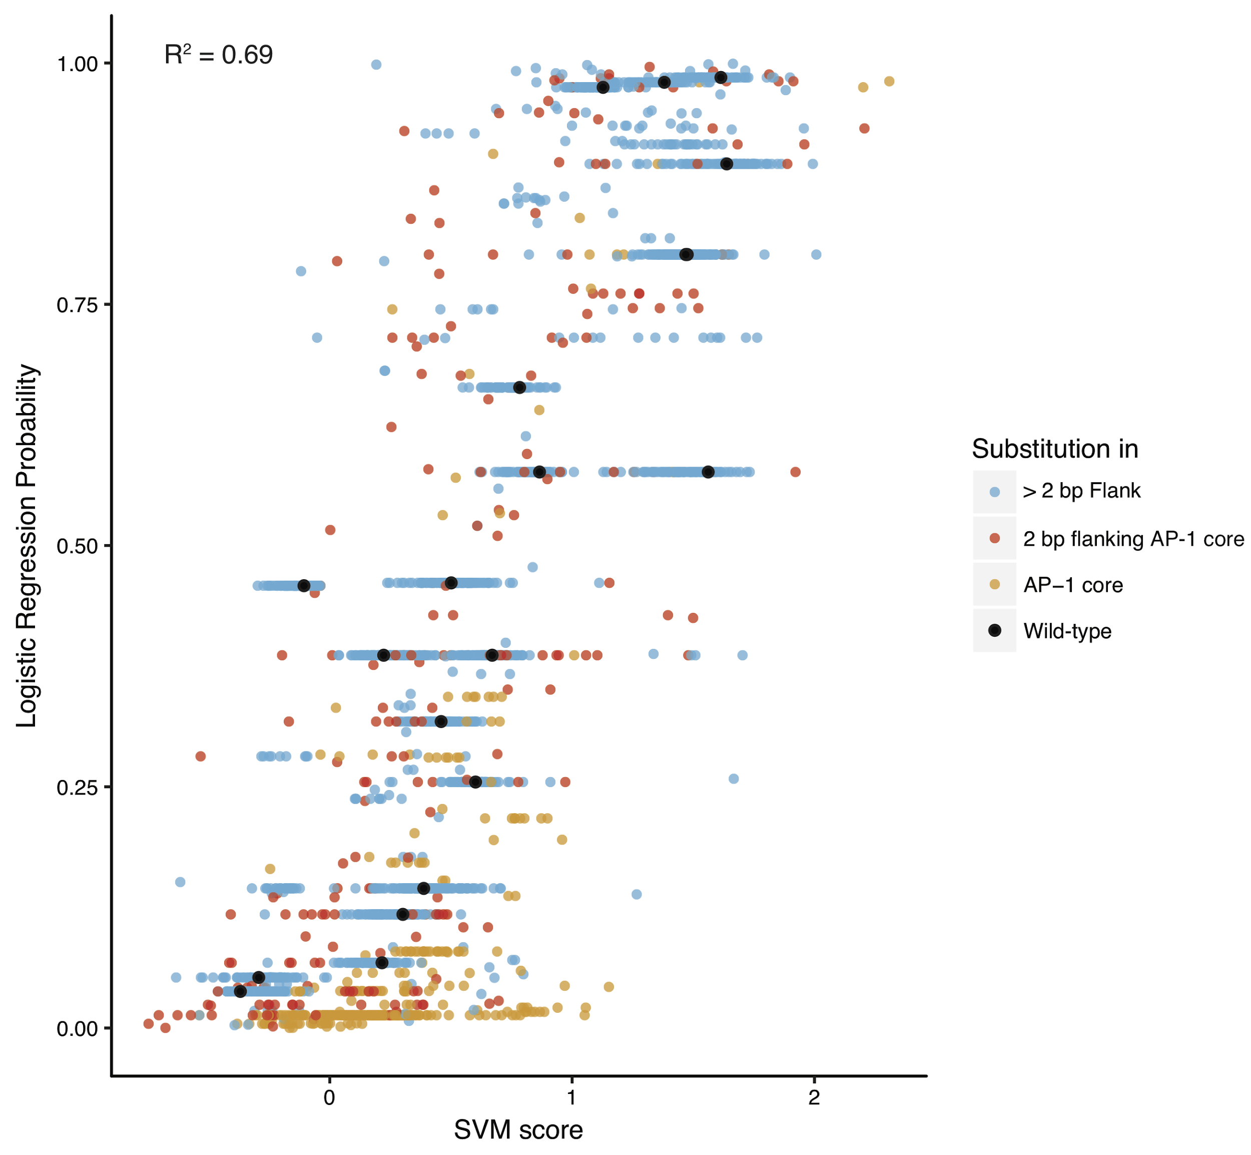
Supplemental Fig S11: Predictions of saturation mutagenesis library from logistic regression model and gkmSVM are highly correlated. Each point represents a sequence with one base pair substitution and color of the point represents the position of the mutation. Wild-type sequences are shown in black.

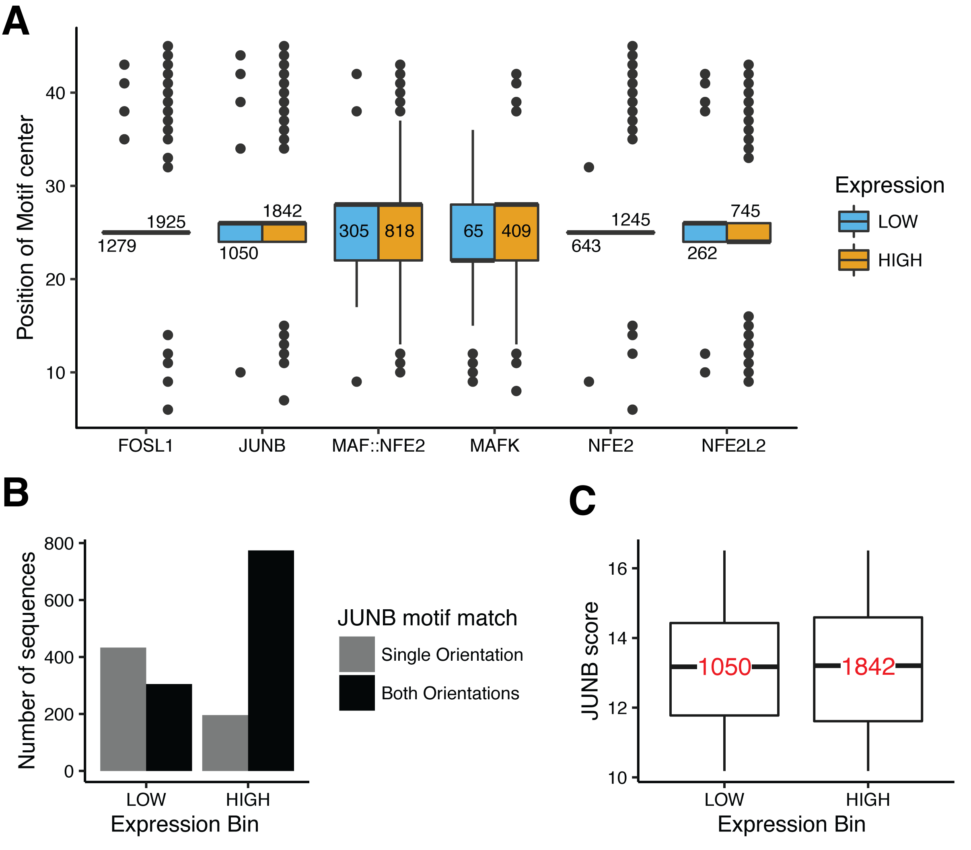
Supplementary Fig. S12: HIGH sequences contain AP-1 sites that bind multiple AP-1 TFs in both orientations. A. Number of matches for different AP-1 motifs are shown for 1000 HIGH (Orange) and 1000 LOW (Blue) groups. Position of the center of the motif is plotted on the Y-axis. More than 1000 matches in each group indicate that some sequences had two or more instances of the motif. AP-1 sites in the center of HIGH sequences score well for multiple transcription factors in both orientations. B. 77% of the sequences in the HIGH group have AP-1 sites that score well for JUNB motif in both orientations, whereas only 30% of the sequences in the LOW group have AP-1 sites that score well for JUNB motif in both orientations. C. JUNB motif match score (FIMO) distributions are not statistically different for HIGH and LOW sequences (Wilcoxon test, P = 0.75,). Numbers in red depict number of data points in each box.

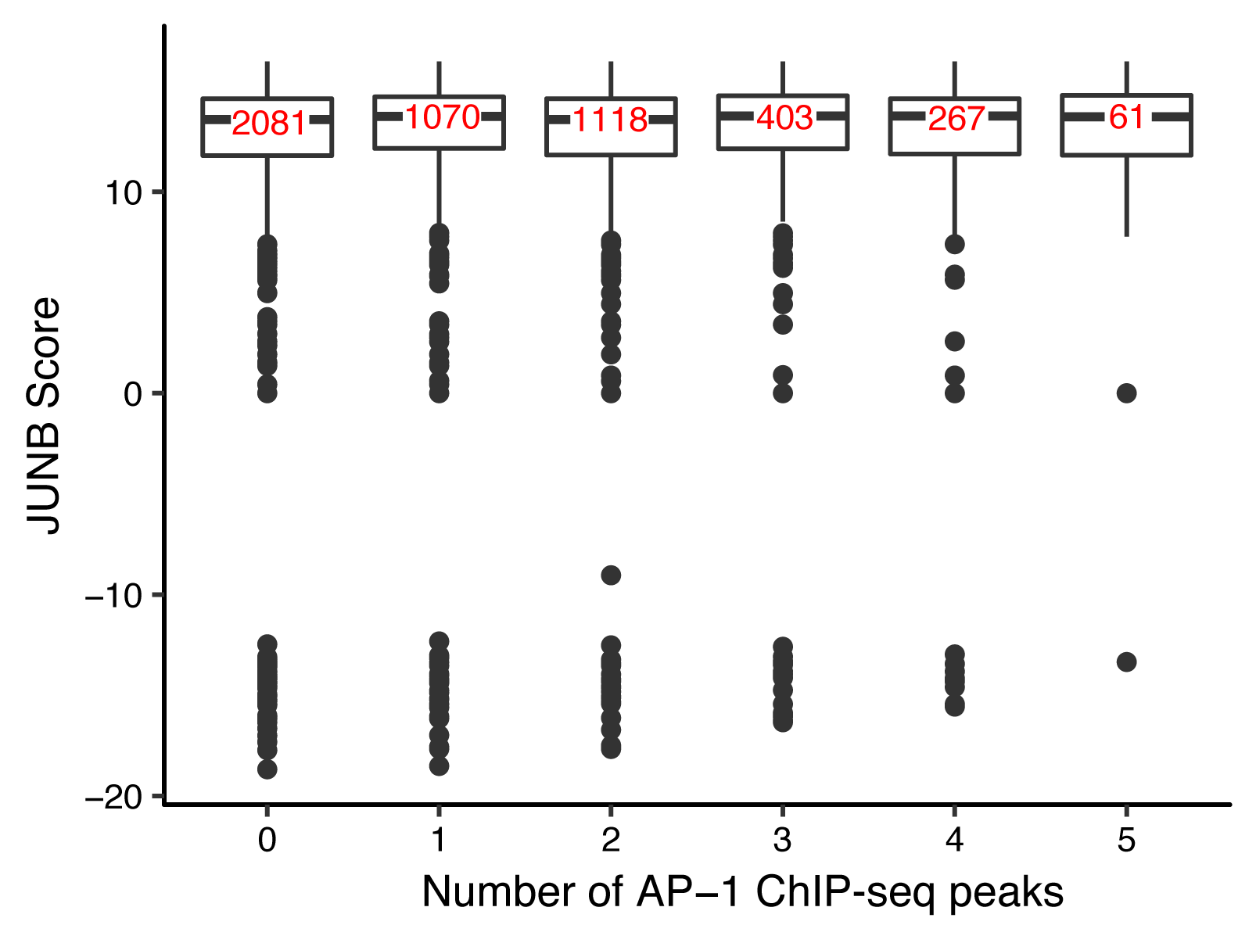
Supplementary Fig. S13: Sequences in DHS regions with different number of AP-1 ChIP-seq peaks have similar JUNB motif score distributions. X-axis, number of peaks observed in total in five ChIP-seq experiments (JUNB, MAFF, MAFK, NFE2 and FOSL1 (The ENCODE Project Consortium 2012)). Y-axis, score for the JUNB PWM (JASPAR database) calculated with FIMO for 5000 DHS sequences. In most sequences, the AP-1 site matched the JUNB PWM in both orientations with different scores. We used the higher score for this analysis. There were no significant differences between groups using the Wilcoxon test (P = 1).

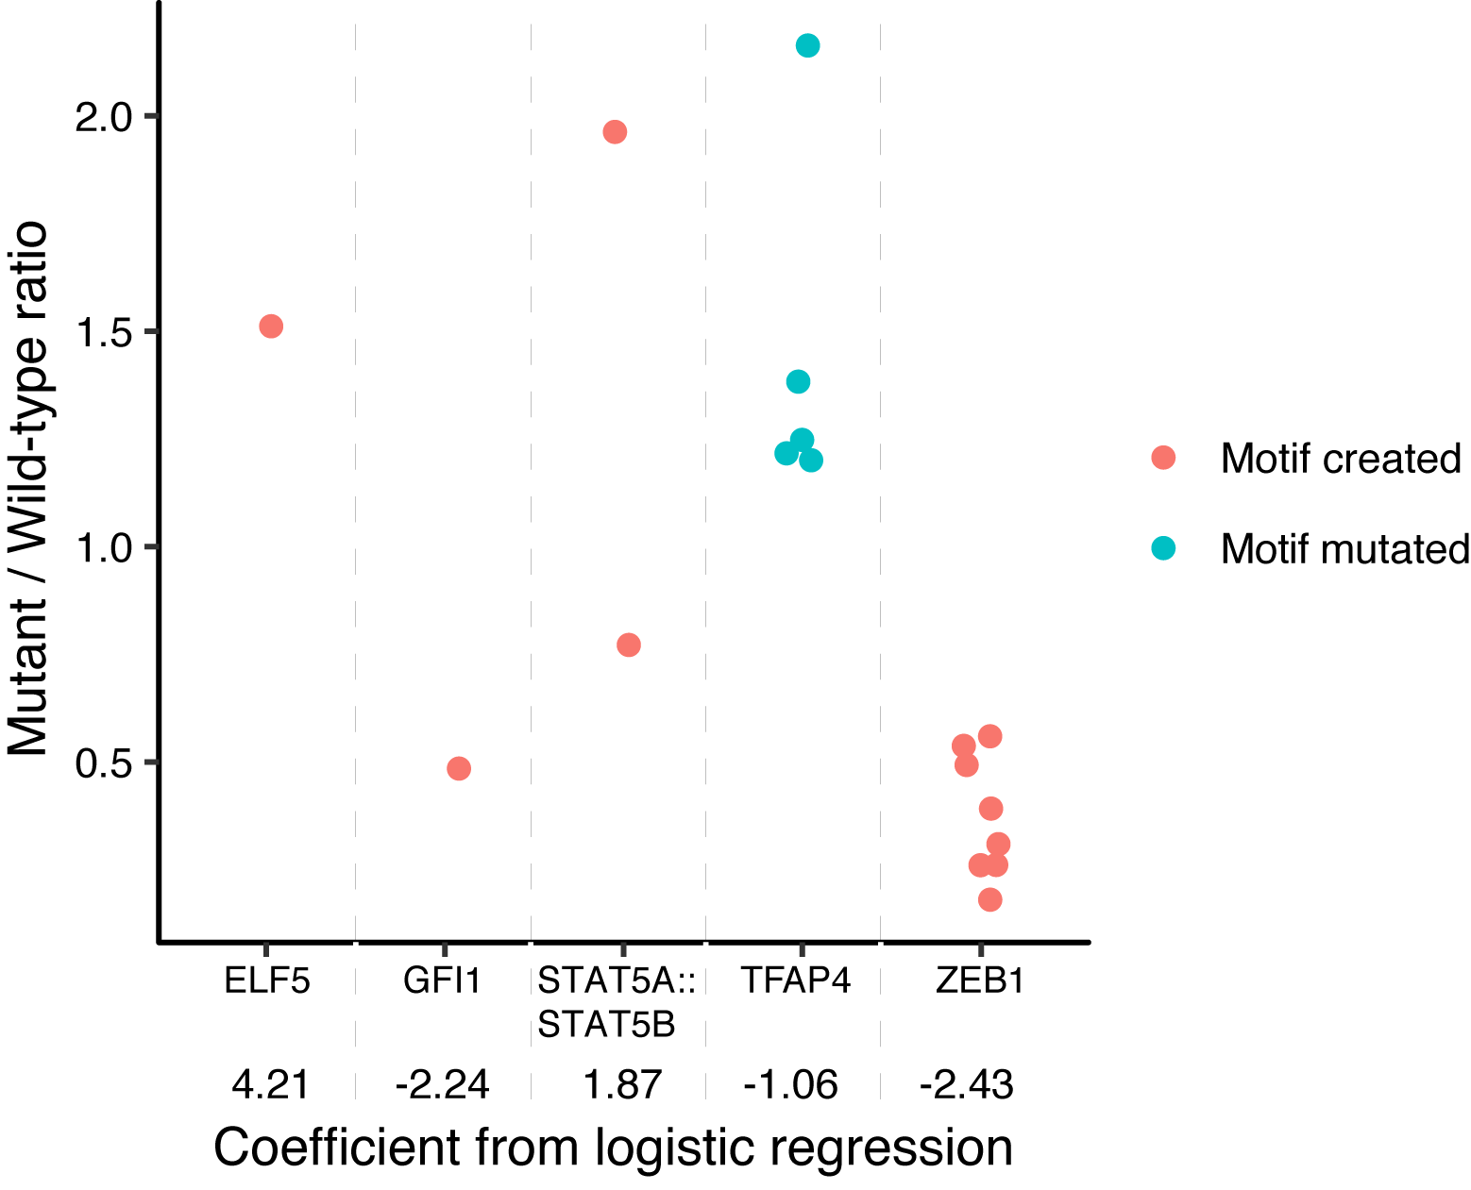

Supplementary Fig. S14: The effect on expression due to creation or disruption of a TF in Library 2 matches prediction from the logistic regression model built on data from Library 3. X-axis, five most significant TFs from logistic regression whose motifs were created or mutated because of substitutions in the sequence flanking the AP-1 binding sites. Coefficients from the logistic regression are mentioned below the TF name. Y-axis, expression of a sequence with substitution normalized by wild-type expression. For ELF5, a substitution created a motif that drove high expression, which is consistent with its positive coefficient from the logistic regression model. For TFAP4, mutating the motif increased expression, consistent with its negative coefficient.

