Supplemental Material
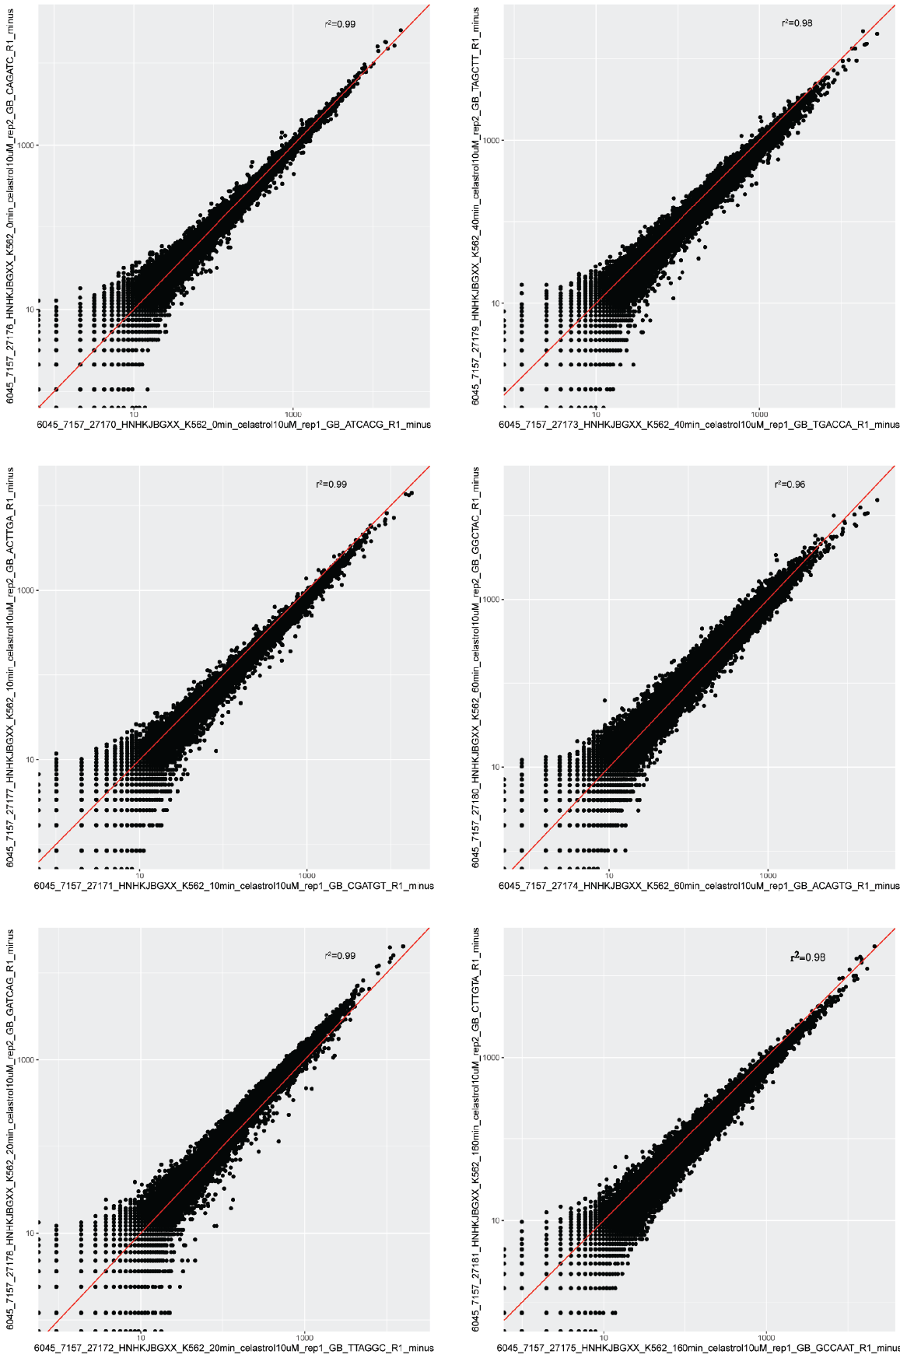
Supplemental Figure 1. Concordance in read-counts between replicates in gene bodies on the negative strand.

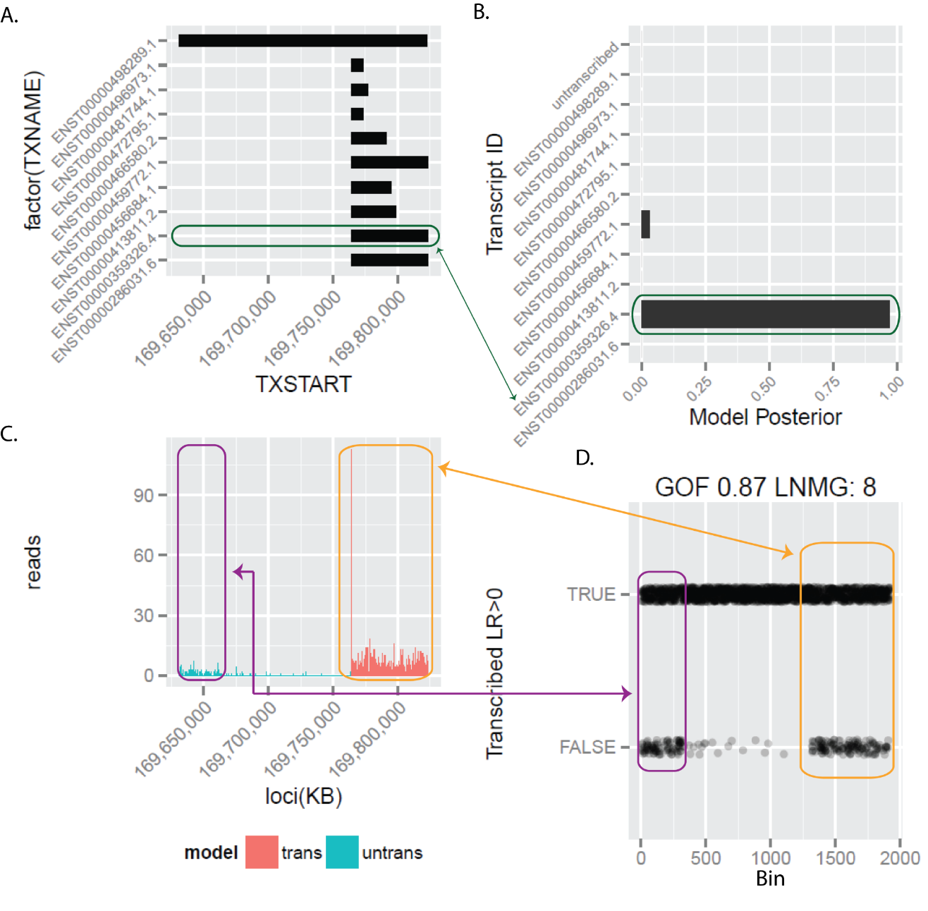
Supplemental Figure 2. Example of tuSelector call in the presence of multiple GENCODE transcripts. (A) Illustration of the coordinates of each uniquely identifiable candidate transcript model (obtained from GENCODE annotations) for C1orf122. All models differ in state (transcribed vs. untranscribed) in at least one bin. (B) The posterior probability of each transcript model as computed by tuSelector. (C) The raw PRO-seq data labeled with the state calls (transcribed/untranscribed) for the most likely transcript model. Notice in this case that there is a weak indication of transcription near the start of the longest transcript model, but the absence of transcription in the middle region, and the difference in read depth compared with the stronger evidence at the right (in red), suggest that a shorter transcript model is much more likely overall. (D) Some performance metrics to compute how well the data matches the most likely annotated transcript. GOF is the fraction of bins at which an independent prediction of transcription (not considering other bins) agrees with the corresponding state in the most likely transcript model. LNMG is the longest non-matching group of consecutive bins whose individual state calls do not agree with the annotated state in the most likely model. Each dot matches a 50-bp bin of reads. If labeled “true,” the independent state calls agree with the state in the most likely model, and if labeled “false,” they do not agree.
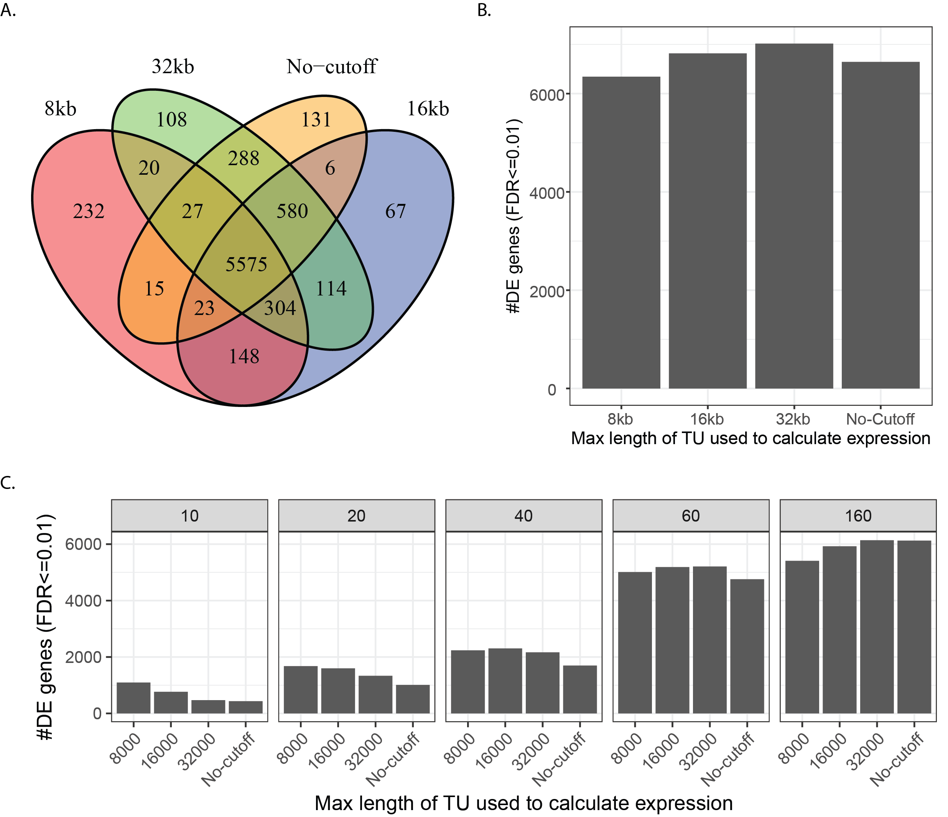
Supplemental Figure 3. Validation of choice of 16 Kb interval for estimating transcription levels of genes. Here we compare 16 Kb intervals with alternative intervals of 8 Kb and 32 Kb, in all cases starting 500bp after the TSS (to avoid pausing artifacts). For example, the 8Kb label indicates that reads were counted in the interval [TSS+500,TSS+8500). (A) Overlap between gene sets called as differentially expressed (DE) using the likelihood ratio test (LRT) at FDR ≤ 0.01 for different interval lengths. (B) Total numbers of genes called as DE using the likelihood ratio test (FDR ≤ 0.01) for different interval lengths. (C) Numbers of genes called as DE per interval length at each individual time-point using the Wald test, since our LRT aggregates across time-points (FDR ≤ 0.01). The results are similar across interval lengths, but the shorter lengths result in somewhat decreased numbers of DE genes at later time points due to reduced statistical power deriving from consideration of fewer sequencing reads. At the same time, the shorter lengths result in slightly improved sensitivity for differential expression at 10 minutes. Overall, the 16 Kb length cutoff appears to strike a good balance between sensitivity for immediate changes of large effect and sensitivity for delayed changes of modest effect.
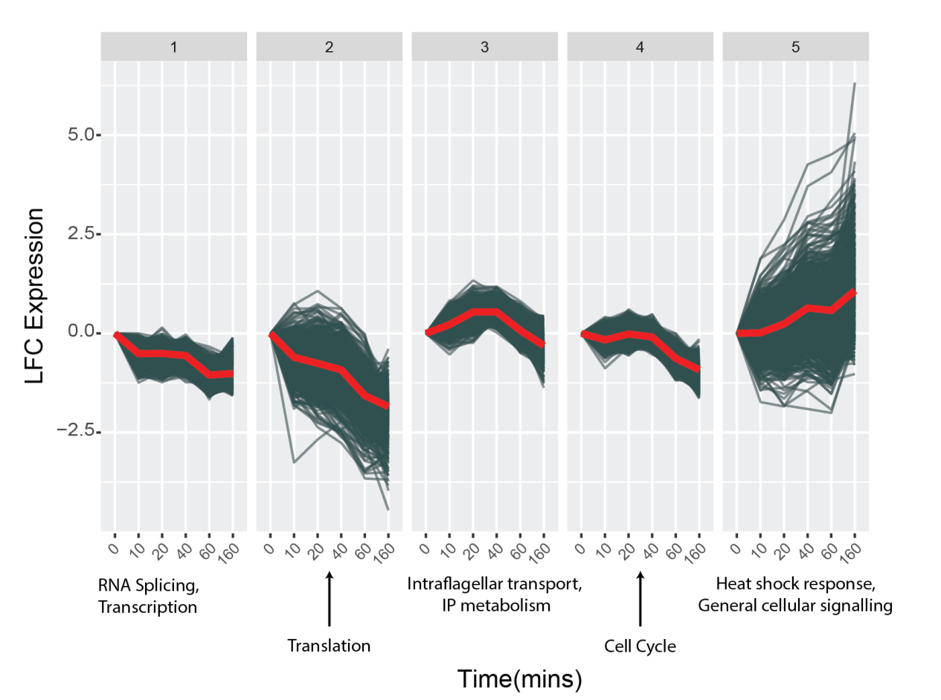
Supplemental Figure 4. Clustering of DE genes into five clusters and summary of enriched cluster-specific terms.

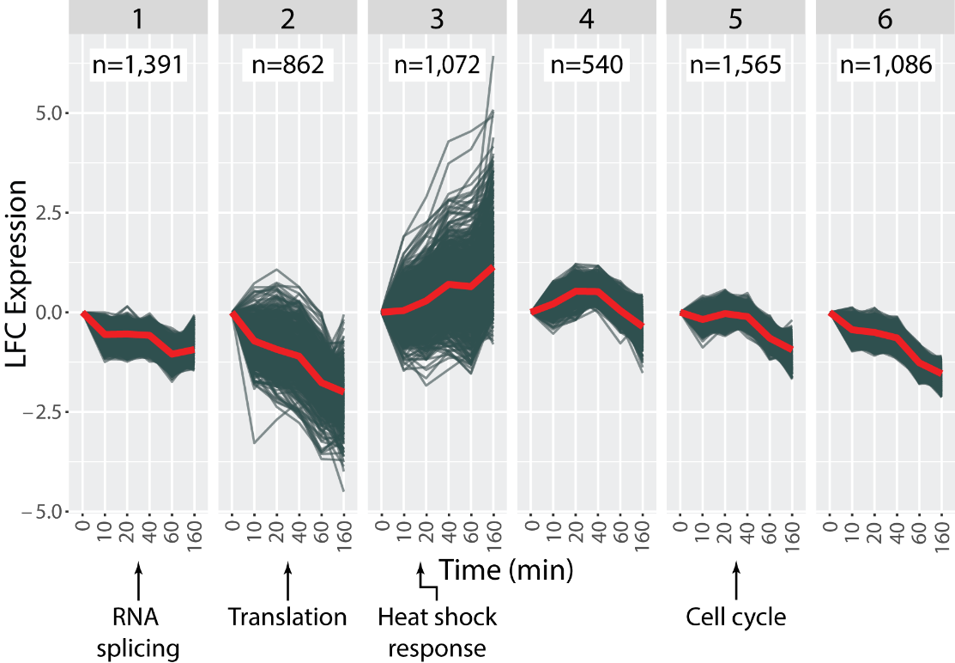
Supplemental Figure 5. Clustering of DE genes into six clusters and summary of enriched cluster-specific terms.
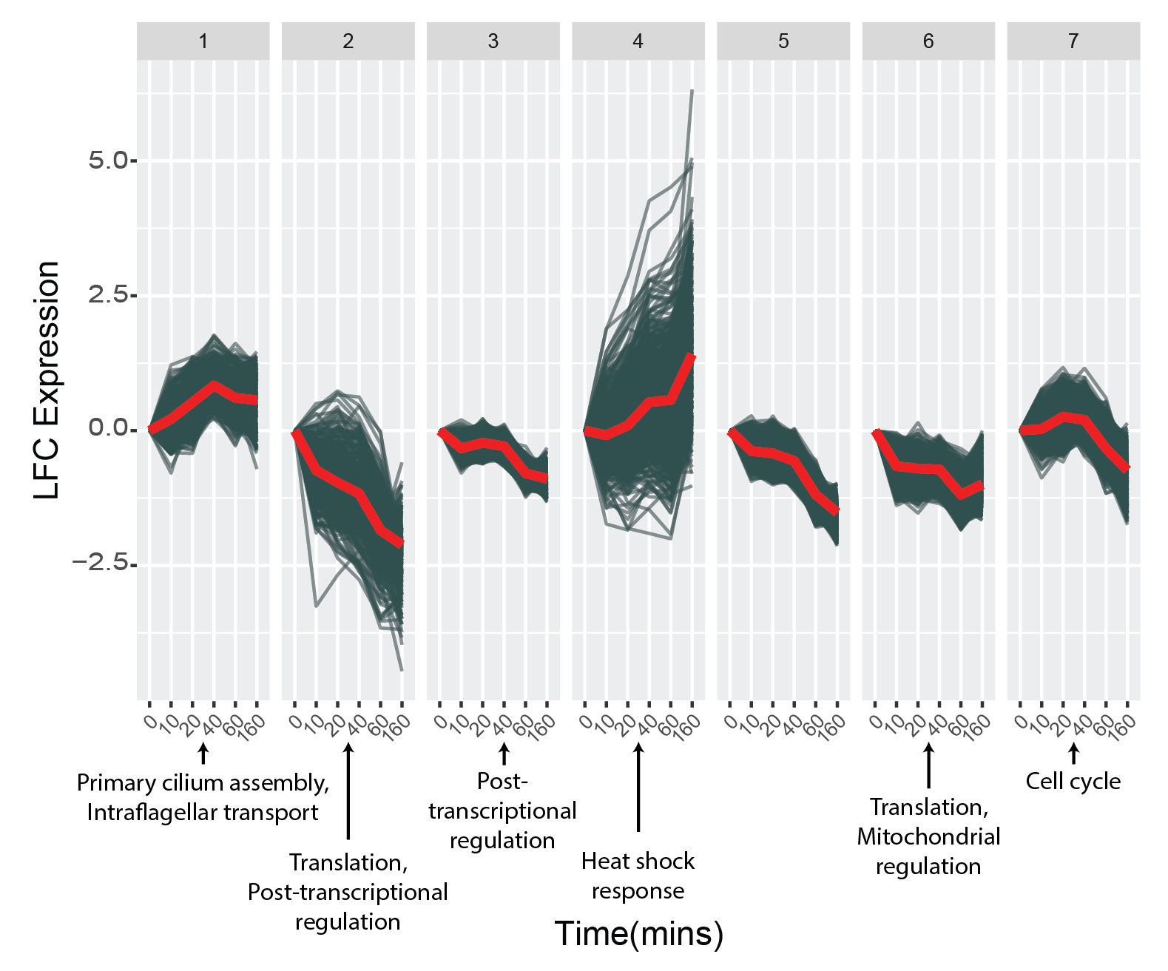
Supplemental Figure 6. Clustering of DE genes into seven clusters and summary of enriched cluster-specific terms.

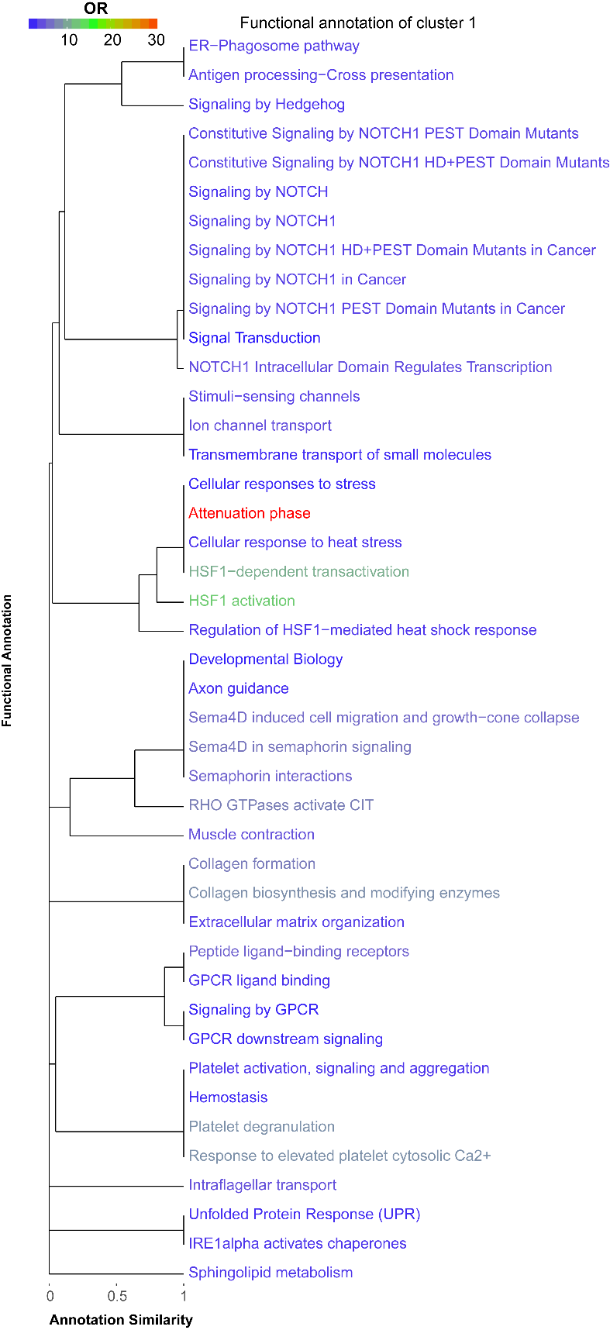
Supplemental Figure 7. Full set of Reactome terms enriched in cluster #1 with respect to the other clusters (FDR ≤ 0.05). Annotation similarity indicates what fraction of genes (based upon the term associated with less genes) are shared between two terms.
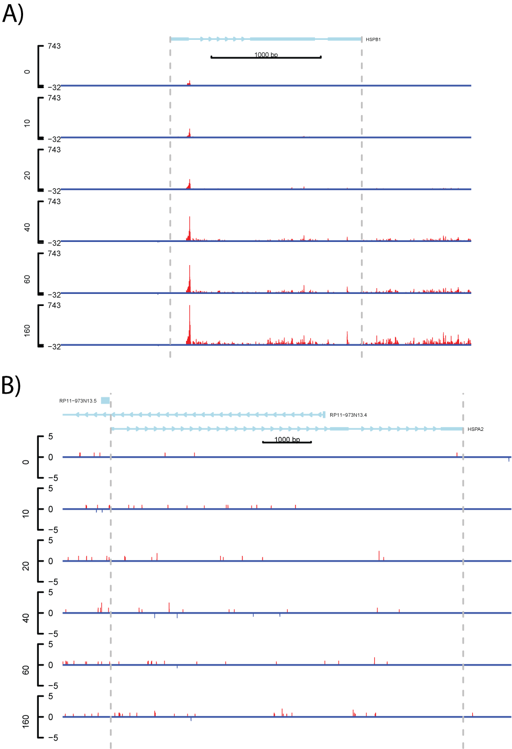
Supplemental Figure 8. Expression of HSPB1 and HSPA2, key genes in heat-shock induced translational repression. (A) Expression of HSPB1 with each library normalized by size factor and replicates for each time point added together. (B) Expression of HSPA1 with each library normalized by size factor and replicates for each time point added together.

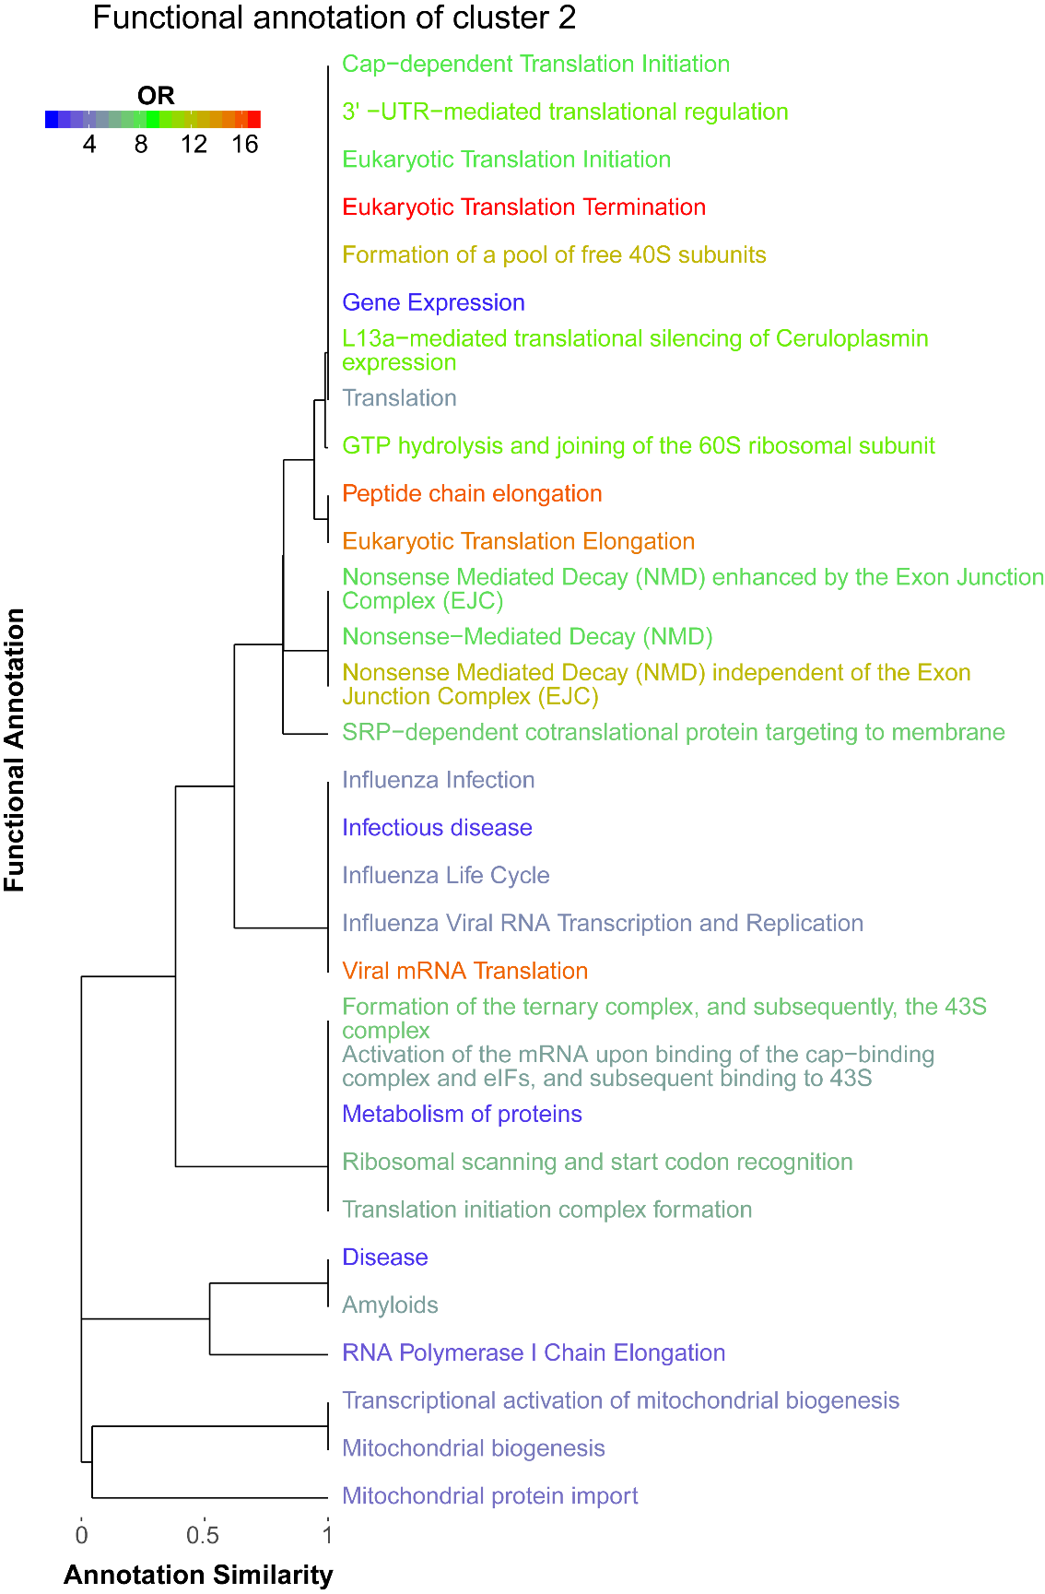
Supplemental Figure 9. Full set of Reactome terms enriched in cluster #2 with respect to the other clusters (FDR ≤ 0.05) . Annotation similarity indicates what fraction of genes (based upon the term associated with less genes) are shared between two terms.
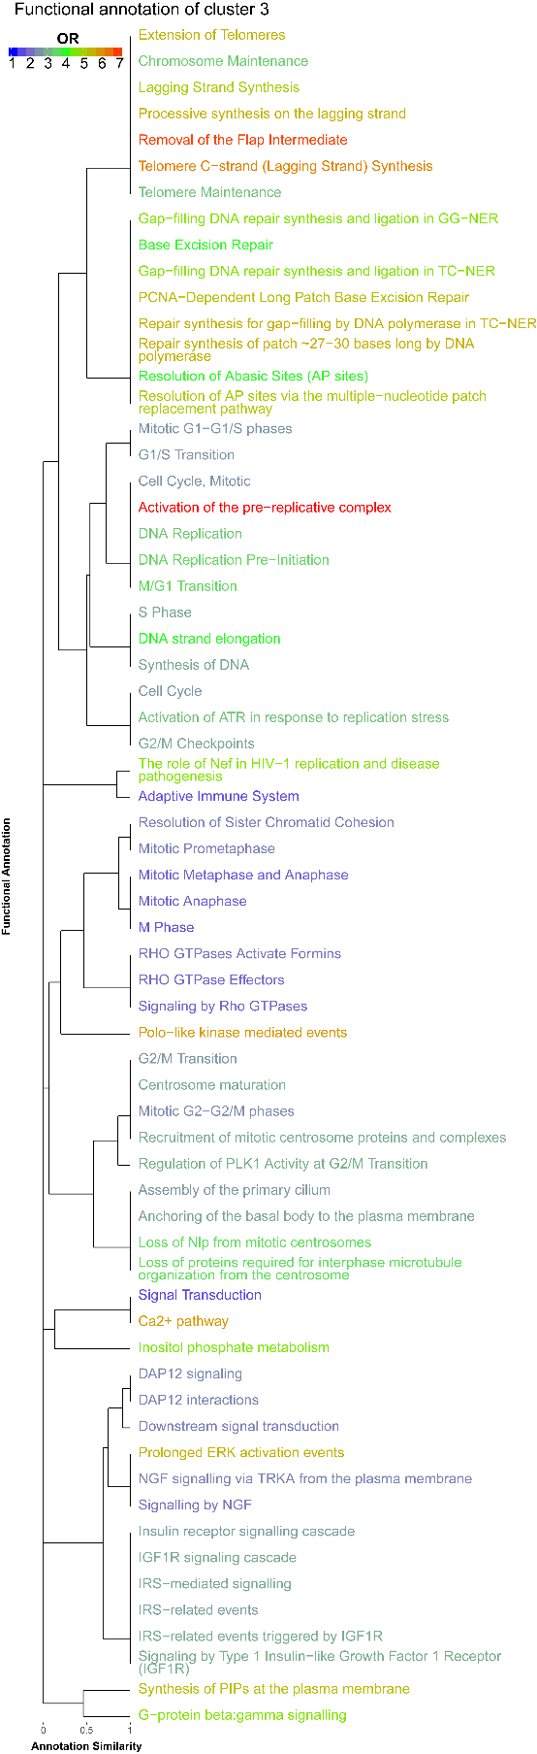
Supplemental Figure 10. Full set of Reactome terms enriched in cluster #3 with respect to the other clusters (FDR ≤ 0.05). Annotation similarity indicates what fraction of genes (based upon the term associated with less genes) are shared between two terms.
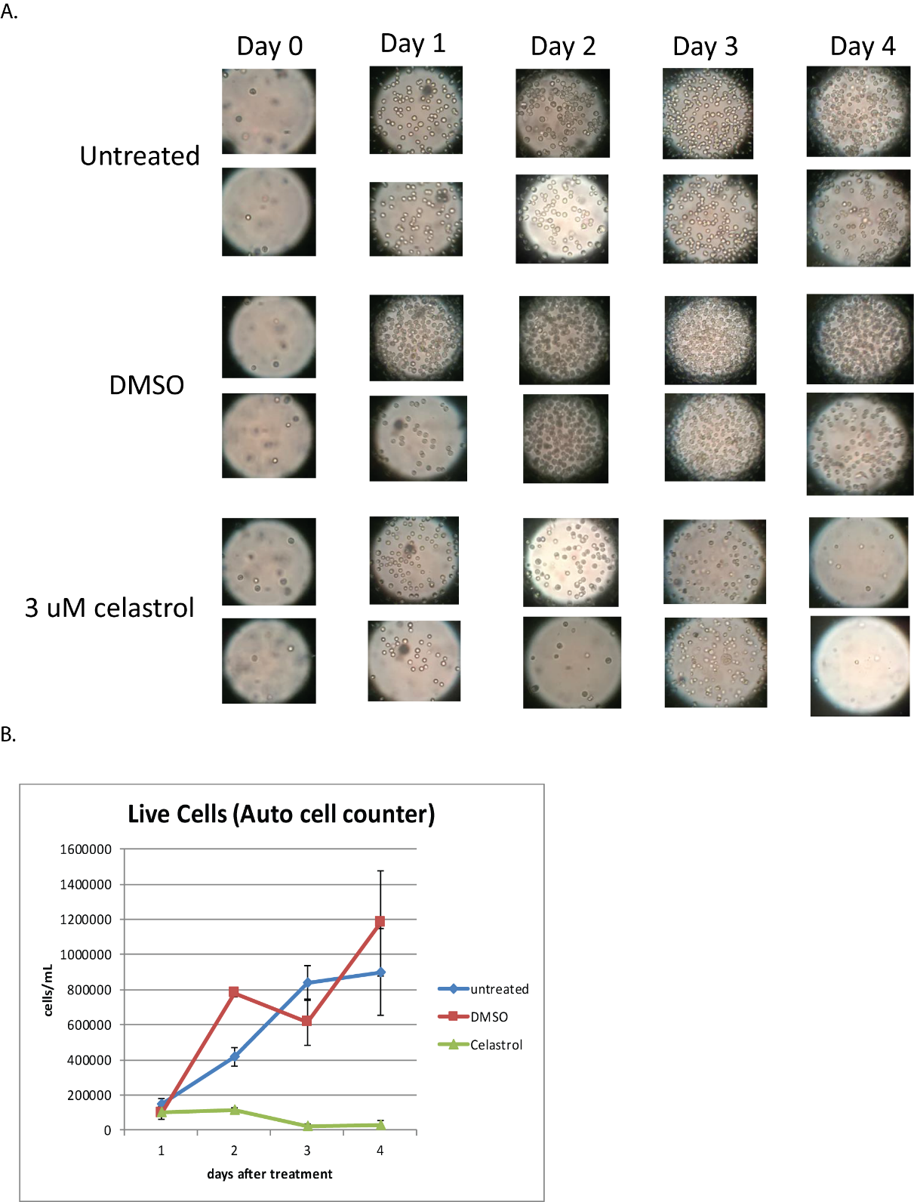
Supplemental Figure 11. Celastrol inhibits cell proliferation. (A) Images of cell cultures over 4 days, two replicates of three conditions: untreated, DMSO, and 3uM celastrol. (B) Number of live cells in each cell culture as counted by an automatic cell counter (TC20, Bio-Rad).

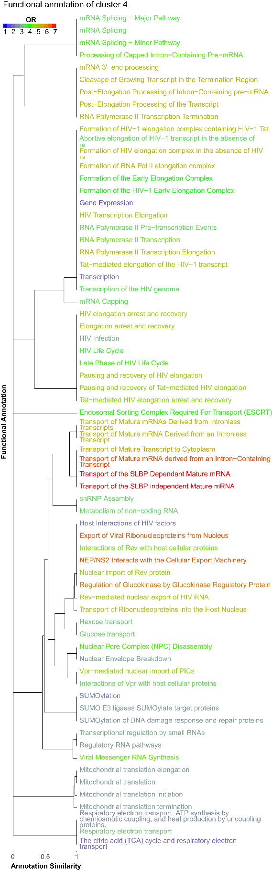
Supplemental Figure 12. Full set of Reactome terms enriched in cluster #4 with respect to the other clusters (FDR ≤ 0.05). Annotation similarity indicates what fraction of genes (based upon the term associated with less genes) are shared between two terms.

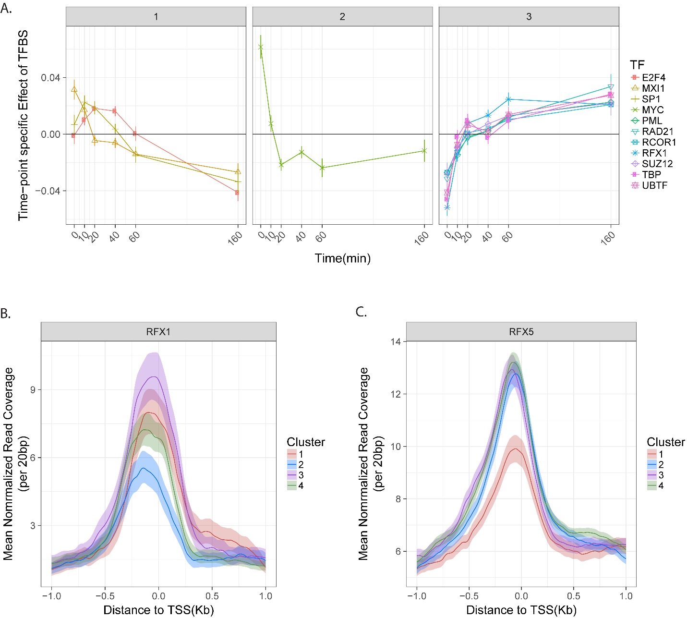
Supplemental Figure 13. (A) Weights from the regression model to predict gene expression from ChIP-seq peak scores in K562 cells. A positive weight for a TF at given timepoint means that genes at which that TF is predicted to bind in the promoter region showed increased expression relative to those without binding by that TF. Negative weights mean the opposite. Time-point specific TF coefficients explain ~15% of the residual variance not explained by gene-specific or time-point-specific terms. (B) Pre-celastrol treatment ChIP-seq signal for RFX1 grouped by clustering based on expression profiles. Each line represents an average over all genes in the cluster in the region of the TSS, with lighter-colored bands representing 95% confidence intervals obtained by bootstrap sampling. (C) Same as (B) but for RFX5.

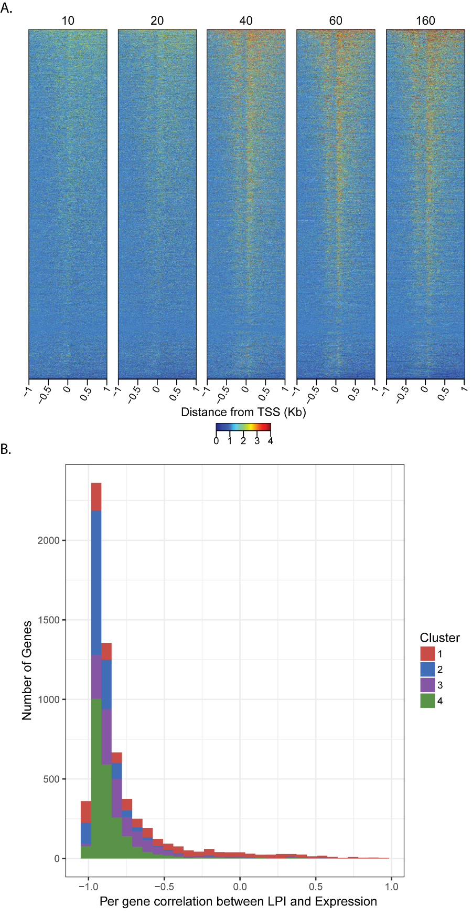
Supplemental Figure 14. Increased pausing at promoters is pervasive and broadly anti-correlated with gene expression. (A) Heatmap of fold-change in read counts near promoters of all protein coding genes relative to the 0-minute time point. Numbers at top indicate minutes after celastrol treatment. (B) Histogram of per-gene Pearson correlations between log pause index (LPI) and gene expression. Cluster labeling is from the clustering of gene expression profiles in Figure 3. For most genes, pausing and expression are anti-correlated, but cluster #1 has a long tail of genes with correlations near, or greater than 0.
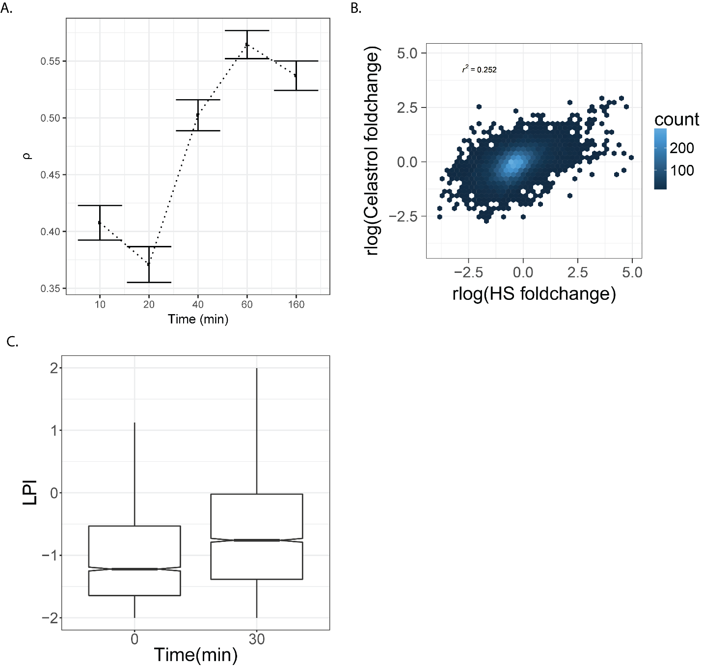
Supplemental Figure 15. Heat shock induces a similar, but more pronounced, response than celastrol. (A) Pearson correlation of gene expression after 30 minutes of heat shock (Vivevaara et al., in press) with gene expression at each time-point after celastrol treatment. Error bars represent 95% CIs of the mean computed using Fisher’s method for computing errors of Pearson correlation coefficients. (B) Distribution of fold changes in gene expression after 30 minutes of heat shock vs. after 40 minutes of celastrol treatment. (C) Distribution of log fold pause indices for all active genes at each time point during heat shock.
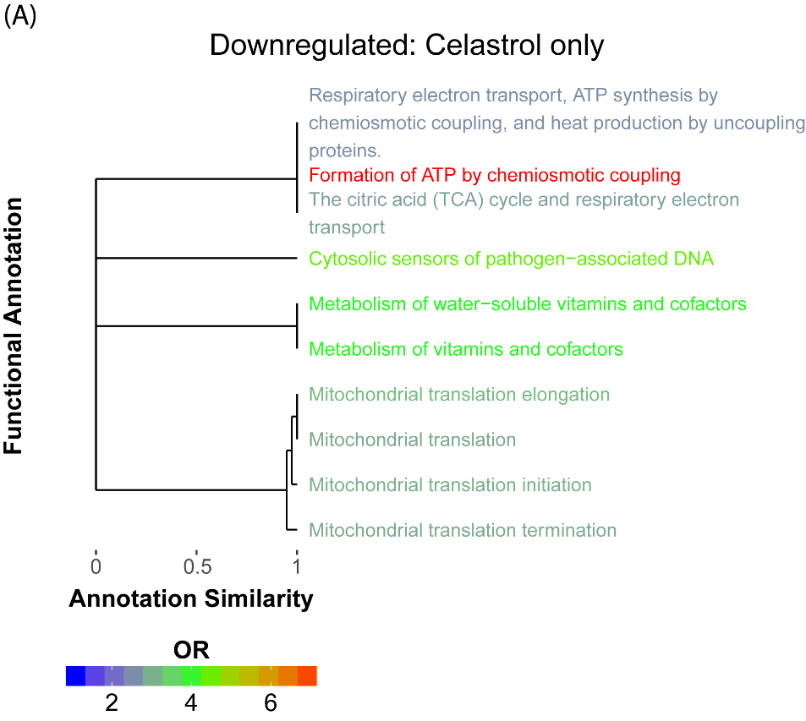
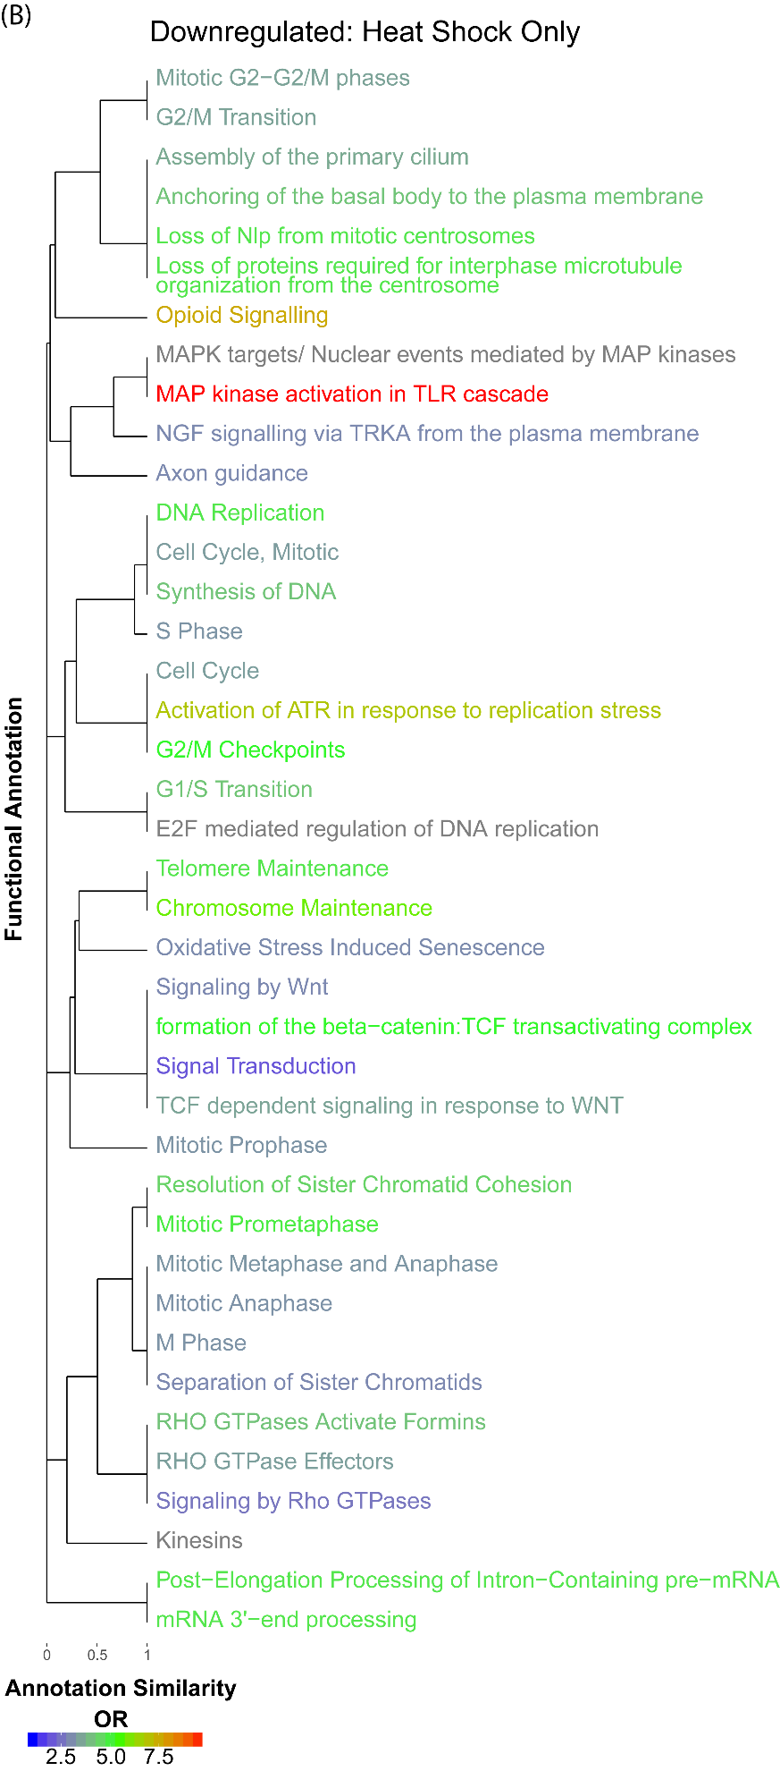
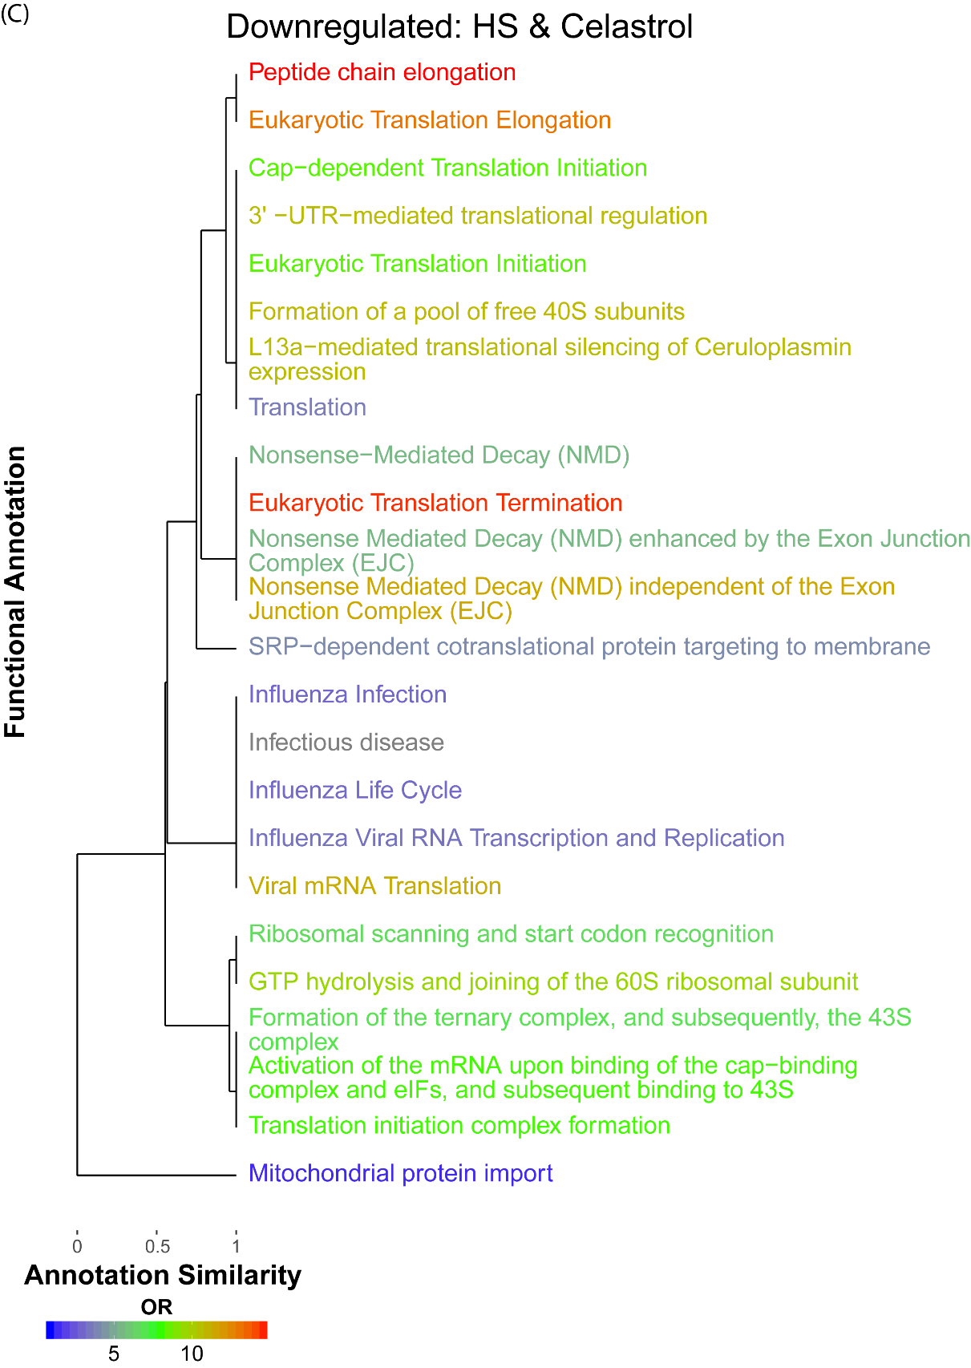
Supplemental Figure 16. The shared repressive celastrol and heatshock response is dominated by translation and nonsense mediated decay. (A) Enrichment of celastrol (40 min.) specific repressed genes relative to all repressed genes (FDR ≤ 0.05). (B) Enrichment of heat shock (30 min.) specific repressed genes relative to all repressed genes (FDR ≤ 0.05). (C) Enrichment of genes repressed in both the heat shock and celastrol treatments relative to all repressed genes (FDR ≤ 0.05).

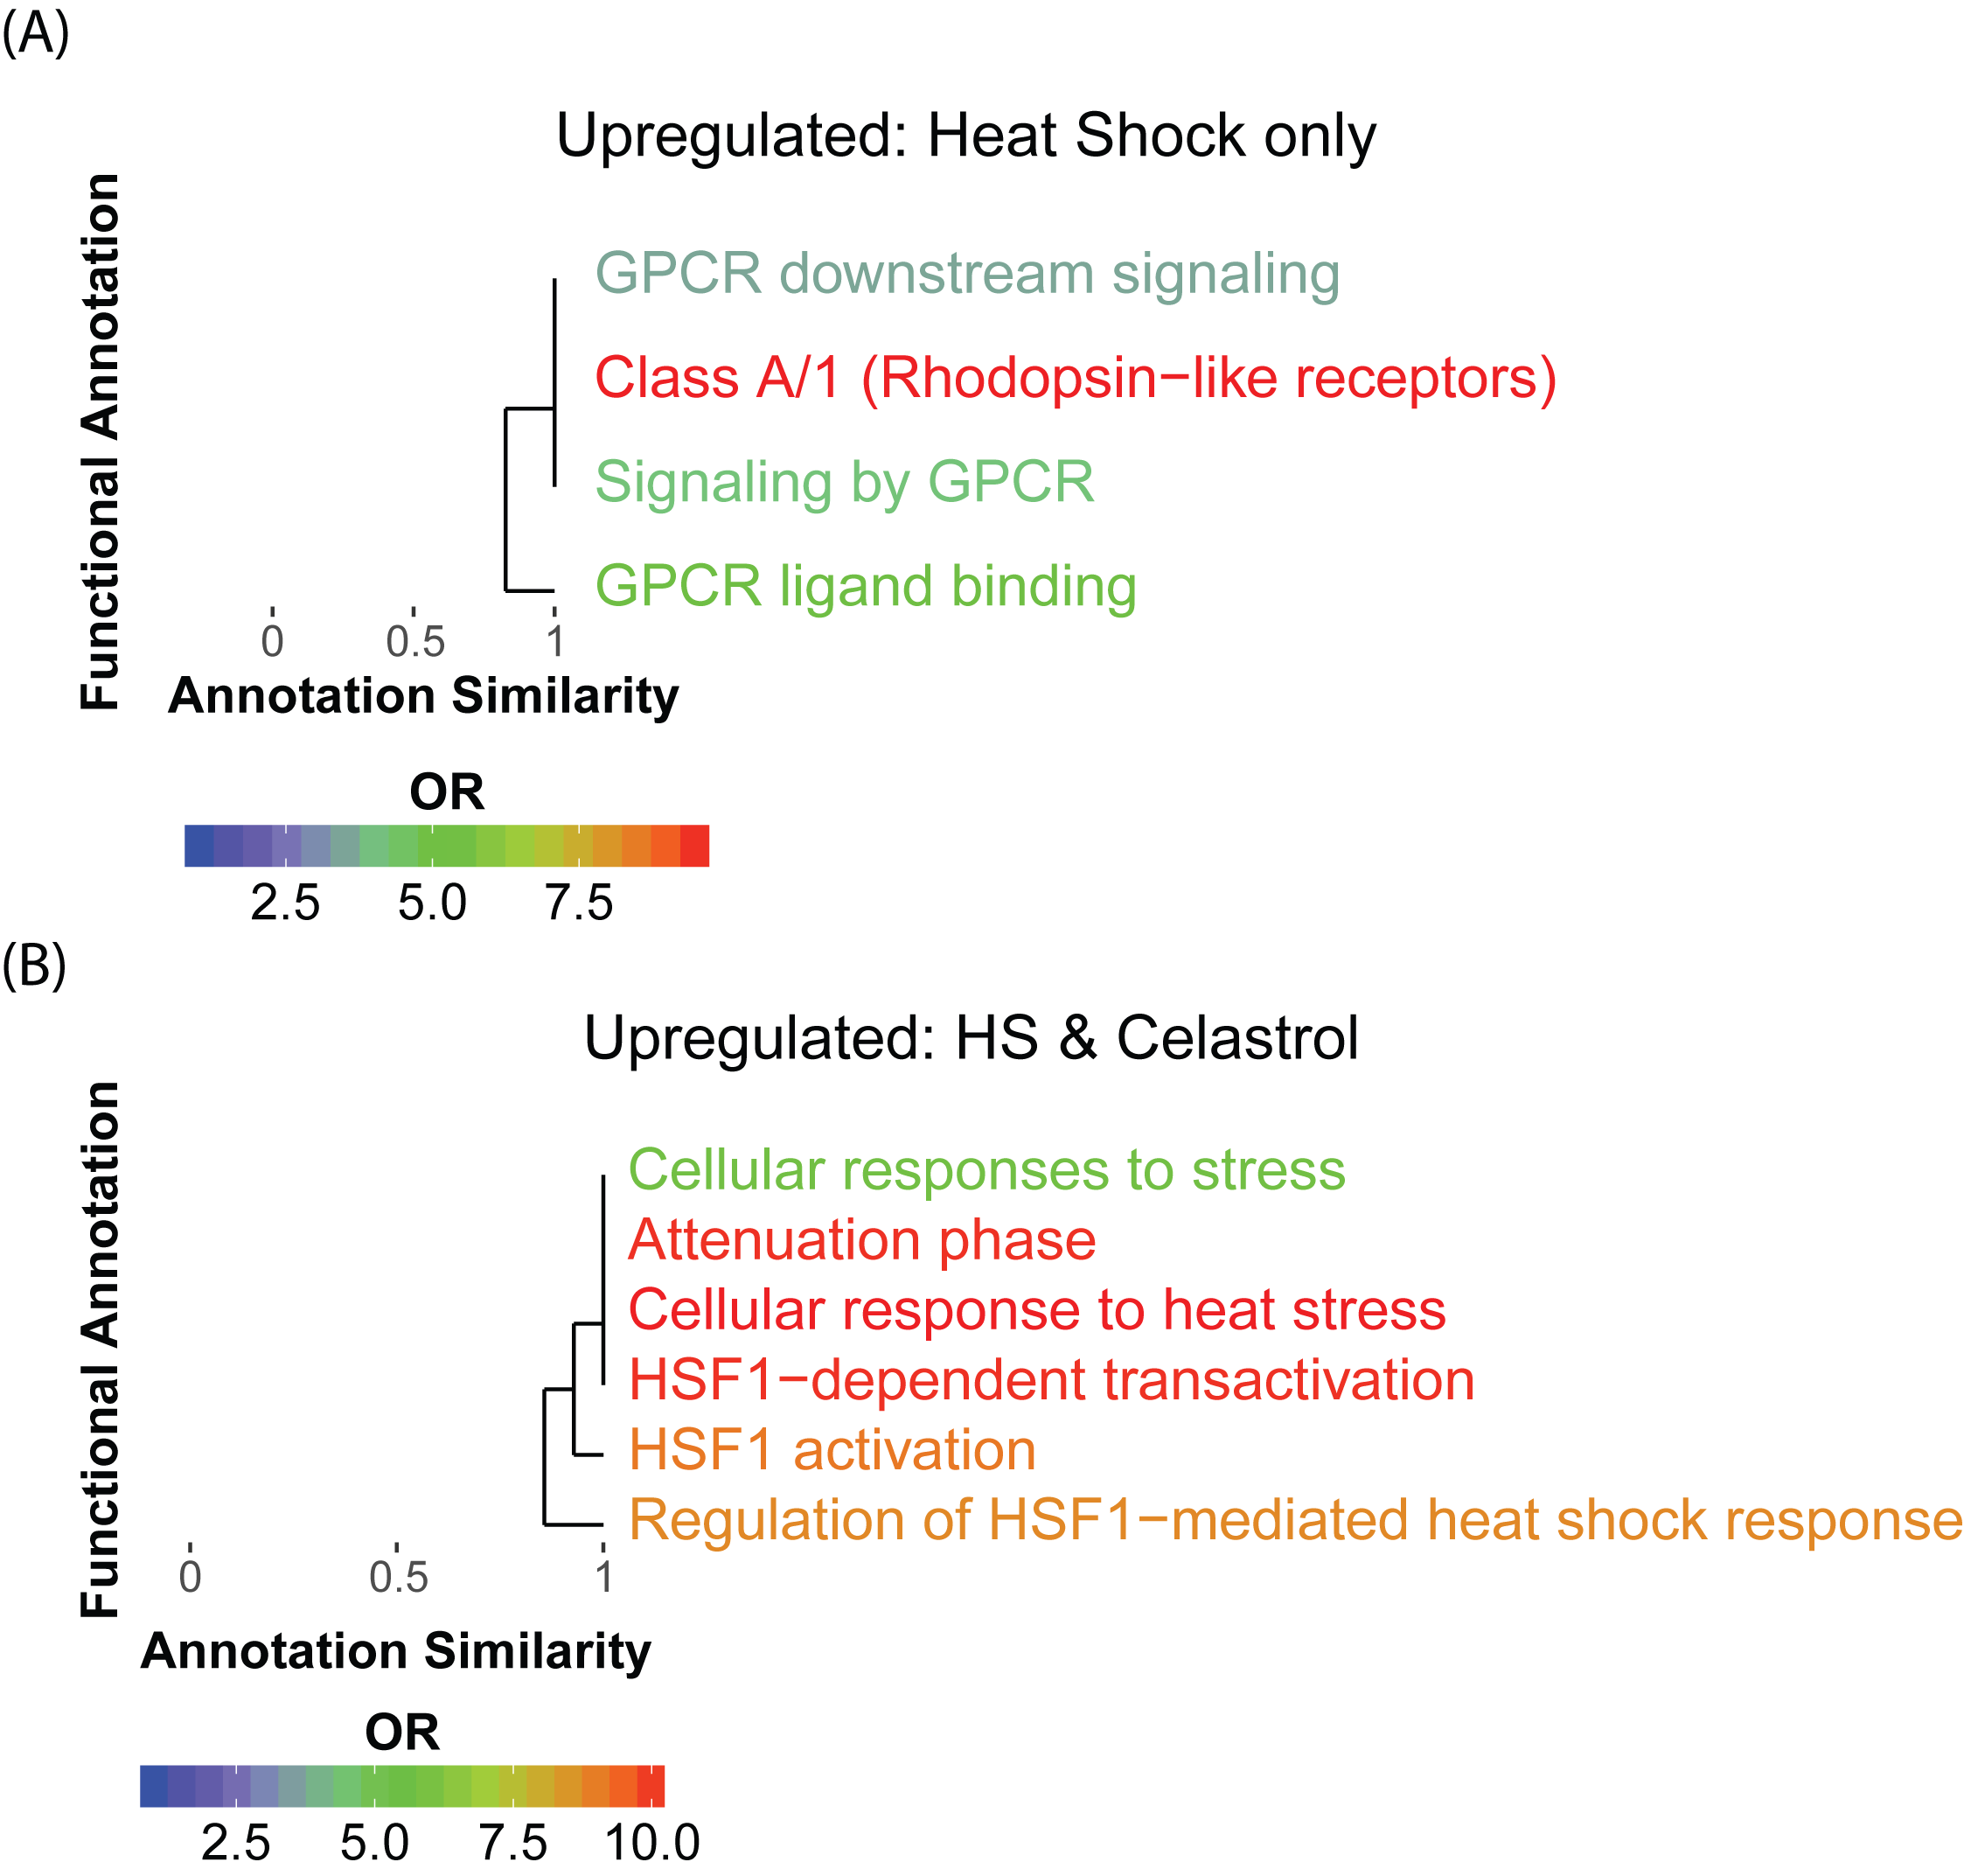
Supplemental Figure 17 The shared celastrol and heat-shock response for up-regulated genes is dominated by the HSF response. (A) Enrichment of heat shock (30 min.)-specific activated genes relative to all activated genes (FDR ≤ 0.05). (B) Enrichment of genes repressed in both the heat shock and celastrol responses relative to all repressed genes (FDR ≤ 0.05).
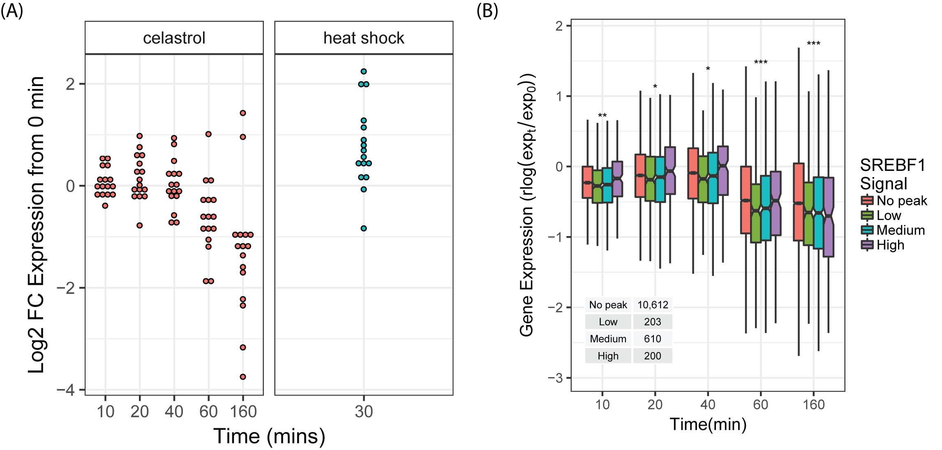
Supplemental Figure 18. (A) Log2 fold-changes in expression in the celastrol (left) and heat shock (right) responses of genes that are involved in cholesterol biosynthesis and that are differentially expressed in at least one sample (FDR ≤ 0.01). (B) Log2 fold-change expression of genes stratified by status of ChIP-seq signal for SREBF1 within 500bp of the promoter, based on ChIP-seq data for untreated K562 cells from ENCODE. Low: <20th percentile; Medium: 20th–80th percentile; High: > 80th percentile in peak intensity.

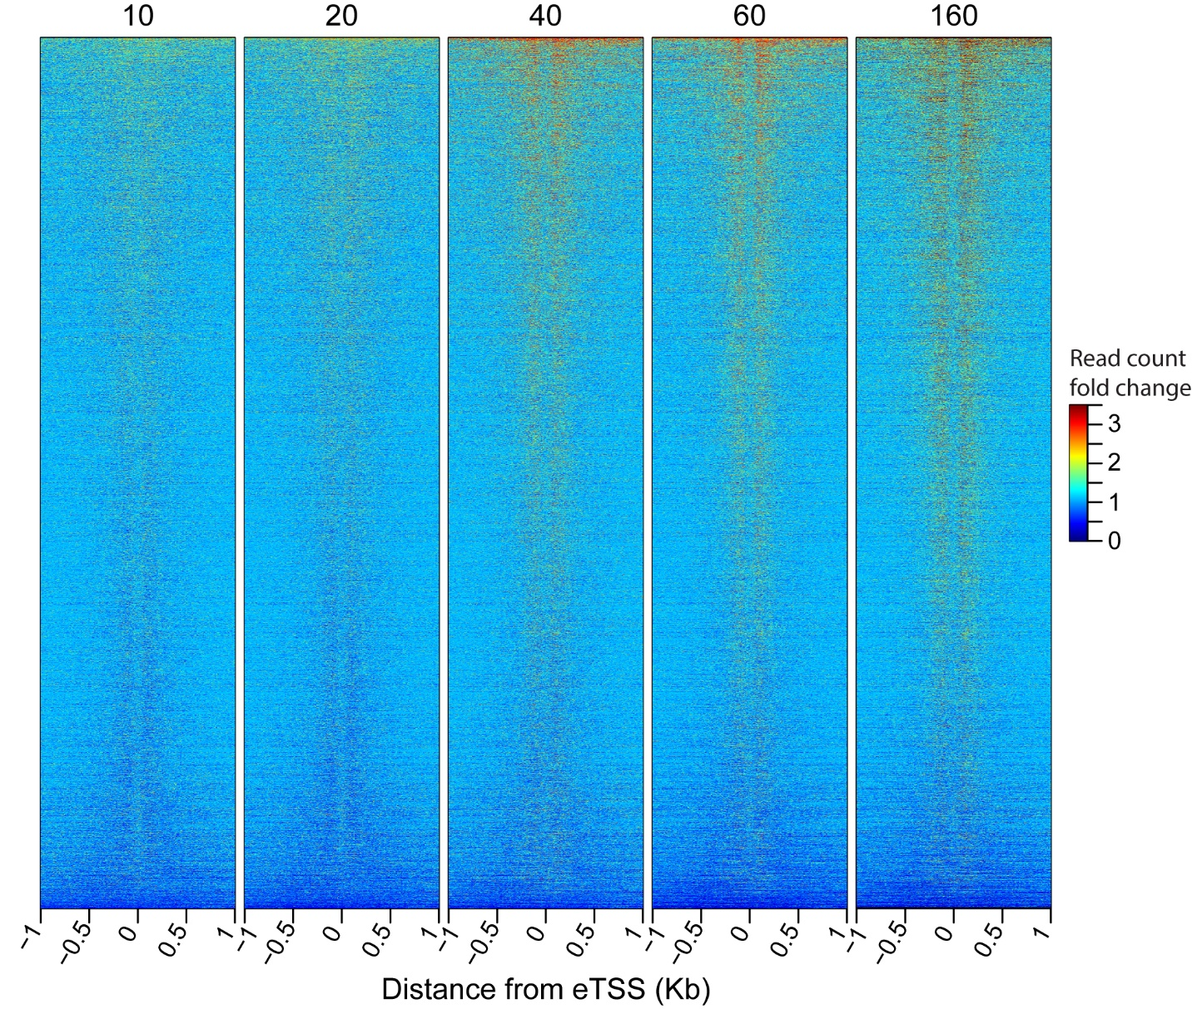
Supplemental Figure 19. Increased pausing at enhancers is pervasive. Heatmap of fold-change in read counts relative to the 0-minute time point near all enhancers. Numbers at top indicate minutes after celastrol treatment.
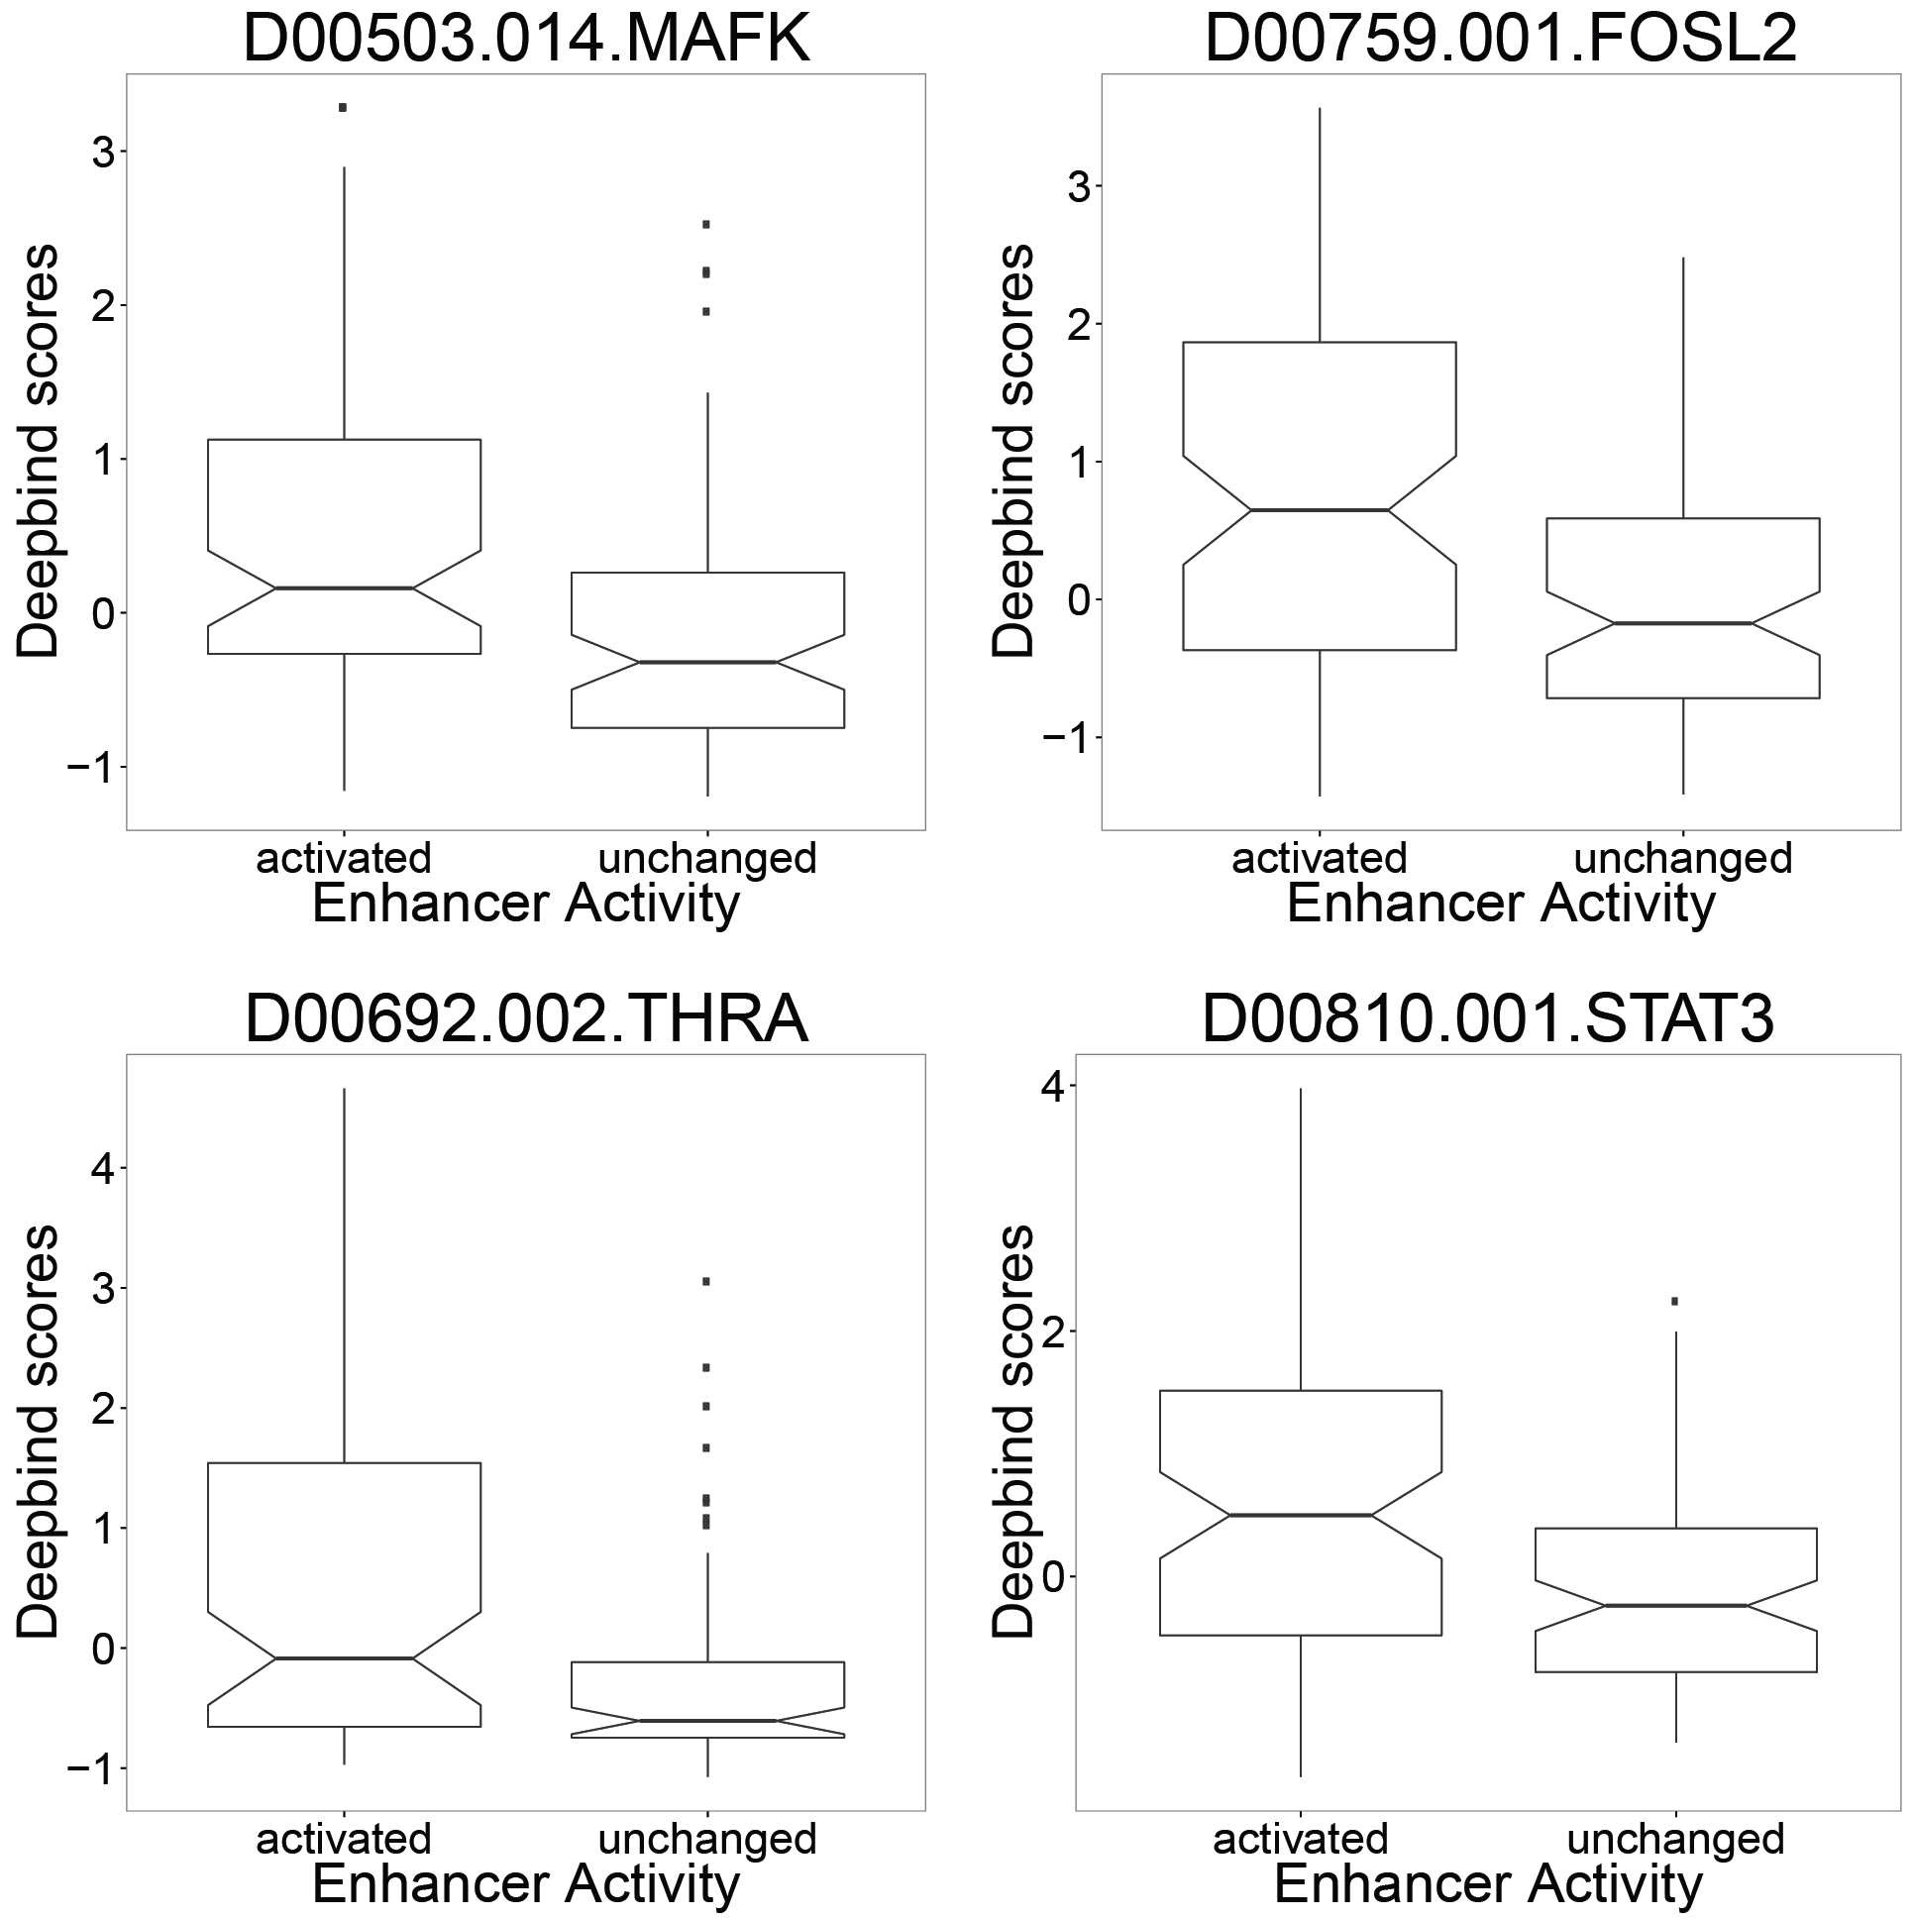
Supplemental Figure 20. A subset of transcription factors is associated with enhancer activation. Activated enhancers are those that were not transcribed pre-celastrol treatment but were strongly up-regulated at some point in the time course whereas unchanged enhancers showed no change in expression throughout the whole time course (matched for average expression level). DeepBind scores are computed per TF per enhancer. The notch corresponds to median +/- 1.58*IQR/sqrt(n), roughly a 95% confidence interval of the median.

