The telomere length measurement based on labeling intensity.
In our optical setup, the 532nm laser was expended 28.3 times to cover the full CMOS camera. This results in the exponential decay of the laser power from the centroid. We use fosmids with known telomere length to quantify the system and normalize the telomere length measurements.
Figure S1A shows typical fosmid molecules with 800bp telomeres, green dots representing Nt.BspQI sequence motifs, and red dots for CRISPR/Cas9 telomeric labeling. The DNA backbone is blue. 99.3% of the fosmid molecules ware labeled at telomeric sites. The total raw intensity of telomeric labeling from individual fosmids is plotted in Figure S1B. The telomere labeling intensity is following the laser power exponential decay. The intensity is the highest close to the center of the imaging frame, and the weakest at the edges. After normalizing the telomeric intensity to the center of the imaging frame according to the laser power exponential decay. Use the center of the intensity to represent the true 800bp telomeric repeats, the average telomere length is calculated to be 814bp±195bp. We also tested the system with another fosmid of 100bp telomeric repeats. 93.4% of fosmids are labeled at telomeric sites, the average telomere length is calculated to be 153bp±97bp. The shorter telomere length measurements show higher variation. Clearly, we can detect telomeric repeats as short as 100bp. To make the calibration more accurate, it is necessary to have a standard of a few kb. However, it is impossible to stably clone several kb of telomere sequence. We decided to randomly select 4 molecules of the fosmids containing 800bp telomere as a group to simulate a 3.2kb telomere. The average telomere length is calculated to be 3056bp±456bp, which is in good agreement with expected results. The calibration is summarized in Figure S1C.

Comparison between Cas9 labeling and no Cas9 labeling.
For the IMR90 and UMUC cell lines, we generate data of more than 60x coverage with and without Cas9 telomeric labeling. The assembly results are shown in Figure S2. The consensus maps from de novo assembly and the hg38 reference are shown as light blue bars and the dark blue vertical lines within these indicate the Nt.BspQI nick-label sites. The single molecules that comprise the respective consensus map are the yellow lines shown directly below the reference and consensus maps. The labels on the single molecules that align with the hg38 reference are dark green and those that do not align are light blue. The top consensus map were nick-labeled with Nt.BspQI and Cas9. The telomeres are the additional labels on the far left side of the single molecules (red T above) which are absent in the sample without Cas9. This clearly shows that Cas9 will specifically label the telomeric sites.

Novel subtelomeric structures.
As indicated in the main text, several new novel subtelomeric structures were discovered. We compared the novel structures with our other mapped genomes without telomere labeling. Similar structures are found through all mapped genomes. Some of them are as long as 1Mb, and cannot be aligned to the hg38 reference. Based on the conserved pattern similar to 4p, we believe these novel structures belong to some of the unknown acrocentric chromosomes.
Molecules for telomere length measurement.
The telomere length was measured for approximately 30 molecules for each chromosome arm of a sample. Figure S3 shows the 32 molecules that were measured for 12p of LNCaP. The telomeres are designated as a red T. The consensus map aligned to the hg38 reference is shown above the nick-labeled single molecules after de novo assembly. The raw data can be downloaded at sftp telomere_length@map-seq.urcf.drexel.edu with password: Rimt?ofAphs6.
Supplementary figures
Figure S1A.
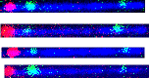
Figure S1B.
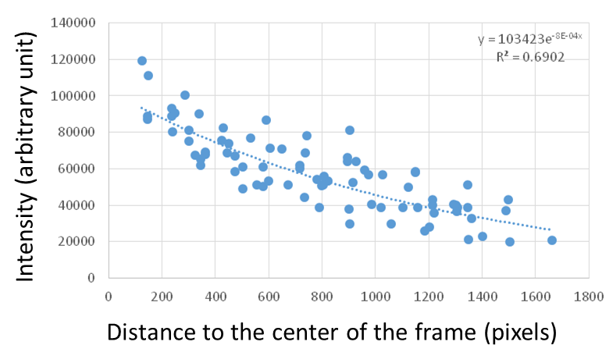
Figure S1C.
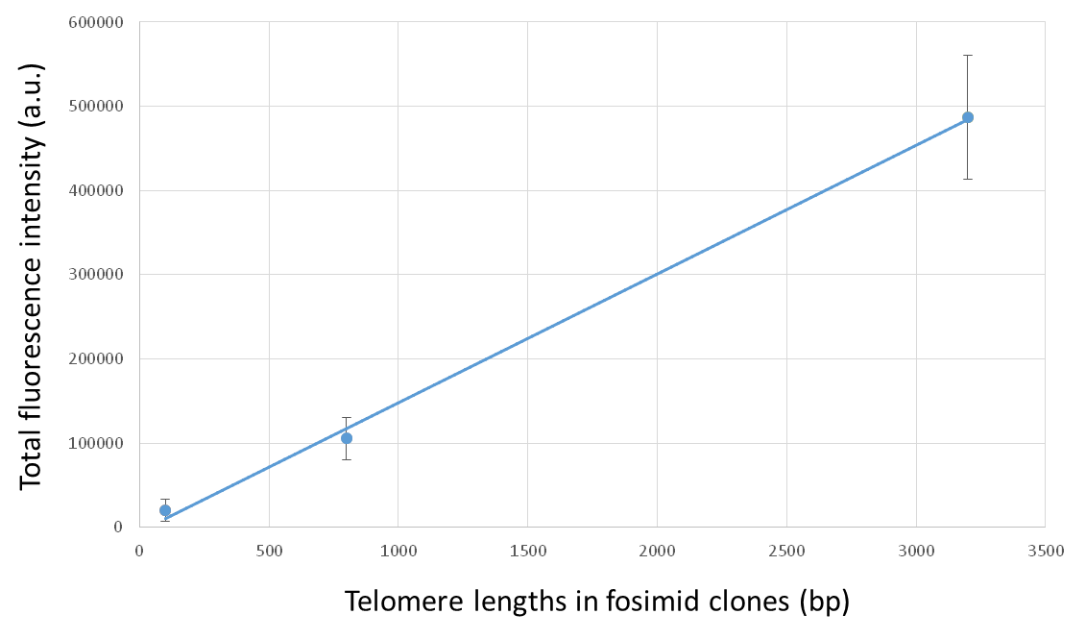

Figure S2. 11q of UMUC3 with and without Cas9 telomere labeling.
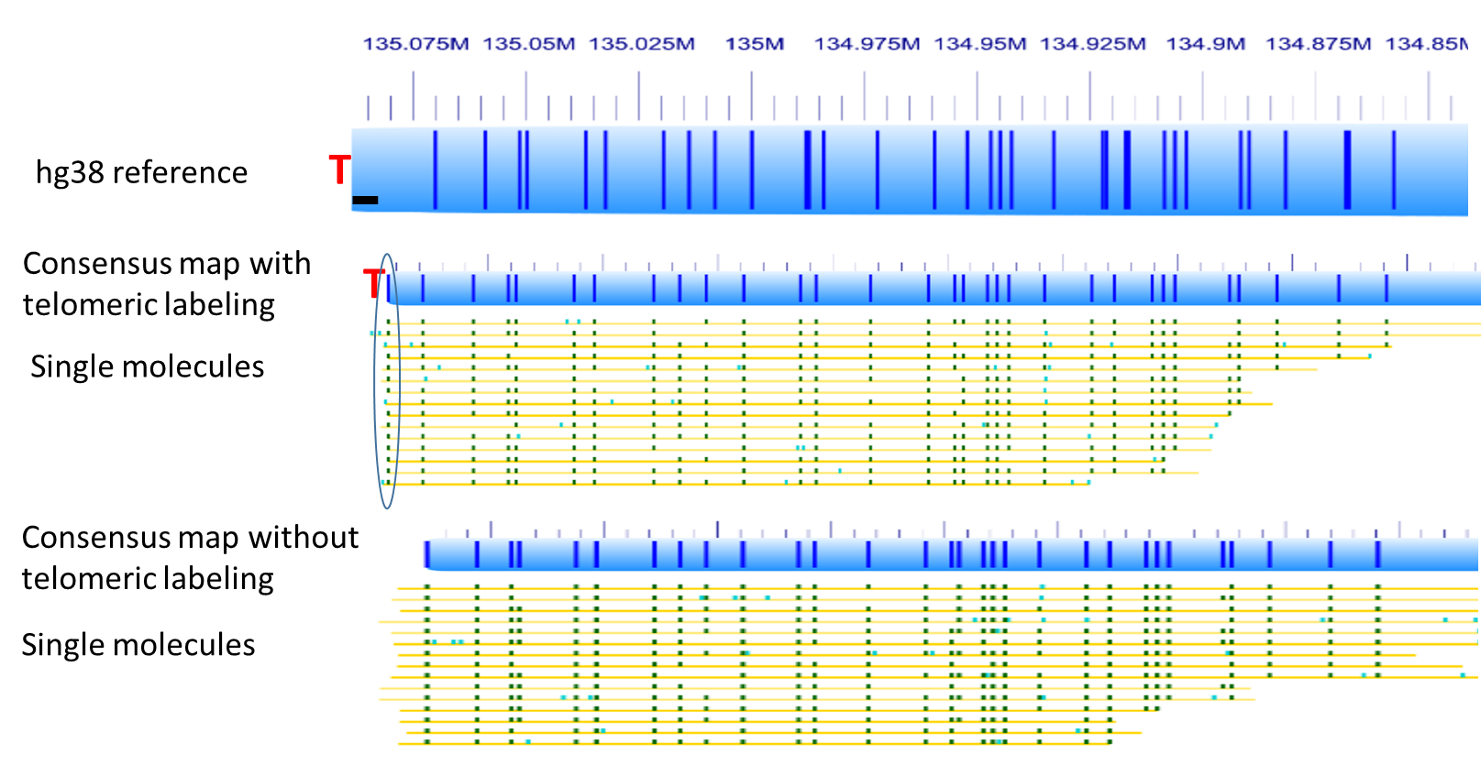

Figure S3. 12p of LNCaP molecules for telomere length measurement.
