Motif ID | Motif | MEIS | PBX | PREP1 | PREP2 | TGIF
M1 | 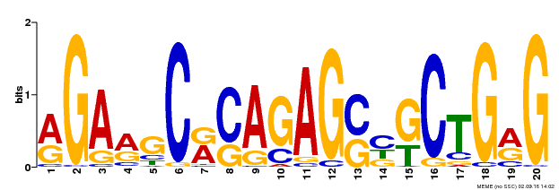 | 5.81 | 170.70 | 128.12 | 7.64 | 28.12
M2 | 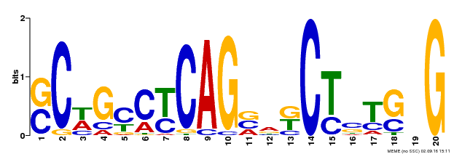 | 9.00 | 116.82 | 78.80 | 2.77 | 10.03
M3 | 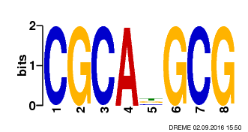 | 5.67 | 139.97 | 38.90 | 64.61 | 14.65
M4 |  | 8.43 | 217.72 | 28.33 | 6.49 | 5.75
M5 | 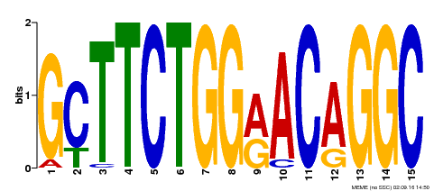 | 3.32 | 45.75 | 41.82 | ______ | 6.11
M6 | 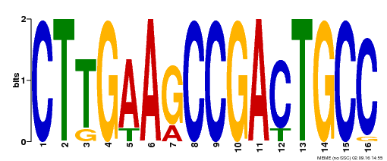 | 1.45 | 26.16 | 11.05 | ______ | 4.10
M7 | 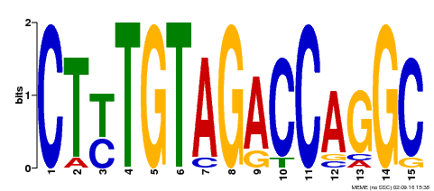 | 2.03 | 19.76 | 5.53 | ______ | 3.42
M8 | 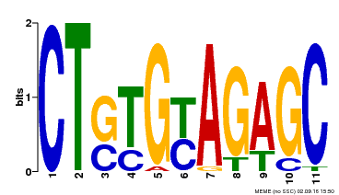 | 1.75 | 17.39 | 6.44 | ______ | 3.41
M9 | 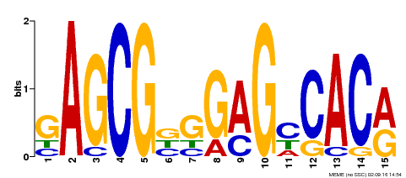 | 5.77 | 85.81 | 10.39 | ______ | ______
M10 | 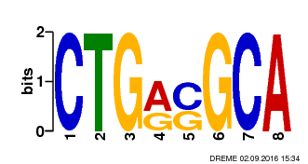 | 2.82 | 9.17 | 49.85 | ______ | ______
M11 | 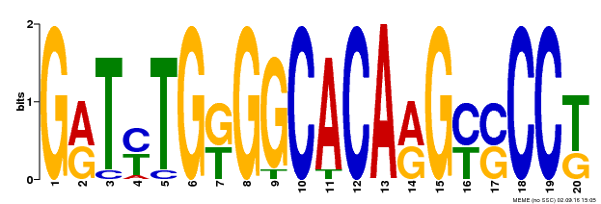 | 2.72 | 58.69 | 41.68 | ______ | ______
M12 | 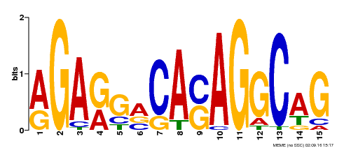 | 3.40 | 36.52 | 24.74 | ______ | ______
M13 | 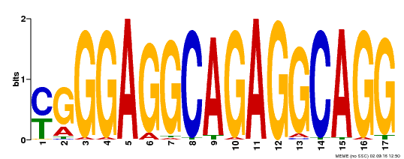 | 6.05 | 44.61 | 9.24 | ______ | ______
M14 | 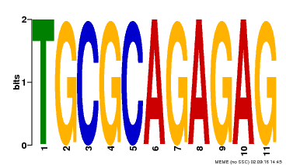 | 2.88 | 43.35 | 9.16 | ______ | ______
M15 | 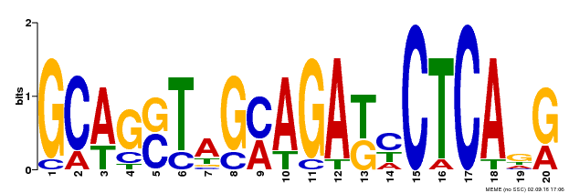 | 2.59 | 6.11 | 8.42 | ______ | ______
M16 | 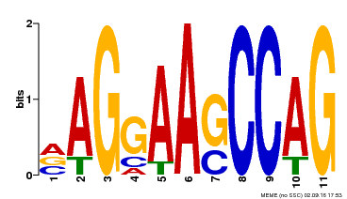 | 2.42 | 9.58 | 2.37 | ______ | ______
M17 | 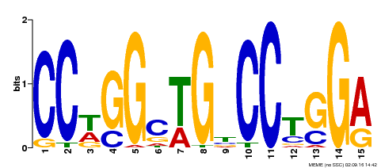 | ______ | 74.91 | 50.42 | 3.85 | 25.76
M18 | 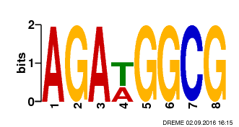 | ______ | 47.37 | 42.58 | ______ | 2.73
M19 | 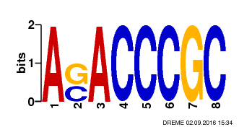 | ______ | 35.47 | 18.86 | ______ | 5.59
M20 | 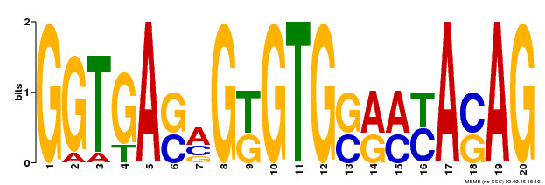 | ______ | 15.84 | 36.26 | ______ | ______
M21 | 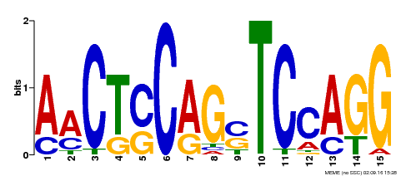 | ______ | 20.94 | 19.18 | ______ | ______
M22 | 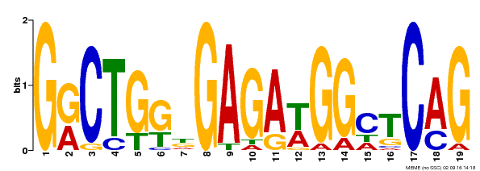 | ______ | 23.87 | 15.54 | ______ | ______
M23 | 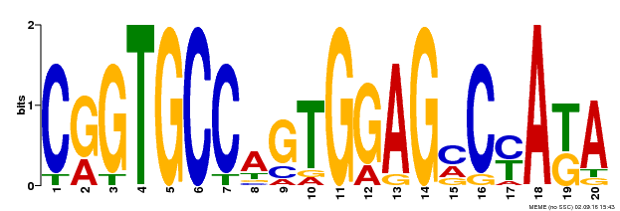 | ______ | 8.18 | 2.76 | ______ | ______
M24 | 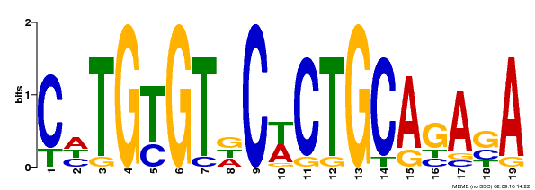 | ______ | 1.98 | 1.35 | ______ | ______
M25 | 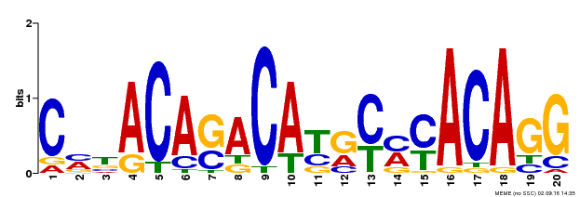 | ______ | ______ | 172.27 | ______ | ______
M26 | 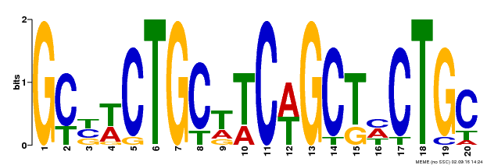 | ______ | ______ | 109.63 | ______ | ______
M27 | 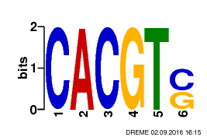 | ______ | ______ | 72.29 | ______ | ______
M28 | 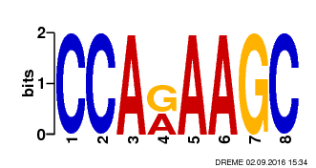 | ______ | ______ | 35.04 | ______ | ______
M29 | 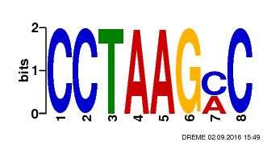 | ______ | ______ | 23.33 | ______ | ______
M30 | 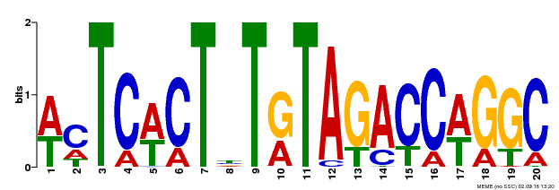 | ______ | ______ | 5.42 | ______ | ______
M31 | 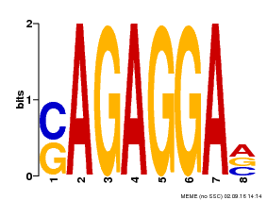 | ______ | ______ | 5.01 | ______ | ______
M32 | 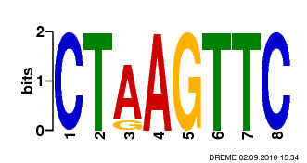 | ______ | ______ | 3.75 | ______ | ______
M33 | 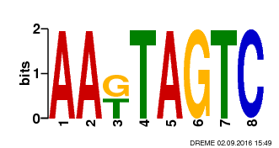 | ______ | ______ | 2.81 | ______ | ______
M34 | 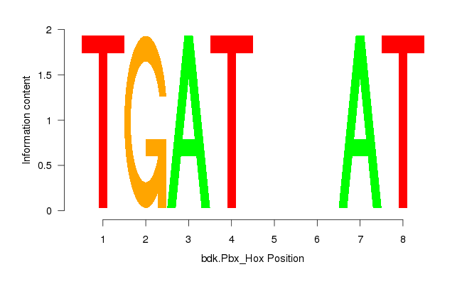 | ______ | ______ | 1.51 | ______ | ______
M35 | 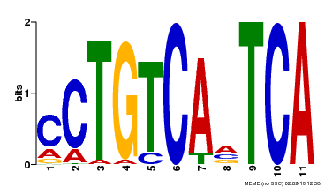 | 12.30 | 37.07 | ______ | ______ | ______
M36 | 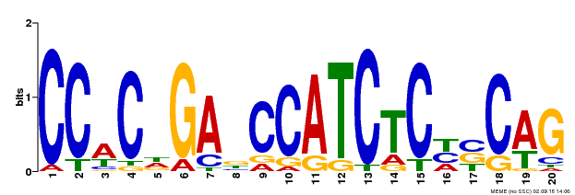 | 3.53 | 10.89 | ______ | ______ | ______
M37 | 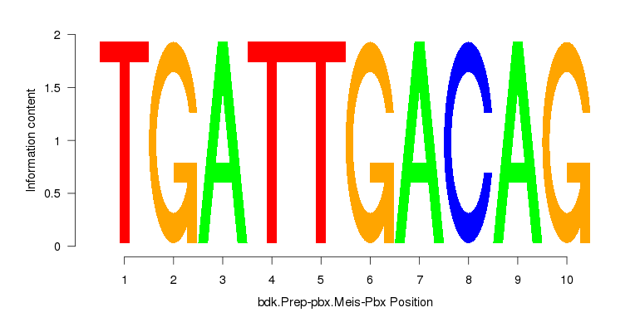 | 4.46 | 1.98 | ______ | ______ | ______
M38 | 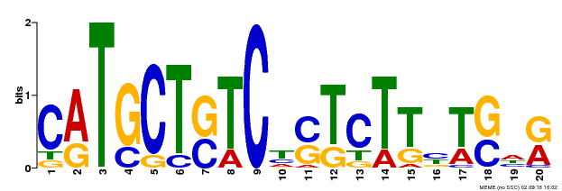 | 3.11 | 1.70 | ______ | ______ | ______
M39 | 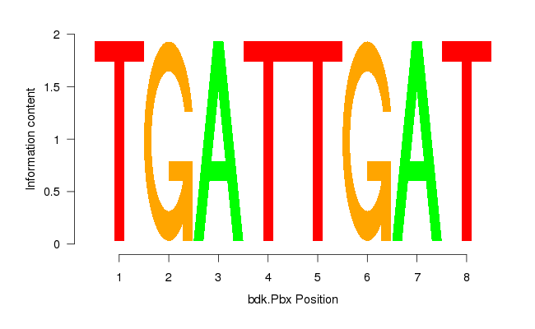 | 13.15 | ______ | ______ | ______ | ______
M40 | 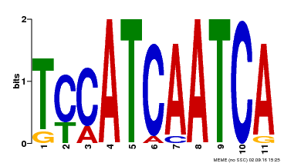 | 4.78 | ______ | ______ | ______ | ______
M41 | 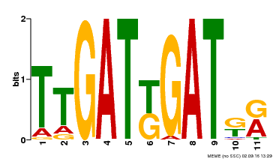 | 3.99 | ______ | ______ | ______ | ______
M42 | 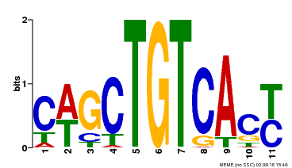 | 3.47 | ______ | ______ | ______ | ______

Adjusted P-values as –log(10)

