Supplementary Materials
Study Design and sampling
Total mRNA was obtained from three biological replicates of dissected reproductive or carcass tissues of male and female adult pools from four malaria vectors derived from MR4/BEI colonies that span the phylogeny of the Anopheles genus, An. gambiae G3, An. arabiensis Dongola, An. minimus MINIMUS1 and An. albimanus STECLA (Supplemental Fig S1A and 1B). Samples comprised 3-4 day old adult males and 48 hour blood-fed females from a mixed cage. Reproductive tissues (RT) from females included the ovaries and the common oviduct and for males included the testis and the accessory glands (Supplemental Fig S1C). The remaining carcass (CA) included the head, thorax and abdomen. Females were blood-fed 48 hours prior to sampling to release ovarian development from its pre-vitellogenic diapause (Clements 1992). Three replicates were collected for each sample. mRNA was prepared for sequencing using the Illumina mRNA-Seq Sample Preparation kit and samples were paired-end sequenced using 100bp reads. An. gambiae data were previously published to the NCBI SRP045243. In total, we generated 92.9 Gb of sequence read data in 100bp paired-end reads. After quality filtering, reads were mapped to the appropriate species assembled genomes (version 4.2 for An. gambiae, 1.3 for An. arabiensis, 1.3 for An. minimus and 1.3 for An. albimanus) retrieved from Vectorbase (Giraldo-Calderón et al. 2015) using Tophat2 (Kim et al. 2013) to quantify gene level expression. Expression values in read counts for each gene were extracted using HTSeq (Anders et al. 2014) and differential expression (DE) analysis was performed using DESeq2 (Love et al. 2014)
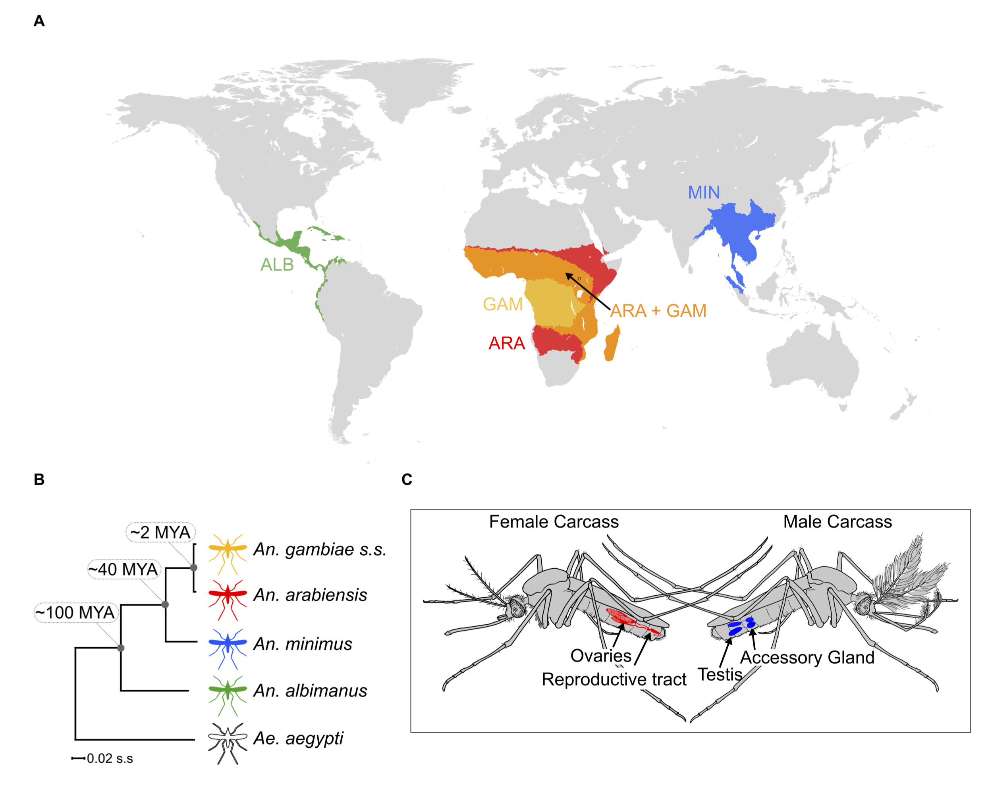
Supplementary Figure 1. Study design: A) Global map displaying geographic ranges of the study species: An. gambiae (yellow), An. arabiensis (red) An. minimus (blue) An. albimanus (green). B) The maximum likelihood molecular phylogeneny of the study species within the Anopheles genus with Aedes aegypti as the outgroup. (Divergence time estimates from (Neafsey et al. 2014) and (Fontaine et al. 2015)) C) Overview of the dissected tissues used for RNA-seq samples. Reproductive tissues included 48hrs post-blood meal ovaries and lower reproductive tract for females (in red) and testes with accessory glands for males (in blue). The remaining carcass tissues of both sexes are colored in grey.

Differential Expression analysis.
TopHat2 (Kim et al. 2013) was used to align paired-end RNA-seq data from each species on the reference genomes, which were retrieved from Vectorbase (Giraldo-Calderón et al. 2015). Mapping was performed using default settings and the number of mapping reads for each gene were extracted using HTSeq (Anders et al. 2014). Sex-biased differential expression analysis was performed using the DESeq2 (Love et al. 2014), for each species in three steps (Supplemental Fig S2): the first step was to test for a sex-bias in gene expression between tissues (e.g. female CA vs male CA). Genes displaying a statistically significant fold difference higher than 2 between samples (Bonferroni corrected p-value < 0.05) and expressed above the threshold of 10 FPKM in at least one tissue were considered as sex-biased and classified according to their sex-biased magnitude. Weakly sex-biased showing a Male/Female fold change (FC) between 2 and 5, strongly sex-biased showing FC greater than 5, and sex-specific being expressed at more than 20 FPKM in one sex and less than 10 in the opposite sex. To be included in the weakly or strongly biased classification, we required a minimum gene expression of 10 FPKM in both samples. In the second step, we repeated the DESeq2 analysis now testing for significant differential expression between the two tissues in each sex, using the same criteria as above for cutoffs. In the third and final step, we combined the two differential expression analyses, and genes showing a concordance between the two analysis were called sex-biased for a tissue (e.g female-biased between the RT samples and RT-bias between female tissues = female-RT-biased). Genes that displayed a sex-bias in both tissues in the first step and no bias between tissues in that sex were classified as ubiquitously sex-biased. On average 4290 genes per species (~33%) were classified as sex-biased in either one or both tissues.

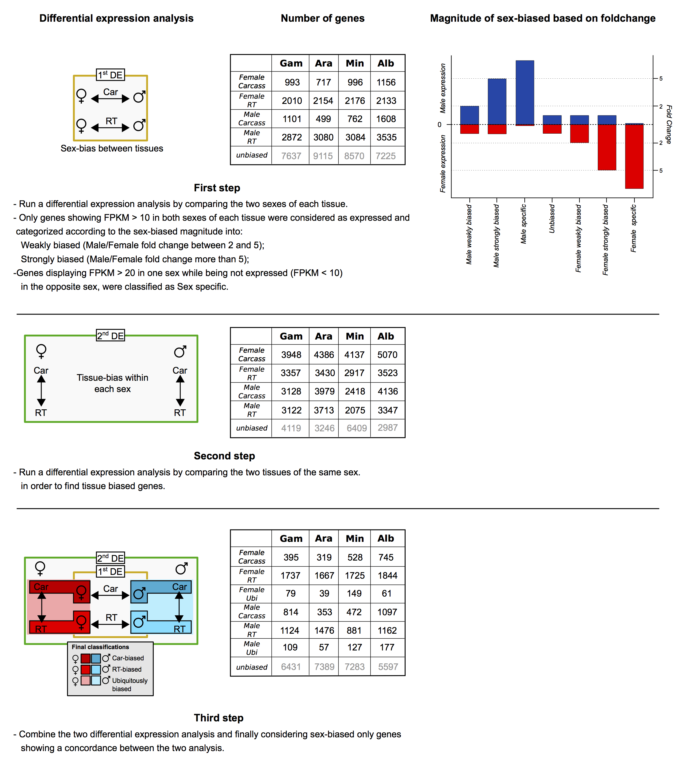
Supplementary Figure 2. Flow chart and results of the two-step differential expression analysis in the four species. The first step (A) tested for a sex-bias between tissues (e.g. male Car vs female Car), the table shows the number of genes called in this first step, the bar plot depicts examples the fold change cutoffs used for magnitude of sex-biased classification. The second step (B) was a tissue-bias differential expression analysis within each sex (e.g. male Car vs male RT) using a false discovery rate < 0.05 between conditions. The table shows the number of genes called in this second step. The third and final step (C) was to combine the two DE analysis and to classify only genes displaying concordant classifications in both analyses as sex-biased. The table shows the final amount of genes resulted by combing the two analysis.
Expression bias discordances
We excluded genes showing discordance between the two differential expression analysis to maintain a conservative approach when linking gene expression data and their evolutionary rates to putative gene functions. There are three different types of gene expression-bias discordances that are possible from our DE pipeline: (1) those that are non-tissue biased are sex-biased genes found biased in one tissue when comparing male to female that do not show any tissue bias when comparing Carcass to RT; (2) those that are sex-discordant are biased to one sex when comparing male to female, but biased in the opposite sex when comparing Carcass to RT, and (3) sex-and-tissue discordant are those biased in one sex when comparing male to female, but biased in the opposite sex and opposite tissue when comparing Carcass to RT. As we expected, the majority of discordant genes fell in the 3rd category of sex-and-tissue discordance (1= 234.75 average per species; 2= 2.75 average per species; 3= 1639.25 average per species). We compared the evolutionary rates of our previously computed sex-biased categories to these discordant genes at the sequence (d_{N}/d_{S}) and expression divergence level (SD of expression ratios between species) (Supplemental Fig S3). Based on these analyses we concluded that discordant genes behave similarly to unbiased genes, and show both a low level of d_{N}/d_{S} overall and SD. To ensure that our SD analyses were not biased by gene expression levels, as we did in the main manuscript, we split the analysis between highly expressed genes and lowly expressed genes based on the median expression of all genes in that species, tissue and sex. Taken together, these data confirm that the exclusion of discordant genes does not lead to a significant loss of potentially interesting genes, affects only a small portion of the genes of each species and allows us to make better inferences of the functional role and evolutionary implications of sex biased gene expression.

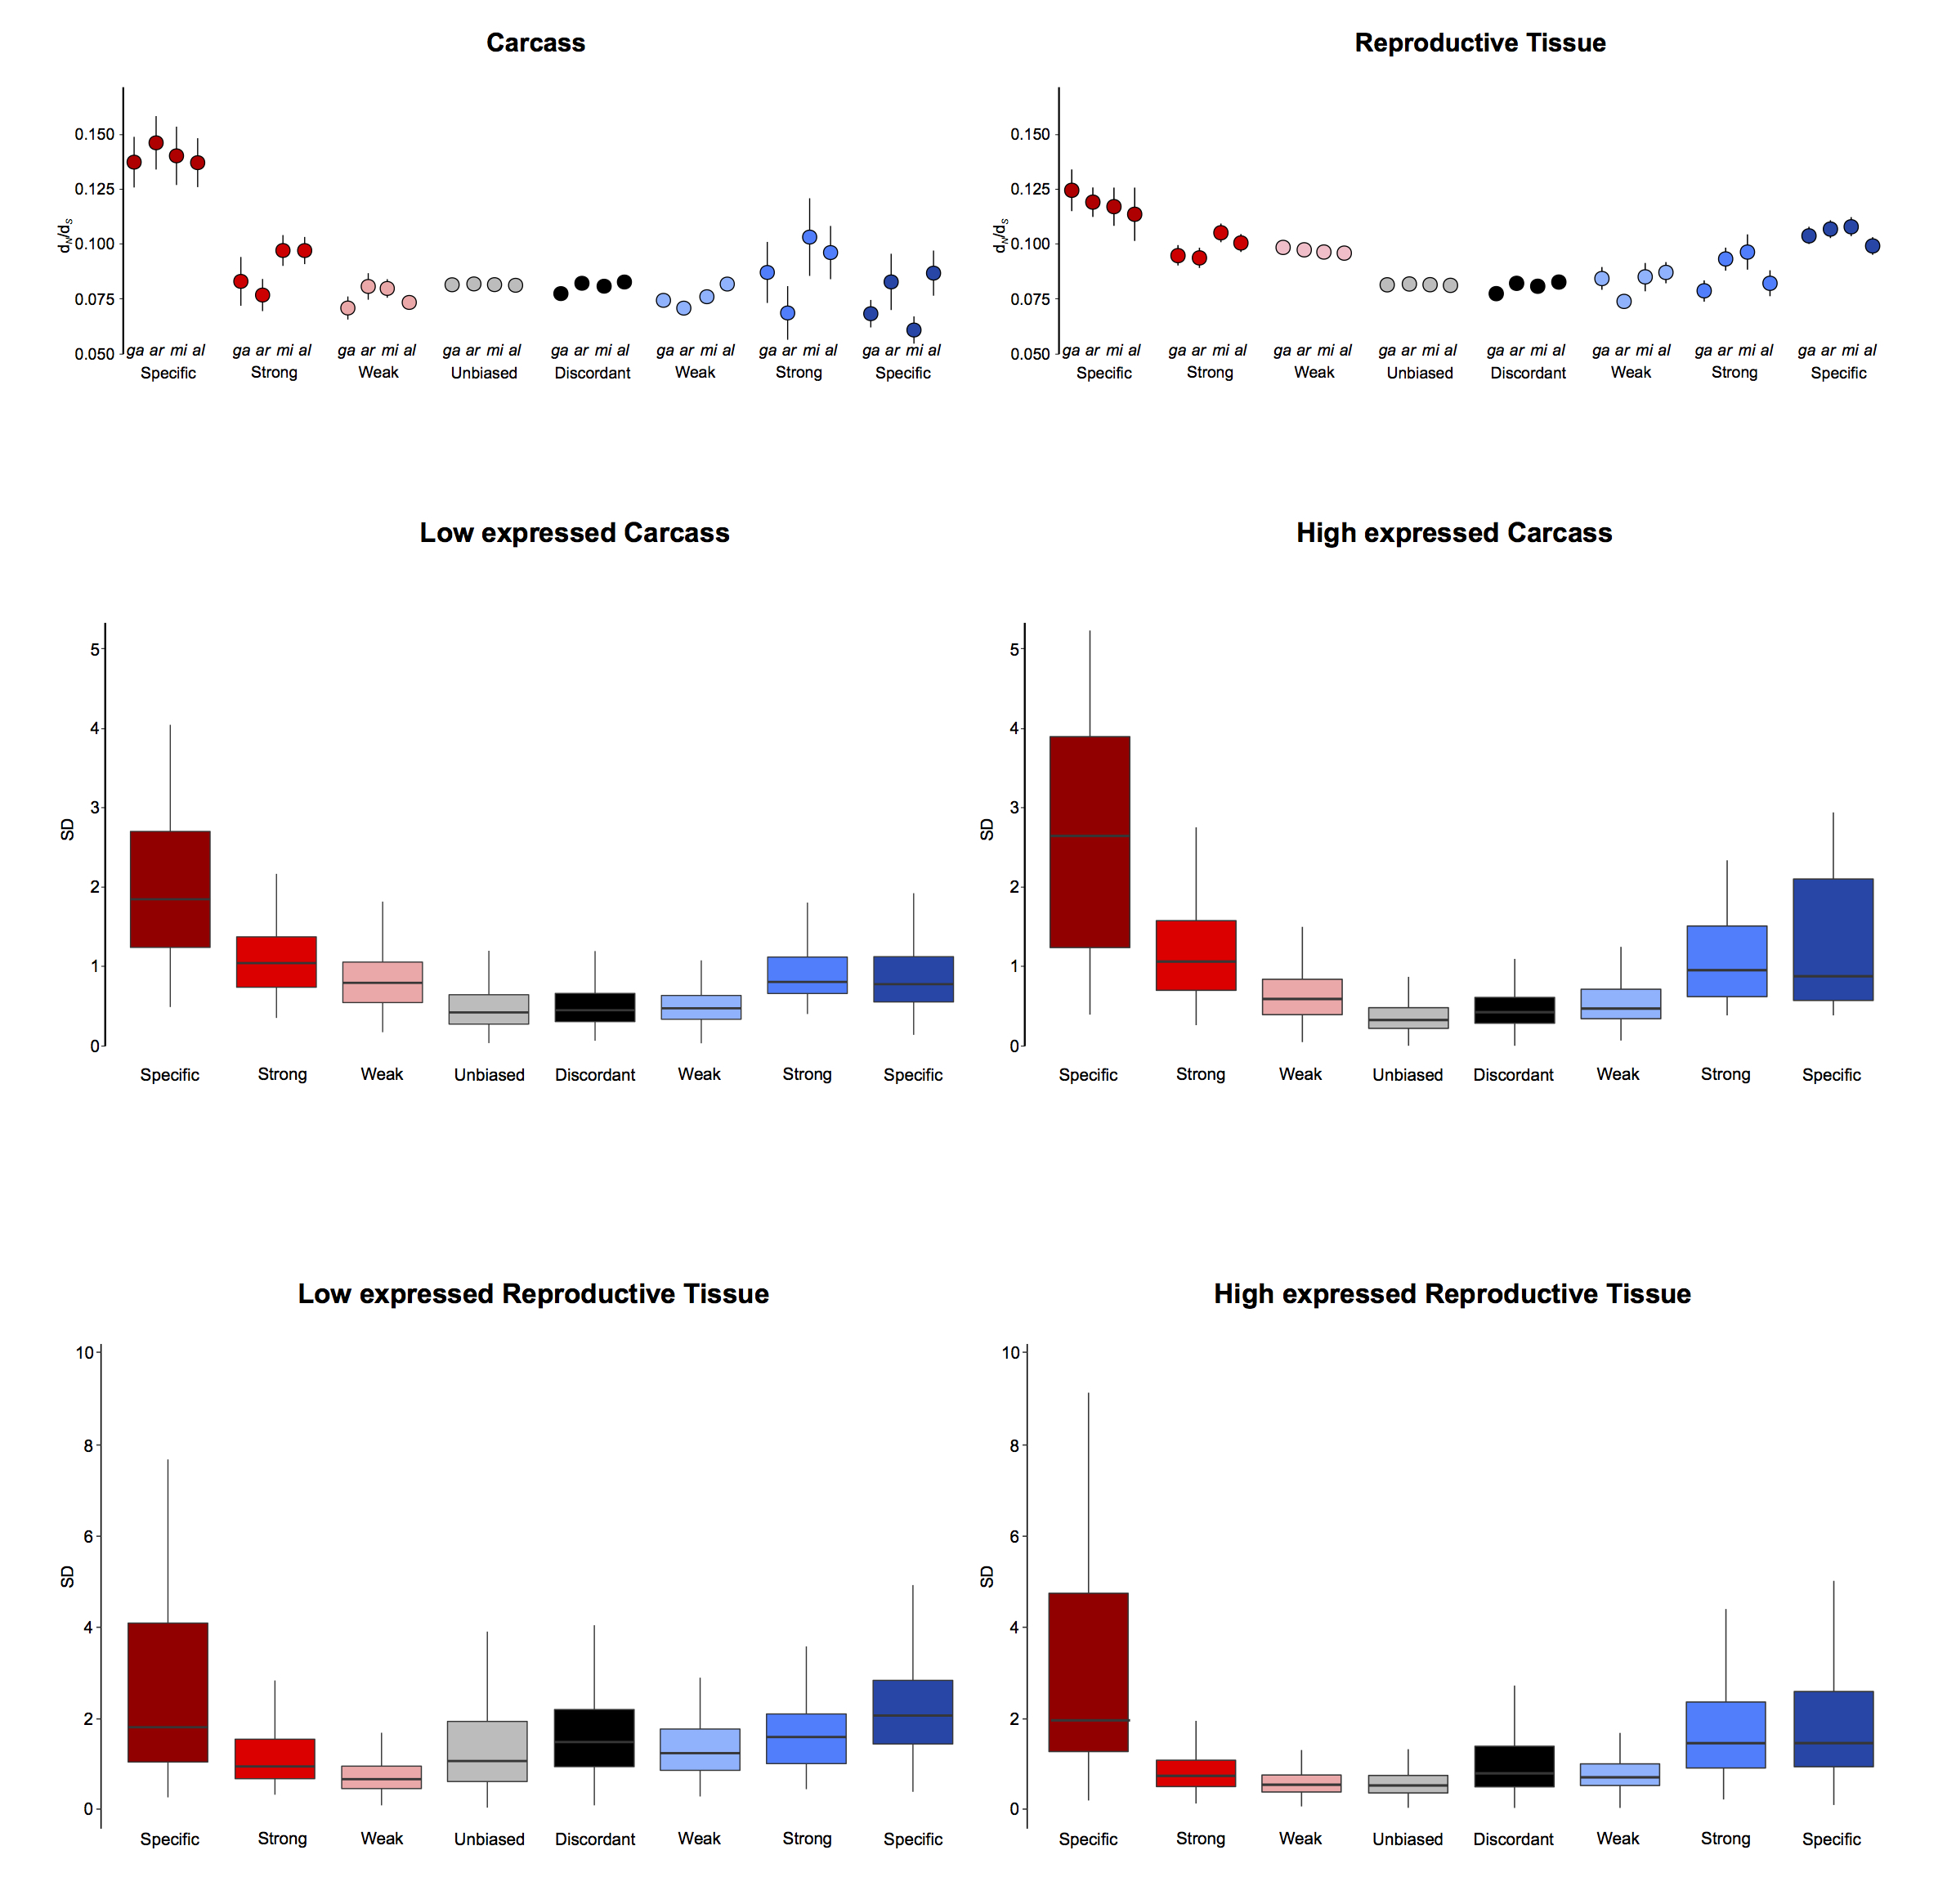
Supplementary Figure 3. Evolutionary rates of genes displaying discordant genes expression compared to other categories. A) Sequence divergence rates (d_{N}/d_{S}) of the sex-biased genes in the four-species orthologs and genes showing discordance between differential expression analysis (black points) which were previously classified as unbiased. B) Median standard deviations (SD) of expression ratios (male/female) of carcass and reproductive tissue male-biased (blue), female-biased (red) and genes showing discordance between differential expression analysis (black) amongst the four-species orthologs. For each tissue we classified genes into lowly expressed (expressed below the median FPKM for that tissue) and highly expressed (above the median).

Tau index for tissue specificity
The tau tissue specificity index, τ, was calculated for each gene in each species using the formula
$$τ=\frac{\sum_{i=1}^{N}{1-\frac{log2Ei}{log2Emax}}}{N-1}$$
where N is the number of tissues, E_{i} is expression in tissue i, and E_{max} is the maximal expression level for that gene across all samples (Yanai et al. 2005; Larracuente et al. 2008; Meiklejohn and Presgraves 2012). τ ranges from 0 to 1, with higher τ values indicating greater tissue specificity. In all four species, genes biased towards the male reproductive tissues were more likely to display sample-specific expression compared to genes biased in the other three tissues (Supplemental Fig S4)
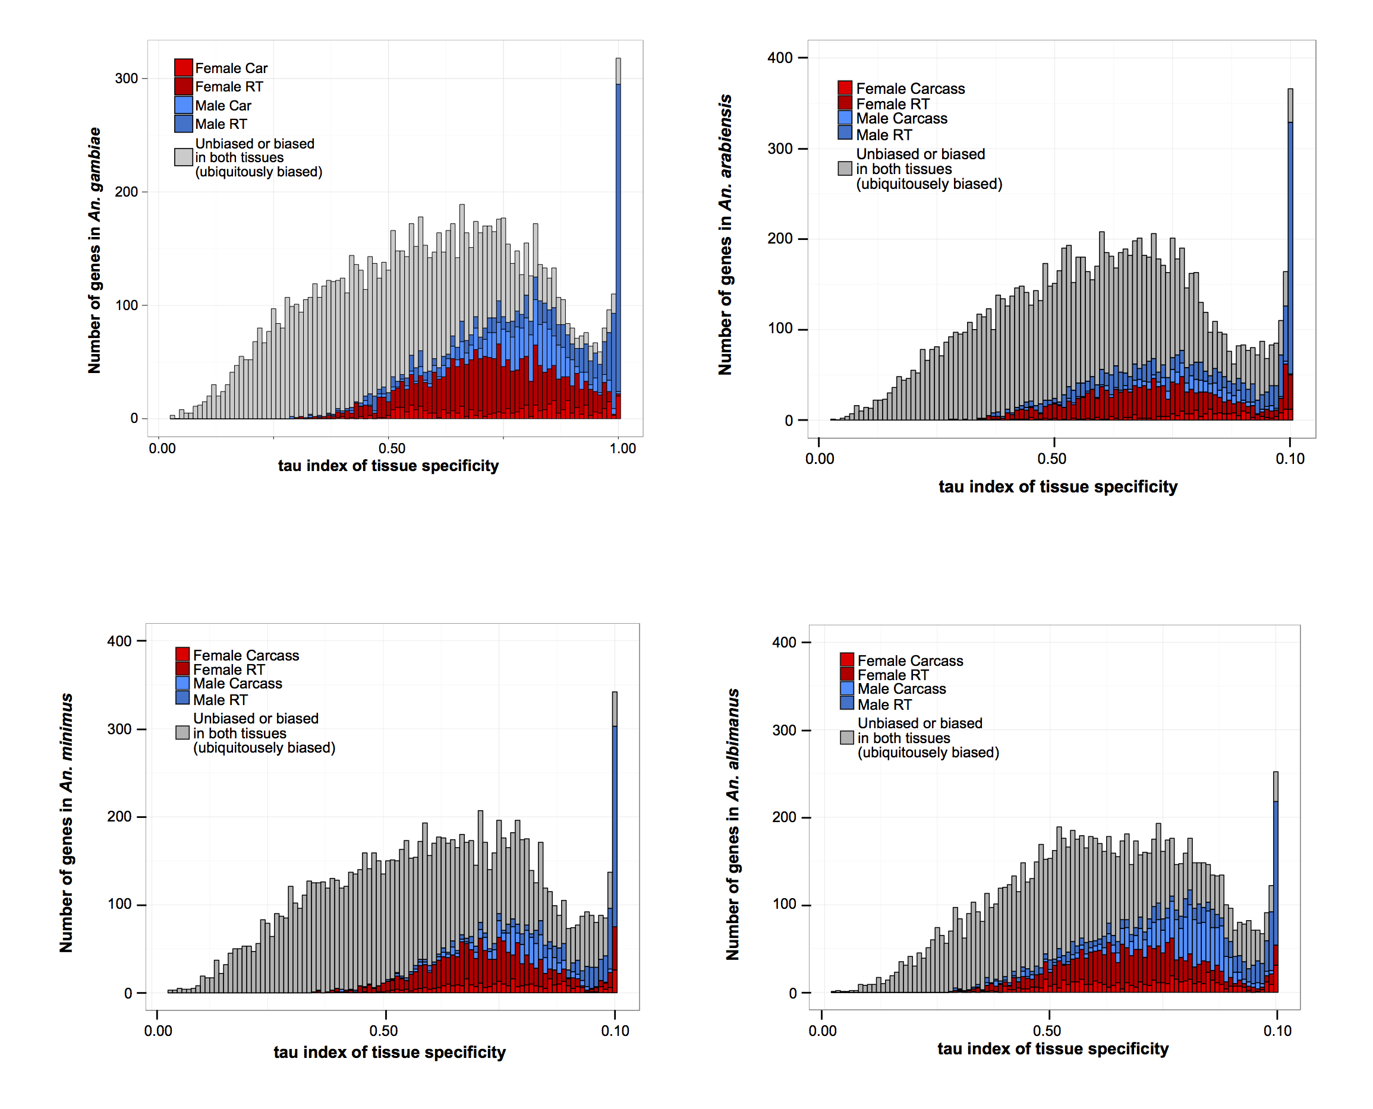Supplementary Figure 4. Distribution of τ values of tissue specificity in An. gambiae, An. arabiensis, An. minimus and An. albimanus. Colors indicated sex- and tissue-biased classification of the DE pipeline. Genes with high τ values are enriched for male-biased reproductive tissue genes in all three species.
Orthology relations
To ensure reliability of our result interpretation, we followed a conservative approach and utilized for the most part the 7400 one-to-one orthologs across the four species for all analyses (Supplemental Table S2) as these are less likely to contain annotation errors that may bias data interpretation, for example incorrect automated gene predictions or orthology calls among many-to-many orthologs. However, because genes that are unambiguously orthologous across the entire genus may also show the least evolutionary divergence we also used a larger subset of orthologs with 31472 orthologs across all species, containing species-restricted genes (2289 on average per species) and those with one-to-one orthology between at least two of the study species (3183 orthogroups). ‘Many-to-many’ orthologous relationships were excluded from the analysis. The inclusion of these additional orthology calls, does not affect the pattern observed (Supplemental Fig S8).

Expression divergence of sex-biased genes
We analyzed the standard deviation (SD) of the expression ratio (log2(male/female)) for each species individually and observed a pattern that was not different to what we observed when looking at the average of all four species combined (Figure 2A). Female-specific genes expressed in the carcass exhibited the highest levels of expression divergence of all sex-bias categories in all species. While in the reproductive tissues, female-specific, male-specific and strongly male-biased genes showed high levels of expression divergence while all other classes evolve at similar or lower levels compared to unbiased genes (Supplemental Fig S5).
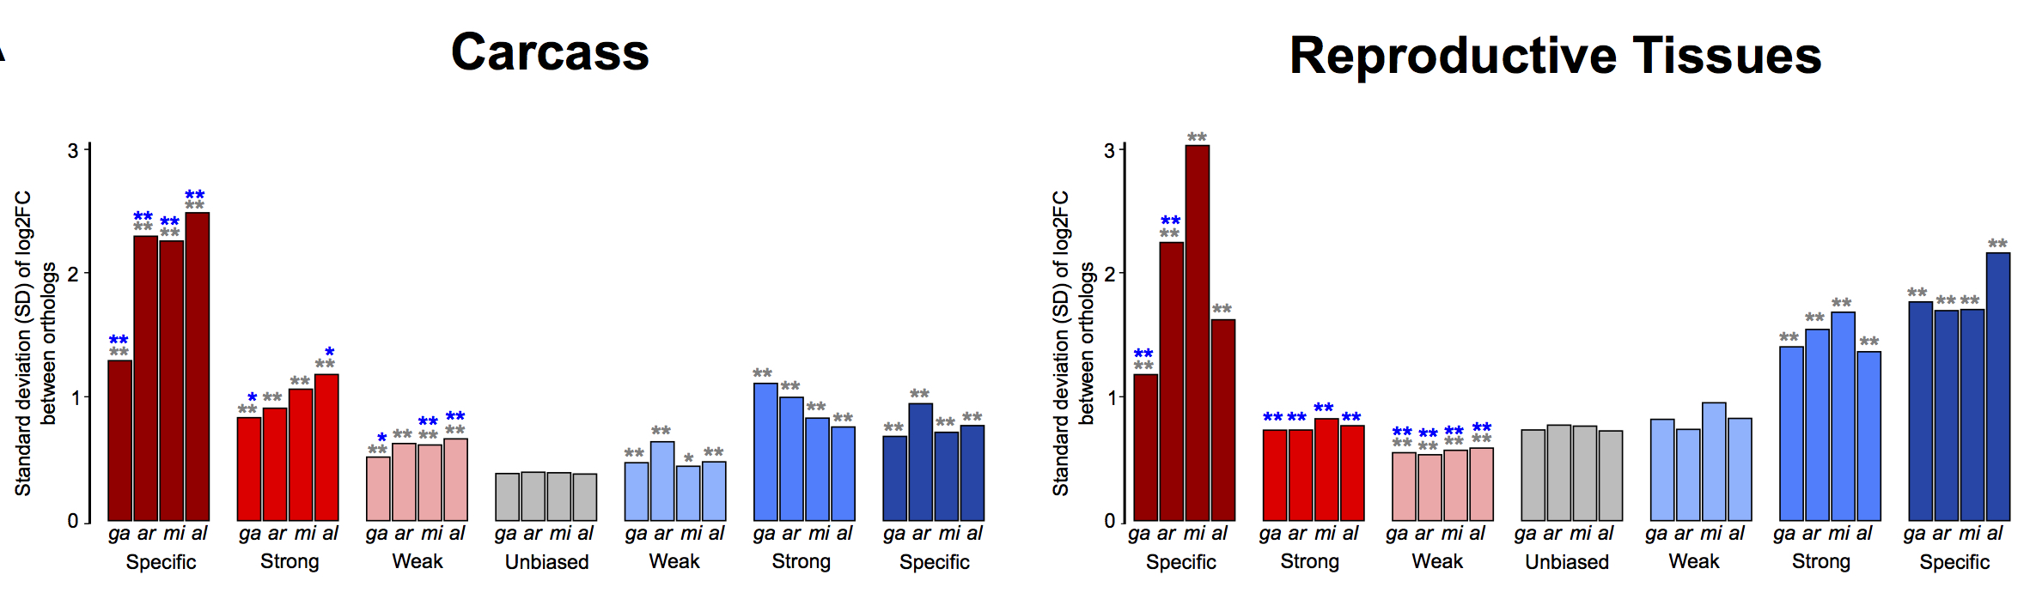
Supplementary Figure 5. Expression divergence levels for each study species. Levels of expression divergence (in standard deviation SD) of carcass and reproductive tissue male-biased (blue) and female-biased (red) genes, shown for each species individually. Wilcoxon rank-sum test of significance comparing sex-bias gene expression categories between the sexes (blue asterisk) or to unbiased genes (gray asterisk) and indicated p-value < 0.001 (**), p-value < 0.05 (*).

In the reproductive tissues, sex-biased genes exhibited greater dynamic ranges of SD compared to genes biased in the carcass, but we noted that the correlation between SD and gene expression levels (FPKM) of sex-biased genes irrespective of their sex-bias category in both tissues was weak but positive (average R² = 0.0825, Supplemental Fig S6A). We noted however, that there is an inverse relationship between median SD and overall gene expression levels (FPKM) among the sex-bias categories, e.g. female-specific genes in the carcass have higher levels of SD but also have lower expression levels than strongly- or weakly female-biased genes (Figure 2A and Supplemental Fig S6B). To rule out that high expression divergence was not an artifact of low gene expression, we first split the sex-biased genes into subsets of either rapidly and slowly evolving based on a SD value higher or lower than 1, respectively. If high SD rates were predominantly driven by noisy fold change ratios resulting from low gene expression levels we expected that the subset of highly divergent genes (SD>1) (Zhang et al. 2007) would show significantly lower levels of expression. With the exception of the male reproductive tissues, we observed the opposite: that is the expression spectrum of genes with SD>1 shifted to higher expression levels in comparison to the less divergent genes, with significant differences between median levels between the two subsets (Wilcoxon rank-sum test minimum p-value < 0.05) (Supplemental Fig S6C).

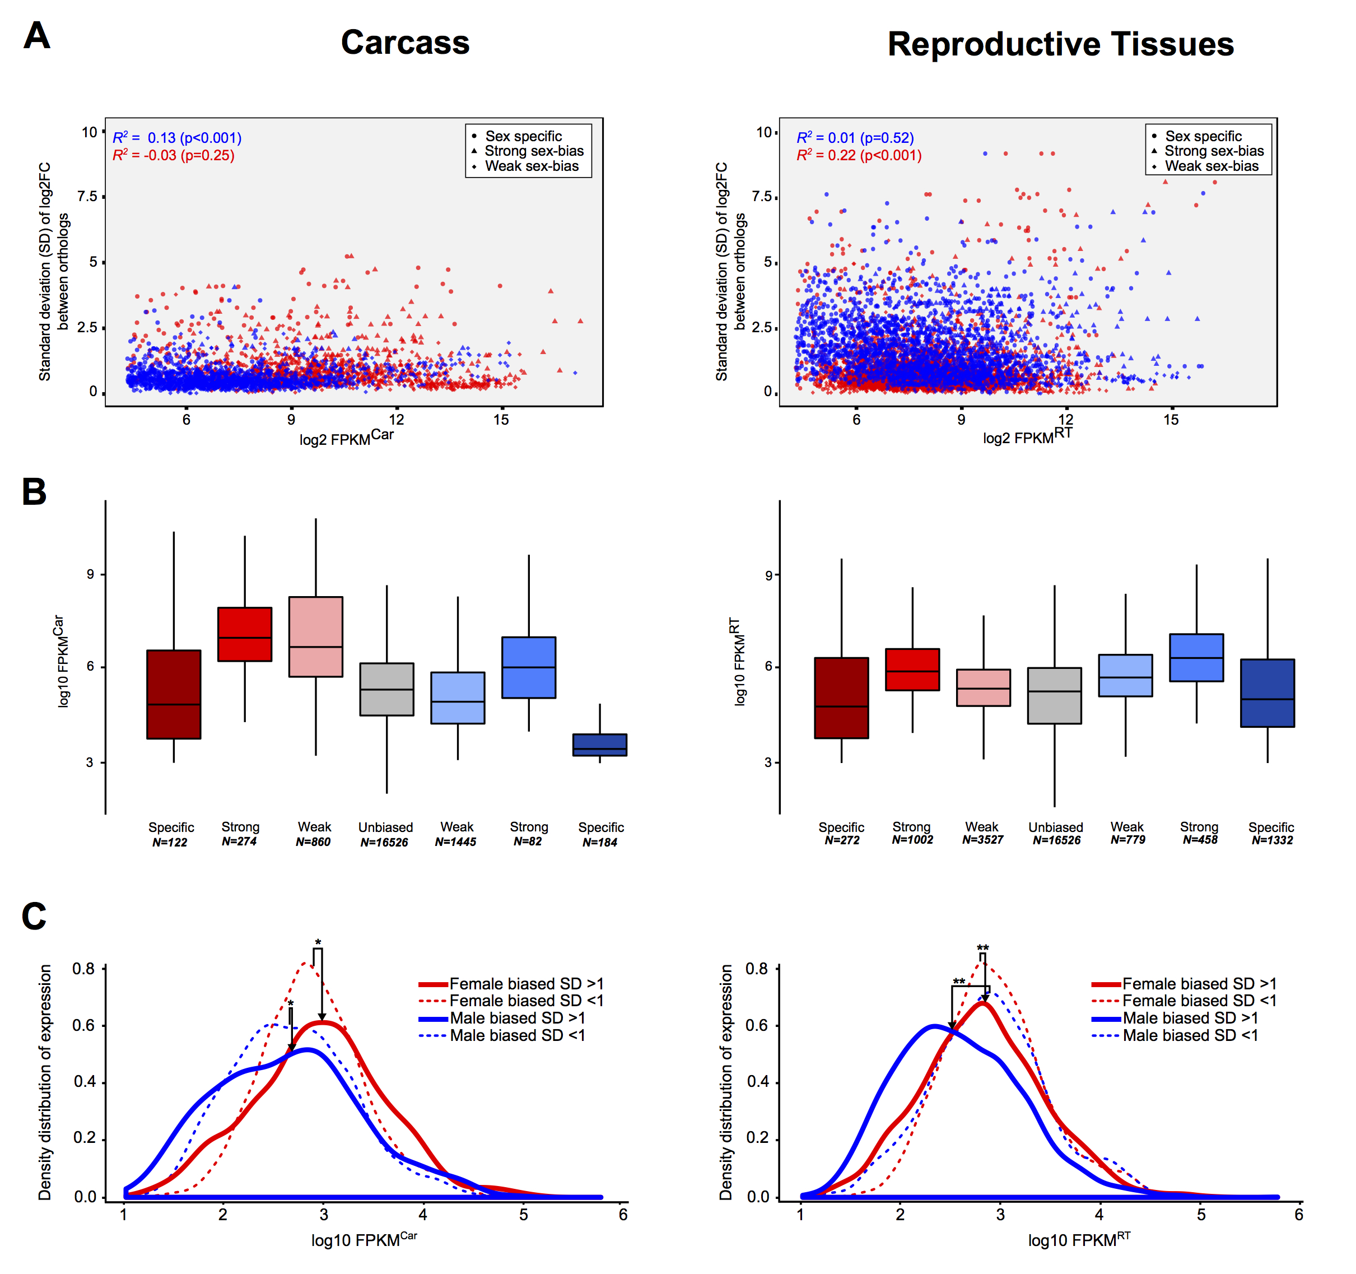
Supplementary Figure 6. Correlation between SD of expression ratio and gene expression. A) Scatterplots of sex-biased genes of all species in the carcass and the reproductive tissues, showing the relationship of gene expression levels (in log2 FPKM) and expression divergence (standard deviation). B) Levels of gene expression (in FPKM) of all four species and their relationship to the sex- and tissue-bias classification. C) Density distribution plots of gene expression levels (in log2 FPKM) from all four species combined separately for genes with high (SD>1) and low (SD<1) levels of expression divergence.

To confirm this, we also divided the entire gene expression range in each tissue and sex into three subsets – low, medium and high expression - and compared the median SD rates of each of the sex-bias categories within these defined ranges of expression (Supplemental Fig S7). These results confirmed that genes showing stronger sex-bias displayed higher levels of expression divergence, regardless of their levels of gene expression.
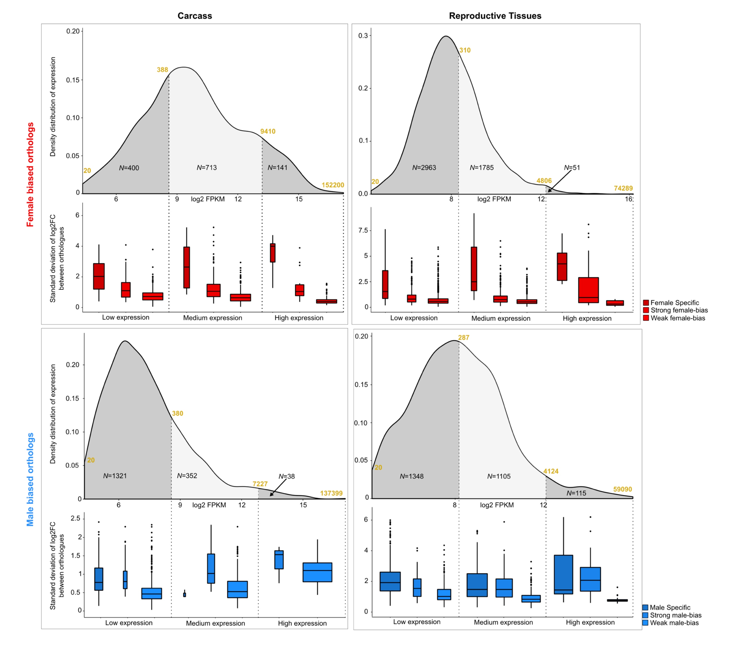
Supplementary Figure 7. Expression divergence levels are not influence by gene expression levels. For each tissue and sex, the spectrum of gene expression of all genes is divided into three subsets (lowly expressed, medium expressed and highly expressed). For each subset, the standard deviation (SD) was calculated for all four species separately for sex-specific, strongly- and weakly-biased genes. N indicates the number of genes in each subset. In yellow are shown the FPKM values selected to create the three subsets

Sequence divergence of sex-biased genes
DNA evolutionary constraints were computed for each orthogroup using the number of non-synonymous substitutions per non-synonymous site (d_{N}) and the number of synonymous substitutions per synonymous site (d_{S}) to quantify d_{N}/d_{S} ratios. Protein evolutionary rates were computed to quantify the relative sequence conservation or divergence among orthologs in terms of their normalized amino acid identities (Waterhouse et al. 2011; Kriventseva et al. 2015). To test whether any of the DE pipeline filtering steps had any impact on the pattern we observed in sequence divergence rates, we dissected our workflow and analyzed d_{N}/d_{S} levels at every stage of the analysis (Supplemental Fig S8).
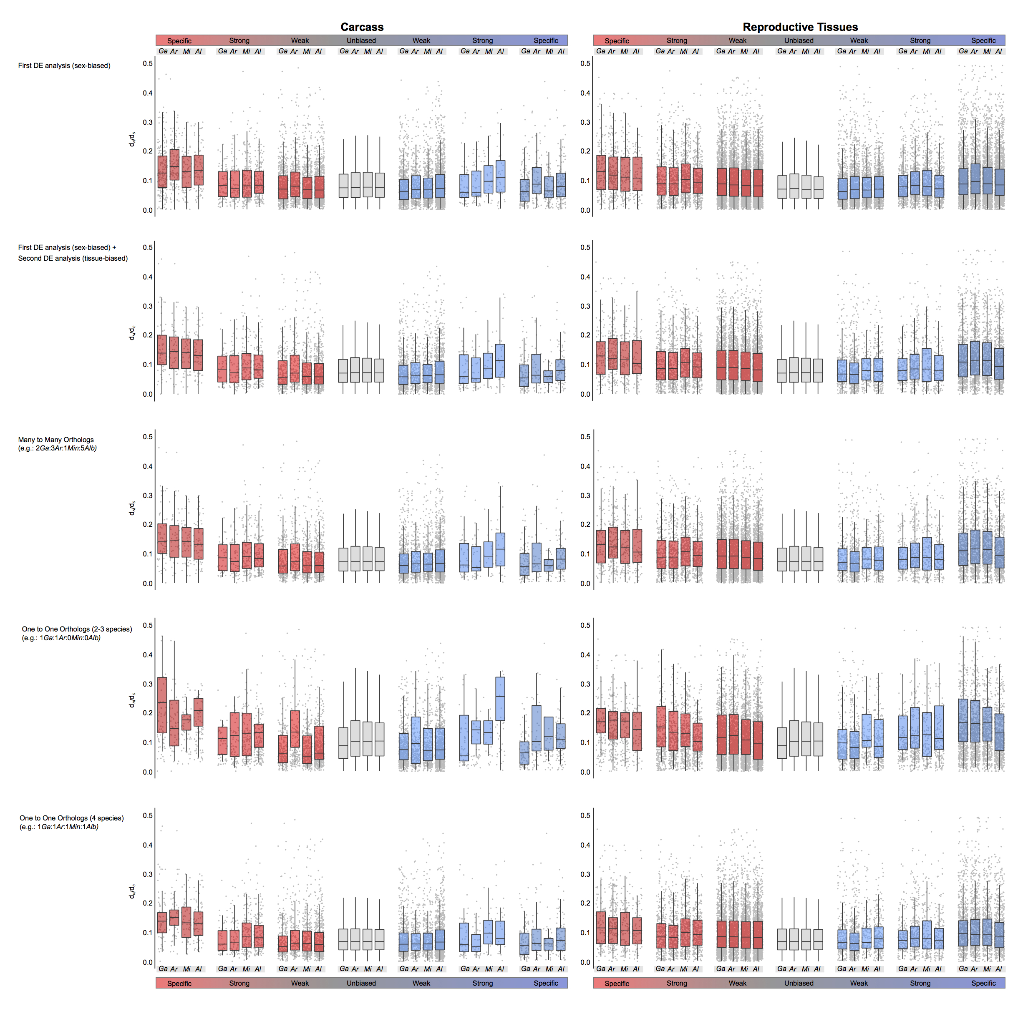
Supplementary Figure 8. DNA sequence divergence rates (d_{N}/d_{S}) of sex-biased genes with increasing implementations of DE pipeline does not change overall patterns. Tow row: sex-biased genes without tissue bias classification (1st DE analysis), second row: inclusion of results from the 2nd DE analysis, where tissues biases within each sex are evaluated. The lower three panels show d_{N}/d_{S} levels for each sex- and tissue-biased classification but including only certain orthology relationships: many-to-many; one-to-one at least two species and finally the one-to-one four-species orthologs. The observation of higher sequence divergence for female-specific genes of the carcass remains consistent in all stages of filtering.

We also tested for an association between expression and sequence divergence among sex-biased genes of all species and found that genes displaying rapid expression divergence (SD>1) also show higher d_{N}/d_{S} ratios compared to those with an SD<1 (Supplemental Fig S9)
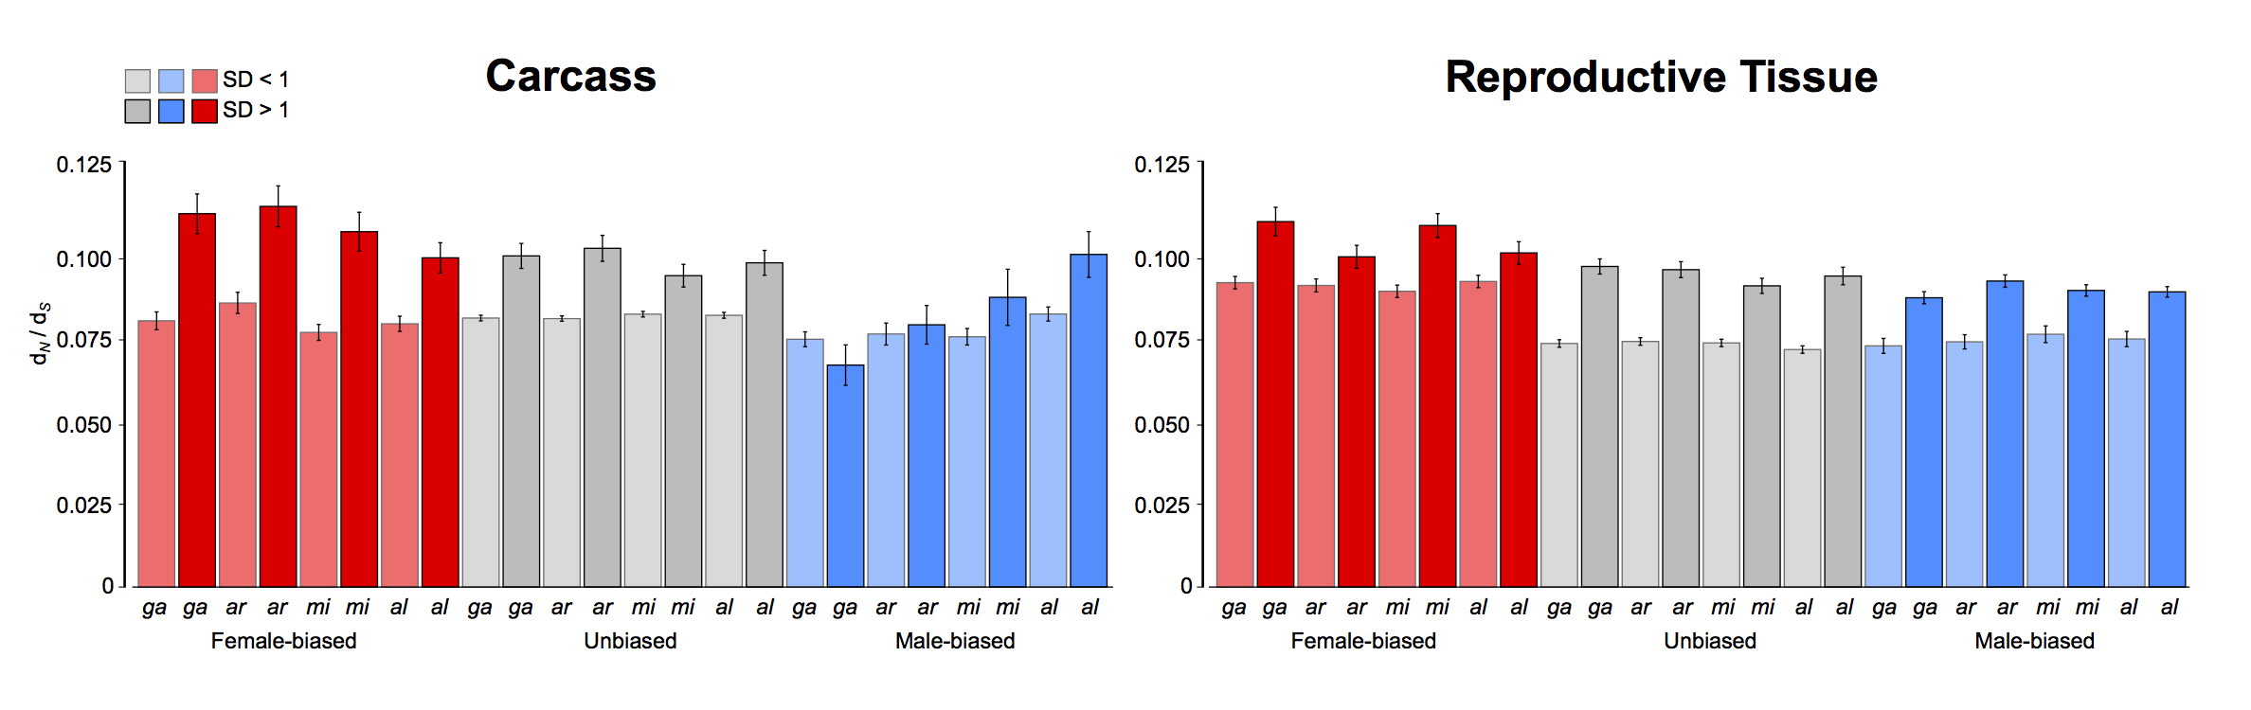Supplementary Figure 9. Relationship between sequence and expression divergence rates of sex-biased genes in the four species. Mean DNA sequence divergence levels (d_{N}/d_{S}) increase amongst genes that display high levels of expression divergence (SD>1, darker colors), compared to genes showing lower levels of expression divergence (SD<1, lighter colors).

Positive selection
We first aligned protein sequences and coding sequences (CDS) of each gene in the four-species orthologs using Clustal Omega (Sievers F et al. 2011) and converted them using PAL2NAL (Suyama M et al. 2006) to produce a codon-aware nucleotide sequence for each ortholog in every species. We then evaluated the impact of positive selection on each orthogroup using the program codeml from the package PAML. For each CDS alignment, we fitted two different evolutionary models: M7 and M8 (Nielsen R et al. 1998). The M7 model calculates the ω value (d_{N}/d_{S}) for each orthogroup assuming that ω values follow a beta distribution, limiting the interval to 0-1, whereas model M8 allows for an additional class of codons with ω > 1. Each test produces a log Likelihood value, we then performed a χ² test by comparing the likelihood ratio M8-M7 to contrast whether model M8 fits the data significantly better than model M7. Genes showing a p-value < 0.05 were considered to be under positive selection.

Genic Turnover of sex-biased genes
In the main paper we analyzed the conservation of sex-biased genes across our 4 study species and found a lowest conservation for female-specific genes in the carcass with decreasing conservation as the magnitude of sex-bias increases but since this result was obtained using also multi-copy orthologs that might be not as reliable, we repeated the analysis using only one-to-one orthologs and observed a similar pattern (Supplemental Fig S10)
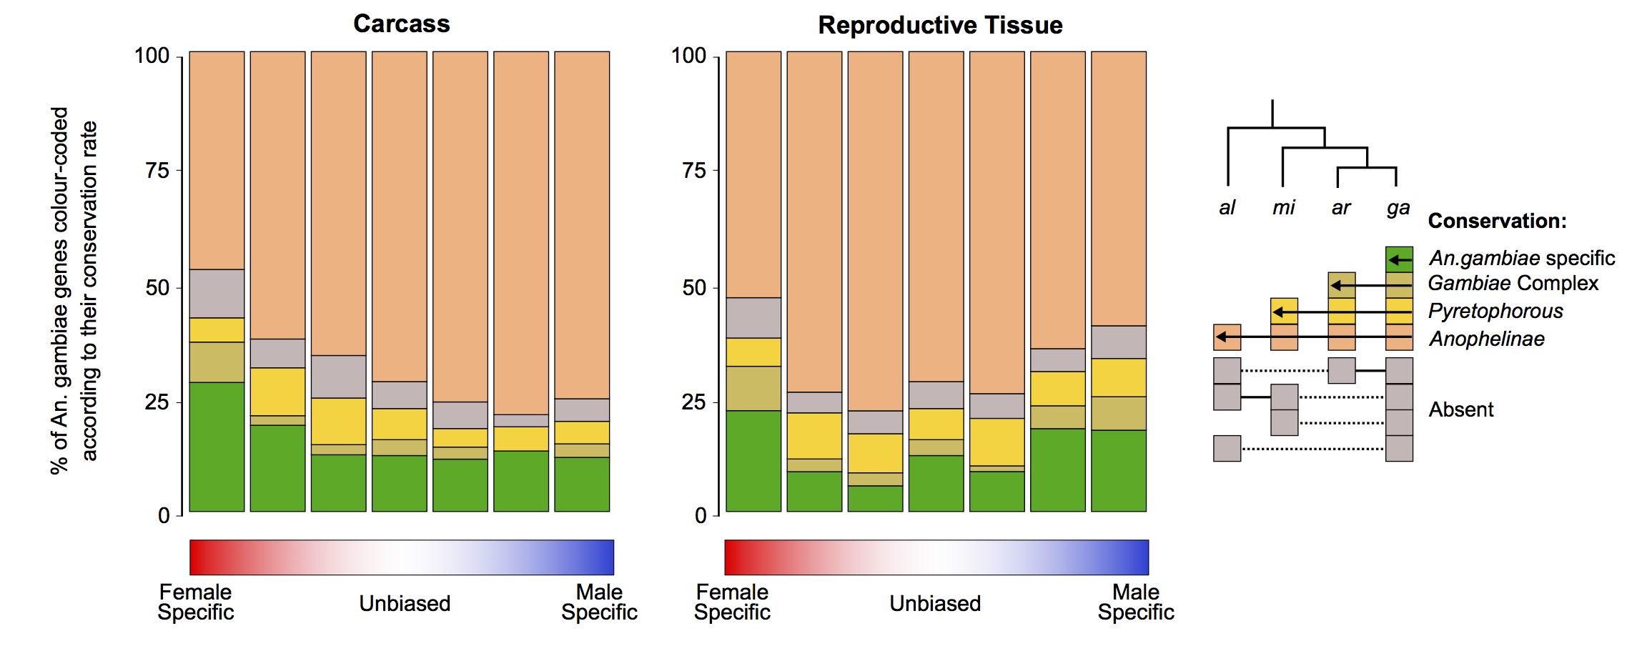Supplementary Figure 10. Conservation levels of An. gambiae sex-biased genes across the Anopheles phylogeny, allowing only one-to-one relationships among orthologs. As in Figure 4B in which all relationships among orthologs are considered, the fraction of species-specific genes increases with the magnitude of sex-biased gene expression (except male-specific in the carcass), and female-biased genes displayed higher or similar levels of turnover to male-biased genes in all species and in both tissues.

Functional analysis of genes showing rapid expression divergence.
For the functional analysis of An. gambiae sex-biased genes we included manual functional annotations provided generously from the community that included chemosensation (gustatory and olfactory), neuropeptide hormones, immunity (recognition; signal transduction; cascade modulation; effectors), insecticide resistance, epigenetic modification, cuticle formation, as well gene expression datasets in the female salivary gland and male accessory gland. In the main manuscript, we investigated the functions of genes showing rapid evolution according to the d_{N}/d_{S}, here we assessed whether a similar functional enrichment pattern of sex-biased genes, holds when considering the standard deviation of expression ration between males as females. We selected carcass strongly and weakly male- and female-biased genes for An. gambiae, applied a threshold of SD>1 for selecting rapidly evolving genes and used the same repertoire of functional annotations used in the previous analysis to categorize gene functions. We found that functional categories were both similar between the two metrics and showed similar biases between the sexes. In some cases, genes previously found to show high d_{N}/d_{S} were shared (e.g. SG1cb and SG1c, LRIM8A, LRIM8B) and in others, genes were unique to this analysis: like the gustatory receptor Gr37: AGAP001117 or the enolase-binding-protein EBP: AGAP010479, that binds to the ookinete surface enolase, and it is required for midgut invasion (Vega-Rodríguez J et al. 2014).
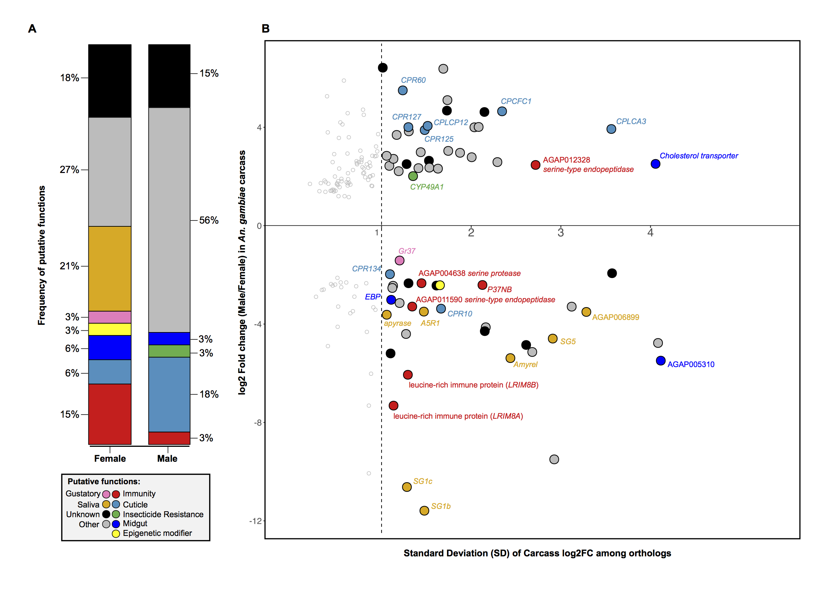Supplementary Figure 11. Functional analysis of highly sex-biased carcass genes of An. gambiae showing high expression divergence (SD>1) (A) Relative proportions of putative functions amongst rapidly evolving sex-biased genes (sex-specific and strongly-biased) in the carcass of An. gambiae. (B) Sex-biased expression ratios (in log2 fold change male/female) over Standard deviation of Carcass log2FC (SD) for genes displaying strong-bias or sex-specific expression in the carcass of An. gambiae. The dashed line (SD=1) highlights the cutoff for high expression divergence we used for the downstream analysis. Genes with SD value greater than 1 are highlighted with putative functions using GO, orthology-based predicitions and community annotations (colored circles). Empty circles indicate genes evolving below our threshold of expression divergence.

Sex-specific splicing isoform identification
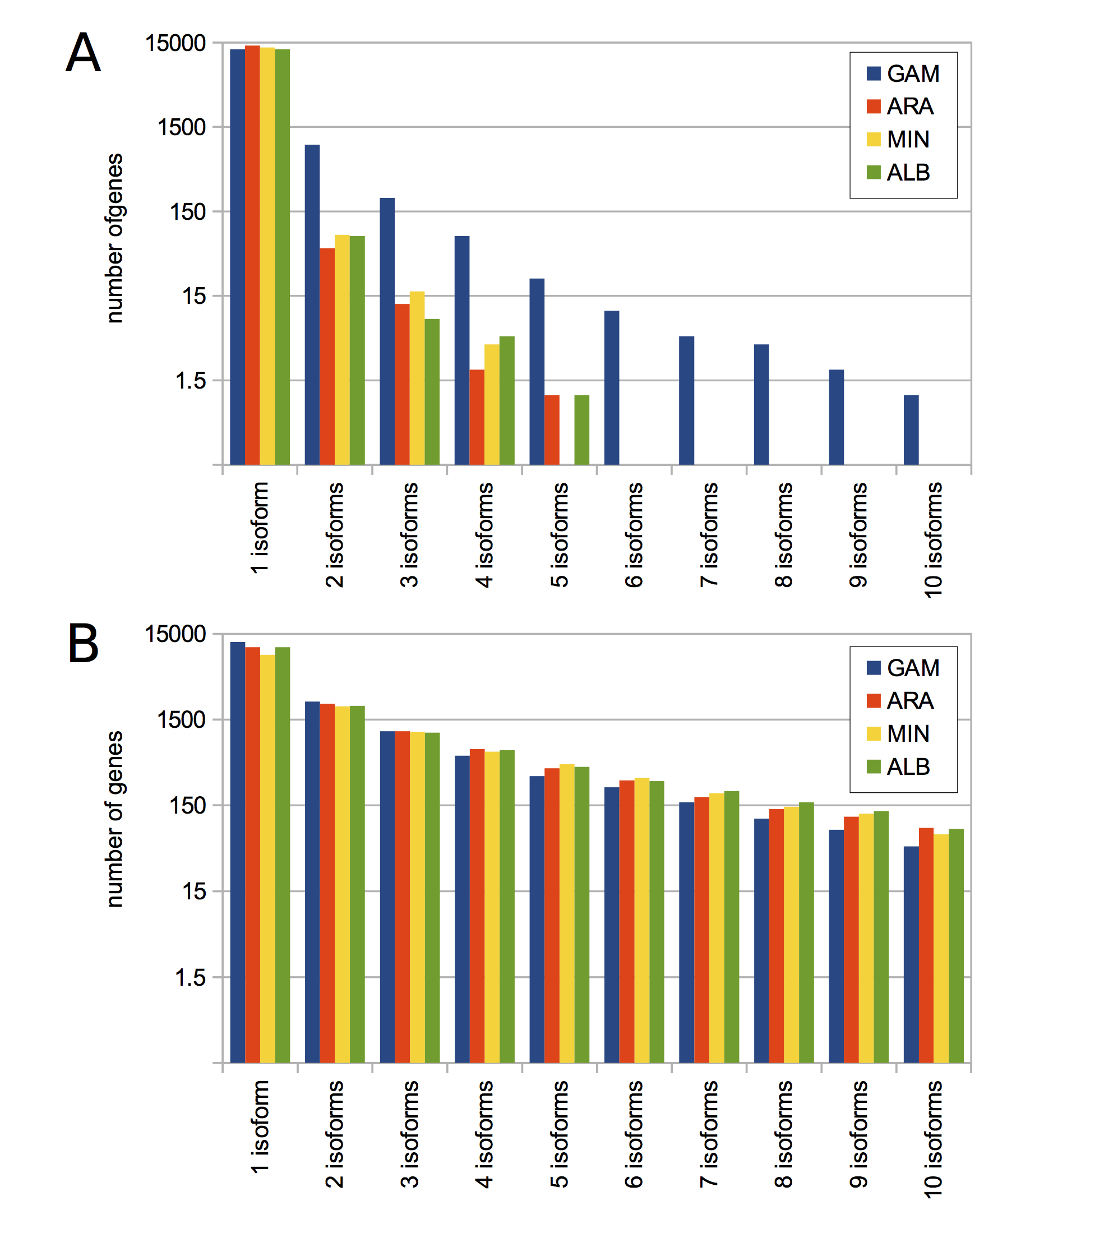
Supplementary Figure 12. Improving the alternative isoforms for non-An. gambiae species is required for alternative isoform usage analysis. Shown is the number of loci that contain from 1 to 10 annotated isoforms in (A) the reference gene-sets of An. gambiae (GAM), An. arabiensis (ARA), An. minimus (MIN) and An. albimanus (ALB) as well as in (B) the expanded gene-sets of the same species generated from RNA-seq data from this study.

Chromosomal distribution of genes.
An. gambiae is the only species out of the four we used with gene-to-chromosome assignments. To predict chromosomal localization of genes in the other three species, we used orthology relationships and synteny. We assigned scaffolds to a chromosomal arm if more than half of the genes on that scaffold had orthologs in An. gambiae, and of these, if two thirds had hits to the same chromosomal arm of An. gambiae. To assess the reliability of this approach we mapped whole genome sequencing (WGS) data based on Illumina pair end reads from male and female pools of An. arabiensis (NCBI SRA project SRP044010) to the An. arabiensis scaffolds and calculated the ratio of mapping reads from females over males for each scaffold. X-linked scaffolds were distinguished from autosomal scaffolds when scaffolds displayed a mapping ratio higher than 1.48, which is the mean ratio of all scaffolds plus one SD of the ratio, we found that all 1200 orthology predicted X-linked genes in An. arabiensis were derived from scaffolds with female-biased coverage in mapping DNA reads.
(Supplemental Fig S13).
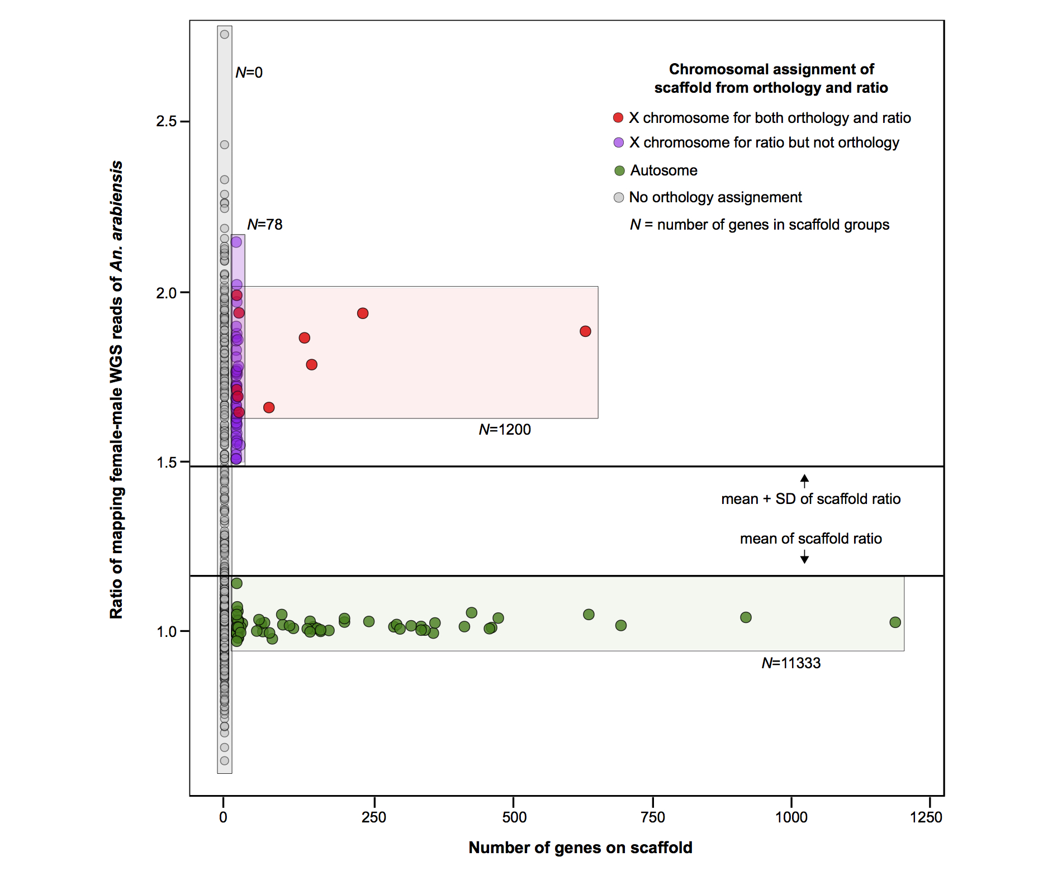Supplementary Figure 13. Reliability of synteny-based predictions to assign chromosomal origin of genomic scaffolds in An. arabiensis. Ratio of mapping female and male WG reads of An. arabiensis against assembled scaffolds. Horizontal line at 1.48 shows the mean of the mapping ratio of all scaffolds plus one SD, which was used to distinguish X-linked scaffolds. Each point represents a scaffold in An. arabiensis and its position on the X axis is based the number of genes it contains. Scaffold colors show results from orthology-predictions and/or ratio-based decisions of chromosomal location (green – autosomal scaffolds; red - X-linked scaffolds based on orthology; purple – X-linked scaffolds based on ratio but insufficient number of genes for orthology predictions (excluded from the analysis), grey – scaffold with no annotated genes precluding orthology predictions to An. gambiae).

Then we analyzed the chromosomal distribution of sex-biased genes in all four species. For simplicity, autosomal arms were combined for all subsequent analysis, as re-arrangements of autosomal arms within the genus have been documented (Neafsey et al. 2014). We calculated the expected number of male/female-biased genes for each chromosome by multiplying the total number of male/female-biased genes in the genome by the proportion of all expressed genes per chromosome. Then we calculated the ratio of observed/expected by dividing the number of sex-biased genes in each chromosome by the number of expected genes in that chromosome. A ratio of observed over expected of 1 would imply there is a random distribution of genes, while values higher than 1 indicate an enrichment, and values lower than 1 indicate a paucity.
To assess whether X chromosomes were dosage compensated in both tissues we calculated the ratio of autosome/X-chromosome median gene expression. To understand if the apparent demasculinization of the X chromosome was due to a lack of dosage compensation in the male reproductive tissues, we “pseudo-normalized” the numbers of mapping raw read counts for X-linked genes in the male reproductive tissues of each species by multiplying them by the A:X ratio from each species. We then re-run the DE pipeline to re-classify sex-biased expression. Using this modeled dosage compensation, we calculated the ratios of observed/expected genes finding no evidence of an underrepresentation of male-biased genes on the X chromosomes of each species.

Evidence of X-chromosome demasculization with RNA-seq versus microarray data
Both the Baker & Russell 2011 and the Meiklejohn & Presgraves 2012 meta-analyses found a significant under-representation of testis-specific genes on the X chromosome of An. gambiae, using the same MozAtlas dataset from Baker et al 2011. Indeed, using MozAtlas data we also found a statistically significant paucity of male-RT-specific genes on the X chromosome (χ² test: p-value = 0.02) - a signal that we don’t observe with our RNA-seq and DE pipeline. We therefore repeated some of these analyses focusing on tissue-specific expression, in part to account for a design difference in our sampling - that is the combining of testes and accessory glands as the male-RT sample, and to be able to rule this is out as the source of these divergent outcomes. In our study, we identified 426 autosomal and 20 X-linked, male-RT-specific genes (Male-RT-biased with tau > 0.95). By comparison, in the MozAtlas data we identified 443 autosomal and only 4 X-linked male-RT-specific genes (testes+AcG-biased with tau > 0.95). 201 autosomal and 3 X-linked genes were identified by both data sources (Supplemental Table S4).

Supplemental Table S4. Comparison of the number of genes found as testis or accessory glands specific in the MozAtlas data or Male RT specific in our RNA-seq data, with a tau > 0.95.
Genes unique to the MozAtlas list (242 autosomal and 1 X-linked gene) typically had weaker male-biased expression and/or tau<0.95 based on the RNA-seq data, despite being abundantly expressed (Supplemental Fig S14A, C). Of the 225 autosomal and 17 X-linked male-RT-specific genes unique to RNA-seq dataset, 79 are not represented on the chip, because an older version of genome annotation was used to make the array. Of the remaining genes, 22 are male-RT biased in the MozAtlas (19 testis and 3 AcG), but they were either lowly expressed or displayed tau<0.95 based on the microarray data (Supplemental Fig S14B, D). Taken together, these results suggest that the use of RNA-seq, with its advantages of increased dynamic range and detachment from genome assembly versioning we were able to identify 17 additional male-RT-specific, X-linked genes that were previously not found in the Mozatlas data (8/17 are not present in MozAtlas chip and 9/17 are not classified as Testes or AcG specific due to lower expression or tau < 0.95). Importantly, because this pipeline did not increase measurably the total number of autosomal genes, probably by eliminating numerous false positives, the previous signal for a non-random distribution across the genome disappeared.

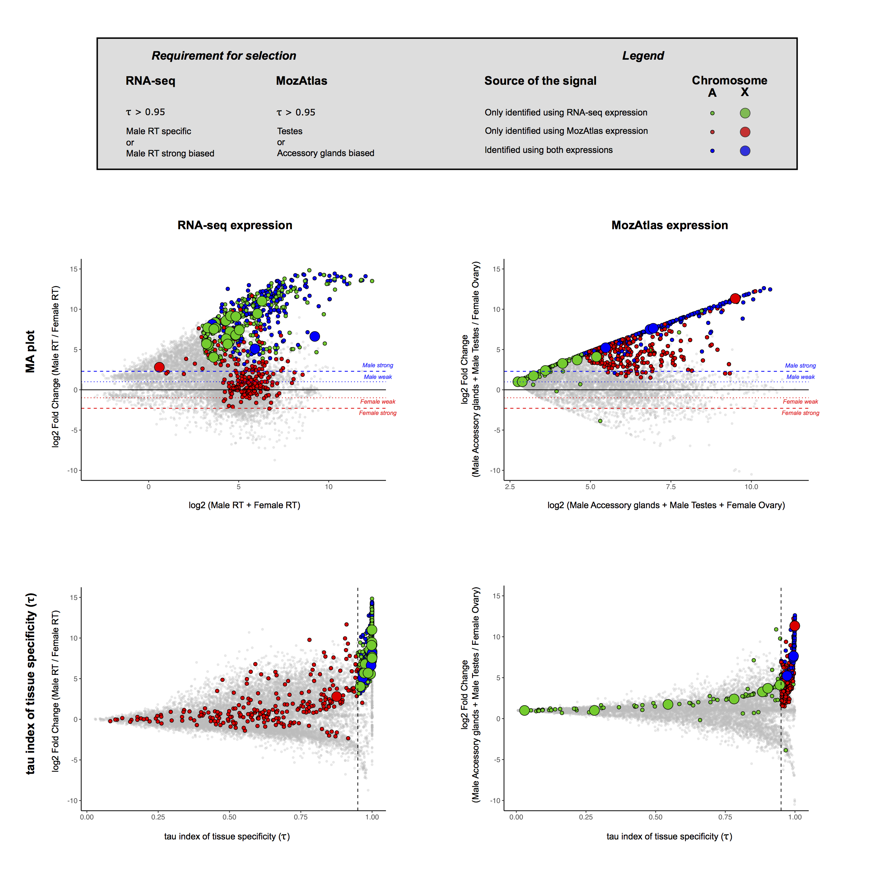Supplementary Figure 14. Comparison of male reproductive tissue-specific genes identified using this RNA-seq dataset or the microarray data from MozAtlas (Baker et al 2011). A and B) MA plots of log2 male/female fold change over log2 of the sum of expression of respective tissues included in the analysis. Fold change was calculated as male RT/female RT expression for RNA-seq dataset and (testes+accessory glands mean expression)/ovary mean expression for MozAtlas. Dotted line (log2FC = 1) indicate the threshold for inclusion in the weakly biased class and dashed line (log2FC =2.3), the threshold for inclusion in the strong biased class. C and D) Distribution of tau index for tissue specificity over the same log2 Fold change of male/female expression used above. The dashed vertical line indicates the threshold of tau > 0.95 used to select highly tissue specific genes. Grey points indicate genes not passing the minimum cutoffs, green points indicate genes identified exclusively using RNA-seq data, red points depict genes only identified using MozAtlas data and blue points represente genes commonly identified using both datasets. The size of the points indicates the chromosomal localization of genes: smaller points for autosomal genes and larger points for X-linked genes.

