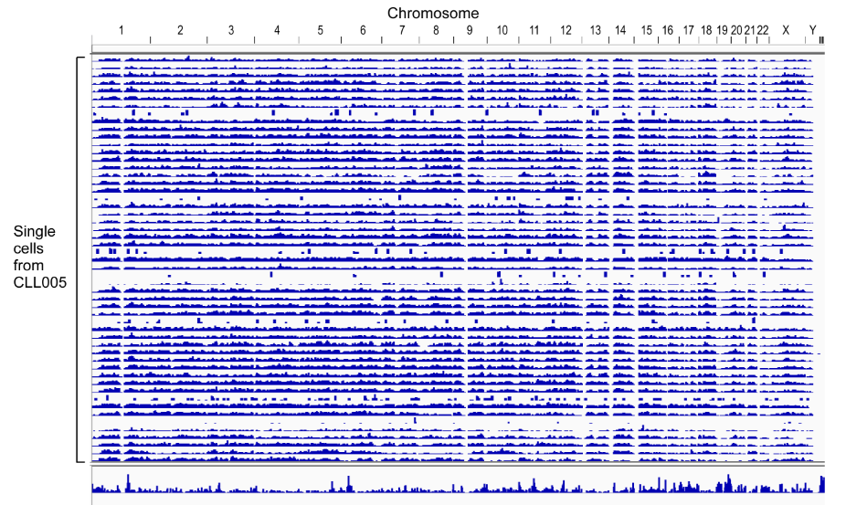

Figure 1. Low coverage single cell whole genome sequencing reveals even coverage across different single cells. DNA from 96 single cells of CLL005 was whole genome amplified and representative data from 53 single cells were shown. Sequencing library was generated and sequenced by MiSeq. An Integrative Genomics View (Robinson et al. 2011) of each individual cell is shown.

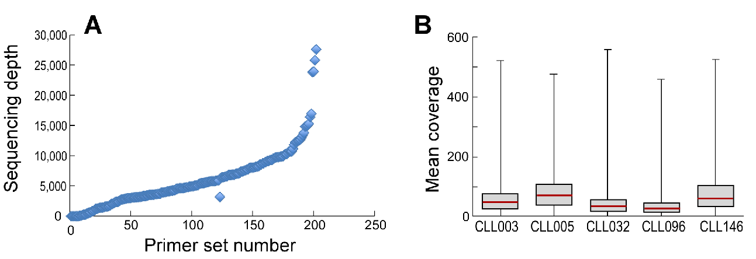
Figure 2. Amplification efficiency of the multiplexed PCR primer set through bulk DNA and single-cell analysis
(A) 201 primer pairs that cover the SNPs and SNVs from the 5 CLL samples in the study were amplified with bulk DNA. A DNA sequencing library was generated and MiSeq was performed. Sequence depth for each individual primer pair was plotted.
(B) Average of mean coverage rate of number of reads for all the primers from single-cell analysis in each individual sample.

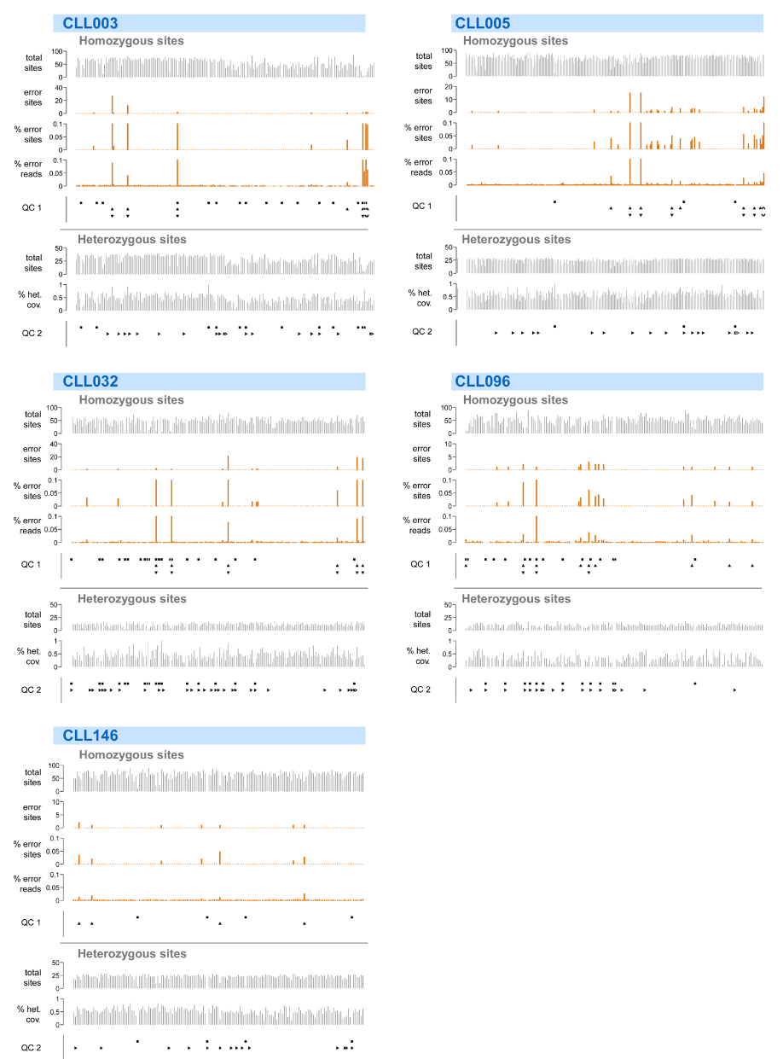
Figure 3. Quality assessment of single-cell targeted sequencing libraries.
The quality of single-cell libraries was assessed by three metrics: the percentage of target coverage, the frequency of amplification or sequencing errors, and the deviation from random allelic amplification. These metrics were assessed in each single-cell library by the sequence coverage at sites inferred to be either homozygous or heterozygous at the clonal level (see Supplementary Methods). There are eight panels for each sample. The top five panels are derived from the sequence coverage at homozygous sites. From top to bottom: the total number of homozygous sites covered in each cell, the total number of sites showing a high error read frequency (>5% and >2 reads), the percentage of sites showing a high error read frequency (capped at 10%), the mean error read frequency across all covered sites (capped at 10%). The QC1 panel shows the samples that were excluded based on different criteria: squares represent samples that cover fewer than 20% of all homozygous sites, up-triangles represent samples with a mean error read frequency > 1%, down-triangles represent samples with 5% or more sites showing a high error read frequency. The bottom three panels are derived from the sequence coverage at heterozygous sites. From top to bottom: the total number of heterozygous sites covered in each cell, the percentage of sites showing heterozygous coverage (>5% allelic frequency and >2 supporting reads for both alleles). The bottom panel (QC2) shows the samples that were excluded due to low coverage (<20%) of heterozygous sites (squares) or significant non-random allelic amplification bias.

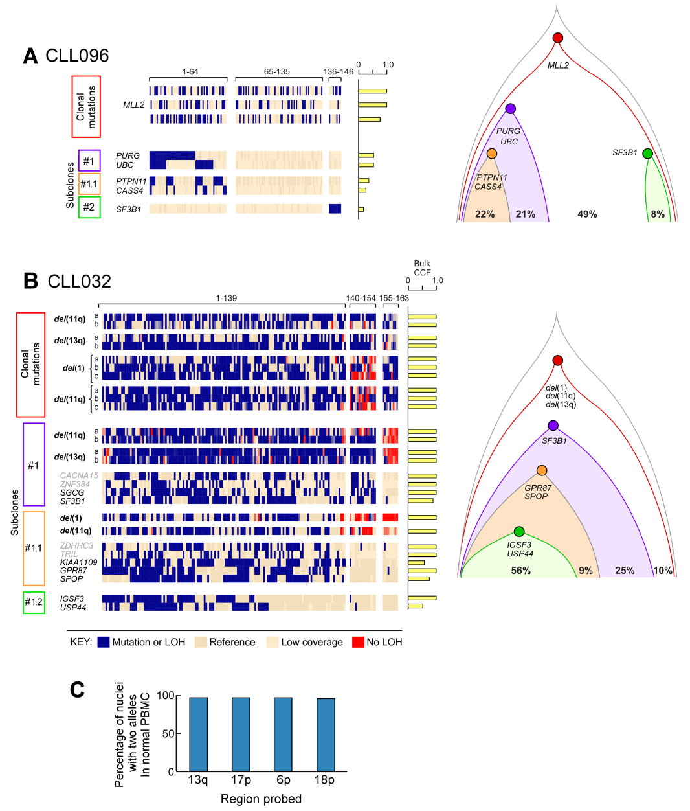

Figure 4. Phylogeny reconstruction using single-cell DNA analysis from CLL096 and CLL032.
(A-B) Somatic mutations and chromosomal deletions were analyzed using a targeted PCR approach in 146 and 163 single viable CD19⁺CD5⁺ cells from CLL096 (A) and CLL032 (B), respectively. Left: each column and each row represent a single cell and a mutation or chromosomal deletion, respectively. Blue and beige indicate the presence and absence of mutation or chromosomal deletion, respectively. Red shows the absence of chromosomal deletion. Right: clonal architecture derived from single cell DNA analysis.
(C) Sensitivity of FISH probes was evaluated of slides with FISH hybridization by detection of 2 signals using normal PBMC. 200 cells were counted and percentage of cells with 2 signals were plotted.

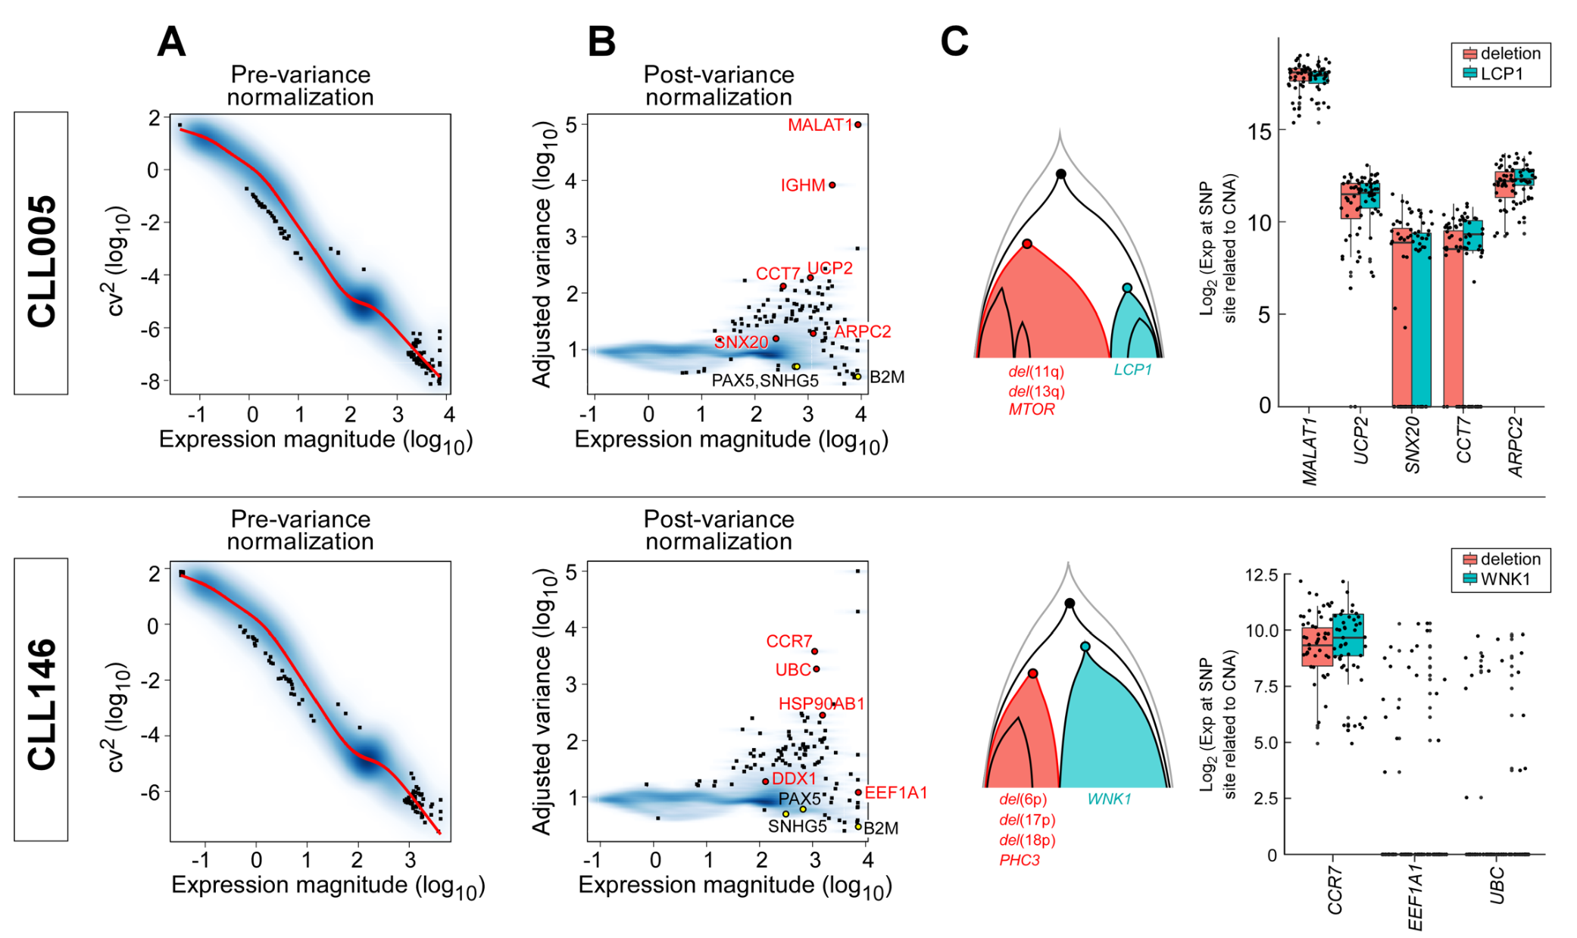

Figure 5. Variance normalization of single-cell RNA-seq data.
(A-B) Gene expression variation as a function of expression magnitude in single-cell RNA-seq data before (A) and after (B) variance normalization. Each dot represents a gene. CV is coefficient of variation. Single-cell RNA-seq data has high degree of technical noise. In general, gene expression variance depends on expression magnitude, with more lowly expressed genes being generally more variable due to technical noise. To identify highly variable genes that contribute to transcriptional heterogeneity, we performed variance normalization. Specifically, the residual expression variance for each gene is determined relative to the transcriptome-wide expectation model (red curve), taking into account the uncertainty in the variance estimate for each gene by determining the effective degrees of freedom for a χ2 distribution. Highly variable genes that drive different aspects identified by the PAGODA analysis were labeled as in red. Lowly variable housekeeping genes are in black.
(C) Highly variable genes were confirmed by targeted single-cell RNA assay. Highly variable genes determined by the PAGODA analysis to drive the transcription heterogeneity exhibit comparable expression levels between the two genetic branches.
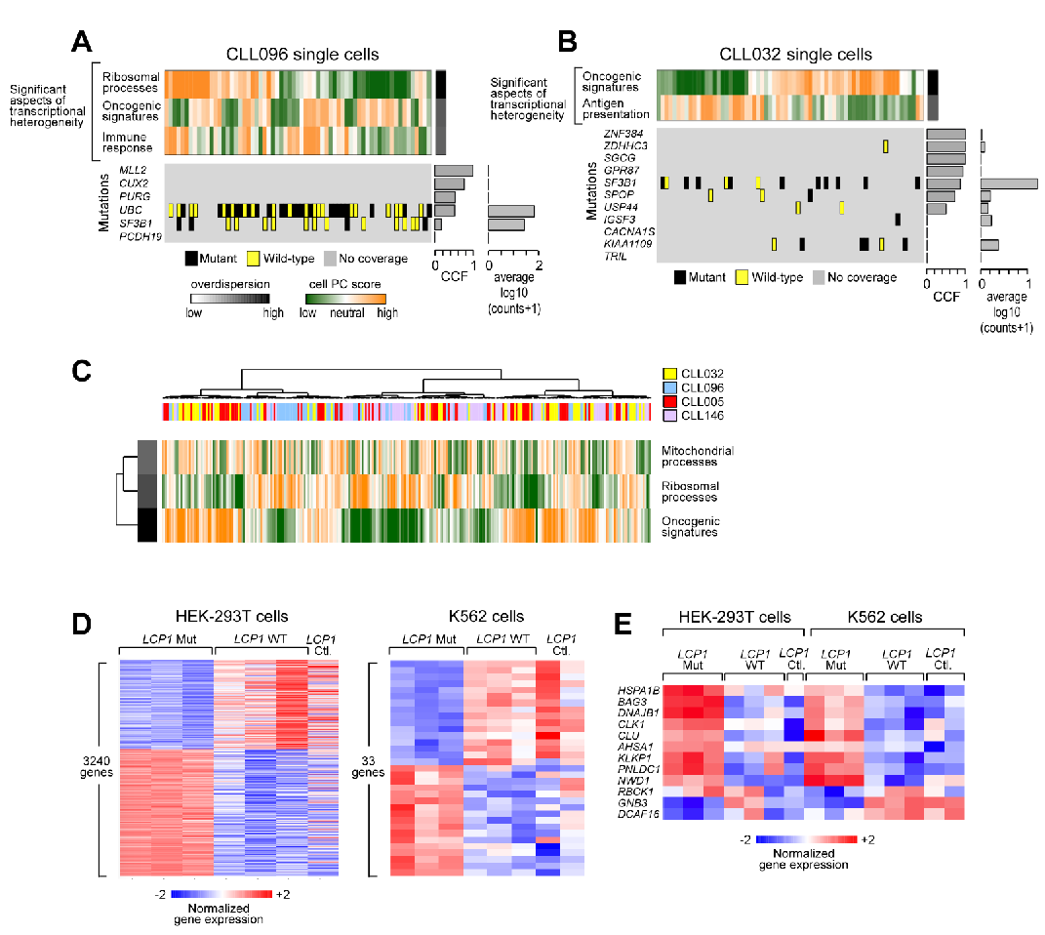
Figure 6. Single-cell transcriptome analysis reveals transcriptional heterogeneity.
(A-B) Correspondence of transcriptional and genetic subpopulations for CLL096 (A) and CLL032 (B). Significantly over-dispersed pathway clusters identified by PAGODA on the basis of gene sets defined by MSigDB annotations group cells into coherent and distinct aspects of transcriptional heterogeneity. Aspect scores (Cell PC score) are oriented so that high values generally correspond to increased expression of associated gene sets. Also shown are expression patterns of select genes driving each aspect of transcriptional heterogeneity along with their loading contributions to the aspect scores (left). Mutation calls for known subclonal variants from single cell RNA-seq data are limited due to lack of coverage and does not demonstrate a clear correspondence with identified transcriptional subpopulations.
(C) Overlapping aspects among the 4 CLL samples identified from single cell transcriptome analysis.
(D) Gene expression analysis in HEK293 cells with overexpression of LCP1. HEK293 and K562 cells were transiently expressed with either control, wild-type or mutant LCP1 constructs. 48 hours after the transfection, GFP positive cells were sorted and RNA was extracted from these cells. RNA-Seq was performed and differentially expressed genes were identified using DESeq2 R package (Love et al. 2014). (E) Overlapping differentially expressed genes were also identified between HEK293 and K562 cell lines.

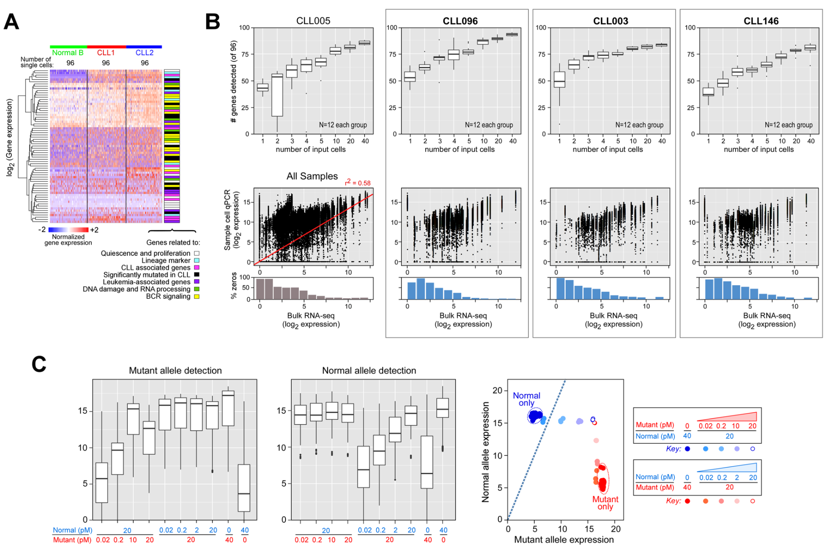

Figure 7. Targeted gene expression and mutation detection
(A) Targeted gene expression from single cell distinguishes normal and CLL-B cells. Heatmap of 96 gene expression from single cells that derived from one normal and two CLL-B cells.
(B) Targeted gene expression from various cell number of CLL cells. Upper panel: The number of genes detected from 96 genes using various number of cells (1 to 40 cells) by targeted multiplex PCR approach was plotted from 4 CLL samples. Lower panel: Correlation of gene expression detected between bulk RNA-Seq and single cell targeted PCR approach.
(C) Mutation detection sensitivity was assessed using oligonucleotide templates. Different ratios of either WT or MT oligo templates were mixed and qPCR were performed using assays that specifically detected WT or MT alleles. Detection of MT (left), Normal (middle), or MT vs Normal allele was plotted.

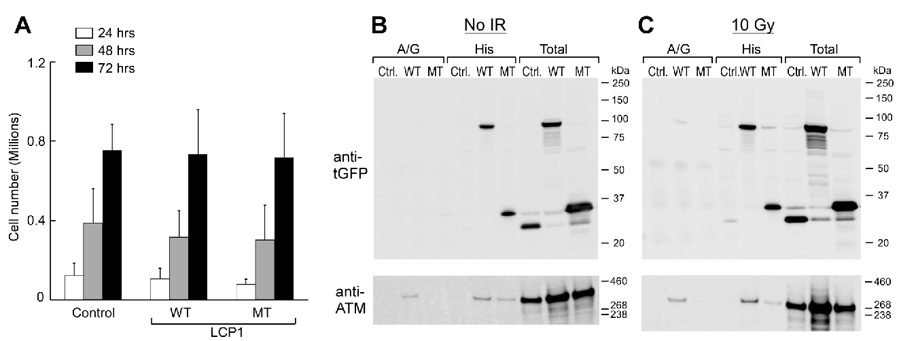
Figure 8. LCP1 mutation has no impact on cell proliferation in the stable cell lines.
(A) Expression of mutant LCP1 has no impact on cell proliferation and apoptosis. Cell proliferation and apoptosis of HEK293 cells stably express either wild-type or mutant LCP1 was monitored by cell counts and flow cytometry in a 4-day time course.
(B-C) Irradiation does not change the physical association between LCP1 and ATM protein. HEK293 cells stably expressed wild-type, mutant or control constructs were transiently transfected with ATM expressing construct (with N-terminal His tag, provided by Dr. Brendan Price). 48 hours after the transfection, cells were either treated (right panel) or untreated (left panel) with irradiation. Protein lysates were generated and immunoprecipiations were performed using anti-His beads or anti-GFP as well as isotype control antibodies followed by immunoblot against GFP or ATM protein.

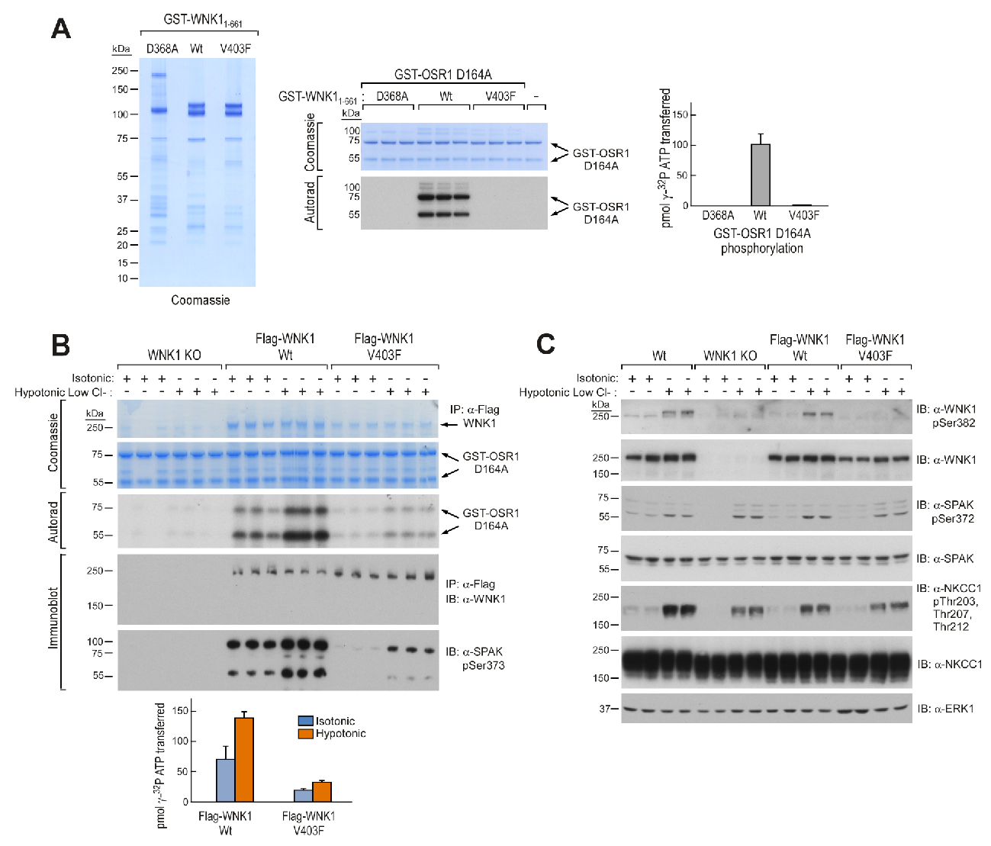
Figure 9. WNK1V304F mutation lost the kinase activity.
(A) V403F mutation in WNK1 inactivates the kinase. Left panel – SDS-PAGE and colloidal Coomassie stain of purified recombinant WNK1 kinases used in study. Right panel – Kinase assay of recombinant WNK1 kinases (0.08 μM recombinant kinase in reaction) against GST-OSR1 D164A (0.4 μM in reaction) was assayed for 30 minutes at 30°C. Quantification and autoradiography of GST-OSR1 D164A bands show that GST-WNK1 V403F has little to no kinase activity compared to GST-WNK1 WT kinase reactions are presented as means±S.D for triplicate reactions.
(B) Flag-WNK1 V403F has reduced kinase activity. HEK-293 Flp-In T-Rex WNK1 KO cells, HEK-293 Flp-In T-Rex WNK1 KO Flag-WNK1 WT/V403F expressing cells were stimulated with isotonic or hypotonic low chloride buffer for 30 minutes at 37°C. Cells were lysed and WNK1 immunoprecipitated with anti-Flag M2 beads. The immunoprecipitates were assayed for activity against GST-OSR1 D164A followed by immunoblotting to verify autoradiography and quantification using the indicated antibodies. The activity of Flag-WNK1 V403F against GST-OSR1 D164A may be explained by the immunoprecipitation pulling down other Wnk kinases, which all share OSR1 as a common substrate. Kinase reactions are presented as means±S.D for triplicate reactions.
(C) V403F mutation of WNK1 does not affect WNK signaling cascade. HEK-293 Flp-In T-Rex WT, WNK1 KO, WNK1 KO Flag-WNK1 Wt/V403F cells were stimulated with isotonic or hypotonic low chloride buffers for 30 minutes at 37°C. Cells were lysed, and lysates were subjected to immunoblotting using anti-WNK1, anti-WNK1 phosphoSer³⁷³, anti-SPAK, anti-SPAK phosphoSer³⁷², anti-NKCC1, and anti-phosphoThr²⁰³,Thr²⁰⁷,Thr²¹² antibodies. The mutation of WNK1 shows little to no change in WNK signaling compared to the WT and WNK1 KO cells due to compensation by other WNK kinases expressed in the cell.

References

Robinson JT, Thorvaldsdottir H, Winckler W, Guttman M, Lander ES, Getz G, Mesirov JP. 2011. Integrative genomics viewer. Nat Biotechnol 29(1): 24-26.
Love MI, Huber W, Anders S. 2014. Moderated estimation of fold change and dispersion for RNA-seq data with DESeq2. Genome Biol 15(12): 550.

