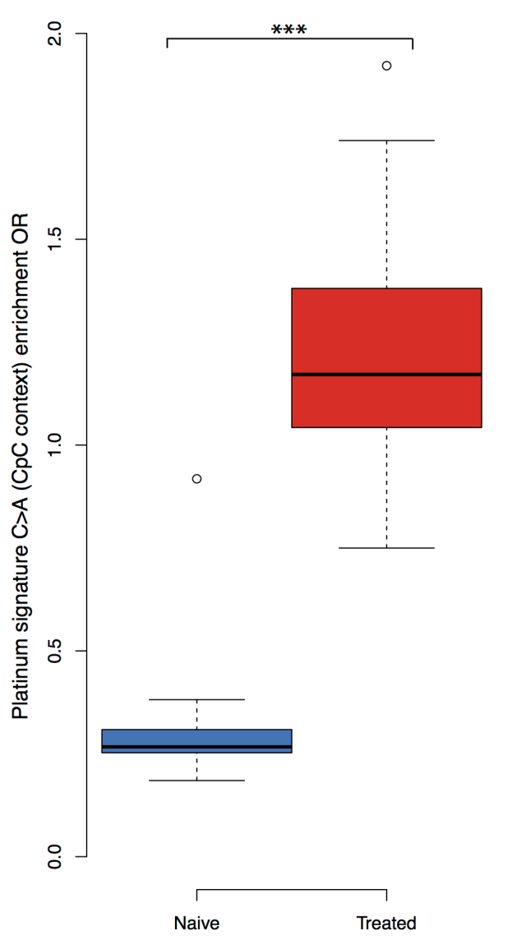
Supplemental Figure 5. Platinum signature enrichment odds ratio for chemotherapy naive (n=62) and chemotherapy treated (n=58) samples. The platinum signature encompasses C>A (G>T) mutations in a CpC (GpG) context. A significant enrichment of a platinum signature is observed in the chemotherapy treated group (Fisher exact test p-value<<0.0001).

