Supplemental Table S1: Summary of the roles of DNMTs in mouse and human cells

Supplemental Table S2: Sequences for shRNA and CRISPR guide RNA
Gene | TRC Clone | Sequence
DNMT1
 | TRCN0000232749 | CCGGCGATGAGGAAGTCGATGATAACTCGAGTTATCATCGACTTCCTCATCGTTTTTG
 | TRCN0000232751 | CCGGGAGGTTCGCTTATCAACTAATCTCGAGATTAGTTGATAAGCGAACCTCTTTTTG
 | TRCN0000021890 | CCGGGCCGAATACATTCTGATGGATCTCGAGATCCATCAGAATGTATTCGGCTTTTT
 | TRCN0000021891 | CCGGGCCCAATGAGACTGACATCAACTCGAGTTGATGTCAGTCTCATTGGGCTTTTT
 | TRCN0000021893 | CCGGCGACTACATCAAAGGCAGCAACTCGAGTTGCTGCCTTTGATGTAGTCGTTTTT
UHRF1
 | TRCN0000273315 | CCGGATGTGGGATGAGACGGAATTGCTCGAGCAATTCCGTCTCATCCCACATTTTTTG
 | TRCN0000273313 | CCGGCGTCATTTACCACGTGAAATACTCGAGTATTTCACGTGGTAAATGACGTTTTTG
gRNA
DNMT3A1 | sense | caccgCGATGACGAGCCAGAGTACG
 | antisense | aaacCGTACTCTGGCTCGTCATCGc
DNMT3A2 | sense | caccgGCATGATGCGCGGCCCAAGG
 | antisense | aaacCCTTGGGCCGCGCATCATGCc
DNMT3B1 | sense | caccgATCCGCACCCCGGAGATCAG
 | antisense | aaacCTGATCTCCGGGGTGCGGATc
DNMT3B2 | sense | caccgAGAGTCGCGAGCTTGATCTT
 | antisense | aaacAAGATCAAGCTCGCGACTCTc

Figure S1.
Figure S1. DNMT1 protein is the major player of DNA methylation maintenance.
- DNMT1 western blot analysis of SW48 and HT29 cells with or without 1 uM DAC treatment.
- Depletion of DNMT1 by shRNA knockdown (MT1sh51) below a threshold induced global demethylation in colorectal (HT29, DLD1), lung (A549), and breast (MCF7) cancer cell lines measured by Illumina Infinium HumanMethylation450K array. The density plots include all probes on individual arrays for each sample. β values: scores in the range between 0 and 1 indicating the level of DNA methylation (lowest to highest = increasing DNA methylation) (see Figures 1C and 1D)
- DNA methylation analyses by Illumina Infinium HumanMethylation 450K array in HCT116-derivative cell lines with various levels of DNMT1 protein depletion showing that DNA demethylation takes place in the promoter & 5’UTR, intergenic and gene body regions (left panel), and is irrespective of CpG islands (right panel). Y-axis denotes changes in β values for individual probes with respect to those in the wild type HCT116 cells (see Figures 1E and 1F)
Figure S2
Figure S2. Depletion of DNMT1 protein below a threshold level disrupts epigenetic silencing of tumor suppressor genes.

- Upper panel, DNA methylation analyses by Illumina Infinium HumanMethylation 450K arrays in HCT116 cells and its derivative cell lines showing gradual decreases in DNA methylation of 4 representative genes, AKR7A3, ZFP42, TMEFF2, MGMT, corresponding to the reducing levels of DNMT1 protein in each cell line. Levels of DNA methylation are indicated by β values in the range between 0 (totally unmethylated) and 1 (totally methylated). An artificial line is drawn to connect the CpG sites in each gene for easy visualization. Lower panel, gene expression analyses by Agilent human GE 4x44K arrays showing re-expression of four genes, AKR7A3, ZFP42, TMEFF2, MGMT, as the levels of DNA methylation decrease. Y-axis denotes log2 fold changes in gene expression relative to the wild type HCT116 cells.
- Bisulfite sequencing of the promoter region CpG island of CDKN2A in RKO cells showing that DNA demethylation occurs when sufficient DNMT1 knockdown is obtained using shRNA of higher efficiency (sh49) as opposed to that of lower efficiency (sh93). Open circles: unmethylated CpG dinucleotides. Closed circles: methylated CpG dinucleotides. Percentages of methylation for CDKN2A are calculated from all valid clones for each sample. (See Figure 2E)
- Bisulfite sequencing of the promoter region CpG island of the methylated wild-type CDKN2A allele in HCT116 DNMT1 hypomorph cells showing that DNA demethylation occurs when sufficient DNMT1 knockdown is obtained using shRNA of higher efficiency (sh49) as opposed to that of lower efficiency (sh93). Open circles: unmethylated CpG dinucleotides. Closed circles: methylated CpG dinucleotides. Percentages of methylation for CDKN2A are calculated from all valid clones for each sample. (See Figure 2E)

Figure S3

Figure S3. Depletion of de novo DNMTs results in both losses and gains of DNA methylation.
- Examples of genes that lose DNA methylation following knockout of DNMT3A (GRHL3), DNMT3B (MAGEA10) or both (ZNF217) in HCT116 cells. Individual bars represent Infinium 450K array probes with respect to the reference genome (RefSeq) for each gene. The heights of the bars indicate β values ranging from 0 (totally unmethylated) to 1 (totally methylated). Green bars below the reference genome denote CpG islands.
- Examples of genes (TMEM100, ANGPTL2, and PRSS1) that gain DNA methylation following knockout of DNMT3A. Individual bars represent Infinium 450K array probes with respect to the reference genome (RefSeq) for each gene. The heights of the bars indicate β values ranging from 0 (totally unmethylated) to 1 (totally methylated).

- Expression-methylation plots showing substantial DNA demethylation in HCT116 cells subject to knockout of DNMT3A or DNMT3B through the CRISPR approach (HCT116.3AcKO.1, HCT116.3BcKO) and the traditional genetic knockout approach (HCT116.3BgKO), or the combination of both (3BgKO.3AcKO.1). Y-axis denotes changes in average β values of promoter probes for individual genes with respect to those in the wild type HCT116 cells measured by Illumina Infinium HumanMethylation 450K array. Only hypermethylated genes—average β values of promoter probes greater than 0.75—in HCT116 wild type cells are included in the analysis. X-axis denotes log2 fold changes in gene expression relative to the wild type HCT116 cells measured by Agilent human GE 4x44K arrays.

Figure S4

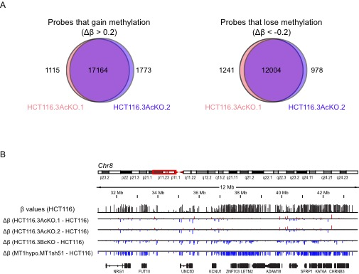

Figure S4. DNMT3A KO clones generated with different gRNAs share similar DNA methylation changes.
- Venn diagrams showing the overlap of gains (left) and losses (right) of DNA methylation of Infinium 450K probes in two HCT116 DNMT3A KO clones generated with different gRNAs (HCT116.3AcKO.1 and HCT116.3AcKO.2)
- Genome browser tracks covering a 12Mb region of chromosome 8. Black track represents the β values of Infinium 450K probes in HCT116 cells. The heights of the bars indicate β values ranging from 0 (totally unmethylated) to 1 (totally methylated). Blue and red tracks represent the β values decreases or increases of Infinium 450K probes in HCT116 DNMT mutant cells relative to wild type cells.

Figure S5
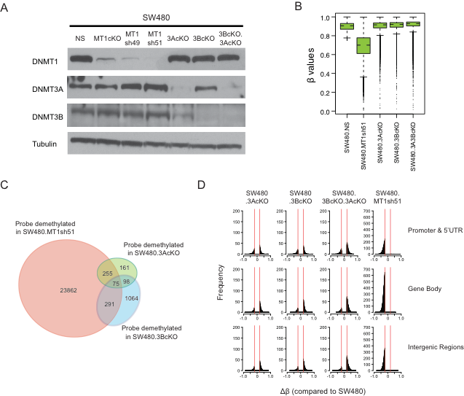

Figure S5. Global DNA methylation dynamics in SW480 cells deficient in DNMTs.
(A) DNMT western blot of SW480 cells subject to depletion of DNMTs using either CRISPR knockout (1KO, 3AcKO, 3BcKO, 3AcKO.3BcKO) or shRNA knockdown (MT1sh49, MT1sh51).
(B) DNA methylation boxplots showing β values changes (Y- axis) of hypermethylated CpG probes in SW480 cells (β values greater than 0.75) in the isogenic DNMT mutant cell lines (X-axis).
- Venn diagram showing the overlap of demethylated Infinium 450K probes in SW480 DNMT1
knockdown (SW480.MT1sh51), DNMT3A knockout (SW480.3AcKO) and DNMT3B knockout (SW480.3BcKO) cells. The analysis includes promoter probes with basal β values greater than or equal to 0.5 in wild type SW480 cells, and β value decreases larger than 0.2 upon depletion of individual DNMTs.
- Histograms of frequency distribution (Y- axis) of differentially methylated CpG (Δ β ≥ 0.2) of
Infinium 450K probes with increased or decreased β values (X-axis) in various SW480 DNMT mutant cells compared to SW480 wild type cells.

Figure S6

Figure S6. DNMT1 knockdown disrupts gene body DNA methylation maintenance.
- DNA methylation analyses by Illumina Infinium HumanMethylation 450K array in HCT116 and the derivative cell lines depleted of individual DNMTs. All probes with β values greater than 0.75 in HCT116 cells were included in the analysis. Genes are categorized by their promoter CpGi status, as well as by methylation status of promoters and gene bodies. Green boxes represent promoter probes. Pink boxes represent gene body probes.
- Gene expression changes upon below-threshold depletion of DNMT1 in HCT116 DNMT1 hypomorph cells (MT1hypo.MT1sh51.d12) relative to that in the wild-type HCT116 cells, measured by Agilent human GE 4x44K arrays. Highly expressing genes (genes with baseline expression signal intensities greater than the 50 percentile of all genes) in the wild-type HCT116 cells are divided into 4 groups based on their promoter and gene body methylation status. Genes with at least two-fold changes are considered up- or down-regulated.

Figure S7

Figure S7. DNMT1 maintains the bulk of DNA methylation in HCT116 cells
(A) Dot blot analysis of global 5-methylcytosine (5mC) levels in HCT116 DNMT mutant cells with an antibody against 5-methylcytosine.
(B) Dot blot analysis of global 5-hydroxymethylcytosine (5hmC) levels in HCT116 DNMT mutant cells with an antibody against 5-hydroxymethylcytosine.

Figure S8

Figure S8. The relationships of DNMT1 level and key gene expression in HCT116 DKO cells
(A) DNMT western blot analysis of different HCT116 DKO cell clones (the combination of DNMT1 hypomorph and DNMT3B knockout).
(B) Whisker box plots of overall DNA methylation levels in different DKO clones. All probes on the Infinium Methylation 450K array are included in the analyses.
(C) Dynamics of DNMT1, DNMT3A and CDKN2A proteins in DKO2 cells at different passages (p30, p80, p100).
(D) Western blot analysis of DNMT1, DNMT3A and CDKN2A proteins in late passage DKO2 cells (p110) treated with efficient (sh51) and inefficient (sh93) DNMT1 shRNAs.
(E) Gene expression changes of representative genes in DKO2 cells at different passages (p30, p80, p100) measured by Agilent human GE 4x44K arrays. The data demonstrate that several genes (RARB, CLDN1, CXCL3 and GFAP) have similar expression patterns with CDKN2A, and are down-regulated at later passages.
(F) Western blot analysis of DNMTs in HCT116 MT1hypo cells subject to depletion of DNMT3s using CRISPR (3AcKO.1, 3AcKO.2, 3BcKO.1 and 3BcKO.2) for 14 or 28 days.
Figure S9

Figure S9. DNA Methylation of distal enhancers are maintained primarily by DNMT1
- Distributions of enhancer-associated Infinium 450K array probes around the transcription start sites (TSS). Enhancers are divided into 3 groups based on their enrichment of H3K4me1 and H3K27ac marks in HCT116 cells— K4me1+/K27ac-, K4me1+/K27ac+, and K4me1-/ K27ac+. The data reveal that three enhancer groups have similar propensities for TSS.
- Distances of enhancer-associated Infinium 450K array probes to the TSS. No significant differences were noted among three groups of enhancers.
- DNA methylation levels of poised enhancers (H3K4me1+, H3K27ac-) measured by Illumina Infinium HumanMethylation 450K array in various HCT116 DNMT knockout clones (y-axis) as opposed to the parental HCT116 cells (x-axis).

Figure S10

Figure S10. Decitabine and azacitidine at clinically-relevant doses induce moderate DNA demethylation as opposed to maximum DNMT1 knockdown
- DNA methylation analyses of HCT116 cells subject to 5-aza-2’-deoxycytidine (DAC) treatment at different concentrations. The heatmap includes all promoter CpGi probes with β values greater than or equal to 0.75 in HCT116 mock-treated (Mock) cells.
- Western blot analysis of DNMT1 levels in HCT116 cells following 5-aza-cytidine (AZA) treatment in comparison with DNMT1 knockdown using shRNA51.
- Western blot analysis of DNMT1 levels in DLD1 and RKO cells following 5-aza-cytidine (AZA) treatment in comparison with DNMT1 knockdown using shRNA51.
- DNA methylation changes measured by Infinium 450k arrays in HCT116, DLD1 and RKO cells following AZA treatment. Analyses include promoter CpG island probes with β values greater than or equal to 0.5.

Figure S11

Figure S11. Moderate UHRF1 inhibition augments the DNA demethylation effect of low-dose DAC
- Western blot analysis of DNMT1 and UHRF1 proteins, with alpha tubulin as a loading control, in HCT116 colorectal cancer cells subject to ~ 90% UHRF1 shRNA knockdown. NS: Non-silencing shRNA control.
- Effects of DNA demethylation in HCT116 by low-dose DAC treatment, UHRF1 knockdown (~60% reduction of UHRF1 protein), or a combination of both. Infinium 450K probes with β values greater than or equal to 0.75 in HCT116 wild type cells at promoter & 5’UTR, gene body and enhancer regions are included in the analyses.
- and (E) Expression-methylation plots of HCT116 following DAC treatment, UHRF1 knockdown with ~60% (C) or ~90% (E) reduction of UHRF1 protein) or a combination of both. Y-axis denotes changes in average β values for individual genes with respect to those in the wild type HCT116 cells measured by Infinium 450K array. Only hypermethylated genes with average β values of promoter probes greater than 0.75 are shown. X-axis denotes log2 fold changes in gene expression relative to the wild type HCT116 cells measured by Agilent human GE 4x44K arrays.
- and (F) Gene expression changes of seven representative genes with methylated promoter CpG island in HCT116 cells measured by Agilent human GE 4x44K arrays following DAC treatment (yellow bars), UHRF1 knockdown with ~60%(D) or ~90% (F) reduction of UHRF1 protein (red bars) or a combination of both (purple bars). Y-axis denotes log2 fold changes of gene expression relative to that in the untreated HCT116 cells.

Figure S12

Figure S12. Profound UHRF1 inhibition diminishes additive effects with DAC treatment.
- Expression-methylation plots of HCT116 following DAC treatment, UHRF1 knockdown (~90% reduction of UHRF1 protein level) or a combination of both. Y-axis denotes changes in average β values for individual genes with respect to those in the wild type HCT116 cells measured by Infinium 450K array. Only hypermethylated genes with average β values of promoter probes greater than 0.75 are shown. X-axis denotes log2 fold changes in gene expression relative to the wild type HCT116 cells measured by Agilent human GE 4x44K arrays.
- Gene expression changes of seven representative methylated genes with CpG-poor promoters in HCT116 cells measured by Agilent human GE 4x44K arrays following DAC treatment (yellow bars), UHRF1 knockdown with ~90% reduction of UHRF1 protein level (red bars) or a combination of both (purple bars). Y-axis denotes log2 fold changes of gene expression relative to that in the untreated HCT116 cells.
- Gene expression changes of immune-related, viral defense genes measured by Agilent human GE 4x44K arrays following DAC treatment (yellow bars), UHRF1 knockdown with ~90% reduction of UHRF1 protein level (red bars) or a combination of both (purple bars). Y-axis denotes log2 fold changes of gene expression relative to that in the untreated HCT116 cells.

