Pan-cancer analysis distinguishes transcriptional changes of aneuploidy from proliferation

Christopher Buccitelli¹, Lorena Salgueiro², Konstantina Rowald², Rocio Sotillo², Balca R. Mardin^{1,3*}, Jan O. Korbel^{1*}

Supplemental Material containing 5 figures

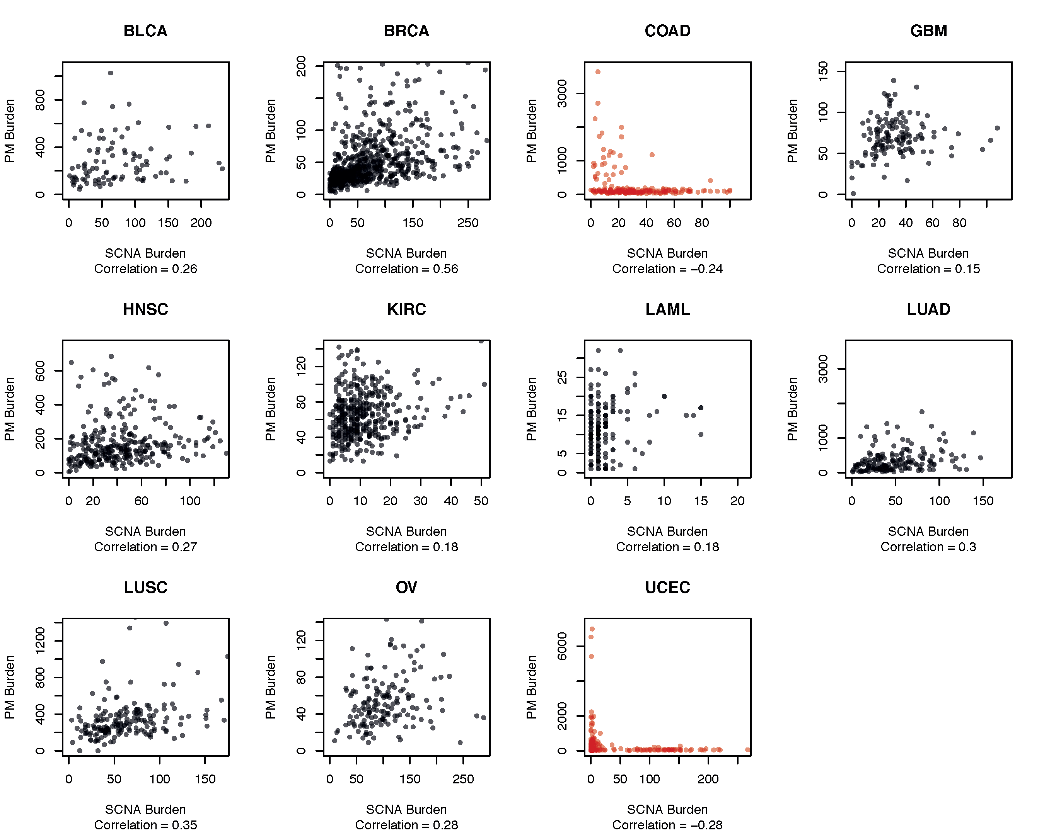
Supplemental Fig. S1: PM and SCNA burdens of individual tumor types.
Each dot represents an individual tumor. Tumors with negative correlations between PM and SCNA burden are shown in red. For display purposes, outermost samples with SCNA or PM burdens exceeding the mean +3 standard deviations have been omitted.
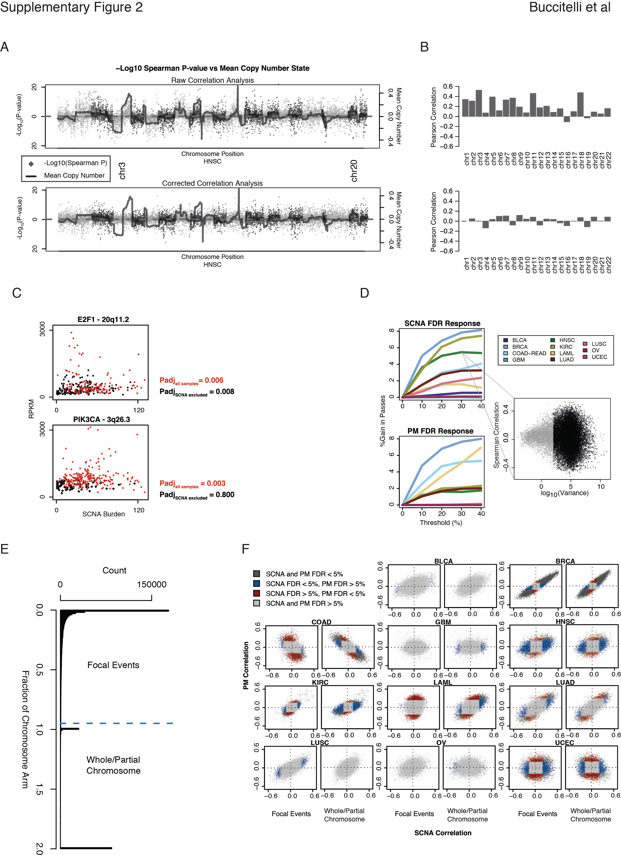

Supplemental Fig. S2: Pre-analysis and filtering of correlation analysis
A-D Representative example of the data pre-processing for HNSC.
(A) Dot plot ordered by gene position (X-axis, alternating dot colors indicate different chromosomes). Y-axis displays the –log10 transformed Spearman correlation P-value with the directionality denoting negative (down) or positive (up) correlations. The overlaying line gives the average copy number state of each gene across the tumor dataset. Upper panel displays the relationship between our correlation analysis and the recurrence of SCNAs at that genomic position before correction whereas the lower panel presents the corrected correlation analysis.
(B) Barplot displaying the Pearson correlation per chromosome between copy number means and P-values for each gene on that chromosome. Upper and lower panels are ordered as in A.
(C) Example of dosage correction approach on two genes. mRNA expression is plotted on the Y-axis as RPKM and SCNA burden on the X-axis. Sample dots colored red indicate that for the respective gene (e.g. E2F1), an SCNA is found overlapping the gene in that sample. Black dots represent samples where the corresponding locus is not affected by SCNA. Adjusted correlation P-values are shown on the side before and after correction in red and black, respectively.
(D) Independent filtering based on variation in gene expression. The left-hand panels present, per tumor type (see legend), the increase in the percentage of genes passing an FDR < 5% (Y-axis) depending on percentage of low-variable genes discarded (X-axis) in both SCNA and PM analyses. The lower right hand panel displays the dependence of correlation on variation. X-axis displays the log10 transformed variation in gene expression per gene. Y-axis displays the Spearman correlation value. Grey dots represent the 30% of genes with the lowest expression variation that have been discarded before future analysis.
E-F Effect of SCNA size on correlation distribution
(E) Distribution of sizes of amplification and deletion calls from Zack, Schumacher et al. 2013. Blue line depicts size threshold of fraction of chromosome corresponding to one arm length, distinguishing larger (whole or arm chromosome loss) from smaller (focal) events.
(F) Correlation plots as in Figure 1B except using SCNA burdens derived uniquely from either focal or whole/partial chromosome events as defined in E.

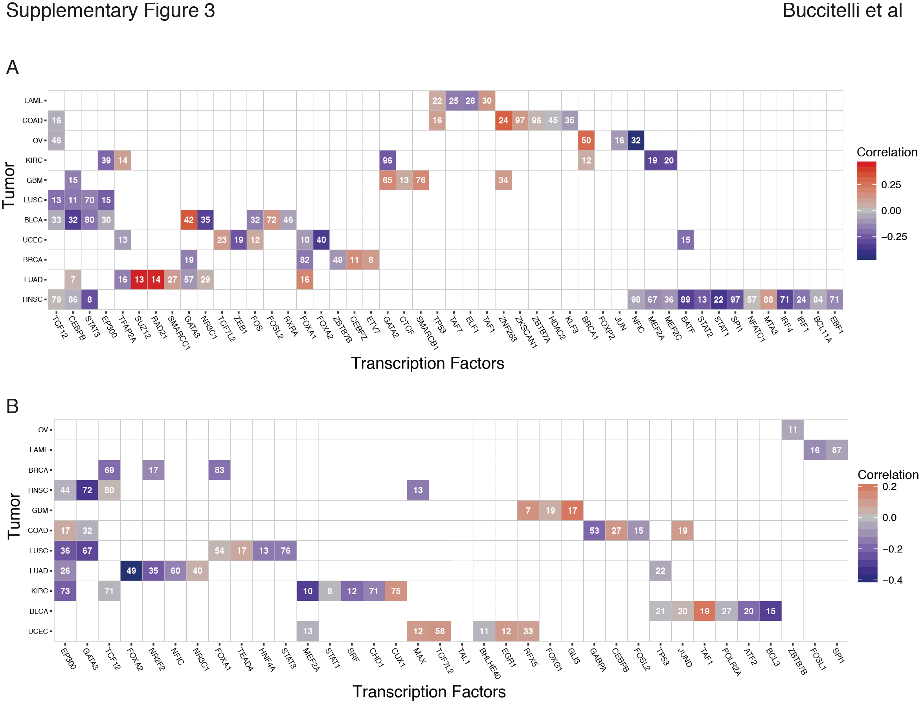

Supplemental Fig. S3: Pathway and transcriptional regulation prediction analyses of genes negatively associated with PM and SCNA burden
(A) iRegulon transcription factor prediction of the bottom 200 genes correlating with SCNA burden. Per tumor type (rows), transcription factors (columns) predicted to regulate a significant number (number within tile) are shown. In cases where a transcription factor is predicted, the correlation coefficient of that factors gene itself is denoted by the color (see legend).
(B) iRegulon transcription factor prediction performed as in A, focused on the bottom 200 genes correlating with PM burden.

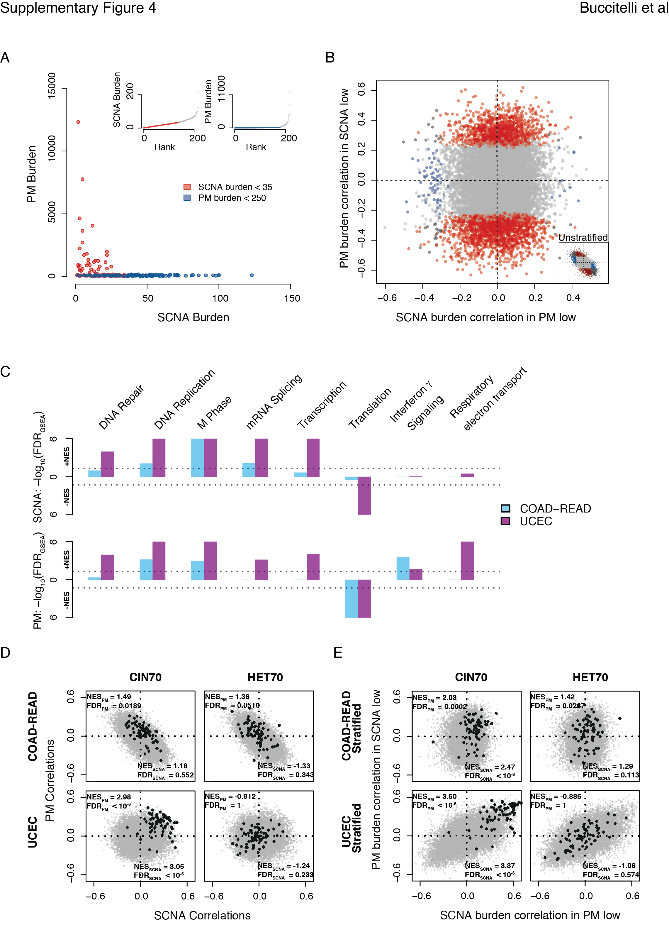
Supplemental Fig. S4: Comparative correlative analysis of gene expression in tumors stratified by variant type
(A) Colorectal cancers segregated based on low SCNA (red) or low PM (blue) burden. Insets show sample composition of low-SCNA (right) and low-PM (left) tumors.
(B) Comparison between SCNA burden correlations in low-PM tumors (X-axis) and PM burden correlations in low-SCNA tumors (Y-axis). Grey: FDR_{PM} > 5% and FDR_{SCNA} > 5%, Blue: FDR_{PM} > 5% and FDR_{SCNA} < 5%, Red: FDR_{PM} < 5% and FDR_{SCNA} > 5%, Black: FDR_{PM} < 5% and FDR_{SCNA} < 5%. Lower right inset displays distribution of the unstratified COAD-READ correlation distribution.
(C) GSEA of stratified PM and SCNA correlation analyses in COAD-READ and UCEC. –log10-transformed FDR_{GSEA}s displayed on Y-axis with directionality denoting the direction of the enrichment. Colors denote tumor types described in the legend. Upper panel: SCNA correlation enrichments. Lower panel: PM correlation enrichments. Dotted lines denote cutoffs corresponding to FDR_{GSEA} < 5%.
(D) Focus on 2D GSEA for CIN70 and HET70 signatures in unstratified COAD-READ and UCEC correlation analyses. Genes from signatures are superimposed on correlation plots in black. Normalized Enrichment Score (NES) and FDR_{GSEA} displayed in plot.
(E) As with D using the stratified variant correlation output.

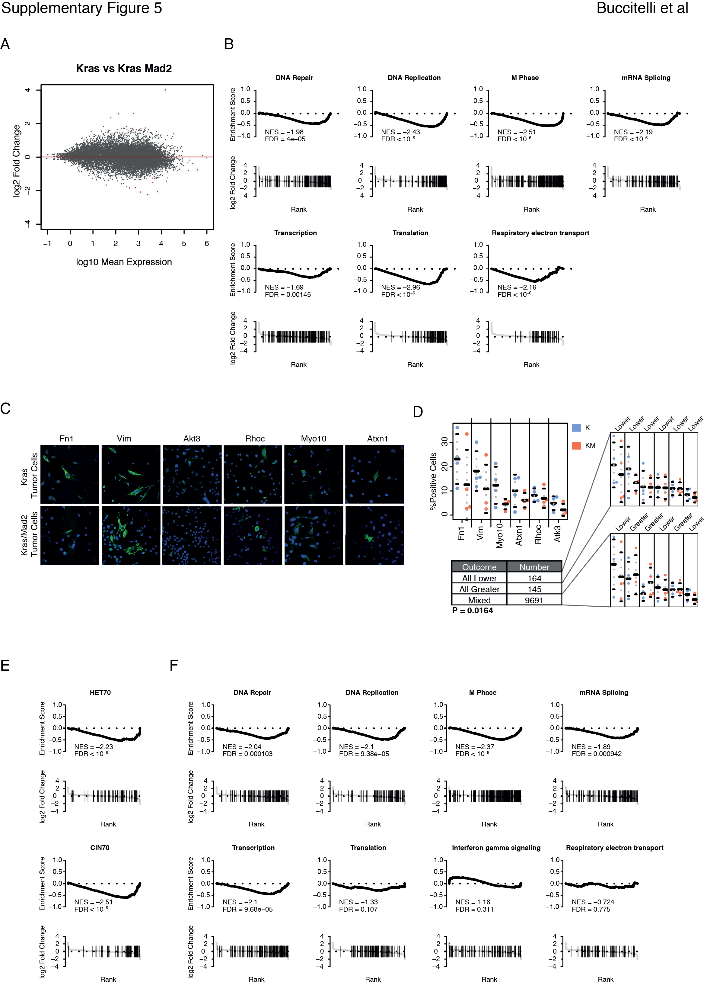

Supplemental Fig. S5: Gene expression analysis of Kras versus Kras-Mad2
(A) –log10 transformed mean expression (counts) per gene (X-axis) are plotted against the log2 fold changes (Y-axis). Genes marked by red dots pass and FDR threshold of 0.1 and have log2 fold changes > 1.
(B) GSEA plots of sample gene sets of Figure 5. Per panel, running-sum plots with the running sum on the Y-axis and gene rank based on fold changes on the X-axis are displayed above ranked fold changes with gene-set members denoted by black lines. Normalized Enrichment Score (NES) and FDR_{GSEA} displayed in plot.
(C) Representative images of immunofluorescence staining for HET70 genes in K and KM breast tumor cell explants. DAPI staining shown in blue, test-gene staining shown in green.
(D) Statistical analysis of microscopy images taken. Upper left panel showing average percentage of positive staining cells on Y-axis and gene of interest on X-axis. Mean percentages shown +/- one standard error of the mean. Right panels showing examples of outcomes of permutation test. Lower table showing summary of outcomes of permutation test and the calculated permutation P-value.
(E) GSEA analysis of HET70 and CIN70 from KM versus K lung tumor microarray analysis.
(F) GSEA analysis of gene sets as in Figure 5C and Supplementary Figure 4B from KM versus K lung tumor microarray analysis.

