Supplementary Materials

DNA and RNA Sanger sequencing
To obtain cDNA, extracted RNA was treated with DNase I (Ambion) and then a reverse transcriptase reaction was performed with SuperScriptIII (Invitrogen), using 6-mer random primers. DNA was extracted using Phire Tissue Direct PCR Master Mix (Thermo Scientific). PCR amplification was performed using specific primers (listed below). The amplification products were either directly sequenced by Sanger sequencing or cloned into pGEM-T vector (Promega). Individual colonies were picked up and were subjected to PCR using M13 reverse and M13 forward primers and were sequenced by Sanger sequencing.

Quantitative PCR on mRNA
RNA (9ug) was treated with DNase using TURBO DNA-free kit (Invitrogen) and then 500ng were reverse transcribed by Q-SCRIPT flex cDNA synthesis kit (Quanta Biosciences) using random primers, according to the manufacturer’s protocol. qPCR primers were designed using Primer designing tool (http://www.ncbi.nlm.nih.gov/tools/primer-blast). When possible, primers spanning exon junctions were chosen. qPCR reactions were prepared in triplicate using PerfeCTa SYBR Green FastMix ROX (Quanta Biosciences) according to manufacturer’s protocol and run on CFX-96 Real Time system (Bio-Rad). The results were analyzed using Bio-Rad CFX manager software. Gene expression was calculated by normalizing to reference genes (ΔΔCq).
Melting curve confirmed an existence of a single product in each reaction. All NTC controls were negative. All NRT controls were either negative or not significant (<3% of total product). For efficiencies of the amplification reactions and stability of reference genes in embryo and L4 see supplemental tables S5 and S6 respectively. Mean stability of the two calibrator genes was 0.09 in embryos and 0.12 in L4.

Primers used in this study
egl-2, genomic
Forward 5' - ATTTTAAAAATCGGGTCTTC - 3'
Reverse 5' - AGCATCTGCCAAAATATTTA - 3'
egl-2, cDNA
Forward 5' - ATCACGAAATGATCAGCAATG - 3'
Reverse 5' - CAAGACGAAAACAACTGTGC - 3'
egl-2, 3'UTR
Forward 5' - ATTTGTGATATGTAAACTTCATTG - 3'
Reverse 5' - CAGTTTTAATAAATAAAAACGGC - 3'
adr-1, cDNA
Forward 5' - TTCATGCAACAACAACAGAG - 3'
Reverse 5' - GAACAGCTCATGAAGCAAC - 3'
adr-2, cDNA
Forward 5' - TCTATAACAGAAACCAACCG - 3'
Reverse 5' - CTCTTCTTGCGAGAATTTC - 3'
lem-2, 3'UTR first PCR
Forward 5' - CGAGCAAAAATCCATCG - 3'
Reverse 5' - GTGGATCGGAAATCAGTCTC - 3'
lem-2, 3'UTR second PCR
Forward 5' - CGAGCAAAAATCCATCG - 3'
Reverse 5' - GGTATCACAATGACCGAATATC - 3'
F48E8.4, 3'UTR
Forward 5' - CTTCTAGTCCCGCCAAATTTATG - 3'
Reverse 5' - CAGTTGAAGTTATTCCACGACCC - 3'
T28A8.3, 3'UTR
Forward 5' - TTTGTTCAAGTTATGAAAGAATTTTCG - 3'
Reverse 5' - CGAAACCTAGATTTTCTGAATTCTCC - 3'
pot-3, 3' UTR
Forward 5' - TTGCCGAGTGATCTTCCAC - 3'
Reverse 5' - GCGATTTCTTTTACAAAGAAACCG -3'
F07B7.12, 3'UTR
Forward 5' - AGGTCTTAGCTTGAGTCATTCAC - 3'
Reverse 5' - TTGTGCTGGATATAAAGTTGATG - 3'
lrg-1 (F55H2.4), 3'UTR
Forward 5' AAACTGCTCTTCGTAACCAG 3'
Reverse 5' TTCGGCTGGAGAGAGTC 3'
C52E12.6, 3'UTR
Forward 5' GAAGATTTACGTGCCAGAG 3'
Reverse 5' CAAATATTTTTTCTTCTCCACTG 3'
K09F6.7 , 3'UTR
forward 5' GCATTTGAAGCTAAGAATAAATTAC 3'
reverse 5' CAAGTCTCTCACTCTCTCGTC 3'
K11H12.1, 3'UTR
forward 5' ATGAAACTCGAACTAGTGGG 3'
reverse 5' TTTTCCGTGTTTCATTGAC 3'
Y53F4B.6, 3'UTR
forward 5' AGACGGGTGGTATCAGC 3'
reverse 5' ACCGTCTCTTCCTCCATAG 3'

Primers used for qPCR

Gene ID | Transcript type | Direction | Sequence | Tm | Product length | Exon junction span
rncs-1 | lncRNA | FOR | TGAGCAAGATGGGGATGTAGTC | 59.56 | 85 | no
 | lncRNA | REV | TCTTTCAGCTCGATGCCCTT | 59.38 | 85 | no
M04D5.1 | Coding | FOR | AAATGAGATCCCCGGCATGG | 60.18 | 101 | yes
 | Coding | REV | TCCATCCATACGCGTCCTTG | 59.9 | 101 | no
pot-3 | Coding | FOR | GAGTTCCAACAGCCGGAAGA | 59.97 | 87 | no
 | Coding | REV | AGATCACTCGGCAAAGGGTC | 59.75 | 87 | no
Y92H12BL.1 | Coding | FOR | GTTGAAGGGCAATAAGGTGCG | 60.14 | 121 | yes
 | Coding | REV | GTTAAGGCAACCGGTGGAGA | 59.96 | 121 | no
clec-41 | Coding | FOR | TTGCTCCGGGATACCCTCTT | 60.33 | 143 | yes
 | Coding | REV | GATTGGGCTTGTTGGTGCTG | 60.04 | 143 | no
col-98 | Coding | FOR | GTTCTGCGTTCTTTCCGTCG | 59.84 | 108 | no
 | Coding | REV | TGCTTGCAGAATGAGACCTCC | 60.34 | 108 | yes
fbxb-4 | Pseudogene | FOR | CCACTTCTGTTGCTACCCGA | 59.68 | 219 | no
 | Pseudogene | REV | CGTCACAACGCACAAGATCC | 59.84 | 219 | no
T26E3.11 | Pseudogene | FOR | ACCAGCCAAACCATATCGGA | 59.08 | 91 | no
 | Pseudogene | REV | TTGTGTGGGTTGAGCACACT | 60.03 | 91 | no
F55B12.11 | Pseudogene | FOR | TGGGCGCTTTCAGATTGACT | 59.96 | 117 | no
 | Pseudogene | REV | AGGGCTTCTGACTGTTCAGC | 59.96 | 117 | no
F59C6.10 | Pseudogene | FOR | ATGATGGGACAAGAGCCACG | 60.11 | 144 | no
 | Pseudogene | REV | GGACCGCAGATGTAAGCAGT | 60.11 | 144 | no
Y116F11B.10 | Pseudogene | FOR | GAAATGCTGTGCCCGACTTC | 59.83 | 114 | no
 | Pseudogene | REV | GGTTCGGACGAGAAAGAGCA | 60.04 | 114 | no
orai-1 | Coding | FOR | TGCAGCTGGAATAGATCCCC | 59.23 | 131 | yes
 | Coding | REV | TTGGAGCATTTTCCACGGGT | 60.18 | 131 | no
fce-1 | Coding | FOR | TCTGGGCCATGAATTGGGTC | 60.03 | 136 | no
 | Coding | REV | TGAGCAAGATGGGGATGTAGTC | 60.06 | 136 | no
scpl-4 | Coding | FOR | TCTTTCAGCTCGATGCCCTT | 60.18 | 163 | no
 | Coding | REV | AGGAAGTGAACAAGTCGCCA | 60.11 | 163 | no

Supplementary Figures and Tables

Supplemental Fig S1. Editing sites in mis-annotated 3'utr of lem-2 gene region. UCSC Genome Browser image showing the position of editing sites found in chrII:14065900-14066800 relative to the 3'utr of lem-2 (https://genome.ucsc.edu/). Editing sites are shown in black track and lem-2 gene annotations are shown in blue and red. Tight cluster of edited sites all related to lem-2 are annotated both as 3’UTR and as intergenic regions.

C.
Gene ID | Editing observed by Sanger sequencing of total cDNA amplification product | Editing observed by Sanger sequencing of individual clones
Y53F4B.6 | Yes | NA
K11H12.1 | Yes | NA
K09F6.7 | No | 3/24
F55H2.4 | No | 2/53
C52E12.6 | No | 6/62

Supplemental Fig S2. Validating RNA editing in specific genes by Sanger sequencing.
A. Sanger sequencing of Y53F4B.6 genomic DNA (upper panel) and mRNA from L4 stage (Lower panel). Nucleotide change in the predicted editing site (blue arrow) is only observed at the mRNA level suggesting that this gene undergoes RNA editing. B. Sanger sequencing of C52E12.6 genomic DNA (upper panel) and sequencing of two specific clones of mRNA after colony PCR (middle and lower panels). Nucleotide change was observed in sequenced colony number 25 (green arrow) but not in the DNA nor in colony number 21 (blue arrows). C. A table that summarizes the results of Sanger sequencing either directly or by sequencing individual clones after colony PCR. Colony PCR was performed in cases where directly sequencing the product by Sanger sequencing did not yield editing.

A.

B.

Supplemental Fig S3. Comparing expression changes of 3’UTR edited genes and pseudogenes upon knockout of the A-to-I RNA editing as measured by qPCR or HTS. (A) Embryo and (B) L4 developmental stages. Vertical axis indicates the expression level in ADAR mutant strain relative to wildtype. Error bars represent standard deviation.

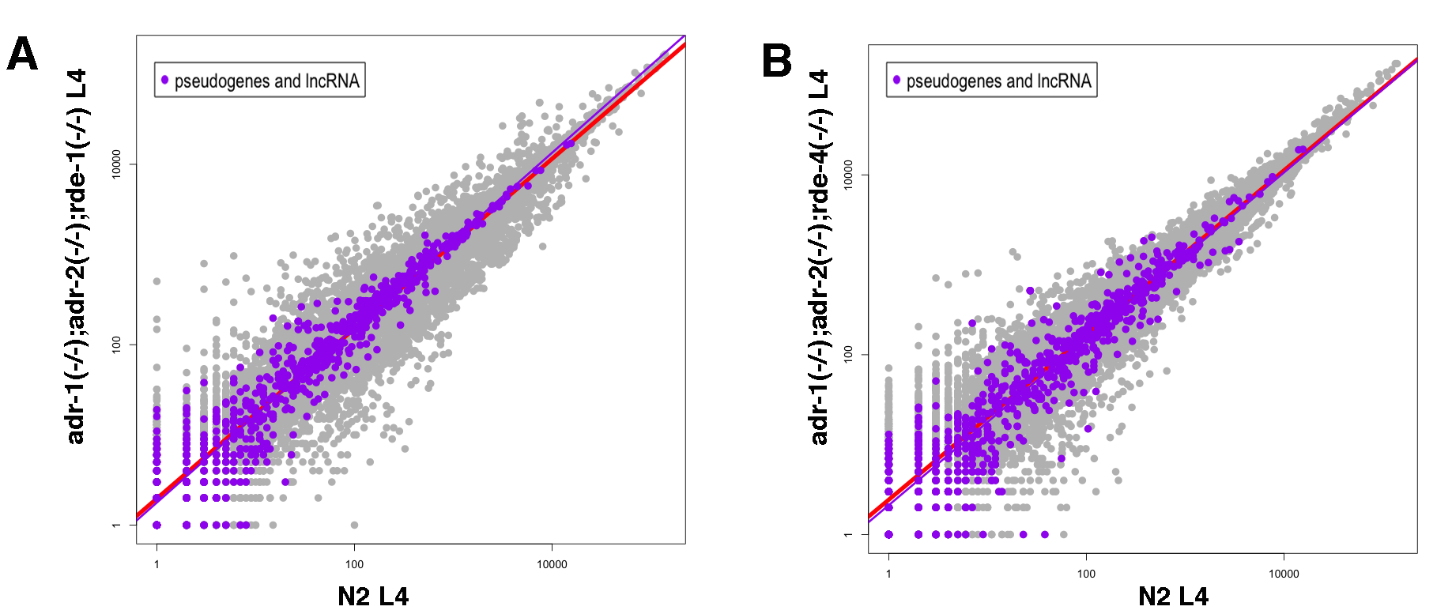
Supplemental Fig S4. At L4 stage, pseudogenes are upregulated in ADAR and RNAi mutants. Log scale plots comparing gene expression of wildtype (N2) worms to adr-1(-/-);adr-2(-/-);rde-1(- /-) (A) or adr-1(-/-);adr-2(-/-);rde-4(-/-) (B) mutant worms at L4 stage of development. Every dot represents a gene. Red line is the regression line for all genes. Purple dots indicate pseudogenes and their regression line is presented in purple.

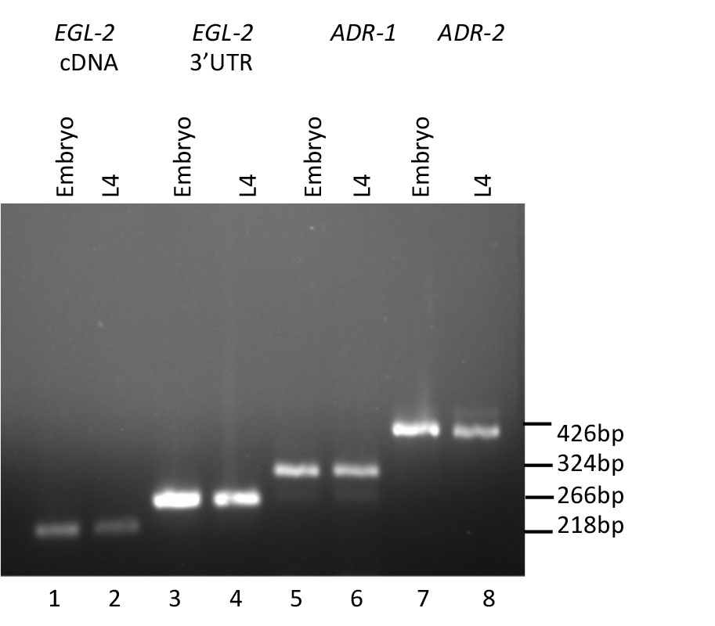
Supplemental Fig S5. egl-2, adr-1 and adr-2 are expressed in both embryo and L4 developmental stages. cDNA was extracted from wildtype worms at embryo or L4 stage. PCR was performed with specific primers for egl-2 cDNA (lanes 1- embryo, 2 – L4), egl-2 3’UTR (lanes 3- embryo, 4 – L4), adr-1 (lanes 5- embryo, 6- L4), and adr-2 (lanes 7- embryo, 8- L4). All amplifications were successful in verifying that these genes are expressed in both stages.

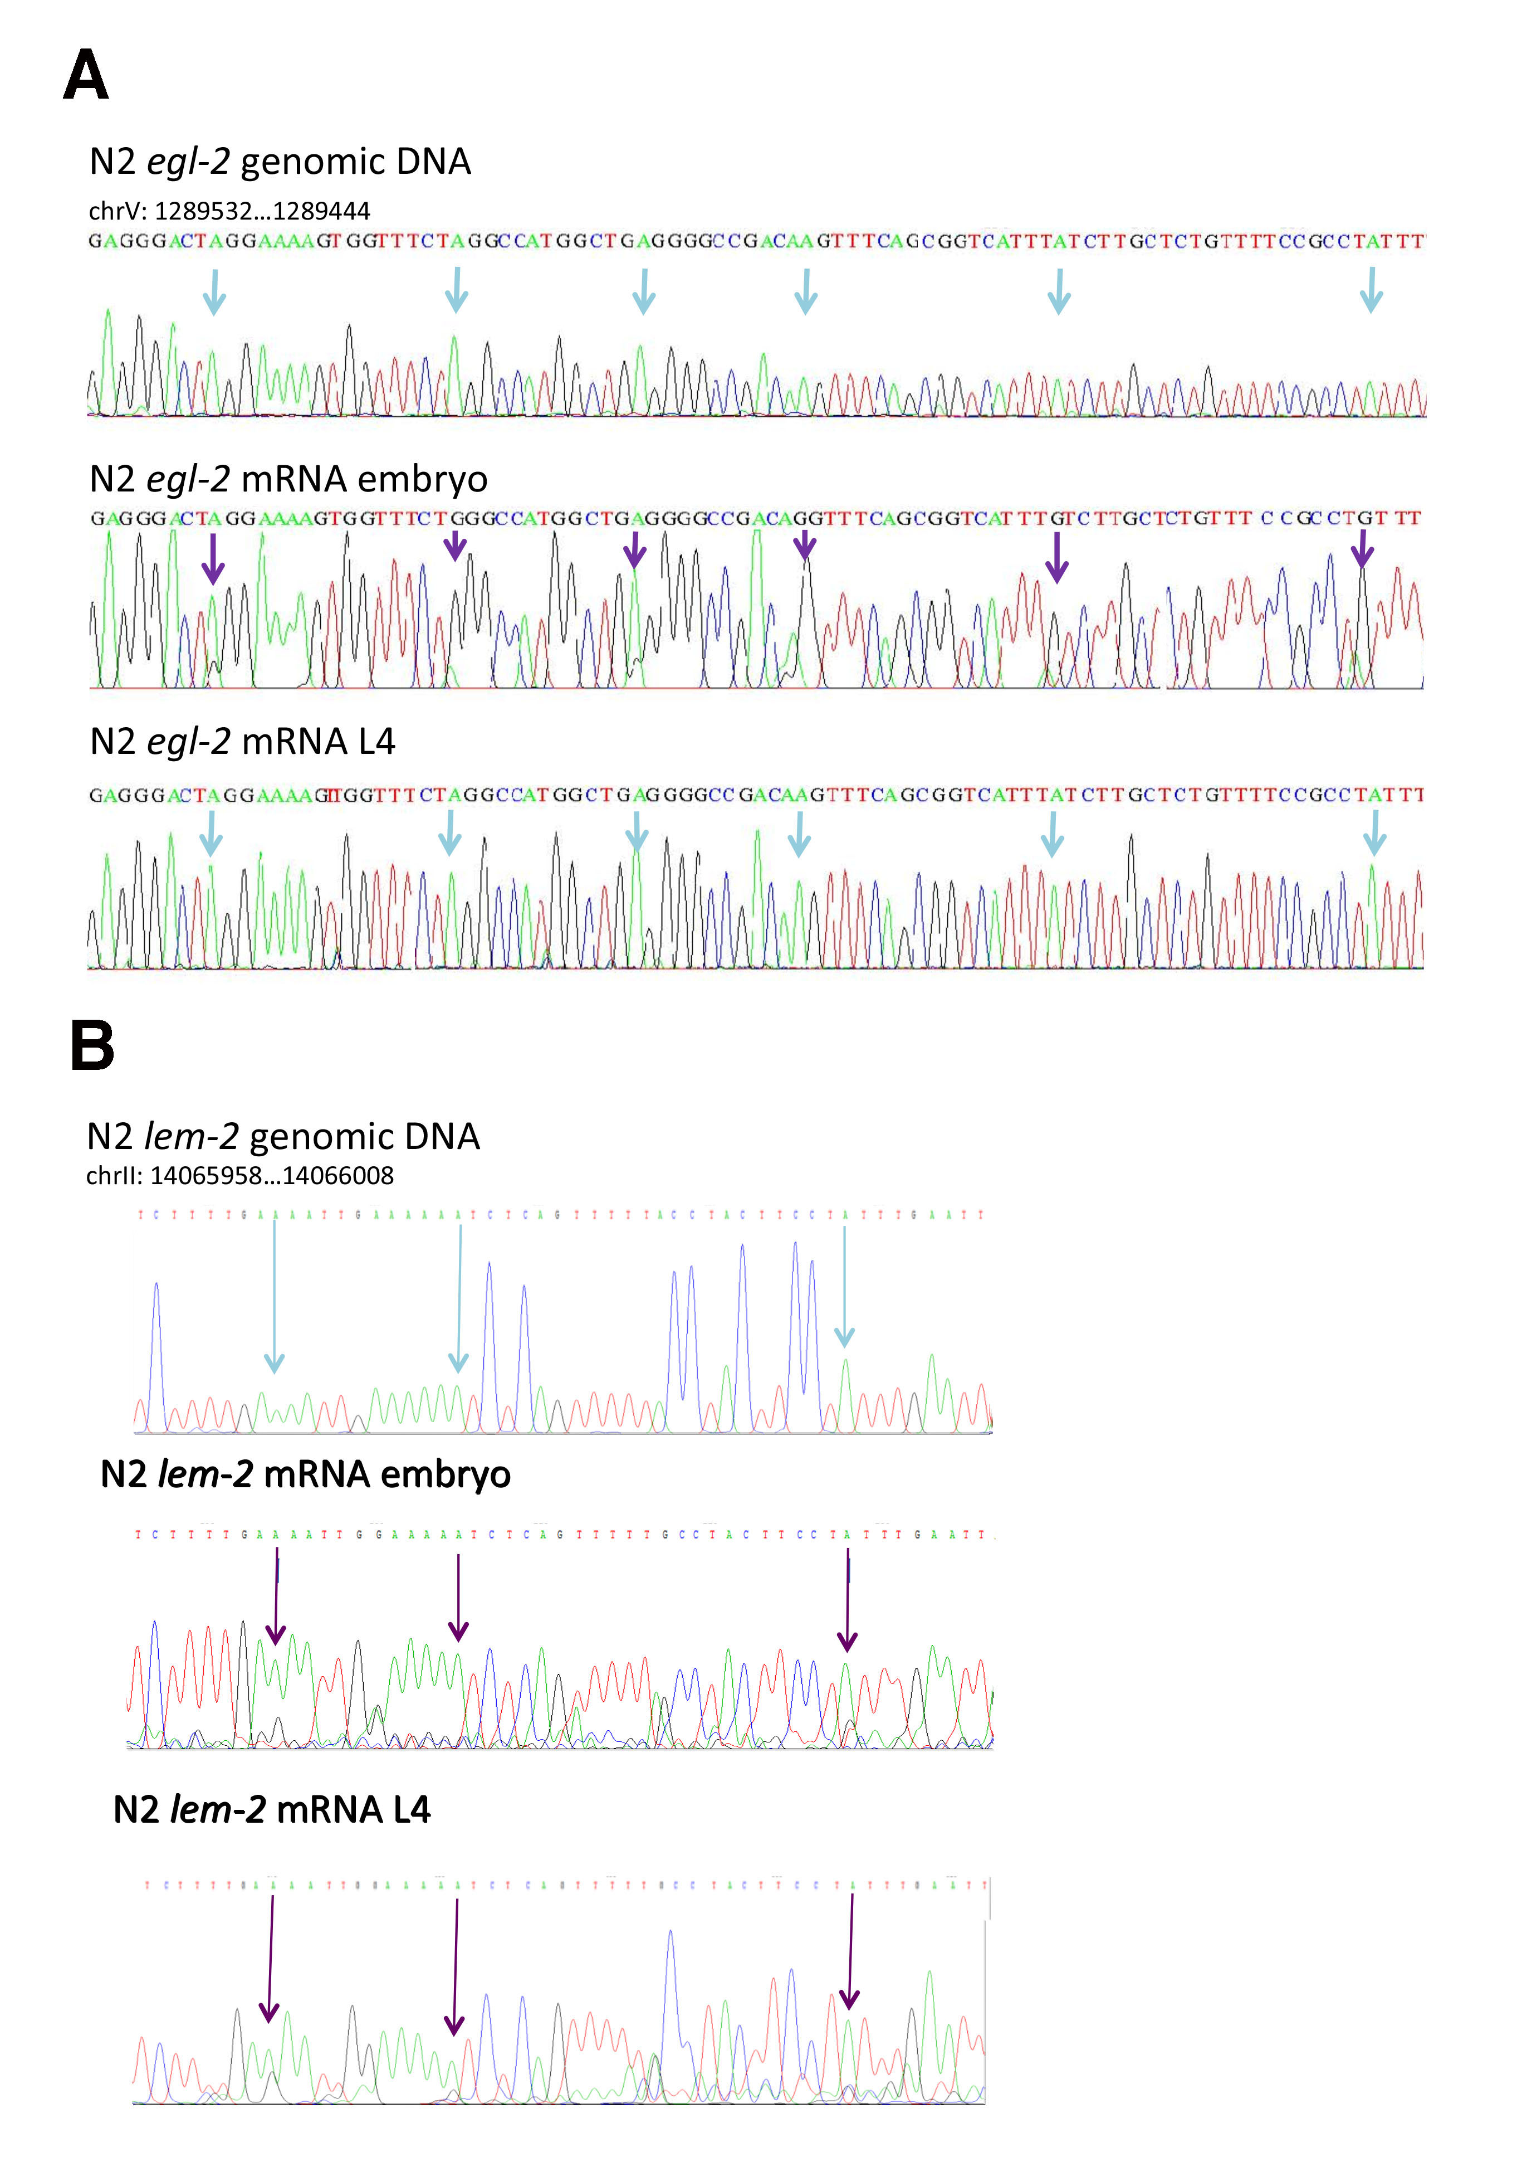
Supplemental Fig S6. egl-2 is edited at embryo stage, while lem-2 is edited in both embryo and L4 stages. Sanger sequencing of egl-2 (A) or lem-2 (B) genomic DNA and cDNA from embryo and L4 wildtype worms (N2), confirming stage specific A-to-I editing. Arrows above the genomic DNA indicate adenosines present in the genome that upon transcription can be modified by ADARs. Purple arrows indicate edited loci in isolated RNA, while blue arrows indicate non-edited loci.

Supplemental Table S1. Novel editing sites found in this study
 | % overlap with EER ranges (Whipple et al. 2015) | % overlap with ARL ranges (Wu et al. 2011) | % overlap with sites from (Zhao et al. 2015) | % overlap with sites from (Washburn et al. 2014) | % overlap with sites from (Whipple et al. 2015)
Sites in repetitive regions | 7.22 | 17.57 | 13.91 | 0.14 | 7.67
Sites in non-repetitive regions | 18.5 | 11.21 | 37.36 | 0.48 | 19.22
Sites in non-repetitive 3’UTR regions | 45.74 | 23.26 | 68.6 | 8.53 | 51.16
Random sites 1 | 0 | 0 | 0 | 0 | 0
Random sites 2 | 0.1 | 0 | 0 | 0 | 0
The table presents the percentage of overlap between editing sites found by this study and editing sites or ranges found by other studies.

Supplemental Table S2. A-to-I editing sites found in this study.

Supplemental Table S3. Novel A-to-I editing sites found in this study.

Supplemental Table S4. Changes in gene expression levels between wildtype, ADAR mutant worms, and ADAR and RNAi mutant worms.

Supplemental Table S5. qPCR results on RNA extracted from ADAR mutant and wildtype worms at embryo stage.

Gene ID | Amplification  efficiency % | ADAR mutant/wildtype fold change
Gene ID | Amplification  efficiency % | qPCR | HTS
F55B12.11 | 96.9 | 0.82 | 0.76
Y92H12BL.1 | 97.7 | 0.80 | 0.82
M04D5.1 | 95.7 | 0.68 | 0.65
F59C6.10 | 91.6 | 0.75 | 0.76
T26E3.11 | 99.5 | 0.77 | 0.72
fbxb-4 | 101.7 | 0.78 | 0.75
pot-3 | 93.4 | 0.75 | 0.77
orai-1 reference gene | 98.6 |  | 0.973
sclp-4 reference gene | 101.5 |  | 1.033

Supplemental Table S6. qPCR results on RNA extracted from ADAR mutant and wildtype worms at L4 stage.

Gene ID | Amplification  efficiency % | ADAR mutant/wildtype fold change
Gene ID | Amplification  efficiency % | qPCR | HTS
col-98 | 95.1 | 0.58 | 0.79
Y92H12BL.1 | 95.6 | 0.76 | 0.85
rncs-1 | 98.9 | 0.12 | 0.18
Y116F11B.10 | 96.4 | 2.07 | 3.03
pot-3 | 91.7 | 0.60 | 0.83
clec-41 | 93.7 | 1.06 | 0.81
fce-4 reference gene | 97.3 |  | 0.99
sclp-4 reference gene | 101.5 |  | 1.06

Supplemental Table S7. Percentage of editing found by sequencing of individual clones.
Gene name | Number of predicted editing sites | % clones containing editing out of total clones in Embryo | % clones containing editing out of total clones in L4 | Prediction by RNA-seq
T28A8.3 | 3 | 6/40=15% | 2/40=5% | Editing mainly in embryo
Pot-3 | 2 | 4/40=10% | 6/35%=17% | Editing mainly in L4
F07B7.12 | 10 | 6/40= 15% | 2/39=5% | Editing mainly in embryo
F48E8.4 | 27 | 9/20=45% | 11/19=58% | Editing in both L4 and embryo

References
Washburn MC, Kakaradov B, Sundararaman B, Wheeler E, Hoon S, Yeo GW, Hundley HA. 2014. The dsRBP and inactive editor, ADR-1, utilizes dsRNA binding to regulate A-to-I RNA editing across the C. elegans transcriptome. Cell Rep 6: 599-607.
Whipple JM, Youssef OA, Aruscavage PJ, Nix DA, Hong C, Johnson WE, Bass BL. 2015. Genome-wide profiling of the C. elegans dsRNAome. RNA (New York, NY) 21: 786-800.
Wu D, Lamm AT, Fire AZ. 2011. Competition between ADAR and RNAi pathways for an extensive class of RNA targets. Nat Struct Mol Biol 18: 1094-1101.
Zhao H-Q, Zhang P, Gao H, He X, Dou Y, Huang AY, Liu X-M, Ye AY, Dong M-Q, Wei L. 2015. Profiling the RNA editomes of wild-type C. elegans and ADAR mutants. Genome Res 25: 66-75.

