D. melanogaster
C. elegans

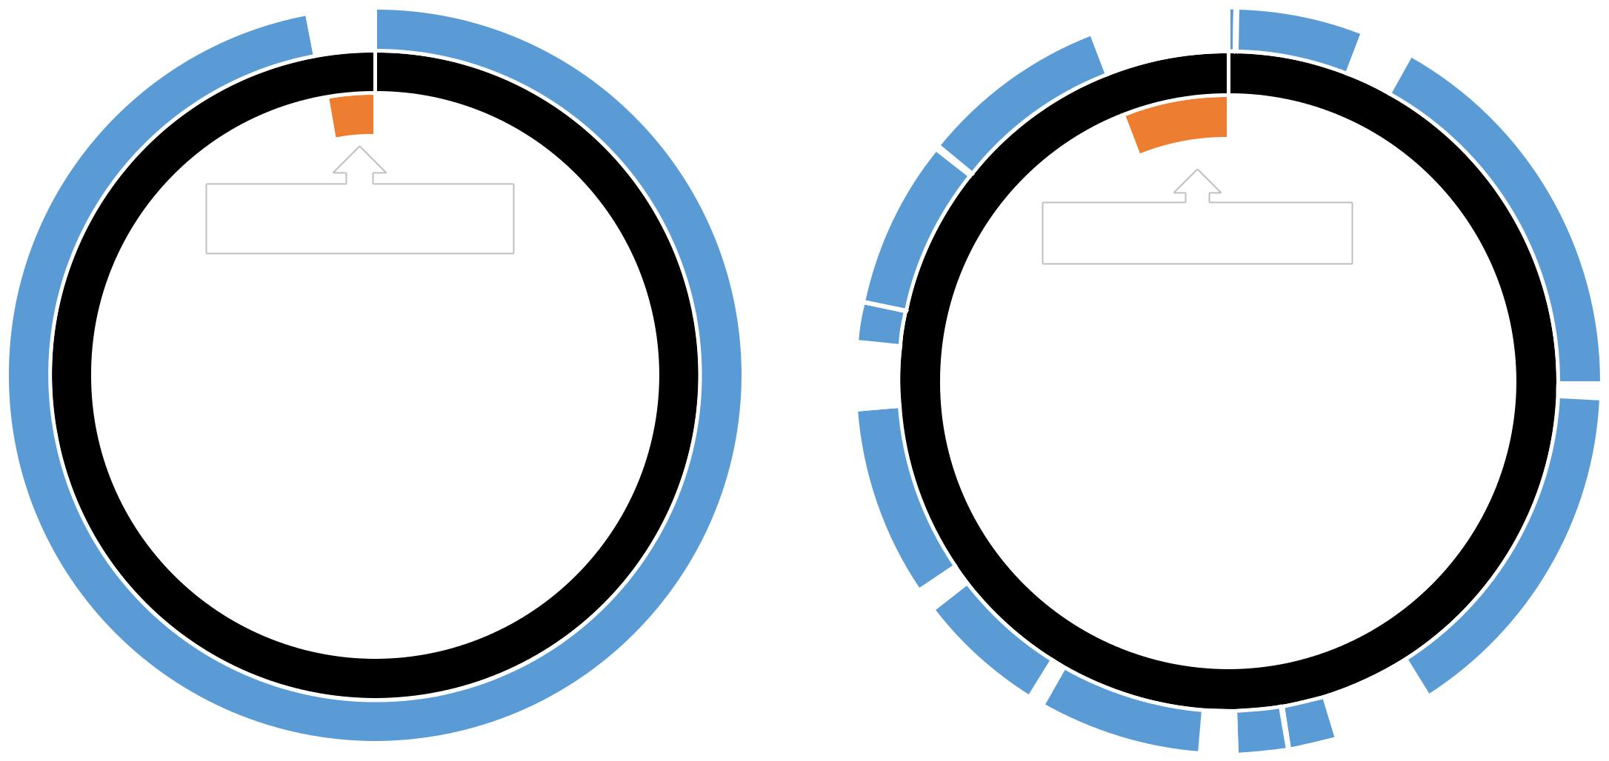

control region | control region
Supplemental Fig S3. De-novo assembly of medina in invertebrates. PRO-seq and GRO-seq data enabled de-novo assembly of the entire invertebrate mtDNA sequence without a reference sequence. Left panel – C. elegans. Right panel – Drosophila. Scaffold used for de novo assembly: for Drosophila – Bactrocera arecae mtDNA and for worm - mtDNA from Litoditis aff. Marina Pml. Blue cycle – mapped de-novo assembly contigs. Black cycle – the scaffold mtDNA sequence used to map the de novo assembly contigs. For worm, the mtDNA reads covered 97% of the scaffold genome, and for Drosophila they covered 80% of the scaffold genome. Notably, the gaps mostly correspond to the non-coding control region.

