Supplementary

Predicting origin-specific effects:
We analyzed the case of mutations that specifically affect the affinity of a subset of origins. For simplicity we assume that origins are divided into two temporal classes that are differentially regulated. We defined those subsets based on their firing efficiencies in wild-type cells, considering origin i as early if f_{i} is higher than the median firing frequency and late if this frequency is lower. A mutation j therefore modulates firing probabilities according to:
The parameter $ρϵ[0.5,1]$ defines the specificity of the perturbation: ρ =1 simulates a fully asymmetric (local) perturbation, where mutations affect either the early or the late origins, whereas ρ =1/2 corresponds to fully symmetric (global) perturbations, where mutations modulate all origins to the same extent. This last case is equivalent to changing the replicon length, λ.
We selected different values of ρ, and for each value generated a dataset of 200 profiles that differ by the mutation strength m and the random noise. Each dataset was then subjected to SVD. Notably, the number of eigenprofiles that correctly predicted origins now changed with ρ: in the case of a global perturbation (ρ=0.5), only the first two eigenprofiles properly predicted origins, consistent with our results above. In contrast, when the perturbation was local (ρ > 0.5), at least three eigenprofiles properly captured real origins (Figure S4). In this case, different eigenprofiles were tuned to specific subsets of origins.

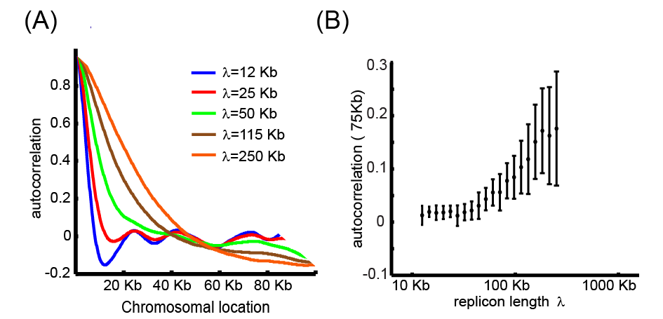
Figure S1: The autocorrelation measure depends on the replicon length: A dataset of 400 simulated profiles generated by changing the replicon length λ was subjected to autocorrelation analysis. The autocorrelation as a function of λ (the replicon length) was used to generate the profile for the values of 12 Kb (blue), 23 Kb (red), 52 Kb(green), 114 Kb (brown) and 251 Kb (orange) all shown in (A). The λ value predicted from the autocorrelation (at 30 Kb) , is shown in (B).

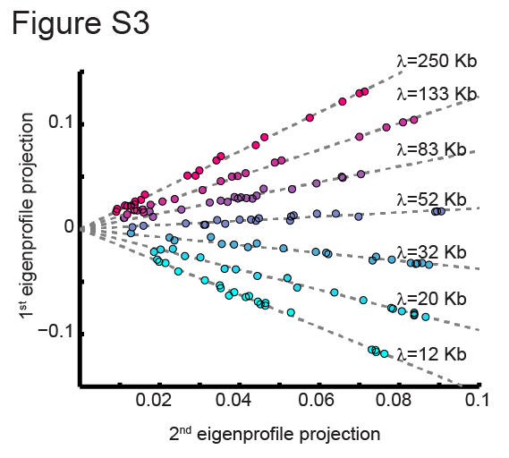
Figure S2: Projection of simulated profiles to the first two leading eigenprofiles. The color gradient reflects the replicon length λ. The dashed lines represent the slope of profiles with the same replicon length λ parameter.

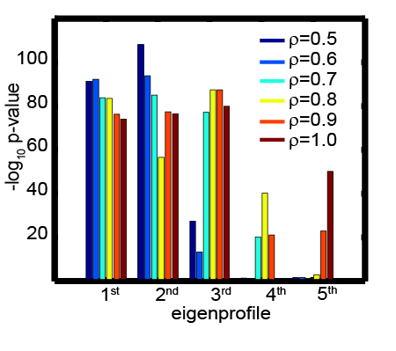
Figure S3: SVD analysis of local perturbations predicts multiple significant eigenprofiles: The ρ parameter in our model controls the significance of local vs. global perturbations. Five simulated datasets corresponding to different levels of ρ were generated and subjected to SVD analysis. Shown is the significance by which each of the eigenprofiles predicts replication origins for ρ=0.5 (dark blue), ρ=0.6 (light blue), ρ=0.7 (blue sky), ρ=0.8 (yellow), ρ=0.9 (orange) and ρ=1.0 (red).

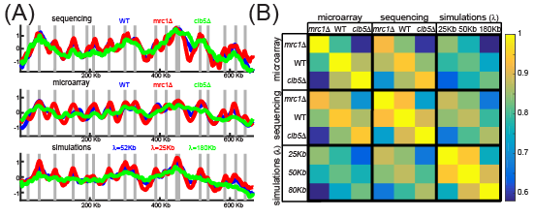
Figure S4: replicon length parameter describes the observed phenotypes: (A)Shown are the profiles of chromosome XI of cells deleted of CLB5 and cells deleted of MRC1 compared to the wildtype in both sequencing (upper panel ), microarray (middle panel ),and fit to the simulations (lower panel) . This fit can also be observed from the correlartion matrix (B).

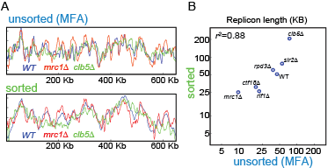
Figure S5: comparison between sorting and MFA: (A) Shown are the profiles of chromosome XI of cells deleted of CLB5 and cells deleted of MRC1 compared to the wildtype in both unsorted\MFA (upper panel) and sorted cells (lower panel). (B) The estimated replicon length (in Kb) values are correlated between sorted and MFA samples for the indicated strains.

Supplementary Materials and Methods
Model parameters used in the simulations:
There are two types of parameter sets for this model, local and global. Local parameters are the origins locations and efficiency. We have used the multi-initiator model parameters from (Yang et al. 2010), and normalized the origins efficiency to mean 1.
The global parameters selection was as following: There are two global parameters v replication fork velocity (kb/min) and I initiation rate (1/min). Fork velocity was estimated before to velocity of 1.5-3 Kb/min (Sekedat et al. 2010; Yabuki et al. 2002; Raghuraman et al. 2001). As for the initiation rate parameter, S phase duration is ~20 minutes, so we expect a typical origins to fire at least once during that time so we get I=0.05 min⁻¹. This gives a replicon length value of λ=30-60 Kb. Indeed, the λ value which showed the highest correlation to the experimental wild-type profile was ~50 Kb.

In the simulation, we modulated λ levels as shown and also included noise in the form 0.1*randn* randn(n,1) (to capture randomness in each position as well as randomness in overall signal level)

All the simulation process is the matlab file: generate_simulations.m available in the supplemental code files

Assigning a significance value to the origins predicted by principle eigenprofiles:

For each origin in the origin list we set a window of 5Kb upstream and downstream to the origin center. The fraction of the genome covered by these 5-Kb windows was p=0.21 (for the active origin list mentioned below). Under the assumption that predicted origins are randomly distributed (H₀), the probability for a random location to be considered as an origin is p. Let N be the total number of predicted origins, and K the number of origins defined as ‘real’. We calculate the probability that K of N randomly chosen genomic regions will be considered as real origins using the binomial distribution:

Note that this p-value is used to compare different eigenprofiles and different replication profiles, rather than comparing our data with the published origin datasets. In analyzing the simulated profiles, direct origin parameters used to generate the profiles were used.

List of active origins

The confirmed origin list from OriDB(Nieduszynski et al. 2007) was downloaded and compared to all the sequencing data. An origin was considered active if at least 10% of the profiles showed a peaks in proximity (<5Kb) or this origin. By this, 258 origins were scored as active. The origin list is available as a mat file in the supplemental code files.

Estimating the unexplained fraction

Once replicon length was assigned, each profile was given an additional score, defining the fraction not explained by the model assuming no change in origin-specific properties. To this end, we first projected the profile onto the two principle eigenprofile, obtaining a projected-profile. This residual score was define as the Var(profile-projected_profile)/Var(profile).

Telomeric systematic bias

Telomeres are harder to sequence and align accurately which may lead to systematic bias. To account for that, when defining telomere specific regulation, all experiments were compared to wild-type telomeres (measured mean bias of -0.5), instead of the general genome average replication time.

DNA staining and cell sorting:

To assess cell cycle synchronization efficiency and position along the cell cycle, we followed DNA staining of samples from every time point using flow cytometry. Briefly, cells were washed twice with 50mM Tris-HCl pH8, re-suspended in RNase A for 40 minutes in 37°C, washed twice with 50mM Tris-HCl pH8, and re-suspended in Proteinase K for 1 hour incubation at 37°C. Then, cells were washed twice again, and re-suspended in SYBR green (S9430, Sigma-Aldrich) (1:1000) and incubated in the dark at room temperature for 1 hour. Then, cells were washed from the stain and re-suspended in 50mM Tris-HCl pH8 and sonicated in diagenode bioruptor for 3 cycles of 10’’ ON and 20’’ OFF in low intensity.

Flow cytometry and cell sorting:

Sorting was performed using FACSAria at minimal flow rate and sorting speed of ∼20,000–30,000 cells/sec. Eight million cells were sorted from each of G1 and S phases.

Flow cytometry for unsorted cells was measured using BD LSRII system (BD Biosciences).

Processing and Analysis of Microarray data :

We analyzed the new data together with previously published data (Koren et al. 2010) following the procedure described therein. We removed Cy3 or Cy5 measurements with extreme intensity (median<50 or >65000) or with CV ( $\frac{σ}{μ}$) > 40%. The intensity value, I, was calculated for Cy3 and Cy5 separately as I=F-B (F, B – foreground and background median value). Small I values were removed (I<0.001). The normalized signal N was calculated as N = log(IS)-M. M is matlab’s lowess curve of log(I_{S}) as a function of log(I_{G1}) using matlab function malowess.m with span of 10%. In order to compare different data sets, the mean and standard deviation were normalized N’ = ( $\frac{N-μ}{σ}$). The normalized data was further smoothed using cubic spline interpolation (csaps.m in matlab) with smoothing parameter p that was selected using cross validation with a randomly selected 1% of the data points and comparison with the interpolation based on the remaining 99% data points. We have used p=exp(-27) . The smoothed data was calculated for the whole chromosome size excluding 10Kb from the edges with even spaces of 1.4 Kb.

Processing and Analysis of DNA sequencing – free cycling cells:

The signal The sequencing reads were aligned to the S. cerevisiae genome using bowtie(Langmead et al. 2009) with the parameters “-X 4000 -m 1 –best –strata” and then grouped according to the expected DNA fragments resulting from DpnII cleavage (GATC). Each experiment data was normalized to mean of 1. We have removed the following data points:
- data points representing fragments shorter than 150 bp
- data points representing fragments that failed to align in the W303 strains
- data points with zero reads in more than 80% of the experiments.

Experiments with less than 100,000 reads were fully removed. Chromosomal duplications and deletions were normalized. Read distributions in each experiment were normalized to mean 0 and std of 1, and length bias (number of reads as a function of fragment length) was removed using lowess. The whole data matrix was divided by the mean G1/G2 signal (which represent the sequencing bias without the replication signal). The signal was smoothed using Savitzky–Golay filter.

Processing and Analysis of DNA sequencing – synchronized cells:

Preprocessing: The sequencing reads were aligned to the S. cerevisiae genome using bowtie(Langmead et al. 2009) with the parameters “-X 4000 -m 1 –best –strata” and then grouped to bins of 500 bp. Each experiment data was normalized to mean of 1. We have removed data points with values <0.7 in more than 50% of the experiments. Each time point was multiplied in its DNA content (described below), based on a sigmoid function that is going from 1 to 2, fitted from the FACS measurements of the DNA staining.

Estimation of total DNA content in synchronized samples: DNA content was estimated in two ways. The first was based on the DNA staining measured using flow-cytometer. Each cell measurement was assigned to a specific bin, and each bin was assigned to a specific value. When the G1 peak is at 1, and the G2 peak is at 2. The integral of all the bins normalized by the number of cells resulted in a value between 1 and 2, which indicate the mean DNA content of the cell population. A sigmoid was fitted to describe DNA content as a function of time. The second way was based on the DNA sequencing itself. Each location was normalized by its value in G1, and matlab’s k-means was applied (K=5). The coefficients vector was defined in each time point as the minimal value that will guarantee that all clusters are monotonically increasing. The coefficients vector was later fitted to minimal value of 1, and maximal value of 2, and was used as another measure for DNA content.

Estimating Initiation capacity: Changes in initiation capacity are defined from overall delay in the firing of all origins. Specifically, initiation capacity, I is defined as a global parameter multiplying all origin-specific efficiencies to define their initiation rates. Thus, define t_{r,i} to be the time at which origin i was initiated, and let n_{i} be the efficiency of origin i. In our model, I is related to the t_{r,i} by:
$$0.5=1-e^{-It_{i}n_{i }}$$

$$I=\frac{\log{2}}{t_{i}f_{i }}$$

Changes in I e.g a decrease in I will therefore delay the replication time of all origins, in proportion to their wild-type replication time. To measure such changes in a robust way (and to ensure that it indeed reflect a proportional changes in the replication time of all origins), we partition origin into five clusters based on their wild-type activation time, and calculate the average activation time of origins within each cluster. To control for the time at which replication is initiation, the replication timing of the first cluster is subtracted from timing of all other clusters. Plotting the resulting values in the mutant, vs. the average values in wild-type is expected give linear slope, as is indeed the case (c.f. Fig. 4. This slope is defined the mutant’s initiation capacity I (assuming I=1 in wild-type).

Estimating Fork Velocity:

Fork velocity was defined by the increasing times at which DNA around each origin x_{i} was replicated. Specifically, for each origin, a window of 70 data points (~35 Kb) was defined. For each spatial position in this window, we defined t_{rep}(x) as the time at which 40% of the cells replicated at position x. Therefore, each spatial position x around the origin was assigned a time value, t_{rep}(x). A linear curve with a slope v was then defined as the best linear fit to obtain x = x_{i}+v t_{rep} (x). This defined the velocity v around this origin. The value of v was averaged over all origins for which the goodness of fit was >0.75. In the fitting procedure, outliers were removed.

