Supplemental Figures
Supplemental Figure S1: Example correlation plots between morphological features (mean) and genes. Morphological features are scaled between 0 and 1. Each dot represents a BCL. Red: luminal, green: basal A, blue: basal B.
Supplemental Figure S2: Example correlation plots between morphological features (std) and genes. Morphological features (std) are scaled between 0 and 1. Each dot represents a BCL. Red: luminal, green: basal A, blue: basal B.
Supplemental Figure S3: Phenotype-genotype network analysis (A-B) Optimal and sub-optimal paths from cell width/length feature to (A) SMAD3 and (B) RELA. Nodes in yellow indicate TFs that we included for investigation and are excluded from path analysis results. (C) Schematic of two ways a shape-correlated gene may affect a TF (using RELA as an example).

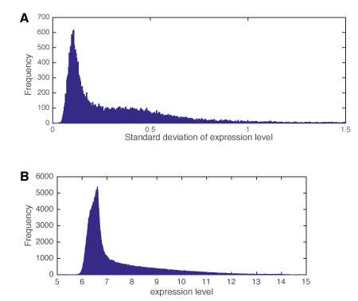
Supplemental Figure S4: Distribution of gene expression statistics. (A) The standard deviation and (B) average expression of all genes across 18 BCLs.

