Supplementary Information

APOBEC3A/B -induced mutagenesis is responsible for 20% of heritable mutations in TpCpW context

Vladimir B. Seplyarskiy, Maria A. Andrianova, and Georgii A. Bazykin.
Correspondence to: alicodendrochit@gmail.com

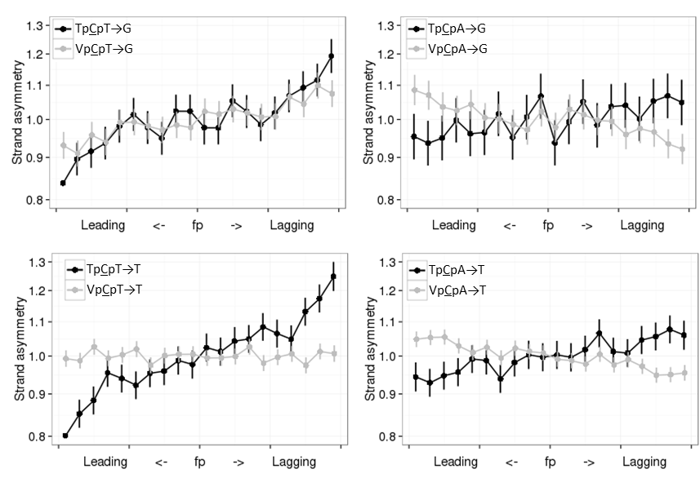
A
D
B
C
Figure S1. Interspecies substitutions in the APOBEC3A/B context are more frequent on the lagging strand. Horizontal axis, propensity of the region of the DNA strand to be replicated as lagging or leading. Vertical axis, ratio of the frequencies of the two complementary mutation types on the strand in this category. Vertical bars represent 95% confidence intervals.

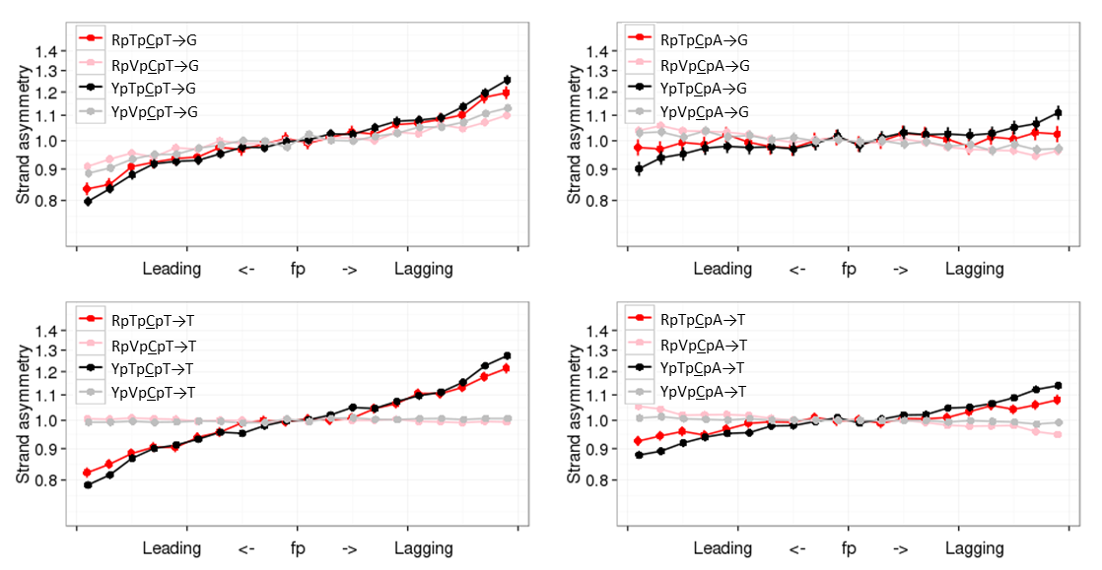
p=2.0*10⁻⁴

p=1.7*10⁻⁵

p=1.2*10⁻⁴

p=0.002385

A
D
B
C
Figure S2. C→K mutations in the YpTpCpW context are more biased towards the lagging strand than in the RpTpCpW context. Horizontal axis, propensity of the DNA region to be replicated as lagging or leading strand. Vertical axis, the ratio of the frequencies of the two complementary mutation types on the strand in this category. Vertical bars represent 95% confidence intervals. V corresponds to A, C or G.
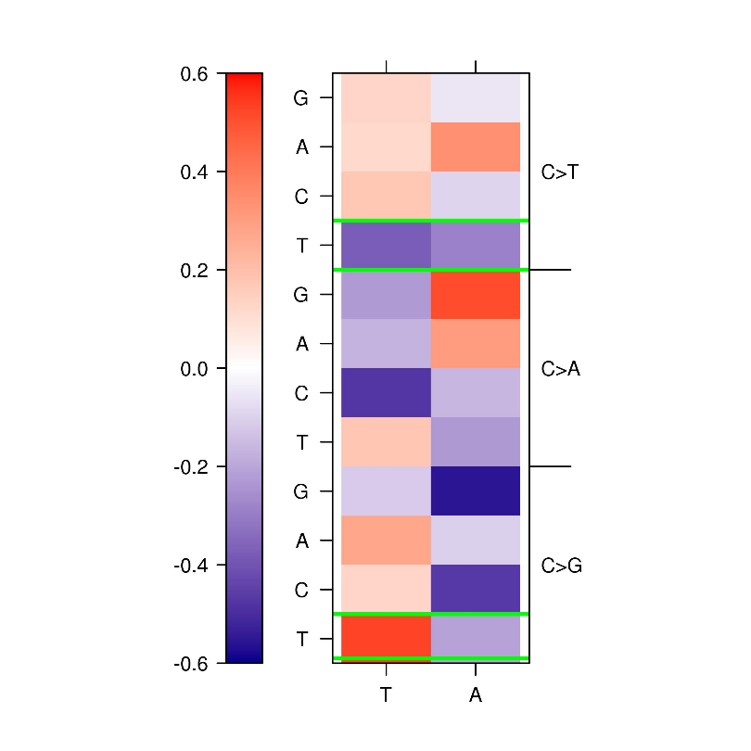
Figure S3. Context influence on mutation rate. For visualization how mutational context affected mutation rate we calculate log₂ ratio between mutation rate in appropriate context to the mutation rate of the same mutation type irrespective to the context, e.g. for TpCpT→T mutations we calculate log₂(µ(TpCpT→T)/ µ(NpCpW→T)).

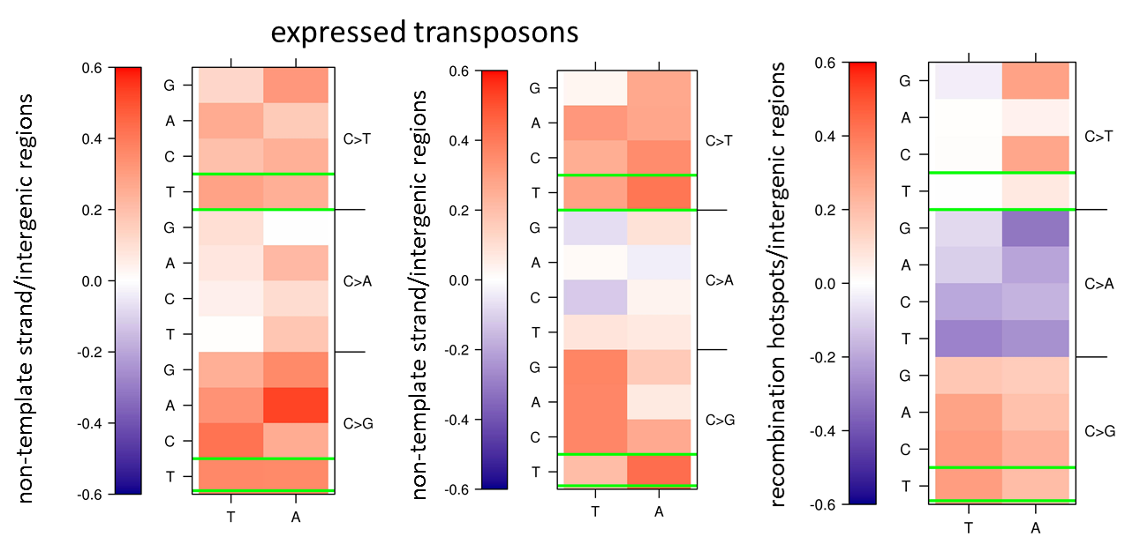
C
B
A
Figure S4. APOBEC3A/B-induced mutations not associates with transposons or meiotic DSBs. Color coded log₂ of the ratio of densities of rare polymorphisms on non-template (A) or template strands (B) of expressed transposons or regions enriched by meiotic DSBs (C) and on intergenic regions. Mutations in the TpCpW→K context that may be associated with APOBEC3A/B activity are in green boxes.

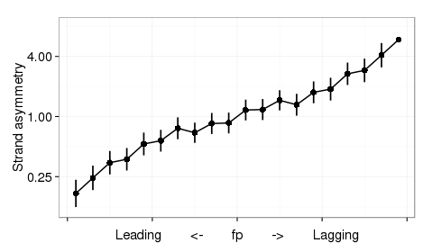
Figure S5. Replication strand asymmetry calculated for strand-coordinated clusters of TpCpW→K mutations in cancers prone to APOBEC3A/B activity
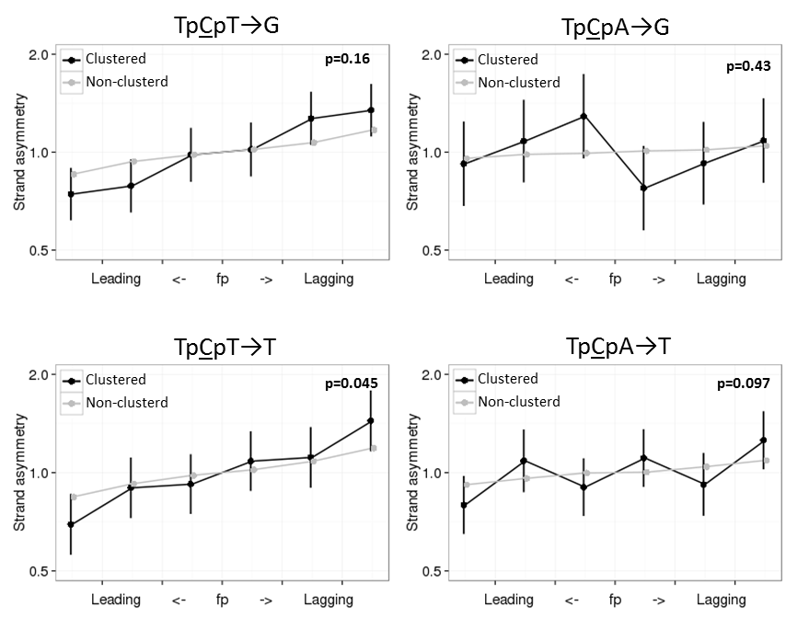
D
C
B
A
Figure S6. Clustered and non-clustered mutations in APOBEC3A/B context are more frequent on the lagging strand. Horizontal axis, propensity of the region of the DNA strand to be replicated as lagging or leading. Vertical axis, ratio of the frequencies of the two complementary mutation types on the strand in this category. Vertical bars represent 95% confidence intervals. One-sided chi-square test p-values are calculated for the differences in asymmetry in the last bin of fp. While the p-values are rather high in individual comparisons, p=0.0055 for the joined dataset.

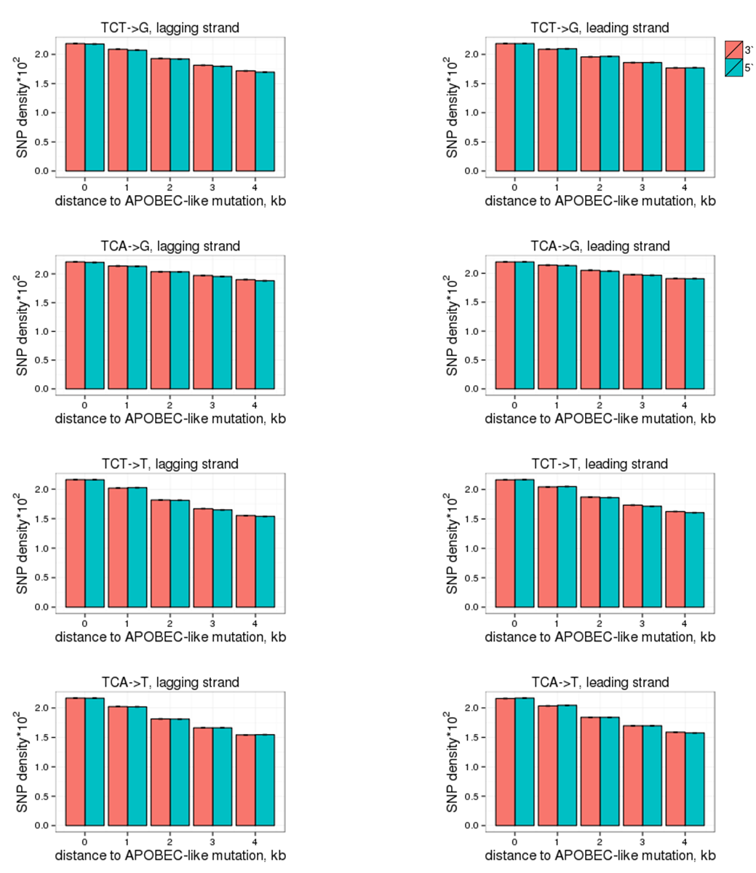
A
B
C
D
E
F
G
H
Figure S7. Density of unlinked SNPs is equal at 5’ and at 3’ of a TpCpW→K mutation. The rate of mutations on the lagging (A-D) or the leading (E-H) strand is measured in 5 non-overlapping 1kb windows at increasing distance from the TpCpW→K SNPs.

A
B
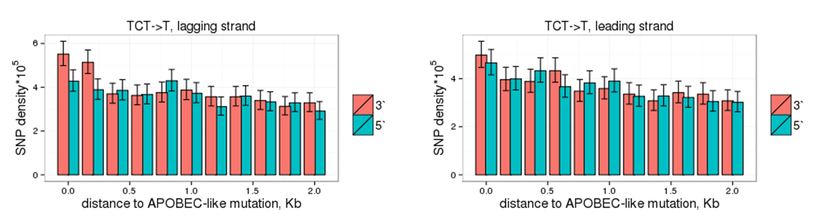
***
**
Figure S8. Density of linked SNPs 5’ and 3’ of a TpCpT→T mutation in 11 non-overlapping 0.2Kb windows at increasing distance from it. ***p-value < 0.001, **p-value < 0.01 (chi-square test).
A
B
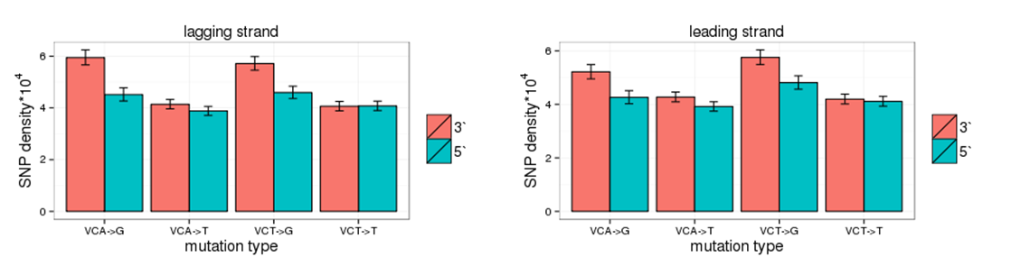
*
***
***
***
***
Figure S9. Density of linked SNPs 5’ and 3’ of a VpCpW→K mutation at distance up to 1Kb. The mutation rate increases 3' of VpCpW→G mutations both on the leading (A) and on the lagging (B) strands. ***p < 0.001, *p < 0.05 (chi-square test).

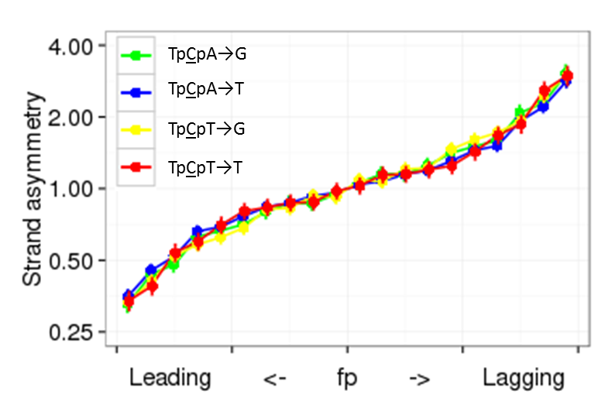
Figure S10. APOBEC3A/B-induced mutations in breast cancer with tissue matched fp are ~3 times more frequent on the lagging strand. Horizontal axis, propensity of the region of the DNA strand to be replicated as lagging or leading. Vertical axis, ratio of the frequencies of the two complementary mutation types on the strand in this category. Vertical bars represent 95% confidence intervals.

 | singletons |  | rare |  | intermediate |  | frequent |  | ALL |  | divergence
 | rank | log₂ | rank | log₂ | rank | log₂ | Rank | log₂ | rank | log₂ | rank | log₂
TCT>T | 1 | 0.24 | 1 | 0.26 | 2 | 0.25 | 1 | 0.31 | 1 | 0.25 | 1 | 0.24
TCT>G | 2 | 0.21 | 2 | 0.24 | 1 | 0.29 | 2 | 0.27 | 2 | 0.23 | 4 | 0.18
TCA>T | 3 | 0.21 | 3 | 0.23 | 4 | 0.20 | 3 | 0.25 | 3 | 0.22 | 6 | 0.14
ACT>G | 4 | 0.19 | 4 | 0.18 | 3 | 0.21 | 6 | 0.17 | 4 | 0.19 | 5 | 0.15
GCT>G | 10 | 0.12 | 5 | 0.16 | 16 | 0.11 | 13 | 0.13 | 7 | 0.14 | 9 | 0.10
CCA>T | 5 | 0.18 | 6 | 0.15 | 6 | 0.16 | 5 | 0.18 | 6 | 0.17 | 7 | 0.11
TCT>A | 12 | -0.10 | 7 | -0.15 | 13 | -0.12 | 16 | -0.11 | 11 | -0.12 | 3 | -0.19
TCA>G | 6 | 0.17 | 8 | 0.15 | 5 | 0.19 | 4 | 0.22 | 5 | 0.17 | 12 | 0.10
CCT>G | 9 | 0.13 | 9 | 0.14 | 9 | 0.14 | 9 | 0.17 | 8 | 0.13 | 18 | 0.05
GCT>T | 8 | -0.13 | 10 | -0.13 | 8 | -0.14 | 15 | -0.12 | 9 | -0.13 | 14 | -0.07
Table S2. APOBEC3A/B-driven replication asymmetry is concordantly observed for polymorphisms of all frequencies and interspecies divergence. We list the top 10 mutation types in the NpCpW context with the highest asymmetry among rare SNPs. Categories of SNP frequencies are as follows: singletons, variants observed in 1000 genomes only once; rare; 1%≥x>singleton; intermediate, 10%≥x>1%; frequent, 90%>x>10%, where x denotes the frequency of the derived allele.
Table S3. Ratio of frequencies of C→K mutations in TpCpW and VpCpW contexts calculated for rare SNPs.
mutation type | Ratio of frequencies
TpCpT→T/VpCpT→T | 0.68
TpCpT→G/VpCpT→G | 1.34
TpCpA→T/VpCpA→T | 0.76
TpCpA→G/VpCpA→G | 1.12

Table S4. APOBEC3A/B-driven replication asymmetry is concordantly observed for transcribed and non-transcribed regions. We list the top 10 mutation types in the NpCpW context with the highest asymmetry among SNPs collected all over the genome.
 | Whole genome |  | non-transcribed regions |  | transcribed regions |  | non-template strand |  | template strand
 | rank | log₂ | rank | log₂ | rank | log₂ | rank | log₂ | rank | log₂
TCT>T | 1 | 0.26 | 2 | 0.28 | 1 | 0.22 | 2 | 0.23 | 2 | 0.20
TCT>G | 2 | 0.24 | 1 | 0.30 | 3 | 0.17 | 4 | 0.20 | 9 | 0.07
TCA>T | 3 | 0.23 | 3 | 0.23 | 2 | 0.22 | 6 | 0.19 | 1 | 0.23
ACT>G | 4 | 0.18 | 4 | 0.21 | 6 | 0.15 | 1 | 0.23 | 17 | 0.03
GCT>G | 5 | 0.16 | 5 | 0.20 | 12 | 0.10 | 11 | 0.13 | 12 | 0.06
CCA>T | 6 | 0.15 | 7 | 0.16 | 9 | 0.14 | 9 | 0.15 | 5 | 0.12
TCT>A | 7 | -0.15 | 9 | -0.16 | 7 | -0.15 | 13 | -0.11 | 3 | -0.19
TCA>G | 8 | 0.15 | 8 | 0.16 | 8 | 0.14 | 8 | 0.17 | 8 | 0.07
CCT>G | 9 | 0.14 | 10 | 0.14 | 5 | 0.15 | 3 | 0.21 | 13 | 0.05
GCT>T | 10 | -0.13 | 6 | -0.17 | 14 | -0.07 | 16 | -0.05 | 11 | -0.07

Table S5. The numbers of strand coordinated and non-coordinated clusters for TpCpW and VpCpW contexts, the ratio of fractions of strand coordinated clusters among all clusters for mutations in APOBEC3A/B-prone vs. non-APOBEC3A/B-prone contexts, and significance of the difference of this ratio from 1 (chi-square test).
APOBEC3A/B-prone | coordinated | non- coordinated |  | Non-APOBEC3A/B-prone | coordinated | non-  coordinated |  | Ratio | p-value
TpCpT→T | 3379 | 3144 |  | VpCpT→T | 33031 | 32736 |  | 1.07 | 0.0078
TpCpA→T | 3329 | 3058 |  | VpCpA→T | 40243 | 39861 |  | 1.08 | 0.002
TpCpT→G | 1883 | 1595 |  | VpCpT→G | 4501 | 4244 |  | 1.11 | 0.0041
TpCpA→G | 507 | 549 |  | VpCpA→G | 2785 | 2713 |  | 0.90 | >0.05

Table S7. Ratio of frequencies of C→K mutations in TpCpW and VpCpW context.
Dataset | TpCpW→K / VpCpW→K
Francioli et al, 2015 | 0.79
Wong et al, 2016 | 0.90
Merged | 0.87

