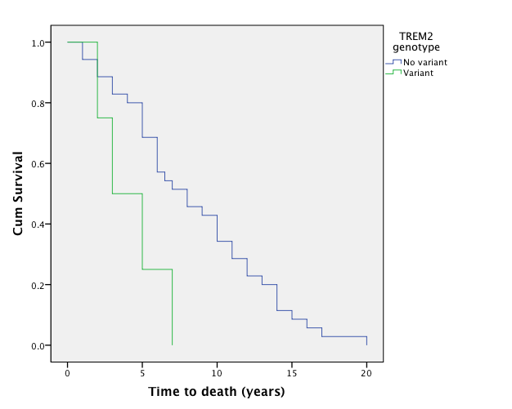

Supplemental Figure S4. Genotype-clinical and genotype-pathological correlates of disease. Kaplan Meier curve of time to death for Alzheimer disease cases with TREM2 variants (green line) and no TREM2 variant (blue line) (p=0.024, Mantel-Cox test).

