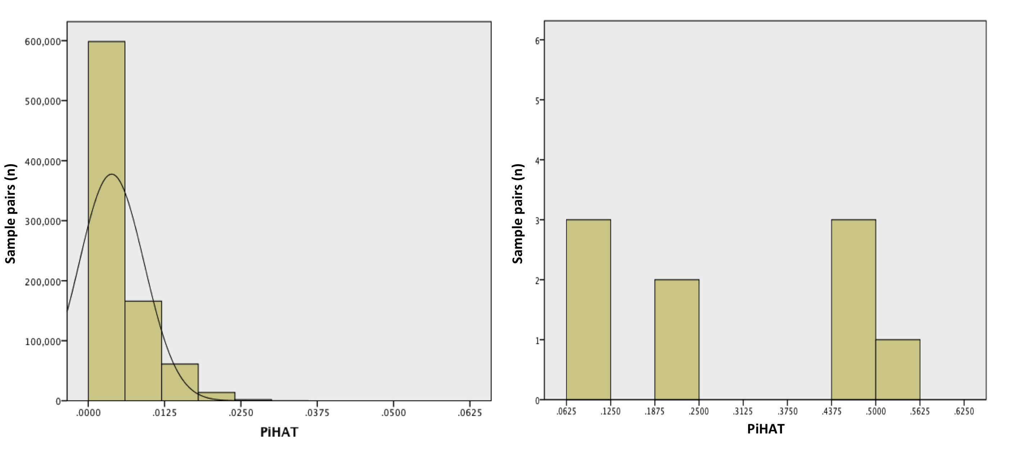

Supplemental Figure S3. Identity by Descent analysis for all cases within the whole cohort (a), and for those with cryptic ancestry suggesting between 1st-4th degree relatedness (b). PiHAT scores of 0.625, 0.125, 0.25 and 0.5 were considered as 4th, 3rd, 2nd and 1st degree relatives respectively. A description of the 9 pairs with cryptic ancestry can be seen in Supplemental Table S6.

