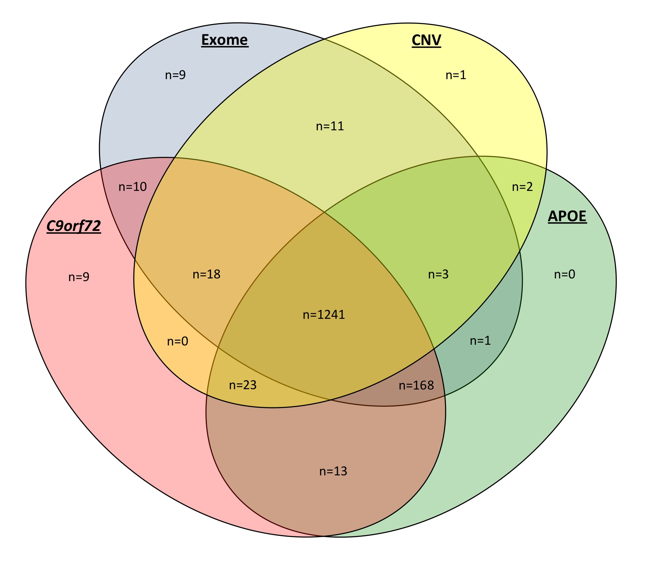
Supplemental Figure 2. A Venn diagram of all sequencing modalities utilized in this study (total case cohort n=1511). Overlapping ovals represent the number of samples covered by each of those modalities. In total, 1241 samples were sequenced on all 4 platforms.

