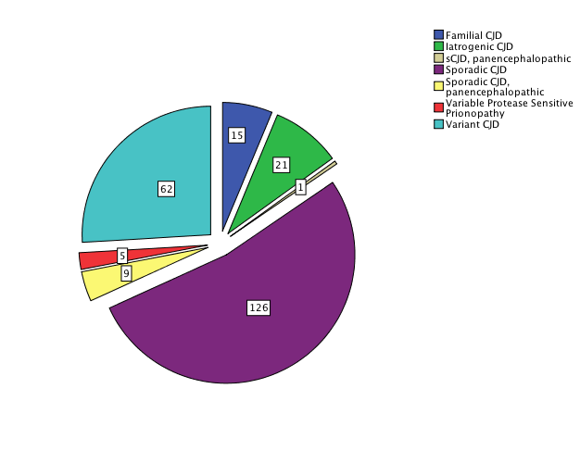
Supplemental Figure S1. Stratification of CJD cases within the cohort. Numbers identify the number of cases of each sub-type of CJD.

