Supplemental Material

Drosophila poised enhancers are generated during tissue patterning with the help of repression

References for known DV enhancers
Enhancer name | Coordinates (dm3) | Reference
Ady43A_Markstein | chr2R:3133869-3134085 | Markstein et al. (2004)
Ance_Rusch | chr2L:13904733-13905265 | Rusch and Levine (1997)
apt_Ozdemir | chr2R:19460067-19462066 | Ozdemir et al. (2011)
Asph_Ozdemir | chr2R:11997142-11999642 | Ozdemir et al. (2011)
BobA_Ozdemir | chr3L:14945343-14947303 | Ozdemir et al. (2011)
C15_650_Lin | chr3R:17331786-17332437 | Lin et al. (2006)
cact_Sandmann | chr2L:16319411-16320423 | Sandmann et al. (2007)
CG4221_Sandmann | chr3R:11746513-11748343 | Sandmann et al. (2007)
CG8788_Sandmann | chr2R:5025946-5026574 | Sandmann et al. (2007)
Cnx99A_Ozdemir | chr3R:25134141-25135377 | Ozdemir et al. (2011)
Cyp310a1_Ozdemir | chr2L:18652293-18653292 | Ozdemir et al. (2011)
dpp_Huang | chr2L:2455866-2457725 | Huang et al. (1993)
Dscam_Ozdemir | chr2R:3268100-3268475 | Ozdemir et al. (2011)
Dtg_Hodar | chr3R:8473379-8473902 | Hodar et al. (2014)
emc_Ozdemir | chr3L:742059-743659 | Ozdemir et al. (2011)
htl_Stathopoulos | chr3R:13875600-13876391 | Stathopoulos et al. (2004)
Ilp4_Stathopoulos | chr3L:9797449-9797743 | Stathopoulos et al. (2002)
Mdr49_Zeitlinger | chr2R:8833934-8834294 | Zeitlinger et al. (2007)
Mef2_Nguyen | chr2R:5819214-5819493 | Nguyen and Xu (1998)
Mef2_Ozdemir | chr2R:5847634-5848273 | Ozdemir et al. (2011)
mir-1_Biemar | chr2L:20480577-20481741 | Biemar et al. (2006)
mir-1_Zeitlinger | chr2L:20475806-20477901 | Zeitlinger et al. (2007)
Ocho_Ozdemir | chr3L:14968341-14970091 | Ozdemir et al. (2011)
Phm_Markstein | chr2R:19875348-19875790 | Markstein et al. (2004)
pnr_Zeitlinger | chr3R:11854234-11854784 | Zeitlinger et al. (2007)
pnt_Ozdemir | chr3R:19169181-19170380 | Ozdemir et al. (2011)
sna_Ip | chr2L:15478144-15481082 | Ip et al. (1992)
sna-S_Perry | chr2L:15485484-15486749 | Perry et al. (2010)
stumps_Sandmann | chr3R:10414437-10416493 | Sandmann et al. (2007)
T48_Sandmann | chr3R:22707641-22709469 | Sandmann et al. (2007)
tin_Yin | chr3R:17205819-17205999 | Yin et al. (1997)
tld_Kirov | chr3R:20574728-20575524 | Kirov et al. (1994)
trbl_Sandmann | chr3L:20394270-20396658 | Sandmann et al. (2007)
tup_Zeitlinger | chr2L:18875141-18875548 | Zeitlinger et al. (2007)
twi_Jiang | chr2R:18932429-18933663 | Jiang et al. (1991)
twi_Ozdemir | chr2R:18936997-18938126 | Ozdemir et al. (2011)
VT0984_Kvon | chr2L:1958014-1960258 | Kvon et al. (2012)
VT1404_Kvon | chr2L:2752765-2754884 | Kvon et al. (2012)
VT15341_Kvon | chr2R:7779541-7781099 | Kvon et al. (2012)
VT17873_Kvon | chr2R:12671212-12673370 | Kvon et al. (2012)
VT20119_Kvon | chr2R:16988930-16989475 | Kvon et al. (2012)
VT21015_Kvon | chr2R:18689548-18691090 | Kvon et al. (2012)
VT26325_Kvon | chr3L:5976078-5978250 | Kvon et al. (2012)
VT34695_Kvon | chr3L:22175053-22177267 | Kvon et al. (2012)
VT36350_Kvon | chr3R:282570-284657 | Kvon et al. (2012)
VT37495_Kvon | chr3R:2548627-2550765 | Kvon et al. (2012)
VT40612_Kvon | chr3R:8473805-8476580 | Kvon et al. (2012)
VT42492_Kvon | chr3R:12076924-12079107 | Kvon et al. (2012)
VT44117_Kvon | chr3R:15157311-15159508 | Kvon et al. (2012)
VT44757_Kvon | chr3R:16368758-16370878 | Kvon et al. (2012)
VT49279_Kvon | chr3R:25088511-25090669 | Kvon et al. (2012)
VT56148_Kvon | chrX:3032372-3034558 | Kvon et al. (2012)
VT57022_Kvon | chrX:4833051-4835256 | Kvon et al. (2012)
VT6477_Kvon | chr2L:12665181-12667293 | Kvon et al. (2012)
VT7402_Kvon | chr2L:14485084-14487223 | Kvon et al. (2012)
VT8889_Kvon | chr2L:17381424-17383547 | Kvon et al. (2012)
VT9677_Kvon | chr2L:18893565-18895695 | Kvon et al. (2012)
wntD_Zeitlinger | chr3R:9118955-9119462 | Zeitlinger et al. (2007)
zen_dist_Doyle | chr3R:2580742-2581377 | Doyle et al. (1989)
zen_prox_Doyle | chr3R:2580211-2580586 | Doyle et al. (1989)

Consistency of ChIP-seq replicates
The consistency between ChIP-seq replicates was determined by calculating the Pearson correlation across 1000 bp bins covering the whole genome for all samples. Most replicates were performed on different days, often using different library preparation kits (see Supplemental Table S3).
Sample | Pearson correlation
H3K27ac gd⁷ | 0.9533
H3K4me1 gd⁷ | 0.8212
H3K27me3 gd⁷ | 0.973
Mad gd⁷ | 0.9157
Zen gd⁷ | 0.9710
Zld gd⁷ | 0.9372
H3K27ac Tl^{10b} | 0.9238
H3K4me1 Tl^{10b} | 0.7205
H3K27me3 Tl^{10b} | 0.852
Dl Tl^{10b} | 0.6409
Twi Tl^{10b} | 0.8202
Zld Tl^{10b} | 0.8495

Assignment of some known DV enhancers to potential target genes
Enhancers from Kvon et al. (2012) and Ozdemir et al. (2011) were originally discovered independently of a target gene and thus their target genes are uncertain. For Supplemental Fig. S1, enhancers were assigned to the most likely target gene based on the similarity of the gene’s expression domain to the expression domain driven by the enhancer in question. As likely target genes, we considered (1) the nearest or overlapping gene assigned by hand, or the gene to which the enhancer was previously assigned by Ozdemir et al. (2011) by similar means (‘Gene assigned by hand’), and (2) the nearest TSS with a reasonable amount of transcript levels (FPKM > 5) in Tl^{10b} or gd⁷ mRNA-seq (‘Nearest expressed gene’). When we considered genes further away, no additional target gene candidate was identified with confidence. The expression domains of the enhancers provided by Kvon et al. (2012) (Supplemental Fig. S2) and Ozdemir et al. (2011) (Sup Fig. 3) were compared with the expression domain of the putative target genes documented by the Berkeley Drosophila Genome Project (BDGP) database (Tomancak et al. 2002; Tomancak et al. 2007; Hammonds et al. 2013) or published expression patterns, as indicated. If the gene’s and the enhancer’s expression domain were similar, the gene was assigned as the enhancer’s most likely target gene (see below and Supplemental Table S1). If the gene’s and the enhancer’s expression domain were not similar or if no in situ hybridization stainings for a gene’s expression domain could be found, the target gene was assigned as “Unknown” in Supplemental Table S1 (also see below) and these genes were not utilized for the analysis shown in Supplemental Fig. S1.

Enhancers whose gene assigned by hand is the correct target gene:
Enhancer name | Enhancer expression in | Most likely target gene | Gene assigned by hand | Nearest expressed gene | Gene expression from BDGP (Tomancak et al. 2002; Tomancak et al. 2007; Hammonds et al. 2013) | Enhancer expression from Ozdemir et al. (2011)¹ or Kvon et al. (2012)² (VT…)
apt_Ozdemir | Mesoderm | apt | apt  FBgn0015903 | apt  FBgn0015903 | apt  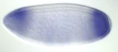 | apt_Ozdemir  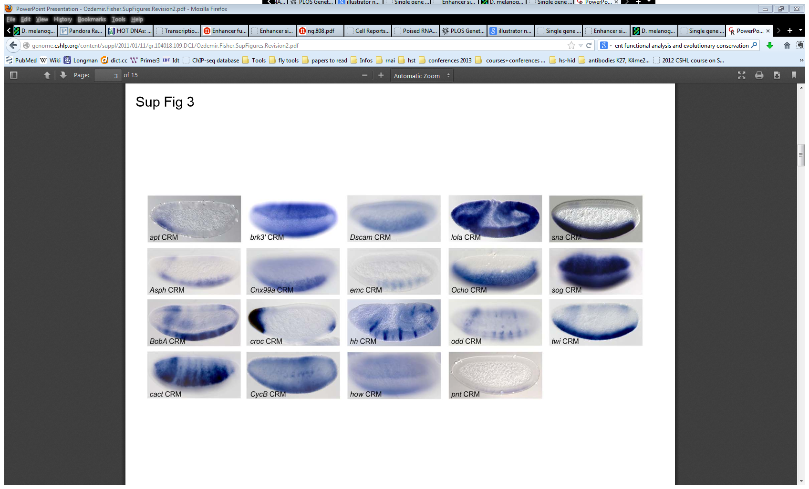
Asph_Ozdemir | Mesoderm | Asph | Asph  FBgn0034075 | Ric  FBgn0265605 | Asph  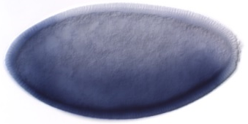  Ric  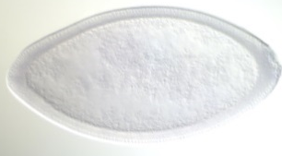 | Asph_Ozdemir
Cyp310a1_Ozdemir | Mesoderm | Cyp310a1 | Cyp310a1  FBgn0032693 | MESR3  FBgn0032694 | Cyp310a1  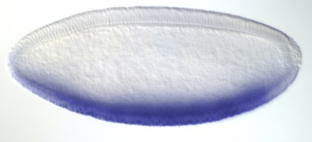  MESR3  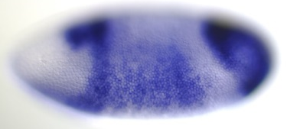 | Cyp310a1_Ozdemir  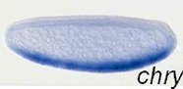
Mef2_Ozdemir | Mesoderm | Mef2 | Mef2  FBgn0011656 | Pal1  FBgn0033466 | Mef2  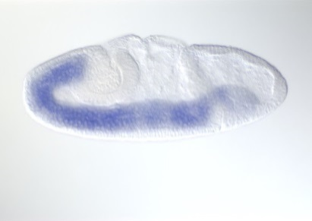  Pal1  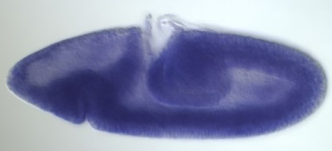 | Mef2_Ozdemir  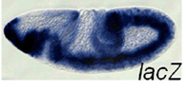
twi_Ozdemir | Mesoderm | twi | twi  FBgn0003900 | twi  FBgn0003900 | twi  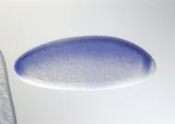 | twi_Ozdemir
VT0984_Kvon | Dorsal ectoderm | erm | erm  FBgn0031375 | Der-1  FBgn0031376 | erm  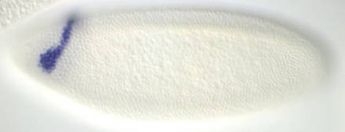  Der-1  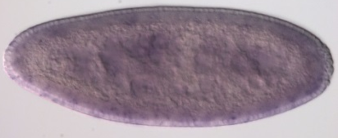 | 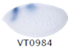
VT17873_Kvon | Mesoderm | CG5522 | CG5522  FBgn0034158 | CG5522  FBgn0034158 | CG5522  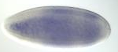 | 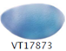
VT20119_Kvon | Mesoderm | ktub | ktub  FBgn0015721 | ktub  FBgn0015721 | ktub  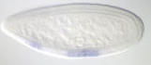 | 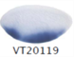
VT26325_Kvon | Dorsal ectoderm | CG10479 | CG10479  FBgn0035656 | CG10479  FBgn0035656 | CG10479   | 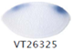
VT37495_Kvon | Dorsal ectoderm | zen2 | pb  FBgn0051481 | zen2  FBgn0004054 | pb  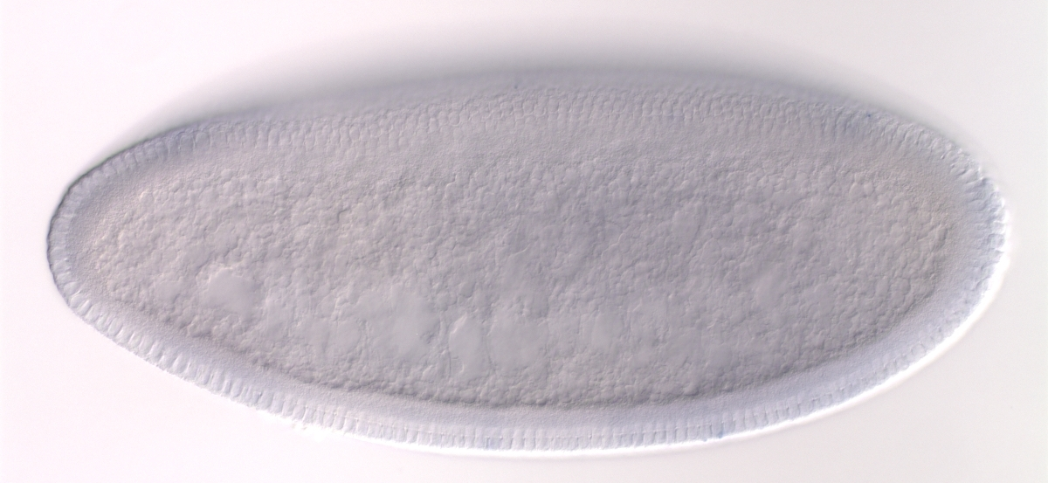  zen2  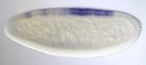 | 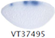
VT42492_Kvon | Dorsal ectoderm | tara | tara  FBgn0040071 | tara  FBgn0040071 | tara  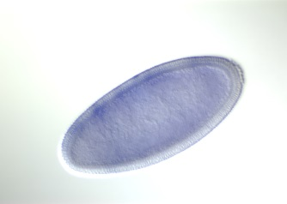 | 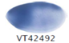
VT44117_Kvon | Dorsal ectoderm | Dl | Dl  FBgn0000463 | Dl  FBgn0000463 | Dl  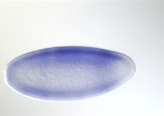 | 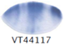
VT56148_Kvon | Mesoderm | N | N  FBgn0004647 | N  FBgn0004647 | N  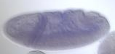 | 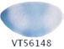
VT6477_Kvon | Dorsal ectoderm | pdm2 | pdm2  FBgn0004394 | pdm2  FBgn0004394 | pdm2  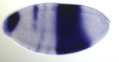 | 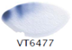
VT7402_Kvon | Mesoderm | noc | noc  FBgn0005771 | noc  FBgn0005771 | noc  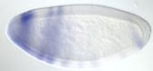 | 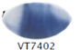
VT9677_Kvon | Dorsal ectoderm | tup | tup  FBgn0003896 | tup  FBgn0003896 | tup  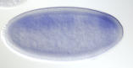 | 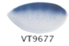

¹ Reprinted from Ozdemir A, Fisher-Aylor KI, Pepke S, Samanta M, Dunipace L, McCue K, Zeng L, Ogawa N, Wold BJ, Stathopoulos A. 2011. High resolution mapping of Twist to DNA in Drosophila embryos: Efficient functional analysis and evolutionary conservation. Genome Res 21: 566-577. Copyright 2011, with permission from Cold Spring Harbor Laboratory Press.
² Reprinted from Kvon EZ, Stampfel G, Yanez-Cuna JO, Dickson BJ, Stark A. 2012. HOT regions function as patterned developmental enhancers and have a distinct cis-regulatory signature. Genes Dev 26: 908-913. Copyright 2012, with permission from Cold Spring Harbor Laboratory Press.

Enhancers whose nearest expressed gene was assigned:
Enhancer name | Enhancer expression in | Likely target gene | Gene assigned by hand | Nearest expressed  gene | Gene expression from BDGP (Tomancak et al. 2002; Tomancak et al. 2007; Hammonds et al. 2013) | Enhancer expression from Kvon et al. (2012)² (VT…)
VT8889_Kvon | Mesoderm | Lrch | CG15141  FBgn0032635 | Lrch  FBgn0032633 | Lrch  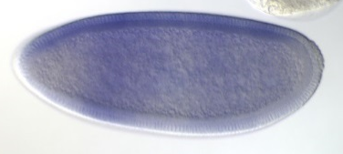  CG15141  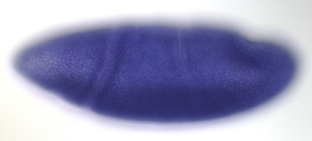 | 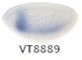

Enhancers with unknown target gene:
Enhancer name | Enhancer expression in | Likely target gene | Gene assigned by hand | Nearest expressed  gene | Gene expression from BDGP (Tomancak et al. 2002; Tomancak et al. 2007; Hammonds et al. 2013) or publication | Enhancer expression from Ozdemir et al. (2011)¹ or Kvon et al. (2012)² (VT…)
BobA_Ozdemir | Mesoderm | Unknown:  target gene not expressed in mesoderm | BobA  FBgn0040487 | BobA  FBgn0040487 | BobA  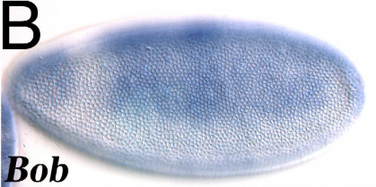  Bardin and Schweisguth (2006)³ | BobA_Ozdemir
Cnx99A_Ozdemir | Mesoderm | Unknown: no early expression pattern found for target gene | Cnx99A  FBgn0015622 | Cnx99A  FBgn0015622 | No early expression pattern found for Cnx99A | Cnx99A_Ozdemir
Dscam1_Ozdemir | Mesoderm | Unknown: target gene expression pattern not similar | Dscam1  FBgn0033159 | Dscam1  FBgn0033159 | Dscam1  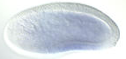 | Dscam_Ozdemir
emc_Ozdemir | Mesoderm | Unknown: target genes are not expressed in mesoderm | emc  FBgn0000575 | hng3  FBgn0035160 | emc  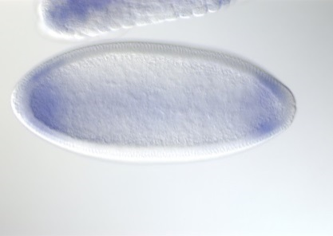  hng3  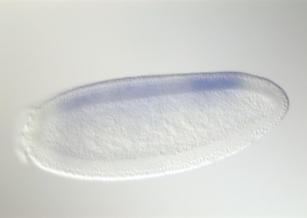 | emc_Ozdemir
Ocho_Ozdemir | Mesoderm | Unknown: target gene expressed ubiquitously | Ocho  FBgn0040296 | CR43432  FBgn0263380 | Ocho  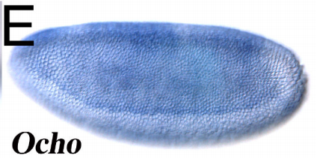  Bardin and Schweisguth (2006)³  No expression pattern found for CR43432 | Ocho_Ozdemir
pnt_Ozdemir | Mesoderm | Unknown: target gene not expressed in mesoderm | pnt  FBgn0003118 | pnt  FBgn0003118 | pnt  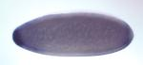 | pnt_Ozdemir
VT1404_Kvon | Dorsal ectoderm | Unknown: target gene does not show expression by in situ | Pgk  FBgn0250906 | Pgk  FBgn0250906 | Pgk  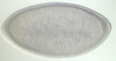 | 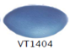
VT15341_Kvon | Mesoderm | Unknown: no expression pattern found for target gene | snoRNA: Me28S-A1322  FBgn0015543 | snoRNA: Me28S-A1322  FBgn0015543 | No expression pattern found for snoRNA: Me28S-A1322 | 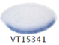
VT21015_Kvon | Mesoderm | Unknown: target gene expressed ubiquitously | blw  FBgn0011211 | blw  FBgn0011211 | blw  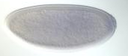 | 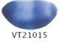
VT34695_Kvon | Dorsal ectoderm | Unknown: target gene not expressed or in situ not available | olf413  FBgn0037153 | Rich  FBgn0028500 | olf413  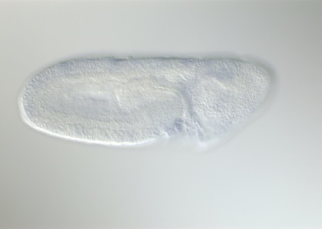  No expression pattern found for Rich | 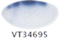
VT36350_Kvon | Dorsal ectoderm | Unknown: target gene expressed ubiquitously | CG31522  FBgn0051522 | CG31522  FBgn0051522 | CG31522  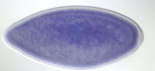 | 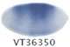
VT44757_Kvon | Dorsal ectoderm | Unknown: target gene expression pattern not similar | Stat92E  FBgn0016917 | Stat92E  FBgn0016917 | Stat92E  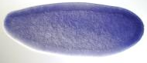 | 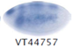
VT49279_Kvon | Dorsal ectoderm | Unknown: target gene not expressed in dorsal ectoderm | stg  FBgn0003525 | stg  FBgn0003525 | stg  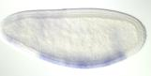 | 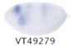
VT57022_Kvon | Dorsal ectoderm | Unknown: target gene expression pattern not similar | Ptp4E  FBgn0004368 | Ptp4E  FBgn0004368 | Ptp4E  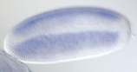 | 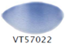

³ Reprinted from Developmental cell (10), Bardin AJ, Schweisguth F, Bearded family members inhibit Neuralized-mediated endocytosis and signaling activity of Delta in Drosophila, 245-255, Copyright (2006), with permission from Elsevier.

Supplemental references
Bardin AJ, Schweisguth F. 2006. Bearded family members inhibit Neuralized-mediated endocytosis and signaling activity of Delta in Drosophila. Developmental cell 10: 245-255.
Biemar F, Nix DA, Piel J, Peterson B, Ronshaugen M, Sementchenko V, Bell I, Manak JR, Levine MS. 2006. Comprehensive identification of Drosophila dorsal-ventral patterning genes using a whole-genome tiling array. Proceedings of the National Academy of Sciences of the United States of America 103: 12763-12768.
Doyle HJ, Kraut R, Levine M. 1989. Spatial regulation of zerknullt: a dorsal-ventral patterning gene in Drosophila. Genes Dev 3: 1518-1533.
Hammonds AS, Bristow CA, Fisher WW, Weiszmann R, Wu S, Hartenstein V, Kellis M, Yu B, Frise E, Celniker SE. 2013. Spatial expression of transcription factors in Drosophila embryonic organ development. Genome Biol 14: R140.
Hodar C, Zuniga A, Pulgar R, Travisany D, Chacon C, Pino M, Maass A, Cambiazo V. 2014. Comparative gene expression analysis of Dtg, a novel target gene of Dpp signaling pathway in the early Drosophila melanogaster embryo. Gene 535: 210-217.
Huang JD, Schwyter DH, Shirokawa JM, Courey AJ. 1993. The interplay between multiple enhancer and silencer elements defines the pattern of decapentaplegic expression. Genes Dev 7: 694-704.
Ip YT, Park RE, Kosman D, Yazdanbakhsh K, Levine M. 1992. dorsal-twist interactions establish snail expression in the presumptive mesoderm of the Drosophila embryo. Genes Dev 6: 1518-1530.
Jiang J, Kosman D, Ip YT, Levine M. 1991. The dorsal morphogen gradient regulates the mesoderm determinant twist in early Drosophila embryos. Genes Dev 5: 1881-1891.
Kirov N, Childs S, O'Connor M, Rushlow C. 1994. The Drosophila dorsal morphogen represses the tolloid gene by interacting with a silencer element. Mol Cell Biol 14: 713-722.
Kvon EZ, Stampfel G, Yanez-Cuna JO, Dickson BJ, Stark A. 2012. HOT regions function as patterned developmental enhancers and have a distinct cis-regulatory signature. Genes Dev 26: 908-913.
Lin MC, Park J, Kirov N, Rushlow C. 2006. Threshold response of C15 to the Dpp gradient in Drosophila is established by the cumulative effect of Smad and Zen activators and negative cues. Development 133: 4805-4813.
Markstein M, Zinzen R, Markstein P, Yee KP, Erives A, Stathopoulos A, Levine M. 2004. A regulatory code for neurogenic gene expression in the Drosophila embryo. Development 131: 2387-2394.
Nguyen HT, Xu X. 1998. Drosophila mef2 expression during mesoderm development is controlled by a complex array of cis-acting regulatory modules. Developmental biology 204: 550-566.
Ozdemir A, Fisher-Aylor KI, Pepke S, Samanta M, Dunipace L, McCue K, Zeng L, Ogawa N, Wold BJ, Stathopoulos A. 2011. High resolution mapping of Twist to DNA in Drosophila embryos: Efficient functional analysis and evolutionary conservation. Genome Res 21: 566-577.
Perry MW, Boettiger AN, Bothma JP, Levine M. 2010. Shadow enhancers foster robustness of Drosophila gastrulation. Curr Biol 20: 1562-1567.
Rusch J, Levine M. 1997. Regulation of a dpp target gene in the Drosophila embryo. Development 124: 303-311.
Sandmann T, Girardot C, Brehme M, Tongprasit W, Stolc V, Furlong EE. 2007. A core transcriptional network for early mesoderm development in Drosophila melanogaster. Genes Dev 21: 436-449.
Stathopoulos A, Tam B, Ronshaugen M, Frasch M, Levine M. 2004. pyramus and thisbe: FGF genes that pattern the mesoderm of Drosophila embryos. Genes Dev 18: 687-699.
Stathopoulos A, Van Drenth M, Erives A, Markstein M, Levine M. 2002. Whole-genome analysis of dorsal-ventral patterning in the Drosophila embryo. Cell 111: 687-701.
Tomancak P, Beaton A, Weiszmann R, Kwan E, Shu S, Lewis SE, Richards S, Ashburner M, Hartenstein V, Celniker SE et al. 2002. Systematic determination of patterns of gene expression during Drosophila embryogenesis. Genome Biol 3: RESEARCH0088.
Tomancak P, Berman BP, Beaton A, Weiszmann R, Kwan E, Hartenstein V, Celniker SE, Rubin GM. 2007. Global analysis of patterns of gene expression during Drosophila embryogenesis. Genome Biol 8: R145.
Yin Z, Xu XL, Frasch M. 1997. Regulation of the twist target gene tinman by modular cis-regulatory elements during early mesoderm development. Development 124: 4971-4982.
Zeitlinger J, Zinzen RP, Stark A, Kellis M, Zhang H, Young RA, Levine M. 2007. Whole-genome ChIP-chip analysis of Dorsal, Twist, and Snail suggests integration of diverse patterning processes in the Drosophila embryo. Genes Dev 21: 385-390.

