Supplemental Information
Supplemental Figure S1
Flow chart of the molecular biology pipline.
The full streamlined molecular biology pipline of the cell lineage analysis platform. (Red) Single cell DNA extraction, (Blue) Targeted enrichment & NGS library preparation and (Green) Pooling & Sequencing.

Supplemental Figure S2
Scheme of the performed PCR reactions in the molecular biology pipeline.
Step 1: Each PCR product (amplicon) is amplified by a target-specific primer, which consists of a universal 5' tail (red and green). Step 2: All amplified amplicons are pulled-out to a single well. Step 3: Following dilution of the pool by a ratio of 1:100, a 2nd PCR is performed, targeting all amplicons in the well using a single primer pair which targets the universal sequences. Primers consist of a 5' tails which consists of an Illumina index sequence and an Illumina adapter. The final PCR product is a ready-to-run Illumina library which can be multiplexed with other indexed PCR products in an NGS run. For simplicity, only one index is presented in the illustration, while in our pipeline we utilize primer combinations which insert unique index combinations for each sample, finalizing with a standard Illumina TruSeqHT dual indexed library (Supplemental Figure S4, Supplemental Table S3)
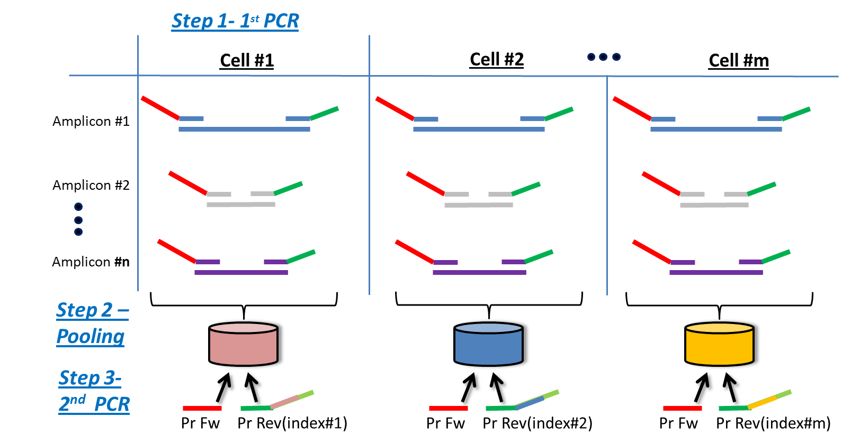

Supplemental Figure S3
Mouse colon experiment samples reanalysis using the NGS based pipeline.

(a) Tree reconstruction of the mouse colon samples. Samples were reanalyzed from (Reizel et al. 2011) and used as a proof of concept validation for the pipeline. Colored circles show that the single cells from each crypt are clustered together (p-values were calculated using hypergeometric test). Cyan boxes show that 2nd PCR duplicates (were attached by a different barcode) are clustered together, as expected. On the right panel, cell depth of the younger mouse (left tree) is shallower than the older mouse (right tree), as expected (Reizel et al. 2011) (p-value was calculated using the KS test). (b) An algorithm for MS length calling using clustering of the histograms. The three left plots show signals that correlate best at 28, 29 and 30 repeat units respectively. The right plot shows that optimal correlation after all the signals have been shifted. The somatic mutations are derived from the amount of shifting units of each histogram.

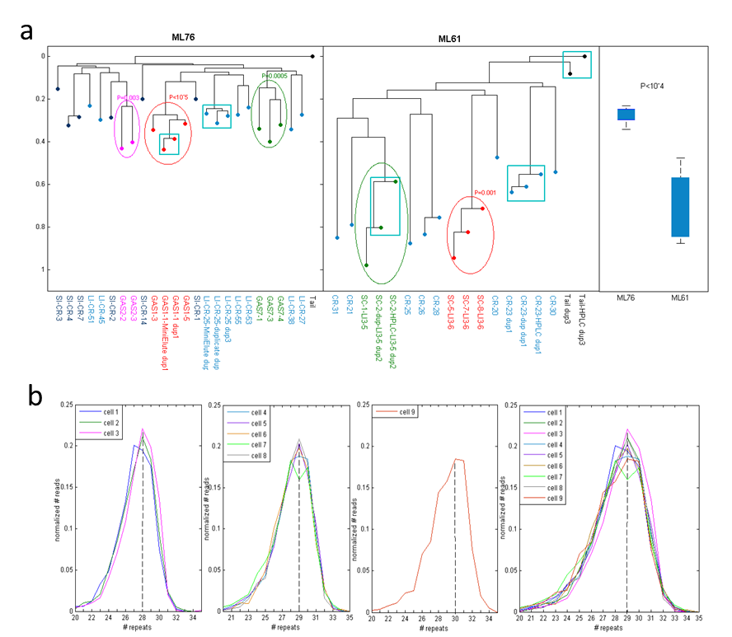

Supplemental Figure S4
Barcode plate containing primer pairs utilized in the 2nd PCR.
Primers/index combinations form a unique combination in the 2nd PCR thus creating a barcoded NGS library annotating the original sample. To simplify sample processing we have created stock plates containing 48 primer combinations each, corresponding with the 48 sampled retrieved from Access Array (AA) chip. The indexes in each plate are a combination of top row and first column indexes (see index sequences in: Supplemental Table S3).

Supplemental Figure S5
Lineage platform replicate controls
For each experiment, the samples were automatically and randomly distributed within the participating AA chips in order to eliminate manual errors and to enable a true double blind analysis, thus removing doubts of user selection and/or chip order/location biases. To validate the success of the randomization we randomly assigned DU145 cells over 9 AA chips and validated the accurate reconstruction replicate cells. (A) Representation of replicate samples in 48 wells batches (circles) in each AA chip. Colors indicate single cell sample duplicates/triplicates (light grey indicate samples without replicates). B) Cell lineage reconstruction of samples from (A). Colored lines indicate significant clustering and correspond to the colors in (A). Replicates were perfectly clustered on the reconstructed tree.

Supplemental Figure S6
Successfully aligned read count before and after volume normalization to an equal read count.
Results from the two experiments which are described in the manuscript: The cancerous cell line (DU145) and the normal cell line (H1) samples are shown in panels (A) and (B), respectively. The successfully aligned reads for each sample which participated in the Nextseq500 run are plotted before volume normalization (Miseq, left box), and after normalization (Nextseq500, right box). Only samples that were normalized to an equal expected successfully aligned read count are shown. Some samples were deliberately picked at higher or lower volumes to achieve a different normalized read number.
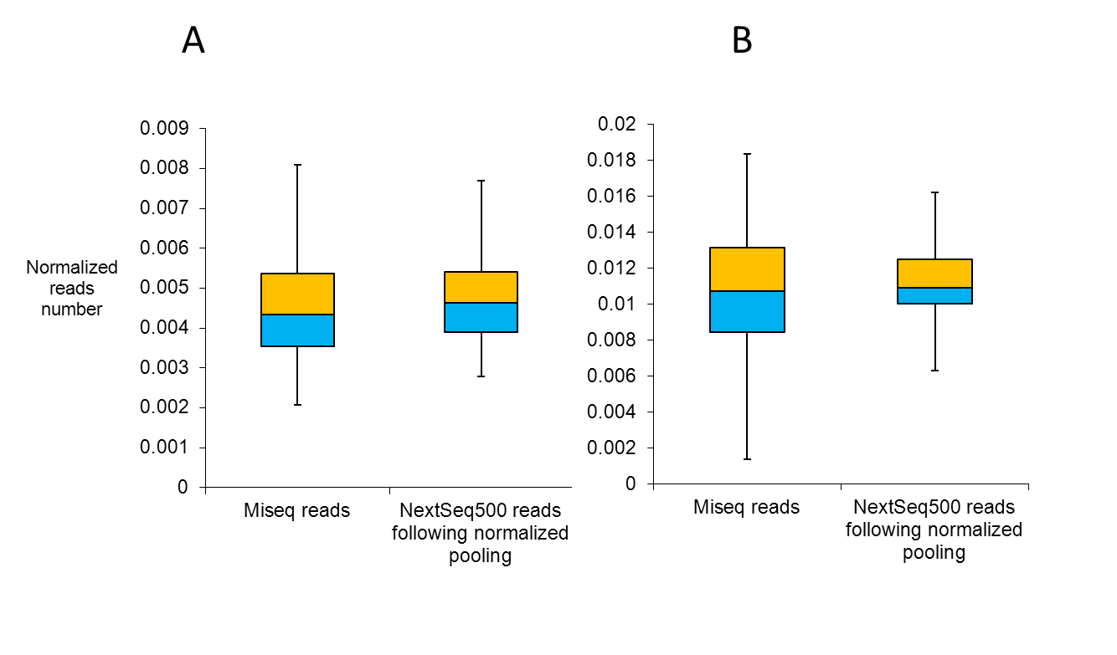

Supplemental Figure S7
A schematic diagram of the computational pipeline.

Supplemental Figure S8
Loci read count distribution.
Average read count of the 1759 loci across all samples of the DU145 experiment.

Supplemental Figure S9
Paired-end quality score enhancement.
Example of the quality score of each of the paired-end reads and the resulting merge (using FastQC).

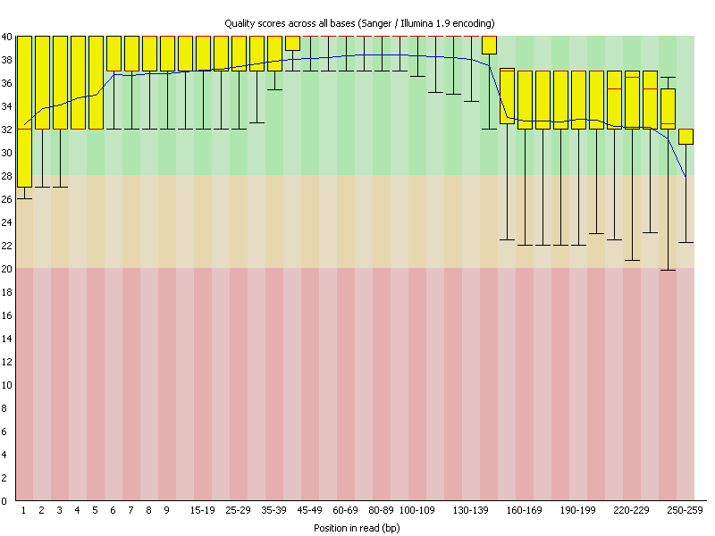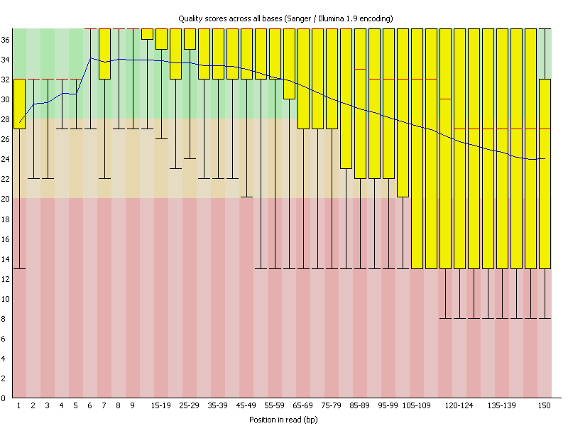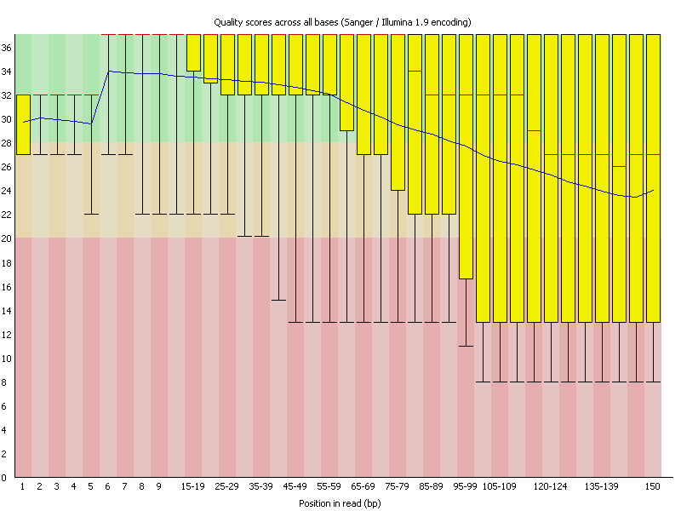
R1:
R2:
Merged:
TGATCAGCATAAAGGCACTCTCTTTATTATATGTGTGTGTGTGTGTGTGTGTGTGTCACCACTAAATCATATAGA
AAAGGGTCTGTCTCTATTATATGTGTGTGTGTGTGTGTGTGTGTGTGACAACAAAAGGAGATAGAGAGTCAGAGCA
TGATCAGCATAAAGGCACTCTCTTTATTATATGTGTGTGTGTGTGTGTGTGTGTGTGACAACAAAAGGAGATAGAGAGTCAGAGCA
R1
R2
Position
Position
Quality
Quality
Quality

Supplemental Figure S10
MS reads mapping
Each read is mapped to a specific target locus according to its flanking regions.

ATACTTTATAATATATGTCACTTTTATATATATGTGTGTGTGTGTGTGTGTGTGTGTGTGTGTGTGTGTGACATAATAAAGGA
GCGAAAGTNGTTCAAGCCCATGCCAGCCTCTCTCTCTCTCTCTCTCTATCTCTCTCTCTCTCTCTCGGATAACACATTTAACA
GGCAGTCTCTTTCTTTCTTTCTTTTCTTTCTTTCTTTCTTTCTTTCTTTCTTTCTTTCTTTCTTTCTTTCTGTCAAGTTGGGG
CCACTAGCCCACATTGAGCATTAACAGTGAGAGACCCTGAATGAGAGAGAGAGAGAGAAAGAGAGAGAGAGAGCTGCGTTAC
…
MS_Target_130
MS_Target_25
MS_Target_253
MS_Target_335
…
Fw/Rev Primers

$$p_{sub}$$
$$p_{add}$$
Supplemental Figure S11
Using synthetic oligos with known number of MS repeats we estimated the parameters of the Binomial model.

Supplemental Figure S12
Ex vivo reconstructed tree.
Reconstructed tree showing only the single cells from terminating sub-clones, analyzed from the ex vivo DU145 experiment. Colors indicate statistically significant clustering (hypergeometric test, analyzing sub-clones from the third passage as the same).

Supplemental Figure S13
Examples of microscopic views of cell picking of DU145 cells

a, b) Before and after screenshots (respectively) of single cell picking using an automated picking device (CellCelector, ALS). Dashed circle was added to represent needle picking location. Bar = 200µm.
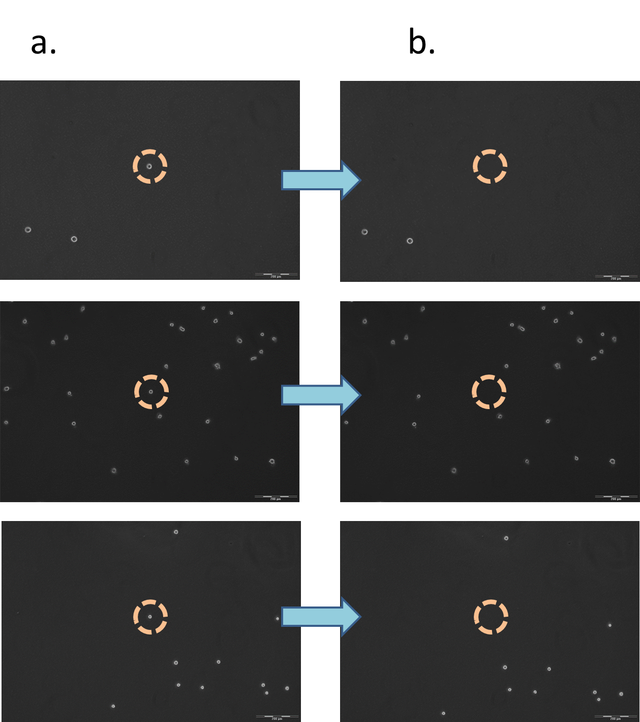
Supplemental Figure S14
Topology of the true experimental ex vivo tree.
The name of each level starts with a letter followed by an index. The number below indicates the number of single cells that were sampled and analyzed from that sub-clone.

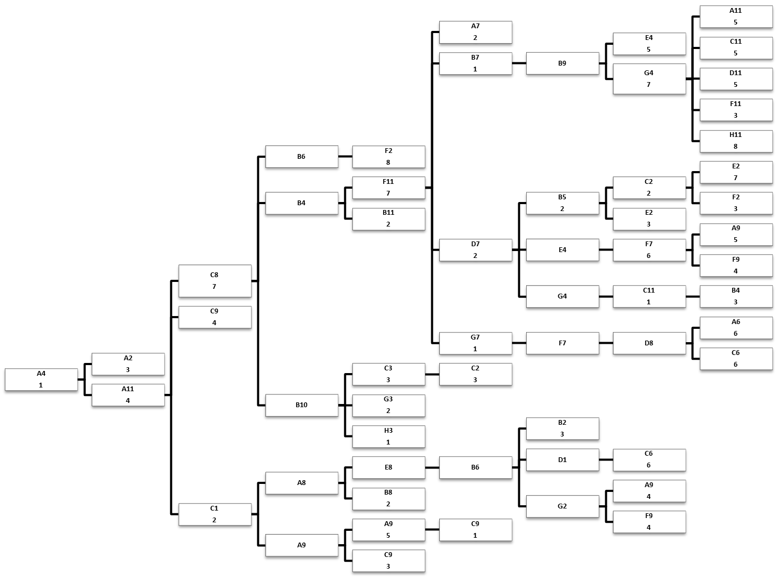

Supplemental Figure S15
Loci and samples signal distribution.
Distribution of the signal probability of the samples (left) and the loci (right) estimated according to the real experimental mutation table data of the DU145 ex vivo experiment.

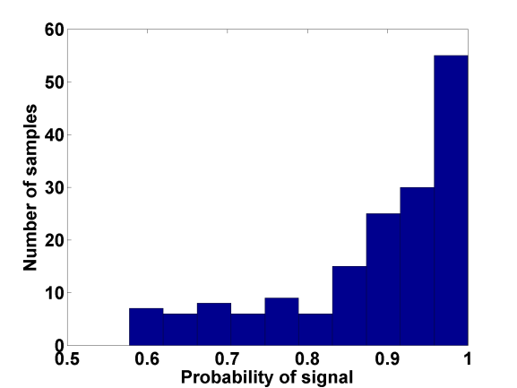
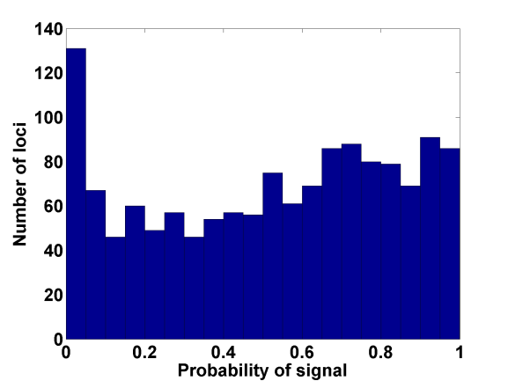

Sample signal distribution $P$
Loci signal distribution $Q$

Supplemental Figure S16
Calibration of optimal reconstruction parameters using simulated trees.
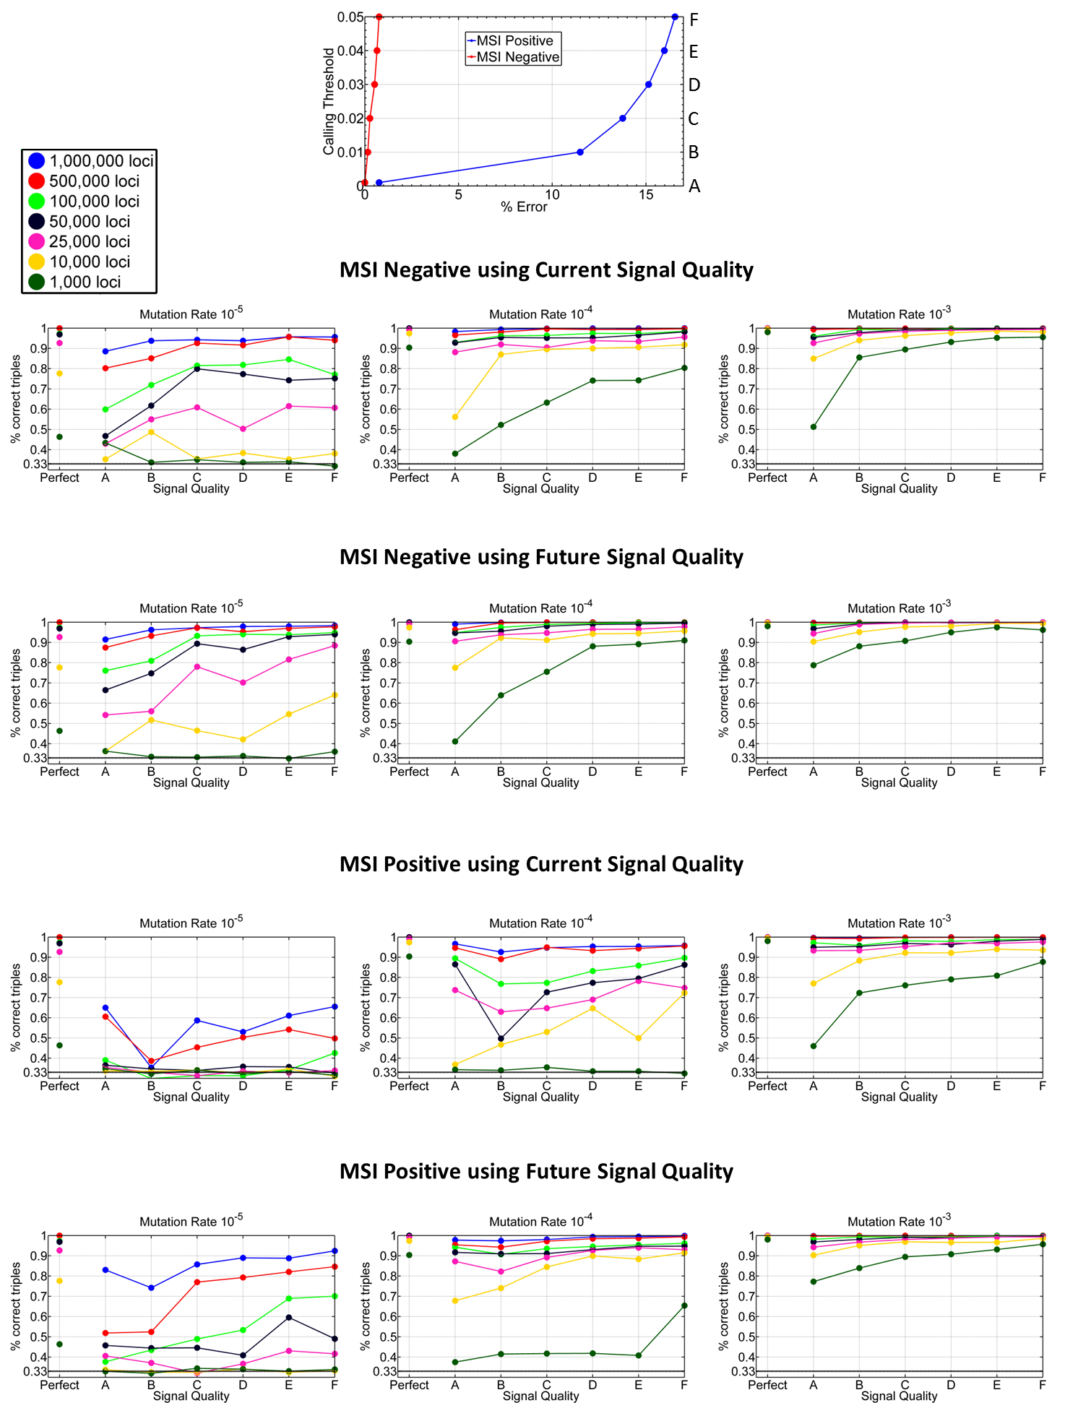
(a) Tradeoff between calling threshold and errors in the mutations calling using data from ex vivo trees of both MSI negative (H1 normal cells) and MSI positive (DU145 cancer cells). Using different thresholds one can balance between less filtering + more errors and high filtering + less errors, thus selecting the optimal threshold for reconstruction. (b) Reconstruction accuracy of simulated trees with different mutation rate as a function of the different thresholds corresponding to the A-F dots in (a). Data includes errors of both MSI negative and positive as indicated in (a). Cells harboring MSI are known to have higher mutation rates (in the order of 10⁻³ mutations per locus per cell division), while MSI negative cells mutate in the rate order of 10⁻⁵. However, mutation rates can vary depending on the MS length and repeat type. Reconstruction accuracy is measured using the triples distance (see text). Random trees receive score of around 1/3 (indicated in the figures as black line).
b
a
Supplemental Figure S17
DU145 cell line karyotype.

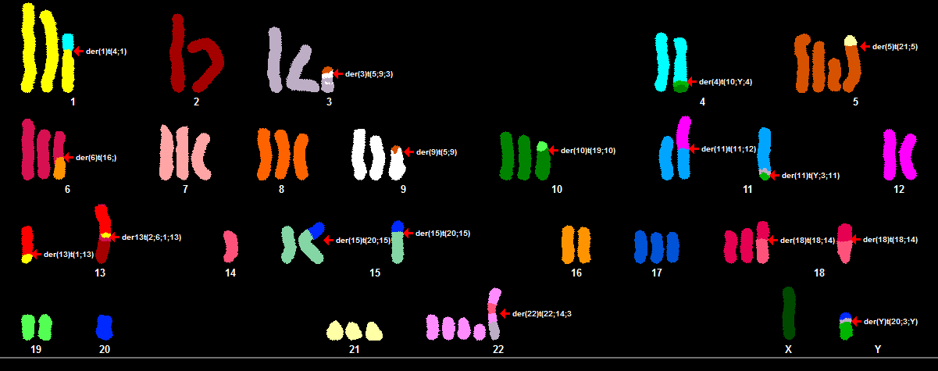

Supplemental Figure S18
The Triples distance.
Each three leaves in a tree (e.g., nodes $x,y,z$ on the left tree) induce a triplet tree (right tree). Given 3 nodes there are 3 possible triplet tree arrangements: 1. where $y,z$ have a more recent common ancestor (as shown in the figure), 2. where $x,y$ have a more recent common ancestor, and 3. where $x,z$ have a more recent common ancestor. Given two trees (in our case the real and the reconstructed trees) we go over all possible combinations of 3 leaves and compare the induced triplet trees from both trees. The Triples Score is the percentage of agreement between the induced triplet trees. Note, that a random tree would agree in one third of the times so a score of 1/3 is considered the worse. Trees with identical topologies would get a score of 1.
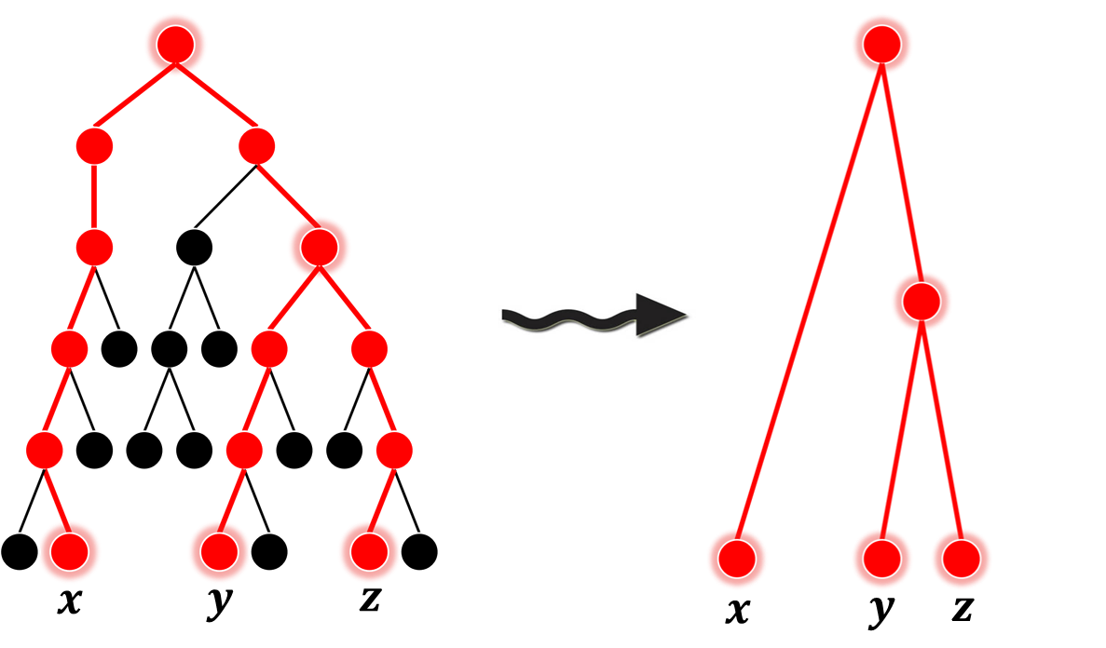

Supplemental Figure S19
Schematic description of the distance between the root and the branch of a triple.

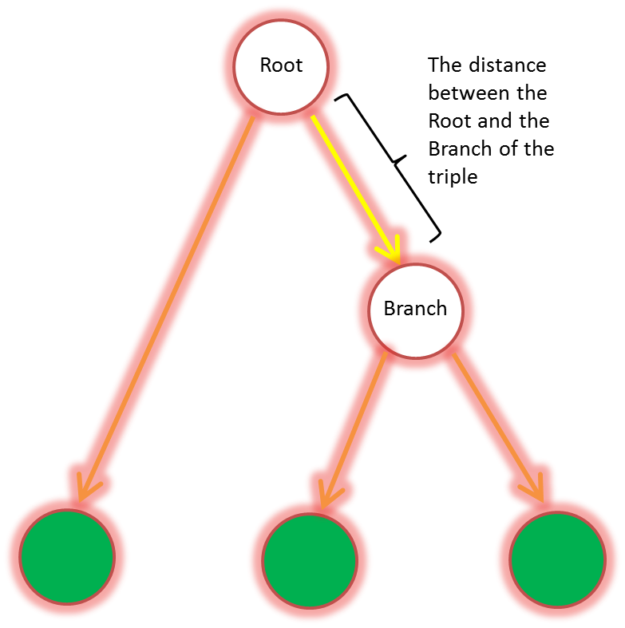

Supplemental Figure S20
Boxplot describing the average number of reads across 167 single cells for each multiplex group.
The color indicates the % of loci within the multiplex group which have been amplified within 75% of the expected number of reads (see Supplemental Note 6 for details).

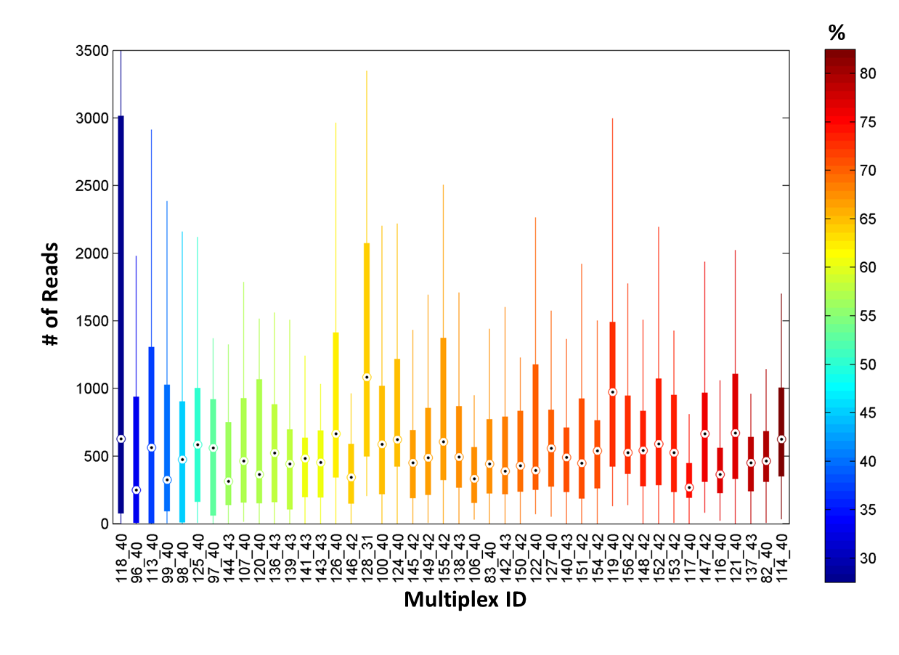

Supplemental Figure S21
Heat maps of the 219 SNP targets multiplex group in the DU145 experiment.
A) The entire set of 219 SNPs (columns) over all valid samples (rows). B) Only SNPs that managed to amplify in at least half of the samples (194 SNPs). C) Same as (B) but binarized by SNPs that have a coverage ≥10 (red).

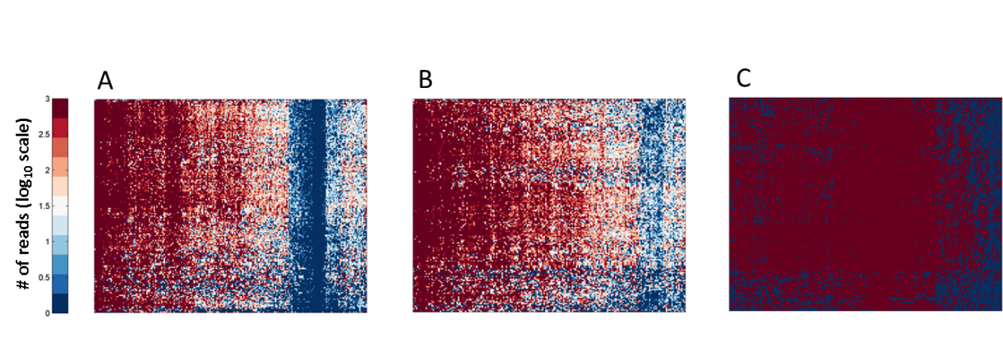

Supplemental Table S1
Mouse experiment targets and their corresponding PCR primers. Coordinates are based on mm9 assembly.
See corresponding Excel file.

Supplemental Table S2
Human experiment targets, their corresponding PCR primers and their multiplex groups. Coordinates are based on hg19 assembly. Note that some targets are shared by the same primer pairs, as discussed in the manuscript.
See corresponding Excel file.

Supplemental Table S3
Index sequences used in the lineage platform to barcode samples in a multiplexed NGS run.

Indexes that were used in the Forward and Reverse primers in the 2nd PCR, which contribute a unique index combination to the library (See Methods in the manuscript, Supplemental Figure S4).

Rows (inserted in Fw primer) |  | Columns (inserted in Rev primer)
i5 index |  | i7 index
i5 bases in D5xx adapter |  | i7 bases in D7xx adapter
D501 | TATAGCCT | D701 | ATTACTCG
D502 | ATAGAGGC | D702 | TCCGGAGA
D503 | CCTATCCT | D703 | CGCTCATT
D504 | GGCTCTGA | D704 | GAGATTCC
D505 | AGGCGAAG | D705 | ATTCAGAA
D506 | TAATCTTA | D706 | GAATTCGT
D507 | CAGGACGT | D707 | CTGAAGCT
D508 | GTACTGAC | D708 | TAATGCGC
D509 | CCAGTGTG | D709 | CGGCTATG
D510 | CTGCTAAT | D710 | TCCGCGAA
D511 | CAGCACTA | D711 | TCTCGCGC
D512 | ACTATGTC | D712 | AGCGATAG
D513 | GTATTAAG | D713 | ACCCTCTT
D514 | GTTCTATA | D714 | GCCATAAT
D515 | CCGGGAAC | D715 | GTCTCCCA
D516 | ACACCTAG | D716 | CAGCGTCC
D517 | CATTAGCT | D717 | TAATTGAT
D518 | TTCTTTTA | D718 | TGGGAGCC
D519 | GGAGCTAA | D719 | ATGCTGAC
D520 | TGCAACCT | D720 | ACAGTGCG
D521 | CTGGGCCA | D721 | CACAAAAC
D522 | CGGAGGGA | D722 | AAGGTCGC
D523 | AGCCGGAA | D723 | CGCGGAAG
D524 | TTGGCTTT | D724 | GTGACCAG
D525 | ACTGGACT | D725 | TAAGAAGA
D526 | TGGTATCG | D726 | GACCATTT
D527 | TGTGATCT | D727 | GTCAGAAC
 |  | D728 | TTGTACAA
 |  | D729 | CCACGAGC
 |  | D730 | ATGACCGT
 |  | D731 | CCATCCGG
 |  | D732 | AATACTTC
 |  | D733 | TAGATCTT
 |  | D734 | AGACCAGA
 |  | D735 | GTCGCTAC
 |  | D736 | TAAGTATC
Supplemental Table S4
Example of a mutation table.
A complete mutation table generated according to the mutation calling algorithm. Dropouts are loci that did not amplify within a certain sample are marked with Null values in the mutation table.

 | MS_Tatget_1 | MS_Tatget_2 | MS_Tatget_3 | … | MS_Tatget_N
Sample 1 | 24 | 15 | 18 |  | 32
Sample 2 | 23 | Null | 19 |  | Null
Sample 3 | 23 | 15 | Null |  | 32
…
Sample M | 23 | Null | 18 |  | 31

Supplemental Table S5
Costs summary for a cell lineage analysis project.
Costs are calculated for a project of 480 cell samples. Calculation considers for a standard platform run in which 48 samples are processed together (from AA chip to 2nd PCR), until combining to 96 well plate while equalizing concentration and to a 384 well plate for echo pooling.
 | cost per kit/reagent($) | number of reactions in kit (calculated according to the lineage protocol) | cost per sample ($) | comment
REPLI-g mini | 1,276.99 | 300 | 4.26 | Modified protocol
FastStart HiFi PCR System dNTPack, 500 U | 759.94 | 200 | 3.81 | Considering excess, considering twice the recommended master mix volume, to reduce robot liquid handling bias. 5 U/μL X 24=120U per 48 wells reaction
Access Array chip | 484 | 48 | 10.08
Q5 High-Fidelity DNA Polymerase - 500 U | 592.01 | 5000 | 0.12
Agencourt AMPure XP (beads), 60 ml | 774.38 | 375 | 2.07 | 10µl reaction
QuantiT™ dsDNA HS Assay Kit, 100 assays | 152.62 | 250 | 0.61 | Considering 80µlX2=160µl per two purification reactions
Miseq run (600bp) | 1,900.00 | 480 | 3.96
Nextseq (300bp) | 5,500.00 | 480 | 11.46
Consumables |  |  | 3.00
Total |  |  | 39.37

Supplemental Note S1 - Colon validation
As an initial validation to our pipeline we have reanalyzed samples that were previously analyzed using an older system based on capillary electrophoresis (Reizel et al. 2011). DNA samples from whole crypts, small intestine and large intestine from young and old mice were analyzed, and their cell lineage tree was reconstructed. Similarly to what was previously reported, single cells from the same crypts were clustered together and the depth of the cells (corresponding to the number of cell divisions since the zygote) was significantly increased in the older mouse (Supplemental Figure S3). The main differences between this pipeline and the final pipeline (which is described in the manuscript) are that: (1) It is performed in PCR plates only (and not utilizes the AA chip) (2) Only ~180 amplicons per sample - in separate wells (no multiplexing, primer sequences are described in Supplemental Table S1) (3) Constructs single indexed TruSeqLT compatible NGS libraries. (4) Mutation calling was performed by shifting and clustering the histogram.

1st PCR
PCR was performed individually for each amplicon separately in a 96 well PCR plate (Axygen) in a 10µl volume reaction.
PCR was performed using KOD Hot Start DNA Polymerase (Novagen) according to recommended protocol with the exceptions of: (1) In order to track and prevent over cycling, PCR reaction was added with SYBR green I (Lonza) at a final reaction of 0.5x and was tracked using a real time PCR machine (LC480, Roche). (2) Final concentration of 0.4µM per primer (purchased from Sigma-aldrich).
2µl of DNA products were used as a template: Tail bulk was diluted to 1ng/µl and WGA DNA (originated from a template of either single cells or whole crypts) was diluted 1:2. Samples were taken from the batches of the sample production done for (Reizel et al. 2011).
Primers 5’ tail sequences were as described in the manuscript methods.

In order to enable the addition of primer 5’ tails, we have used a 2-step PCR protocol:
Activation was performed at 2 minutes at 95ºC followed by 5 cycles of 95ºC for 20 seconds, 62ºC at 20 seconds and 70ºC for 10 seconds, and 25 more cycles of 95ºC for 20 seconds, 70ºC at 20 seconds and 70ºC for 30 seconds.
Following determination of number of cycles, reactions were performed in a standard thermal cycler DNA Engine Tetrad 2 (Bio-Rad). When real-time monitoring was performed, a melt-curve step was added: 95ºC for 10 seconds followed by a gradual decrease (0.11C/second) until 37ºC.

Pooling and 2nd PCR
PCR reactions were pooled at an equal volume, and dilution was diluted 1:10,000. The diluted mix was used as a template for a 2nd PCR as described for the 1st PCR with the exceptions of: (1) Reaction volume of 20µl. (2) 8µl of template used (3) Differential amplification for pools which originated from single cells or bulks: 20 cycles (5+15) or 15 cycles (5+10) respectively. Primer sequences are:
amp_Final_Fw:
AATGATACGGCGACCACCGAGATCTACACTCTTTCCCTACACGACGCTCTTCCGATCT.
amp_Final_Rev: CAAGCAGAAGACGGCATACGAGAT[Index]GTGACTGGAGTTCAGACGTGTGCTCTTCCGATC, where [Index] marks for index region. Indexes were excerpted from “Illumina TruSeq Small RNA Sample Prep” index list.

Samples were purified using AMPure XP magnetic beads at a 1.5x volume ratio or by MinElute PCR purification kit (Qiagen) and their concentration was measured using Qubit dsDNA HS Assay Kit. Following dilution to an equal concentration, samples were pooled together for 2X150bp sequencing run (Miseq, Illumina).

MS Calling algorithm
Using the histograms generated from the sequencing data, distances between the different samples were calculated. The histograms were first normalized with the read count, and then correlated to histograms from the other samples to find the optimal shifting of the histogram. The amount of shifting units that corresponds to the highest correlation is assumed to be the consequence of the somatic mutation (if exists). Example of such histograms and the clustering derived from the shifting to the highest correlation is shown in Supplemental Figure S3B.

Supplemental Note S2 – Examples of robotic scripts
In this section we elaborate on the robotic scripts which are performed during the molecular biology pipeline (Supplemental Information
Supplemental Figure S1-2). Two main robotic scripts are being performed before the AA targeted enrichment process. The first one is the "Multiplex group creation script" and the second one is the "Access array preparation - Sample cherry picking script". Subsequent scripts are the "Agencourt AMPure XP PCR cleanup script" and "NGS libraries dilution script".

Multiplex group creation script
Multiplex (MPX) group creation script allows the user to control for the primers which will run in the AA reaction. In accordance with user specifications (number of primers in group, number of groups, restriction of distance between different loci in our panel, a distance of a minimum of 10,000bp between loci in group) a home-designed algorithm creates the following script, which cherry picks 3µl volume of a primer pair mix (50µM each) to DNA suspension buffer (10 mM TRIS, pH 8.0, 0.1 mM EDTA) (TEKnova, PN T0221) In the next step, each multiplex group is diluted 19:20 using a 20x Access Array Loading Reagent (Fluidigm) to a final concentration of 1µM per primer in multiplex group in accordance with Fluidigm protocol. When the number of source plates is too large (as the limiting number of plates on the table is 9), only a subset of the plates is placed on the table. Additional script/scripts are then automatically generated to complete the requested transfers from the additional source plates. This script supports the insertion of up to 47x primer pairs in a single multiplex group.
The number of multiplex groups in an AA run is 48 while the custom buildup of the multiplex groups allows creating only a requested subset of any primers panel, as shown in the example:

Example:
1st script: TE addition (DNA suspension buffer)
############ DOCS ###############################
DOC
DNE Script
Script details
Project Name: Lineage
Created on2014-05-20 18:24:38.744443
ENDDOC
############ TABLE ###############################
Robot table layout

TABLE TABLE_DNE
############ HEADER ###############################
OPTION UPDATE_VOL_DB
Constants and reagents locations on table

OPTION VERIFY_TABLE
#GLOBAL REAGENTS
REAGENT TE_BUF T10 13 PIE_AUTBOT 2
############# END OF DEFAULT HEADER #########################
# anything from here on is produced by the automation,
# Parameters should be changed through AUT_CONFIG only
LIST TE_LIST
22.5
22.5
22.5
22.5
22.5
22.5
List of TE volumes per multiplex group

22.5
22.5
22.5
22.5
22.5
22.5
37.5
ENDLIST
Plate locations and plate types
(Here: Target MPX plate)
# Table Layout (for liquid handling)
LABWARE MM_MPX_w/o_LB_P4 P2 "96 Well PCR Plate"
############ SCRIPT SECTION ###############################
SCRIPT
Command & Source Reagent
DIST_REAGENT2 TE_BUF
Targets plates:
Targets wells
P2:A1+1;P2:B1+1;P2:C1+1;P2:D1+1;P2:E1+1;P2:F1+1;
P2:G1+1;P2:H1+1;P2:A2+1;P2:B2+1;P2:C2+1;P2:D2+1;P2:E2+1;
Volumes list (µl) Liquid class definition and tip type
TE_LIST AUT_AIR TIPTYPE:200
ENDSCRIPT

2nd script: primers cherry picking
############ DOCS ###############################
DOC
DNE Script
Project Name: Lineage
Created on2014-05-20 18:24:38.803287
ENDDOC
############ TABLE ###############################
TABLE TABLE_DNE
############ HEADER ###############################
OPTION UPDATE_VOL_DB
OPTION VERIFY_TABLE
#GLOBAL REAGENTS
############# END OF DEFAULT HEADER #########################
# anything from here on is produced by the automation,
Plate locations and plate types:
# Parameters should be changed through AUT_CONFIG only
# Table Layout (for liquid handling)
Target MPX plate)
LABWARE MM_MPX_w/o_LB_P4 P2 "96 Well PCR Plate"
LABWARE United_hg19_Tails_plt2 P3 "96 Well PCR Plate"
LABWARE United_hg19_Tails_plt3 P4 "96 Well PCR Plate"
United primer (Fw&Rev 50µM each) plates
MPX plate)
LABWARE United_hg19_Tails_plt1 P5 "96 Well PCR Plate"
LABWARE United_hg19_Tails_plt4 P6 "96 Well PCR Plate"
LABWARE United_hg19_Tails_plt9 P11 "96 Well PCR Plate"
LABWARE United_hg19_Tails_plt10 P13 "96 Well PCR Plate"
LABWARE United_hg19_Tails_plt11 P14 "96 Well PCR Plate"
LABWARE United_hg19_Tails_plt12 P15 "96 Well PCR Plate"
############ SCRIPT SECTION ###############################
SCRIPT
Command
TRANSFER_LOCATIONS P5:G09+1;P5:G10+1;P5:G11+1;P5:G12+1;P5:H01+1;P5:H03+1;P5:H04+1;P5:H05+1;P5:H06+1;P5:H07+1;P5:H08+1;P5:H09+1;P5:H10+1;P5:H12+1;P3:A01+1;P3:A02+1;P3:A03+1;P3:A04+1;P3:A05+1;P3:A06+1;P3:A07+1;P3:A08+1;P3:A09+1;P3:A10+1;P3:A11+1;P3:A12+1;P3:B02+1;P3:B03+1;P3:B04+1;P3:B05+1;P3:B06+1;P3:B07+1;P3:B08+1;P3:B09+1;P3:B10+1;P3:B11+1;P3:B12+1;P3:C01+1;P3:C02+1;P3:C03+1;P5:B10+1;P5:B11+1;P5:D06+1;P5:D07+1;P5:D08+1;P5:D09+1;P5:D10+1;P5:D11+1;P5:D12+1;P5:E01+1;P5:E02+1;P5:E03+1;P5:E04+1;P5:E05+1;P5:E06+1;P5:E07+1;P5:E08+1;P5:E09+1;P5:E10+1;P5:E11+1;P5:E12+1;P5:F01+1;P5:F02+1;P5:F03+1;P5:F04+1;P5:F05+1;P5:F06+1;P5:F07+1;P5:F08+1;P5:F09+1;P5:F10+1;P5:F11+1;P5:F12+1;P5:G02+1;P5:G03+1;P5:G04+1;P5:G05+1;P5:G06+1;P5:G07+1;P5:G08+1;P5:A01+1;P5:A02+1;P5:A03+1;P5:A04+1;P5:A06+1;P5:A07+1;P5:A08+1;P5:A09+1;P5:A10+1;P5:A11+1;P5:A12+1;P5:B01+1;P5:B02+1;P5:B03+1;P5:B04+1;P5:B05+1;P5:B06+1;P5:B07+1;P5:B08+1;P5:B09+1;P5:B12+1;P5:C01+1;P5:C02+1;P5:C03+1;P5:C04+1;P5:C05+1;P5:C06+1;P5:C07+1;P5:C08+1;P5:C09+1;P5:C10+1;P5:C11+1;P5:C12+1;P5:D01+1;P5:D02+1;P5:D03+1;P5:D04+1;P5:D05+1;P6:A04+1;P6:A05+1;P4:E12+1;P4:F01+1;P4:G08+1;P4:G09+1;P4:G10+1;P4:G11+1;P4:G12+1;P4:H01+1;P4:H02+1;P4:H03+1;P4:H04+1;P4:H05+1;P4:H06+1;P4:H07+1;P4:H08+1;P4:H09+1;P4:H10+1;P4:H11+1;P4:H12+1;P6:A01+1;P6:A02+1;P6:A03+1;P6:A06+1;P6:A07+1;P6:A08+1;P6:A09+1;P6:A10+1;P6:A11+1;P6:A12+1;P6:B01+1;P6:B02+1;P6:B03+1;P6:B04+1;P6:B05+1;P6:B06+1;P6:B07+1;P6:B08+1;P6:B09+1;P6:B10+1;P6:B11+1;P4:B08+1;P4:B09+1;P4:D04+1;P4:D05+1;P4:D06+1;P4:D07+1;P4:D08+1;P4:D09+1;P4:D10+1;P4:D11+1;P4:D12+1;P4:E01+1;P4:E02+1;P4:E03+1;P4:E04+1;P4:E05+1;P4:E06+1;P4:E07+1;P4:E08+1;P4:E09+1;P4:E10+1;P4:E11+1;P4:F02+1;P4:F03+1;P4:F04+1;P4:F05+1;P4:F06+1;P4:F07+1;P4:F08+1;P4:F09+1;P4:F10+1;P4:F11+1;P4:F12+1;P4:G01+1;P4:G02+1;P4:G03+1;P4:G04+1;P4:G05+1;P4:G06+1;P4:G07+1;P3:G04+1;P3:G05+1;P3:H12+1;P4:A01+1;P4:A02+1;P4:A03+1;P4:A04+1;P4:A05+1;P4:A06+1;P4:A07+1;P4:A08+1;P4:A09+1;P4:A10+1;P4:A11+1;P4:A12+1;P4:B01+1;P4:B02+1;P4:B03+1;P4:B04+1;P4:B05+1;P4:B06+1;P4:B07+1;P4:B10+1;P4:B11+1;P4:B12+1;P4:C01+1;P4:C02+1;P4:C03+1;P4:C04+1;P4:C05+1;P4:C06+1;P4:C07+1;P4:C08+1;P4:C09+1;P4:C10+1;P4:C11+1;P4:C12+1;P4:D01+1;P4:D02+1;P4:D03+1;P5:A05+1;P3:D01+1;P3:E08+1;P3:E09+1;P3:E10+1;P3:E11+1;P3:E12+1;P3:F01+1;P3:F02+1;P3:F03+1;P3:F04+1;P3:F05+1;P3:F06+1;P3:F07+1;P3:F08+1;P3:F09+1;P3:F10+1;P3:F11+1;P3:F12+1;P3:G01+1;P3:G02+1;P3:G03+1;P3:G06+1;P3:G07+1;P3:G08+1;P3:G09+1;P3:G10+1;P3:G11+1;P3:G12+1;P3:H01+1;P3:H02+1;P3:H03+1;P3:H04+1;P3:H05+1;P3:H06+1;P3:H07+1;P3:H08+1;P3:H09+1;P3:H10+1;P3:H11+1;P3:D02+1;P3:D03+1;P3:D04+1;P3:D05+1;P3:D06+1;P3:D07+1;P3:D08+1;P3:D09+1;P3:D10+1;P3:D11+1;P3:D12+1;P3:E01+1;P3:E02+1;P3:E03+1;P3:E04+1;P3:E05+1;P3:E06+1;P3:E07+1;P14:A12+1;P14:C03+1;P14:A04+1;P14:B07+1;P14:B02+1;P14:C12+1;P14:C11+1;P14:A08+1;P14:A06+1;P14:A07+1;P14:A01+1;P14:A09+1;P14:B01+1;P14:A10+1;P14:B06+1;P14:A11+1;P14:A03+1;P14:A05+1;P14:A02+1;P14:B04+1;P14:B08+1;P14:B05+1;P15:A10+1;P15:B03+1;P14:D05+1;P15:A11+1;P14:D06+1;P15:A02+1;P15:A03+1;P15:A04+1;P15:A06+1;P15:A07+1;P15:A01+1;P14:B09+1;P15:B01+1;P15:A09+1;P15:A12+1;P15:A05+1;P14:D09+1;P14:D01+1;P15:B04+1;P15:A08+1;P15:B02+1;P14:B03+1;P14:D03+1;P14:C01+1;P14:D07+1;P14:C04+1;P14:C10+1;P14:B10+1;P14:D08+1;P14:B11+1;P14:B12+1;P14:D10+1;P14:D02+1;P14:C06+1;P14:C07+1;P14:C08+1;P14:C05+1;P14:D04+1;P14:C09+1;P14:C02+1;P11:D12+1;P11:E01+1;P11:E02+1;P11:E03+1;P11:E04+1;P11:E05+1;P11:E06+1;P11:E07+1;P11:E08+1;P11:E09+1;P11:E10+1;P11:E11+1;P11:E12+1;P11:F01+1;P11:F02+1;P11:F03+1;P11:F04+1;P11:F05+1;P11:F06+1;P11:F07+1;P11:F08+1;P11:F09+1;P11:F10+1;P11:F11+1;P11:F12+1;P11:G01+1;P11:G02+1;P11:G03+1;P11:G04+1;P11:G05+1;P11:G06+1;P11:G07+1;P11:G08+1;P11:G09+1;P11:G10+1;P11:G11+1;P11:G12+1;P11:H01+1;P11:H02+1;P14:D11+1;P11:H03+1;P11:H04+1;P11:H05+1;P11:H06+1;P11:H07+1;P11:H08+1;P11:H09+1;P11:H10+1;P11:H11+1;P11:H12+1;P13:A01+1;P13:A02+1;P13:A03+1;P13:A04+1;P13:A05+1;P13:A06+1;P13:A07+1;P13:A08+1;P13:A09+1;P13:A10+1;P13:A11+1;P13:A12+1;P13:B01+1;P13:B02+1;P13:B03+1;P13:B04+1;P13:B05+1;P13:B06+1;P13:B07+1;P13:B08+1;P13:B09+1;P13:B10+1;P13:B11+1;P13:B12+1;P13:C01+1;P13:C02+1;P13:C03+1;P13:C04+1;P13:C05+1;P13:C06+1;P13:C07+1;P13:C08+1;P13:C09+1;P13:C10+1;P13:C11+1;P13:C12+1;P13:D01+1;P13:D02+1;P13:D03+1;P13:D04+1;P13:D05+1;P13:D06s+1;P13:D07+1;P13:D08+1;P13:D10+1;P13:D11+1;P13:D12+1;P13:E01+1;P13:E02+1;P13:E03+1;P13:E04+1;P13:E05+1;P13:E06+1;P13:E07+1;P13:E08+1;P13:E09+1;P13:E10+1;P13:E11+1;P13:E12+1;P13:F01+1;P13:F02+1;P13:F03+1;P13:F04+1;P13:F05+1;P13:F06+1;P13:F07+1;P13:F08+1;P13:F09+1;P13:F10+1;P13:F11+1;P13:D09+1;P13:F12+1;P13:G01+1;P13:G02+1;P13:G03+1;P13:G04+1;P13:G05+1;P13:G06+1;P13:G07+1;P13:G08+1;P13:G09+1;P13:G10+1;P13:G11+1;P13:G12+1;P13:H01+1;P13:H02+1;P13:H03+1;P13:H04+1;P13:H05+1;P13:H06+1;P13:H07+1;P13:H08+1;P13:H09+1;P13:H10+1;P13:H11+1;P13:H12+1;P14:E05+1;P14:G11+1;P14:F06+1;P14:G12+1;P14:H03+1;P14:H04+1;P14:F07+1;P14:D12+1;P14:H09+1 P2:A1+1;P2:A1+1;P2:A1+1;P2:A1+1;P2:A1+1;P2:A1+1;P2:A1+1;P2:A1+1;P2:A1+1;P2:A1+1;P2:A1+1;P2:A1+1;P2:A1+1;P2:A1+1;P2:A1+1;P2:A1+1;P2:A1+1;P2:A1+1;P2:A1+1;P2:A1+1;P2:A1+1;P2:A1+1;P2:A1+1;P2:A1+1;P2:A1+1;P2:A1+1;P2:A1+1;P2:A1+1;P2:A1+1;P2:A1+1;P2:A1+1;P2:A1+1;P2:A1+1;P2:A1+1;P2:A1+1;P2:A1+1;P2:A1+1;P2:A1+1;P2:A1+1;P2:A1+1;P2:B1+1;P2:B1+1;P2:B1+1;P2:B1+1;P2:B1+1;P2:B1+1;P2:B1+1;P2:B1+1;P2:B1+1;P2:B1+1;P2:B1+1;P2:B1+1;P2:B1+1;P2:B1+1;P2:B1+1;P2:B1+1;P2:B1+1;P2:B1+1;P2:B1+1;P2:B1+1;P2:B1+1;P2:B1+1;P2:B1+1;P2:B1+1;P2:B1+1;P2:B1+1;P2:B1+1;P2:B1+1;P2:B1+1; P2:B1+1;P2:B1+1;P2:B1+1;P2:B1+1;P2:B1+1;P2:B1+1;P2:B1+1;P2:B1+1;P2:B1+1;P2:B1+1;P2:B1+1;P2:C1+1;P2:C1+1;P2:C1+1;P2:C1+1;P2:C1+1;P2:C1+1;P2:C1+1;P2:C1+1;P2:C1+1;P2:C1+1;P2:C1+1;P2:C1+1;P2:C1+1;P2:C1+1;P2:C1+1;P2:C1+1;P2:C1+1;P2:C1+1;P2:C1+1;P2:C1+1;P2:C1+1;P2:C1+1;P2:C1+1;P2:C1+1;P2:C1+1;P2:C1+1;P2:C1+1;P2:C1+1;P2:C1+1;P2:C1+1;P2:C1+1;P2:C1+1;P2:C1+1;P2:C1+1;P2:C1+1;P2:C1+1;P2:C1+1;P2:C1+1;P2:C1+1;P2:C1+1;P2:D1+1;P2:D1+1;P2:D1+1;P2:D1+1;P2:D1+1;P2:D1+1;P2:D1+1;P2:D1+1;P2:D1+1;P2:D1+1;P2:D1+1;P2:D1+1;P2:D1+1;P2:D1+1;P2:D1+1;P2:D1+1;P2:D1+1;P2:D1+1;P2:D1+1;P2:D1+1;P2:D1+1;P2:D1+1;P2:D1+1;P2:D1+1;P2:D1+1;P2:D1+1;P2:D1+1;P2:D1+1;P2:D1+1;P2:D1+1;P2:D1+1;P2:D1+1;P2:D1+1;P2:D1+1;P2:D1+1;P2:D1+1;P2:D1+1;P2:D1+1;P2:D1+1;P2:D1+1;P2:E1+1;P2:E1+1;P2:E1+1;P2:E1+1;P2:E1+1;P2:E1+1;P2:E1+1;P2:E1+1;P2:E1+1;P2:E1+1;P2:E1+1;P2:E1+1;P2:E1+1;P2:E1+1;P2:E1+1;P2:E1+1;P2:E1+1;P2:E1+1;P2:E1+1;P2:E1+1;P2:E1+1;P2:E1+1;P2:E1+1;P2:E1+1;P2:E1+1;P2:E1+1;P2:E1+1;P2:E1+1;P2:E1+1;P2:E1+1;P2:E1+1;P2:E1+1;P2:E1+1;P2:E1+1;P2:E1+1;P2:E1+1;P2:E1+1;P2:E1+1;P2:E1+1;P2:E1+1;P2:F1+1;P2:F1+1;P2:F1+1;P2:F1+1;P2:F1+1;P2:F1+1;P2:F1+1;P2:F1+1;P2:F1+1;P2:F1+1;P2:F1+1;P2:F1+1;P2:F1+1;P2:F1+1;P2:F1+1;P2:F1+1;P2:F1+1;P2:F1+1;P2:F1+1;P2:F1+1;P2:F1+1;P2:F1+1;P2:F1+1;P2:F1+1;P2:F1+1;P2:F1+1;P2:F1+1;P2:F1+1;P2:F1+1;P2:F1+1;P2:F1+1;P2:F1+1;P2:F1+1;P2:F1+1;P2:F1+1;P2:F1+1;P2:F1+1;P2:F1+1;P2:F1+1;P2:F1+1;P2:G1+1;P2:G1+1;P2:G1+1;P2:G1+1;P2:G1+1;P2:G1+1;P2:G1+1;P2:G1+1;P2:G1+1;P2:G1+1;P2:G1+1;P2:G1+1;P2:G1+1;P2:G1+1;P2:G1+1;P2:G1+1;P2:G1+1;P2:G1+1;P2:G1+1;P2:G1+1;P2:G1+1;P2:G1+1;P2:G1+1;P2:G1+1;P2:G1+1;P2:G1+1;P2:G1+1;P2:G1+1;P2:G1+1;P2:G1+1;P2:G1+1;P2:G1+1;P2:G1+1;P2:G1+1;P2:G1+1;P2:G1+1;P2:G1+1;P2:G1+1;P2:G1+1;P2:G1+1;P2:H1+1;P2:H1+1;P2:H1+1;P2:H1+1;P2:H1+1;P2:H1+1;P2:H1+1;P2:H1+1;P2:H1+1;P2:H1+1;P2:H1+1;P2:H1+1;P2:H1+1;P2:H1+1;P2:H1+1;P2:H1+1;P2:H1+1;P2:H1+1;P2:H1+1;P2:H1+1;P2:H1+1;P2:H1+1;P2:H1+1;P2:H1+1;P2:H1+1;P2:H1+1;P2:H1+1;P2:H1+1;P2:H1+1;P2:H1+1;P2:H1+1;P2:H1+1;P2:H1+1;P2:H1+1;P2:H1+1;P2:H1+1;P2:H1+1;P2:H1+1;P2:H1+1;P2:H1+1;P2:A2+1;P2:A2+1;P2:A2+1;P2:A2+1;P2:A2+1;P2:A2+1;P2:A2+1;P2:A2+1;P2:A2+1;P2:A2+1;P2:A2+1;P2:A2+1;P2:A2+1;P2:A2+1;P2:A2+1;P2:A2+1;P2:A2+1;P2:A2+1;P2:A2+1;P2:A2+1;P2:A2+1;P2:A2+1;P2:A2+1;P2:A2+1;P2:A2+1;P2:A2+1;P2:A2+1;P2:A2+1;P2:A2+1;P2:A2+1;P2:A2+1;P2:A2+1;P2:A2+1;P2:A2+1;P2:A2+1;P2:A2+1;P2:A2+1;P2:A2+1;P2:A2+1;P2:A2+1;P2:B2+1;P2:B2+1;P2:B2+1;P2:B2+1;P2:B2+1;P2:B2+1;P2:B2+1;P2:B2+1;P2:B2+1;P2:B2+1;P2:B2+1;P2:B2+1;P2:B2+1;P2:B2+1;P2:B2+1;P2:B2+1;P2:B2+1;P2:B2+1;P2:B2+1;P2:B2+1;P2:B2+1;P2:B2+1;P2:B2+1;P2:B2+1;P2:B2+1;P2:B2+1;P2:B2+1;P2:B2+1;P2:B2+1;P2:B2+1;P2:B2+1;P2:B2+1;P2:B2+1;P2:B2+1;P2:B2+1;P2:B2+1;P2:B2+1;P2:B2+1;P2:B2+1;P2:B2+1;P2:C2+1;P2:C2+1;P2:C2+1;P2:C2+1;P2:C2+1;P2:C2+1;P2:C2+1;P2:C2+1;P2:C2+1;P2:C2+1;P2:C2+1;P2:C2+1;P2:C2+1;P2:C2+1;P2:C2+1;P2:C2+1;P2:C2+1;P2:C2+1;P2:C2+1;P2:C2+1;P2:C2+1;P2:C2+1;P2:C2+1;P2:C2+1;P2:C2+1;P2:C2+1;P2:C2+1;P2:C2+1;P2:C2+1;P2:C2+1;P2:C2+1;P2:C2+1;P2:C2+1;P2:C2+1;P2:C2+1;P2:C2+1;P2:C2+1;P2:C2+1;P2:C2+1;P2:C2+1;P2:D2+1;P2:D2+1;P2:D2+1;P2:D2+1;P2:D2+1;P2:D2+1;P2:D2+1;P2:D2+1;P2:D2+1;P2:D2+1;P2:D2+1;P2:D2+1;P2:D2+1;P2:D2+1;P2:D2+1;P2:D2+1;P2:D2+1;P2:D2+1;P2:D2+1;P2:D2+1;P2:D2+1;P2:D2+1;P2:D2+1;P2:D2+1;P2:D2+1;P2:D2+1;P2:D2+1;P2:D2+1;P2:D2+1;P2:D2+1;P2:D2+1;P2:D2+1;P2:D2+1;P2:D2+1;P2:D2+1;P2:D2+1;P2:D2+1;P2:D2+1;P2:D2+1;P2:D2+1;P2:E2+1;P2:E2+1;P2:E2+1;P2:E2+1;P2:E2+1;P2:E2+1;P2:E2+1;P2:E2+1;P2:E2+1;P2:E2+1;P2:E2+1;P2:E2+1;P2:E2+1;P2:E2+1;P2:E2+1;P2:E2+1;P2:E2+1;P2:E2+1;P2:E2+1;P2:E2+1;P2:E2+1;P2:E2+1;P2:E2+1;P2:E2+1;P2:E2+1;P2:E2+1;P2:E2+1;P2:E2+1;P2:E2+1;P2:E2+1;P2:E2+1;P2:E2+1;P2:E2+1;P2:E2+1;P2:E2+1
Source plate:
Source well
3 BOT_BOT_LIQUID TIPTYPE:20
Volume(µl) Liquid class definition and tip type
Target plate:
Target well
ENDSCRIPT

Access array preparation - Sample cherry picking script
Sample cherry picking script allows the user to collect samples from multiple 96-well PCR plates to a PCR reaction, ready for insertion to the AA sample inlets. We used 2µl of sample picking into 8µl of PCR reaction mix (dNTPack, Roche), as described in the AA manual, scaling volumes up by 2x, in order to reduce robotic liquid handling bias. This script can be done in advance and preparative plate can be kept in 4ºC for a few weeks without losing efficiency, due to the hot start features of the enzyme.
Script example:
In this example the number of source plates is too large (as the limiting number of plates on the table is 9), hence, only a subset of the plates appears. A different script adds the remaining reagents to the target plate from different source plates (to a total of 48 samples). The division to several scripts is done automatically when scripts are generated.
############ DOCS ###############################
DOC
DNE Script
Project Name: Lineage
Created on2014-09-14 17:47:22.099000
ENDDOC
############ TABLE ###############################
TABLE TABLE_DNE

############ HEADER ###############################
OPTION UPDATE_VOL_DB
OPTION VERIFY_TABLE
#GLOBAL REAGENTS
#Volumes

# anything from here on is produced by the automation,
# Parameters should be changed through AUT_CONFIG only
# Table Layout (for liquid handling)
LABWARE AAR15 P2 "96 Well PCR Plate"
LABWARE AA controls plate P3 "96 Well PCR Plate"
LABWARE WGA 9th seeding 03072014 P4 "96 Well PCR Plate"
Plate locations and types
LABWARE WGA 6th seeding 22052014 P5 "96 Well PCR Plate"
LABWARE WGA 8th seeding 19062014 P6 "96 Well PCR Plate"
LABWARE WGA 4th seeding 24042014 plate 1 P11 "96 Well PCR Plate"
LABWARE WGA 4th seeding 24042014 plate 2 P13 "96 Well PCR Plate"
LABWARE WGA 2nd seeding 27032014 plate 1 P14 "96 Well PCR Plate"
LABWARE WGA 2nd seeding 27032014 plate 2 P15 "96 Well PCR Plate"
############ SCRIPT SECTION ###############################
SCRIPT
Command
TRANSFER_LOCATIONS P13:H4+1;P5:G7+1;P4:A1+1;P4:B2+1;P4:G7+1;P4:H6+1;P13:H3+1;P11:C7+1;P15:A8+1;P4:E3+1;P5:C9+1;P4:G8+1;P6:F1+1;P15:B8+1;P14:D3+1;P15:G9+1;P5:E10+1;P4:G3+1;P13:F7+1;P11:E6+1;P4:H11+1;P11:B4+1;P5:F7+1;P4:A2+1;P6:H2+1;P4:E1+1;P3:A1+1;P3:H1+1; P2:B1+1;P2:C1+1;P2:E1+1;P2:G1+1;P2:H1+1;P2:A2+1;P2:E2+1;P2:F2+1;P2:G2+1;P2:H2+1;P2:A3+1;P2:B3+1;P2:C3+1;P2:D3+1;P2:G3+1;P2:H3+1;P2:B4+1;P2:C4+1;P2:E4+1;P2:A5+1;P2:B5+1;P2:E5+1;P2:H5+1;P2:D6+1;P2:E6+1;P2:F6+1;P2:G6+1;P2:H6+1; 2 BOT_BOT_LIQUID TIPTYPE:20
Source plate:
Source well
ENDSCRIPT
Target plate:
Target well
Volume(µl) Liquid class definition and tip type

Agencourt AMPure XP PCR cleanup script
We applied Agencourt AMPure XP magnetic beads (Beckman Coulter) according to manufacture manual. Beads concentration controls the cleanup cutoff, therefore, we applied two different concentrations to maximize PCR dimer cleanup: Following the Access Array run, the harvested sample is processed by the addition of 1x volume of beads concentration (~<100bp cutoff). This purification was found to reduce the byproducts and primer dimers which, due to the universal primer tails, allow for hybridization of the primers in the 2nd PCR and creation of NGS libraries which take over reads in the Illumina flow cell. The second purification is done after the 2nd PCR which adds ~80bp to the DNA fragments by the addition of 0.8x volume of beads concentration (~<150bp cutoff). Water was automatically added to each sample before purification in order to reduce pipetting errors. Magnum FLX magnetic plate (Alpaqua) was used for magnetic separation.

Script example:

############ TABLE ###############################
TABLE TABLE_DNE

############ HEADER ###############################
OPTION UPDATE_VOL_DB
OPTION VERIFY_TABLE

#GLOBAL REAGENTS

REAGENT DDW_RGT T10 1 AUT_AIR 8
#DDW-PCR grade water
REAGENT BEADS T10 9 AUT_AIR 4
REAGENT ELUTION T10 13 AUT_AIR 4

REAGENT ETOH BUF12 1 AUT_AIR 8

LABWARE trough BUF12 "1 pos trough"
LABWARE PCR2clean P2 "96 Well PCR Plate"
LABWARE PCRonMag P3 "96 Well PCR Plate Magnet2Alp"
LABWARE WASTE1 P4 "96 Well Shnekel Plate"
LABWARE WASTE2 P5 "96 Well Shnekel Plate"
LABWARE PCR6Original P6 "96 Well PCR Plate"

############ SCRIPT SECTION ###############################
SCRIPT
###########SCRIPT is for beads purification with Alpaqua magnet (MAGNET LX) and TETRAD plate as source

#column 1: 80ul total DNA
Water additon
#column 1: X1
DIST_REAGENT2 DDW_RGT P6:A1+48 70 AUT_AIR TIPMODE:MULTITIP,TIPTYPE:200

#X1
Magnetic Beads addition
DIST_REAGENT2 BEADS P6:A1+48 80 AUT_AIR TIPTYPE:200,MIX:LCWMX:3x150
START_TIMER 1
WAIT_TIMER 1 300
PROMPT Did you wait for 5 min? (press ENTER)

PROMPT Put plate with beads in P3 on the magnet.\nWait for 2 min Press ENTER
#MOVE_PLATE P6 P3
START_TIMER 1
Separation on magnetic plate and removal fluids
WAIT_TIMER 1 120

TRANSFER_WELLS P3 A1+48 P4 A1+48 170 BOT_BOT_LIQUID_TRANSFER_WELLS TIPTYPE:200

#############################################################################################
Ethanol purification
#First wash
PROMPT Put Ethanol in trough
DIST_REAGENT2 ETOH P3:A1+48 100 BOT_AIR_SLOW TIPTYPE:200

GET_TIPS 8 50

TRANSFER_WELLS P3 A1+8 P5 A1+8 40 BOT_BOT_LIQUID_TRANSFER_WELLS TIPTYPE:50,TIPMODE:NOTIP
TRANSFER_WELLS P3 A1+8 P5 A1+8 40 BOT_BOT_LIQUID_TRANSFER_WELLS TIPTYPE:50,TIPMODE:NOTIP
TRANSFER_WELLS P3 A1+8 P5 A1+8 20 BOT_BOT_LIQUID_TRANSFER_WELLS TIPTYPE:50,TIPMODE:NOTIP
DROP_TIPS

GET_TIPS 8 50

TRANSFER_WELLS P3 A2+8 P5 A2+8 40 BOT_BOT_LIQUID_TRANSFER_WELLS TIPTYPE:50,TIPMODE:NOTIP
TRANSFER_WELLS P3 A2+8 P5 A2+8 40 BOT_BOT_LIQUID_TRANSFER_WELLS TIPTYPE:50,TIPMODE:NOTIP
TRANSFER_WELLS P3 A2+8 P5 A2+8 20 BOT_BOT_LIQUID_TRANSFER_WELLS TIPTYPE:50,TIPMODE:NOTIP
DROP_TIPS
GET_TIPS 8 50

TRANSFER_WELLS P3 A3+8 P5 A3+8 40 BOT_BOT_LIQUID_TRANSFER_WELLS TIPTYPE:50,TIPMODE:NOTIP
TRANSFER_WELLS P3 A3+8 P5 A3+8 40 BOT_BOT_LIQUID_TRANSFER_WELLS TIPTYPE:50,TIPMODE:NOTIP
TRANSFER_WELLS P3 A3+8 P5 A3+8 20 BOT_BOT_LIQUID_TRANSFER_WELLS TIPTYPE:50,TIPMODE:NOTIP
DROP_TIPS

GET_TIPS 8 50

TRANSFER_WELLS P3 A4+8 P5 A4+8 40 BOT_BOT_LIQUID_TRANSFER_WELLS TIPTYPE:50,TIPMODE:NOTIP
TRANSFER_WELLS P3 A4+8 P5 A4+8 40 BOT_BOT_LIQUID_TRANSFER_WELLS TIPTYPE:50,TIPMODE:NOTIP
TRANSFER_WELLS P3 A4+8 P5 A4+8 20 BOT_BOT_LIQUID_TRANSFER_WELLS TIPTYPE:50,TIPMODE:NOTIP
DROP_TIPS

GET_TIPS 8 50

TRANSFER_WELLS P3 A5+8 P5 A5+8 40 BOT_BOT_LIQUID_TRANSFER_WELLS TIPTYPE:50,TIPMODE:NOTIP
TRANSFER_WELLS P3 A5+8 P5 A5+8 40 BOT_BOT_LIQUID_TRANSFER_WELLS TIPTYPE:50,TIPMODE:NOTIP
TRANSFER_WELLS P3 A5+8 P5 A5+8 20 BOT_BOT_LIQUID_TRANSFER_WELLS TIPTYPE:50,TIPMODE:NOTIP
DROP_TIPS

GET_TIPS 8 50

TRANSFER_WELLS P3 A6+8 P5 A6+8 40 BOT_BOT_LIQUID_TRANSFER_WELLS TIPTYPE:50,TIPMODE:NOTIP
TRANSFER_WELLS P3 A6+8 P5 A6+8 40 BOT_BOT_LIQUID_TRANSFER_WELLS TIPTYPE:50,TIPMODE:NOTIP
TRANSFER_WELLS P3 A6+8 P5 A6+8 20 BOT_BOT_LIQUID_TRANSFER_WELLS TIPTYPE:50,TIPMODE:NOTIP
DROP_TIPS
#End of first wash
#############################################################################################
#Second Wash

DIST_REAGENT2 ETOH P3:A1+48 100 BOT_AIR_SLOW TIPTYPE:200
GET_TIPS 8 50

TRANSFER_WELLS P3 A1+8 P5 A7+8 40 BOT_BOT_LIQUID_TRANSFER_WELLS TIPTYPE:50,TIPMODE:NOTIP
TRANSFER_WELLS P3 A1+8 P5 A7+8 40 BOT_BOT_LIQUID_TRANSFER_WELLS TIPTYPE:50,TIPMODE:NOTIP
TRANSFER_WELLS P3 A1+8 P5 A7+8 40 BOT_BOT_LIQUID_TRANSFER_WELLS TIPTYPE:50,TIPMODE:NOTIP
DROP_TIPS

GET_TIPS 8 50

TRANSFER_WELLS P3 A2+8 P5 A8+8 40 BOT_BOT_LIQUID_TRANSFER_WELLS TIPTYPE:50,TIPMODE:NOTIP
TRANSFER_WELLS P3 A2+8 P5 A8+8 40 BOT_BOT_LIQUID_TRANSFER_WELLS TIPTYPE:50,TIPMODE:NOTIP
TRANSFER_WELLS P3 A2+8 P5 A8+8 40 BOT_BOT_LIQUID_TRANSFER_WELLS TIPTYPE:50,TIPMODE:NOTIP
DROP_TIPS
GET_TIPS 8 50

TRANSFER_WELLS P3 A3+8 P5 A9+8 40 BOT_BOT_LIQUID_TRANSFER_WELLS TIPTYPE:50,TIPMODE:NOTIP
TRANSFER_WELLS P3 A3+8 P5 A9+8 40 BOT_BOT_LIQUID_TRANSFER_WELLS TIPTYPE:50,TIPMODE:NOTIP
TRANSFER_WELLS P3 A3+8 P5 A9+8 40 BOT_BOT_LIQUID_TRANSFER_WELLS TIPTYPE:50,TIPMODE:NOTIP
DROP_TIPS

GET_TIPS 8 50

TRANSFER_WELLS P3 A4+8 P5 A10+8 40 BOT_BOT_LIQUID_TRANSFER_WELLS TIPTYPE:50,TIPMODE:NOTIP
TRANSFER_WELLS P3 A4+8 P5 A10+8 40 BOT_BOT_LIQUID_TRANSFER_WELLS TIPTYPE:50,TIPMODE:NOTIP
TRANSFER_WELLS P3 A4+8 P5 A10+8 40 BOT_BOT_LIQUID_TRANSFER_WELLS TIPTYPE:50,TIPMODE:NOTIP
DROP_TIPS

GET_TIPS 8 50

TRANSFER_WELLS P3 A5+8 P5 A11+8 40 BOT_BOT_LIQUID_TRANSFER_WELLS TIPTYPE:50,TIPMODE:NOTIP
TRANSFER_WELLS P3 A5+8 P5 A11+8 40 BOT_BOT_LIQUID_TRANSFER_WELLS TIPTYPE:50,TIPMODE:NOTIP
TRANSFER_WELLS P3 A5+8 P5 A11+8 40 BOT_BOT_LIQUID_TRANSFER_WELLS TIPTYPE:50,TIPMODE:NOTIP
DROP_TIPS

GET_TIPS 8 50

TRANSFER_WELLS P3 A6+8 P5 A12+8 40 BOT_BOT_LIQUID_TRANSFER_WELLS TIPTYPE:50,TIPMODE:NOTIP
TRANSFER_WELLS P3 A6+8 P5 A12+8 40 BOT_BOT_LIQUID_TRANSFER_WELLS TIPTYPE:50,TIPMODE:NOTIP
TRANSFER_WELLS P3 A6+8 P5 A12+8 40 BOT_BOT_LIQUID_TRANSFER_WELLS TIPTYPE:50,TIPMODE:NOTIP
DROP_TIPS

#End of second wash
############################################################################################

#MOVE_PLATE P3 P6

PROMPT Move plate to P6 (W/O magnet)
DIST_REAGENT2 ELUTION P6:A1+48 20 BOT_BOT_LIQUID_TRANSFER_WELLS TIPTYPE:50,MIX:LCWMX:10x15
START_TIMER 1
WAIT_TIMER 1 120
PROMPT Did you wait for two min in room temp? (press ENTER)
PROMPT PLACE A CLEAN PCR PLATE IN P2.\nPLACE DNA plate with beads in P3(press ENTER)
Elution

START_TIMER 1
WAIT_TIMER 1 240
PROMPT Did you wait for 4 min (press ENTER)
TRANSFER_WELLS P3 A1+48 P2 A1+48 25 BOT_BOT_LIQUID_TRANSFER_WELLS TIPTYPE:50

ENDSCRIPT

NGS libraries dilution to equal concentration script
According to concentration measurement of the purified libraries (after 2nd PCR purification), each library was diluted to 1ng/µl, by a calculated ratio with DDW.
############ DOCS ###############################
DOC
DNE Script
Project Name: GFPRun
Created on2014-07-20 16:11:08.196000
ENDDOC
############ TABLE ###############################
TABLE TABLE_DNE
############ HEADER ###############################
OPTION UPDATE_VOL_DB
OPTION VERIFY_TABLE
#GLOBAL REAGENTS
REAGENT DDW_RGT T10 1 AUT_AIR 8
#Wetting Parameters
PCR_VOL = 8
MIX_TIMES = 3
MIX_VOL = 3

LABWARE AA_DNA+PCR_Plate P2 "96 Well PCR Plate"
################################################
#Here should be parsed the dna plates

LABWARE Source P3 "96 Well PCR Plate Magnet"
LABWARE Destination P6 "96 Well PCR Plate"
################################################
LIST DNA_LIST
10
10
10
10
10
10
10
10
10
10
10
10
10
10
10
10
10
10
10
10
10
10
10
10
10
10
10
10
10
10
10
10
10
10
10
10
10
10
10
10
10
10
10
10
10
10
10
10
ENDLIST

LIST DDW_LIST
0.0
24.8
25.3
29.3
33.6
33.3
34.9
39.0
24.4
29.7
9.8
0.0
35.3
26.5
50.5
56.3
41.7
25.2
41.7
16.1
38.1
40.2
43.2
43.3
27.0
27.6
23.7
47.1
33.3
31.7
47.0
16.8
20.7
22.9
13.2
22.8
37.9
34.7
29.3
47.2
28.5
37.9
21.7
23.0
38.2
32.2
37.7
0.0

ENDLIST

############ SCRIPT SECTION ###############################
SCRIPT
#AAR21 dilution to 1ng/ul
TRANSFER_LOCATIONS P3:A1+48 P6:A1+48 DNA_LIST BOT_BOT_LIQUID TIPTYPE:20
PROMPT LOOK AT PLATE
DIST_REAGENT2 DDW_RGT P6:A1+48 DDW_LIST AUT_AIR TIPMODE:MULTITIP,TIPTYPE:200

ENDSCRIPT

Supplemental Note S3 – Computational pipeline of cell lineage reconstruction using MS
Supplemental Figure S7 shows a schematic diagram of the different computational stages. Due to biased amplification (both the WGA and targeted PCR) there is a dispersion in the read count between the different loci, as shown in Supplemental Figure S8.
The raw sequencing data was processed using cutadapt in order to trim low quality bases and Illumina’s adapter sequences. The following command was used separately for the first read (R1) and the paired-end read (R2):
cutadapt -m 5 -f fastq -a AGATCGGAAGAGCACACGTC -a ATCTCGTATGCCGTCTTCTGCTTG -q 20 -e 0.2 ${fastq_R1}.gz -o ${fastq_R1}_cutadapt.gz
cutadapt -m 5 -f fastq -a AGATCGGAAGAGCGTCGTGTAGGGAAAGAGTGTAGATCTCGGTGGTCGCCGTATCATT -q 20 -e 0.2 ${fastq_R2}.gz -o ${fastq_R2}_cutadapt.gz
In order to increase the accuracy of the MS genotyping we combine the information of reads from both directions. We used PEAR (Untergasser et al. 2012) for merging the reads using the following command:
pear -f ${fastq_R1}_cutadapt.gz -r ${fastq_R2}_cutadapt.gz –o ${fastq}_cutadapt_PEAR -v 40 -m 300
Supplemental Figure S9 shows an example of paired-end reads and the resulting change in the Phred quality score.
After merging the reads, each read is mapped to a specific PCR target. This is done by searching for the primers sequences within each read. A read is considered successful if it includes both the forward and the reverse primers of the same locus (Supplemental Figure S10).
The reads are indexed and the primers sequences are mapped using bowtie2 (Langmead and Salzberg 2012):
bowtie2-build ${fastq_final_merged}.fa ${fastq_final_merged}
bowtie2 -a --very-sensitive -x -f ${fastq_final_merged} ${Targets_Primers}.fa –S ${fastq_final_merged_primers}.sam
Histogram creation per locus per sample:
After all reads have been assigned to their target loci, the MS length is determined by generating reference sequences that include a range of possible MS lengths. The reference sequence with the highest alignment score to the read is selected, thus assigning each read with a specific MS length. By combining the MS lengths of all the reads that are mapped to a specific locus, we generate a histogram of lengths representing the distribution outcome of the amplified locus originated from the single cell.
The stuttering pattern of the amplified MS is caused by a stochastic process that causes slippage mutations thus changing the number of repeat units. These mutations are known to be dependent on the MS context, primarily the number of repeat units and the unit type (Lai and Sun 2003). In order to determine the MS length from the histogram we employed a Binomial modeling approach where in each PCR cycle there are two fixed probabilities $p_{add},p_{sub}$, which are dependent on the MS repeat type and initial length, and correspond to the probability of contraction or expansion of one repeat unit during one replication event. Taken together, the expected distribution of the MS lengths after $n$ PCR cycles is the difference between the two Binomial distributions:
$$X\sim B\left(n,p_{add}\right)-B\left(n,p_{sub}\right)$$
Using synthetic oligos that include a range of known MS types and lengths we estimated the probabilities $p_{add},p_{sub}$ for each MS type and length (Supplemental Figure S11).
In order to perform the actual MS length calling of a specific histogram we first compared the histogram to the theoretical histogram generated using the Binomial modeling using the following correlation score:
$$d\left(H_{1},H_{2}\right)=\frac{\sum_{I}{(H_{1}\left(I\right)-{\overline{H}}_{1})(H_{2}\left(I\right)-{\overline{H}}_{2})}}{\sqrt{\sum_{I}{{\left(H_{1}\left(I\right)-{\overline{H}}_{1}\right)}^{2}}\sum_{I}{{\left(H_{2}\left(I\right)-{\overline{H}}_{2}\right)}^{2}}}}$$
where
${\overline{H}}_{k}=\frac{1}{N}\sum_{I}{H_{k}(I)}$
and $N$ is the total number of histogram bins.
The score was calculated for a range of theoretical histograms with different initial MS length and the MS length with the highest score was chosen as the MS calling value of the experimental histogram. The calling score was also compared to a threshold such that MS callings that had a lower score than a specific threshold were discarded (i.e., regarded as allele dropouts). We note, that the lower thresholds (i.e., more permissive) reduces the dropout quantity but increases noisy callings, where is higher thresholds (more stringent) increases dropout but yields a cleaner signal. In order to avoid overfitting during threshold calibration we first simulated in silico the ex vivo scenario and modeled the MS signal corresponding to the different thresholds. We then reconstructed the lineage tree of the different in silico scenarios and selected the threshold that achieved the best reconstruction score (0.9, see Supplemental Note S4 for more details).
Following the calling procedure we generated the complete mutation table as shown in Supplemental Table S4.
In most cases (except in X and Y Chromosomes of normal male genomes) there are two alleles which should be computationally separated (in cancer cells there can be more than two). In the cases where there is more than one allele the mutation table might contain values that correspond to the different MS lengths of the different alleles. We thus employed another step, namely the multi-allelic separation, in order to split the columns of the mutational table in the cases where we identify a multi-allelic signal. The following MATLAB code identifies and splits the multi-allelic signal:
Given a vector MS, which corresponds to one column in the mutation table:
S = count_unique(MS);
[pck locs] = findpeaks(S);
[Idx,D] = knnsearch(locs,Table);
MS(D > MAX_MUT_NUM) = nan;
for k=1:length(locs)
tab = nan(size(MS));
tab(Idx == k) = MS(Idx == k);
tab1 = tab(1:len);
inds = isnan(tab1);
A=sum(~isnan(tab1)>0);

if (sum(~isnan(tab1))<2)
continue;
end
MSSep = [MSSep tab1];
c = c+1;
end

where count_unique(X)returns an array S such that for each element x in X, S(x)equals the number of occurrences of x in X, and MAX_MUT_NUM corresponds to the maximum number of possible mutations from the peak of the allele.
The algorithm searches for peaks in the histogram of MS lengths (correspond to the signal of the different alleles) and then performs k-nearest-neighbor clustering in order to assign each length signal to the closest peak. The output of the algorithm MSSep is a set of separated signal vectors, each corresponds to a single allele.

The mutation table is then used for the tree reconstruction by using the Neighbor-Joining algorithm with the absolute distance function:
Given a mutation table $T=\left\{T_{i}^{l};i=1..M,l=1..N\right\}$, with $M$ samples and $N$ loci, the distance between each two samples is:
$$D\left(i,j\right)=\frac{1}{N}\sum_{l=1}^{N}{|T_{i}^{l}-T_{j}^{l}|}$$
where only loci with signal in both samples are counted.
Supplemental Figure S12 shows the cell lineage reconstruction of the 115 cell samples from the DU145 experiment that correspond only to leaves (cells from terminating sub-clones), with statistical significance analysis annotation up to the third sub-clones level.

Hypergeometric score – this measure detects a statistically significant clustering of a predefined group of cells on the reconstructed lineage tree. According to the method, given a dichotomous classification of $N$ cells in an experiment where $s$ cells belong to group $A$ and $N-s$ cells belong to the complementary group $B$, for every branch/internal node in the inferred lineage tree, the null hypotheses of no association between the sub-tree and the classification is tested. This is done by performing a hypergeometric test. Given a sub-tree of $n$ cells in which $x$ cells are of type $A$ the branch's p-value is the probability to see $x$ or more cells of type $A$ given that the $n$ cells are random samples from $N$:
$$p=f\left(n,N,s,x\right)=\frac{\left(\begin{matrix}s \\ n\end{matrix}\right)\left(\begin{matrix}N-s \\ x-s\end{matrix}\right)}{\left(\begin{matrix}N \\ x\end{matrix}\right)}$$
We use a False Discovery Rate correction with an FDR of 20% to determine the p-value threshold for the tree.

Supplemental Note S4 – Signal modelling and calibration of the calling threshold

Allele dropout modelling

The problem of allelic dropout becomes much more evident when analyzing single cell DNA samples. Since single cell DNA contains only one copy of DNA there is a big chance that some parts of the DNA will be damaged or lost during the different amplification stages. Because of the stochastic nature of the amplification, one could also expect a relatively large variability in the amplification quality of different samples. In addition, there could be amplification biases where some parts of the genome are better amplified than others, resulting in some loci having a better chance to be detected.
In order to simulate the dropout patterning of the experimental data we sought to find a modeling approach that will mimic the real behavior as much as possible. The experimental data evidently show that the allelic dropout is not random but is dependent on both the sample quality and the locus identity. In order to capture the variability of the signal quality in both the individual samples and the different loci we model the allelic dropout of single cell DNA samples by assigning distinct dropout probabilities for each sample and for each locus.
Given $M$ individual samples and $N$ loci we define the mutation table $T=\{t_{ij}:i=1..M, j=1..N\}$ such that $t_{ij}$ equals the mutation calling of sample $i$ at locus $j$. In the case of allelic dropout we set $t_{ij}=∅$. We define the mutation signal table as
$X=\{x_{ij}:i=1..M, j=1..N\}$, where
$$x_{ij}=\left\{\begin{matrix}0 if t_{ij}=∅ \\ 1 otherwise\end{matrix}\right.$$

We define ${P=(p}_{i}:i=1..M)$ as the probability of obtaining a signal in each sample and $Q=(q_{j}:j=1..N)$ as the probability of obtaining a signal in each locus. The probability of obtaining a signal in sample $i$ and locus $j$ thus equals $p_{i}q_{j}$.
In order to estimate these probabilities using the real ex vivo data, we used a Maximum Likelihood (ML) approach. Given the mutation signal table data $X=\{x_{ij}\}$, the log likelihood is:
$$logL\left(P,Q;X\right)=logP\left(X | P,Q\right)=\sum_{i=1}^{M}{\sum_{j=1}^{N}{{log(x}_{ij}p_{i}q_{j}+(1-x_{ij})(1-p_{i}q_{j})})}$$
The ML estimator of $P$ and $Q$ is thus:
$$\underset{P,Q}{argmax}\left(log⁡(L\left(P,Q;X\right))\right)$$
We approximated the solution using simulated annealing and validated the results by repeating the procedure with various starting points.
Supplemental Figure S15 shows the distribution of the probabilities for signal in the samples $P=\{p_{i}\}$ and in the loci $Q=\{q_{j}\}$ as estimated from the real data. It can be seen that most of the samples have a good probability for a signal (>0.9) whereas the signal probability for the loci is more evenly distributed.
In the simulations presented in this paper, given values for $P$ and $Q$, the complete mutation tables were first generated and then for each cell in row $i$ and column $j$ (representing the genotype in locus $j$ of sample $i$) we removed the signal with probability $(1-p_{i}q_{j})$.

Noise modelling and calibration of the calling threshold

As described in the main text, noise is defined as the probability $p_{noise}$ for each locus call to randomly shift by one repeat unit compared to its true value. In order to model the noise of both normal and MSI positive cells we used ex vivo clones of both the normal (H1) and the cancerous (DU145) cell lines. The estimation was performed by sampling cells from single-cell clones of both cell types and measuring the variability in their mutation calling. Knowing the mutation rate of both cell types we managed to separate between real mutation events and mutations caused by the system’s noise. As discussed, a more permissive calling threshold increases signal quantity but also increases the noise, whereas a more stringent calling threshold reduces signal quantity but also decreases the noise. For each threshold we thus estimated the $p_{noise}$ of both normal and cancer cells by calculating the number of pairs of different MS values divided by the total number of pairs. Supplemental Figure S16a shows the tradeoff between the calling threshold and the % of erroneous calling as calculated from both normal (MSI negative) and cancer (MSI positive) experiments. Supplemental Figure S16b shows the reconstruction accuracy of the simulated tree using the different thresholds for a range of loci number. For each scenario, the optimal threshold was selected and used in the analysis of the ex vivo tree experiment.

Future enhancements

Figure 4b presents the reconstruction accuracy based on prediction of future enhancements of the signal and noise parameters. For that we used the calculated probabilities $p,q$ and increased their relative value by 25%. For the noise parameter we used the calculated value $p_{noise}$ divided by 2.

Supplemental Note S5 - Simulating the ex vivo cell lineage tree
Simulations were carried out using a dedicated formal language called eSTG for the description of the stochastic dynamics of lineage trees (Spiro et al. 2014). The simulations follow the same topology as the real experimental trees. Specifically, they start from a single cell, which is the founder of the first clone. The cell goes through a stochastic process of recurrent binary multiplication (with a fixed division rate) until reaching a population size of 1000 cells, corresponding to ~10 cell divisions. Next, random leaves are sampled in order to generate the next level of clones and so on until reaching the last level (Supplemental Figure S14).
Following is a partial eSTG program that includes the set of rules for generating the DU145 ex vivo topology depicted in Supplemental Figure S14:

$$A1\underset{→}{r}{\left\{A1,A1\right\}}_{p_{1}}|{\left\{B1\right\}}_{p_{2}}|{\left\{B2\right\}}_{ow}$$
$$B1\underset{→}{r}{\left\{B1,B1\right\}}_{p_{1}}$$
$$B2\underset{→}{r}{\left\{B2,B2\right\}}_{p_{1}}|{\left\{C1\right\}}_{p_{2}}|{\left\{C2\right\}}_{p_{3}}|{\left\{C3\right\}}_{ow}$$
$$C1\underset{→}{r}{\left\{C1,C1\right\}}_{p_{1}}|{\left\{D1\right\}}_{p_{2}}|{\left\{D2\right\}}_{p_{3}}|{\left\{D3\right\}}_{ow}$$
$$C2\underset{→}{r}{\left\{C2,C2\right\}}_{p_{1}}$$
$$C3\underset{→}{r}{\left\{C3,C3\right\}}_{p_{1}}|{\left\{D4\right\}}_{p_{2}}|{\left\{D5\right\}}_{ow}$$

The probabilities $p_{1}$are all initiated to $1$ such that the population grows exponentially and when the population reaches 1000 $p_{1}$is set to $0$, and then $p_{i} (i>1)$ are set to $1$ in order to initiate the next level of clones (if exist). The rate $r$ is always initiated to $1$, and is set to $0$ as soon as the population size reaches 1000 and the next clones have been initiated.
A pseudo-code example for the dynamics of the first clone $A1$ ($|A1|$ stands for population size):

$$If \left(\left|A1\right|==1000 and \left|B1\right|==0 and \left|B2\right|==0\right)$$
$$p_{1}=0$$
$$p_{2}=1$$
$$p_{3}=0$$
$$end$$
$$If \left(\left|B1\right|==1 and \left|B2\right|==0\right)$$
$$p_{1}=0$$
$$p_{2}=0$$
$$p_{3}=1$$
$$end$$
$$If \left(\left|B2\right|==1\right)$$
$$r=0$$
$$end$$

We also define an internal state for each cell that simulates the MS mutations using the single-step model (Ohta and Kimura 1973). For each rule we define the internal state $\vec{MS}$:
$$A1\left(\vec{MS}={\vec{x}}_{MS}\right)\underset{→}{r }{\left\{A1\left(\vec{MS}=f_{MS}\left({\vec{x}}_{MS}\right)\right),A1\left(\vec{MS}=f_{MS}\left({\vec{x}}_{MS}\right)\right)\right\}}_{p_{1}}…$$

$$f_{MS}\left(x\right)=\left\{\begin{matrix}\begin{matrix}x+1 with probability\frac{p}{2} \\ x-1 with probability\frac{p}{2}\end{matrix} \\ x otherwise\end{matrix}\right.$$

where $\vec{MS}$ is a vector representing the MS lengths, ${\vec{x}}_{MS}$ is their current value, $p$ is the probability for a mutation during cell division, and $f_{MS}$ is the function for the single-step model.
Next, we modelled the allele dropout by using the ML estimation of $P$ and $Q$ and the noise (as described in Supplementary Note 4). We then performed the in silico cell lineage analysis on the resulted mutation tables as described.

Supplemental Note S 6 - High multiplexed PCR reactions
The current panel uses an average of 42x MS primer pairs per well reaction. The preferable scenario would be that each primer pair in a multiplexed reaction would amplify an equable amount of molecules, such that if there are total of $N$ reads arising from a specific multiplex group consists of $S$ primer pairs, each primer pair would contribute $\frac{N}{S}$ reads. In order to quantify the disparity of targets amplification within each multiplex group we performed the following calculation. Let us mark $X_{ij}$ as the number of reads of sample $i$ in locus $j$. Then $T_{j}=\frac{1}{N_{samp}}\sum_{i}{X_{ij}}$ is the average number of reads per locus $j$ over all samples, where $N_{samp}$ is the number of samples. Let $Θ_{k}⊂\{1…N_{loci}\}$, where $N_{loci}$ is the total number of loci, be the set of loci indices, which comprise of the multiplex group $k$. Let $N_{k}=\sum_{j∈Θ_{k}}{T_{j}}$ be the total number of reads of the multiplex group $k$. Let $S_{k}$ be the number of loci in the multiplex group $k$. We define the disparity score $D_{k}$ of the multiplex group $k$ to be equal:
$$D_{k}=\% of loci j in multiplex group k such that T_{j} is within \frac{N_{k}}{S_{k}}±75\%$$
The score indicates the percentage of loci within the multiplex group that does not deviate significantly from the average expected number of reads.
Supplemental Figure S20 shows the DU145 experiment boxplot of $T_{j}$ stratified by the different multiplex groups. The colors of the boxplots indicate the disparity score $D_{k}$ value of the multiplex groups.
In order to examine the potential of higher multiplex size we tested an AA well with 219x primer pairs that target known SNPs regions (Supplementary Table 2). Supplemental Figure S21A shows the amplification heat map of the targets over all samples. Out of the 219 targets 194 were successfully amplified in more than half of the samples (Supplemental Figure S21B). Supplemental Figure S21C shows a binarized heat map of targets that had coverage of ≥10x reads, which indicate the effective successful targets amplification. It can be seen that a majority of the SNPs were successfully amplified.

References:

Dey SS, Kester L, Spanjaard B, Bienko M, Oudenaarden Av. 2015. Integrated genome and transcriptome sequencing of the same cell. Nature Biotechnology 33: 285-289.
Lai Y, Sun F. 2003. The relationship between microsatellite slippage mutation rate and the number of repeat units. Mol Biol Evol 20: 2123-2131.
Langmead B, Salzberg SL. 2012. Fast gapped-read alignment with Bowtie 2. Nat Methods 9: 357-359.
Macaulay IC, Haerty W, Kumar P, Li YI, Hu TX, Teng MJ, Goolam M, Saurat N, Coupland P, Shirley LM et al. 2015. G&T-seq: parallel sequencing of single-cell genomes and transcriptomes. Nature Methods 12: 519-522.
Ohta T, Kimura M. 1973. A model of mutation appropriate to estimate the number of electrophoretically detectable alleles in a finite population. Genet Res 22: 201-204.
Reizel Y, Chapal-Ilani N, Adar R, Itzkovitz S, Elbaz J, Maruvka Y, Segev E, Shlush L, Dekel N, Shapiro E. 2011. Colon Stem Cell and Crypt Dynamics Exposed by Cell Lineage Reconstruction. Plos Genetics 7.
Spiro A, Cardelli L, Shapiro E. 2014. Lineage grammars: describing, simulating and analyzing population dynamics. BMC Bioinformatics 15: 249.
Untergasser A, Cutcutache I, Koressaar T, Ye J, Faircloth BC, Remm M, Rozen SG. 2012. Primer3--new capabilities and interfaces. Nucleic Acids Res 40: e115.

