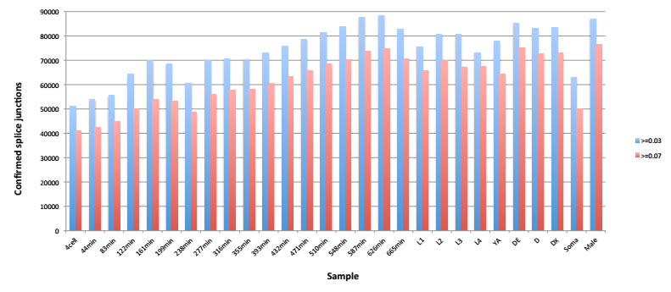

Supplemental Figure 9. The number of splice junctions confirmed in each sample at a dcpm threshold of 0.03 and 0.07 are shown. There are a total of 157,292 splice junctions confirmed across these samples at >=0.03 and 143,054 at >=0.07.

