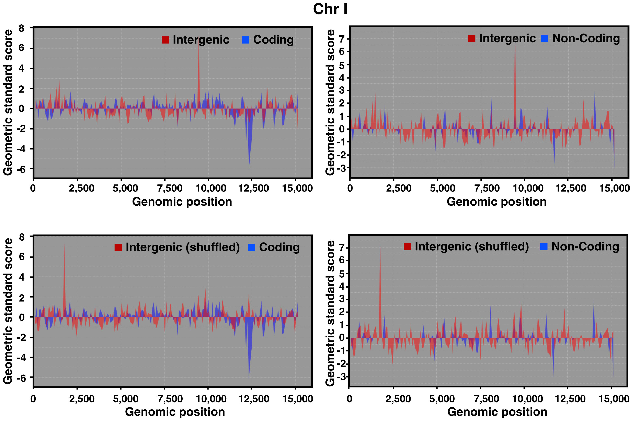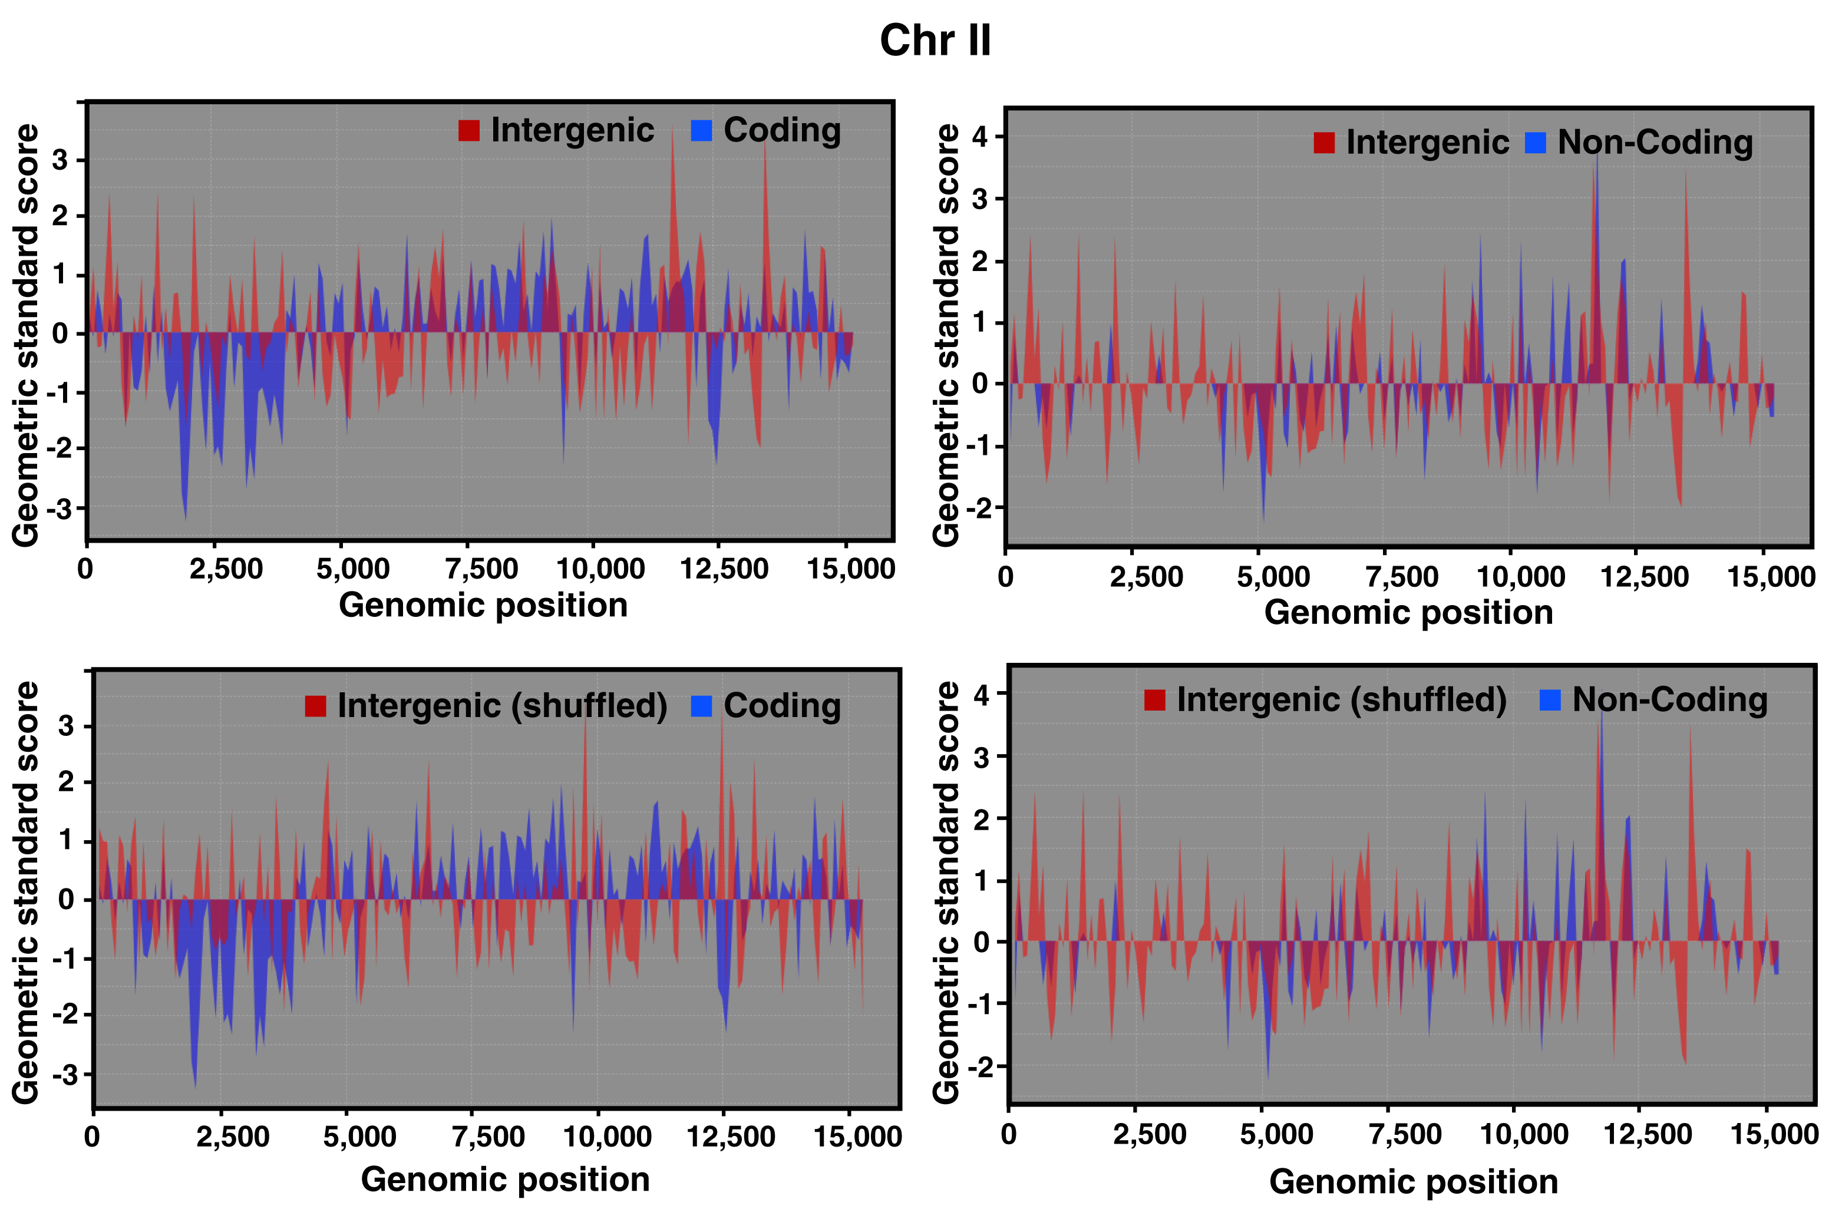

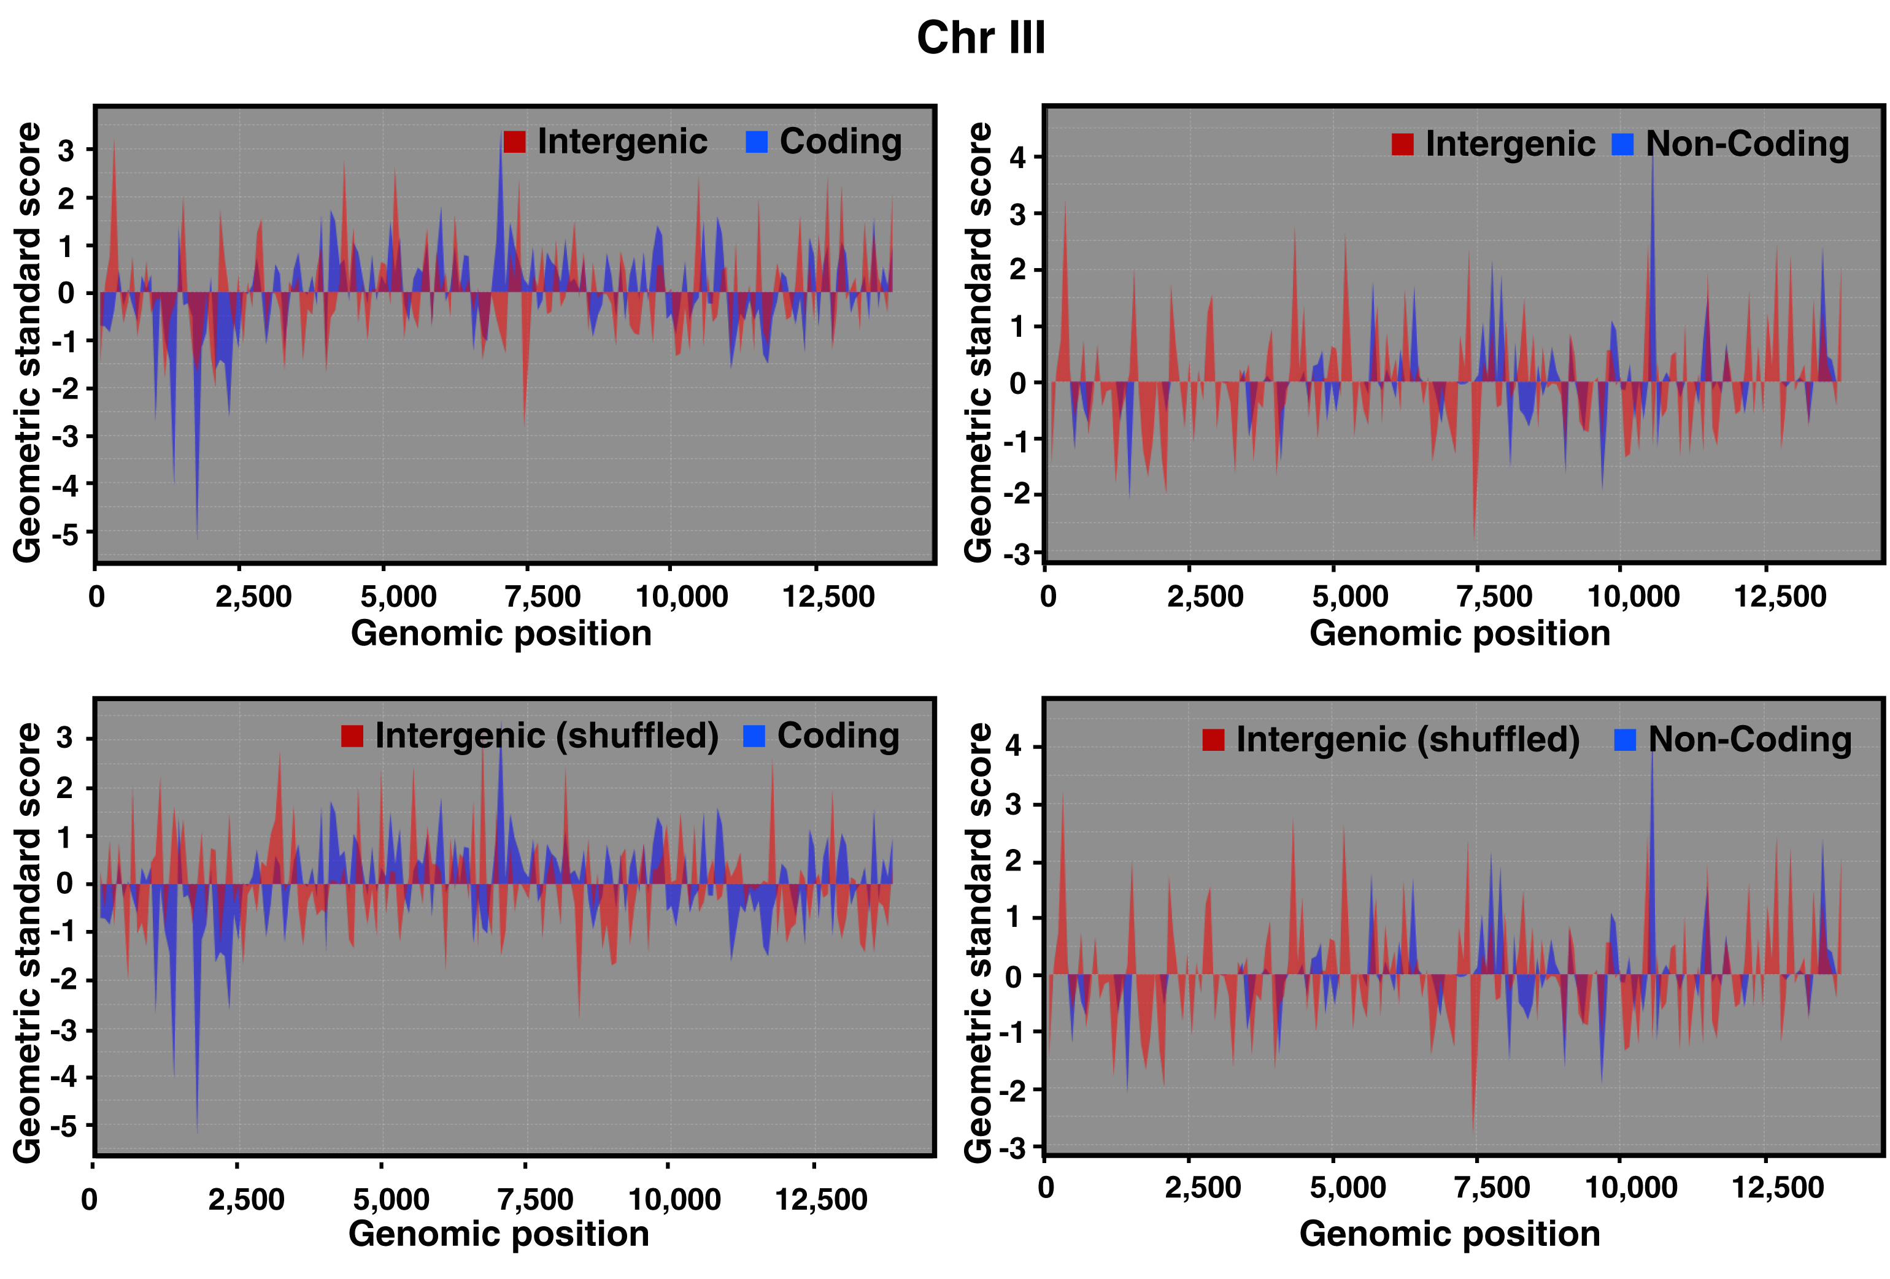
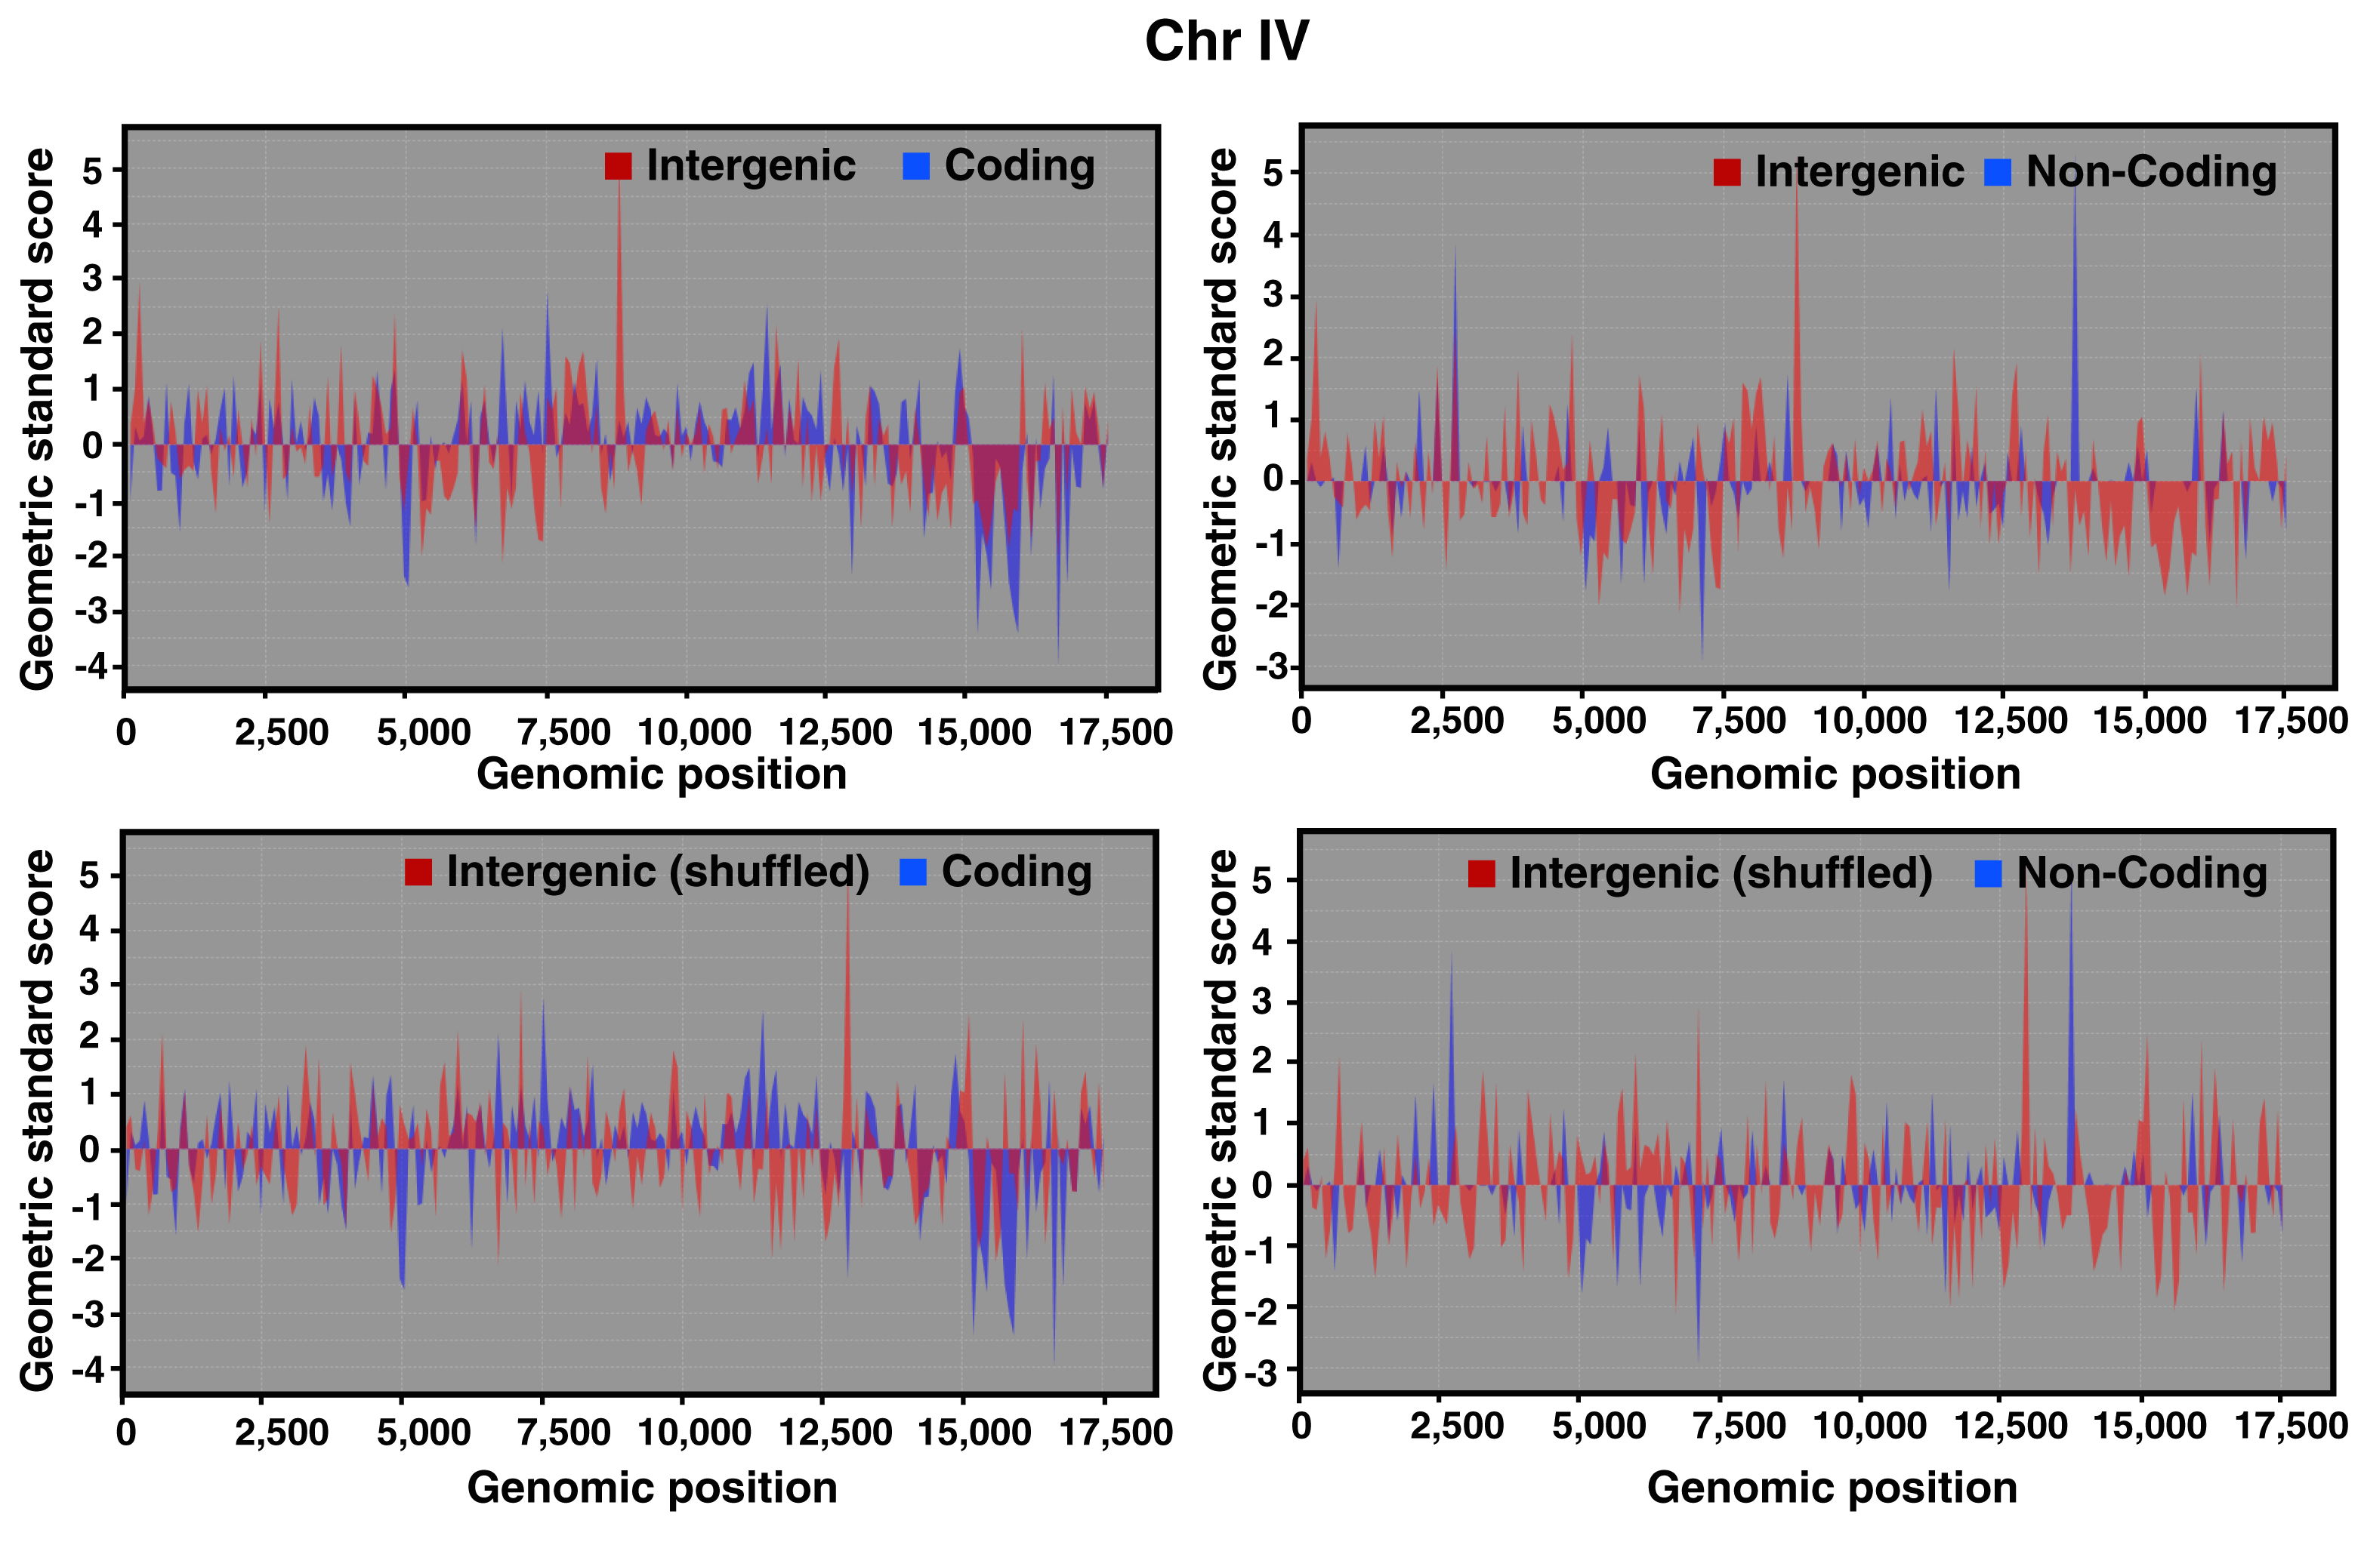
Supplemental Figure 16. Average dcpm values for 80kb regions for bases annotated as intergenic, protein coding gene, or non-coding gene in each 80kb region. The regional dcpm values were averaged across all high quality embryonic samples. The per-region dcpm values are normalized by transforming to the geometric standard score for each chromosome, to facilitate comparison of intergenic, coding and non-coding signals. The x-axis is the genomic position of the 80kb regions, in thousands of bases, for each chromosome. Charts with intergenic signal labeled shuffled show one example of a randomization of the regional intergenic values together with non-randomized coding and non-coding signals.
