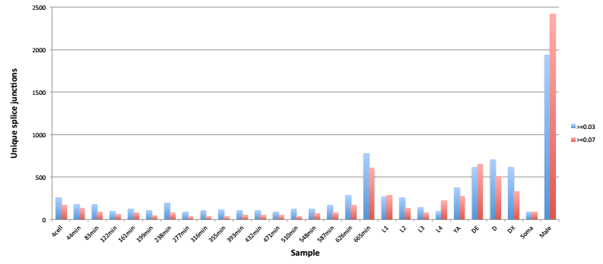

Supplemental Figure10. Unique introns per sample. The number of splice junctions unique to each sample at a dcpm threshold of 0.03 and 0.07 are shown.

